DOM207
MP-2 DOM 207: Introduction to Data Science for Business Using R and Python Dr. Jaideep Ghosh

K.JAIDEEP
2410110565
M.HARSHIL
2410110878

INTRODUCTION:
This project was conducted as part of a consulting assignment for HCL Technologies, aimed at understanding the key determinants of employee salary variations within the company. The dataset provided, ITEmp.xlsx, contains detailed information about HCL employees, covering aspects such as education, professional experience, tenure, job role, demographic background, and work mode. The primary objective of this analysis is to identify which factors significantly influence salary levels and how these relationships align with human capital theory and organisational compensation practices. The study follows a structured analytical approach beginning with data processing and transformation, including outlier treatment and log transformation of salary to address skewness. It then progresses through bivariate and multivariate regression modelling, testing linearity, normality, multicollinearity, and heteroskedasticity assumptions to ensure the reliability of findings. Key variables such as education, experience, and tenure were transformed to capture their nonlinear effects, while categorical predictors like gender, IT division, and metro residence were included to assess group-level differences. The final Multiple Linear Regression (MLR) model integrates human capital, IT role, and demographic factors to explain variations in employee salary. It not only highlights how education, experience, and tenure contribute to earnings but also uncovers disparities across departments, genders, and work modes. The insights from this model form the basis for data driven recommendations that can support HCL Technologies in developing equitable, performance-oriented, and strategically aligned compensation policies.

DATA PROCESSING:
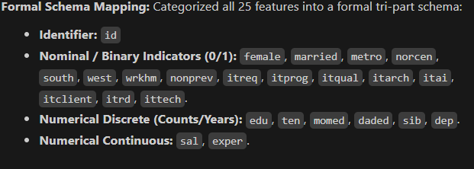
Data Processing:
The dataset, comprising 526 employee records across 25 attributes, was initially assessed for completeness, accuracy, and consistency. Column names were standardized by removing leading and trailing spaces and converting them to lowercase. All feature columns were subsequently converted to numeric format. This process identified eight invalid text entries, including “acb” in salary and “SS0” in education, which helped for better model usage of data.
A total of 30 missing values, including those identified during numeric conversion, were imputed according to variable type. Missing binary indicators were replaced with their respective modes, while missing salary and experience values were replaced with their respective means. For discrete variables, including education, tenure, siblings, and dependents, rounded means were used to preserve integer values. One negative numerical entry was converted to its absolute value. These procedures retained all 526 observations during the initial cleaning stage.
Logical consistency was assessed by comparing related variables within each employee record. The checks identified 16 records in which company tenure exceeded total work experience, 285 records with overlapping regional indicators. Potential outliers were identified using interquartile range (IQR) rule, with observations below flagged for review. This procedure identified 29 salary outliers and no experience outliers. Flagged observations were initially retained to assess their influence through sensitivity analysis.
Before regression estimation, predefined boundary filters were applied. Salary was restricted to values greater than zero and below 100; education and parental education were limited to 30 years; and the numbers of siblings and dependents were limited to 25 and 20, respectively. Three records failed these criteria and were excluded, yielding a final modelling sample of 523 observations. Duplicate checks across all non-identifier variables identified no repeated profiles, and subsequent validation confirmed that no missing values remained.
Finally, salary was transformed using the logarithm to reduce positive skewness and support a semi-logarithmic regression specification. Selected numerical predictors were mean-centred by subtracting their respective sample means before constructing quadratic and interaction terms. This procedure was used to reduce nonessential multicollinearity between the original predictors and their derived terms. A separate standardized dataset was also prepared for better analysis this focused on better usage of data for designing the model.

Analysis of the Correlation Matrix:
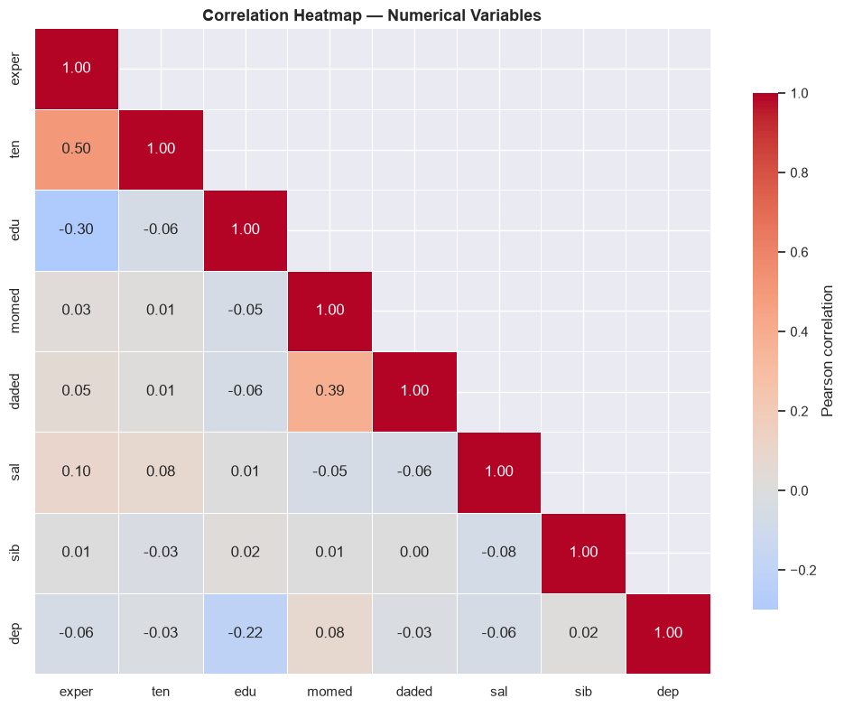
Most coefficients are small, with the clearest relationships occurring between professional experience and company tenure, between the two parental education measures, and between education and professional experience. These associations do not give proper implications of taking conclusions.
Professional experience and company tenure
Professional experience and company tenure have the strongest positive association in the matrix, with a correlation coefficient of 0.499. This indicates that employees with greater accumulated professional experience generally tend to have longer service with their current employer.
Professional experience measures total career exposure, whereas tenure reflects service within a specific organisation.
Maternal and paternal education
Maternal and paternal education are positively correlated at 0.385. This indicates that employees whose mothers have more years of education also tend to have fathers with higher educational attainment.
The relationship suggests educational similarity within parental households. However, the matrix cannot determine whether this reflects partner selection, shared socioeconomic circumstances, or other influences.
Education and professional experience
Formal education has a negative correlation of −0.299 with professional experience. Employees with more years of education therefore tend to report fewer years of professional experience.
One possible explanation is that longer education delays entry into full-time employment.
By comparison, education has only a weak relationship with company tenure, at −0.056. This suggests that educational attainment is more closely associated with total accumulated experience than with the length of service at the current company.
Education and dependents
Education and the number of dependents have a negative correlation of −0.215. This indicates a modest tendency for employees with higher educational attainment to report fewer immediate-family dependents.
The relationship may reflect differences in age, household composition, or family formation. Since these factors have not been controlled for, the results do not establish that higher education directly reduces dependency responsibilities.
Employee education and parental education
Employee education has very weak negative correlations with maternal education (−0.054) and paternal education (−0.060). The matrix therefore provides little evidence of a linear relationship between employees’ years of education and their parents’ educational attainment within this sample.
Limited variation in educational attainment, together with selection into the sampled workforce, may restrict the observable relationship between the factors.
Salary and employee characteristics
Salary has weak correlations with all the numerical variables included in the matrix. Its correlations with professional experience and company tenure are 0.100 and 0.080, respectively, indicating only slight positive linear associations. The correlation with formal education is almost zero, at 0.009. Correlations with parental education, siblings, and dependents are also small, ranging from −0.054 to −0.075.
An unusually large salary observation can materially alter Pearson correlation coefficients, potentially weakening or strengthening the apparent relationships.
the matrix excludes categorical characteristics such as job function and location, which may help explain salary differences. Salary may also vary nonlinearly with experience or differ across employee groups.
Remaining relationships and implications
Most remaining correlations are close to zero. Sibling count, in particular, shows little linear association with the other numerical characteristics. The correlation between siblings and dependents is only 0.015, indicating that these variables describe distinct aspects of family composition rather than equivalent measures of household size.
The matrix contains no very high pairwise correlations among the displayed variables, so it provides no immediate indication of severe pairwise redundancy.

DESCRIPTIVE STATS ANALYSIS:
refer the code file for full analysis
1.The mean hourly salary of 9.83 is more than twice the median of 4.735, indicating that high-salary observations substantially raise the average. Meanwhile, the middle 50% of employees earn between 3.350 and 7.335. The median and interquartile range should accompany the mean when describing compensation levels.
2.Salary has a standard deviation of 53.84, skewness of 17.725, and a maximum of 1,111. These statistics indicate an exceptionally uneven distribution with an extreme upper tail. This high observations may lead to substantial influence on the estimated relationships and prediction errors. comparing results using salary in its original form and logarithmic form would help assess whether the findings depend on extreme values.
3.Professional experience ranges from 1 to 51 years, with the middle 50% of employees having 5–26 years of experience. This broad distribution provides scope to investigate whether salary differs across career stages. It also supports examining a potentially nonlinear relationship: the salary difference associated with an additional year of experience may vary between early and later career stages. The descriptive statistics establish the availability of this variation, but do not demonstrate an experience premium.
4.Median company tenure is 2 years, compared with median professional experience of 13 years. This contrast indicates that company service and accumulated professional experience represent different dimensions of employees’ careers. Including both in salary analysis would help assess whether compensation is associated with experience gained across employers, service within the current organisation, or both. Since tenure is concentrated at lower values and extends to 44 years,

5. The middle 50% of employees have 12–14 years of formal education, and both the median and mode are 12 years.. Moreover, years of education do not capture qualification type, field of study, technical expertise, or professional certifications.
6. Maternal and paternal education average 9.93 and 14.48 years, indicating variation in parental educational background. These variables may help investigate whether salary differs with family background after accounting for employees’ own education and employment history. parental education is only a partial indicator of socioeconomic circumstances and this do not give complete picture.
Similarly, variation in siblings and dependents describes family circumstances rather than employee productivity or compensation as a criterion.

Normality Assessment

Normality tests were performed to examine the salary distribution, assess the usefulness of logarithmic transformation, and check whether the regression residuals followed a normal distribution. Residuals represent the differences between observed and predicted log salaries.

The Shapiro–Wilk test was applied to hourly salary and log salary using the final sample of 523 employees. Normality was rejected for both salary (W = 0.5548, p < 0.001) and log salary (W = 0.9523, p < 0.001). However, the statistic moved closer to one after transformation, indicating that log salary more closely resembled a normal distribution. The transformation therefore improved the distribution’s shape without achieving normality.

Test | Statistic | p-value | Conclusion at 5%
Shapiro–Wilk | 0.9366 | < 0.001 | Reject normality
Jarque–Bera | 814.3433 | < 0.001 | Reject normality
Residual skewness of 0.9650 indicated a longer positive tail, while excess kurtosis of 5.8004 indicated more extreme residuals than expected under a normal distribution.
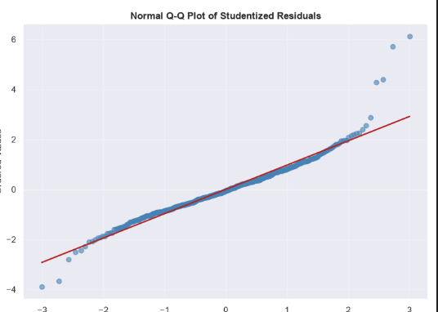
Normal Q–Q plot of studentized residuals from the combined log-salary regression (N = 523).
Observations near the centre broadly follow the reference line, but both tails depart from it, particularly the upper tail. The large positive residuals indicate that the model substantially underpredicts salary for some employees.
These findings show that residual normality is not supported, despite the logarithmic transformation of salary. This does not automatically invalidate the regression estimates, but it warrants caution when interpreting conventional statistical inference. Unusual observations should be examined through influence diagnostics and sensitivity analysis.
Variable Transformation
Variable transformations were applied to improve the salary model’s specification, capture nonlinear relationships, and make coefficients easier to interpret.
Logarithmic transformation of salary
Hourly salary was transformed using the natural logarithm:
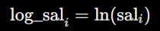
All salary observations in the final sample were positive, ranging from 0.53 to 60, making the transformation valid for all 523 employees. The transformation reduced the relative scale of high salaries and allowed salary differences to be expressed in percentage terms. The Shapiro–Wilk statistic increased from 0.5548 for salary to 0.9523 for log salary, indicating an improvement in distributional shape, although normality remained rejected.
Mean-centring of continuous predictors
Education, professional experience, company tenure, parental education, and the number of dependents were centred by subtracting their respective sample means:
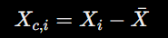
Centring made zero represent the sample average rather than the absence of the characteristic. This improved the interpretation of coefficients in models containing quadratic and interaction terms. It can also reduce correlations introduced by constructing these terms, although it does not eliminate all multicollinearity. With the corresponding lower-order terms retained, centring changes the interpretation of coefficients without changing fitted values.
Quadratic terms
Squared terms for centred education, experience, and tenure were included to allow their relationships with log salary to vary across their observed ranges:
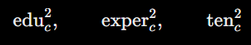
In the combined model, the education squared term was positive and statistically significant (p = 0.0012), while the experience squared term was negative and significant (p < 0.001). These results supported an upward-curving education relationship and a downward-curving experience relationship, respectively. The tenure squared term was not individually significant at the 5% level (p = 0.0990).

Assessment of Multiple Linear Regression Assumptions
The combined log-salary model was assessed using diagnostic tests and plots at a 5% significance level.
Assumption or diagnostic |  | Result | Interpretation
Multicollinearity |  | VIFs: 1.11–6.15 | Education had the highest VIF. Some predictor overlap exists and may reduce coefficient precision.
Constant error variance |  | Breusch–Pagan: p = 0.4996; White: p = 0.2391 | Neither test found significant evidence of unequal error variance.
Functional form |  | RESET: p = 0.1092 | No significant evidence of the specification problems examined by this test.
Residual normality |  | Shapiro–Wilk ap < 0.001 | Normality was rejected. The Q–Q plot also showed clear departures in the tails.
Influential observations |  | 33 observations exceeded the Cook’s distance threshold of 4/N ≈ 0.0076 | These observations require further investigation and sensitivity checks, rather than automatic removal.

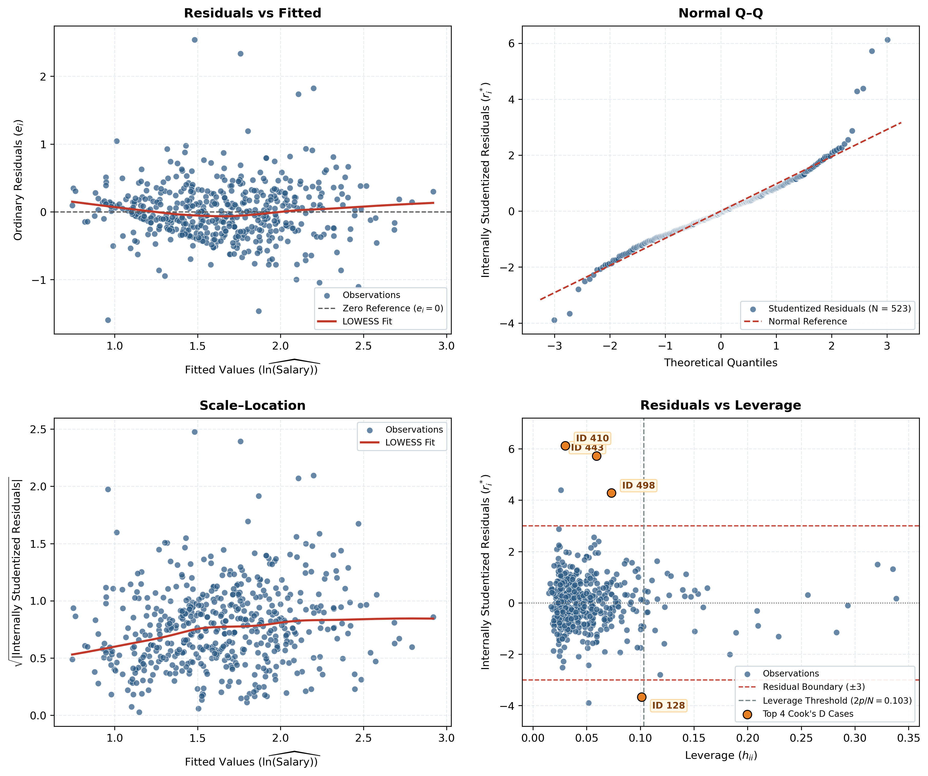

Theoretical Basis of the Hypotheses
The hypotheses were based on human capital theory and labour-market reasoning. Human capital theory.
Variable | Theoretical or logical explanation | Expected association with salary
Education | More education may improve knowledge and skills and provide employers with evidence of an employee’s abilities. | Positive
Professional experience | Experience may improve productivity, but the benefit of each additional year may decrease over time. | Initially positive,
Company tenure | Longer service may build knowledge of the organisation and create opportunities for promotion. These benefits may become smaller over time. | Initially positive,
Female indicator | Unequal career opportunities and differences in work and family responsibilities may contribute to salary differences between women and men. | Negative
Metropolitan residence | Metropolitan areas may offer more specialised jobs and greater demand for skilled employees. | Positive
Non-privileged status | Barriers to training, professional networks, and career opportunities may be associated with lower salaries. | Negative
Parental education | Parents’ education may support access to learning, career guidance, and professional networks. | Positive anticipated
Marital status and dependents | Family responsibilities may influence employment choices in different ways. | uncertain
Work-from-home status | Salary differences may depend on job type, flexibility, and which employees work from home. | uncertain
IT work indicators | Different work activities may require different skills and responsibilities, leading to salary differences. | Varies by activity
For each individual coefficient, the null hypothesis stated that it was zero, while the alternative stated that it differed from zero:
Two-sided tests were conducted at the 5% significance level. The expected signs provided a basis for interpreting the findings.

How is significance level is chosen?
A 5% significance level was used for hypothesis testing. This provides a conventional threshold for balancing the risk of falsely identifying an association against the risk of overlooking one. A p-value below 0.05 was considered statistically significant; a larger p-value indicated insufficient evidence to reject the null hypothesis.
Two-sided tests were used because an association could occur in either direction.
Effect Size and Direction
After accounting for the other variables in the model, metropolitan residence was associated with 18.7% higher salary at average education. Among employees working on-site with average education, women had an estimated 23.9% lower salary than men. AI-related work was associated with 13.7% lower salary, while working exclusively with IT clients was associated with 11.1% higher salary.
Education, experience, and company tenure were positively associated with salary at the model’s reference values. However, the size of these associations varied across employee characteristics because the model included squared and interaction terms. All estimates were assessed alongside their 95% confidence intervals and represent associations rather than evidence of cause and effect.

HOW ARE CONFIDENCE INVERVALS CHOOSEN?
95% confidence intervals, calculated using robust standard errors, were reported to show the uncertainty around the estimated coefficients. This confidence level corresponds to the 5% significance level used for two-sided hypothesis tests. The intervals helped assess the direction, precision, and range of plausible values for each association.
For example, the education coefficient had an interval of 0.0307 to 0.1115, while the female coefficient ranged from −0.3620 to −0.1852. Neither interval included zero, supporting positive and negative associations, respectively, at the model’s reference values. In contrast, the tenure-squared interval (−0.0012 to 0.0001) included zero, indicating insufficient evidence of tenure curvature at the 5% level.
These intervals are expressed in log-salary coefficient units, not percentages. They helped distinguish clearly supported associations from uncertain estimates rather than relying on p-values alone.
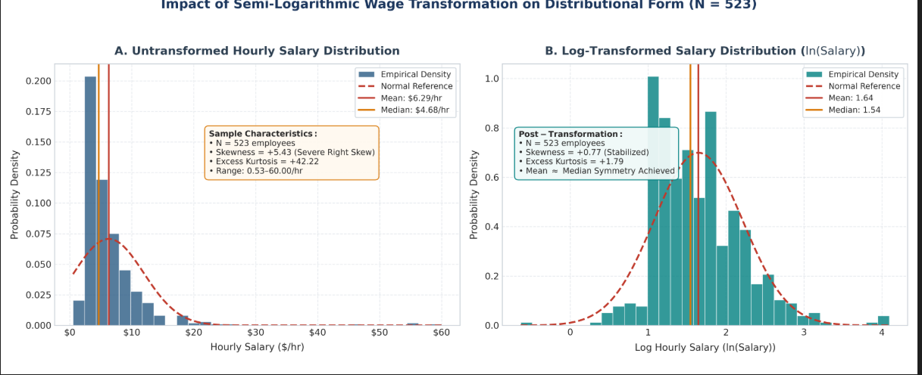

Salary and Log-Salary Distributions
The histograms compare hourly salary before and after logarithmic transformation. They show whether the transformation reduces the long upper tail and makes the distribution more balanced.

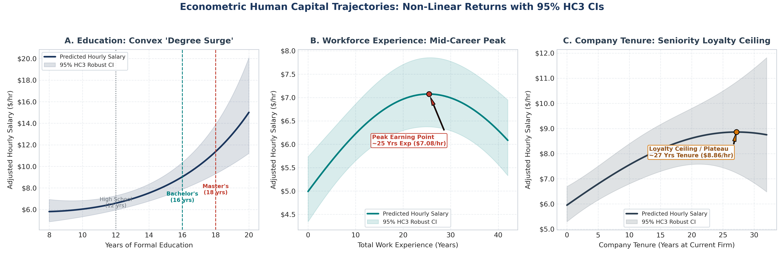
2. Adjusted Education, Experience, and Tenure Curves
These curves show how predicted salary varies with education, experience, and company tenure while other characteristics are held constant. The 95% confidence bands show uncertainty around the estimated relationships.
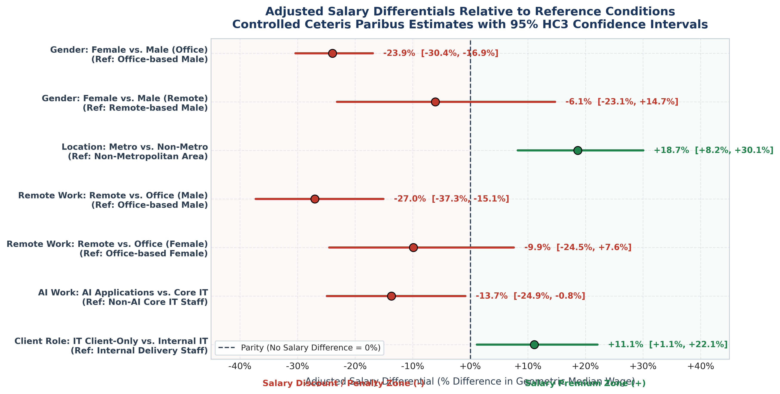
3. Estimated Salary Differences with Confidence Intervals
This plot presents adjusted percentage salary differences for selected employee characteristics under clearly stated reference conditions. The 95% confidence intervals show precision; intervals crossing zero indicate insufficient evidence of a difference at the 5% level.
Regression Results and Interpretation
The combined regression model examined the association between employee characteristics and hourly salary using 523 observations. The dependent variable was the natural logarithm of salary. HC3 robust standard errors were used to calculate p-values and 95% confidence intervals.
Table X. Combined log-salary regression results
Predictor | Coefficient | HC3 SE | p-value | 95% confidence interval
Intercept | 1.6958 | 0.0673 | <0.001 | [1.5640, 1.8277]
Education, centred | 0.0711 | 0.0206 | 0.0006 | [0.0307, 0.1115]
Experience, centred | 0.0091 | 0.0022 | <0.001 | [0.0048, 0.0135]
Company tenure, centred | 0.0238 | 0.0055 | <0.001 | [0.0131, 0.0345]
Female | −0.2736 | 0.0451 | <0.001 | [−0.3620, −0.1852]
Married | 0.0513 | 0.0467 | 0.2724 | [−0.0403, 0.1429]
Dependents, centred | −0.0239 | 0.0167 | 0.1525 | [−0.0566, 0.0088]
Metropolitan residence | 0.1711 | 0.0468 | 0.0003 | [0.0793, 0.2629]
Non-privileged status | −0.0451 | 0.0649 | 0.4864 | [−0.1723, 0.0820]
Mother’s education, centred | 0.0061 | 0.0073 | 0.4065 | [−0.0083, 0.0204]
Father’s education, centred | −0.0006 | 0.0062 | 0.9203 | [−0.0129, 0.0116]
AI-related work | −0.1474 | 0.0709 | 0.0376 | [−0.2864, −0.0084]
Works only with IT clients | 0.1054 | 0.0480 | 0.0282 | [0.0112, 0.1996]
IT technical support | −0.0219 | 0.0605 | 0.7168 | [−0.1405, 0.0966]
IT research and development | 0.0809 | 0.0595 | 0.1740 | [−0.0357, 0.1975]
Primarily works from home | −0.3148 | 0.0773 | <0.001 | [−0.4663, −0.1633]
Education squared, centred | 0.0060 | 0.0018 | 0.0012 | [0.0024, 0.0096]
Experience squared, centred | −0.0005 | 0.0001 | <0.001 | [−0.0008, −0.0003]
Tenure squared, centred | −0.0005 | 0.0003 | 0.0990 | [−0.0012, 0.0001]
Education × female | 0.0083 | 0.0165 | 0.6162 | [−0.0240, 0.0406]
Education × mother’s education | 0.0004 | 0.0027 | 0.8787 | [−0.0049, 0.0057]
Education × father’s education | 0.0027 | 0.0027 | 0.3225 | [−0.0026, 0.0080]
Experience × non-privileged status | −0.0121 | 0.0063 | 0.0562 | [−0.0246, 0.0003]
Education × non-privileged status | −0.0302 | 0.0243 | 0.2142 | [−0.0778, 0.0174]
Dependents × work from home | 0.0119 | 0.0433 | 0.7829 | [−0.0729, 0.0967]
Female × work from home | 0.2108 | 0.1090 | 0.0531 | [−0.0028, 0.4244]
Education × metropolitan residence | −0.0092 | 0.0192 | 0.6325 | [−0.0469, 0.0285]
HC3 robust standard errors were used to calculate confidence intervals and p-values that allow for unequal error variance across observations

Interpretation of coefficients
Education, professional experience, and company tenure were positively associated with salary at the model’s reference values. The positive education-squared coefficient (p = 0.0012) indicates that the slope of the education–log-salary relationship increases with education. The negative experience-squared coefficient (p < 0.001) indicates that additional experience is associated with progressively smaller gains in log salary. Tenure curvature was not individually significant at 5% (p = 0.0990).
At average education, metropolitan residence was associated with approximately 18.7% higher fitted geometric salary, holding the other included characteristics constant. Among employees working on-site with average education, women had approximately 23.9% lower fitted salary than men. These differences identify adjusted associations and do not establish their causes.
AI-related work was associated with approximately 13.7% lower fitted salary, whereas working exclusively with IT clients was associated with approximately 11.1% higher fitted salary. These estimates may reflect differences in responsibilities, seniority, or other characteristics not fully captured by the model. They should not be interpreted as the causal effects of entering these work activities.
Working primarily from home was associated with approximately 27.0% lower fitted salary among men at the average number of dependents, holding other characteristics constant. This comparison varies by gender and dependency count because the model includes corresponding interaction terms.
Marital status, dependents, non-privileged status, parental education, technical support, and research-and-development work were not individually significant at 5%. Their confidence intervals included zero, indicating insufficient evidence of an association at the relevant reference values.
None of the eight interaction terms was individually significant at 5%, and the interaction block was not jointly significant (p = 0.2793). Consequently, the model did not provide clear evidence that the specified salary relationships differed across employee groups.

Model fit
Model measure | Result
Observations | 523
R² | 0.4827
Adjusted R² | 0.4555
Residual standard error | 0.4209
Joint significance of quadratic terms | p < 0.001
Joint significance of interaction terms | p = 0.2793
The model explained approximately 48.3% of the observed variation in log salary. After accounting for the number of predictors, adjusted R² was 45.6%. These values indicate meaningful but incomplete explanatory power.
The remaining variation may reflect unmeasured factors such as job grade, performance, specialised skills, working hours, and employer characteristics. Measurement error and individual differences may also contribute.
Model Specification
A semi-log (log-linear) regression model was used, with the natural logarithm of hourly salary as the dependent variable. The predictors included employee characteristics, squared terms for education, experience, and tenure, and eight interaction terms.
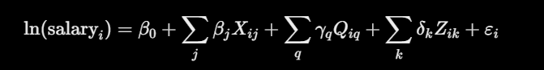
Here, \(X\) represents the main predictors, \(Q\) the squared terms, and \(Z\) the interaction terms. Continuous variables were mean-centred before constructing squared and interaction terms, and the corresponding main effects were retained.

ANALYSIS OF THE FINAL REGRESSION MODEL
1. Intercept: Reference Salary Level
The intercept was 1.6958 and statistically significant (p < 0.001). It represents the predicted log salary for an employee whose continuous characteristics are at their sample averages and whose binary indicators equal zero. This reference employee is male, unmarried, non-metropolitan, and does not primarily work from home.
Converting the intercept to the original salary scale gives approximately 5.45 salary units.
2. Education
Education had a positive and statistically significant coefficient of 0.0711 (p = 0.0006). The education-squared coefficient was also positive and significant at 0.0060 (p = 0.0012). Together, these results indicate that the relationship between education and log salary becomes more positive as education increases.
This pattern is consistent with additional education developing skills or qualifications that employers reward. However, the estimated relationship varies with gender, location, parental education, and non-privileged status because these characteristics interact with education in the model. The findings do not establish salary premiums for particular degrees, as the variable measures years of education rather than qualification type.

3. Professional Experience
Professional experience had a positive coefficient of 0.0091 (p < 0.001), while its squared term was negative and significant (p < 0.001). This indicates that the salary association of additional experience becomes smaller as experience increases.
The pattern may reflect strong learning gains early in a career followed by smaller gains later. However, the model does not establish the reason for this pattern or show how an individual employee’s salary changes over time.
4. Company Tenure
Company tenure had a positive and significant coefficient of 0.0238 (p < 0.001). At average tenure, the estimated local salary increase was approximately 2.38% per additional year, holding other included characteristics constant.
Longer service may be associated with organisation-specific knowledge, promotion opportunities, and accumulated pay increases. The tenure-squared coefficient was negative but not significant at the 5% level (p = 0.0990). Therefore, the evidence supports a positive association around average tenure but does not clearly establish a later salary plateau or decline.
5. Gender
The female coefficient was −0.2736 and statistically significant (p < 0.001). Among employees working on-site with average education, women had approximately 23.9% lower fitted salary than men, after accounting for the other included characteristics.
This difference warrants further investigation into job grades, responsibilities, working hours, and promotion opportunities. The education–gender interaction was not significant (p = 0.6162), providing insufficient evidence that the education–salary relationship differed between women and men.
6. Metropolitan Residence
Metropolitan residence had a positive coefficient of 0.1711 (p = 0.0003). At average education, employees living in metropolitan areas had approximately 18.7% higher fitted salary than comparable non-metropolitan employees.
The education–metropolitan interaction was not significant (p = 0.6325), so different education–salary relationships across locations were not clearly supported.
7. Work-from-Home Status
Working primarily from home had a negative coefficient of −0.3148 (p < 0.001). Among men with an average number of dependents, this corresponded to approximately 27.0% lower fitted salary than for those not primarily working from home.
The comparison varies with gender and the number of dependents. However, neither related interaction was significant at 5%. The results do not establish that working from home causes lower salary. Differences in job type, seniority, hours, or employment arrangements may contribute.
8. IT Work Characteristics
AI-related work had a negative coefficient of −0.1474 (p = 0.0376), corresponding to approximately 13.7% lower fitted salary. This finding concerns reported involvement in AI applications and should not be interpreted as evidence that AI skills reduce earnings. Differences in responsibilities and seniority may help explain the association.
Working exclusively with IT clients had a positive coefficient of 0.1054 (p = 0.0282), corresponding to approximately 11.1% higher fitted salary. Client-related responsibilities or skill requirements may contribute, although these explanations were not directly examined.
Technical support and research-and-development indicators were not statistically significant.
9. Marital Status and Dependents
Marital status had a positive coefficient but was not significant (p = 0.2724). The number of dependents had a negative coefficient that was also not significant (p = 0.1525).
These results provide insufficient evidence of salary associations at the relevant reference values. They do not demonstrate that family circumstances are unrelated to employment or earnings.
10. Non-Privileged Status
Non-privileged status had a negative coefficient of −0.0451 but was not significant (p = 0.4864). At average education and experience, the model did not establish a clear salary difference associated with this indicator.
Its interactions with education and experience were also not significant at 5%.
11. Parental Education
Neither mother’s education (p = 0.4065) nor father’s education (p = 0.9203) was significant at average employee education. Their interactions with employee education were also insignificant.
The model therefore provided insufficient evidence of a separate association between parental education and salary after accounting for the included characteristics.

Recommendations

1. Link education to job-related skills.
Education was positively associated with salary (p = 0.0006), and the relationship became stronger at higher education levels (p = 0.0012). The organisation should consider how qualifications support the skills needed for each role. Relevant education, certifications, and the application of knowledge should inform training opportunities and salary reviews.
2. Reward contribution alongside experience.
Salary gains became smaller at higher experience levels, while company tenure remained positively associated with salary (p < 0.001). Career progression should therefore consider technical skills, leadership, mentoring, and responsibility alongside years of service. Clear promotion criteria would help employees understand how they can progress.
3. Review gender pay differences in similar jobs.
Among employees working on-site with average education, women had approximately 23.9% lower fitted salary than men. The organisation should compare employees with similar job grades, duties, working hours, and performance. Any differences without a clear justification should be reviewed through starting-pay, promotion, and salary-adjustment decisions.
4. Explain location-based salary differences clearly.
Metropolitan residence was associated with approximately 18.7% higher fitted salary at average education. The organisation should assess whether these differences reflect living costs, hiring conditions, or job responsibilities. Clear salary bands and location allowances would make pay decisions easier to understand.
5. Review pay differences between remote and on-site employees.
Working primarily from home was associated with approximately 27.0% lower fitted salary among men with an average number of dependents. Compare remote and on-site employees in similar roles, considering job level, hours, responsibilities, and contract type. Pay decisions should follow clear criteria, as this result does not establish that remote work causes lower salary.
6. Examine salary differences in AI-related work.
AI-related work was associated with approximately 13.7% lower fitted salary (p = 0.0376). The organisation should check whether these employees hold more junior positions or have different responsibilities. Comparisons with similar roles would help determine whether salary levels or career opportunities need review.
7. Apply consistent criteria to IT client-related pay.
Working exclusively with IT clients was associated with approximately 11.1% higher fitted salary (p = 0.0282). The organisation should examine whether this difference reflects workload, specialist skills, or client responsibilities. Any additional pay should follow documented criteria and apply consistently to employees performing comparable work.

