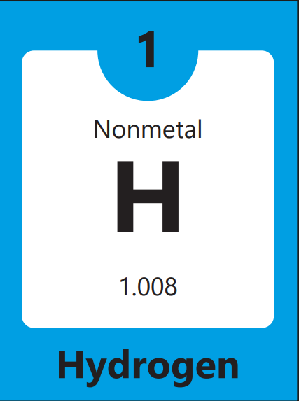

Atomic Mass | 1.008
Melting Point | -259.14
Boiling Point | 20.28
Electronegativity | 2.2
Density | 0.00008988

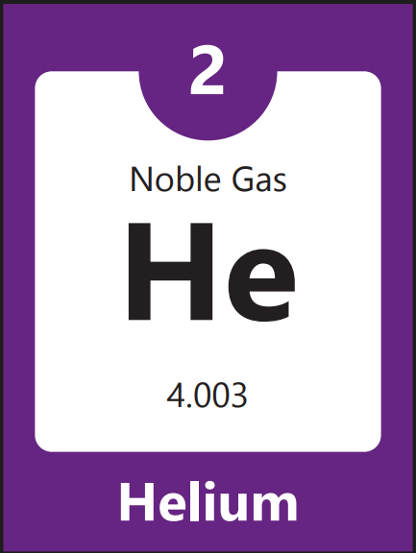

Atomic Mass | 4.006
Melting Point | -272.2
Boiling Point | -268.9
Electronegativity | NA
Density | 0.17

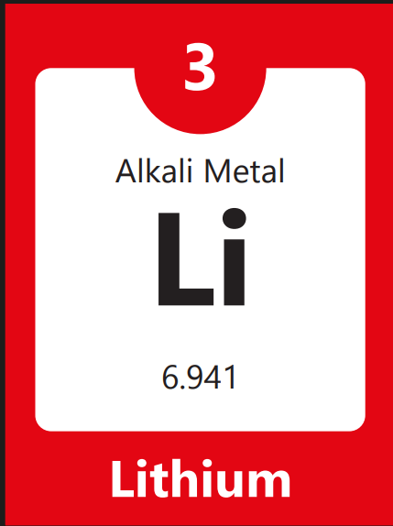

Atomic Mass | 6.94
Melting Point | 180.54
Boiling Point | 1342
Electronegativity | 0.98
Density | 148

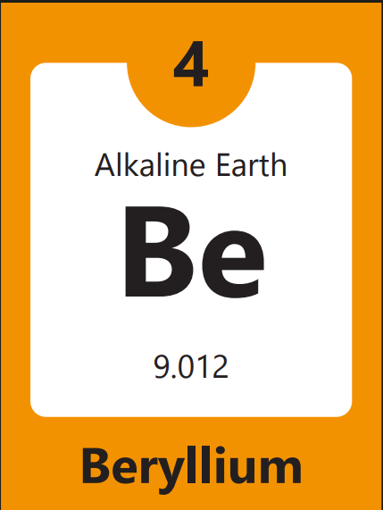

Atomic Mass | 9.01
Melting Point | 1287
Boiling Point | 2470
Electronegativity | 1.57
Density | 0.00008988

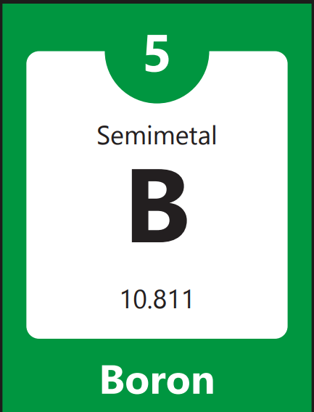

Atomic Mass | 10.81
Melting Point | 2076
Boiling Point | 3900
Electronegativity | 2.04
Density | 2.34

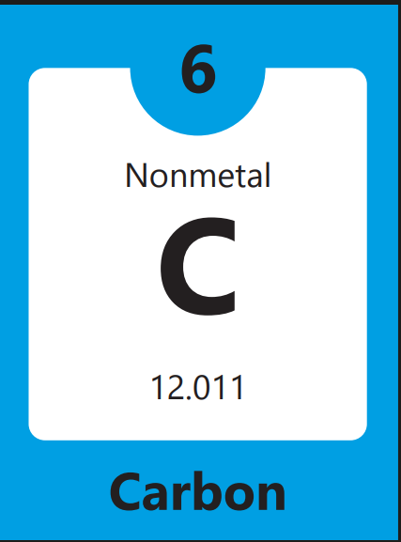

Atomic Mass | 12.011
Melting Point | 3642 Sublime
Boiling Point | 3825
Electronegativity | 2.55
Density | 2.26

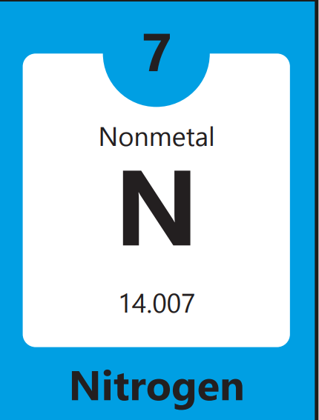

Atomic Mass | 14.007
Melting Point | -210
Boiling Point | -195.8
Electronegativity | 3.04
Density | 1.251

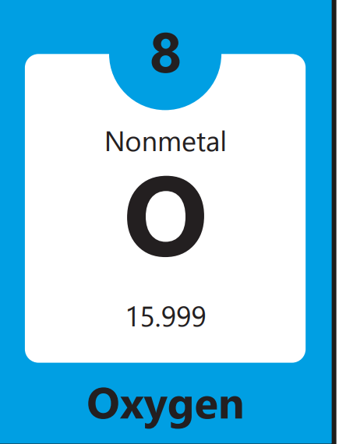

Atomic Mass | 15.99
Melting Point | -218.79
Boiling Point | -182.96
Electronegativity | 3.44
Density | 1.42

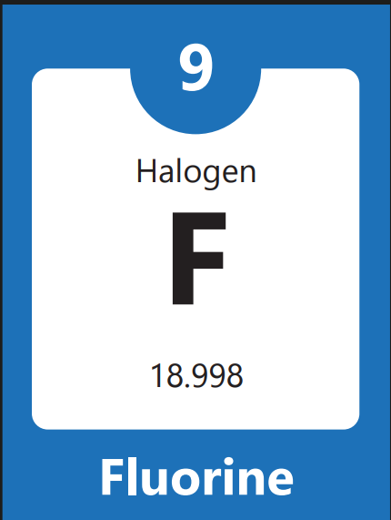

Atomic Mass | 18.9
Melting Point | -219.67
Boiling Point | -188.12
Electronegativity | 3.98
Density | 1.69

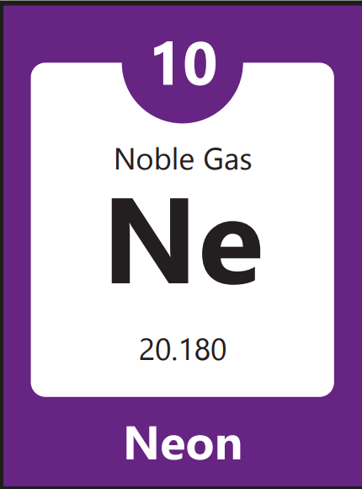

Atomic Mass | 20.180
Melting Point | -248.59
Boiling Point | -246.08
Electronegativity | NA
Density | 0.9

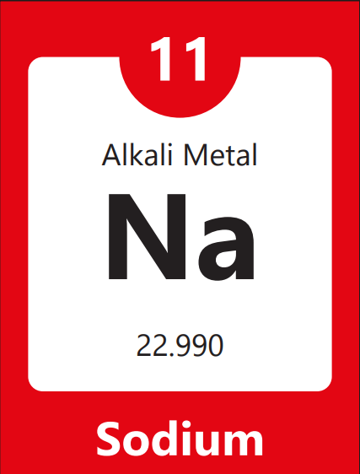

Atomic Mass | 22.99
Melting Point | 97.79
Boiling Point | 883
Electronegativity | 0.93
Density | 0.968

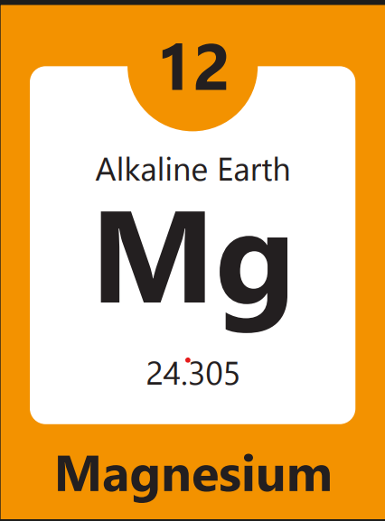

Atomic Mass | 24.305
Melting Point | 650
Boiling Point | 1090
Electronegativity | 1.31
Density | 1.74

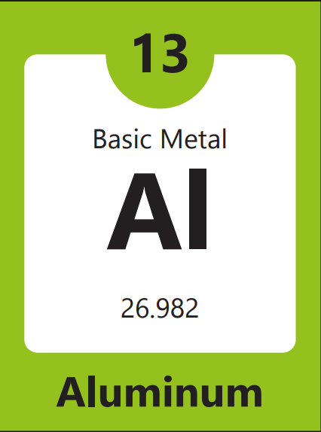

Atomic Mass | 26.982
Melting Point | 660.32
Boiling Point | 2519
Electronegativity | 1.61
Density | 2.70

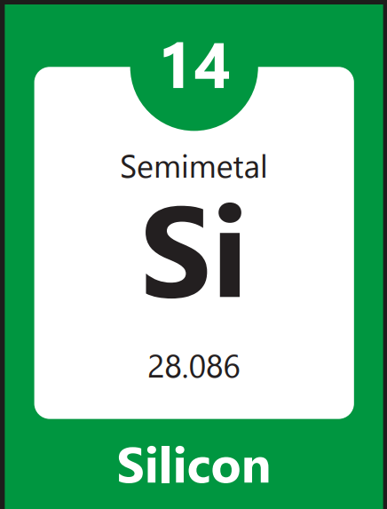

Atomic Mass | 28.085
Melting Point | 1414
Boiling Point | 280.5
Electronegativity | 1.90
Density | 2.33

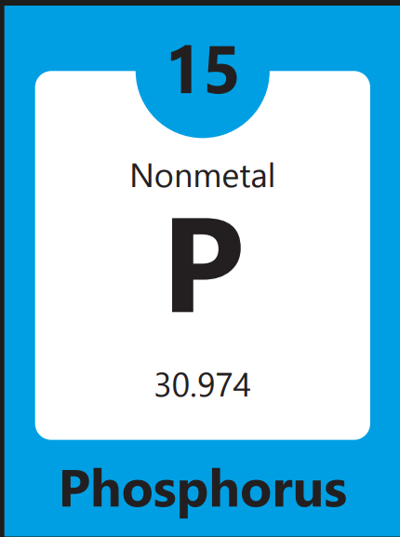

Atomic Mass | 30.974
Melting Point | 44.15
Boiling Point | 280.5
Electronegativity | 2.19
Density | 2.197

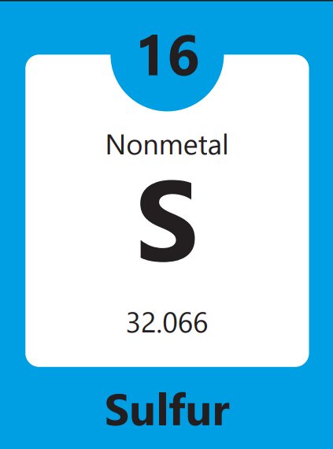

Atomic Mass | 32.06
Melting Point | 115.21
Boiling Point | 444.6
Electronegativity | 2.58
Density | 2.197

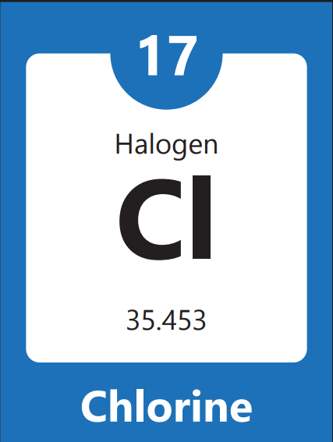

Atomic Mass | 35.45
Melting Point | -101.5
Boiling Point | 34.04
Electronegativity | 3.16
Density | 3.214

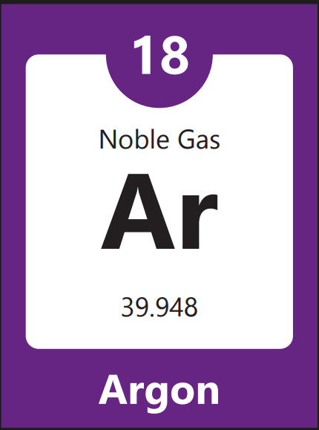

Atomic Mass | 39.948
Melting Point | -189.3
Boiling Point | -185
Electronegativity | NA
Density | 0.0017

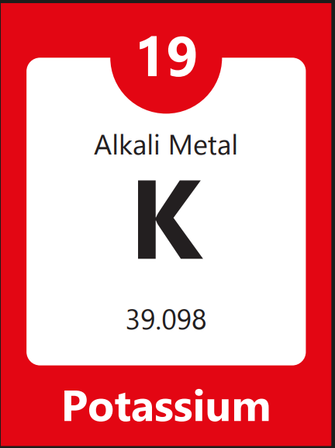

Atomic Mass | 39.098
Melting Point | 63.38
Boiling Point | 759
Electronegativity | 0.82
Density | 0.862

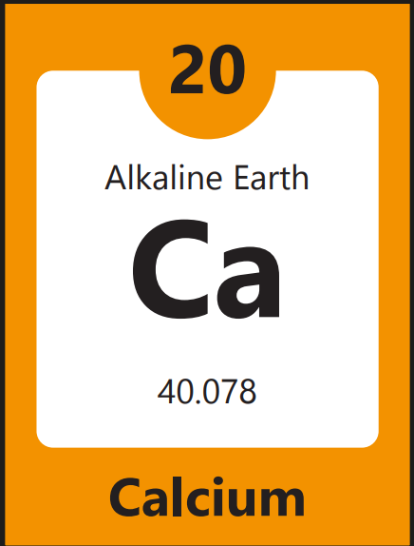

Atomic Mass | 40.078
Melting Point | 842
Boiling Point | 1484
Electronegativity | 1
Density | 1.55

