BCU/ITARI Lesson Plan

Section A – Information
Subject:  Science | Date:  14-11-2025 | Time of Lesson:  5 -5:45 pm | Duration of Lesson:  45 minutes
Unit of Work:  Introduction to Periodicity | Class:  MYP 4 | Number of Learners:  1 | Lesson number in unit:  1
Title/Focus of Lesson:
Foundational Concepts to Understand Periodicity

Section B – Professional Development Links:
The following Teachers’ Standards (Prompts) will be addressed:
- 1(a) establish a safe and stimulating environment for pupils, rooted in mutual respect.
- 4(b) promote a love of learning and children’s intellectual curiosity.
- 4(c) set homework and plan other out-of-class activities to consolidate and extend the knowledge and understanding pupils have acquired.
- 6(b) make use of formative and summative assessment to secure pupils’ progress.

Section C – Aims: Select aims related to the Unit of Work (maximum 2)
To provide opportunities for learners to:
- Understand and value science and its impact on our world.
- Develop curious, analytical and open-minded thinking that encourages asking questions, solving problems, explaining ideas, and evaluating arguments.
- Build awareness of the importance of clear communication.
- Use scientific language and skills confidently.

Section D – Differentiated Statements of Intended Learning:
By the end of the lesson…
ALL learners (including those requiring additional support) will have learned:
- The basic meaning of atomic number, atomic mass, valency and electronegativity.
- How to identify these terms on a periodic table for familiar elements.
- How to write the electronic configuration for simple elements (e.g., H, C, O, Na, Cl).
- That elements with the same number of valence electrons show similar properties.
MOST learners will have learned:
- How to use electronic configuration to determine valence electrons accurately.
- How valence electrons relate to an element’s group number and position in the periodic table.
- How to recognise basic patterns (periodicity) such as similarities within a group.
- How to explain in simple terms why periodic patterns exist based on atomic structure.
SOME learners (including those requiring additional challenge) may have learned:
- How to justify why elements behave similarly or differently using valence electrons and atomic structure.
- How to connect electronic configuration to predictions about reactivity.
- How to interpret trends using higher-level reasoning, such as linking number of shells to electronegativity.
- How to explain how the periodic table is a predictive model, giving examples from unfamiliar elements.

Section E - Resources Checklist including Technology and AI: | Section F – Homework / Independent Learning:
- Interactive digital periodic table  - PowerPoint slides  - Digital whiteboard  - YouTube video on development of periodic table  - Gizmos electron configuration simulation  - Padlet for interactive responses  - Google Forms quick assessment quiz  - Screen sharing and annotation tools | - Classify 5 random elements based on the patterns learnt in the lesson.  - Create a short digital presentation or infographic on one chosen element and identify three of its properties.  - Complete a short Google Forms quiz based on electronic configuration..

Section G - Lesson Plan:
Time: | Intent  What is the intended learning?  Why are we doing this? | Implementation  What teacher/learner activities will comprise the lesson? How will it be organised and delivered? | Impact  What exactly will I assess? How? What am I looking for? How will I know the intent has been achieved?
0-5 minutes | Introduction:  To introduce the students to the periodic table and build an initial awareness of its structure.  Why are we doing this?  This sets the stage for understanding how elements are organized according to their chemical properties, which is important as the concept of periodicity is explored. | The teacher welcomes the learner into the online session through Zoom/Google Meet and briefly explains the structure of the lesson. Using screensharing, the teacher displays an interactive digital periodic table and asks introductory questions such as: “Where have you seen the periodic table before?” and ““Why do you think scientists organised elements into a table?”  The learner responds verbally and through the chat feature. The teacher then plays a short YouTube video on the development of the periodic table using screen-sharing. During the video, the learner is asked to note one interesting fact using Jamboard sticky notes. After the video, the teacher leads an online discussion using annotation tools on the digital whiteboard to highlight patterns and organisation within the table.  https://www.youtube.com/watch?v=fPnwBITSmgU  The teacher assesses prior knowledge through verbal discussion, chat responses, and Jamboard participation. Evidence of learning is observed when the learner:  - Identifies that the periodic table is organised systematically  - Explains at least one reason why the table was developed  - Uses basic scientific vocabulary such as “elements,” “groups,” or “patterns” during discussion  The teacher also observes engagement during the video and online interaction. Learning is achieved if the learner can identify at least one organising pattern and explain the purpose of the periodic table in simple terms. | The teacher will lead a discussion based on the students' learning from the video.  Through their initial responses, the teacher shall assess students' prior knowledge with the periodic table.  The student's engagement during the video will be observed. Their understanding will be checked through discussions on:  - Why the periodic table was developed.  - How patterns in element properties guided its development.  The teacher also looks for scientific vocabulary used within the video to base the student's understanding and learning upon.  Also, the ability to identify at least one organising pattern will indicate that the learning intent has been achieved.
Rationale for Introducing the Concept |  | The lesson begins with interactive questioning and a visual digital presentation of the periodic table to activate prior knowledge and curiosity. Using multimedia resources such as videos and screen-sharing tools helps make online learning more engaging and interactive for a single learner. Visual demonstrations also help the learner understand the periodic table as an organised scientific model rather than a chart to memorise. According to Chiappetta (1997), inquiry-based questioning supports scientific thinking and conceptual understanding.
5-15 minutes | Prior Knowledge:  The intent is to introduce and define the basic terms:  - atomic number  - atomic mass  - valency  - electronegativity  Why are we doing this?  These terms are needed to understand periodic trends and chemical behaviour. Students should know these definitions when beginning a discussion on periodicity, bonding, and reactivity. | The teacher explains each scientific term using PowerPoint slides, visual diagrams, and live annotation on the digital whiteboard. The learner is encouraged to interact with the online periodic table by locating atomic number and atomic mass for selected elements. The teacher uses questioning throughout the lesson and asks the learner to respond verbally and through the chat feature. Short interactive tasks are included where the learner labels valence electrons and predicts simple element behaviour. The teacher also uses polling tools and mini quizzes through Google Forms to maintain engagement and check understanding continuously. | The teacher evaluates whether the learner can correctly define atomic number, atomic mass, valency, and electronegativity and apply these terms using the digital periodic table. Evidence of learning includes:  - Correct verbal explanations of scientific terms  - Accurate identification of element properties during digital activities  - Active participation in polls and quizzes  - Ability to relate valence electrons to group behaviour  - Learning is achieved if the learner confidently explains the terms in simple words and applies them correctly to familiar elements such as Hydrogen, Oxygen, Sodium, and Chlorine.
Rationale for Introducing Key Terminology |  | Key terminology is introduced using visuals and digital interaction to help the learner build a strong conceptual foundation. Using online annotation tools and interactive resources supports engagement and reduces abstract thinking. According to Taber (2014), connecting scientific terms to observable patterns helps improve conceptual understanding.
15-30 minutes | Prior Knowledge:  To further crosscheck the previous knowledge about electronic configuration and valence electrons, the teacher introduces a simulation of electrons.  Why are we doing this?  Reviewing the arrangement of electrons in shells and how valence electrons determine an element's behaviour will position them to appreciate periodic changes across periods and groups and understand why the periodic table is structured as it is. | The teacher revisits electronic configuration through an interactive online activity. Using the digital whiteboard, the learner writes the electronic configurations for Hydrogen, Carbon, Oxygen, Sodium, and Chlorine. The teacher then screen-shares the Gizmos simulation to visually demonstrate electron arrangement and valence electrons. The learner is encouraged to observe shell filling and identify valence electrons using annotation tools. Guided questions are asked throughout the simulation, such as:  • “Do Hydrogen and Sodium behave similarly because they have the same number of valence electrons?”  • “Why do elements in the same group show similar behaviour?”  The learner also completes a drag-and-drop activity through Jamboard where elements are grouped according to their valence electrons. The teacher provides immediate feedback and clarification throughout the activity.  S.No. Element Electronic Configuration Valence Electron/s  1 Hydrogen 1 1  2 Carbon 2,4 4  3 Oxygen 2,6 6  4 Sodium 2,8,1 1  5 Chlorine 2,8,7 7  The students first write down their answers in their notebooks.  The teacher then shows the electronic configuration and valence electron simulation on Gizmos. (Appendix A)  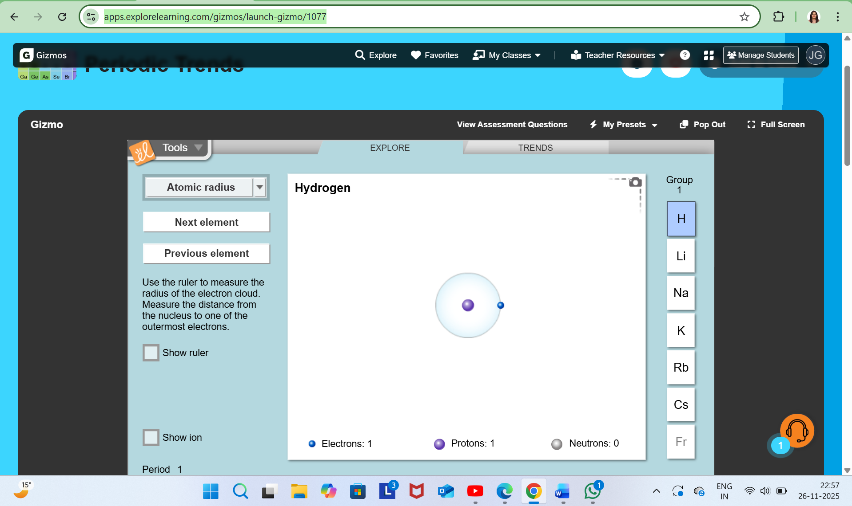  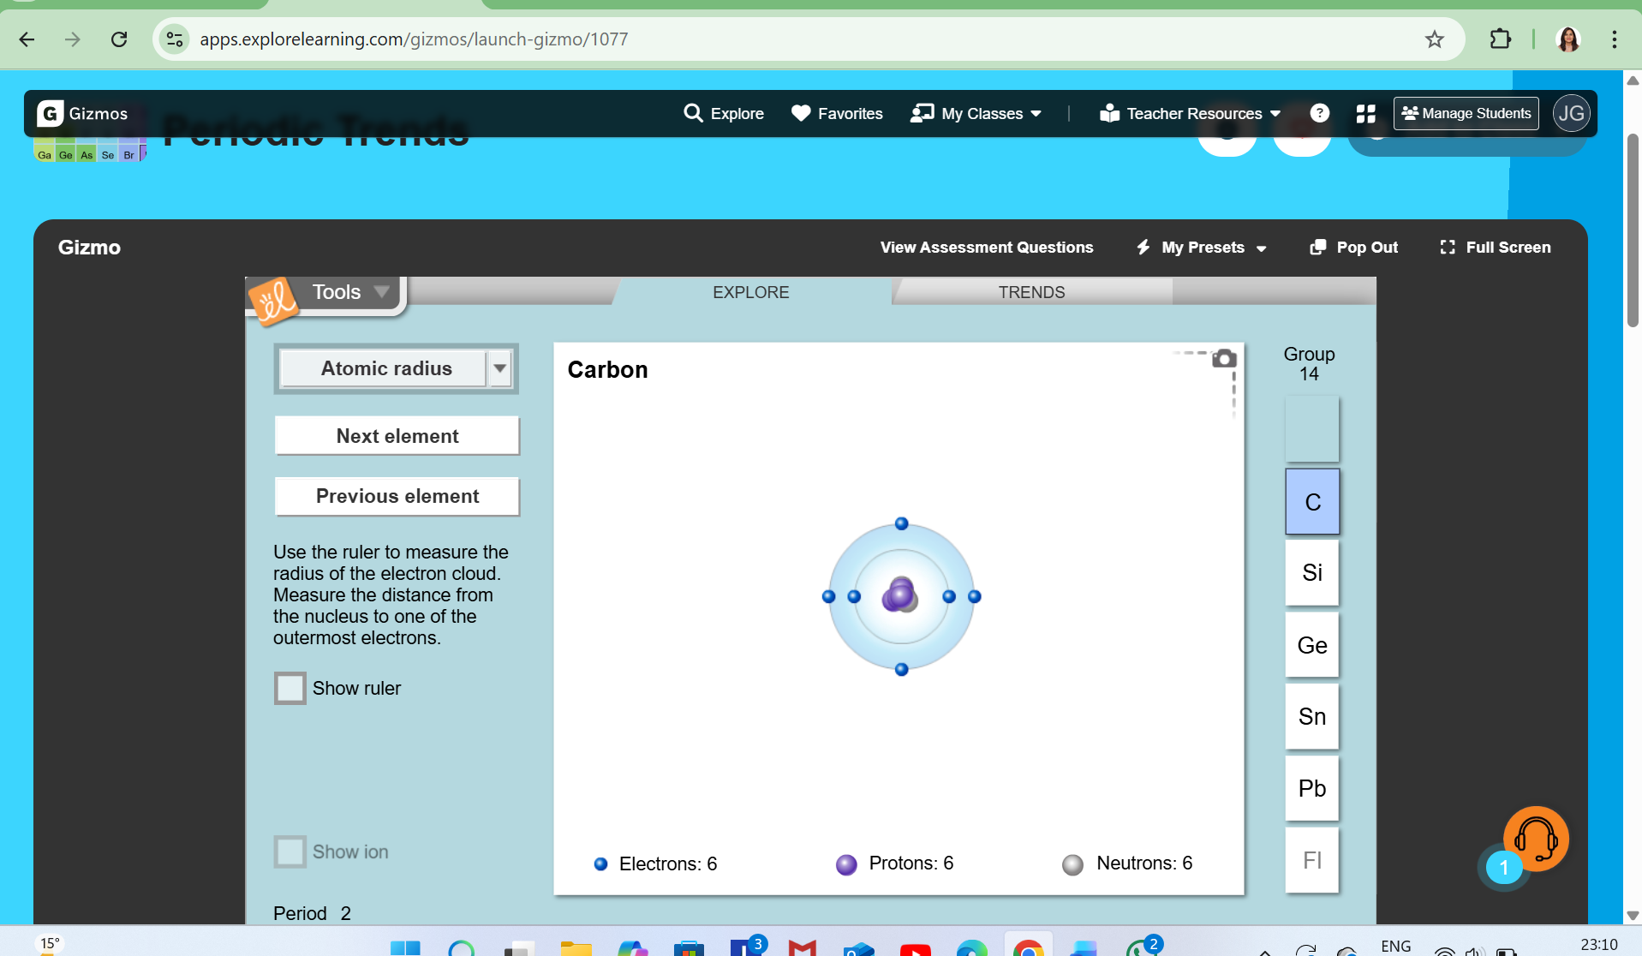  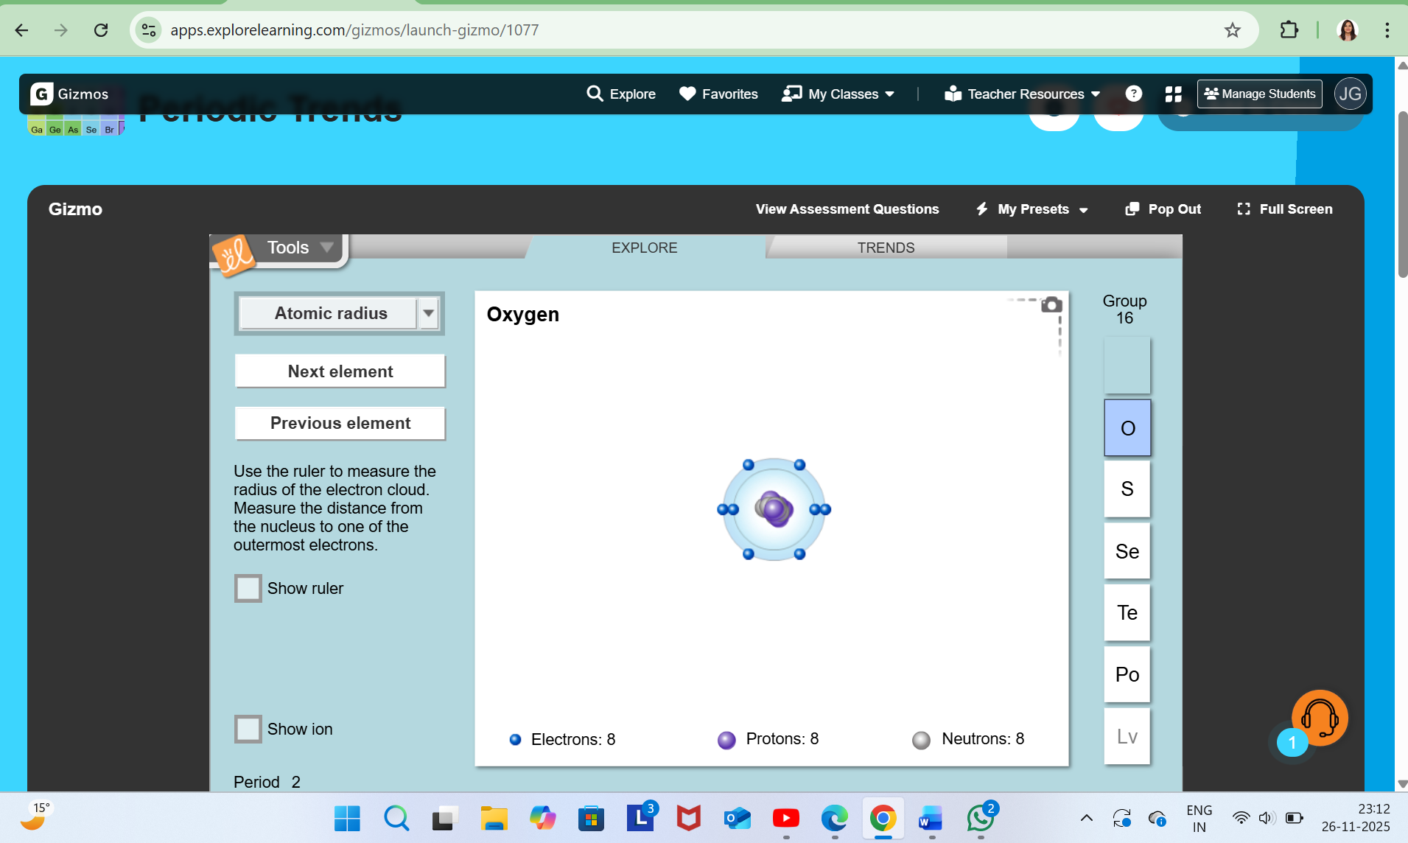  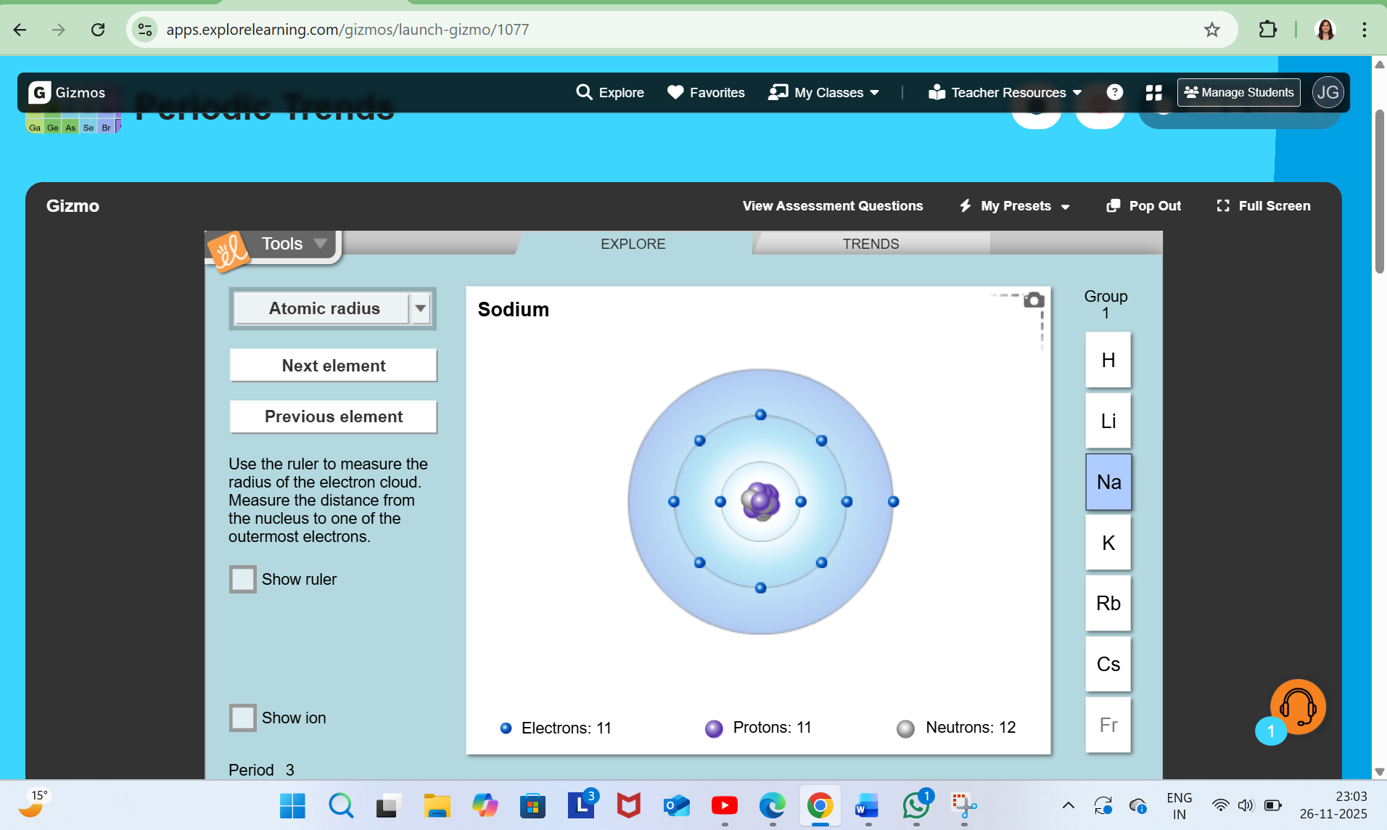  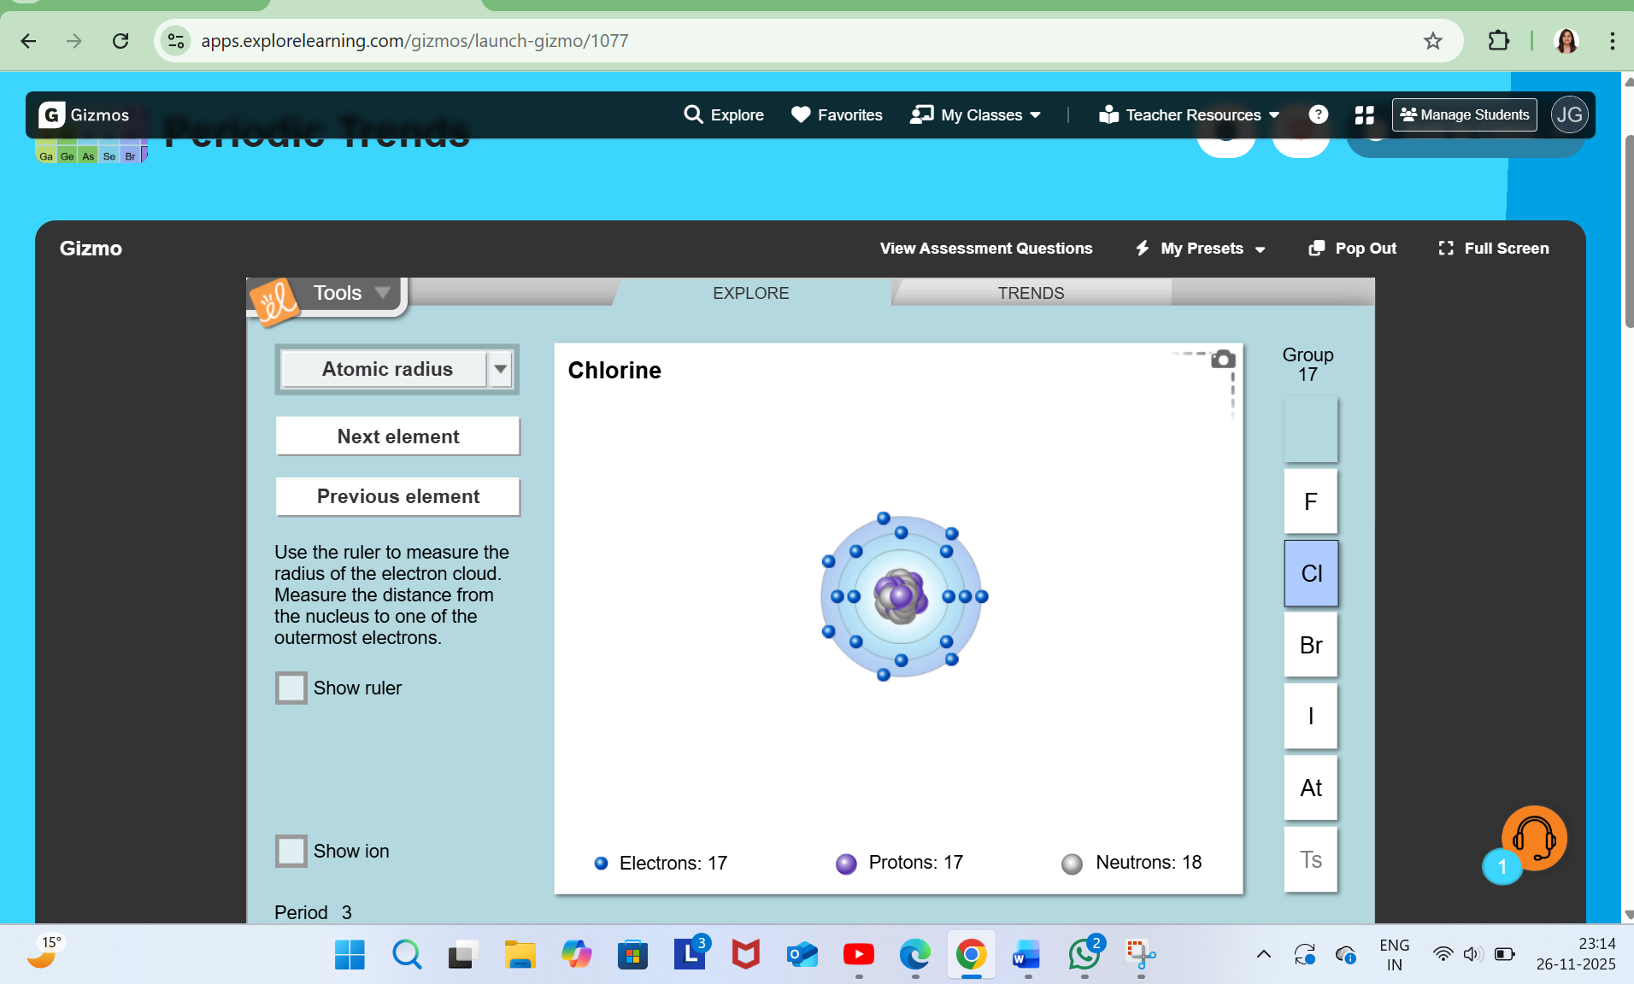 | The teacher assesses whether the learner can correctly identify electronic configurations and valence electrons independently. Evidence of learning is observed through:  Accurate electronic configurations written during the activity  • Correct identification of valence electrons using the simulation  • Ability to explain similarities between elements in the same group  • Participation in Jamboard grouping activities  The teacher also monitors the learner’s reasoning during questioning to assess conceptual understanding rather than memorisation. Learning is achieved if the learner confidently explains why elements with similar valence electrons show similar properties and uses scientific reasoning during discussion.
Rationale for Revisiting Electronic Configuration |  | The use of simulations and digital visualisation tools helps the learner connect sub-microscopic atomic structure with symbolic representations. Online simulations reduce cognitive overload and support conceptual understanding through visual learning. According to Johnstone (2000), linking symbolic and sub-microscopic representations improves Chemistry learning.
30-45 minutes | The teacher addresses an important question- “Why Periodicity is Important?”  1. Builds deep conceptual understanding  - Periodicity allows students to move beyond memorization and find meaningful patterns in the behaviour of elements.  2. Stimulates learning through inquiry.  - It lays emphasis on investigation and reasoning.  3. Deepens one's understanding through relational thinking  - According to Johnstone (2000) students learn better when linking macroscopic properties, sub microscopic structure, and symbolic representations.  - Periodicity naturally connects all three levels.  4. Supports future learning in DP Chemistry  - Provides the basis for bonding, energetics, molecular structure, reactivity, and trends.  5. Develops higher order thinking skills  - Periodic table compares, classifies, predicts and justifies the properties of elements. | The teacher uses inquiry-based discussion and interactive digital tools to help the learner identify periodic trends and patterns. Through Jamboard or Padlet activities, the learner sorts and groups elements according to similarities in properties and valence electrons. The teacher demonstrates how the periodic table acts as a predictive scientific model using screen-sharing and annotation tools. The learner is asked to predict simple properties and behaviours of unfamiliar elements based on their position in the table. Towards the end of the lesson, the learner completes a short Google Forms quiz containing conceptual and application-based questions. The teacher concludes the session with reflective questioning and asks the learner to summarise one key learning point verbally. | The teacher evaluates conceptual understanding through verbal discussion, online activities, and quiz responses. Evidence of learning includes:  • Ability to identify and explain periodic patterns  • Accurate predictions about element behaviour using valence electrons  • Logical explanations during inquiry-based discussion  • Successful completion of the Google Forms assessment  • Use of scientific vocabulary confidently during reflection  The teacher also assesses whether the learner demonstrates deeper understanding rather than memorisation by asking the learner to justify predictions and explain reasoning. Learning is achieved if the learner independently explains how periodicity helps predict properties and behaviour of elements using atomic structure and valence electrons.
Rationale for Exploring the Importance of Periodicity |  | This section focuses on helping the learner move beyond memorisation toward deeper conceptual understanding. Inquiry-based digital activities encourage reasoning, prediction, and scientific thinking. According to Cooper and Klymkowsky (2013), pattern recognition and relational thinking support deeper chemical understanding and metacognitive development.
- Atomic structure, per Taber (2014), correlates with observable properties in the periodic table, which is a predictive framework.
- Chiappetta (1997) notice that data analysis and explanation construction enhance scientific thinking.
- IB (2014) and IB (2022) mentions that conceptual coherence across MYP-DP strengthens readiness for advanced science.
- As per Cooper and Klymkowsky (2013) pattern analysis builds metacognitive awareness and deeper chemical reasoning.
- According to Johnstone (2000) students learn better when linking macroscopic properties, sub microscopic structure, and symbolic representations.

Complete the following evaluation sections as soon as possible after the lesson:

Section H - Assessment for Learning
What have some individual [named] learners learned in relation to your stated learning outcomes? | What is the evidence for this?
- The learner correctly identified atomic number, atomic mass, and valency for familiar elements.  - The learner successfully wrote electronic configurations for Hydrogen, Oxygen, and Sodium but initially needed support with Chlorine.  - The learner demonstrated understanding of the relationship between valence electrons and group behaviour.  - During the final discussion, the learner explained that elements in the same group show similar properties because they have the same number of valence electrons. | - Verbal responses during questioning.  - Digital whiteboard responses.  - Participation in Jamboard and simulation activities.  - Google Forms assessment responses.  - Ability to explain periodic patterns in their own words.
What additional, unexpected or unplanned outcomes were apparent?  Consider Social-Emotional Learning, Cultural Awareness, Mutual Respect. | What learning targets for some individual learners need to be set?
- The learner showed increased confidence in speaking during one-to-one online discussion.  - The learner demonstrated curiosity about how scientists originally discovered periodic patterns.  - The use of digital simulations increased engagement and reduced hesitation in answering questions. | - Develop greater accuracy in writing electronic configurations independently.  - Strengthen explanations of “why” periodic patterns occur.  - Improve confidence in applying periodic trends to unfamiliar elements.

Section I – Evidence of Reflective Practice:
What aspects of the lesson in relation to learner progress were successful, and why? | What changes would you make when you teach this group and/or lesson again?
The use of digital tools such as simulations, screen sharing, Jamboard, and interactive questioning was highly successful in supporting conceptual understanding and learner engagement during the online session. The one-to-one environment allowed immediate feedback, personalised pacing, and continuous formative assessment. The learner responded positively to visual demonstrations and interactive activities, showing improved confidence and participation. | - Include a short retrieval quiz at the beginning of the lesson to reinforce prior knowledge.  - Use additional concept-check questions throughout the lesson to monitor deeper understanding.  - Introduce more collaborative digital activities such as drag-and-drop sorting tasks.  - Provide a short summary sheet after the lesson for revision and independent learning.
Comment on your personal growth as a reflective, ethical and principled practitioner.
This lesson strengthened my understanding of how digital tools can support conceptual learning when used purposefully within online teaching. I recognised the importance of balancing technology with questioning, reflection, and personalised guidance. Teaching a single learner online also reinforced the value of continuous formative assessment and responsive teaching.
As a reflective practitioner, I became more aware of how online learning environments require strong communication, adaptability, and learner-centred approaches. I also recognised the importance of creating a supportive virtual learning environment where the learner feels comfortable asking questions, making mistakes, and developing confidence.

References:

  - Barjis, J., Gupta, A., Sharda, R., Chameeva, T.B., Lee, P.D. and Verbraeck, A. (2012) Innovative Teaching Using Simulation and Virtual Environments. Interdisciplinary Journal of Information, Knowledge, and Management, 7, pp. 237-25.
  - Chiappetta, E.L. (1997) Inquiry-Based Science: Strategies and techniques for encouraging inquiry in the classroom. JSTOR, 64(7), pp. 22-26.
  - Cooper, M. and Klymkowsky, M. (2013) Chemistry, Life, the Universe, and Everything: A New Approach to General Chemistry, and a Model for Curriculum Reform. Journal of Chemical Education, 90(9), pp. 1116-1122.
  - International Baccalaureate Organization. (2014) Middle Years Programme: Sciences guide. Cardiff: International Baccalaureate Organization.
  - International Baccalaureate Organization. (2022) Middle Years Programme: Sciences guide. Cardiff: International Baccalaureate Organization.
  - Johnstone, A.H. (2000) Teaching of Chemistry - Logical or Psychological?. Chemistry Education: Research and Practice in Europe, 1(1), pp. 9-15.
  - Taber, K. (2014) Chemical misconceptions: Prevention, diagnosis and cure. 1. London: Royal Society of Chemistry.

