**CS 5710**

**Machine Learning (Assignment # 2)**

E-mail: [gxm04390@ucmo.edu](mailto:gxm04390@ucmo.edu)

Name: Mogalapu Gideon Jaideep Sudarshan

Course: CS 5710

Assignment: Assignment 2

Git Hub: <https://github.com/JaideepMogalapu/Assignment2>

Video Link: <https://drive.google.com/drive/folders/1F2xWBfVoT5x6v0rC7Gb5P14w2bseI6t6?usp=share_link>

**Question 1**

**Description:** Print the pattern as shown below. 1st for loop runs from 1 to 4 ; the number of stars printed in each row equals the row size. 2nd for loop has a nested loop where it is used to print the prints based on the row number.

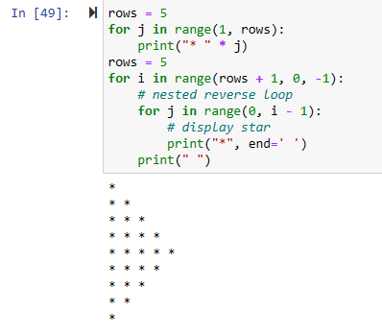

**Question 2**

**Description:** Created a list named my_list. List index starts from 0 so we start printing from 1 and increase in step of 2 to print the odd indexes.

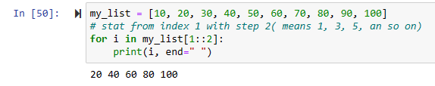

**Question 3**

**Description:** Created a list x and an empty list class_list. Iterated over the list x list and appended each type of data in a list by using type.

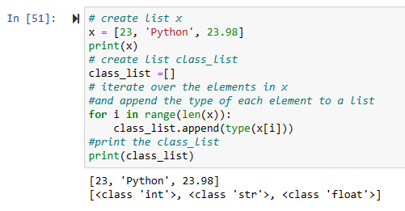

**Question 4**

**Description:** Created a sample list. Passed the sample list as parameter to the unique function. In unique function we have created a list, we will iterate over the elements in the list that are passed in the parameter, and we check if the element is present in the unique list. If it is present we do not append it, if not we will append it to the unique list and print the unique list once we are done with the iteration of all the elements.

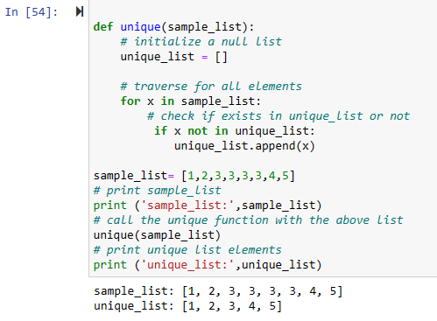

**Question 5**

**Description:** Wrote a function that accepts a string and calculate the number of upper-case letters and lower-case.

