**CS 5710**

**Machine Learning (Assignment # 1)**

E-mail: [gxm04390@ucmo.edu](mailto:gxm04390@ucmo.edu)

Name: Mogalapu Gideon Jaideep Sudarshan

Course: CS 5710

Assignment: Assignment 3

Git Hub: <https://github.com/JaideepMogalapu/Assignment3>

Video Link : <https://drive.google.com/drive/folders/1K8D8JAIg4bi7dxruvSXXnnMKY0nzu16o?usp=share_link>

**Question 1**

**1A)**

**Description:** Created a vector with of size of 15 with random integers in range 1-20.

Reshaped the vector to a size of 3 X 5. Replaced the max element in each row with 0

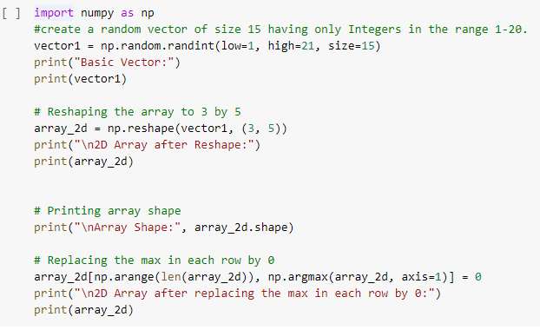

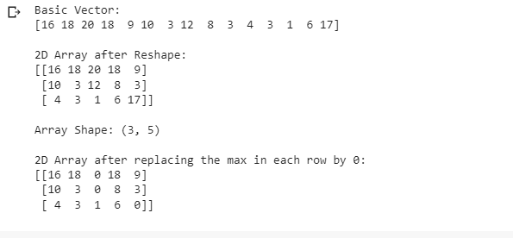

**Description:** Create a 2-dimensional array of size 4 x 3. Printed the shape, type and data type

of the array

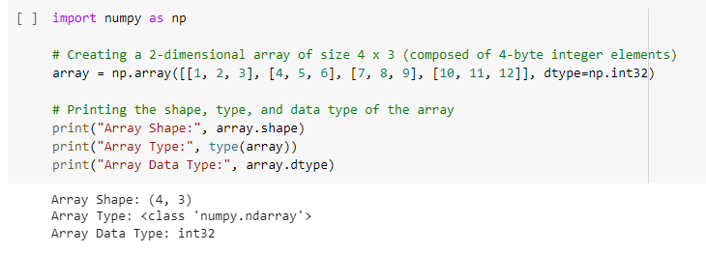

**1B)**

**Description:** This is a program to compute the eigenvalues and right eigenvectors. We have created an array as mentioned values

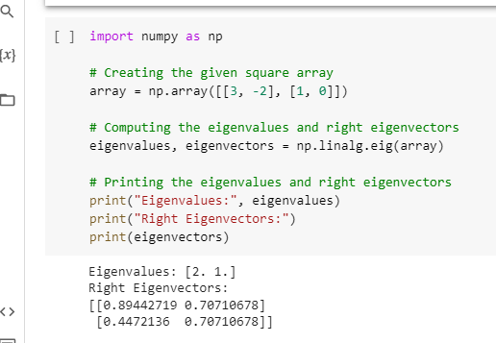

**1C)**

**Description:** This is a program to compute sum of the diagonal element of a given array

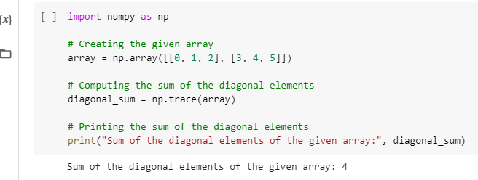

**1D)**

**Description:** This is a NumPy program to create a new shape to an array without changing its data

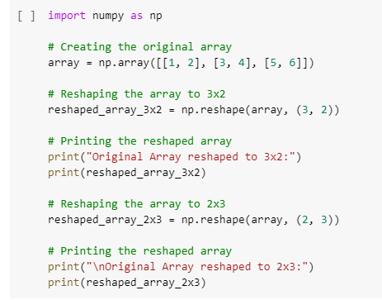

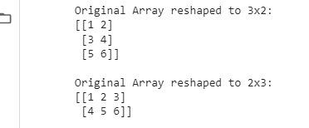

**Question 2**

**Description:** This is a Python program to create a pie chart of the popularity of programming Language. we have created the sample data. We then created the figure and axis object.

We set the explode such that the first slice explodes a little bit from the rest.We have set the title using set_title. And plotted the pie chart.

