**CS 5710**

**Machine Learning (Assignment # 4)**

E-mail: [gxm04390@ucmo.edu](mailto:gxm04390@ucmo.edu)

Name: Mogalapu Gideon Jaideep Sudarshan

Course: CS 5710

Assignment: Assignment 4

Git Hub: <https://github.com/JaideepMogalapu/Assignment4>

Video Link: <https://drive.google.com/drive/folders/1jpC7moc6gbPz-m7hMIa4Zyp_NN1JzpVE?usp=share_link>

**Question 1**

**Description:** . Reading the provided CSV file ‘data.csv’. we also printed basic statistical description about the data

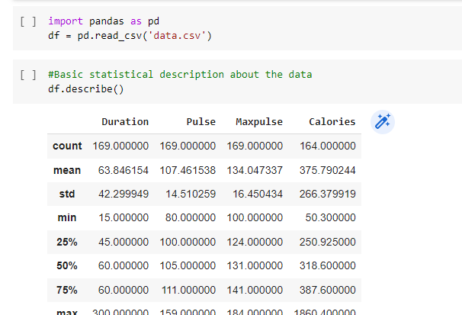

**Description:** . 3. Check if the data has null values. Replace the null values with the mean

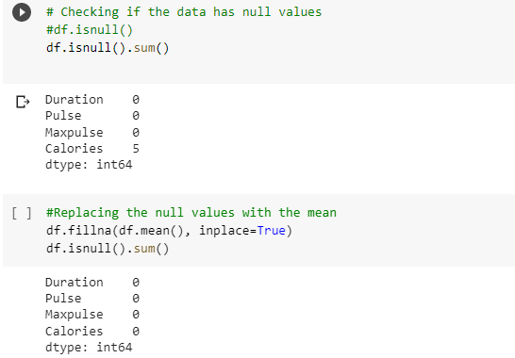

**Description:** . Select at least two columns and aggregate the data using: min, max, count, mean

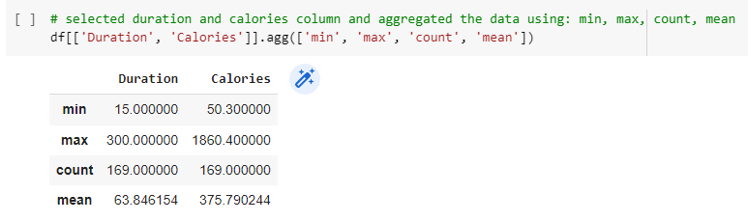

**Description:** . Filter the dataframe to select the rows with calories values between 500 and 1000.

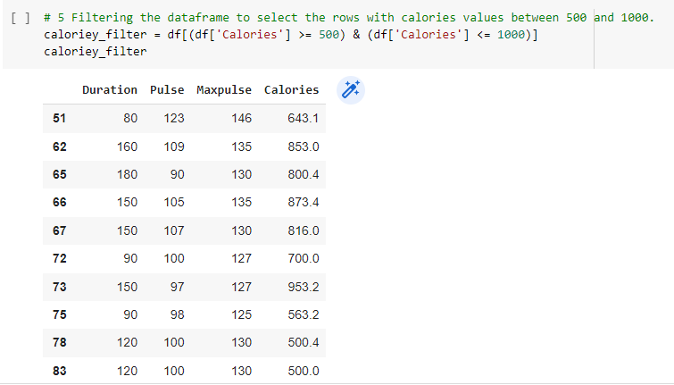

Filter the dataframe to select the rows with calories values > 500 and pulse < 100

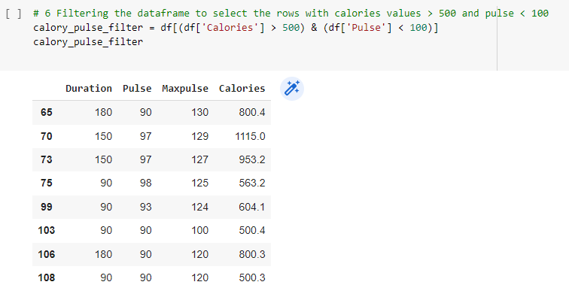

**Description:**Creating a new “df_modified” dataframe that contains all the columns from df except for “Maxpulse” .we set the axix 1 to represent the column

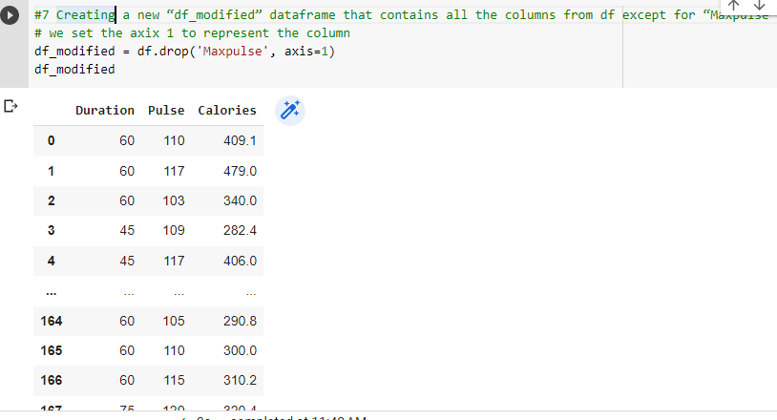

**Description:**  Deleting the “Maxpulse” column from the main df dataframe

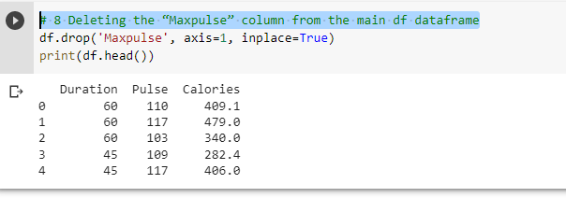

**Description:**Converting the datatype of Calories column to int datatype

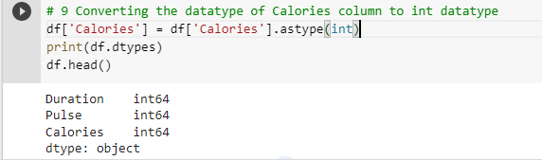

**Description:**Using pandas creating a scatter plot for the two columns (Duration and Calories)

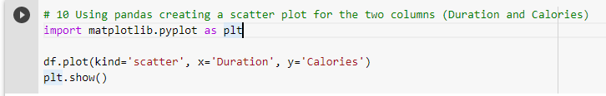

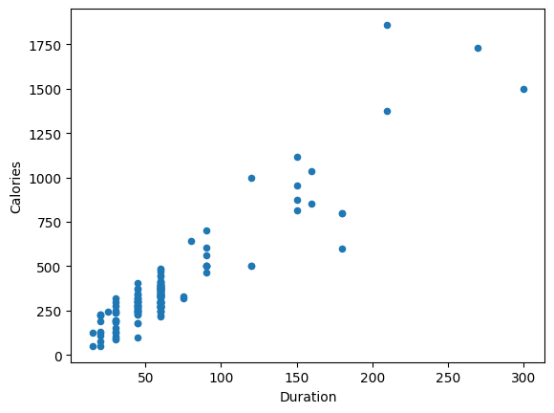

**2) Titanic Dataset**

**Description:** Imported the necessary libraries. As we got negative correlation, we can remove these two variables

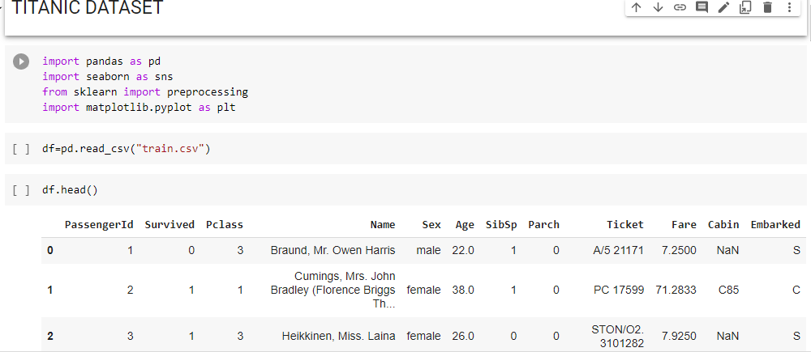

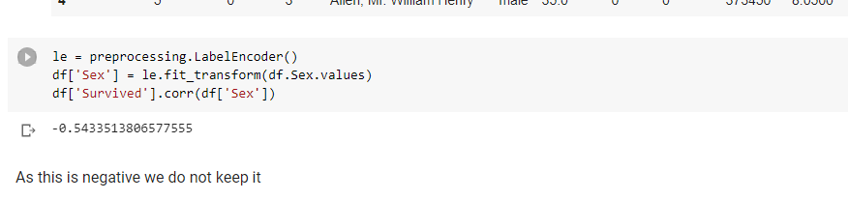

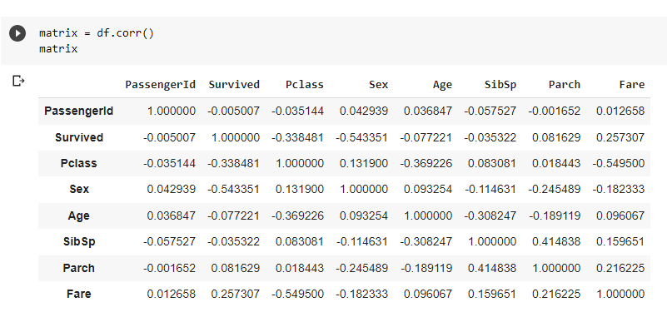

**Description :**  We have plotted the histogram and bar chart for the above data set



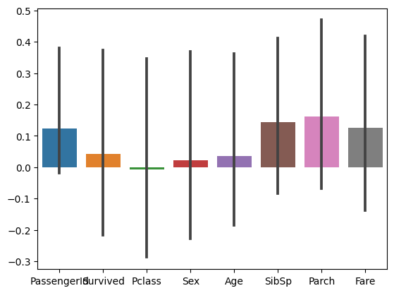



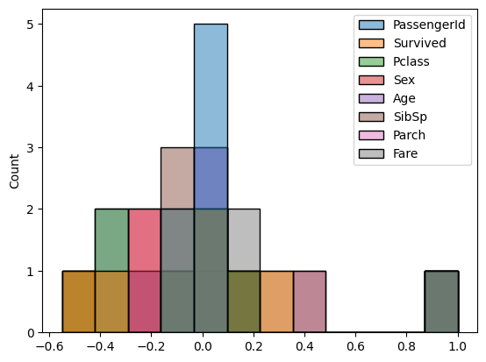

**Description** : Implemented Naïve Bayes method using scikit-learn library and reported the accuracy.

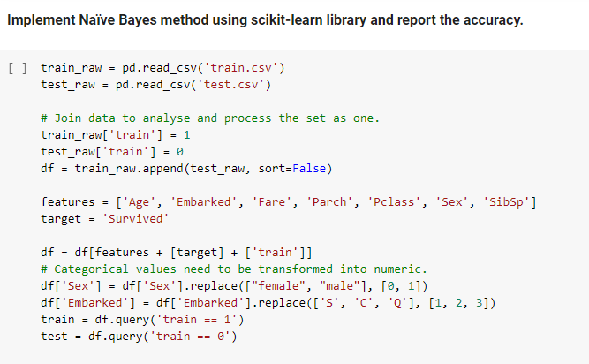

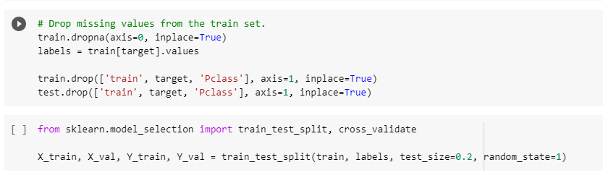

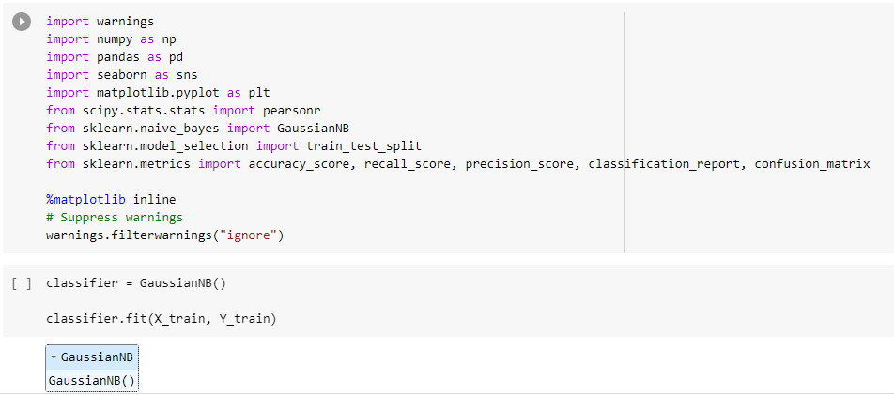

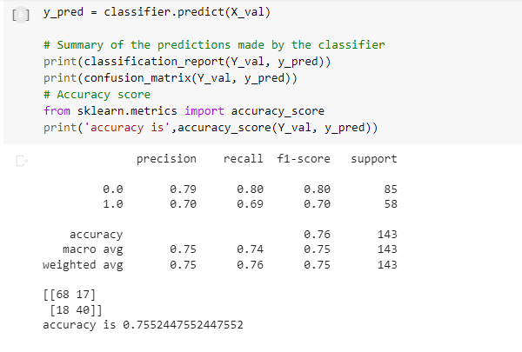

**3) Glass Dataset**

1. Used the glass dataset available in Link also provided in your assignment:

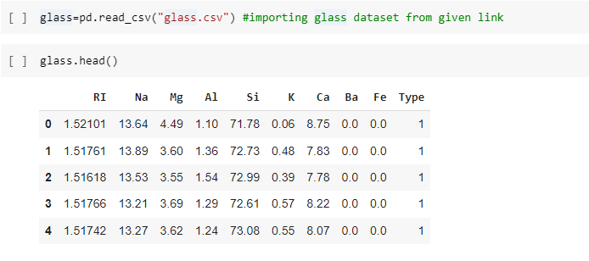

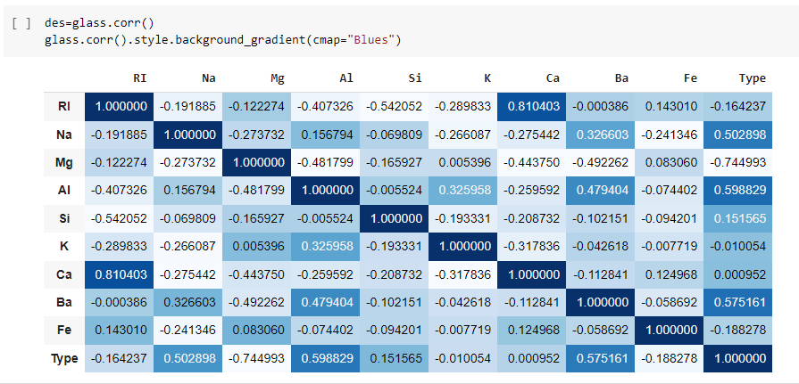

B:Use train_test_split to create training and testing part:

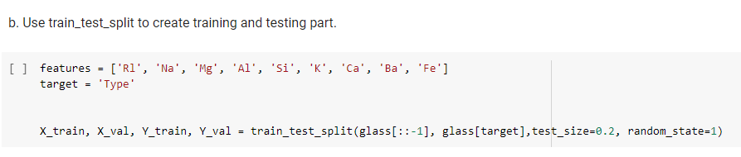

2. Evaluate the model on testing part using score and classification_report(y_true, y_pred)

Output :

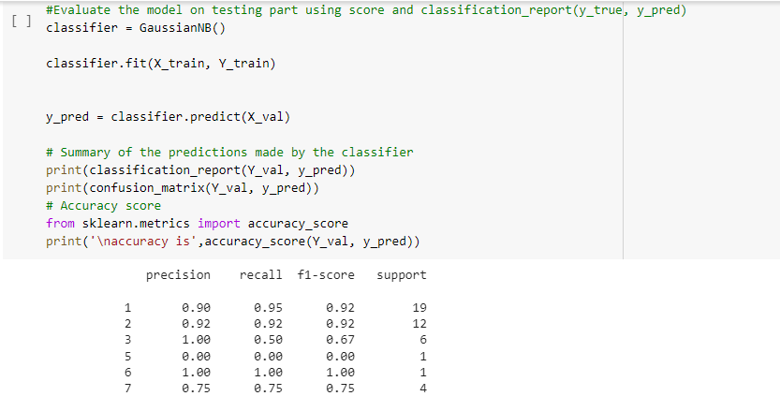

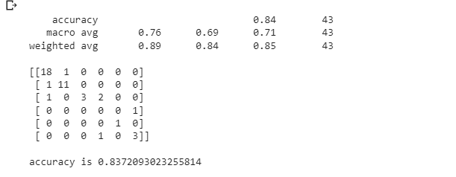

Implement linear SVM method using scikit library

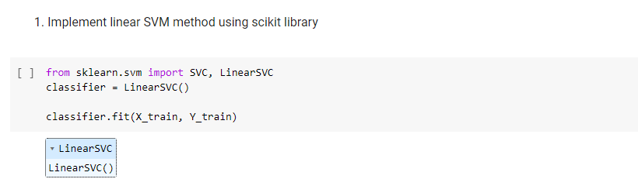

1. Evaluate the model on testing part using score and classification_report(y_true, y_pred) :

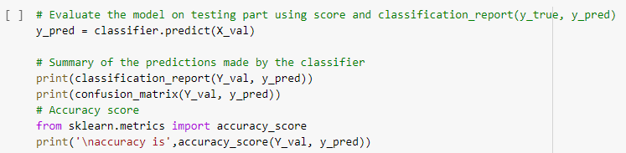

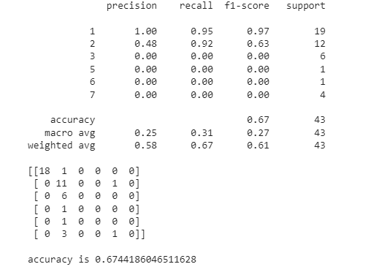

Do at least two visualizations to describe or show correlations in the Glass Dataset:

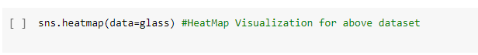

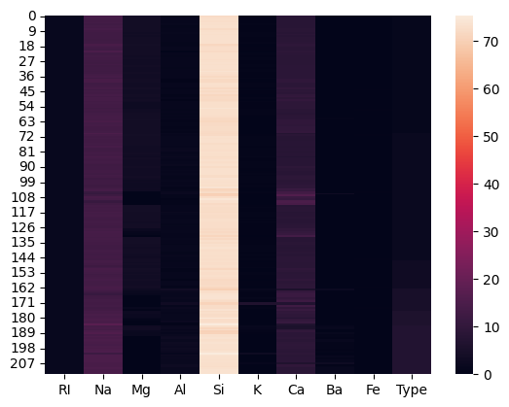



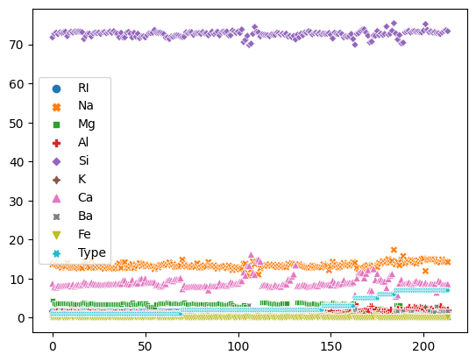

**Which algorithm you got better accuracy? Can you justify why?**

Naïve Bayes accuracy is 83.7% which got more than SVM algorithm which has only 60.46%. While naive Bayes can handle both categorical predictor variables and continuous hence, therefore SVM algorithm can handle only continuous predictors.