POC - Evidence Documentation

UPLOADING THE DOCUMENTS IN AI SYSTEM

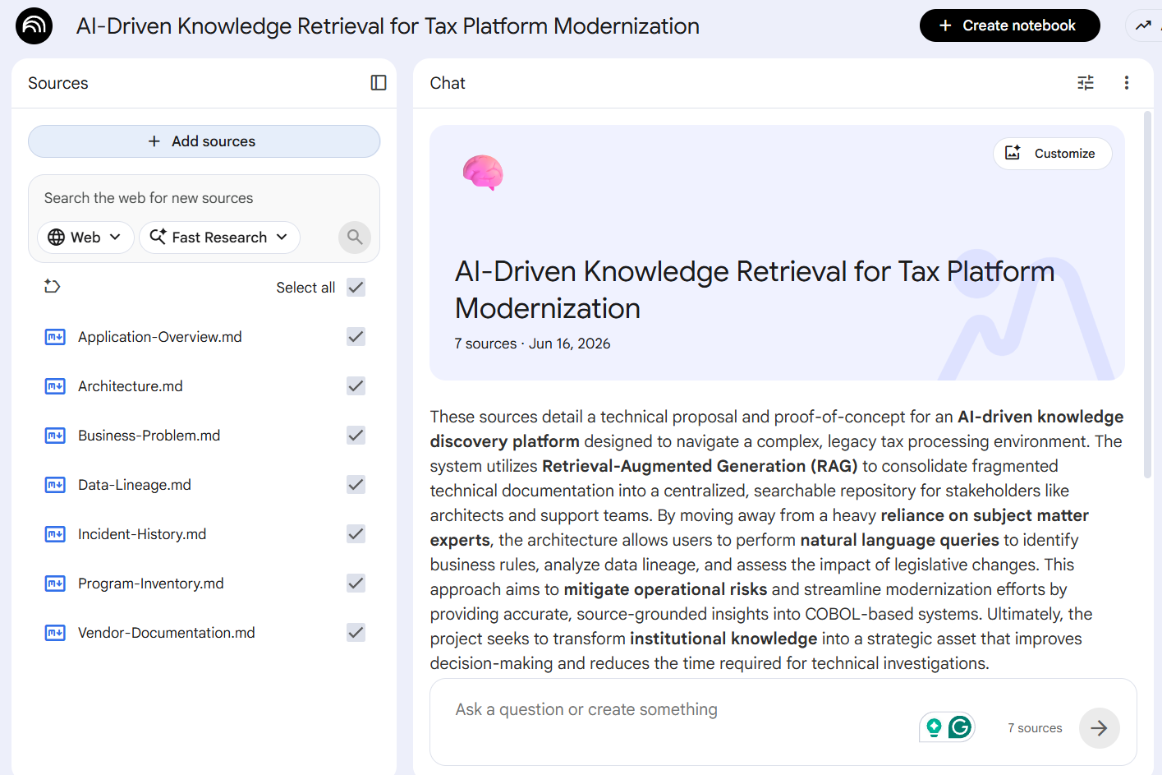

BUSINESS RULE DISCOVERY
Which documents define penalty calculation logic and where is it implemented?
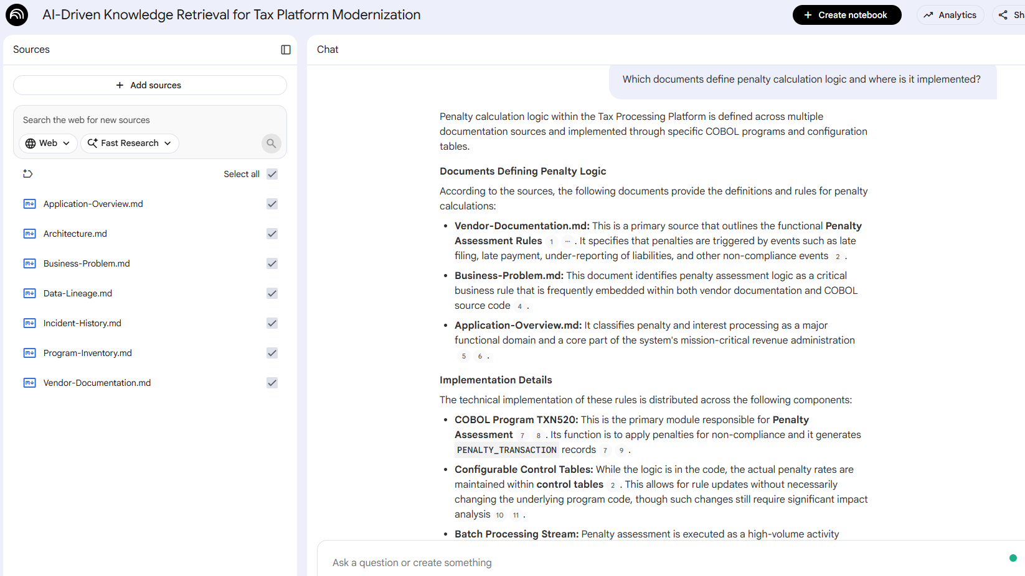

What are the business rules governing statutory interest calculation, and in which COBOL programs or vendor documents are these rules implemented?
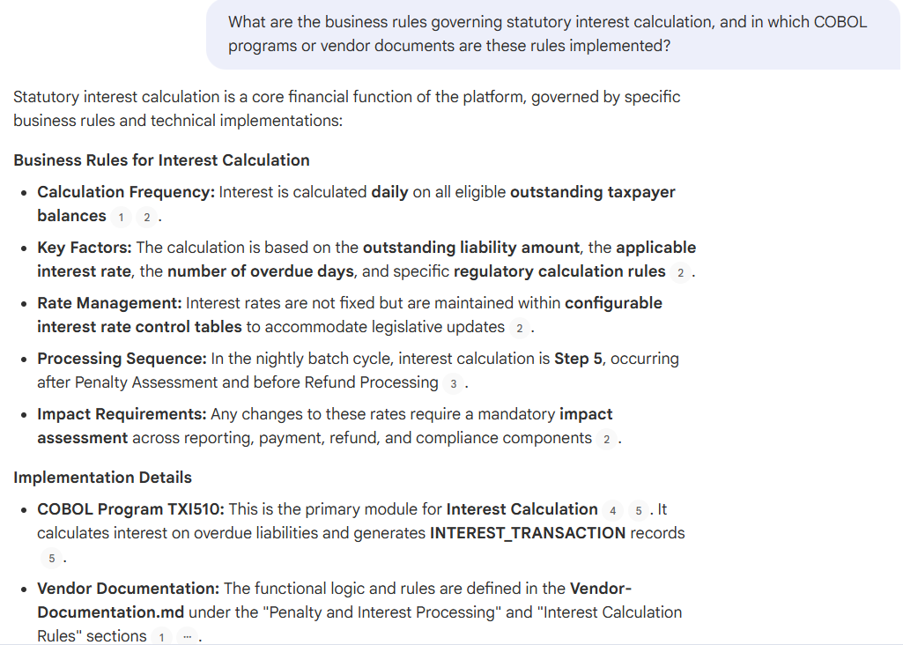
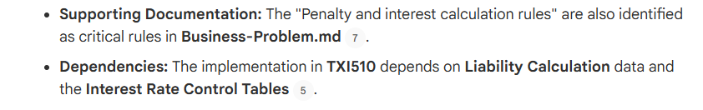

APPLICATION DISCOVERY – UNDERSTANDING THE SYSTEM
Which COBOL programs, batch jobs, and system components are involved in refund processing within the Tax Processing Platform?
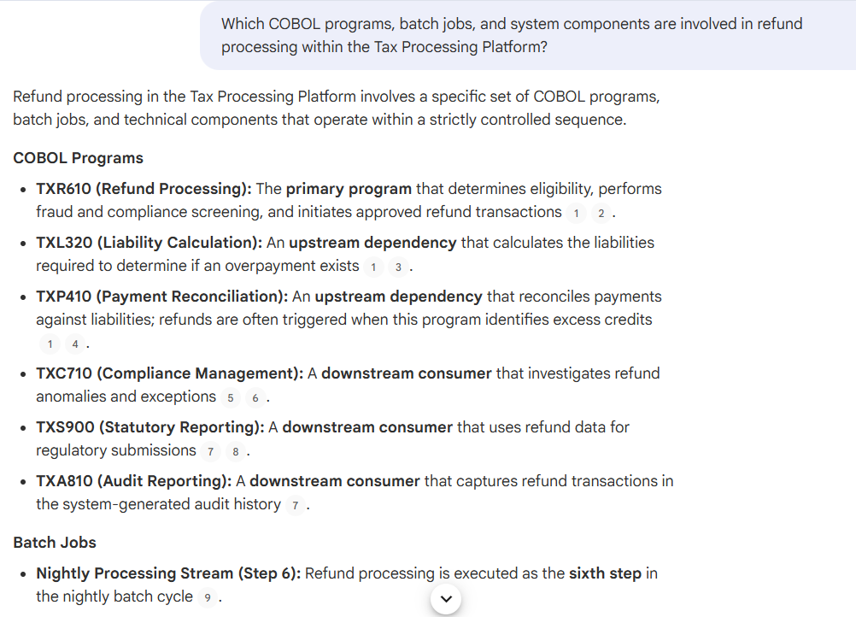
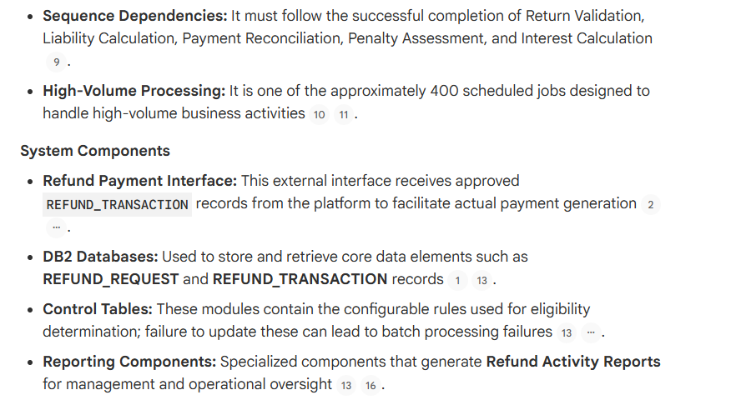

IMPACT ANALYSIS
What is the impact of modifying penalty calculation rules?
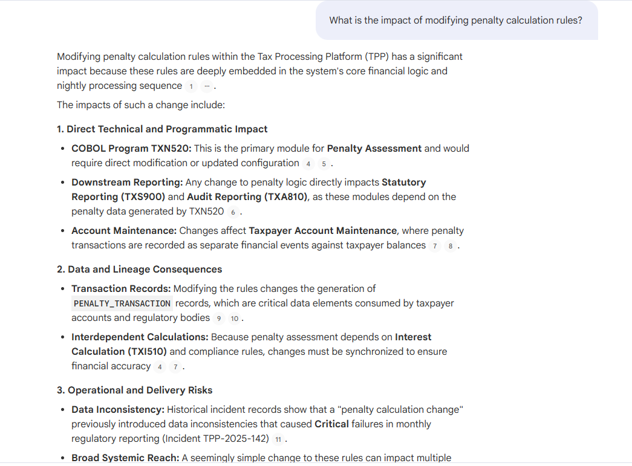
What is the impact on COBOL programs, batch jobs, and downstream reports if the statutory interest rate logic is modified in the Tax Processing Platform?
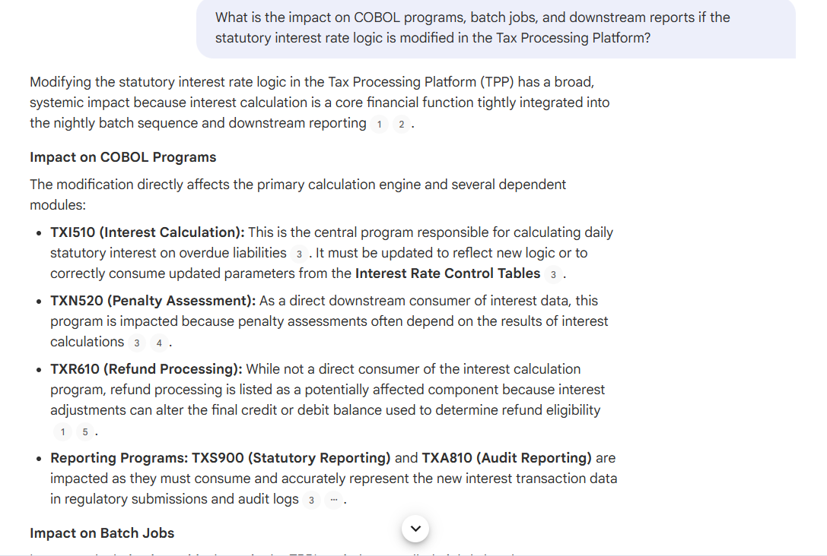

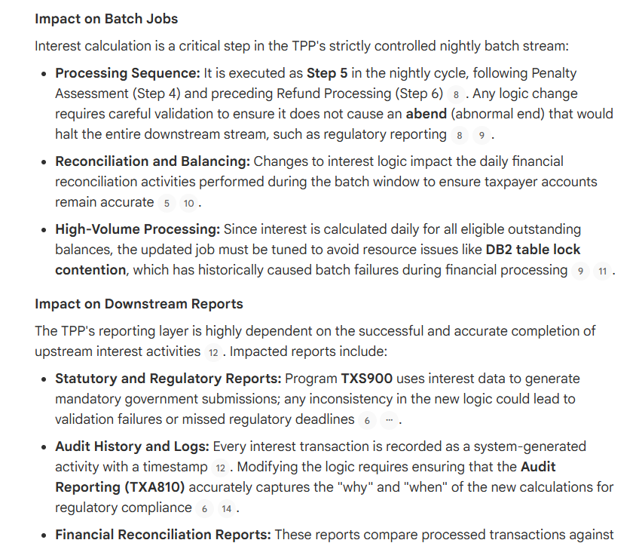
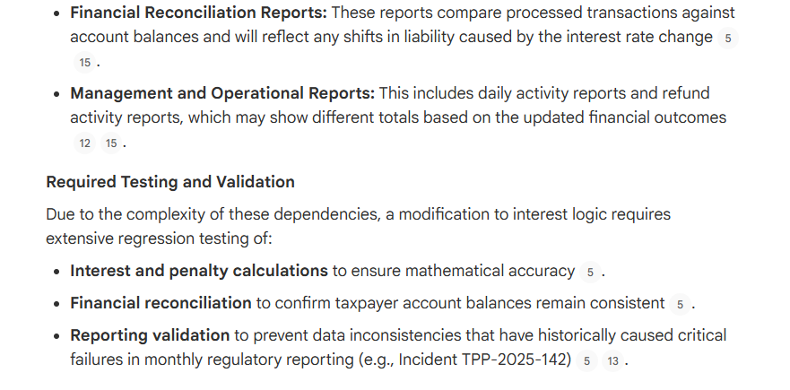

DATA LINEAGE
Trace the end-to-end lifecycle of taxpayer refund amount from creation in COBOL programs to its final consumption in reporting systems.
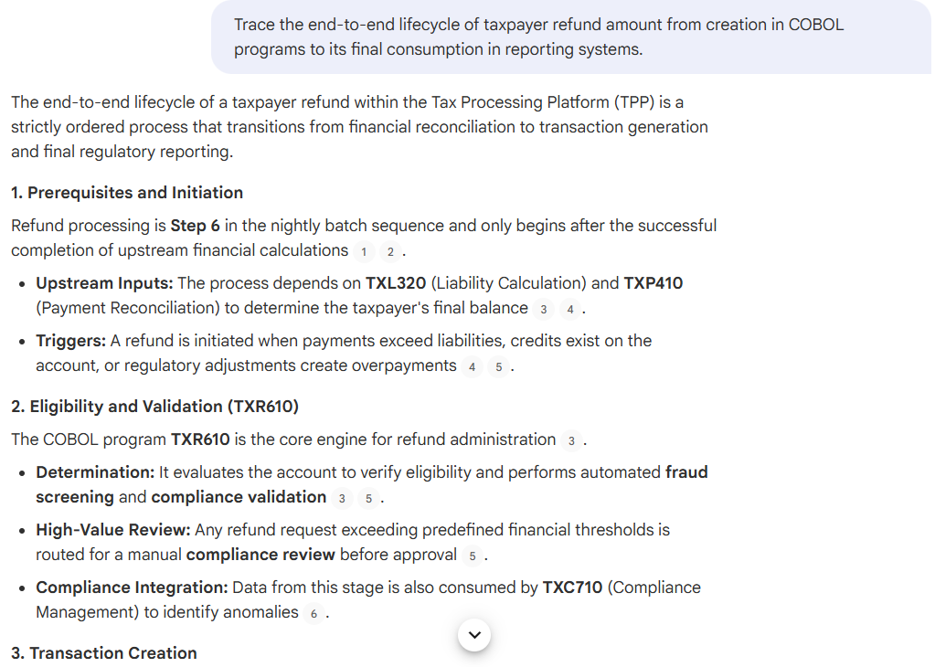
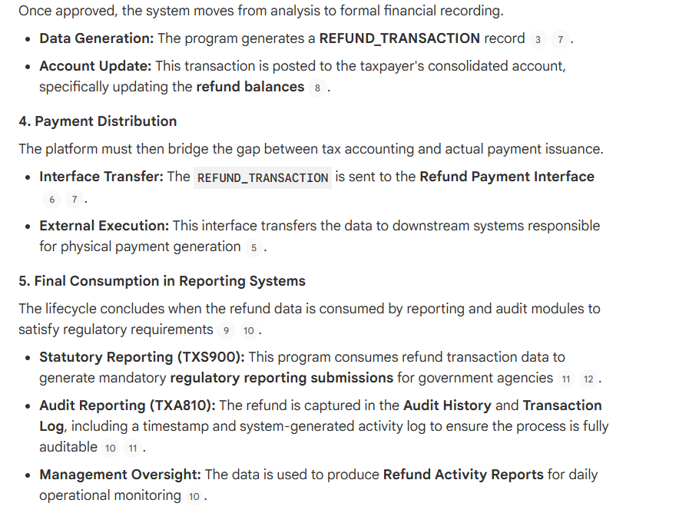

PRODUCTION SUPPORT
A refund batch job fails midway with an ABEND error. Based on incident history and program inventory, what are the possible root causes, impacted components, and recovery steps?
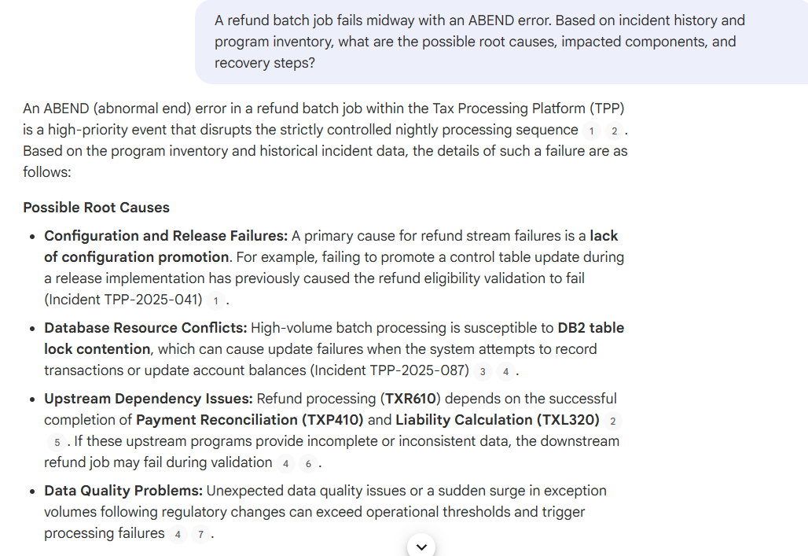
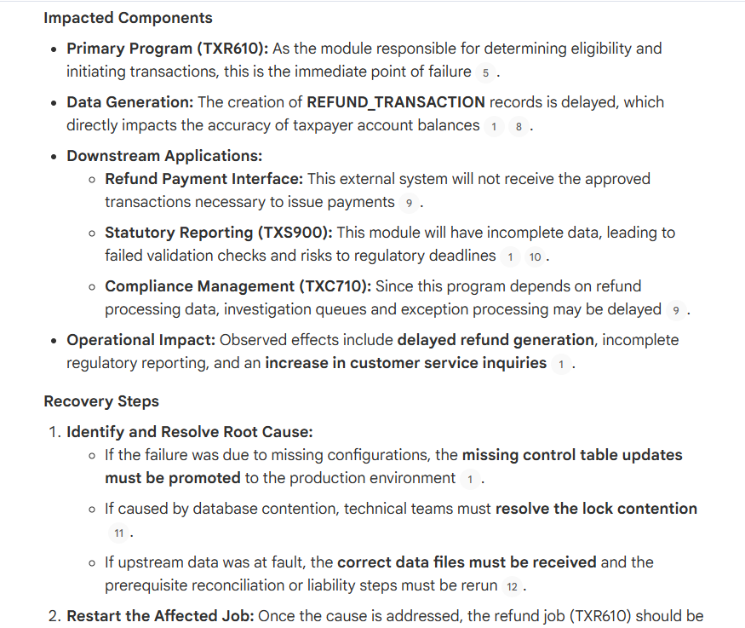
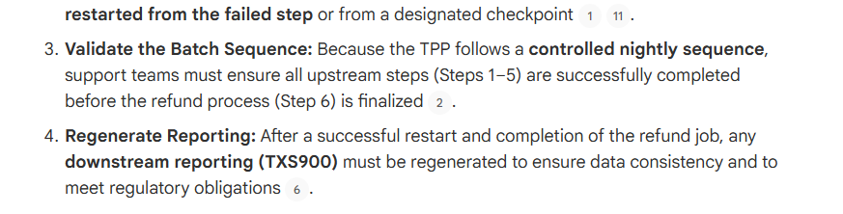

MODERNIZATION RISK
Which components of the Tax Processing Platform are high-risk for modernization, and what makes them complex or tightly coupled?
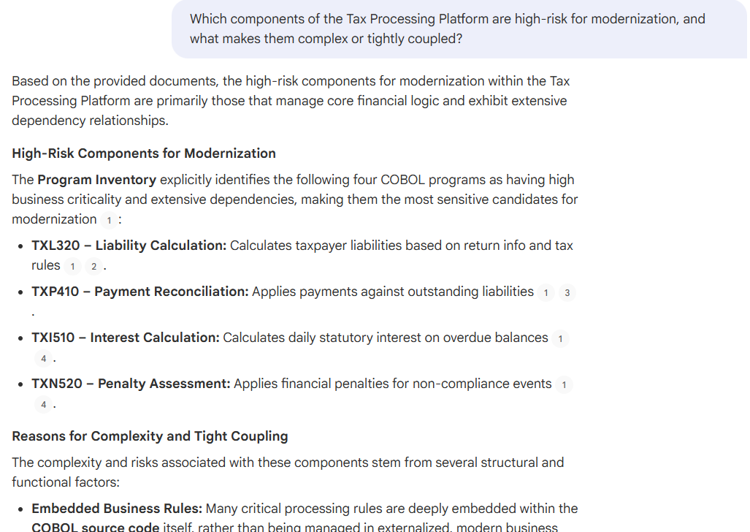
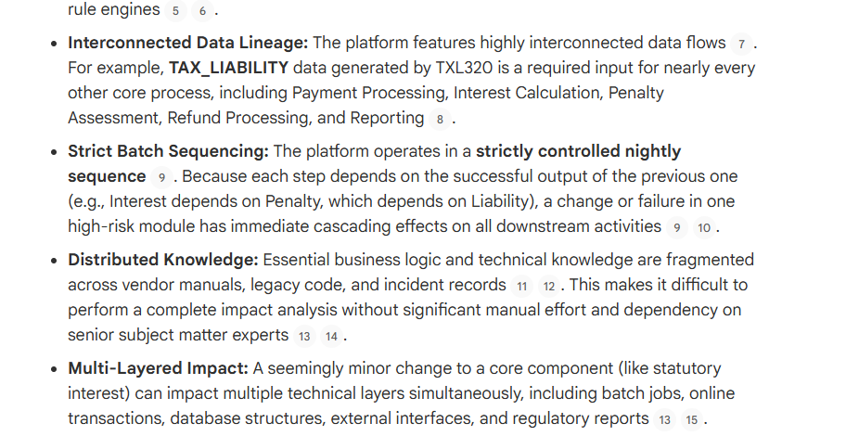

FULL SYSTEM SYNTHESIS
Explain the Tax Processing Platform end-to-end, covering business functions, technical architecture, operational processes, and data flow across the system.
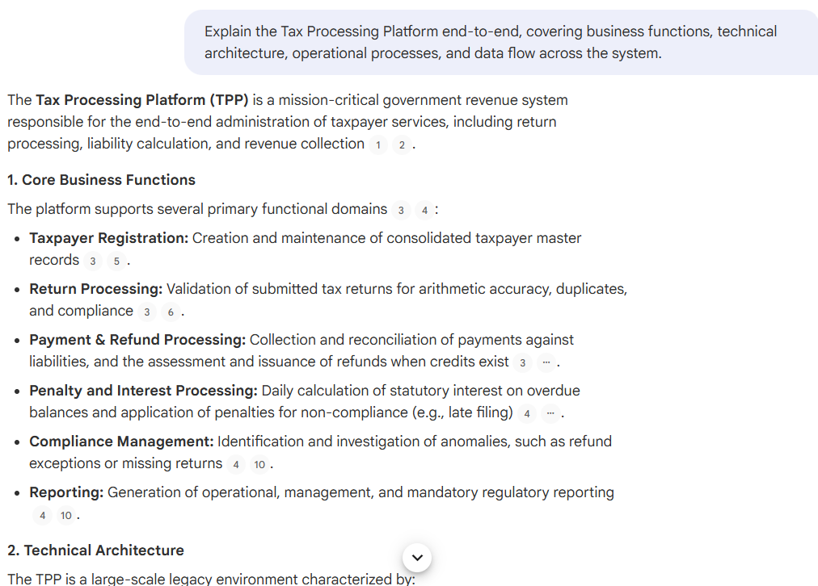
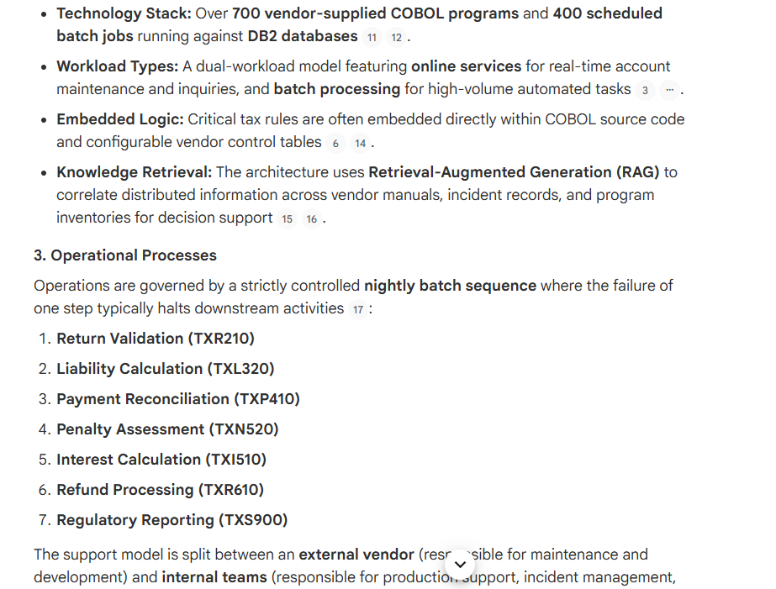
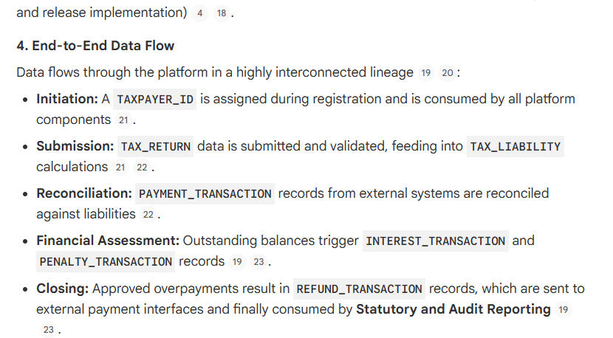

GOVERNANCE CONFLICT
If there is a conflict between vendor documentation and incident history regarding system behavior, which source should be trusted for production decision-making and why?
