# 4 Implementation Chapter

## Tile map

Tile maps are used to create 2D worlds they allow the creator to select the tile they would like to place and draw the tiles into the scene.

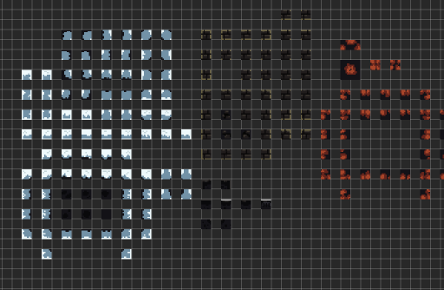

## Sprite sheet

The player’s sprite sheet has been downloaded from the Unity assets store, this came with different animations that weren’t set up properly, I fixed this by just re selecting the animation frames that went together.

## n

## Animation

I have “Idle”, “Jump”, “JumptoFall” and “Run” animations working so far

When the user doesn’t press any buttons and isn’t falling the idle animation will play, if the user presses the “A” or “D” key the run animation will play. if the user presses the “jump” key

From idle to jump I need to have a condition that checks when the parameter “jump” is toggled. Once the user reaches the peak of their jump the variable falling is set to true

When the user stops pressing the “Jump” key or when the user reaches the peak of their jump the “JumptoFall” animation will play when the falling variable is set to true

Once the Character lands on the ground falling is set to false and will no longer play the “JumptoFall” animation.

If the user falls off a platform the “JumptoFall” animation will play

If the user presses the “A” or “D” key to move the “Run” animation will play. Checking if speed is greater than 0.0001 is making the response a bit quicker so the character will react faster to the input of the user.

If the user stops pressing the “A” or “D” keys the “Run” animation will stop playing. Checking if speed is less than 0.0001 is making the player character stop quicker.

