# 2 Requirements Chapter

This chapter will focus on the requirements to make a game. This chapter will investigate similar games, a survey which gathers information on what people want from a 2D game, personas, functional requirements, non-functional requirements, a wireframe sketch of the game map, a story board of the game, what software the Author will use, and the difficulties the creator of the game will potentially encounter. The author’s game will be 2D and contain an interesting environment along with a boss (hopefully multiple bosses) the player can fight. The game will have abilities that the player can find upgrades for, and it will have multiple different types of enemies and allies for the player to interact with and fight.

## 2.1 Similar games

**Hollow Knight**

**Figure 1** is a screenshot of a game called *Hollow Knight (CHAN, 2022).* The creator wants to make a game similar to Hollow Knight, however the scope will be smaller as there is not a team of developers working together.In **figure 1** there is 5 skulls representing the players health bar. Under the skulls there is a number representing the money the player has, and to the left there is a big circle that will fill up with “soul” when the player damages enemies. The player can use this “soul” to heal.

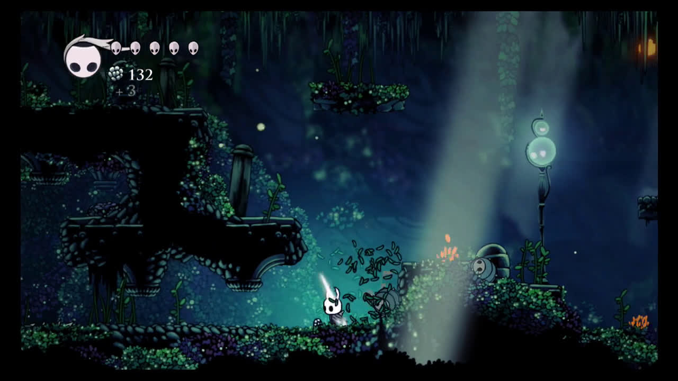

Figure : Screenshot of Hollow Knight game environment and UI

**Figure 2** displays the different types of enemies. The player can encounter in Hollow Knight *(Locke, 2022)*.

Figure : Screenshot of Hollow Knight game showing different types of enemies.

**Figure 3** shows one of the many boss fights from Hollow Knight. Most of the boss fights in Hollow Knight have two phases. The first phase being easier and the second adding another ability or more challenge to the fight.

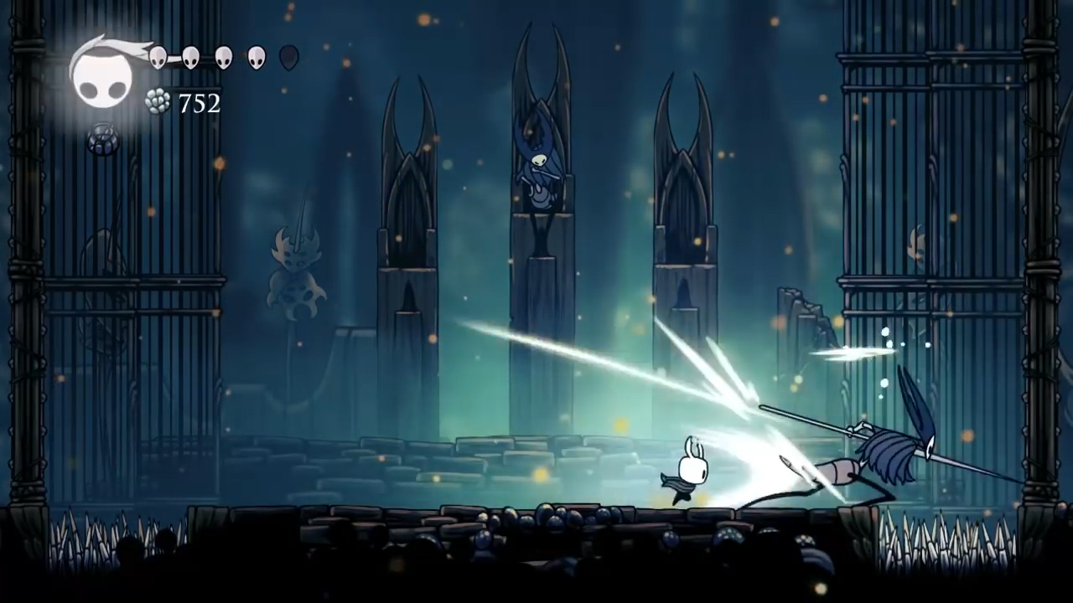

Figure : Screenshot of a Boss fight in Hollow Knight

**Ori and the Will of the Wisps**

**Figure 4** and **Figure 5** are screenshots of a similar game called *Ori and the Will of the Wisps (Irwin, 2022).* The game is a 2D Metroidvania. Metroidvania is a sub-genre of action-adventure games where the player can explore a nonlinear story line while also having progression based on upgraded abilities.In this game the player encounters many incredible characters and is compelled to explore the beautiful world while following along with the story of the game.

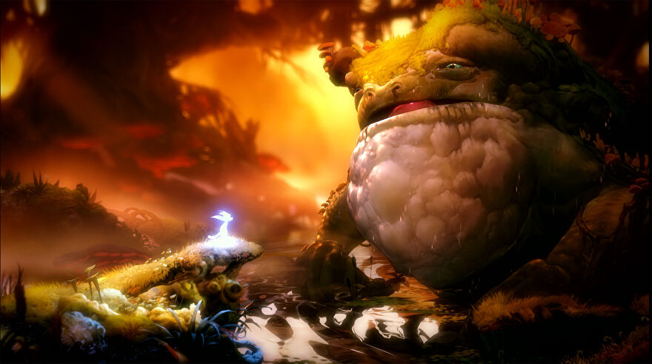

Figure : Screenshot from Ori and the Will of the Wisps showing the player interacting with the creatures in the world.

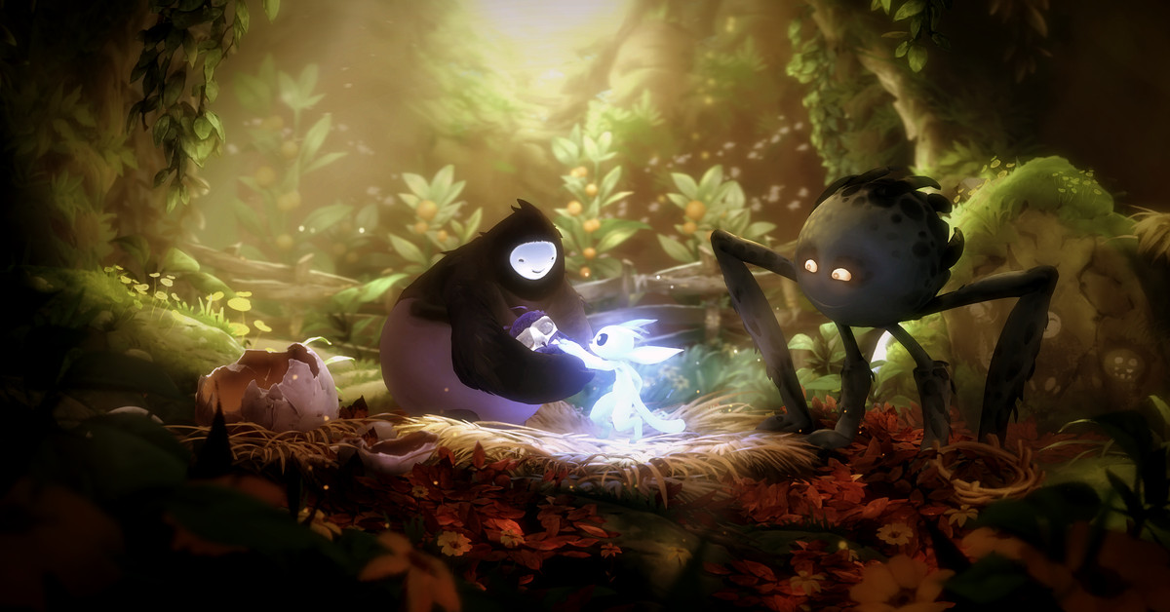

Figure : Screenshot from Ori and the Will of the Wisps showing the player interacting with the creatures in the world

**Figure 6** shows a screenshot of the basic UI. In the top right there is the currency called spirit light, the player can buy maps and items with it. At the bottom middle of the screenshot there are the 3 abilities the player can use. (Ori and the Will of the Wisps PC & Console 2020, 2022)

Figure : Screenshot of Ori and the Will of the Wisps UI

**Figure 7** shows a screenshot of the upgrade system. The player can acquire may upgrades that help the progression of the game and make it easier for the player. (Crego, 2020)

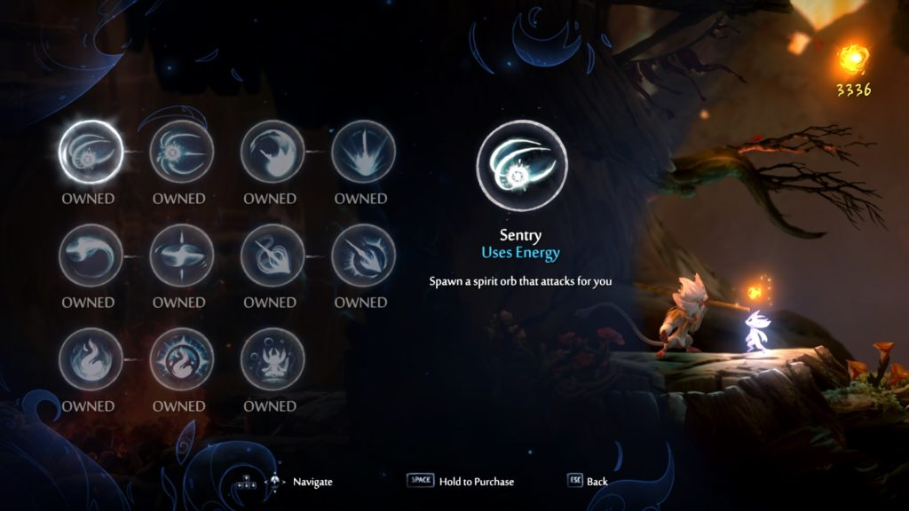

Figure : Screenshot of Ori and the Will of the Wisps Upgrade abilities

### 2.1.1 Advantages and disadvantages of both games

#### Hollow Knight advantages

* Art

Music / Environment / Enemies / Unique Characters

* Story

Deep lore (items and characters have a lot of backstory)

Multiple side Quests / Stories

* Exploration heavy
* Collectables

#### Hollow Knight Disadvantages

* Very difficult combat (frustrating for beginners)
* Story can be hidden and hard to follow.
* Lots of retracing your steps

#### Ori and the Will of the Wisps advantages

* Art

Music / Beautiful Characters / Beautiful World

* Story

Emotional / Captivating

* Intricate Problem-Solving Puzzles
* Exploration heavy
* Collectables

#### Ori and the Will of the Wisps disadvantages

* Very Difficult Beginning
* Poor Performance (FPS drops and stutters)
* Enemies can move and shoot at the player while the player is still loading into an area.
* No Mini Map + Unintuitive Menu Map
* Lots of retracing your steps
* End Game is too easy.

### 2.1.2 Desired Aspects

The author would like the game to be visually appealing, while having unique enemies and characters. The author wants there to be optional quests (E.g., Save certain characters and they will reward the player). The author also wants the mini map to be easy to use.

## 2.2 Survey

<https://docs.google.com/forms/d/e/1FAIpQLSeGQyMOOgO1SkYDsg4qMcWu6zxPIq0sB7CGoT2GqFFmpB1UbA/viewform?usp=sf_link>

This is the link to the Authors survey in which they ask the participant what aspects of 2D games they like and how Important they are to a game. The survey asks for the participants age and gender to see the demographic of people that took the survey.

## 2.3 Persona

**Figure 8** and **figure 9** show two personas that were created to illustrate potential users of the game. In **Figure 8** Gerry likes difficult, fun, and satisfying games while not being too interested in the story or the uniqueness. This type of player is really interested in a challenging game. In **Figure 9** Samantha is much more interested in the Story and the enjoyment of the game while not liking difficult games.

A way to solve the problem of having a game that is hard but also is accessible for people who don’t like difficult boss fights is to make the very hard fights optional.

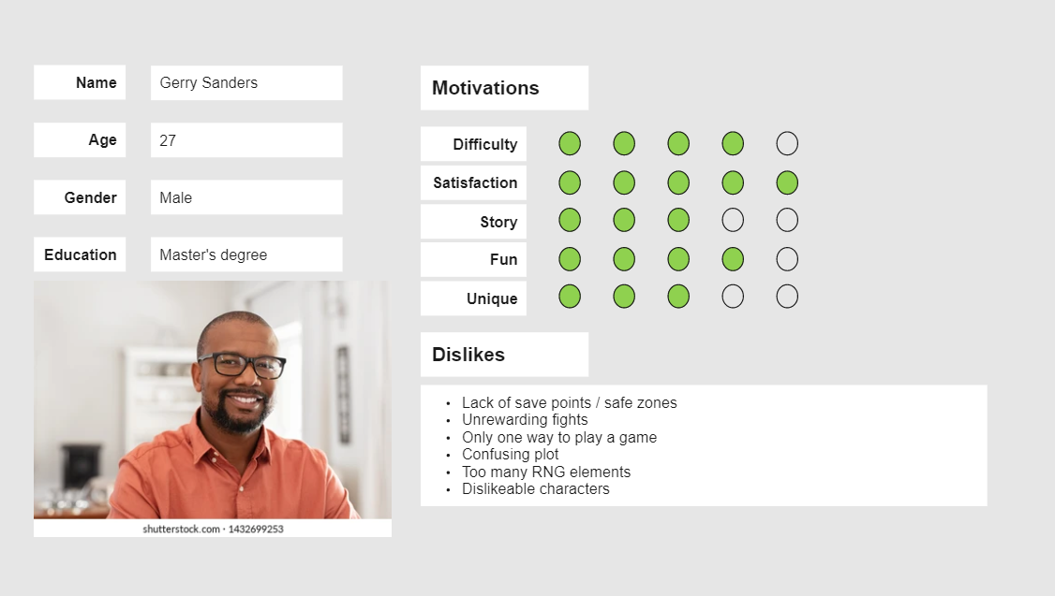

Figure : Persona 1

Figure : Persona 2

## 2.4 Functional Requirements

* Basic movement controls
* Health bar
* Sword attack
* Story progression
* Item pickups
* Enemies
* 3 different areas to explore (possibly 4)
* A boss fight for each area (this might be too much for the time frame)
* Autosave
* Save files.

## 2.5 Non-Functional Requirements

* Satisfying movement
* Pleasing Haptics
* Interactable environment + Destructible terrain

## 2.6 Software

The author researched Unreal Engine and Unity to compare which was the better option to use in their project. The author will be using Unity to create and run the game and visual studio code as their code editor. They will be using a physics engine.

### Advantages of Unity

* The Author has completed 2 projects in Unity already.
* Unity Assets store has many easily accessible free assets (mainly 2D).
* Free Software
* Compatible Cross Platform Development
* C# Coding language (easier than C++, The Author has used C# before)

### Disadvantages of Unity

* Performance-intensive
* Large Unity games take up a lot of space.
* Unity Assets store for 3D models

### Advantages of Unreal Engine

* Real-time networking for multiplayer
* Beautiful Visual Effects
* Extensive 3D Asset libraries

### Disadvantages of Unreal Engine

* C++ Coding Language (The author would have to learn this language)
* Harder than Unity to port to another platform

## 2.7 Paper Prototype

These are the Paper Prototypes the creator sketched for the map of the game.

**Figure 10** shows the starting area of the game. The player learns the controls of the game here, they learn to jump and attack.

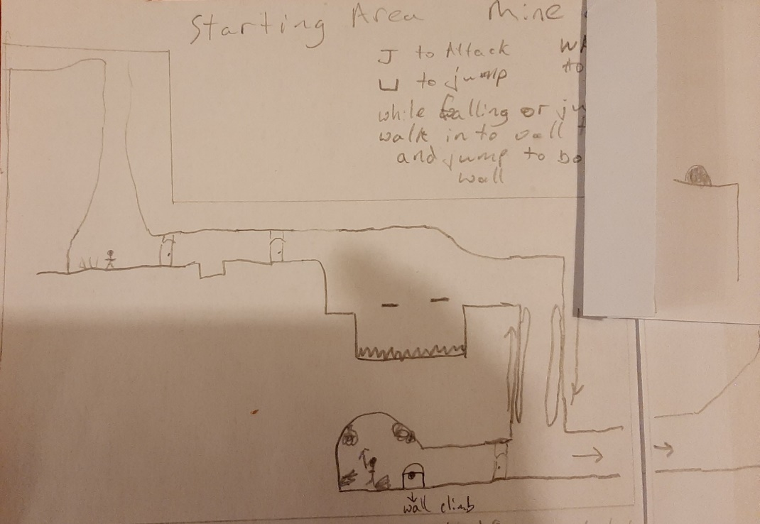

Figure Starting area Paper Prototype

**Figure 11** shows the mid-section of the first area where the player learns to wall jump and scale walls. Wall jumping is when the player can jump off the wall in the opposite direction to get to different areas of the map. Wall scaling is when the player slides down a wall by walking into the wall while falling, this slows the players fall speed and allows for more time to think about where they would like to go.

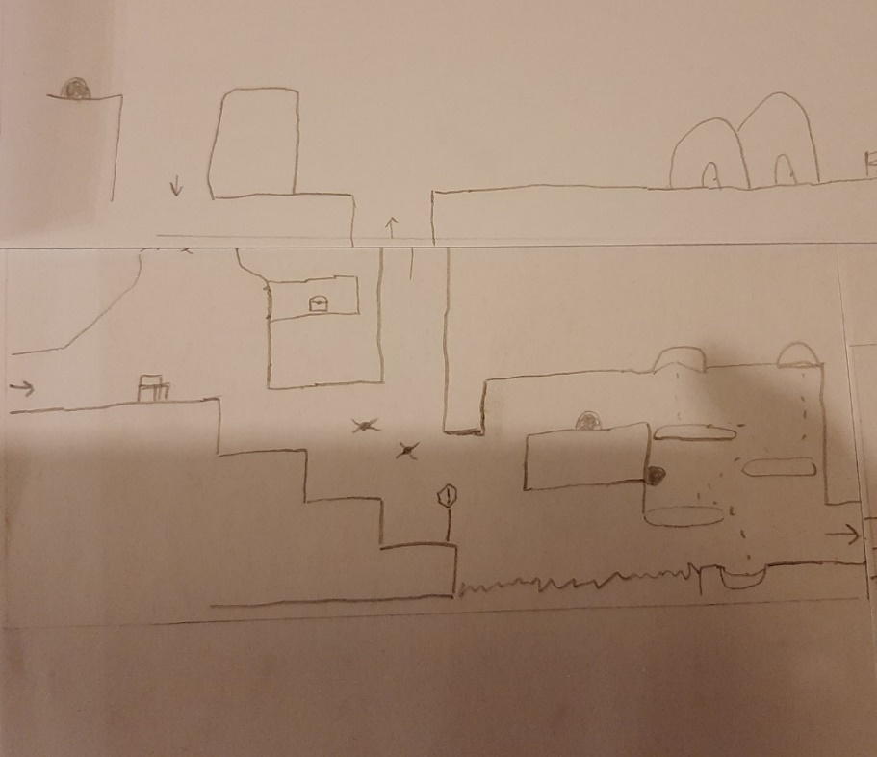

Figure Starting area Paper Prototype mid-section.

**Figure 12** shows the final section of the first area, the boss fight room.

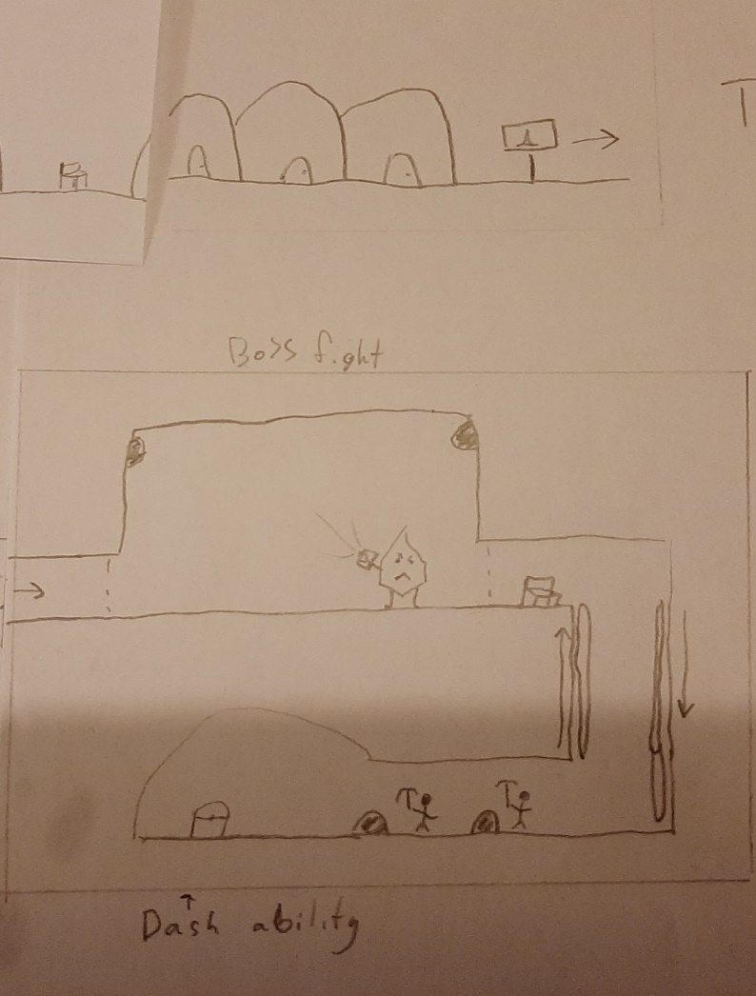

Figure Paper Prototype of Boss fight of area 1

## 2.8 Story board Paper Prototype

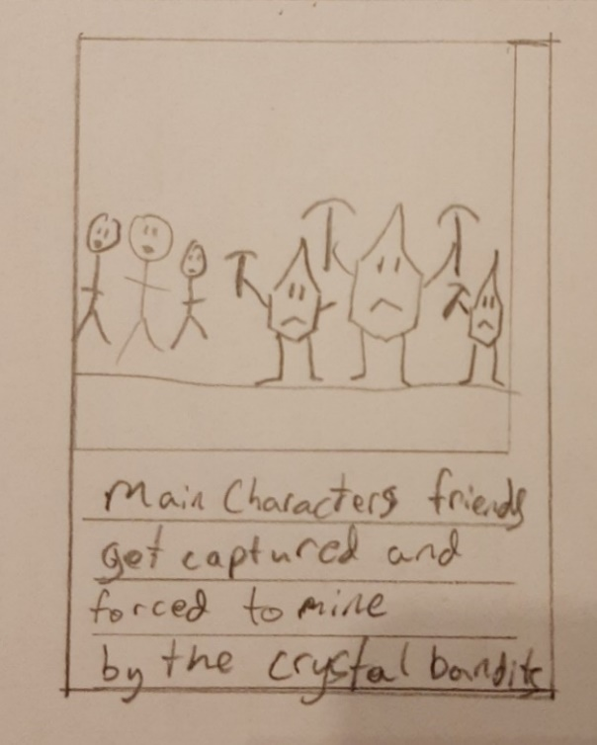

Figure Story board 1 Figure Story board 2

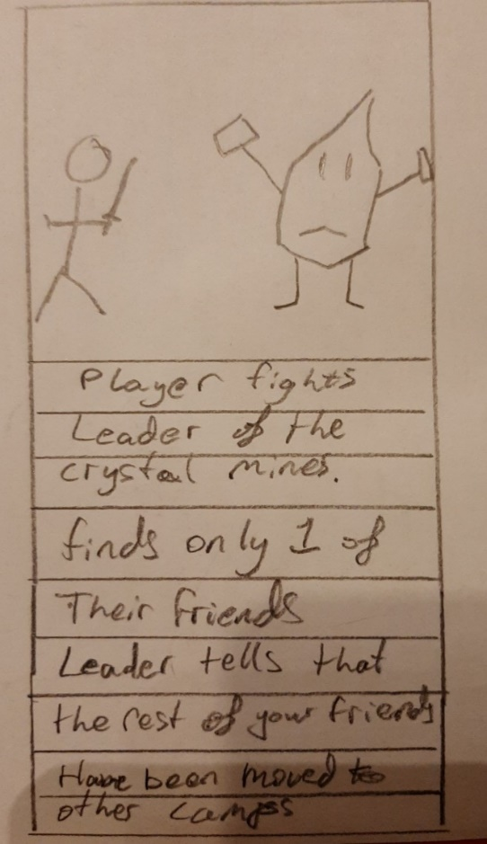

Figure Story Board 3 Figure Story Board 4

Figure Story Board 5

## 2.8 Potential Difficulties

This is the author’s first proper 2D game they have only done very basic 2D games without any storyline or characters and item pickups. Therefore, the author could experience difficulties with coding enemies, coding how the camera follows the player and the bounds of where the camera can go, save files and autosave features.

## 2.9 Conclusion

The author will create a 2D Metroidvania game with basic movement controls, health bars, sword attacks, story progression, item pickups, enemies, 3 different areas to explore (possibly 4), a boss fight for each area (this might be too much for the time frame), autosave features and save files.

## 2.10 References

CHAN, C. (2022). Get lost in the best Metroidvania games for the Switch. Retrieved 11 June 2022, from https://www.imore.com/best-metroidvania-games-nintendo-switch

Crego, V. (2020). What abilities and skills to get first | Ori and the Will of the Wisps Guide. Retrieved 10 June 2022, from https://squadstate.com/guide/what-abilities-and-skills-to-get-first-ori-and-the-will-of-the-wisps-guide

Ori and the Will of the Wisps PC & Console 2020. (2022). Retrieved 10 June 2022, from https://www.gameuidatabase.com/uploads/Ori-and-the-Will-of-the-Wisps06302020-082722-71864.jpg

Irwin, D. (2022). Ori And The Will Of The Wisps guide: 20 tips for beginners. Retrieved 11 June 2022, from https://www.rockpapershotgun.com/ori-and-the-will-of-the-wisps-guide-20-tips-for-beginners

Locke, J. (2022). Retrieved 10 June 2022, from https://mspoweruser.com/hollow-knight-is-coming-to-xbox-one-with-a-physical-edition-next-year/