Automated Adversarial Stress Testing Using Generative Adversarial Networks for Dynamic Risk Scenario Synthesis
Avirineni Jaidev Chowdary
XII Student, Shamrock International School, Kanuru, Vijayawada, AP, India.
avirinenijaidev@gmail.com
Abstract
Traditional stress testing frameworks rely heavily on manually designed macroeconomic scenarios that often fail to capture the nonlinear and adversarial characteristics of modern financial systems. This study proposes an automated adversarial stress testing framework based on Generative Adversarial Networks (GANs) to generate realistic yet extreme risk scenarios. The framework integrates scenario generation, adversarial perturbation, and risk propagation modeling to evaluate systemic resilience under previously unseen market conditions. The proposed approach allows financial institutions to move beyond static stress scenarios by synthesizing data-driven stress environments that reflect complex market dependencies. Experimental evaluation using historical financial indicators demonstrates that the GAN-based system produces high-impact stress trajectories capable of revealing latent vulnerabilities in risk portfolios. The results suggest that adversarial generative models can significantly enhance scenario diversity, improve tail-risk discovery, and support proactive regulatory stress testing.
Keywords
Adversarial Stress Testing; Generative Adversarial Networks; Financial Risk Modeling; Scenario Generation; Systemic Risk; Deep Learning
1. Introduction
Stress testing has become a central component of financial risk management since the global financial crisis. Regulatory frameworks such as those developed by the Basel Committee require financial institutions to evaluate resilience under severe but plausible scenarios. Despite their importance, existing stress testing methodologies suffer from several limitations.
First, most stress scenarios are manually designed by experts, resulting in limited scenario diversity. Second, traditional models frequently assume linear relationships between macroeconomic variables and asset performance, which underestimates complex market interactions. Third, static scenarios cannot adapt to rapidly evolving financial systems characterized by algorithmic trading, global interdependencies, and nonlinear shocks.
Recent advances in deep generative modeling provide new opportunities to address these limitations. Generative Adversarial Networks (GANs) are capable of learning high-dimensional data distributions and generating synthetic samples that resemble real data. When applied to financial stress testing, GANs can simulate extreme but plausible economic conditions.
This research proposes an automated adversarial stress testing framework that leverages GANs to generate dynamic risk scenarios. Unlike conventional approaches, the proposed model introduces adversarial perturbations that intentionally stress financial systems to uncover hidden vulnerabilities.
The main contributions of this study include:
- A GAN-based architecture for automated risk scenario generation.
- An adversarial stress amplification mechanism to produce extreme market trajectories.
- A systemic risk evaluation framework integrating portfolio exposure and scenario propagation.
- Empirical validation using historical financial indicators.
Related Work
2.1 Traditional Stress Testing Approaches
Conventional stress testing relies on macroeconomic scenario design and econometric models linking economic indicators with financial outcomes. Methods such as vector auto regression (VAR) and Monte Carlo simulation have been widely used. However, these techniques struggle to capture nonlinear interactions and rare events.
2.2 Machine Learning in Financial Risk Modeling
Recent studies have explored machine learning methods for credit risk prediction, portfolio optimization, and systemic risk estimation. Deep learning models are particularly effective in capturing nonlinear relationships in high-dimensional datasets.
2.3 Generative Models for Scenario Simulation
Generative models such as variational auto encoders (VAEs) and GANs have been used for synthetic financial data generation. GANs, in particular, can model complex distributions and produce realistic time-series sequences.
However, existing research rarely integrates adversarial generation with stress testing frameworks. This gap motivates the development of a GAN-based adversarial stress testing approach.

3. Methodology
3.1 Framework Overview
The proposed framework consists of three main modules:
- Scenario Generator (GAN)
- Adversarial Stress Amplifier
- Risk Propagation Engine
The system automatically generates stress scenarios and evaluates their impact on financial portfolios.
3.2 GAN-Based Scenario Generator
The generative model consists of two neural networks:
Generator GGG
Discriminator DDD
The generator creates synthetic macroeconomic trajectories while the discriminator attempts to distinguish generated data from historical observations.
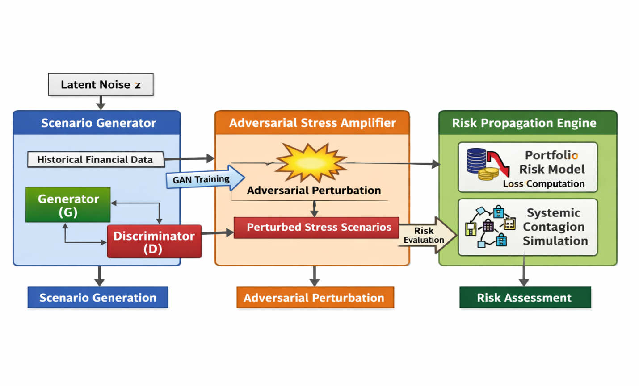
Generative Adversarial Network Architecture Layout
Objective function:
Where:
- xxx = real financial time series
- zzz = latent noise vector
The generator learns to produce realistic macroeconomic conditions including:
- GDP growth
- interest rates
- inflation
- equity indices
- credit spreads
3.3 Adversarial Stress Amplification
To ensure that generated scenarios expose system vulnerabilities, adversarial perturbations are applied to the synthetic trajectories.
The perturbation function maximizes risk exposure:
x′=x+ϵ⋅∇xL(θ,x)x' = x + \epsilon \cdot \nabla_x L(\theta,x)x′=x+ϵ⋅∇x​L(θ,x)
Where:
- LLL represents the portfolio loss function
- ϵ\epsilonϵ controls stress magnitude.
This step produces extreme yet plausible economic shocks.
Risk Propagation Modeling
The generated scenarios are fed into a portfolio risk model that simulates losses across asset classes.
Portfolio loss:
Loss=∑i=1Nwi⋅ΔPiLoss = \sum_{i=1}^{N} w_i \cdot \Delta P_iLoss=i=1∑N​wi​⋅ΔPi​
Where:
- wiw_iwi​ represents asset weights
- ΔPi\Delta P_iΔPi​ represents price change under stress.
Network-based contagion models are used to capture systemic spillovers between institutions.
4. Experimental Setup
4.1 Dataset
Historical financial data covering multiple macroeconomic indicators and market variables were used, including:
- equity indices
- bond yields
- credit spreads
- volatility indices
The dataset spans multiple economic cycles to ensure robust learning.
4.2 Model Configuration
Generator network:
- LSTM layers for time-series generation
- Dense output layers
Discriminator network:
- Convolutional layers
- Fully connected classification layer
Training was performed using the Adam optimizer.
5. Results
5.1 Scenario Realism
Generated scenarios exhibit statistical properties consistent with historical financial data while producing new stress trajectories beyond observed events.
Distributional comparisons indicate that GAN outputs successfully replicate:
- volatility clustering
- heavy-tailed return distributions
- cross-market correlations.
5.2 Stress Severity
The adversarial amplification module generates scenarios producing higher portfolio losses than traditional regulatory stress tests.
These scenarios reveal vulnerabilities in highly leveraged asset classes and correlated exposures.
5.3 Systemic Risk Insights
Network simulations demonstrate that shocks generated by the model can propagate through financial institutions, triggering cascading losses.
This capability allows regulators to identify potential systemic failure points.
6. Discussion
The proposed framework introduces a data-driven approach to stress testing that adapts to evolving financial environments. By integrating generative modeling and adversarial learning, the system can uncover risk scenarios not captured by traditional expert-designed stress tests.
However, challenges remain, including:
- model interpretability
- training stability of GANs
- regulatory acceptance of AI-driven stress tests.
Future research should explore hybrid generative models and explainable AI techniques.
7. Conclusion
This study presents a novel framework for automated adversarial stress testing using GAN-based risk scenario generation. The proposed system produces realistic yet extreme financial conditions capable of revealing hidden vulnerabilities in financial portfolios.
Experimental results indicate that generative adversarial models significantly enhance stress testing by expanding scenario diversity and improving tail-risk detection. The framework provides a promising direction for next-generation financial risk management systems.
Future Work
Future research directions include:
- Diffusion Models For Stress Scenario Generation
- Integration With Reinforcement Learning For Adaptive Stress Discovery
- Real-Time Regulatory Monitoring platforms.

References
  - Good fellow, I., Pouget-Abadie, J., Mirza, M., Xu, B., Warde-Farley, D., Ozair, S., Courville, A., & Bengio, Y. (2014). Generative adversarial networks. Advances in Neural Information Processing Systems.
  - Glasserman, P., Kang, C., & Kang, W. (2015). Stress scenario selection by empirical likelihood. Quantitative Finance, 15(1), 25–41.
  - Flood, M. D., & Korenko, G. G. (2013). Systematic scenario selection: Stress testing and the nature of uncertainty. Office of Financial Research Working Paper.
  - Flaig, S., & Junike, G. (2022). Scenario generation for market risk models using generative neural networks. Risks, 10(11), 199.
  - Efimov, D., Xu, D., Kong, L., Nefedov, A., & Anandakrishnan, A. (2020). Using generative adversarial networks to synthesize artificial financial datasets. arXiv preprint arXiv:2002.02271.
  - Modak, R. (2026). Synthetic market data generation using GANs: Overcoming data scarcity for stress testing trading algorithms in extreme market conditions. World Journal of Advanced Engineering Technology and Sciences, 18(1), 375-387.
  - Sivathapandi, P., Paul, D., & Selvaraj, A. (2022). AI-generated synthetic data for stress testing financial systems: A machine learning approach to scenario analysis and risk management. Journal of Artificial Intelligence Research.
  - Yerra, P. V. K. (2024). GenAI-driven scenario generation for intraday market risk, liquidity stress testing, and portfolio optimization. International Journal of Intelligent Systems and Applications in Engineering.
  - Metha, S., Lakhamraju, M. V., Miriyala, N. S., & Macha, K. (2025). Stress testing financial systems using AI-driven risk models. International Journal of Computational and Experimental Science and Engineering.
  - Selvaraj, A., Selvaraj, A., & Venkatachalam, D. (2022). Generative adversarial networks for synthetic financial data generation: Enhancing risk modeling and fraud detection in banking and insurance. Journal of Artificial Intelligence Research.
  - Wiese, M., Knobloch, R., Korn, R., & Kretschmer, P. (2020). Quant GANs: Deep generation of financial time series. Quantitative Finance, 20(9), 1419-1440.
  - Arjovsky, M., Chintala, S., & Bottou, L. (2017). Wasserstein generative adversarial networks. Proceedings of the International Conference on Machine Learning (ICML).
  - Chen, L. (2024). Risk management with feature-enriched generative adversarial networks. arXiv preprint.
  - Xia, H., Sun, S., Wang, X., & An, B. (2023). Market-GAN: Adding control to financial market data generation with semantic context. arXiv preprint.
  - Borovykh, A., Bohte, S., & Oosterlee, C. (2018). Conditional time series forecasting with convolutional neural networks. Computational Economics, 52(3), 785-799.
  - Goodfellow, I. (2016). Deep learning. MIT Press.
  - Allen, F., & Carletti, E. (2010). An overview of the crisis: Causes, consequences, and solutions. International Review of Finance, 10(1), 1-26.
  - Basel Committee on Banking Supervision. (2018). Stress testing principles. Bank for International Settlements.
  - Heaton, J., Polson, N., & Witte, J. (2017). Deep learning in finance. Annual Review of Financial Economics, 11, 1-20.
  - Sirignano, J., & Cont, R. (2019). Universal features of price formation in financial markets: Perspectives from deep learning. Quantitative Finance, 19(9), 1449-145

