Week 2(2):

ROLL NO.:240701203

Name: Jaiharish D

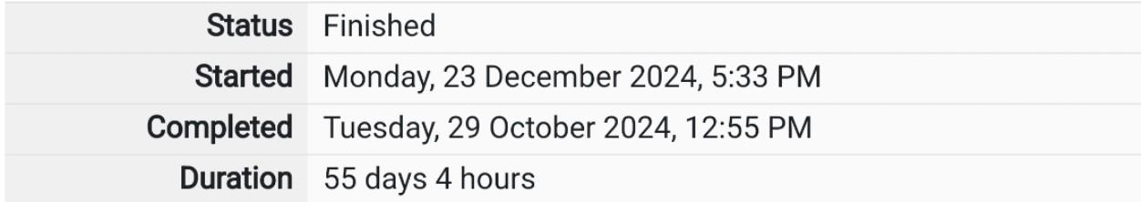

Q1)Goki recently had a breakup, so he wants to have some more friends in his life. Goki has

N people who he can be friends with, so he decides to choose among them according to

their skills set Yi(1<=i<=n). He wants atleast X skills in his friends.

Help Goki find his friends.

Input Format

First line contains a single integer X - denoting the minimum skill required to be Goki's

friend. Next line contains one integer Y - denoting the skill of the person.

Output Format

Print if he can be friend with Goki. 'YES' (without quotes) if he can be friends with Goki

else 'NO' (without quotes).

Constraints

1<=N<=1000000 1<=X,Y<=1000000

SAMPLE INPUT 1

100

110

SAMPLE OUTPUT 1

YES

Code:

#include<stdio.h>

int main()

{

int a,b;

scanf("%d %d",&a,&b);

if(b>=a){

printf("YES");

}

else{

printf("NO");

}

}

OUTPUT:

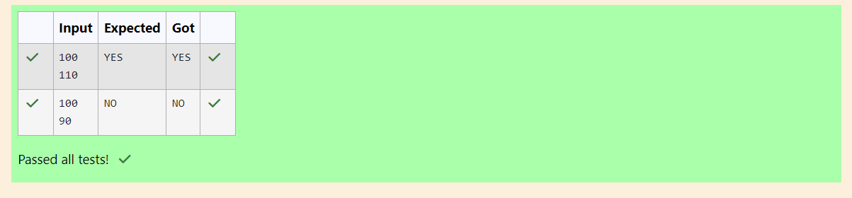

Q2)Before the outbreak of corona virus to the world, a meeting happened in a room in Wuhan.

A person who attended that meeting had COVID-19 and no one in the room knew about it!

So, everyone started shaking hands with everyone else in the room as a gesture of respect

and after meeting unfortunately everyone got infected! Given the fact that any two persons

shake hand exactly once, can you tell the total count of handshakes happened in that

meeting?

Say no to shakehands. Regularly wash your hands. Stay Safe.

Input Format

Read an integer N, the total number of people attended that meeting.

Output Format

Print the number of handshakes.

Constraints

0 < N < 106

SAMPLE INPUT 1

1

SAMPLE OUTPUT

0

Code:

#include<stdio.h>

int main()

{

int a;

scanf("%d", &a);

printf("%d", (a\*(a-1))/2);

return 0;

}

OUTPUT:

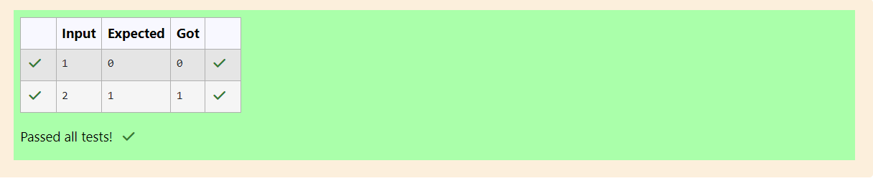

Q3)In our school days, all of us have enjoyed the Games period. Raghav loves to play cricket

and is Captain of his team. He always wanted to win all cricket matches. But only one last

Games period is left in school now. After that he will pass out from school.

So, this match is very important to him. He does not want to lose it. So he has done a lot of

planning to make sure his teams wins. He is worried about only one opponent - Jatin, who

is very good batsman.

Raghav has figured out 3 types of bowling techniques, that could be most beneficial for

dismissing Jatin. He has given points to each of the 3 techniques.

You need to tell him which is the maximum point value, so that Raghav can select best

technique.

3 numbers are given in input. Output the maximum of these numbers.

Input Format:

Three space separated integers.

Output Format:

Maximum integer value

SAMPLE INPUT

8 6 1

SAMPLE OUTPUT

8

Code:

#include<stdio.h>

int main()

{

int a,b,c;

scanf("%d %d %d", &a, &b, &c);

if(a>b && a>c){

printf("%d",a);

}

else if (b>a&&b>c) {

printf("%d",b);

}

else{

printf("%d",c);

}

}

OUTPUT:

