Week 5(1):

ROLL NO.:240701203

Name: Jaiharish D

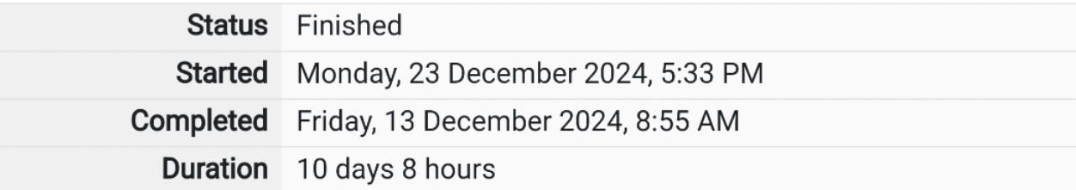

Q1)Write a program that prints a simple chessboard.

Input format:

The first line contains the number of inputs T.

The lines after that contain a different value for size of the chessboard

Output format:

Print a chessboard of dimensions size \* size.

Print W for white spaces and B for black spaces.

Sample Input:

2

3

5

Sample Output:

WBW

BWB

WBW

WBWBW

BWBWB

WBWBW

BWBWB

WBWBW

Code:

#include<stdio.h>

int main()

{

int a,b;

scanf("%d",&a);

for(int i=0;i<a;i++)

{

scanf("%d",&b);

for(int i=0;i<b;i++)

{

for(int j=0;j<b;j++)

{

if((i+j)%2==0)

printf("W");

else

printf("B");

}

printf("\n");

}

}

}

OUTPUT:

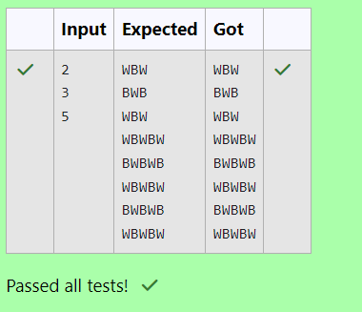

Q2)Let’s print a chessboard!

Write a program that takes input:

The first line contains T, the number of test cases

Each test case contains an integer N and also the starting character of the chessboard

Output Format

Print the chessboard as per the given examples

Sample Input:

2

2 W

3 B

Sample Output:

WB

BW

BWB

WBW

BWB

Code:

#include<stdio.h>

int main()

{

int a,b;

char c;

scanf("%d",&a);

for(int i=0;i<a;i++)

{

scanf("%d %c", &b, &c);

for(int i=0;i<b;i++)

{

for(int j=0;j<b;j++)

{

if(c=='W'){

if((i+j)%2==0){

printf("W");

}

else

printf("B"); }

}

else if(c=='B')

{

if((i+j)%2==0)

printf("B");

else

printf("W");

}

)

printf("\n");

}

}

}

OUTPUT:

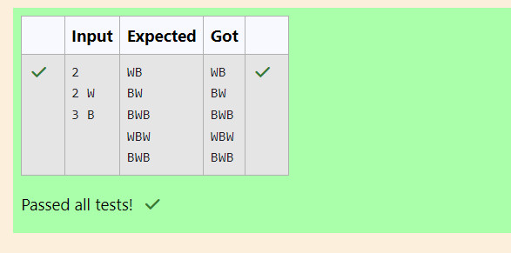

Q3)Decode the logic and print the Pattern that corresponds to given input.

If N= 3 then pattern will be:

10203010011012

\*\*4050809

\*\*\*\*607

If N= 4, then pattern will be:

1020304017018019020

\*\*50607014015016

\*\*\*\*809012013

\*\*\*\*\*\*10011

Constraints: 2 <= N <= 100

Input Format

First line contains T, the number of test cases, each test case contains a single integer N

Output Format

First line print Case #i where i is the test case number, In the subsequent line, print the

pattern

Sample Input

3

3

4

5

Sample Output

Case #1

10203010011012

\*\*4050809

\*\*\*\*607

Case #2

1020304017018019020

\*\*50607014015016

\*\*\*\*809012013

\*\*\*\*\*\*10011

Case #3

102030405026027028029030

\*\*6070809022023024025

\*\*\*\*10011012019020021

\*\*\*\*\*\*13014017018

\*\*\*\*\*\*\*\*15016

Code:

#include<stdio.h>

int main()

{

int n,v,p,c,in, i,j,k,t,1;

scanf("%d",&t);

for( i = 0 i<t;i++)\

{

v = 0

scanf("%d",&n);

printf("Case #%d\n", i + 1 );

for ( j = 0 ;j<n;j++)

{

c = 0

if(j > 0) {

for( k = 0 ;k<j;k++)

{

printf("\*\*");

}

}

for(k=j;k<n;k++){

if(j > 0) {

C++;

}

printf("%d0", ++v);

}

if(j==0){

p=v+(v\*(v-1))+1;

in=p;

}

in=in-c;

p = in

for(l=j;l<n;l++)

{

printf("%d", p++);

if(1! = n - 1){

printf("0");

}

}

printf("\n");

}

}

}

OUTPUT:

