InPatient Hospital Billing & Management System
Complete Entity Relationship Diagram (ERD) Defense Presentation Guide
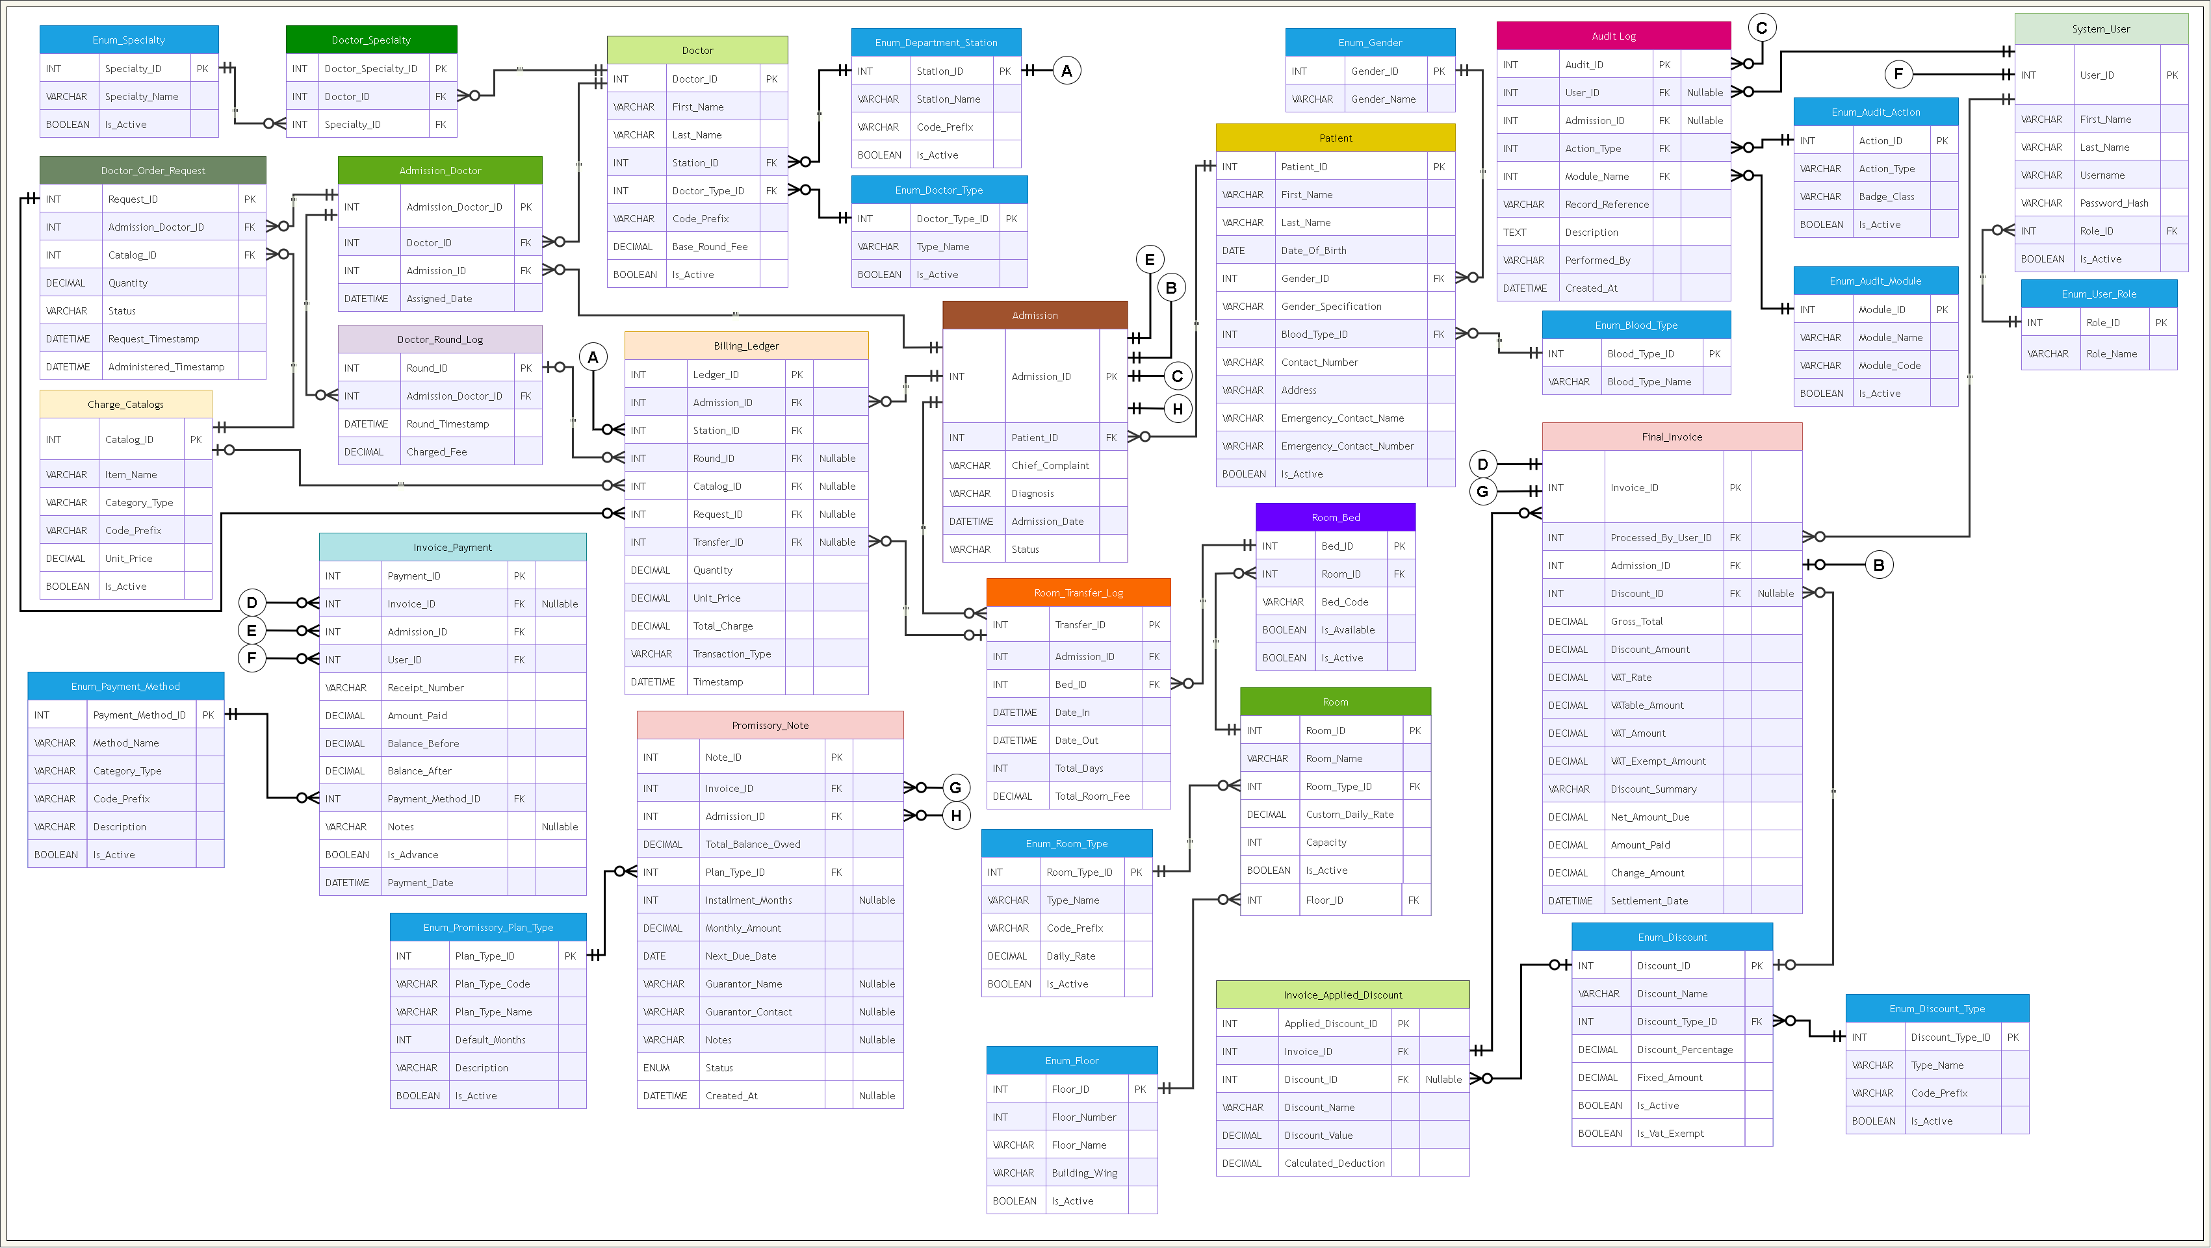
Figure 1.0: Complete 32-Entity Relational Database Architecture (Draw.io Export)
1. Executive Summary & The 1-Minute Elevator Pitch
Use this opening statement to introduce the diagram confidently to your defense panel:
EXACT WORDS TO SAY TO THE PANEL: "Good morning, honorable members of the panel. This Entity Relationship Diagram represents our InPatient Hospital Billing and Management System. Our database consists of 32 normalized relational tables engineered into 5 core modules: Patient Admissions, Medical Staff & Orders, Room & Bed Occupancy, the Central Billing Ledger, and System Security. The central backbone of our entire system is the Admission table, which ties together clinical orders, bed stays, bedside doctor visits, running ledger charges, and final invoice settlement into one seamless, audit-compliant hospital workflow."

2. Breakdown of the 5 Visual Modules on Your Canvas
Your canvas is strategically partitioned into 5 visual zones that represent the real-world workflow of a tertiary hospital:
Module 1: Patient Registration & Inpatient Admissions (Center & Top)
- Patient: Stores permanent demographic profiles (Name, Date of Birth, Gender, Blood Type, Contact, Emergency Contacts). A patient registers only once in the hospital lifetime.
- Admission (The Anchor): Records each specific hospital stay (Admission Date, Chief Complaint, Clinical Diagnosis, Status = 'Admitted'). A patient can have multiple admissions over time, but only one active admission simultaneously.
- Lookup Enums: Enum_Gender and Enum_Blood_Type ensure standardized data integrity.
Module 2: Doctors, Bedside Rounds & Medical Orders (Left Side)
- Doctor & Doctor_Specialty: Physicians stationed in departments (e.g., Surgery, Pediatrics). Linked to specialties via a many-to-many bridge.
- Admission_Doctor: Associates admitted patients with their attending physician and consulting doctors. Allows multi-specialty medical care.
- Doctor_Round_Log: Every time an assigned doctor visits the patient bedside, a timestamped visit record and professional round fee are logged.
- Doctor_Order_Request: Formal medical orders prescribed by doctors (IV medications, laboratory tests, diagnostic scans) referencing master items in Charge_Catalogs. Enforces full clinical chain of custody and accountability through dual-party tracking: the prescribing physician (Admission_Doctor_ID), the delivering healthcare personnel (Administered_By_User_ID for licensed clinical nurses or Administered_By_Doctor_ID for assigned attending physicians), and the exact physical delivery timestamp (Administered_Timestamp). Non-assigned doctors and non-clinical administrative staff are strictly prohibited from administering orders.
- Charge_Catalogs: The centralized hospital price master (Medicines, Scans, Services) with standardized code prefixes (MED, RAD, SRV).
Module 3: Rooms, Beds & Ward Transfers (Center-Right)
- Enum_Floor (Normalized Floor Lookup): Defines physical floors (Floor_Number, Floor_Name) and building wings (Building_Wing). Links to Room via Floor_ID to satisfy 3rd Normal Form (3NF).
- Room: Physical rooms. Linked to Enum_Floor (via Floor_ID) and Enum_Room_Type (via Room_Type_ID). Separates physical floor location from clinical room classification and pricing.
- Enum_Room_Type: Categorizes physical hospital accommodations (ICU, Private, Semi-Private, Ward) with standard daily rates and capacities.
- Room_Bed: Represents each physical bed (e.g., ICU-01, WRD-102-A). Features an Is_Available boolean flag to prevent double-booking.
- Room_Transfer_Log: Tracks patient bed stays with Date_In and Date_Out. When a patient transfers mid-stay, elapsed days and total board/lodging fees are automatically computed and charged.
Module 4: The Financial Hub, Ledger, Invoices & Promissory Notes (Bottom & Center)
- Billing_Ledger: The real-time unified charging ledger. Records charges from medicines, doctor visits, and room days with immutable price snapshots.
- Final_Invoice: The official Statement of Account generated upon discharge. Tallies gross charges, tax/VAT calculations, total discounts, and net amount due.
- Invoice_Applied_Discount: Supports stacking multiple discounts (e.g., Senior Citizen 20% + PhilHealth subsidy) by logging each discount name and calculated peso reduction.
- Invoice_Payment: Logs cashier transactions (advance deposits, partial payments, and final balances) with unique official receipt numbers and payment methods.
- Promissory_Note: Formal legal debt agreement for patients unable to pay their bill upon discharge. Records guarantor info, installment months, monthly payment schedules, and due dates.
- Financial Lookups: Enum_Discount, Enum_Discount_Type, Enum_Payment_Method, and Enum_Promissory_Plan_Type.
Module 5: Security, Access Roles & System Audit (Top-Right)
- System_User & Enum_User_Role: Staff accounts with Role-Based Access Control (Admin, Doctor, Nurse, Cashier). Passwords secured using BCRYPT cryptographic hashing.
- Audit Log: Read-only compliance log tracking every action (Create, Update, Archive, Delete, Settle) with exact timestamps and staff accountability.
3. The Off-Page Connector Jump Bubbles (A through J)
Explain to the panel why circles with letters A through J are used on your diagram:
HOW TO EXPLAIN JUMP BUBBLES: "Honorable panel, circles A through J are Off-Page Jump Connectors. In complex diagrams with over 30 tables, drawing diagonal lines from corner to corner creates a messy 'spiderweb' of overlapping lines. Jump connectors keep the architectural diagram clean, uncluttered, and readable while maintaining 100% exact relational integrity."

Bubble | Source (Parent Table) | Destination (Child Foreign Key) | Clinical / Business Purpose
(A) | Enum_Department_Station | Billing_Ledger.Station_ID | Connects each bill item to the hospital department/station that rendered the service.
(B) | Admission | Final_Invoice.Admission_ID | Connects the final discharge invoice and statement of account to the specific patient admission.
(C) | Admission | Audit Log.Admission_ID | Allows the compliance audit trail to correlate system events to a specific patient stay.
(D) | Final_Invoice | Invoice_Payment.Invoice_ID | Links cashier receipts, partial payments, and installment records to the patient's invoice.
(E) | Admission | Invoice_Payment.Admission_ID | Links advance deposits and payments directly to the admission record before final billing.
(F) | System_User | Invoice_Payment.User_ID | Records the exact cashier who received the physical money and issued the official receipt.
(G) | Final_Invoice | Promissory_Note.Invoice_ID | Links the formal legal deferred debt agreement to the remaining balance on the invoice.
(H) | Admission | Promissory_Note.Admission_ID | Attaches the promissory note to the patient chart so they cannot be archived until settled.
(I) | System_User | Doctor_Order_Request.Administered_By_User_ID | Connects clinical orders to the licensed ward/clinical nurse who physically administered and delivered the medication or supply.
(J) | Doctor | Doctor_Order_Request.Administered_By_Doctor_ID | Connects clinical orders to the attending physician who personally administered or performed the procedure (restricted to assigned doctors).

4. The 5-Step Story of a Patient Through the Database
Walk the panel through a patient's journey step-by-step to demonstrate how data moves between tables:
- Step 1: Patient Admission: Staff registers Patient, creates an Admission record, and assigns an available Bed in Room_Transfer_Log. The bed is immediately flagged Is_Available = 0.
- Step 2: Care & Charging: Doctors are assigned via Admission_Doctor. Bedside visits log to Doctor_Round_Log; medication orders log to Doctor_Order_Request. Both automatically write financial charges into Billing_Ledger.
- Step 3: Discharge & Billing: Cashier closes the room stay in Room_Transfer_Log, calculates elapsed days, and generates Final_Invoice from the sum of all Billing_Ledger rows. Applied discounts are itemized in Invoice_Applied_Discount.
- Step 4: Payment or Promissory Note: If the family pays, Invoice_Payment logs the receipt and payment method. If there is an unpaid balance, a Promissory_Note is signed with guarantor terms and monthly installment schedules.
- Step 5: Bed Release & Audit Trail: The patient is marked Discharged, the bed is freed (Is_Available = 1), and Audit Log stamps a permanent event record with the user ID and timestamp.
5. Evaluator 'Gotcha' Questions & Model Answers
Trap Q1: Why does Billing_Ledger have multiple foreign keys (Catalog_ID, Round_ID, Transfer_ID, Request_ID)?
MODEL ANSWER: "Billing_Ledger is a Unified / Polymorphic Ledger. Hospital charges originate from different clinical events: medicine orders link to Request_ID or Catalog_ID; doctor visits link to Round_ID; room stays link to Transfer_ID. Exactly one reference is populated per line item, allowing the hospital to view a single, reconciled Statement of Account."

Trap Q2: Why is Admission_Doctor a separate table instead of putting Doctor_ID inside Admission?
MODEL ANSWER: "Because an admitted patient is rarely treated by only one doctor. A patient may have an Attending Physician, a Surgeon, and a Consulting Cardiologist. Admission_Doctor is a Many-to-Many bridge table that allows multiple physicians to care for the same patient without duplicating patient or admission records."

Trap Q3: Why separate Room and Room_Bed into two different tables?
MODEL ANSWER: "Because a room contains multiple physical beds. For example, Ward 3 may have 6 beds. By having Room_Bed with an individual Is_Available flag, our system prevents double-booking, enables precise room transfer tracking, and knows the exact real-time occupancy of every bed in the hospital."

Trap Q4: Why did you normalize Floor into its own table (Enum_Floor) and use Floor_ID as a Foreign Key?
MODEL ANSWER (NORMALIZATION JUSTIFICATION): "We normalized Floor into Enum_Floor to satisfy Third Normal Form (3NF). If a floor name or building wing changes, updating it in Enum_Floor automatically propagates across all rooms without update anomalies. It also prevents typo discrepancies (e.g. '2nd Floor' vs 'Floor 2' vs '2F') and allows multi-wing hospital facility expansion."

Trap Q5: Why does Doctor_Order_Request have both Administered_By_User_ID and Administered_By_Doctor_ID instead of a single ID column?
MODEL ANSWER: "In hospital clinical operations, items are delivered by two distinct types of licensed personnel: a clinical nurse (stored in System_User and referenced via Administered_By_User_ID), or an attending physician directly administering a procedure (stored in Doctor and referenced via Administered_By_Doctor_ID). Explicit foreign keys guarantee 100% referential integrity without polymorphic ID collisions. Furthermore, our business logic enforces medical governance: non-assigned doctors and non-clinical administrative staff cannot administer orders, ensuring complete non-repudiation."

6. Complete 32-Table Directory Reference
# | Table Name | Category | Primary Key | Core Function in the Hospital
1 | Enum_Gender | Lookup | Gender_ID | Standardizes patient biological gender.
2 | Enum_Blood_Type | Lookup | Blood_Type_ID | Standardizes blood group classifications (A, B, AB, O).
3 | Enum_Floor | Lookup | Floor_ID | Normalized hospital floor levels, floor numbers, and building wings.
4 | Enum_Room_Type | Lookup | Room_Type_ID | Classifies rooms (Ward, Private, ICU) and sets default daily rates.
5 | Enum_Specialty | Lookup | Specialty_ID | Medical specialties (Cardiology, Pediatrics, Surgery, etc.).
6 | Enum_Doctor_Type | Lookup | Doctor_Type_ID | Categorizes physician ranks (Resident, Attending, Consultant).
7 | Enum_Department_Station | Lookup | Station_ID | Hospital nurse stations and service departments.
8 | Enum_Discount_Type | Lookup | Discount_Type_ID | Categorizes statutory vs institutional discount types.
9 | Enum_Discount | Lookup | Discount_ID | Defines percentage and fixed discount rates (Senior, PWD, PhilHealth).
10 | Enum_User_Role | Lookup | Role_ID | Access permissions for Admin, Doctor, Nurse, Billing Clerk, Cashier.
11 | Enum_Payment_Method | Lookup | Payment_Method_ID | Payment channels (Cash, Credit Card, Debit Card, GCash, Bank Transfer).
12 | Enum_Promissory_Plan_Type | Lookup | Plan_Type_ID | Installment schedule structures (1-month, 3-month, 6-month plans).
13 | Enum_Audit_Module | Lookup | Module_ID | Categorizes system areas in audit logs (Admissions, Billing, Catalog).
14 | Enum_Audit_Action | Lookup | Action_ID | Action event types in audit logs (CREATE, UPDATE, ARCHIVE, DELETE).
15 | System_User | Master | User_ID | Staff credentials and role-based authentication.
16 | Doctor | Master | Doctor_ID | Physician directory, station assignments, and base round fee rates.
17 | Doctor_Specialty | Bridge | Doctor_Specialty_ID | Links doctors to one or multiple medical specialties.
18 | Room | Physical | Room_ID | Hospital rooms linked to Floor_ID (FK) and Room_Type_ID (FK).
19 | Room_Bed | Physical | Bed_ID | Individual physical beds with real-time vacancy flags (Is_Available).
20 | Charge_Catalogs | Master | Catalog_ID | Price master for floor medicines, lab tests, and imaging scans.
21 | Patient | Patient | Patient_ID | Permanent patient demographic and emergency contact records.
22 | Admission | Clinical | Admission_ID | The central anchor table representing individual hospital admissions.
23 | Admission_Doctor | Bridge | Admission_Doctor_ID | Assigns attending and consulting doctors to active patient admissions.
24 | Doctor_Order_Request | Clinical | Request_ID | Doctor orders for medications, labs, and procedures with dual-party tracking (prescribing doctor + administering nurse via Administered_By_User_ID or assigned doctor via Administered_By_Doctor_ID).
25 | Doctor_Round_Log | Clinical | Round_ID | Timestamped bedside doctor visits and professional fee logs.
26 | Room_Transfer_Log | Clinical | Transfer_ID | Tracks patient bed stays, transfer history, days, and room charges.
27 | Billing_Ledger | Financial | Ledger_ID | Running itemized billing ledger with immutable price snapshots.
28 | Final_Invoice | Financial | Invoice_ID | Final Statement of Account, tax/VAT math, discounts, and net due.
29 | Invoice_Applied_Discount | Financial | Applied_Discount_ID | Itemized breakdown of multiple discounts applied to an invoice.
30 | Invoice_Payment | Financial | Payment_ID | Cashier receipts, advance deposits, and installment payments.
31 | Promissory_Note | Financial | Note_ID | Deferred debt agreements with legal guarantor and installment terms.
32 | Audit Log | Security | Audit_ID | Permanent non-repudiation audit trail of all system transactions.

