|  |
| --- |
| **IP ADDRESSES AND RESERVED PORTS**    NAME: R. Jaikiran |

**IPV4 ADDRESS FORMAT:**

It stands for Internet Protocol version four. IPv4 addresses are 32-bit integers that have to be expressed in Decimal Notation. It is represented by 4 numbers separated by dots in the range of 0-255, which have to be converted to 0 and 1, to be understood by Computers. For Eg, An IPv4 Address can be written as 189.123.123.90. IPv4 Address Format is a 32-bit Address that comprises binary digits separated by a dot. The network part of the IPv4 address is on the left-hand side of the IP address. It specifies the particular network to where the IPv4 address belongs. The host portion of the IPv4 address uniquely identifies the device or the interface on your network.

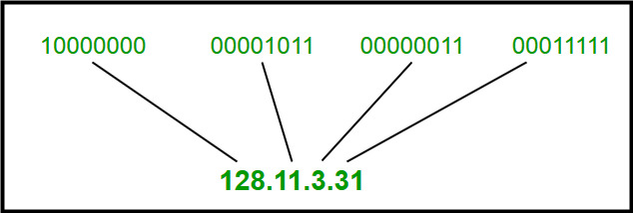

**IPV6 ADDRESS FORMAT:**

IPv6 is based on IPv4 and stands for Internet Protocol version 6. IP version 6 is the new version of Internet Protocol, which is way better than IP version 4 in terms of complexity and efficiency. IPv6 is written as a group of 8 hexadecimal numbers separated by colon (:). It can be written as 128 bits of 0s and 1s. IPv6 Address Format is a 128-bit IP Address, which is written in a group of 8 hexadecimal numbers separated by colon (:).

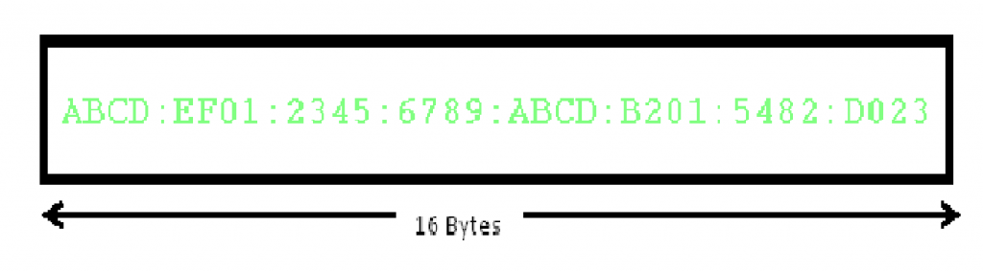

**IP ADDRESSING SCHEMES:**

* IP address is an address that is used to uniquely identify a device on an IP network. IP address is made up of 32 binary bits. These binary bits can be further divided into network portion and host portion with the help of a **subnet mask**.
* The 32 binary bits are broken into four octets of 8 bits each. Each octet is converted to decimal and separated by a period (dot).

**IP ADDRESSING SCHEME IN IPV4:**

**CLASS-A:**

IP addresses belonging to class A are assigned to the networks that contain a large number of hosts.

The network ID is 8 bits long.

The host ID is 24 bits long.

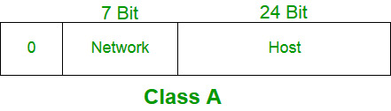

**CLASS-B:**

IP address belonging to class B is assigned to networks that range from medium-sized to large-sized networks.

The network ID is 16 bits long.

The host ID is 16 bits long.

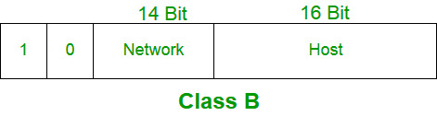

**CLASS-C:**

IP addresses belonging to class C are assigned to small-sized networks.

The network ID is 24 bits long.

The host ID is 8 bits long.

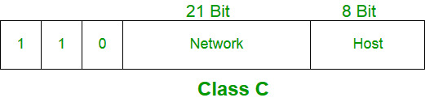

**CLASS-D:**

IP address belonging to class D is reserved for multi-casting. The higher-order bits of the first octet of IP addresses belonging to class D is always set to 1110. The remaining bits are for the address that interested hosts recognize.Class D does not possess any subnet mask. IP addresses belonging to class D range from 224.0.0.0 – 239.255.255.255.

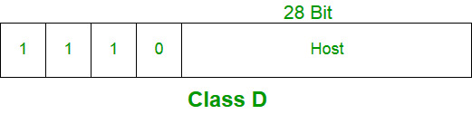

**CLASS-E:**

IP addresses belonging to class E are reserved for experimental and research purposes. IP addresses of class E range from 240.0.0.0 – 255.255.255.254. This class doesn’t have any subnet mask. The higher-order bits of the first octet of class E are always set to 1111.

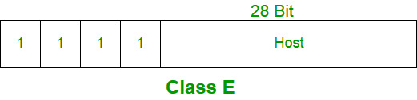

**IP ADDRESSING SCHEME IN IPV6:**

IPv6 addresses are divided into three parts: the prefix, the subnet ID, and the interface ID. The prefix is used to identify the network, the subnet ID is used to identify subnets within the network, and the interface ID is used to identify the device.

**RESERVED PORTS:**

* Reserved ports, also known as well-known ports, are network ports that are assigned and typically used by specific services or protocols. These ports are standardized by the Internet Assigned Numbers Authority (IANA) to ensure consistent usage across different network devices and applications.
* Port numbers in the range 1 to 1023 are considered “reserved” or “privileged.” TCP/IP conventions require that a connection using such low port numbers have special privileges, such as root privileges on the originating machine.
* Port numbers 1024 - 49151 are reserved for user server applications. Port numbers 49152 - 65535 are reserved for clients.
* If you have a server in the client port range (49152 - 65535), define that server in the TCP/IP network services database to prevent port number conflicts.

**APPLICATIONS:**

* Skype uses port 80 (HTTP) and port 443 (HTTPS) for communication.
* FTP uses port 21 for control and port 20 for data transfer.
* SSH uses port 22 for secure remote access.
* DNS uses port 53 for name resolution.
* MySQL uses port 3306 for database management.