- Changed my directory to desktop location, then made a directory named “test_dir” using mkdir command, then entered into test_dir directory using cd command and using touch command i created a file named “example.txt”, check the file in the folder using ls command, renamed the file example.txt to renamed_example.txt using mv command, and once again checked the folder for the file using ls command.
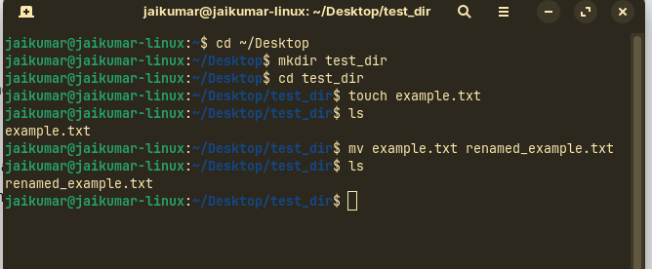

- Used cat command to display the content of the /etc/passwd file.
Used head command to display the top 10 lines of the passwd file.
Used tail command to display the bottom 10 lines of the passwd file.
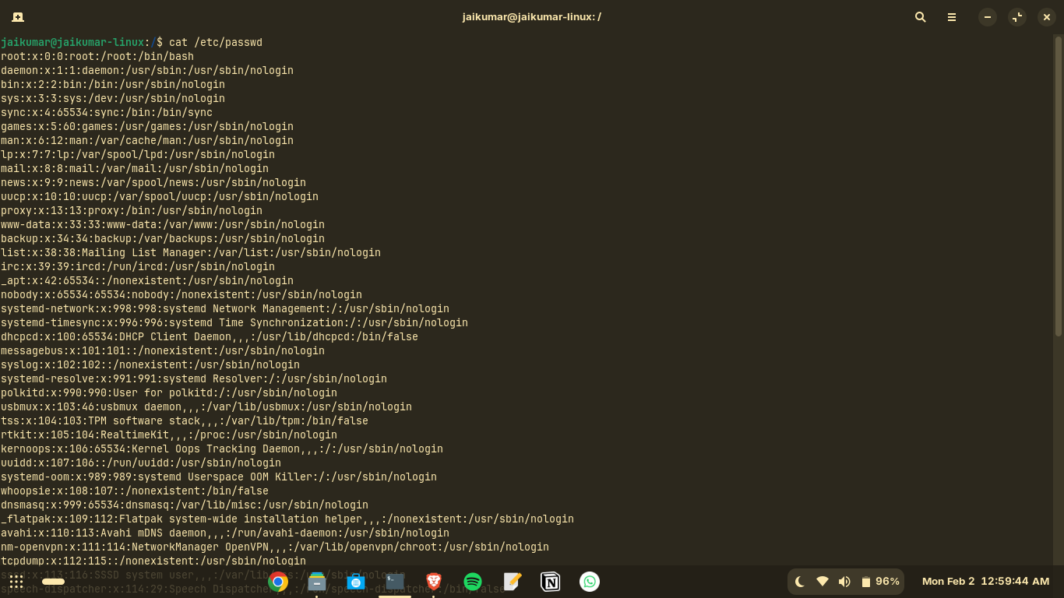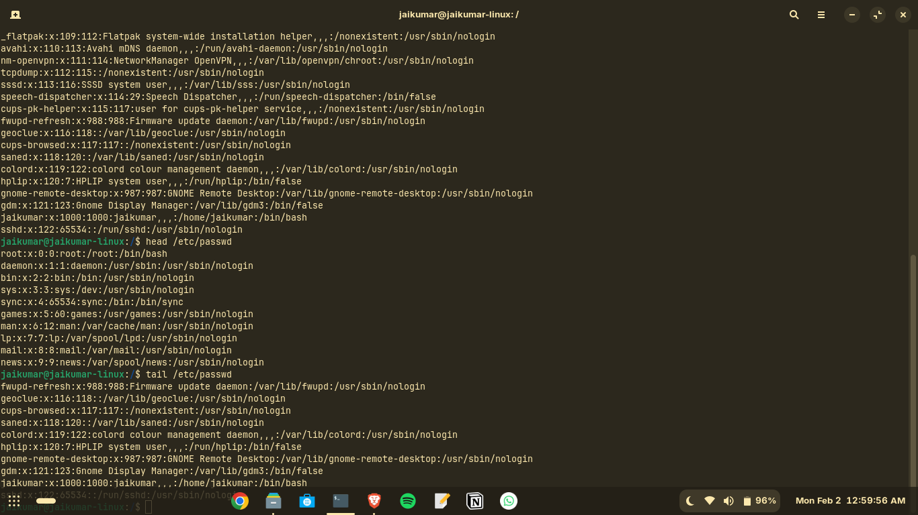
- The cat command fetches all the data in the passwd file and using pipeline to feed the data to the next command, the next command was grep which is used to find a specific word/expression, so the output displays only the line with the “root” word which was mentioned in grep command.
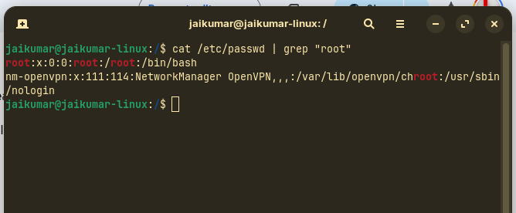

- Used zip command to archive the test_dir folder to the file named test_dir.zip. Used -r option to recursively store all the files in the zip file.
Used Unzip command to unzip the zip file, -d option was used to create the unzipped_dir folder as it was not present in the current working directory, -d command creates the folder if it is not present.
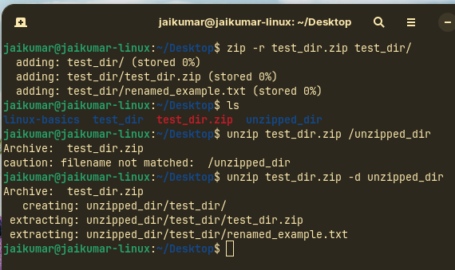

- Used wget command with the URL https://code.jquery.com to download the webpage, the file index.html is saved in the current working directory.
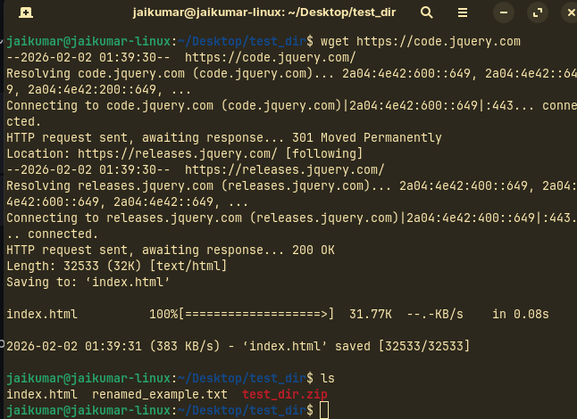

- Used Touch command to create the secure.txt file and then used chmod command to change the permissions of the file, 444 represents the read permission to the user, group and others. Read = 4, write = 2 , execute = 1.
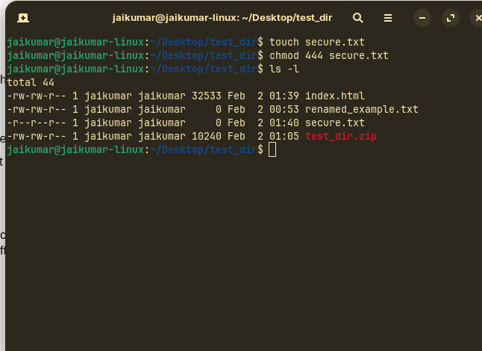
- Used export command to declare the env variable named “MY_VAR” as Hello, Linux !
Used Echo command to print the env variable. The output gives the exact data which we input into the variable.
