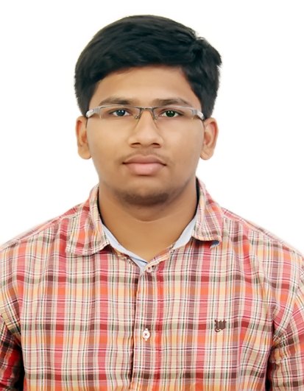

**R.P.Balaji**

B.Tech Leather Technology

[balajirp2@gmail.co](mailto:balajirp2@gmail.co)m

9842146968



**CAREER OBJECTIVE:**

To gain employment at an esteemed company, which will inspire me to enhance my skills and work as a team player in a positive atmosphere.

**EDUCATIONAL QUALIFICATION :**

Along with the B.Sc. Degree from IIT MADRAS, I am currently pursuing a Five month IITM Certified Programming and Data Science course. This course is offered by GUVI(an IITM Incubated company) in partnership with IIT MADRAS.

|  |  |  |  |  |  |  |
| --- | --- | --- | --- | --- | --- | --- |
| **COURSE** |  | **NAME OF THE** | | **BOARD OF** | **YEAR OF** | **PERCENTAGE/** |
|  |  | **INSTITUTION** | | **STUDY** | **PASSING** | **CGPA/GRADE** |
| **B.Sc. in Programming and Data Science** | Indian Institute of Technology, Madras, Chennai | | | IIT MADRAS | Currently in Second term | Completed First term  7.8(CGPA) |
| **B.Tech (Leather)** | AC College of Technology,  Anna University,  Guindy | | | Anna University | 2017 | 7.45(CGPA)  Backlogs-4 |
| **AISSCE** | The Velammal International School, Chennai | | | CBSE | 2013 | 84.8% |
| **AISSE** | The Velammal International School, Chennai | | | CBSE | 2011 | 9.6/10 |
| **SKILL SETS:** | | | |  |  |  |
| LANGUAGES | | | : **PYTHON,C, JAVA, C++, HTML** | |  |  |
| SOFTWARE | | | : **MS-OFFICE PACKAGE** | |  |  |

**AREA OF INTEREST:**

* Programming
* Data Science
* Artificial Intelligence

**WORK EXPERIENCE:**

Worked in Arasababu Associates Leather Industry (Father’s Business) at Ranipet, Tamil Nadu.

**PROJECT DETAILS:**

* **B.Tech project (Leather):**

**Done at CLRI (Central Leather Research Institute)**

**Title:** Upgradation of low grade Indian Cow Wet Blue.

**Description:** To improve the quality of the low grade Indian cow Wet blue. This can be done with the help of some essential chemicals in the tanning and post tanning process. Nanoparticle dispersion for the wet blue using Protein Based Polymer Syntan which is made from hide or skin waste for the crust to improve the quality of wet blue. This method is eco-friendly and improves the exhaustion of chromium also.

**EXTRA CURRICULAR ACTIVITIES:**

* Participated in **BEANMUN-UNICEF, WEMUN EXPO 2010,** **China.**
* Completed first level certification course in **GERMAN language**, conducted **by Centre for International Affairs**, Anna University, Chennai in 2016.
* Participated in **HOCKEY** - CBSE Inter School Sports and Games Competition- **Zonal Level.**
* Participated in **TABLE TENNIS**- CBSE Inter School Sports and Games Competition- **Zonal Level.**
* Secured **Third position in Technical Quiz** in CROSSLINX’15**,** an International level Leather Techno-Management Symposium.
* Secured **First place in Badminton Doubles** in CROSSLINX’14**.**
* Secured **First place in KHO-KHO** in CROSSLINX’14**.**
* Secured **First position** in **Senior Boys Volleyball** in the inter house competition at Chinmaya International Residential school.
* Qualified in **CHAMPAK Story Writing** Competition.
* Participated in **Young World Quiz’ 10** conducted by **THE HINDU** and wonspecial award.
* Took **ASSET diagnostic test** from 6th to 9th standard and had a drastic improvement in 9th standard score. Percentile in 9th English- 96.4, Maths -81.9.
* Attended SHUB SAHAS **Adventure Camp** held at CIRS, Coimbatore by National Adventure Foundation in 2010.
* Obtained 91 marks in the **Verbal Ability Quiz** conducted by “The Quest” in Chinmaya International Residential School.
* Participated in Velammal’s State level Seventh **Science Talent Search exam**
* Selected for final round in Velammal’s State level Eighth **Science Talent Search exam.**
* Regular Blood donor.
* Achievement in **International Olympiad**

|  |  |  |  |
| --- | --- | --- | --- |
| **Standard** | **Subject** | **State rank** | **Olympiad rank** |
| 9th | Mathematics | 19 | 386 |
| 9th | English | 22 | 1000 |
| 10th | General | 125 | 3409 |
| 10th | Cyber (Computer) | **School rank – 1st** | |

**CO-CURRICULAR ACTIVITIES:**

* Participated in **The Guinness World Record Event- Most users to take an online programming lesson in 24 hours** organized by GUVI. Also, completed the final round of the event which is to build a **Face Recognition Application using Python**.
* Participated in **XXXIV International Union of Leather Technologists & Chemists Congress** at Chennai.
* **Student’s** **Secretary** of **CROSSLINX’17,** an International level Leather Techno-Management Symposium. Also, raised a fund of Ten Lakhs for the Symposium.
* Completed **C++** Course in Solo Learn.

**INTERPERSONAL SKILLS:**

* Confident and Determined
* Team Player- Also can convey what I understand, to others in simple words.
* Adaptability
* Positive Thinker

**HOBBIES:**

1. Reading Novels
2. Sports
3. SUDOKU
4. Creative writing

**PERSONAL DETAILS:**

|  |  |  |
| --- | --- | --- |
| Date of Birth | : | 10-04-1996 |
| Address | : | A-87, TNHB, Seekarajapuram, Tiruvalam,Vellore-632515 |
| Known Languages | : | English, Tamil, Hindi, German(first level) |
| Father’s Name | : | Pugazheanthi. P |
| Father’s Occupation | : | Leather Business |
| Mother’s Name | : | Jayabarathi. P |
| Mother’s Occupation | : | Home Maker |
| Phone Number | : | 9842146968 |

**DECLARATION:**

I hereby declare that all the details above are true to my knowledge and belief.

**R.P.Balaji**