**Rent-a-Car Management System**

**Letter of Transmittal**

December, 2019

Md. Saidur Rahman

Department Faculty, Computer Science &Engineering

IUBAT University

Uttara, Dhaka-1212

Dear Sir,

Thank you for assigning us such an attractive topic I have tried my best to make the project successful on time although there were some limitations. After completing all the jobs I have written this report, which will help you to know about our project. It is expected that the report will tell that to focus on Integration of **Rent a car Management System for BJ Company.**

I hope you will find the report relevant and meaningful.

Sincerely,

Jaima Jarnaz Mim

Leader of Queens

Program:BSc in CSE

**Abstract**

This project is mainly developed for the project requirement of Iubat University to ensure the development skill of knowledge. By this information system all activities of any manpower recruitment organization will be distributed among the members through network. Using online form IT people can be member here. As the purpose to keep record of foreign recruited individuals organizations and government may use this system to keep the actual information about human power which is using in abroad.

**Acknowledgement**

In the name of Allah who is the most merciful and the most graceful.

First of all I sincerely I would like to pay my gratitude to my project advisor Md. Saidur Rahman, Department Faculty, Computer Science & Engineering, Iubat University, who has given me the opportunity to make such a report for not only in this semester but also throughout my education life at real sectors by giving his valuable suggestions and advices at any time, at any situation. I would able to make this report effectively and property only for his right direction.

**Declaration**

I, Jaima Jarnaz Mim, a student of BSE in Computer Science & Engineering or Iubat University declaring that, this report on the topic of “Rent a Car Management System for BJ Company” has been prepared for the fulfillment of the project course CSE 387.

CSE 387 , Project as well as the partial requirement of BSE in Computer Science and Engineering degree.

The report and the project on “Rent a Car Management System for BJ Company “ is originally prepared by Queens Group. All module and procedure of this project is being made after proper inspection and internet information.

It has been prepared for any other purposes, rewards or presentations.

…………………………………………..

Jaima Jarnaz Mim

Leaders of Queen Group

Program- BSc in CSE

**Letter of Authorization**

Dated 05th December, 2019

Jaima Jarnaz Mim

Leader of Queens Group

Program: BSc in CSE

Dear Jaima

I hereby authorized you to develop “Rent A Car Management System for BJ Company”to fulfill the requirement of the Project of the of Project of Course CSE 387 to complete the Degree of Bachelor in Computer Science and Engineering.

……………………………..

Md. Saidur Rahman

Faculty

Department of Computer Science & Engineering

Iubat University

Uttara, Dhaka-120

**“Content Page”**

**1.Introduction**

**1.1. Introduction of project**

**1.2. Aim of project**

**2. Existing System**

**2.1. Problems with Existing System**

**3. Proposed System**

**3.1. Aim of Proposed System**

**3.2. System Feasibility Study**

**4. Proposed System Design**

**4.1** **Software Requirement Specification**

**4.2 Database**

**4.2.1 Identifying Entities with Atributes**

**5. Entity Relationship Model**

**5.1 Entity Relationship Diagram ( Diagram)**

**5.2 Relationship Cardinality**

**6. System Description**

**6.1. Data Flow Diagram (Introduction)**

**6.2 Symbol of DFD**

**6.3 DFD of Project**

**6.4 Task Distribution**

**6.6. Time Chart for Activities**

**7.Project Requirements**

**7.1. Hardware Requirements**

**7.2 Software Requirements**

**8. Screen Shoot**

**9. Conclusion**

**-Information References- (Must Include at Least of the Report)**

**-Bibliography**

**1.Introduction**

**1.1 Introduction**

In order to facilitate users to rent a car as and when required we would like to design a car rental system. It is more feasible than owning a car and maintaining it. Car rental system serves people who don't own a car, who are out of town or owners of damaged cars who are awaiting repair orinsurance compensation.

**1.2 Aim of Project**

In the Previous System,Details are Stored Manually in papers,to share the details between employees was a Financial drawback. Updations in the details is a tedious task. But a new system was proposed to overcome the above drawbacks. Functionalities and aim of project system are:

* Data is Centralized which has overcome the Sharing problem in previous system.
* As data is Maintained electronically, it’s easy for a person to update the details, which has overcome the tedious updation in previous system.
* Maintenance is easy and performance is good.
* Mainly the system has automated the Transportation Process.

**2. Existing System**

**2.1. Problems with Existing Manual System**

* Lack of security of data
* More man power
* Time consuming
* Needs manual calculations
* Possibility of lost of information
* No direct role for higher officials

**3. Proposed System**

**3.1. Aim of Proposed System**

The aim of proposed system is to improve the existing system functionalities.

The system can ensure more security.

**3.2. System Feasibility Study**

Preliminary investigation examine project feasibility, the likelihood the system will be useful to the organization. The main objective of the feasibility study is to test the Technical, Operational and Economical feasibility for adding new modules and debugging old running system. All system is feasible if they are unlimited resources and infinite time. There are aspects in the feasibility study portion of the preliminary investigation:

* Technical Feasibility
* Operation Feasibility
* Economical Feasibility

**Technical Feasibility**

The technical issue usually raised during the feasibility stage of the investigation includes the

following:

* Does the necessary technology exist to do what is suggested?
* Do the proposed equipments have the technical capacity to hold the data required to use the new system?
* Will the proposed system provide adequate response to inquiries, regardless of the number or location of users?
* Can the system be upgraded if developed?
* Are there technical guarantees of accuracy, reliability, ease of access and data security?

**Operational Feasibility**

Proposed projects are beneficial only if they can be turned out into information system. That will meet the organization’s operating requirements. Operational feasibility aspects of the project are to be taken as an important part of the project implementation. Some of the important issues raised are to test the operational feasibility of a project includes the following: -

* Is there sufficient support for the management from the users?
* Will the system be used and work properly if it is being developed and implemented?
* Will there be any resistance from the user that will undermine the possible application benefits?

This system is targeted to be in accordance with the above-mentioned issues. Beforehand, the management issues and user requirements have been taken into consideration. So there is no question of resistance from the users that can undermine the possible application benefits.

**Economic Feasibility**

A system can be developed technically and that will be used if installed must still be a good investment for the organization. In the economical feasibility, the development cost in creating the system is evaluated against the ultimate benefit derived from the new systems. Financial benefits must equal or exceed the costs.

**4. Proposed System Design**

**4.1** **Software Requirement Specification**

We aim to become a pioneer in the vehicle rental industry by completely focusing on customers, our employees, growth, innovation and efficiency. All of these elements will drive us towards success and show us as one company that can perform and give value for money. This Service will make A manager to think of whether the transportation is expensive and maintaining quality or not.

* 1. **Database**

**4.2.1 Identifying Entities**

**Admin Module**

Admin is the Super user of the system, he is responsible for the creation and maintenance of the accounts to the sytem.Admin is responsible for the creation of different kind of managers.Admin looks after the maintenance of these accounts. He has a feature of getting the password of a username ..

Tbl_AdminLogin

* UserName
* Password

**Functionalities**

* Admin Creates the Accounts for different types of Customer.
* Admin Logins into the System
* Admin Can view the login details and maintain these Details
* Admin can get the password to the Username.

**Driver Module**

**Tbl_DriverDetails**

* DriverID
* Name
* Address
* NID
* Phone No
* Driving Licence

**Car Module**

* CarID
* DriverID
* RegistorNo
* EngineNo

**Customer_Module**

* CustomerID
* CustomerName
* Address
* PhoneNo
* EmailID

**Trip Module**

* Triptype
* Amount
* Advance
* StartPoint
* EndPoint
* DriverId
* CarID

**5. Entity Relationship Model**

**5.1 Entity Relationship Diagram ( Diagram)**

**Rent-A-Car Management System**

payment

takes

Trip

trips

Customer

admin

Driver

river

Car

has

drives

**6. System Description**

**6.1. Data Flow Diagram (Introduction)**

A picture is worth a thousand words. A Data Flow Diagram (DFD) is a traditional way to visualize the information flows within a system. A neat and clear DFD can depict a good amount of the system requirements graphically. It can be manual, automated, or a combination of both.

**6.2 DFD Symbols:**

In the DFD, there are four symbols

1. A square defines a source(originator) or destination of system data
2. An arrow identifies data flow. It is the pipeline through which the information flows
3. A circle or a bubble represents a process that transforms incoming data flow into outgoing data flows.
4. An open rectangle is a data store, data at rest or a temporary repository of data

Process that transforms data flow.

Source or Destination of data

Data flow

Data Store

**6.3 DFD of Project**

Generate Customer Report

Generate Customer Report

Customer

management

0

Car Rental

System

Check the user login details

Generate driver Report

Generate Car Report

Login

management

Driver management

Car management

Fig : Context Level Diagram

**6.4 Task Distribution**

* + - * Adopt the rules: cooperation and collective intelligence.
      * Use collaborative tools.
      * Learn to distribute tasks and delegate.
      * Running efficient, agile meetings.
      * Manage our time and motivation.

**6.6. Time Chart for Activities**

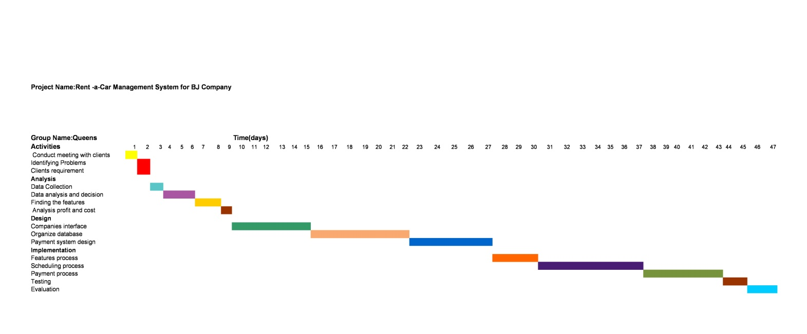

**7.Project Requirements**

**7.1. Hardware Requirements**

* Small dataset hardware recommendations
* Medium dataset hardware recommendations
* Large dataset hardware recommendations

**7.2 Software Requirements**

* + Operating system
  + SharePoint Server 2013
  + SQL Server
  + Requirements for Project Server 2013 features

**9. Screen Shoot**

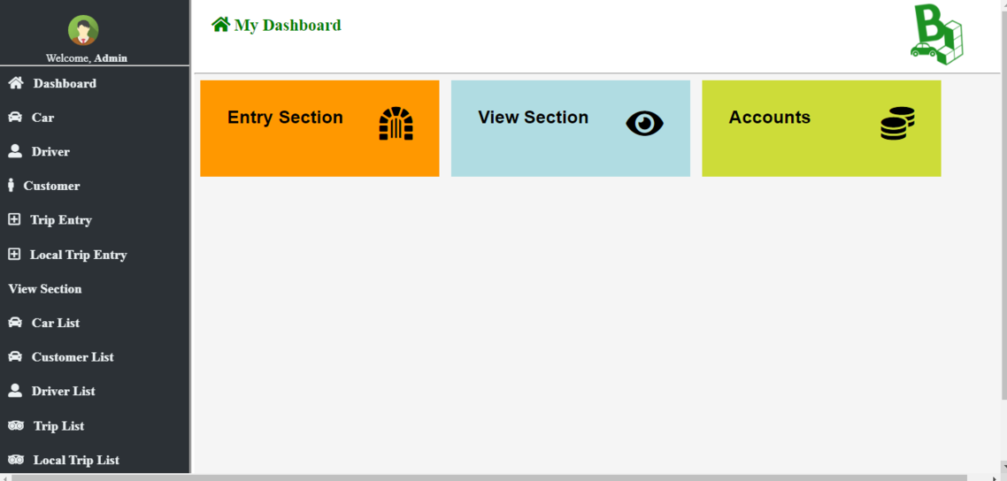

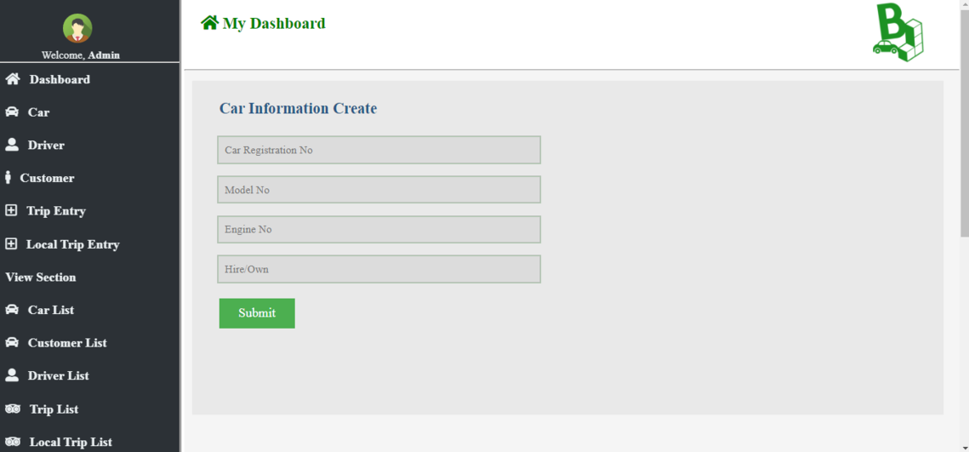

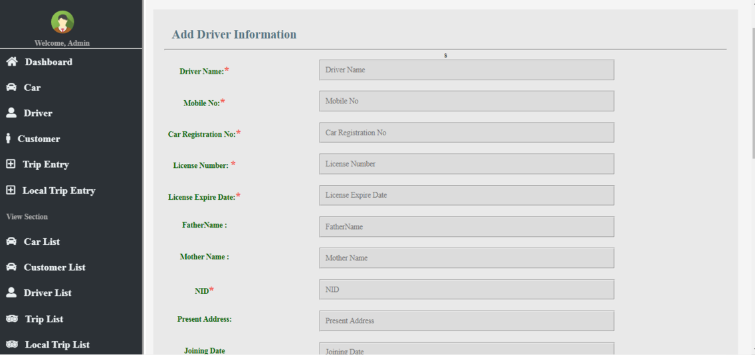

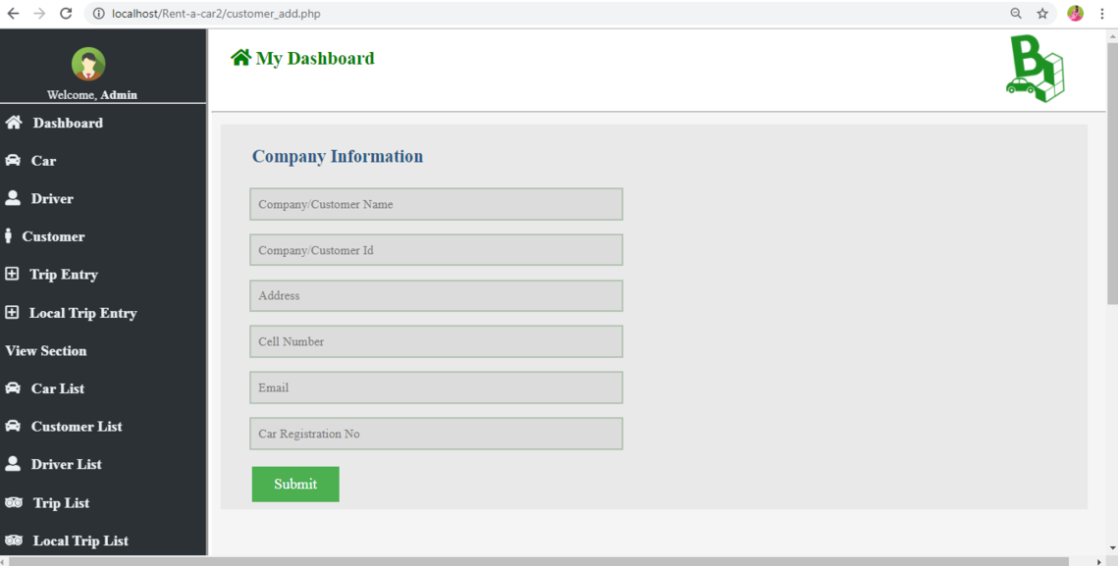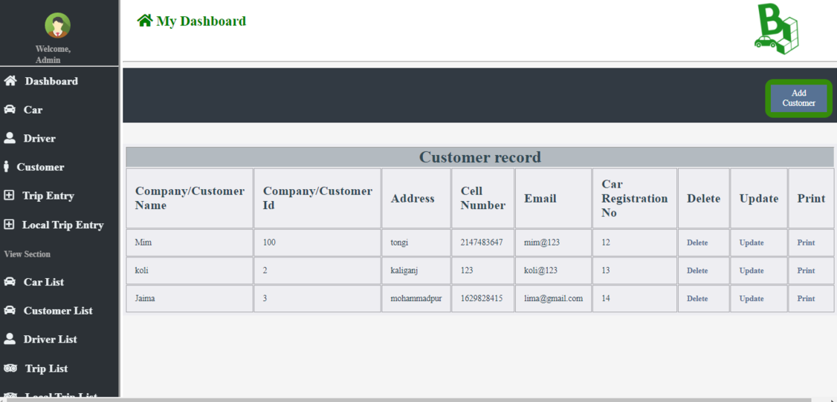

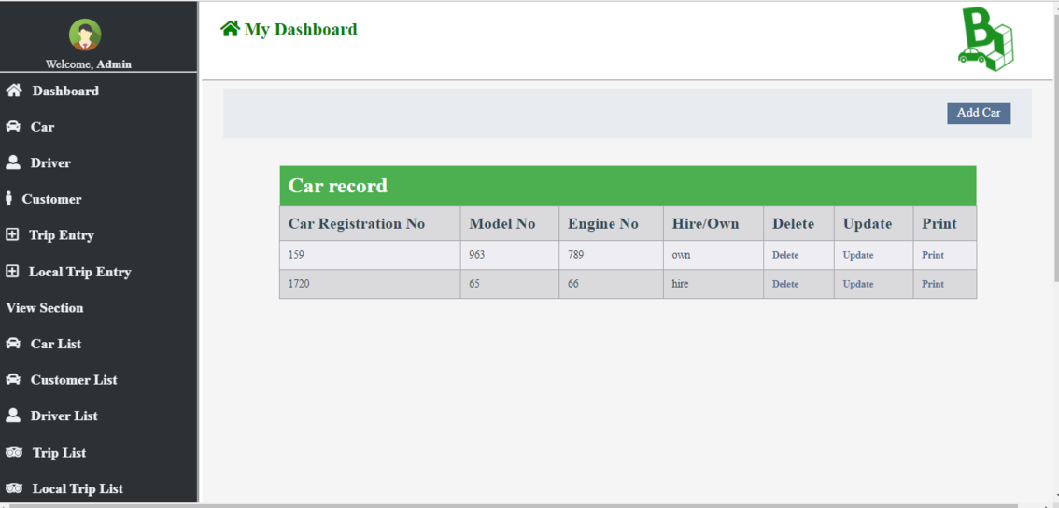

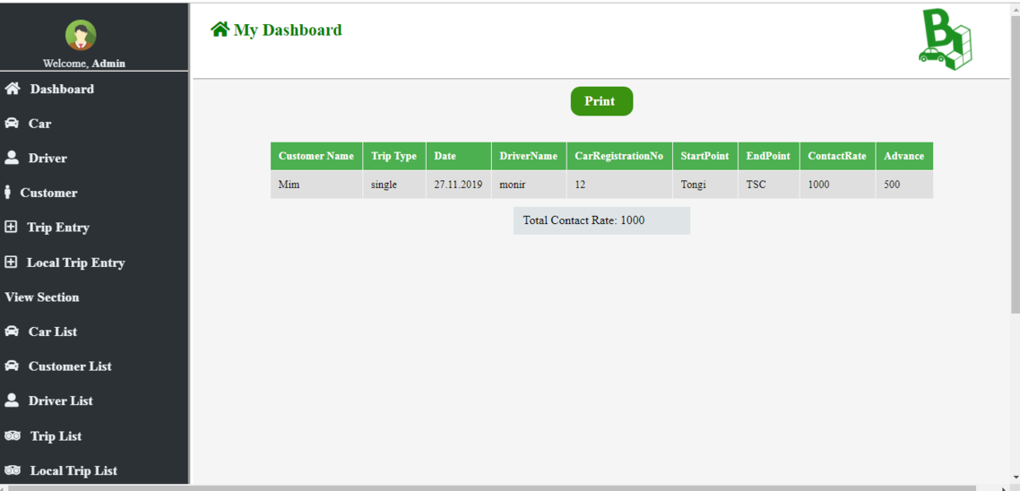

**9. Conclusion**

Car rental business has emerged with a new goodies compared to the past experience where every activity concerning car rental business .

# BIBLIOGRAPHY AND REFERENCES

## Books Used:

* Software Engineering - R.S. Pressman
* PHP For Dummies
* PHP Begineers Guide By McGrawhill Publication
* Javascript By McGrawhill Publication

## References Used:

* <http://www.carrentingsolutions.com/>
* <http://www.flashvortex.com/>
* <http://www.imscart.com/car_rental_software.html>
* Wikipedia.org
* [www.w3schools.com](http://www.w3schools.com/)