Universidad Católica de El Salvador

Facultad de Ingeniería y Arquitectura

**Informe Período III · PROPUESTA TEMÁTICA PARA SIGUIENTE IDC**

Docente Investigador

Mario Jaime Martínez Herrera

Asignatura

Administración de Servidores

Temática de investigación

Servidores de Base de Datos

Ciclo I 2024

Estudiantes colaboradores

Sergio Alexander Moran Núñez

Jaime Mario Herrera Martínez

Santa Ana, 12 de febrero de 2024

adahsdha dah dah dhuiahduia hud hasudhuashduiahdadahsdha dah dah dhuiahduia hud hasudhuashduiahdadahsdha dah dah dhuiahduia hud hasudhuashduiahdadahsdha dah dah dhuiahduia hud hasudhuashduiahdadahsdha dah dah dhuiahduia hud hasudhuashduiahdadahsdha dah dah dhuiahduia hud hasudhuashduiahdadahsdha dah dah dhuiahduia hud hasudhuashduiahdadahsdha dah dah dhuiahduia hud hasudhuashduiahdadahsdha dah dah

1. **¿Continuar taladrando? ¿Ampliando? ¿e investigando sobre el tema y o una de sus ramas?**

adahsdha dah dah dhuiahduia hud hasudhuashduiahdadahsdha dah dah dhuiahduia hud hasudhuashduiahdadahsdha dah dah dhuiahduia hud hasudhuashduiahdadahsdha dah dah dhuiahduia hud hasudhuashduiahdadahsdha dah dah dhuiahduia hud hasudhuashduiahdadahsdha dah dah dhuiahduia hud hasudhuashduiahdadahsdha dah dah dhuiahduia hud hasudhuashduiahdadahsdha dah dah dhuiahduia hud hasudhuashduiahdadahsdha dah dah dhuiahduia hud hasudhuashduiahdadahsdha dah dah dhuiahduia hud hasudhuashduiahdadahsdha dah dah dhuiahduia hud hasudhuashduiahdadahsdha dah dah dhuiahduia hud hasudhuashduiahdadahsdha dah dah dhuiahduia hud hasudhuashduiahdadahsdha dah dah dhuiahduia hud hasudhuashduiahdadahsdha dah dah dhuiahduia hud hasudhuashduiahdadahsdha dah dah dhuiahduia hud hasudhuashduiahdadahsdha dah dah dhuiahduia hud hasudhuashduiahdadahsdha dah dah dhuiahduia hud ha

1. **Proponer al menos 3 temas ya sea derivados de la información y temáticas abordadas en los artículos o 3 temas nuevos.**

adahsdha dah dah dhuiahduia hud hasudhuashduiahdadahsdha dah dah dhuiahduia hud hasudhuashduiahdadahsdha dah dah dhuiahduia hud hasudhuashduiahdadahsdha dah dah dhuiahduia hud hasudhuashduiahdadahsdha dah dah dhuiahduia hud hasudhuashduiahdadahsdha dah dah dhuiahduia hud hasudhuashduiahdadahsdha dah dah dhuiahduia hud hasudhuashduiahdadahsdha dah dah dhuiahduia hud hasudhuashduiahdadahsdha dah dah dhuiahduia hud hasudhuashduiahdadahsdha dah dah dhuiahduia hud hasudhuashduiahdadahsdha dah dah dhuiahduia hud hasudhuashduiahdadahsdha dah dah dhuiahduia hud hasudhuashduiahdadahsdha dah dah dhuiahduia hud hasudhuashduiahdadahsdha dah dah dhuiahduia hud hasudhuashduiahdadahsdha dah dah dhuiahduia hud hasudhuashduiahdadahsdha dah dah dhuiahduia hud hasudhuashduiahdadahsdha dah dah dhuiahduia hud hasudhuashduiahdadahsdha dah dah dhuiahduia hud ha

* adahsdha dah dah dhuiahduia hud hasudhuashduiahd
* adahsdha dah dah dhuiahduia hud hasudhuashduiahdadahsdha dah dah dhuiahduia hud hasudhuashduiahdadahsdha
* adahsdha dah dah dhuiahduia hud hasudhuashduiahdadahsdha dah dah dhuiahduia

**ANÁLISIS DE PERTINENCIA**

**Tema 1: adahsdha dah dah dhuiahduia hud hasudhuashduiahd**

1. **¿Qué tan pertinente es para la materia?**

adahsdha dah dah dhuiahduia hud hasudhuashduiahdadahsdha dah dah dhuiahduia hud hasudhuashduiahdadahsdha dah dah dhuiahduia hud hasudhuashduiahdadahsdha dah dah dhuiahduia hud hasudhuashduiahdadahsdha dah dah dhuiahduia hud hasudhuashduiahdadahsdha dah dah dhuiahduia hud hasudhuashduiahdadahsdha dah dah dhuiahduia hud hasudhuashduiahdadahsdha dah dah dhuiahduia hud hasudhuashduiahdadahsdha dah dah dhuiahduia hud hasudhuashduiahd

1. **¿Qué tan actualizado está el tema? (Google Trends)**

**Nivel global**

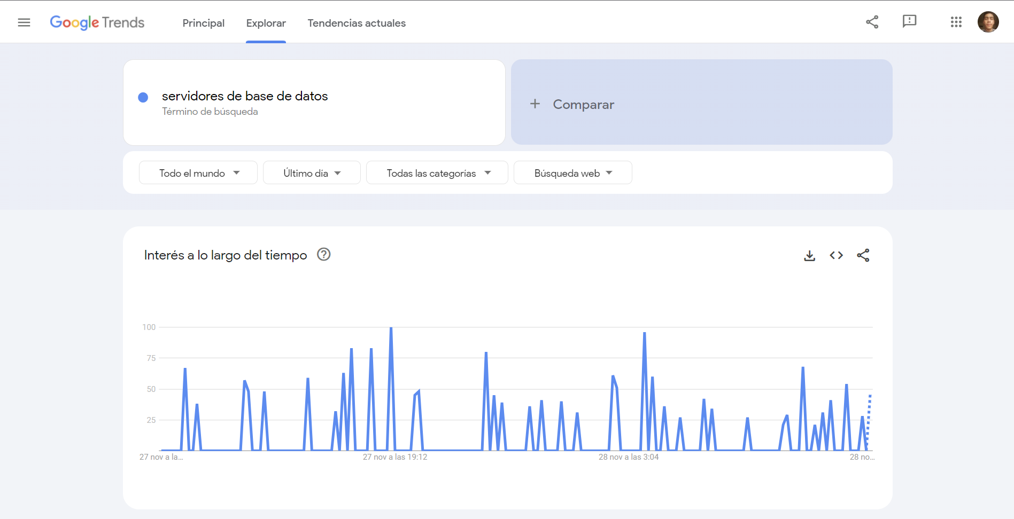

**Nivel local**

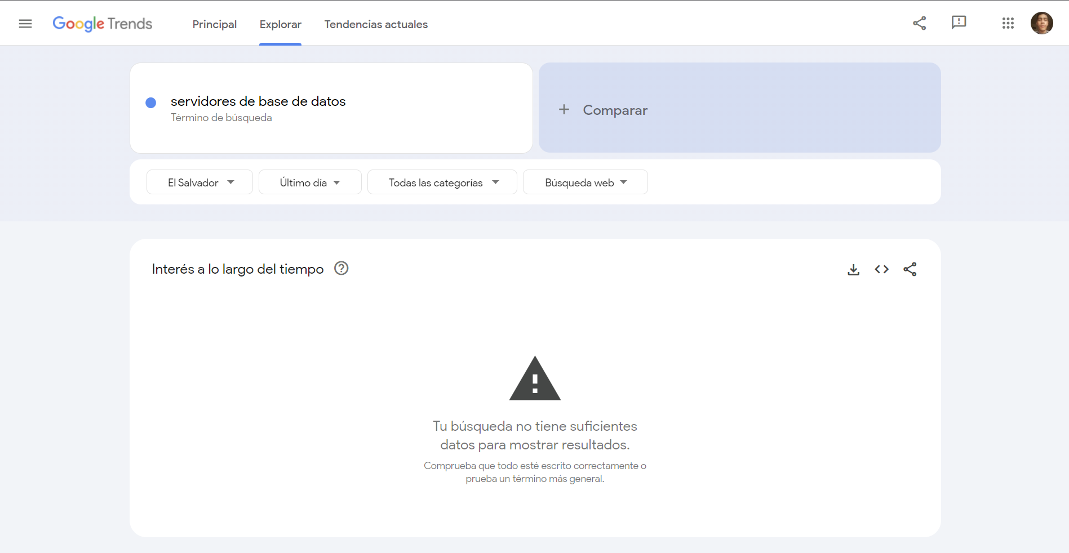

1. **¿Cuánta información actualizada hay sobre el tema?**

adahsdha dah dah dhuiahduia hud hasudhuashduiahdadahsdha dah dah dhuiahduia hud hasudhuashduiahdadahsdha dah dah dhuiahduia hud hasudhuashduiahdadahsdha dah dah dhuiahduia hud hasudhuashduiahdadahsdha dah dah dhuiahduia hud hasudhuashduiahdadahsdha dah dah dhuiahduia hud hasudhuashduiahdadahsdha dah dah dhuiahduia hud hasudhuashduiahdadahsdha dah dah dhuiahduia hud hasudhuashduiahdadahsdha dah dah

1. **¿Qué tan pertinente es el tema geográficamente, que tanto me sirve localmente, ¿hay empresas o instituciones dedicadas al tema?**

adahsdha dah dah dhuiahduia hud hasudhuashduiahdadahsdha dah dah dhuiahduia hud hasudhuashduiahdadahsdha dah dah dhuiahduia hud hasudhuashduiahdadahsdha dah dah dhuiahduia hud hasudhuashduiahdadahsdha dah dah dhuiahduia hud hasudhuashduiahdadahsdha dah dah dhuiahduia hud hasudhuashduiahdadahsdha dah dah dhuiahduia hud hasudhuashduiahdadahsdha dah dah dhuiahduia hud hasudhuashduiahdadahsdha dah dah

1. **¿Cuál es la relevancia a nivel mundial del tema en cuestión? ¿En qué fase se encuentra en términos de pertinencia, se continúa investigando activamente, se encuentra estancado o existen oportunidades para generar nuevo conocimiento?**

adahsdha dah dah dhuiahduia hud hasudhuashduiahdadahsdha dah dah dhuiahduia hud hasudhuashduiahdadahsdha dah dah dhuiahduia hud hasudhuashduiahdadahsdha dah dah dhuiahduia hud hasudhuashduiahdadahsdha dah dah dhuiahduia hud hasudhuashduiahdadahsdha dah dah dhuiahduia hud hasudhuashduiahdadahsdha dah dah dhuiahduia hud hasudhuashduiahdadahsdha dah dah dhuiahduia hud hasudhuashduiahdadahsdha dah dah dhuiahduia hud hasudhuashduiahd

**Tema 2: adahsdha dah dah dhuiahduia hud hasudhuashduiahdadahsdha dah dah dhuiahduia hud hasudhuashduiahdadahsdha**

1. **¿Qué tan pertinente es para la materia**

adahsdha dah dah dhuiahduia hud hasudhuashduiahdadahsdha dah dah dhuiahduia hud hasudhuashduiahdadahsdha dah dah dhuiahduia hud hasudhuashduiahdadahsdha dah dah dhuiahduia hud hasudhuashduiahdadahsdha dah dah dhuiahduia hud hasudhuashduiahdadahsdha dah dah dhuiahduia hud hasudhuashduiahdadahsdha dah dah dhuiahduia hud hasudhuashduiahdadahsdha dah dah dhuiahduia hud hasudhuashduiahdadahsdha dah dah dhuiahduia hud hasudhuashduiahdadahsdha dah dah dhuiahduia hud hasudhuashduiahdadahsdha dah dah dhu

1. **¿Qué tan actualizado está el tema (a nivel global) (Google Trends)**

**Nivel global**



**Nivel local**



1. **¿Cuánta información actualizada hay sobre el tema?**

adahsdha dah dah dhuiahduia hud hasudhuashduiahdadahsdha dah dah dhuiahduia hud hasudhuashduiahdadahsdha dah dah dhuiahduia hud hasudhuashduiahdadahsdha dah dah dhuiahduia hud hasudhuashduiahdadahsdha dah dah dhuiahduia hud hasudhuashduiahdadahsdha dah dah dhuiahduia hud hasudhuashduiahdadahsdha dah dah dhuiahduia hud hasudhuashduiahdadahsdha dah dah dhuiahduia hud hasudhuashduiahdadahsdha dah dah

1. **Qué tan pertinente es el tema geográficamente, que tanto me sirve localmente, ¿hay empresas o instituciones dedicadas al tema?**

adahsdha dah dah dhuiahduia hud hasudhuashduiahdadahsdha dah dah dhuiahduia hud hasudhuashduiahdadahsdha dah dah dhuiahduia hud hasudhuashduiahdadahsdha dah dah dhuiahduia hud hasudhuashduiahdadahsdha dah dah dhuiahduia hud hasudhuashduiahdadahsdha dah dah dhuiahduia hud hasudhuashduiahdadahsdha dah dah dhuiahduia hud hasudhuashduiahdadahsdha dah dah dhuiahduia hud hasudhuashduiahdadahsdha dah dah

1. **¿Cuál es la relevancia a nivel mundial del tema en cuestión? ¿En qué fase se encuentra en términos de pertinencia, se continúa investigando activamente, se encuentra estancado o existen oportunidades para generar nuevo conocimiento?**

adahsdha dah dah dhuiahduia hud hasudhuashduiahdadahsdha dah dah dhuiahduia hud hasudhuashduiahdadahsdha dah dah dhuiahduia hud hasudhuashduiahdadahsdha dah dah dhuiahduia hud hasudhuashduiahdadahsdha dah dah dhuiahduia hud hasudhuashduiahdadahsdha dah dah dhuiahduia hud hasudhuashduiahdadahsdha dah dah dhuiahduia hud hasudhuashduiahdadahsdha dah dah dhuiahduia hud hasudhuashduiahdadahsdha dah dah dhuiahduia hud hasudhuashduiahdadahsdha dah dah dhuiahduia hud hasudhuashduiahdadahsdha dah dah dhu

**Tema 3: adahsdha dah dah dhuiahduia hud hasudhuashduiahdadahsdha dah dah dhuiahduia**

1. **¿Qué tan pertinente es para la materia**

adahsdha dah dah dhuiahduia hud hasudhuashduiahdadahsdha dah dah dhuiahduia hud hasudhuashduiahdadahsdha dah dah dhuiahduia hud hasudhuashduiahdadahsdha dah dah dhuiahduia hud hasudhuashduiahdadahsdha dah dah dhuiahduia hud hasudhuashduiahdadahsdha dah dah dhuiahduia hud hasudhuashduiahdadahsdha dah dah dhuiahduia hud hasudhuashduiahdadahsdha dah dah dhuiahduia hud hasudhuashduiahdadahsdha dah dah dhuiahduia hud hasudhuashduiahdadahsdha dah dah dhuiahduia hud hasudhuashduiahdadahsdha dah dah dhu

1. **¿Qué tan actualizado está el tema (a nivel global) (Google Trends)**

**Nivel global**



**Nivel local**



1. **¿Cuánta información actualizada hay sobre el tema?**

adahsdha dah dah dhuiahduia hud hasudhuashduiahdadahsdha dah dah dhuiahduia hud hasudhuashduiahdadahsdha dah dah dhuiahduia hud hasudhuashduiahdadahsdha dah dah dhuiahduia hud hasudhuashduiahdadahsdha dah dah dhuiahduia hud hasudhuashduiahdadahsdha dah dah dhuiahduia hud hasudhuashduiahdadahsdha dah dah dhuiahduia hud hasudhuashduiahdadahsdha dah dah dhuiahduia hud hasudhuashduiahdadahsdha dah dah

1. **Qué tan pertinente es el tema geográficamente, que tanto me sirve localmente, ¿hay empresas o instituciones dedicadas al tema?**

adahsdha dah dah dhuiahduia hud hasudhuashduiahdadahsdha dah dah dhuiahduia hud hasudhuashduiahdadahsdha dah dah dhuiahduia hud hasudhuashduiahdadahsdha dah dah dhuiahduia hud hasudhuashduiahdadahsdha dah dah dhuiahduia hud hasudhuashduiahdadahsdha dah dah dhuiahduia hud hasudhuashduiahdadahsdha dah dah dhuiahduia hud hasudhuashduiahdadahsdha dah dah dhuiahduia hud hasudhuashduiahdadahsdha dah dah

1. **¿Cuál es la relevancia a nivel mundial del tema en cuestión? ¿En qué fase se encuentra en términos de pertinencia, se continúa investigando activamente, se encuentra estancado o existen oportunidades para generar nuevo conocimiento?**

adahsdha dah dah dhuiahduia hud hasudhuashduiahdadahsdha dah dah dhuiahduia hud hasudhuashduiahdadahsdha dah dah dhuiahduia hud hasudhuashduiahdadahsdha dah dah dhuiahduia hud hasudhuashduiahdadahsdha dah dah dhuiahduia hud hasudhuashduiahdadahsdha dah dah dhuiahduia hud hasudhuashduiahdadahsdha dah dah dhuiahduia hud hasudhuashduiahdadahsdha dah dah dhuiahduia hud hasudhuashduiahdadahsdha dah dah dhuiahduia hud hasudhuashduiahd

**CONCLUSIÓN**

adahsdha dah dah dhuiahduia hud hasudhuashduiahdadahsdha dah dah dhuiahduia hud hasudhuashduiahdadahsdha dah dah dhuiahduia hud hasudhuashduiahdadahsdha dah dah dhuiahduia hud hasudhuashduiahdadahsdha dah dah dhuiahduia hud hasudhuashduiahdadahsdha dah dah dhuiahduia hud hasudhuashduiahdadahsdha dah dah dhuiahduia hud hasudhuashduiahdadahsdha dah dah dhuiahduia hud hasudhuashduiahdadahsdha dah dah dhuiahduia hud hasudhuashduiahdadahsdha dah dah dhuiahduia hud hasudhuashduiahdadahsdha dah dah dhuiahduia hud hasudhuashduiahdadahsdha dah dah dhuiahduia hud hasudhuashduiahdadahsdha dah dah dhuiahduia hud hasudhuashduiahdadahsdha dah dah dhuiahduia hud hasudhuashduiahdadahsdha dah dah dhuiahduia hud hasudhuashduiahdadahsdha dah dah dhuiahduia hud hasudhuashduiahdadahsdha dah dah dhuiahduia hud