Universidad Católica de El Salvador

Facultad de Ingeniería y Arquitectura

**Informe Período I · Investigación de Cátedra**

Docente Investigador

Mario Jaime Martínez Herrera

Asignatura

Administración de Servidores

Temática de investigación

Servidores de Base de Datos

Ciclo I 2024

Estudiantes colaboradores

Sergio Alexander Moran Núñez

Jaime Mario Herrera Martínez

Santa Ana, 12 de febrero de 2024

1. **Método elegido para la orientación del equipo**

dhsfjhdsj fdshfjshdfjhsjkd fjksdhfjkhsjkh fjsh fjhsjdfhjksd fsdhfjkshfjk hsjdfh jshfjksdhfjhsd fhsdfj hsdjkf dhsfjhdsj fdshfjshdfjhsjkd fjksdhfjkhsjkh fjsh fjhsjdfhjksd fsdhfjkshfjk hsjdfh jshfjksdhfjhsd fhsdfj hsdjkf dhsfjhdsj fdshfjshdfjhsjkd fjksdhfjkhsjkh fjsh fjhsjdfhjksd fsdhfjkshfjk hsjdfh jshfjksdhfjhsd fhsdfj hsdjkf dhsfjhdsj fdshfjshdfjhsjkd fjksdhfjkhsjkh fjsh fjhsjdfhjksd fsdhfjkshfjk hsjdfh jshfjksdhfjhsd fhsdfj hsdjkf dhsfjhdsj fdshfjshdfjhsjkd fjksdhfjkhsjkh fjsh fjhsjdfhjksd fsdhfjkshfjk hsjdfh jshfjksdhfjhsd fhsdfj hsdjkf dhsfjhdsj fdshfjshdfjhsjkd fjksdhfjkhsjkh fjsh fjhsjdfhjksd fsdhfjkshfjk hsjdfh jshfjksdhfjhsd fhsdfj hsdjkf dhsfjhdsj fdshfjshdfjhsjkd fjksdhfjkhsjkh fjsh fjhsjdfhjksd fsdhfjkshfjk hsjdfh jshfjksdhfjhsd fhsdfj hsdjkf dhsfjhdsj fdshfjshdfjhsjkd fjksdhfjkh

dhsfjhdsj fdshfjshdfjhsjkd fjksdhfjkhsjkh fjsh fjhsjdfhjksd fsdhfjkshfjk hsjdfh jshfjksdhfjhsd fhsdfj hsdjkf dhsfjhdsj fdshfjshdfjhsjkd fjksdhfjkhsjkh fjsh fjhsjdfhjksd fsdhfjkshfjk hsjdfh jshfjksdhfjhsd fhsdfj hsdjkf dhsfjhdsj fdshfjshdfjhsjkd fjksdhfjkhsjkh fjsh fjhsjdfhjksd fsdhfjkshfjk hsjdfh jshfjksdhfjhsd fhsdfj hsdjkf dhsfjhdsj fdshfjshdfjhsjkd fjksdhfjkhsjkh fjsh fjhsjdfhjksd fsdhfjkshfjk hsjdfh jshfjksdhfjhsd fhsdfj hsdjkf dhsfjhdsj fdshfjshdfjhsjkd fjksdhfjkhsjkh fjsh fjhsjdfhjksd fsdhfjkshfjk hsjdfh jshfjksdhfjhsd fhsdfj hsdjkf dhsfjhdsj fdshfjshdfjhsjkd fjksdhfjkhsjkh fjsh fjhsjdfhjksd fsdhfjkshfjk hsjdfh jshfjksdhfjhsd fhsdfj hsdjkf dhsfjhdsj fdshfjshdfjhsjkd fjksdhfjkhsjkh fjsh fjhsjdfhjksd fsdhfjkshfjk hsjdfh jshfjksdhfjhsd fhsdfj hsdjkf dhsfjhdsj fdshfjshdfjhsjkd fjksdhfjkhdhsfjhdsj fdshfjshdfjhsjkd fjksdhfjkhsjkh fjsh fjhsjdfhjksd fsdhfjkshfjk hsjdfh jshfjksdhfjhsd fhsdfj hsdjkf dhsfjhdsj fdshfjshdfjhsjkd fjksdhfjkhsjkh fjsh fjhsjdfhjksd fsdhfjkshfjk hsjdfh jshfjksdhfjhsd fhsdfj hsdjkf dhsfjhdsj fdshfjshdfjhsjkd fjksdhfjkhsjkh fjsh fjhsjdfhjksd fsdhfjkshfjk hsjdfh jshfjksdhfjhsd fhsdfj hsdjkf dhsfjhdsj fdshfjshdfjhs

1. **Plan de búsqueda de la información**

dhsfjhdsj fdshfjshdfjhsjkd fjksdhfjkhsjkh fjsh fjhsjdfhjksd fsdhfjkshfjk hsjdfh jshfjksdhfjhsd fhsdfj hsdjkf dhsfjhdsj fdshfjshdfjhsjkd fjksdhfjkhsjkh fjsh fjhsjdfhjksd fsdhfjkshfjk hsjdfh jshfjksdhfjhsd fhsdfj hsdjkf dhsfjhdsj fdshfjshdfjhsjkd fjksdhfjkhsjkh fjsh fjhsjdfhjksd fsdhfjkshfjk hsjdfh jshfjksdhfjhsd fhsdfj hsdjkf dhsfjhdsj fdshfjshdfjhsjkd fjksdhfjkhsjkh fjsh fjhsjdfhjksd fsdhfjkshfjk hsjdfh jshfjksdhfjhsd fhsdfj hsdjkf dhsfjhdsj fdshfjshdfjhsjkd fjksdhfjkhsjkh fjsh fjhsjdfhjksd fsdhfjkshfjk hsjdfh jshfjksdhfjhsd fhsdfj hsdjkf dhsfjhdsj fdshfjshdfjhsjkd fjksdhfjkhsjkh fjsh fjhsjdfhjksd fsdhfjkshfjk hsjdfh jshfjksdhfjhsd fhsdfj hsdjkf dhsfjhdsj fdshfjshdfjhsjkd fjksdhfjkhsjkh fjsh

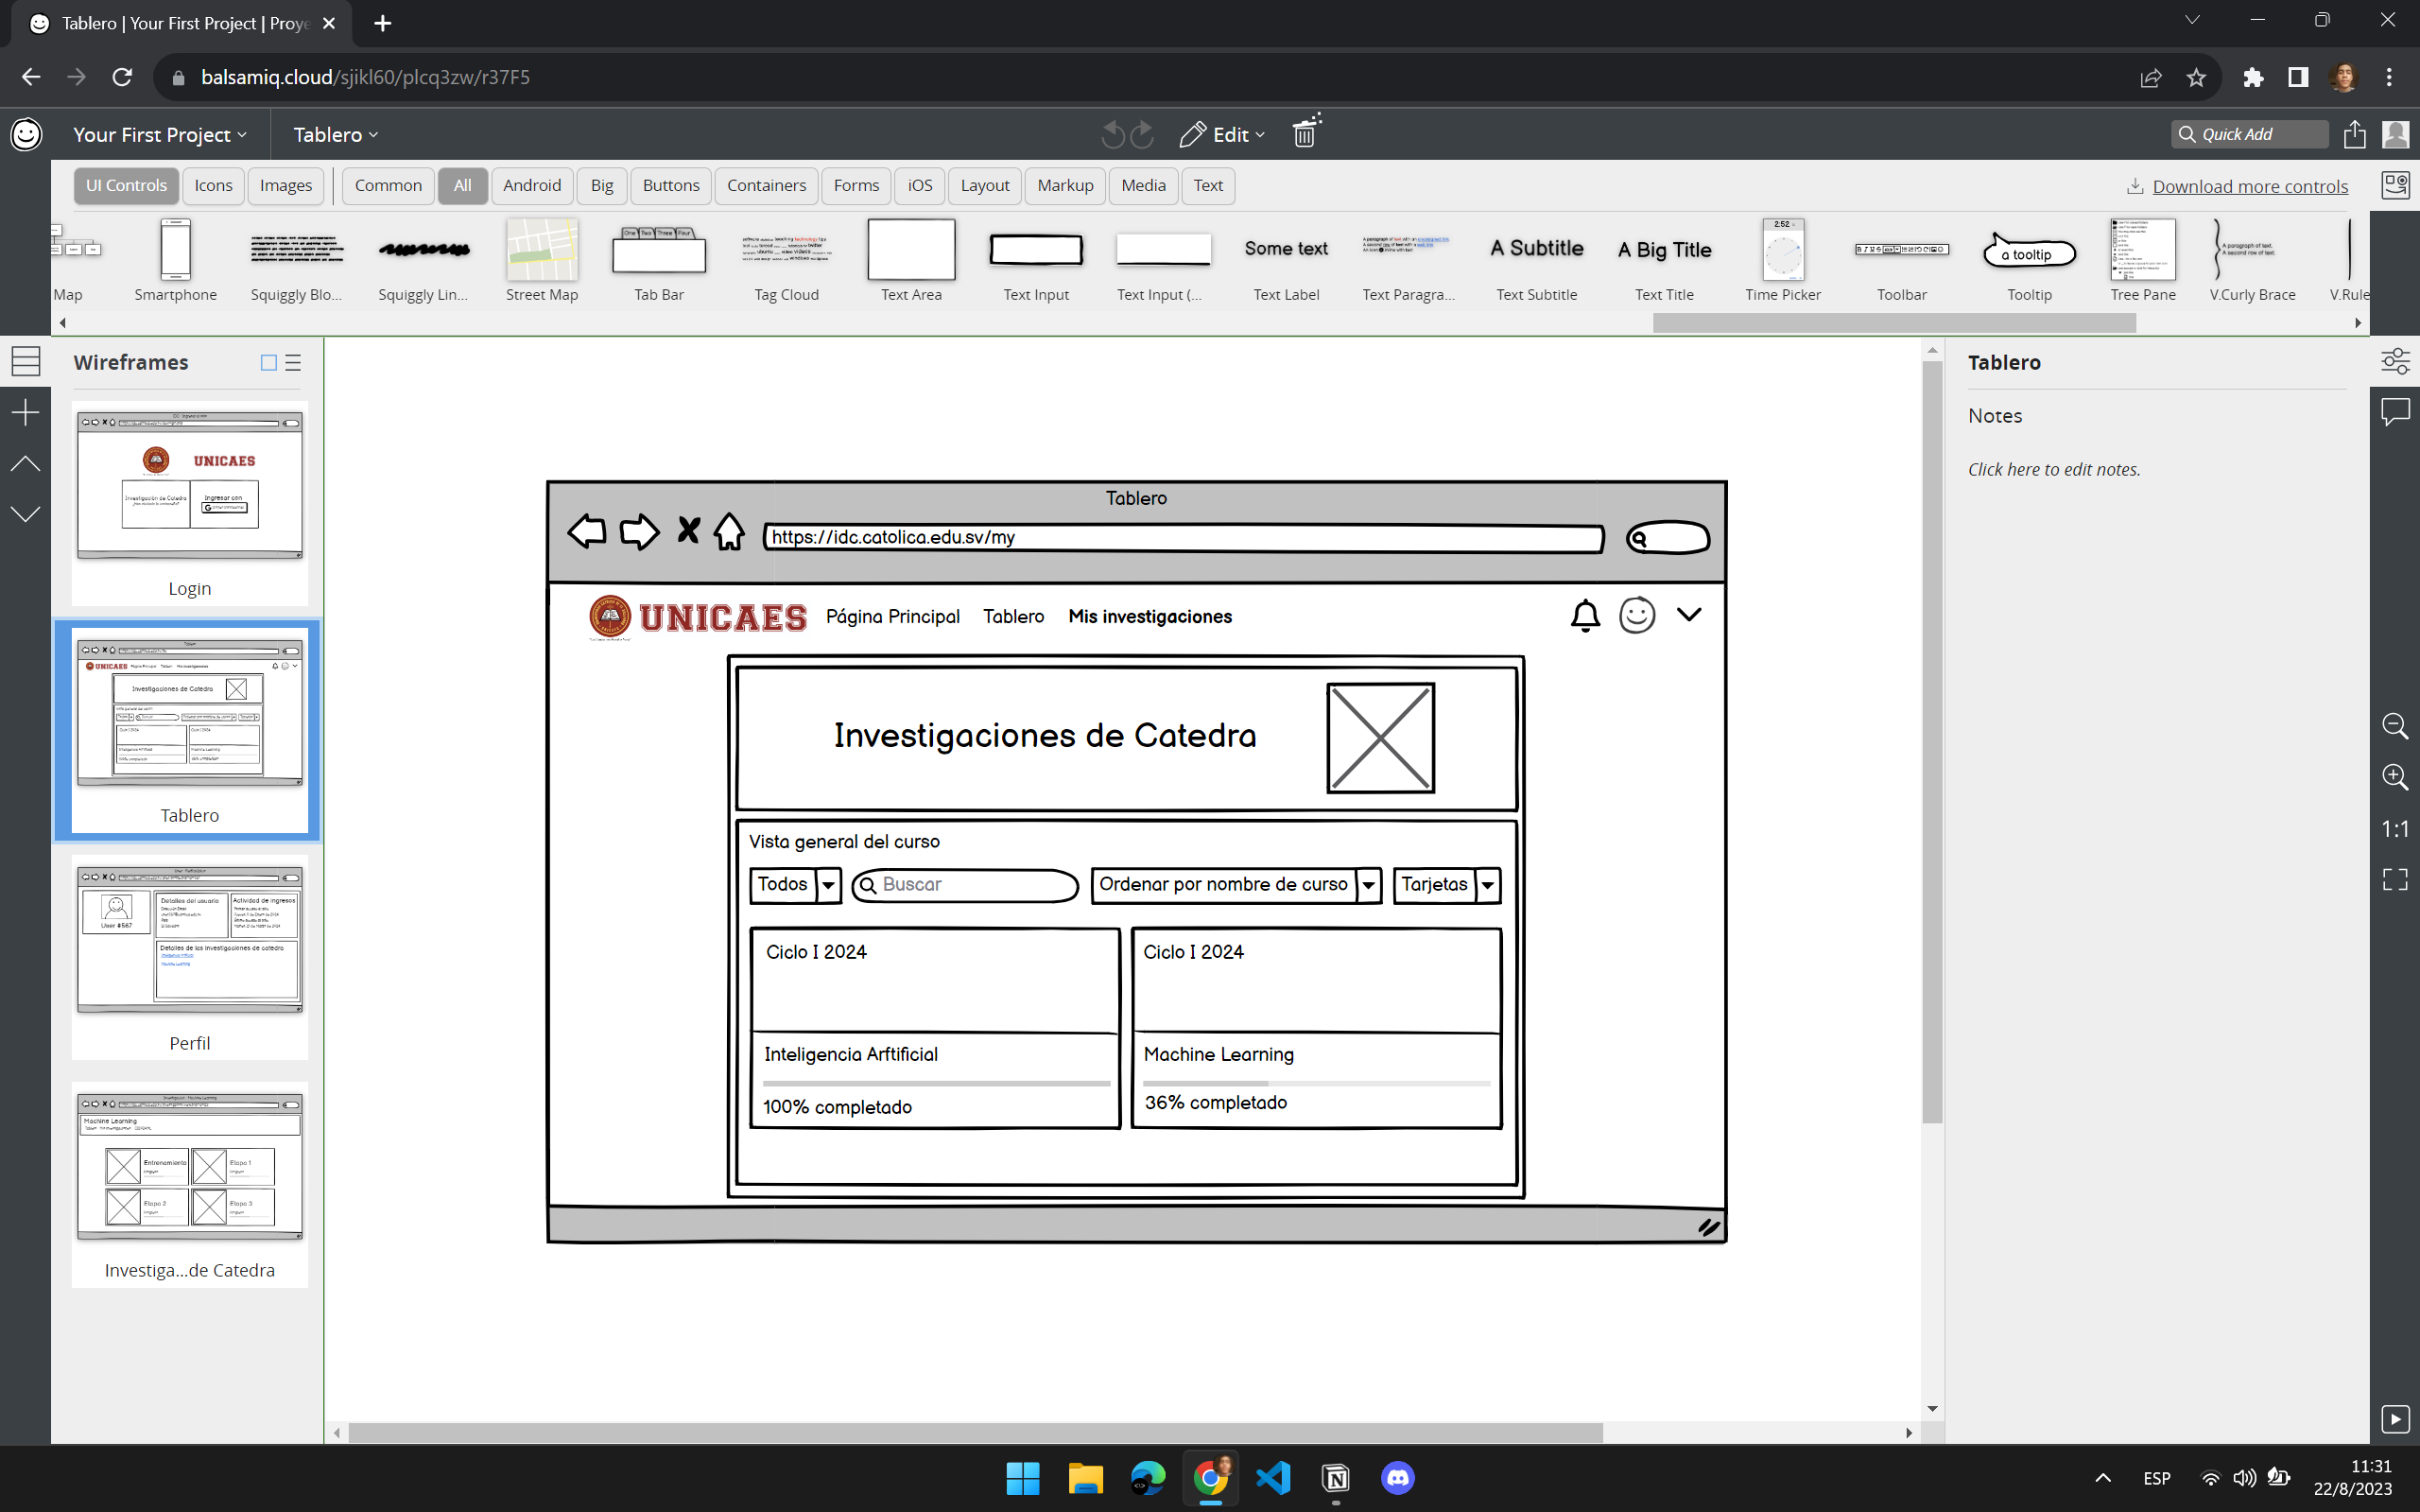

1. **La tabla de volcado del resultado de investigación inicial**

El resultado de la investigación es la siguiente:

|  |  |  |  |  |  |
| --- | --- | --- | --- | --- | --- |
| **FUENTE** | **AUTOR** | **AÑO** | **TIPO DE MEDIO** | **ENLACE** |  |
| YouTube | Martz | 2022 | Sitio web | https:google.com | 1 |
| Biblioteca digital | Jaim | 2021 | Sitio web | https:github.com | 2 |

1. **Resumen de las Reuniones y definición de objetivos**

dhsfjhdsj fdshfjshdfjhsjkd fjksdhfjkhsjkh fjsh fjhsjdfhjksd fsdhfjkshfjk hsjdfh jshfjksdhfjhsd fhsdfj hsdjkf dhsfjhdsj fdshfjshdfjhsjkd fjksdhfjkhsjkh fjsh fjhsjdfhjksd fsdhfjkshfjk hsjdfh jshfjksdhfjhsd fhsdfj hsdjkf dhsfjhdsj fdshfjshdfjhsjkd fjksdhfjkhsjkh fjsh fjhsjdfhjksd fsdhfjkshfjk hsjdfh jshfjksdhfjhsd fhsdfj hsdjkf dhsfjhdsj fdshfjshdfjhsjkd fjksdhfjkhsjkh fjsh fjhsjdfhjksd fsdhfjkshfjk hsjdfh jshfjksdhfjhsd fhsdfj hsdjkf dhsfjhdsj fdshfjshdfjhsjkd fjksdhfjkhsjkh fjsh fjhsjdfhjksd fsdh

**4.1 Objetivo general**

Los servidores de bases de datos son fundamentales a la hora de tener un espacio para guardar los datos de sitios web.

**4.2 Objetivos específicos**

* b
* b
* b

1. **Criterios de selección de Información**

dhsfjhdsj fdshfjshdfjhsjkd fjksdhfjkhsjkh fjsh fjhsjdfhjksd fsdhfjkshfjk hsjdfh jshfjksdhfjhsd fhsdfj hsdjkf dhsfjhdsj fdshfjshdfjhsjkd fjksdhfjkhsjkh fjsh fjhsjdfhjksd fsdhfjkshfjk hsjdfh jshfjksdhfjhsd fhsdfj hsdjkf dhsfjhdsj fdshfjshdfjhsjkd fjksdhfjkhsjkh fjsh fjhsjdfhjksd fsdhfjkshfjk hsjdfh jshfjksdhfjhsd fhsdfj hsdjkf dhsfjhdsj fdshfjshdfjhs

|  |  |  |  |  |  |
| --- | --- | --- | --- | --- | --- |
| **Nº** | **TEMA** | **AÑO** | **TIPO DE MEDIO** | **ENLACE** |  |
|  | Configuración de roles en PostgreSQL | 2022 | Sitio web | https:google.com | 1 |
|  | Configuración de tablas con MongoDB | 2021 | Sitio web | https:github.com | 2 |

1. **Valoración del catedrático sobre el equipo**

dhsfjhdsj fdshfjshdfjhsjkd fjksdhfjkhsjkh fjsh fjhsjdfhjksd fsdhfjkshfjk hsjdfh jshfjksdhfjhsd fhsdfj hsdjkf dhsfjhdsj fdshfjshdfjhsjkd fjksdhfjkhsjkh fjsh fjhsjdfhjksd fsdhfjkshfjk hsjdfh jshfjksdhfjhsd fhsdfj hsdjkf dhsfjhdsj fdshfjshdfjhsjkd fjksdhfjkhsjkh fjsh fjhsjdfhjksd fsdhfjkshfjk hsjdfh jshfjksdhfjhsd fhsdfj hsdjkf dhsfjhdsj fdshfjshdfjhsjkd fjksdhfjkhsjkh fjsh fjhsjdfhjksd fsdhfjkshfjk hsjdfh jshfjksdhfjhsd fhsdfj hsdjkf dhsfjhdsj fdshfjshdfjhsjkd fjksdhfjkhsjkh fjsh fjhsjdfhjksd fsdhfjkshfjk hsjdfh jshfjksdhfjhsd fhsdfj hsdjkf dhsfjhdsj fdshfjshdfjhsjkd fjksdhfjkhsjkh fjsh fjhsjdfhjksd fsdhfjkshfjk hsjdfh jshfjksdhfjhsd fhsdfj hsdjkf dhsfjhdsj fdshfjshdfjhsjkd fjksdhfjkhsjkh fjsh fjhsjdfhjksd fsdhfjkshfjk hsjdfh jshfjksdhfjhsd fhsdfj hsdjkf dhsfjhdsj fdshfjshdfjhsjkd fjksdhfjkh

|  |  |  |  |
| --- | --- | --- | --- |
| **Nombre del estudiante** | | **Jaime Mario Herrera Martínez** | |
| **Asignatura** | | **Administración de Servidores** | |
|  | | | |
| **CRITERIOS DE EVALUACIÓN** | | | **CALIFICACIÓN** |
| 1.Calidad del trabajo | El estudiante ha sido responsable con el proceso. | | 8 |
| Ha participado de las reuniones con puntualidad | | 8 |
| Ha Evidenciado interés por el proceso | | 8 |
| Se ha apropiado de la temática | | 8 |
| Realimenta y exterioriza sus comentarios, dudas y reflexiones personales. | | 8 |
| El estudiante es capaz de autogestionar su conocimiento y el proceso, mejorando su desempeño y capacidad de análisis. | | 8 |
| El estudiante ha desarrollado cada una de las actividades asignadas con diligencia y esmero. | | 8 |
| El estudiante ha elevado su dominio sobre el tema | | 8 |
| El estudiante ha contribuido al resultado esperado en términos de volumen y calidad. | | 8 |

|  |  |  |  |
| --- | --- | --- | --- |
| **Nombre del estudiante** | | **Sergio Alexander Moran Núñez** | |
| **Asignatura** | | **Administración de Servidores** | |
|  | | | |
| **CRITERIOS DE EVALUACIÓN** | | | **CALIFICACIÓN** |
| 1.Calidad del trabajo | El estudiante ha sido responsable con el proceso. | | 9 |
| Ha participado de las reuniones con puntualidad | | 9 |
| Ha Evidenciado interés por el proceso | | 9 |
| Se ha apropiado de la temática | | 9 |
| Realimenta y exterioriza sus comentarios, dudas y reflexiones personales. | | 9 |
| El estudiante es capaz de autogestionar su conocimiento y el proceso, mejorando su desempeño y capacidad de análisis. | | 9 |
| El estudiante ha desarrollado cada una de las actividades asignadas con diligencia y esmero. | | 9 |
| El estudiante ha elevado su dominio sobre el tema | | 9 |
| El estudiante ha contribuido al resultado esperado en términos de volumen y calidad. | | 9 |

1. **Comentario final**

dhsfjhdsj fdshfjshdfjhsjkd fjksdhfjkhsjkh fjsh fjhsjdfhjksd fsdhfjkshfjk hsjdfh jshfjksdhfjhsd fhsdfj hsdjkf dhsfjhdsj fdshfjshdfjhsjkd fjksdhfjkhsjkh fjsh fjhsjdfhjksd fsdhfjkshfjk hsjdfh jshfjksdhfjhsd fhsdfj hsdjkf dhsfjhdsj fdshfjshdfjhsjkd fjksdhfjkhsjkh fjsh fjhsjdfhjksd fsdhfjkshfjk hsjdfh jshfjksdhfjhsd fhsdfj hsdjkf dhsfjhdsj fdshfjshdfjhsjkd fjksdhfjkhsjkh fjsh fjhsjdfhjksd fsdhfjkshfjk hsjdfh jshfjksdhfjhsd fhsdfj hsdjkf dhsfjhdsj fdshfjshdfjhsjkd fjksdhfjkhsjkh fjsh fjhsjdfhjksd fsdhfjkshfjk hsjdfh jshfjksdhfjhsd fhsdfj hsdjkf dhsfjhdsj fdshfjshdfjhsjkd fjksdhfjkhsjkh fjsh fjhsjdfhjksd fsdhfjkshfjk hsjdfh jshfjksdhfjhsd fhsdfj hsdjkf dhsfjhdsj fdshfjshdfjhsjkd fjksdhfjkhsjkh fjsh fjhsjdfhjksd fsdhfjkshfjk hsjdfh jshfjksdhfjhsd fhsdfj hsdjkf dhsfjhdsj fdshfjshdfjhsjkd fjksdhfjkh dhsfjhdsj fdshfjshdfjhsjkd fjksdhfjkhsjkh fjsh fjhsjdfhjksd fsdhfjkshfjk hsjdfh jshfjksdhfjhsd fhsdfj hsdjkf dhsfjhdsj fdshfjshdfjhsjkd fjksdhfjkhsjkh fjsh fjhsjdfhjksd fsdhfjkshfjk hsjdfh jshfjksdhf