ADAPTING AND PARALLIZING ALPHA ZERO FOR SETTLERS OF CATAN

Brennen Ho, Jason Wiemels, Jeremy Sedillo, Jaime Martin

EE 451: Parallel and Distributed Computing

April 28, 2026

INTRODUCTION & MOTIVATION

Computer scientists have long been interested in building systems to play board games. Released in 2017, AlphaZero is an artificial intelligence system built by DeepMind that successfully mastered games like Go and Chess ("AlphaZero and MuZero"). The techniques developed in AlphaZero generalize well to more complex games, including Settlers of Catan. This popular 2-4 player strategy game has significantly greater complexity, making it a prime target for testing the generalization of AlphaZero and Monte Carlo methodologies to more complex tasks. The added intricacies also make this task ideal for evaluating the effectiveness of parallelization towards AlphaZero and Monte Carlo.
This project aims to evaluate AlphaZero's effectiveness under the more complex conditions of the four-player, non-deterministic game Settlers of Catan. AlphaZero has previously performed well in two-player, deterministic games like chess. We hope to generalize the algorithm to broader applications under more challenging conditions.
CONTEXT

Settlers of Catan is a 2 to 4-player turn-based game. It simulates the colonization of an island, and players gather resources to expand their settlements and cities. As they expand their land, players gather more and more resources from a randomized game board. Each player takes a turn, split into three phases: collect resources, trade, and build. Each phase presents players with multiple decisions, leading to many possible actions.

The game board is composed of hexagonal tiles, with each tile representing a resource type. The positions of tiles on the game board are randomly determined, and each tile is assigned a random number. Numbers range from 2 - 11, representing all possible sums for two dice. Each player takes turns rolling the dice, and any tiles with the rolled number provide resources to players with adjacent properties.

On their turn, players can trade with each other or a global bank. For simplicity, we eliminated player-to-player trading and focused on bank trading only. Players can trade four cards of the same resource to receive one of any other resource.

Players can purchase once per turn and choose to buy a property on the board or a development card. Development cards give players a variety of special actions that can be played at any time. Properties and some development cards give players victory points. The first player to get 10 victory points wins.

The large variety of potential moves for each player at each turn makes this a complex game to master and creates a large simulation space, necessitating parallelism.

RELATED WORK

This project sits at the intersection of two strands of prior research: (i) the AlphaZero paradigm and its extensions beyond two-player perfect-information games, (ii) multiplayer Monte Carlo Tree Search (MCTS) and prior attempts to build competitive Catan agents specifically.

AlphaZero Paradigm and Extensions
AlphaZero combines MCTS with a policy-value network trained with self-play. The algorithm has previously proven its effectiveness at games like Chess, Shogi, and Go, surpassing the highest levels of human performance. However, its efficacy hinges on games being two-player, zero-sum, deterministic, and perfectly observable. A sequence of further work has relaxed each of these assumptions.
Petosa and Balch (2019): This study directly addresses AlphaZero’s assumptions on a two-player game. It modifies AlphaZero in three ways: MCTS rotates through all players rather than alternating between two, the value head outputs a vector of estimated returns per player rather than a single scalar, and terminal outcomes are also encoded as score vectors. Petosa and Balch evaluated their approach on a couple of three-player games and found that their agents outperformed a plain MCTS baseline, assuming the same number of rollouts. In fact, their AlphaZero variant defeated human opponents in a variant of Tic-Tac-Toe. The study explicitly acknowledges its computational limitations due to its single-threaded implementation and identifies games with additional players, larger boards, and richer action spaces as potential future work.
Becker and Sunberg (2025): This work extends AlphaZero to effectively handle two-player zero-sum Markov games with simultaneous moves. Each decision node is treated as a matrix game whose entries combine the immediate reward with a bootstrap value estimate. The search uses a regret-matching solver with feedback to approximate the Nash strategy at each node. The network has two policy heads (one per player) and a value head. Evaluation is performed on a continuous-state pursuit-evasion and a satellite maintenance scenario. This research lays a key foundation for our work, showing that matrix-game machinery can be composed with AlphaZero-style search when the turn structure breaks down.
Weil et al. (2023): This work focuses on reducing multiplayer games to a single- or two-player problem within the bounds of an AlphaZero-like framework. The authors propose Single-Player MCTS, which treats all opponents as part of the environment and advances them with fixed opponent models. They also offer Two-Player MCTS, which fully expands the actions of a selected opponent while leaving the rest to the opponent model. Evaluated using a four-player game, both proposed variants achieve proficiency against heuristic opponents. However, the paper identifies a recurring failure mode in which reinforcement learning over self-play samples produces agents that play passively. This highlights the difficulty of shaping behavior under terminal rewards in a four-player setting.

Multiplayer MCTS and Prior Catan Agents
The most direct precedent for our work is Gendre and Kaneko (2020), who train an Advantage Actor-Critic agent on a two-player, no-trading variant of Catan via self-play. To our knowledge, this work is the first reinforcement-learning agent to outperform the existing heuristic-based Settlers of Catan agents.
Two aspects of this study are especially relevant to our project. First, Gendre and Kaneko argue that MCTS is not directly applicable to Settlers of Catan because it is an imperfect-information, stochastic game. Therefore, they rely on policy-gradient methods rather than an AlphaZero-style search. Second, the study utilizes 16 parallel workers, each playing eight games concurrently. This parallelism pattern is similar to our approach. Gendre and Kaneko explicitly flag four-player games as open problems.
Collectively, these works demonstrate AlphaZero's flexibility. At the same time, they highlight the specific algorithmic choices required for additional players, simultaneous moves, and reduced search structure. These choices have not been proven end-to-end on a game with complexity comparable to Settlers of Catan. To achieve this, we apply AlphaZero-style MCTS directly to four-player Settlers of Catan and build on the multiplayer vector-value formulation proposed in Petosa and Balch (2019). Our contribution is not in designing a novel algorithm, but in empirically evaluating whether the AlphaZero paradigm, with multiplayer adjustments, can work in more adversarial environments.
TECHNICAL APPROACH

The challenge with this project is not only to do parallelization but also to properly simulate the game mechanics and represent the game state. The Neural net takes a tensor as input, but the game state is more complex. It consists of a board where every vertex can be empty, contain a settlement, or a city; every side of every hexagon can be a road or not; and which player possesses those buildings. The game state also includes where the robber is located, what resources or development cards each player has, and how many seats away they are (when it is their turn), in addition to multiple other lines of input.

This broad game state, along with the multiple phases in each turn and the number of decisions the player can make, creates an enormous number of possibilities.

To accomplish this challenge, we are modifying AlphaZero (Silver et al. 2017) to support 4 players (since it is usually for 2) and to incorporate randomness. Usually, in board games, every move is deterministic; it either moves closer to or farther from the goal. In our game, there is a significant random component with the board setup and dice rolls, which complicates parallelization. With randomness, the outcome of the move is not deterministic. The player could’ve made the best move, but still had a bad outcome, and those moves or decisions shouldn’t be penalized. The model sees many different random boards, dice rolls, development card draws, and stealing outcomes. If a move is actually strong, it leads to better average results over many games, even if it sometimes loses because of luck.

Monte Carlo simulation tree search is an essential part of our approach (Swaminathan, 2021). Monte Carlo Tree Search (MCTS) is a decision-making algorithm used in games and planning problems where the space of possible moves is too large to search exhaustively. It became famous as a key ingredient in AlphaGo, but it's used in everything from chess engines to robotics planning.
The core idea is to build a search tree by running many random simulations and using the results to determine which moves are worth exploring further. Instead of evaluating every possible position (which is impossible in games like Go), MCTS focuses its computation on the most promising branches.
Catan has an enormous number of possibilities and decisions. For each decision, the algorithm runs multiple search simulations starting at the current game state. Each simulation runs the tree, follows the engine's Catan rules, and uses the neural network to estimate the value of the resulting position for each player.

PARALLELIZATION DESIGN

For Monte Carlo to be effective, we need to simulate millions of games and millions of moves per game. To efficiently do this, we exploit both CPU and GPU parallelism. CPUs handle tracking each game’s state, and traversing and backpropagating the Monte Carlo tree. We defer the forward pass, which must be calculated for every move simulated, to the GPU. Because this forward pass must run millions of times per iteration, it is the most computationally expensive step. Backpropagating the neural net, the actual learning step, only takes place hundreds of times per iteration and is not a major contributor to runtime. We will detail multiple approaches below, all with the common goal of scaling up CPU work to increase GPU throughput. The primary mechanism for achieving this is virtual loss, which allows us to prepare many leaves of the Monte Carlo tree for evaluation on the GPU at once. The sims_per_eval parameter below specifies how many leaves to prepare on the CPU before deferring to the GPU. The details of how we organize and arrange computation differ across the implementations below.

IMPLEMENTATION

All implementations share a common workspace layout.
Workspace layout: 3 crates
- sim/ Catan rules engine.
- az/ Generic AlphaZero training loop, MCTS, and the parallel self-play pipeline.
- catan/ Catan-specific binaries: the Game trait implementation for Catan, the Catan-shaped network, training entrypoint, and our arena for evaluation.
GPU: Burn 0.20 deep-learning framework with multiple backends compiled in:
- Metal on macOS
- Cuda when GPU available
- Ndarray used as a baseline

Key Files
- az/src/lib.rs — train_loop, TrainConfig, the per-iteration pipeline (CPU select / GPU submit / CPU expand), evaluator sharding, replay buffer, training step, checkpointing hooks. The Game, AZNet, and SelfPlayStepInfo traits/structs live here.
- az/src/mcts.rs — Tree and Node, PUCT selection, virtual loss, expand, backprop, root Dirichlet noise.
- az/src/net.rs — generic flat-MLP ResNet (kept as the default).
- src/catan_net.rs — Catan-specific encoder. Splits the 626-d observation into 7 modality slices (tiles / vertices / edges / harbors / self_player / others / meta), encodes each through its own linear+ReLU branch, concatenates, then runs 4 residual blocks of width trunk_hidden = 384 before the policy and value heads.
- src/main.rs — CatanGame impl of Game, the production TrainConfig, the CLI args (--checkpoint-dir, --load), wandb logging, and the inline on_self_play_step closure that emits the diagnostic per-step log lines (action-bucket EMAs, VP spread, etc.).
- src/bin/arena.rs — evaluation harness for playing checkpoints against each other.
Configuration
- games_per_iteration: 256
  - Number of simultaneous games per iteration.
- max_simulations: 576
  - Number of potential moves to explore before choosing one.
- sims_per_eval: 48 ⇒ 12 MCTS rounds per ply
  - Number of potential moves to batch before deferring to GPU.
- batch_size: 256
  - Number of past moves to sample per training step.
- training_steps_per_iteration: 256
- NUM_EVALUATORS: 2
  - Number of dedicated GPU threads, for overlapping CPU and GPU work.
- CatanNet: branch_dim=64, trunk_hidden=384, num_blocks=4
- Optimizer: Adam, lr=2e-4
- Replay buffer: 2 Mi samples
- Root Dirichlet: epsilon=0.25, alpha=0.3
  - Noise is to add extra exploration during Monte Carlo tree search
EXPERIMENTAL SETUP
Machine: 60-core AMD Ryzen 7000 generation CPU; dedicated H100 GPU with CUDA 13.1
Operating system: Ubuntu Server Version 26.0
Software:
- Rust 2024 edition, cargo release builds for all timings.
- mimalloc global memory allocator.
- rayon thread pool, default size = number of logical cores.
- Burn deep learning library version 0.20 with fusion and autotune features enabled.
Workloads / "Datasets"
There is no external dataset. AlphaZero is self-supervised through self-play. The "datasets" used for evaluation are the synthetic game environments:
- Settlers of Catan. 4-player Catan with the standard board, dice, harbor, robber, longest-road, largest-army, and dev-card rules. 626-dimensional observation, 254-way action space.
We compare four discrete versions of the parallel pipeline. Each one is the immediate predecessor of the next. Please note that only the final two implementations saw real prolonged training runs. The first two implementations were ruled out as inferior via runtime profiling.
V1: All games in lock-step with Monte Carlo tree operations and game simulation handled via scatter-join method across a thread-pool. Two dispatches, one for MCT select, one for MCT expand. Notably, during join, a large buffer needs to be briefly allocated to store observation states of all moves of all games. Millions of observations meant this buffer was substantial, multiple hundreds of megabytes.
V2 fused: Fuse expands and selects into a single dispatch per round. Purpose was to test whether reducing dispatch count alone helps (it does not). We still need the contiguous buffer for observations.
V3 persistent + reordered (firm-durian-43): One persistent OS thread per game for the duration of the iteration. This thread owns all game and tree states. They communicate with dedicated gpu threads via a channel. The dedicated GPU thread batches a defined number of observations before executing a large forward pass and then fanning out resultant actions to game threads. We leave all responsibility of interleaving the game threads to the operating system by elegantly blocking and unblocking game threads in sync with GPU threads via channels. In this run we truncate all games to 2500 plies, discarding any stragglers that run longer. As these stragglers result in smaller GPU batches, this run achieves peak throughput. We run this implementation across a range of parameters, this will be detailed below.
V4 GPU thread (bright-wind-48): The same as the previous implementation, but without the game truncation. As a result we capture approximately the last 4% of stragglers that were previously discarded, thus increasing the number of samples per game. We hypothesized that this would improve per-iteration training performance, but this was not the case.
The following is a flamegraph captured from V1 and V2 above.
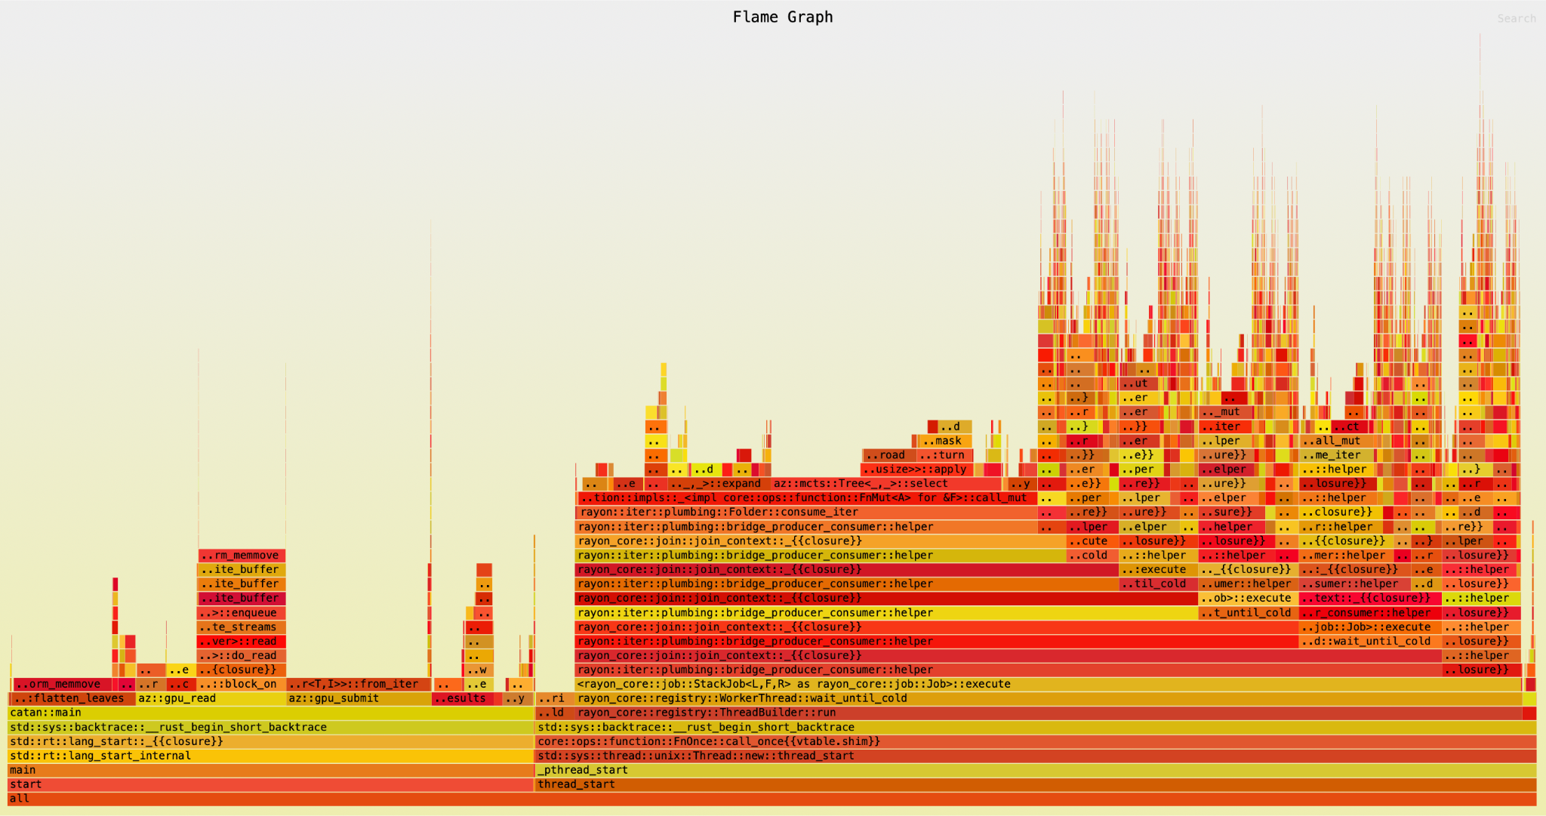
Figure 1: V1 scatter-join flamegraph
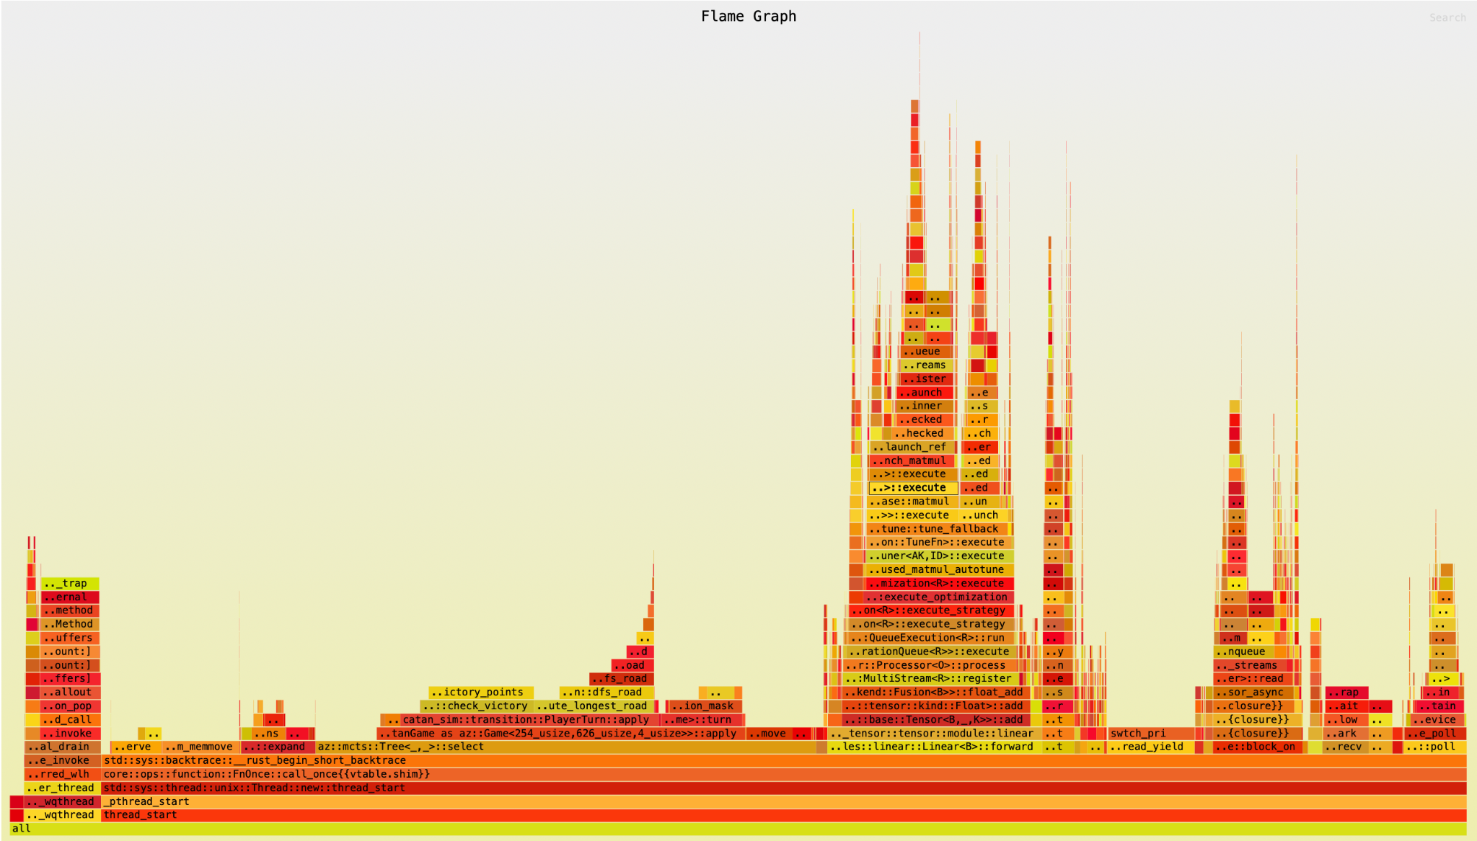
Figure 2: V2 thread-per-game flamegraph
Note the presence of longer, more numerous platform_memmove sections in the first, indicating allocator overhead when creating the aforementioned large buffers during game observation joins. Also significant ‘plumbing’ overhead that represents the work-stealing thread-pool model we used for our scatter-join execution model.
For V3 above, we additionally measure the impact of:
- NUM_EVALUATORS ∈ {1, 2} (GPU evaluator sharding).
- sims_per_eval ∈ {48, 96} (GPU batch size knob).
- games_per_iteration ∈ {256, 512} (simultaneous games)
RESULTS
We evaluate the four versions defined in the Experimental Setup along three axes: end-to-end iteration time, GPU utilization (leaf evaluations per second, average submitted batch size, and total dispatch count), and learning behavior (policy and total loss). Learning curves are reported to confirm that the parallelization changes preserve algorithmic correctness.
Fallen-glitter-25: 512 games_per_iteration, 96 sims_per_eval, 1 executors
Dauntless-sky-26: 256 games_per_iteration, 96 sims_per_eval, 2 executors
Winter-shape-27: 256 games_per_iteration, 48 sims_per_eval, 2 executors
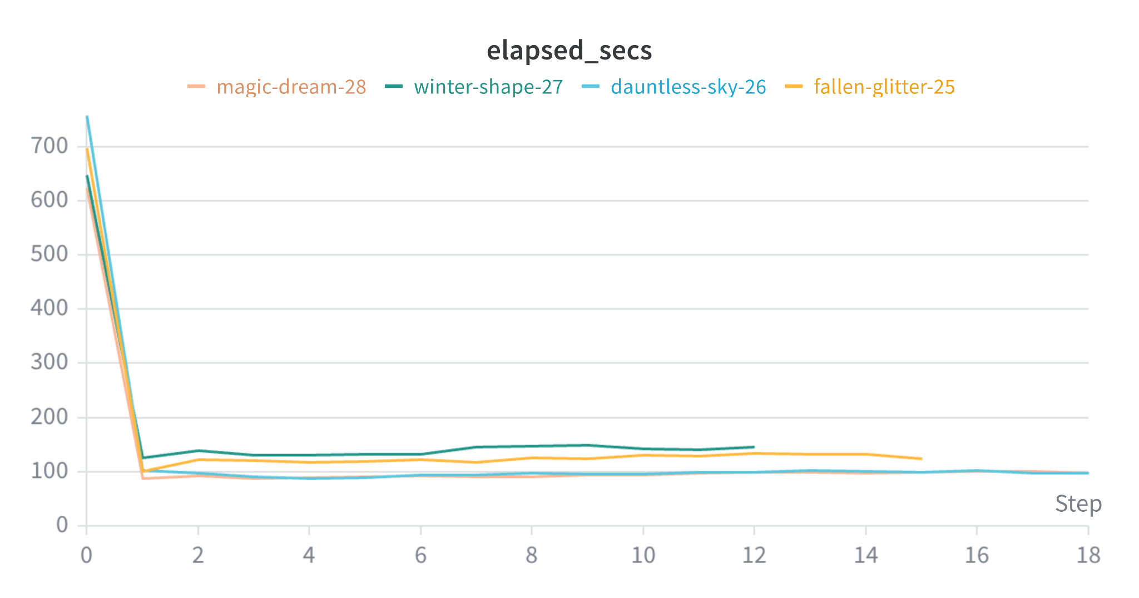
Magic-dream-28: 256 games_per_iteration, 48 sims_per_eval, 1 executor
Figure 3: Execution time per iteration
The first iteration of each run is dominated by the initial fill of the replay buffer (600-750 s) and is excluded from the steady-state comparison.
From iteration 1 onward, winter-shape-27 holds steady at approximately 145s per iteration, fallen-glitter-25 at approximately 125 s, magic-dream-28 at approximately 95 s, and dauntless-sky-26 also at approximately 95 s. The endpoint of dauntless-sky-26 versus winter-shape-27 is a 1.53x wall-clock speedup per training iteration on the same hardware and network.
Note that these runs are performing different amounts of work per iteration. Normalized throughput graphs follow below.
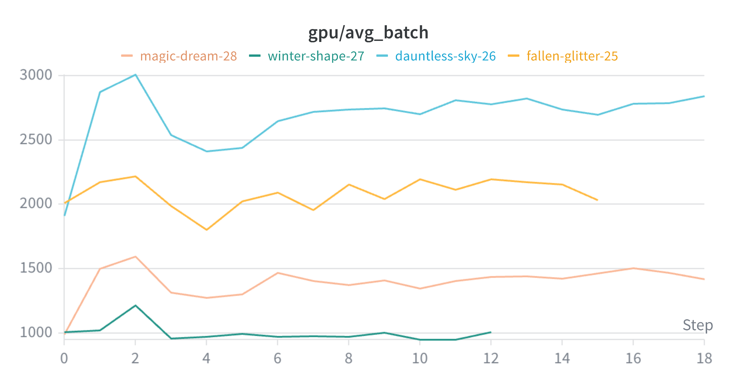
Figure 4: Batch Size
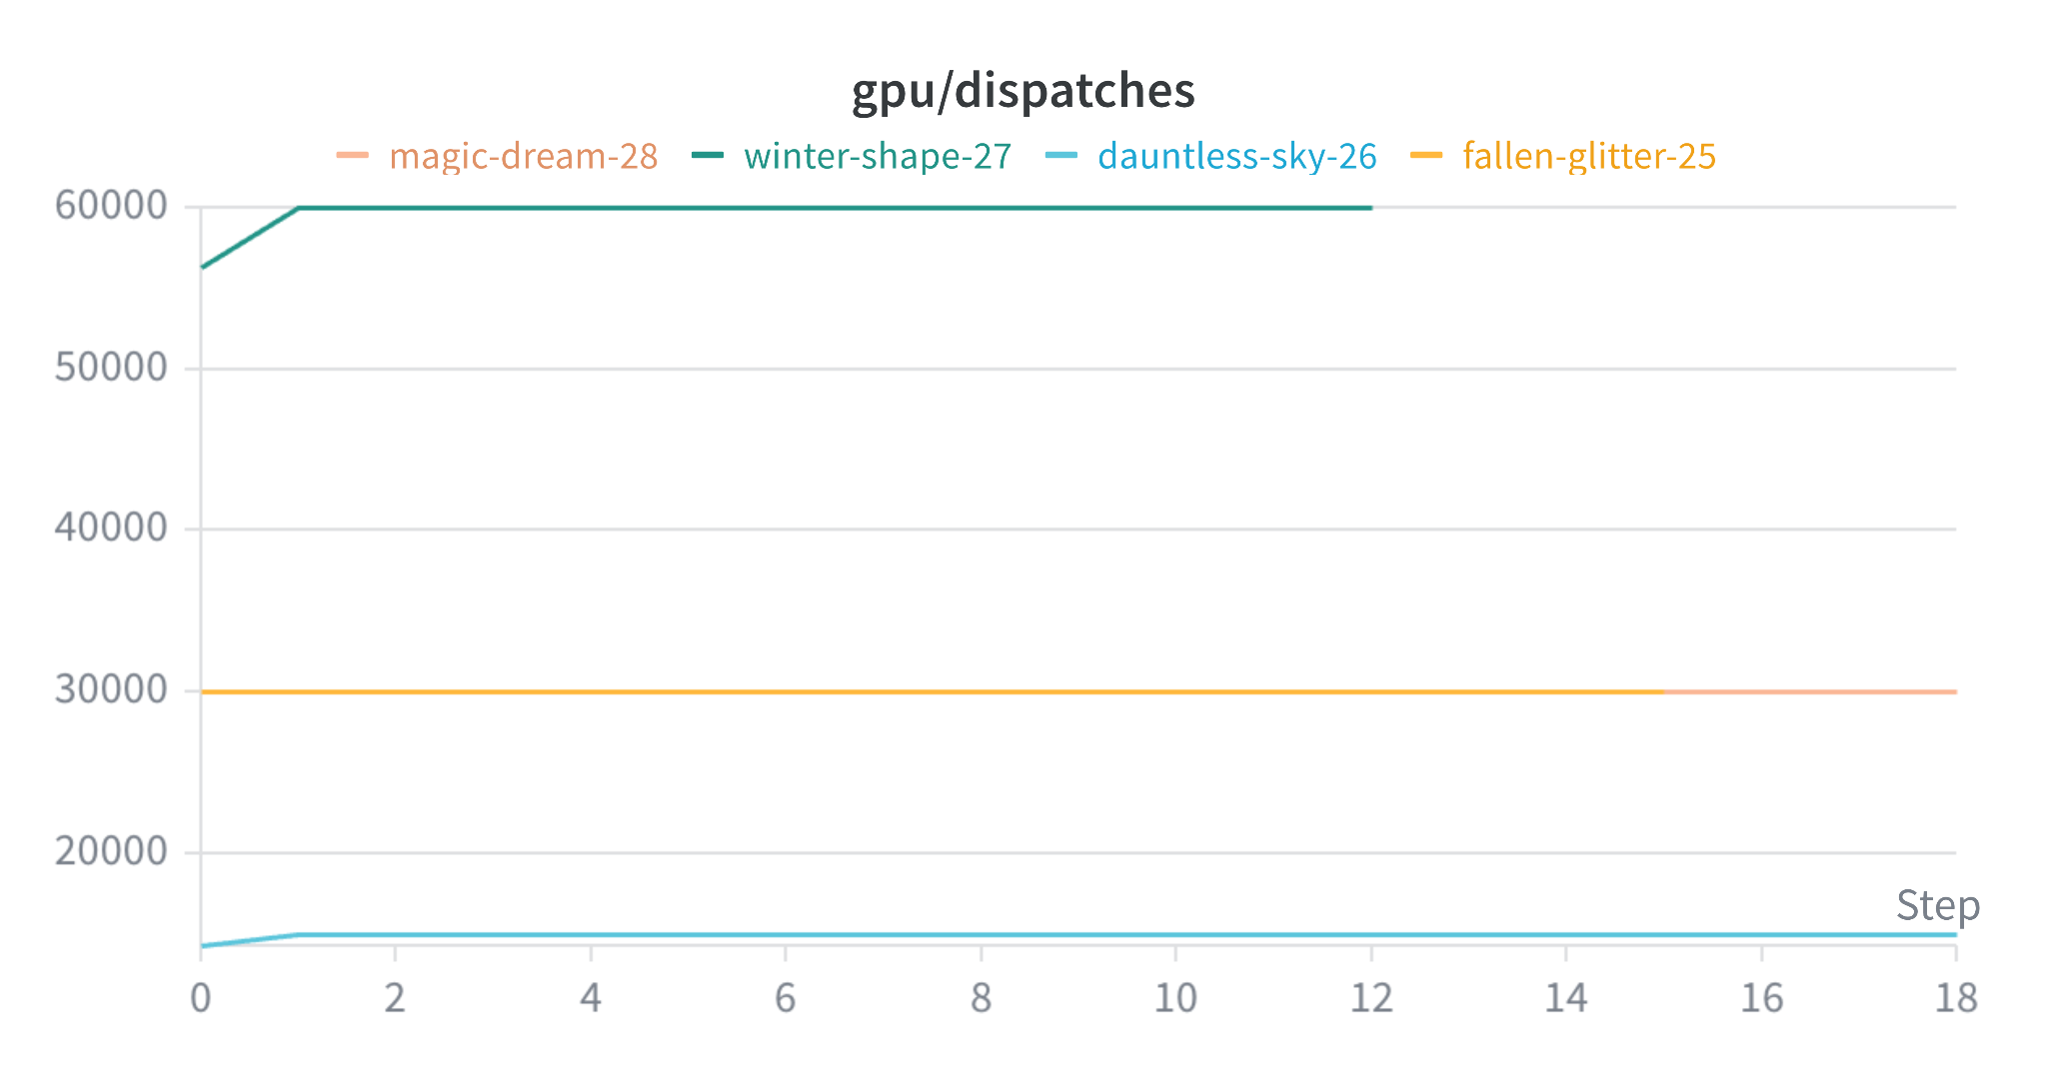
Figure 5: Dispatch Count

Here we show the true differences between these runs, being the frequency and size of GPU dispatches per iteration.

Batch size is proportional to:
games_per_iteration * max_simulations (fixed) / sims_per_eval / NUM_EVALUATORS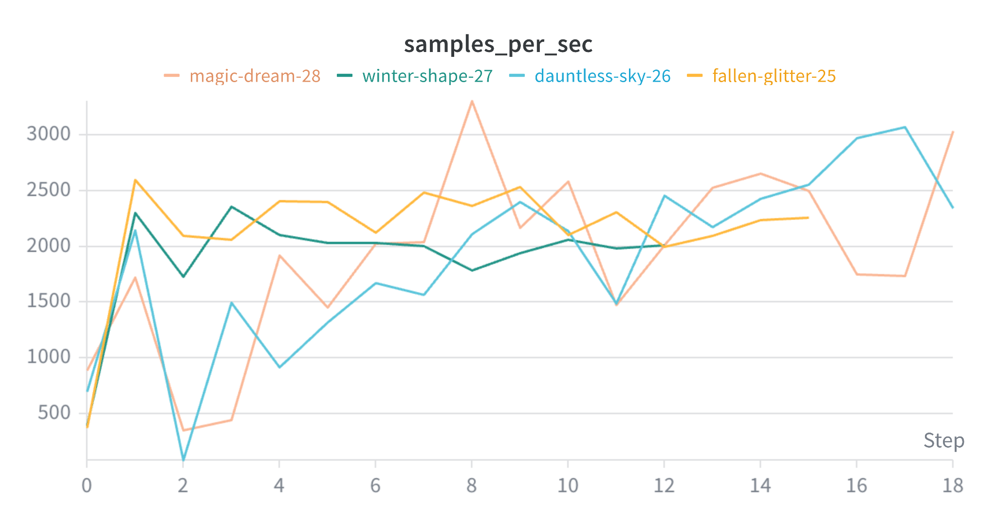
Figure 6: Sample Throughput
Most interestingly, during this testing period, we notice that overall throughput is not strongly dependent on batch size or frequency, suggesting our workload is GPU-bound. GPU execution shadows kernel launch and H2D transfer overhead. Seeing this, we decide to move forward with a configuration identical to winter-shape-25. As with more frequent GPU dispatches, the effects of virtual loss are diminished, and sample quality in later training is improved.
Next, we run full training runs, exploring and comparing leaving the straggler games in rather than truncating them. This reflects V3 and V4 above.
Firm-durian-43: Game truncated to 2500 plies
Bright-wind-48: Game not truncated

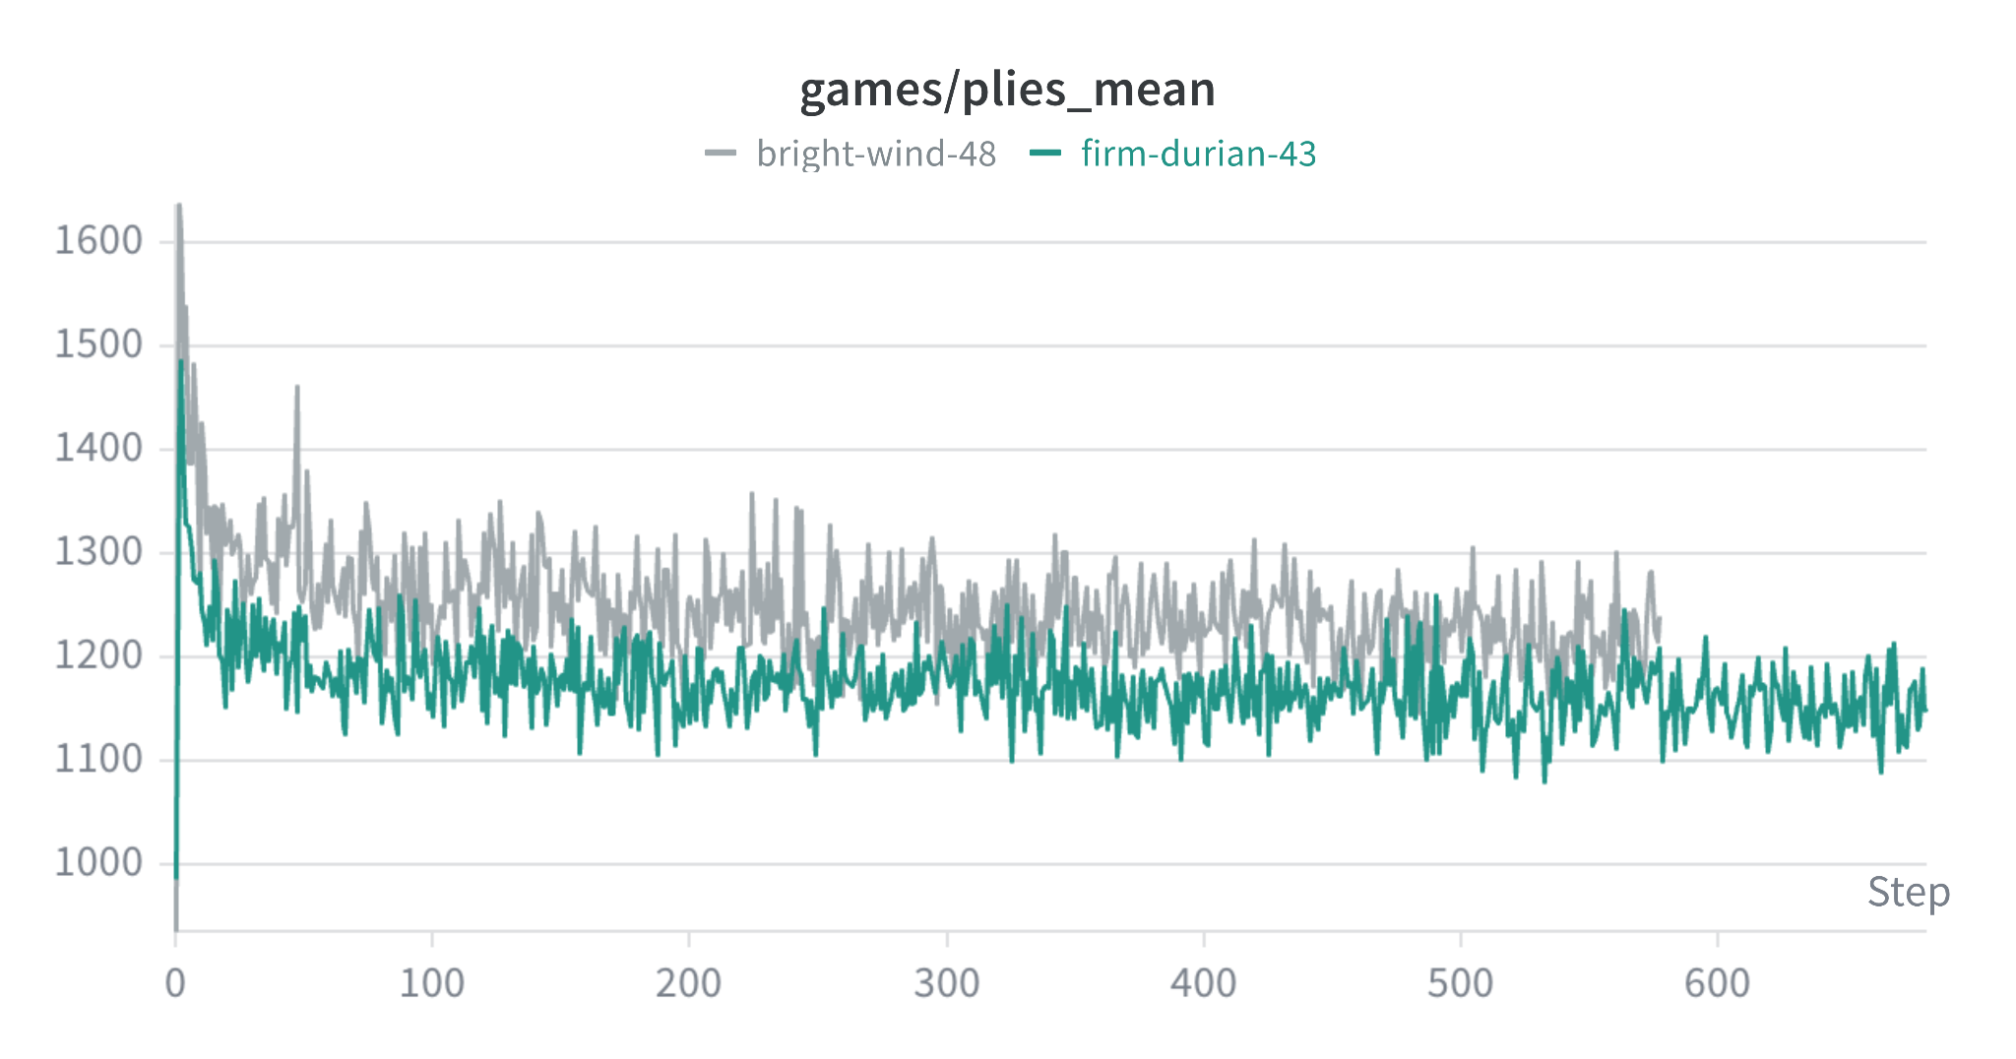
Figure 7: Average game length

Here, we show that the stragglers, representing only about 4% of games, pull the average game length up. Because the distribution of game length is largely right-skewed, the stragglers we leave in V4 represent a significant throughput degradation.

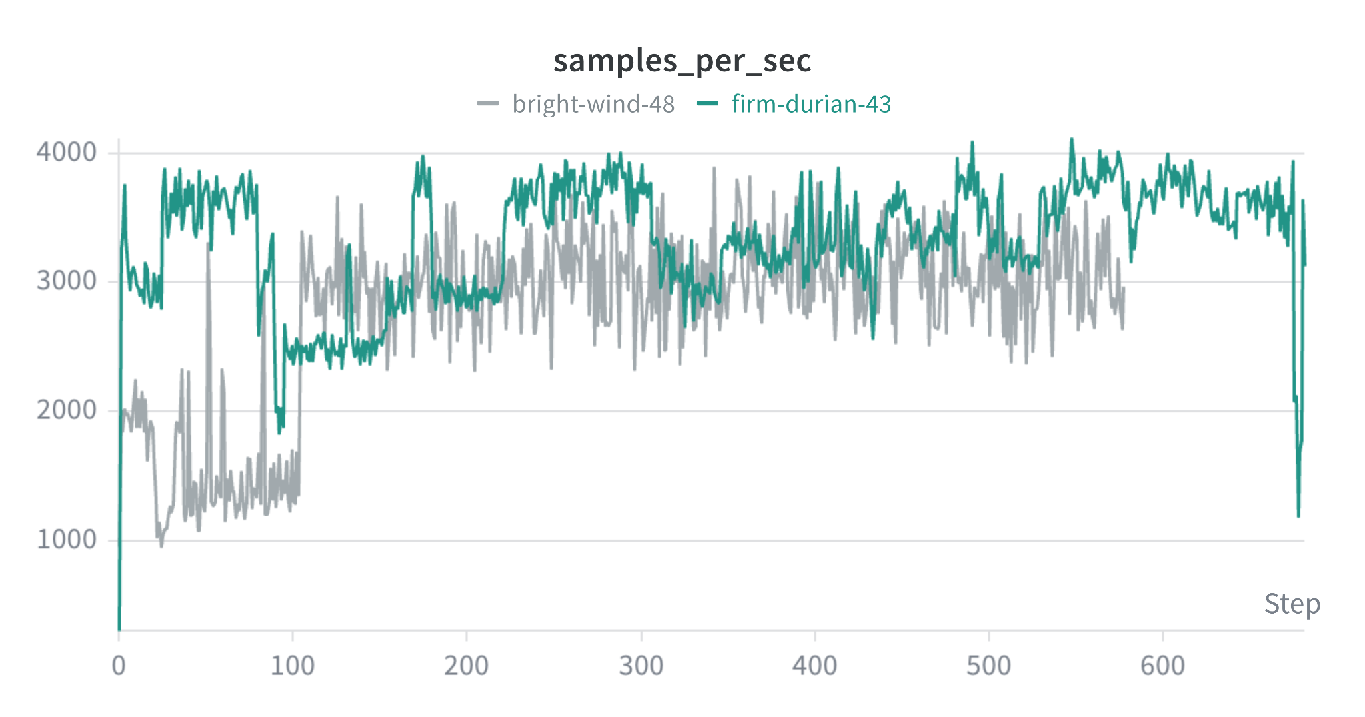
Figure 8: Sample throughput with and without truncation
Sample throughput is severely reduced when we are forced to issue very small GPU batches to handle stragglers.
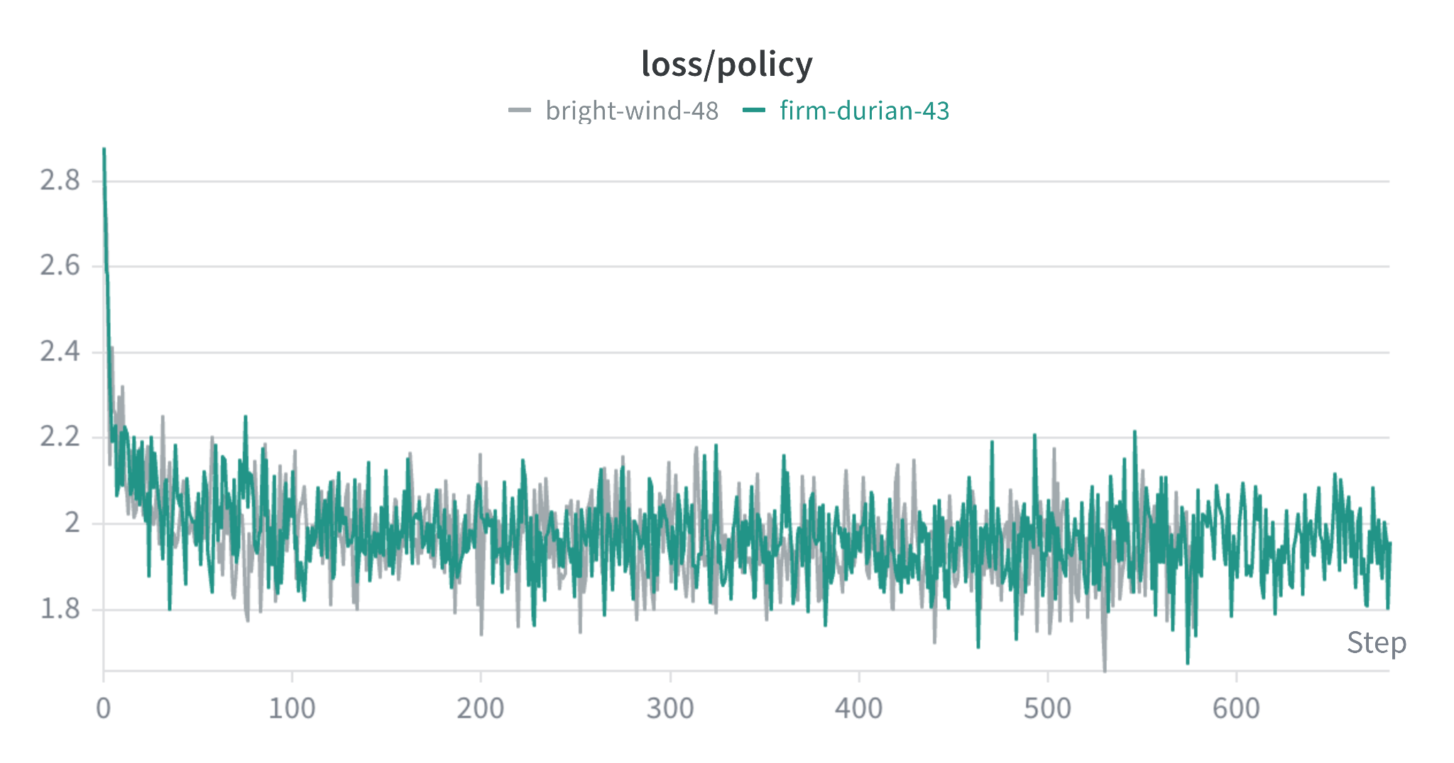
Figure 9: V4 rollout policy loss

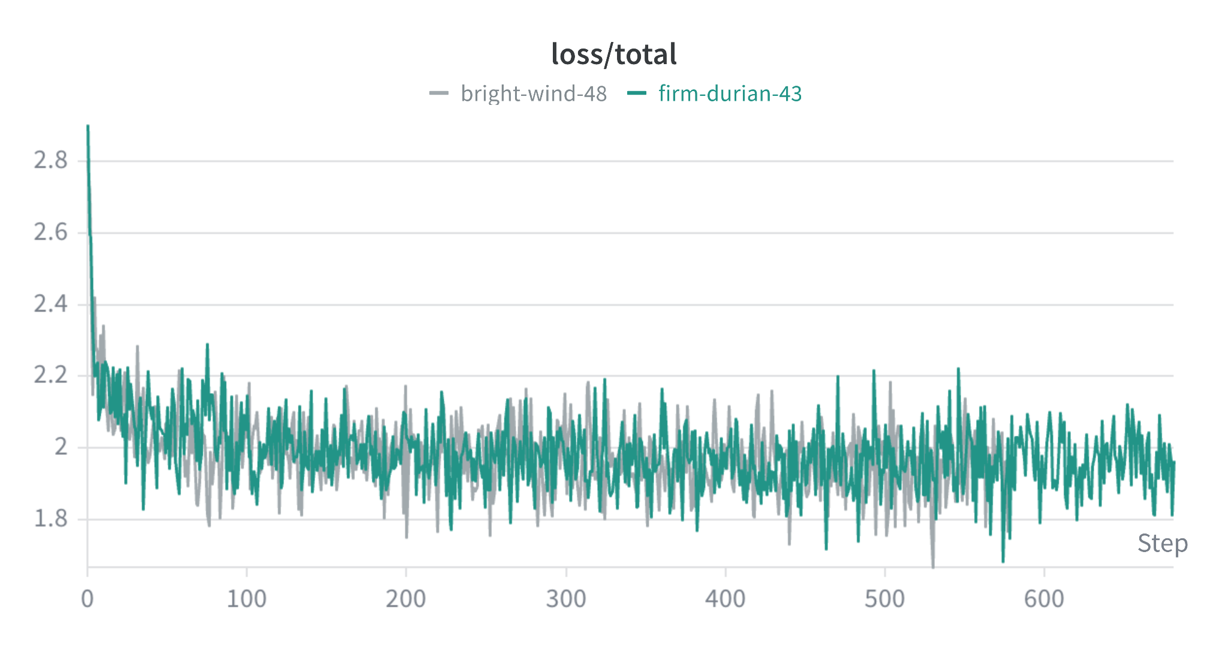
Figure 10: V4 rollout total loss

Figures show that V3 and V4 produce essentially indistinguishable training curves. Both begin near 2.85 at iteration 0 and decay to approximately 1.90 by iteration 600, with overlapping noise envelopes throughout. This demonstrates that the final 4% of samples that are discarded in firm-durian-43 do not have a substantial impact on training quality. This was confirmed in our arena evaluations, which showed neural net checkpoints from bright-wind-48 did not beat similar checkpoints from firm-durian-43.

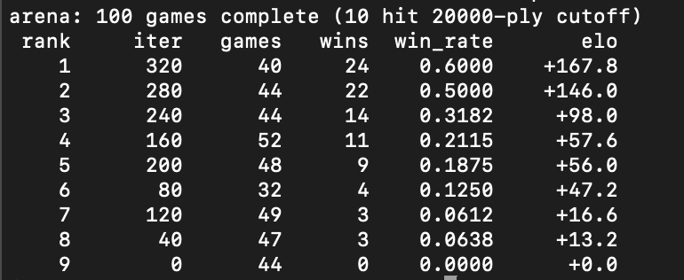
Figure 11: Arena results
Here, we show an obvious improvement in our neural network's Catan-playing performance as training progresses. Elo is calculated by the Plackett-Luce method for multiplayer games, after each arena game.

ANALYSIS
The baseline does two scatter-join dispatches per MCTS round (select, then expand) and synchronizes the whole CPU thread pool on into_data() between them. When we profiled V1, the workers spent most of each round blocked on a small inference call, and the GPU was idle for most of that time. V2 combined the two dispatches into a single dispatch, reducing about half the synchronization barriers, but the resulting speedup was only about 14% (145 s to 125 s). This bounds how much of the baseline's lost time was attributable solely to dispatch overhead. The remainder was time spent waiting on the GPU itself.
The evaluator-shard sweep produced a non-monotonic relationship between shard count and wall-clock time. With one evaluator, iterations were completed in approximately 95 s, while with two evaluators took 125 s. This reflects the standard Amdahl trade-off. With one evaluator, the GPU is well-utilized, but the channel becomes a serial queue where every CPU worker requesting an inference must wait for its turn. With 2 evaluators, the CPU side parallelizes effectively, but the GPU now receives independent streams of small batches and incurs a launch cost per batch, reproducing the dispatch-overhead bottleneck observed in V1. Two evaluators are the optimum on this hardware. On a discrete GPU like the H100, the optimum should shift toward more evaluators because the GPU ceases to be the limiting factor.
Memory versus compute
At the V4 sample rate of approximately 285,000 samples per iteration, this corresponds to roughly seven iterations of the working set. The training step itself (512 batches of 256 samples per iteration, per TrainConfig in main.rs) is GPU-bound on this hardware but accounts for only 12% to 18% of wall-clock time. The system therefore operates in self-play-throughput rather than a training-throughput regime, which is why all of the optimization effort was directed at the MCTS and inference loop rather than the optimizer step.
Configurations that did not scale
Two parameters that we expected to provide additional speedup did not. First, increasing sims_per_eval beyond 48 ceased to increase average batch size, because at that point the rate-limiter became the number of independent in-flight leaves the MCTS tree has available at once, governed by max_simulations and the number of concurrent games per shard, rather than by the GPU's batch capacity. Second, raising games_per_iteration from 96 to 256 produced only a 1.4x improvement in sample rate, rather than the 2.6x the ratio would suggest, because beyond a certain concurrency level, CPU contention on the Rayon pool begins to dominate, and the channel to the evaluator becomes a hot lock.
CONCLUSION
This work evaluated whether the AlphaZero paradigm generalizes to four-player, stochastic, partial-information games like Settlers of Catan. Additionally, it identifies whether the resulting pipeline can be parallelized to run usefully on commodity hardware. Building on the work of Petosa and Balch (2019), we use a multiplayer vector-value formulation that integrates cleanly with a Burn-based AlphaZero loop running multiplayer PUCT search with virtual loss and root Dirichlet exploration. Policy and total loss decrease monotonically over 600+ iterations, and the resulting agent produces materially different and more strategic play compared to a heuristic baseline.
The initial pipeline left over a third of its wall-clock time unused due to thread idleness. This issue was fixed by introducing a persistent evaluator thread. End-to-end, this resulted in a 1.53x speedup per training iteration when evaluated on a dedicated H100. GPU Batches were roughly 47% larger, and dispatches were 50% fewer, while the same total search work and matching loss trajectories were maintained.
This work was limited by both hardware and design. For the hardware, we expect the relative balance of bottlenecks to shift on a discrete GPU like the H100. In terms of the design, V4’s larger concurrent-select width drives a small early-training game-length regression in which roughly 4% of games hit the 2,500-ply ceiling rather than terminating naturally with a winner. This effect diminishes as the policy sharpens, but suggests that the virtual-loss constant and the per-game play cap should be tuned together while training rather than held fixed. Beyond performance, the agent is trained exclusively against three copies of itself rather than against a diverse opponent pool. This setup is known to produce passive play in multi-agent settings (Weil et al., 2023) and is the most natural quality issue to address next.
Further investigation is needed in three categories: scaling, algorithm, and agent quality. To scale this work, we hope to run the same pipeline on a multi-GPU node to identify if the persistent-evaluator design extends naturally to one evaluator thread per GPU with NCCL-style all-reduce on the training step. To expand on our algorithmic work, handling imperfect-information games like Settlers of Catan properly requires determined MCTS with belief sampling or a shift towards information-set MCTS. Neither of these approaches has been explored previously. Finally, introducing an opponent pool with checkpointed past versions, comparable to AlphaStar’s league play, would improve agent quality. This change is most likely to produce non-passive four-player play and should be prioritized over further parallelization efforts.
The AlphaZero template is more flexible than the original works have suggested. However, its parallelization is not a solved problem. Its bottleneck shifts as each variant addresses the previous one, moving from dispatch overhead to GPU idleness to channel contention to game-length tails.

Works Cited
“AlphaZero and MuZero.” Google DeepMind, 2025, deepmind.google/research/alphazero-and-muzero/.
Gendre, Quentin. Playing Catan with Cross-Dimensional Neural Network.
Petosa, Nick, and Tucker Balch. Multiplayer AlphaZero.
Silver, David, et al. “Mastering Chess and Shogi by Self-Play with a General Reinforcement Learning Algorithm.” ArXiv.org, 5 Dec. 2017, arxiv.org/abs/1712.01815.
“Simultaneous AlphaZero: Extending Tree Search to Markov Games.” Arxiv.org, 2020, arxiv.org/html/2512.12486. Accessed 29 Apr. 2026.
Swaminathan, Parasuraman. “Monte Carlo Simulations as a Route to Compute Probabilities.” ArXiv.org, 2021, arxiv.org/abs/2108.00851.
Weil, Jannis, et al. Know Your Enemy: Investigating Monte-Carlo Tree Search with Opponent Models in Pommerman.

