BKM: Creating manifests for a new Yocto image

Steps:
- Put the two base binaries (e.g. bootx64.efi and bzImage) into the Intput folder
- Create new hash values for signing the manifests
There are two config files in which the value of the <byte_array> tag needs to be updated with corresponding hash values in little endian format:
- CoSigningManifest_OS_Yocto_override.xml for bootx64.efi
- CoSigningManifest_NL_Yocto_override.xml for bzImage or shimx64.efi
To get a file’s hash value, open powershell (Win+R and type powershell) and use Get-FileHash tool. Just make sure, that the workding directory in the prompt is C:\Windows\system32 folder.
Hint: You can get the base binaries path by holding Shift while right-clicking on it
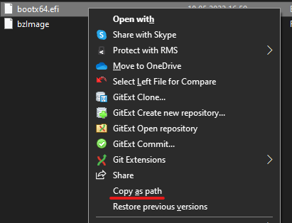
PS C:\WINDOWS\system32> Get-FileHash <<path to ibst_batch_file_keys_overrides>>\Input\bootx64.efi
Algorithm Hash Path
--------- ---- ----
SHA256 5681B1D34896AA55128DE190D48389F6D129CB40A61042A2678623CF11FDBFAB C:\Work\ManifestOsPackages\ib...
Taking the hash value 5681B1D34896AA55128DE190D48389F6D129CB40A61042A2678623CF11FDBFAB – it needs to be converted to a sort-of-little-endian format.
It can be done using this online converter:
Paste the hash into the input field and click AnalyzeData
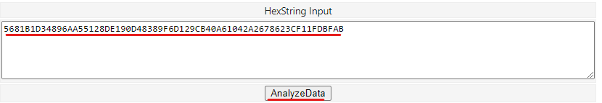
The copy the UINT32 values into a text editor
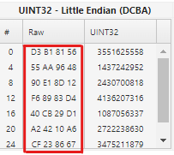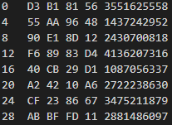
Remove the unnecessary values from # and UINT32 column and spaces…
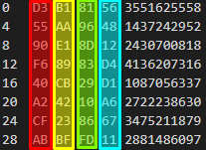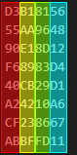
…and newlines.
D3B1815655AA964890E18D12F68983D440CB29D1A24210A6CF238667ABBFFD11
Repeat this process for the other base binary.
- Update configuration files in the Overrides folder
There are two configuration files, that need to be updated:
CoSigningManifest_OS_Yocto_override.xml – using the hash generated from bootx64.efi
CoSigningManifest_NL_Yocto_override.xml – using the hash generated from bzimage or shimx64.efi
Update the value attribute in the byte_array node
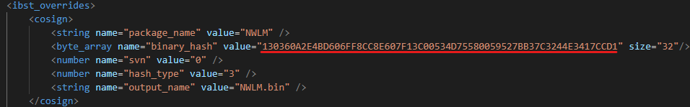
- Run ibst_sign_all_internal.bat
The output should look like this:
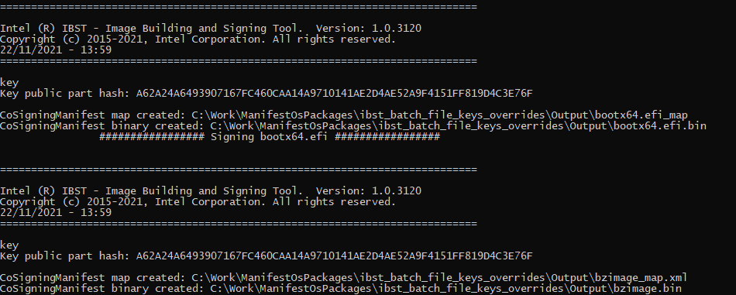
A couple of files will get generated in the Output folder
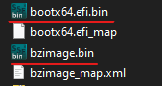
The underlined files are the manifests.

If something goes wrong, it’s worth checking the paths inside the script (although it should work from anywhere). If not, replace every <<path to \ibst_batch_file_keys_overrides>> in ibst_sign_all_internal_template.bat with the non-relative path to the folder with the script and retry.

