Report of training

# Introduction

Report of search and training made on March 24, 2021 at 05:34:34

## Training data

There are 306 training samples. The distribution of the labels is the following:

* Class 1: 81 instances.
* Class 0: 225 instances.

## Optimizing procedure

The parameters for the bayesian search are:

* Nested Cross Validation using 10 outer folds and 10 inner folds.
* Some of the folds will be skipped. In particular, [] outer folds and [] inner folds will be skipped.
* For each outer fold search, a model will be fitted. In order to search for the best hyperparameters, 10 initial points will be evaluated, and 10 additional calls will be made.
* Models will be calibrated using their inner validation set.
* The optimizing metric for the bayesian search is average_precision.
* The function used for the bayesian search is gp_minimize.
* Additionally, 20 instances will be left out for assessing the variance of all models.

The search spaces for the optimization is the following:

* Search space for xgboost model.
* model: XGBClassifier(base_score=None, booster=None, colsample_bylevel=None,  
   colsample_bynode=None, colsample_bytree=None, gamma=None,  
   gpu_id=None, importance_type='gain', interaction_constraints=None,  
   learning_rate=None, max_delta_step=None, max_depth=None,  
   min_child_weight=None, missing=nan, monotone_constraints=None,  
   n_estimators=100, n_jobs=None, num_parallel_tree=None,  
   random_state=None, reg_alpha=None, reg_lambda=None,  
   scale_pos_weight=None, subsample=None, tree_method=None,  
   validate_parameters=None, verbosity=None)
* pipeline_post_process: Pipeline(steps=[('post_process',  
   <nestedcvtraining.utils.pipes_and_transformers.OptionedPostProcessTransformer object at 0x000001D301E0F6A0>),  
   ('resample', SMOTE())])
* Search space:
* undersampling_majority_class: Categorical(categories=(True, False), prior=None)
* max_k_undersampling: Integer(low=2, high=3, prior='uniform', transform='identity')
* resample__sampling_strategy: Categorical(categories=('minority', 'all'), prior=None)
* post_process__option: Categorical(categories=('option_1', 'option_2', 'option_3'), prior=None)
* model__max_depth: Integer(low=2, high=8, prior='uniform', transform='identity')
* model__learning_rate: Real(low=0.05, high=0.31, prior='log-uniform', transform='identity')
* model__min_child_weight: Integer(low=1, high=10, prior='uniform', transform='identity')
* model__subsample: Real(low=0.8, high=1, prior='log-uniform', transform='identity')
* model__colsample_bytree: Real(low=0.13, high=0.8, prior='log-uniform', transform='identity')
* model__scale_pos_weight: Real(low=0.1, high=10, prior='log-uniform', transform='identity')
* model__objective: Categorical(categories=('binary:logistic',), prior=None)

# Report of validation of the model in the outer Cross Validation

## Winner models of each fold and main metrics

|  |  |  |  |  |  |  |  |
| --- | --- | --- | --- | --- | --- | --- | --- |
| **Fold** | **Model** | **Params** | **Comments** | **roc_auc** | **neg_log_loss** | **average_precision** | **neg_brier_score** |
| 0 | XGBClassifier | * undersampling_majority_class: False * max_k_undersampling: 3 * resample__sampling_strategy: all * post_process__option: option_1 * model__max_depth: 4 * model__learning_rate: 0.065 * model__min_child_weight: 5 * model__subsample: 0.962 * model__colsample_bytree: 0.518 * model__scale_pos_weight: 1.935 * model__objective: binary:logistic | * option: build model with resampling * number of folds: 10 * average size of training set before resampling: 231.3 * average prop of minority class before resampling: 0.265 * average size of training set after resampling: 340.2 * average prop of minority class after resampling: 0.5 | 0.643 | 0.576 | 0.431 | 0.192 |
| 1 | XGBClassifier | * undersampling_majority_class: False * max_k_undersampling: 2 * resample__sampling_strategy: minority * post_process__option: option_3 * model__max_depth: 5 * model__learning_rate: 0.065 * model__min_child_weight: 3 * model__subsample: 0.864 * model__colsample_bytree: 0.189 * model__scale_pos_weight: 0.186 * model__objective: binary:logistic | * option: build model with resampling * number of folds: 10 * average size of training set before resampling: 231.3 * average prop of minority class before resampling: 0.265 * average size of training set after resampling: 340.2 * average prop of minority class after resampling: 0.5 | 0.786 | 0.484 | 0.583 | 0.155 |
| 2 | XGBClassifier | * undersampling_majority_class: True * max_k_undersampling: 2 * resample__sampling_strategy: minority * post_process__option: option_2 * model__max_depth: 3 * model__learning_rate: 0.17 * model__min_child_weight: 2 * model__subsample: 0.918 * model__colsample_bytree: 0.457 * model__scale_pos_weight: 0.135 * model__objective: binary:logistic | * option: build model with resampling * number of folds: 10 * average size of training set before resampling: 146.25 * average prop of minority class before resampling: 0.418 * average size of training set after resampling: 170.1 * average prop of minority class after resampling: 0.5 | 0.702 | 0.571 | 0.454 | 0.193 |
| 3 | XGBClassifier | * undersampling_majority_class: True * max_k_undersampling: 2 * resample__sampling_strategy: all * post_process__option: option_3 * model__max_depth: 4 * model__learning_rate: 0.102 * model__min_child_weight: 10 * model__subsample: 0.915 * model__colsample_bytree: 0.57 * model__scale_pos_weight: 1.334 * model__objective: binary:logistic | * option: build model with resampling * number of folds: 10 * average size of training set before resampling: 146.25 * average prop of minority class before resampling: 0.418 * average size of training set after resampling: 170.1 * average prop of minority class after resampling: 0.5 | 0.598 | 0.625 | 0.412 | 0.206 |
| 4 | XGBClassifier | * undersampling_majority_class: True * max_k_undersampling: 3 * resample__sampling_strategy: all * post_process__option: option_2 * model__max_depth: 4 * model__learning_rate: 0.158 * model__min_child_weight: 9 * model__subsample: 0.884 * model__colsample_bytree: 0.297 * model__scale_pos_weight: 5.675 * model__objective: binary:logistic | * option: build model with resampling * number of folds: 10 * average size of training set before resampling: 117.9 * average prop of minority class before resampling: 0.481 * average size of training set after resampling: 122.4 * average prop of minority class after resampling: 0.5 | 0.649 | 0.573 | 0.509 | 0.19 |
| 5 | XGBClassifier | * undersampling_majority_class: True * max_k_undersampling: 2 * resample__sampling_strategy: all * post_process__option: option_2 * model__max_depth: 7 * model__learning_rate: 0.066 * model__min_child_weight: 8 * model__subsample: 0.865 * model__colsample_bytree: 0.75 * model__scale_pos_weight: 1.009 * model__objective: binary:logistic | * option: build model with resampling * number of folds: 10 * average size of training set before resampling: 146.25 * average prop of minority class before resampling: 0.418 * average size of training set after resampling: 170.1 * average prop of minority class after resampling: 0.5 | 0.747 | 0.505 | 0.675 | 0.162 |
| 6 | XGBClassifier | * undersampling_majority_class: True * max_k_undersampling: 3 * resample__sampling_strategy: minority * post_process__option: option_3 * model__max_depth: 4 * model__learning_rate: 0.129 * model__min_child_weight: 6 * model__subsample: 0.864 * model__colsample_bytree: 0.742 * model__scale_pos_weight: 2.937 * model__objective: binary:logistic | * option: build model with resampling * number of folds: 10 * average size of training set before resampling: 118.8 * average prop of minority class before resampling: 0.477 * average size of training set after resampling: 124.2 * average prop of minority class after resampling: 0.5 | 0.844 | 0.407 | 0.694 | 0.134 |
| 7 | XGBClassifier | * undersampling_majority_class: False * max_k_undersampling: 2 * resample__sampling_strategy: minority * post_process__option: option_2 * model__max_depth: 3 * model__learning_rate: 0.154 * model__min_child_weight: 9 * model__subsample: 0.934 * model__colsample_bytree: 0.229 * model__scale_pos_weight: 4.286 * model__objective: binary:logistic | * option: build model with resampling * number of folds: 10 * average size of training set before resampling: 232.2 * average prop of minority class before resampling: 0.267 * average size of training set after resampling: 340.2 * average prop of minority class after resampling: 0.5 | 0.578 | 0.57 | 0.403 | 0.19 |
| 8 | XGBClassifier | * undersampling_majority_class: False * max_k_undersampling: 3 * resample__sampling_strategy: all * post_process__option: option_3 * model__max_depth: 2 * model__learning_rate: 0.073 * model__min_child_weight: 8 * model__subsample: 0.901 * model__colsample_bytree: 0.417 * model__scale_pos_weight: 0.573 * model__objective: binary:logistic | * option: build model with resampling * number of folds: 10 * average size of training set before resampling: 232.2 * average prop of minority class before resampling: 0.267 * average size of training set after resampling: 340.2 * average prop of minority class after resampling: 0.5 | 0.493 | 0.594 | 0.467 | 0.191 |
| 9 | XGBClassifier | * undersampling_majority_class: False * max_k_undersampling: 2 * resample__sampling_strategy: minority * post_process__option: option_3 * model__max_depth: 3 * model__learning_rate: 0.064 * model__min_child_weight: 8 * model__subsample: 0.868 * model__colsample_bytree: 0.279 * model__scale_pos_weight: 2.374 * model__objective: binary:logistic | * option: build model with resampling * number of folds: 10 * average size of training set before resampling: 232.2 * average prop of minority class before resampling: 0.267 * average size of training set after resampling: 340.2 * average prop of minority class after resampling: 0.5 | 0.728 | 0.519 | 0.708 | 0.153 |

For the selected optimization metric average_precision the average score is 0.534, and the standard deviation is 0.115.

## Main plots

### Calibration plots

#### Calibration plot of fold 0

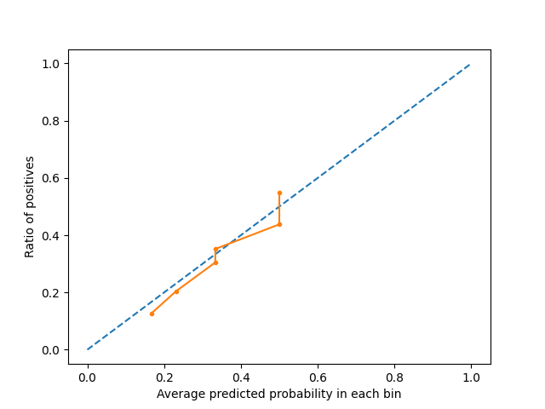

#### Calibration plot of fold 1

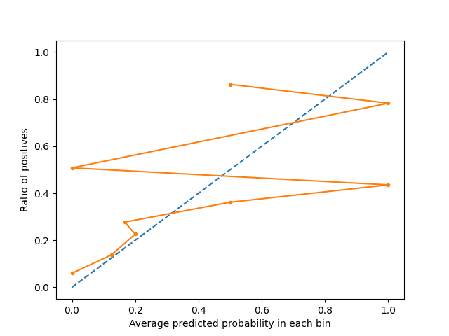

#### Calibration plot of fold 2

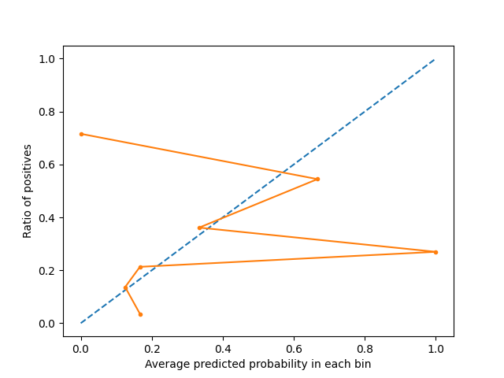

#### Calibration plot of fold 3

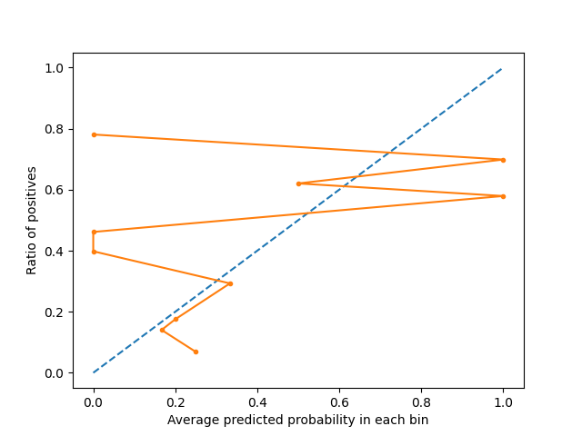

#### Calibration plot of fold 4

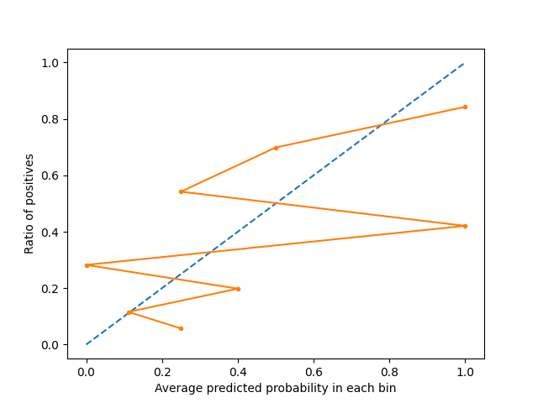

#### Calibration plot of fold 5

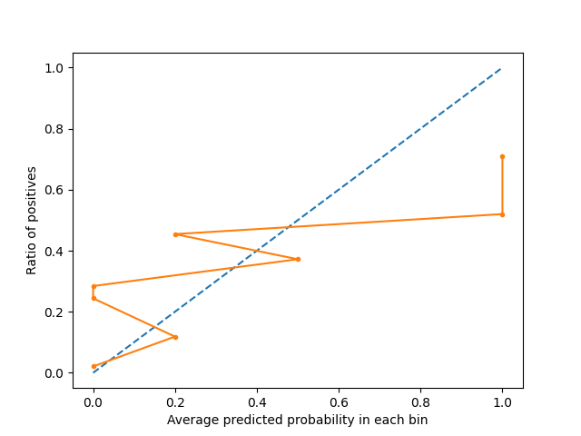

#### Calibration plot of fold 6

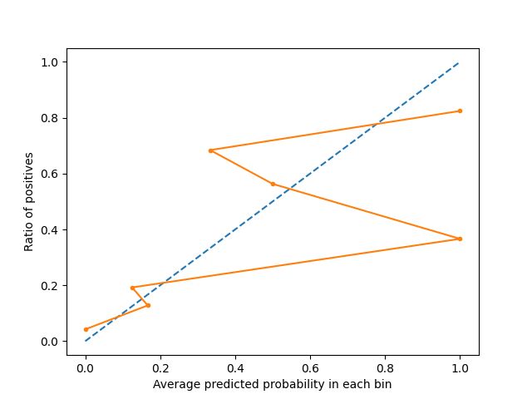

#### Calibration plot of fold 7

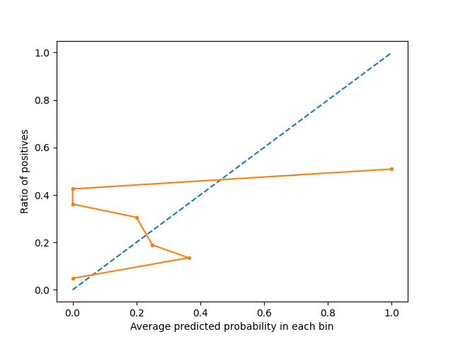

#### Calibration plot of fold 8

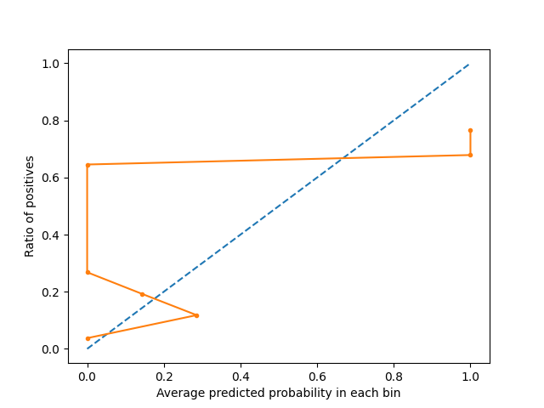

#### Calibration plot of fold 9

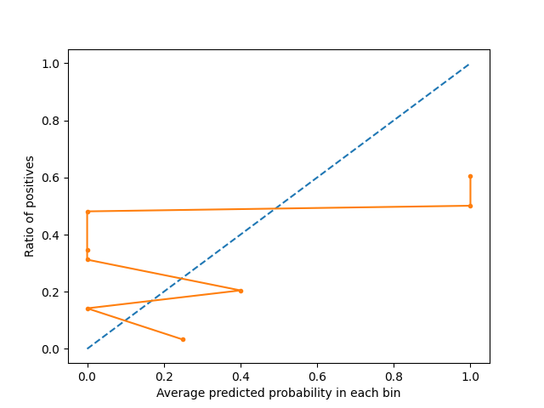

### Precision-recall curve plots

#### Precision-recall curve plot of fold 0

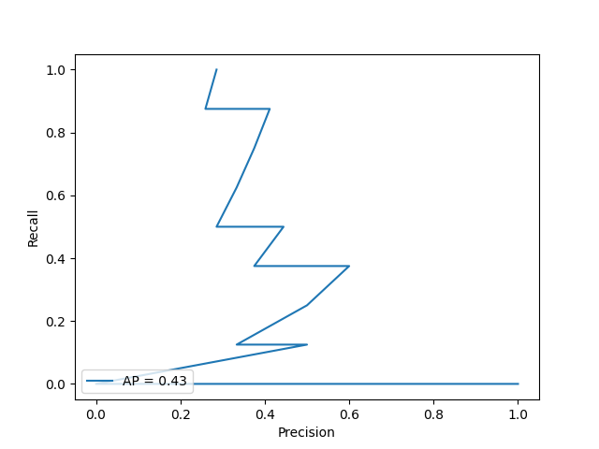

#### Precision-recall curve plot of fold 1

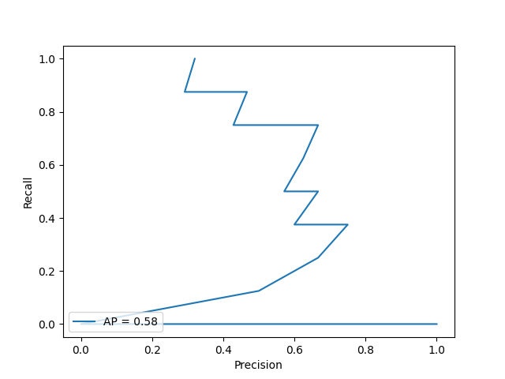

#### Precision-recall curve plot of fold 2

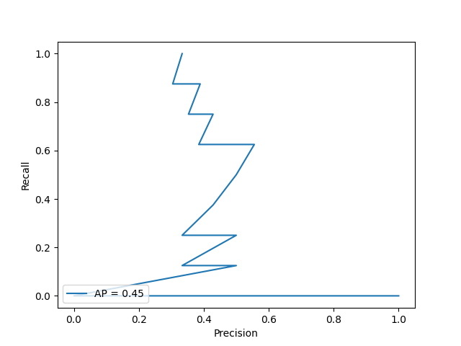

#### Precision-recall curve plot of fold 3

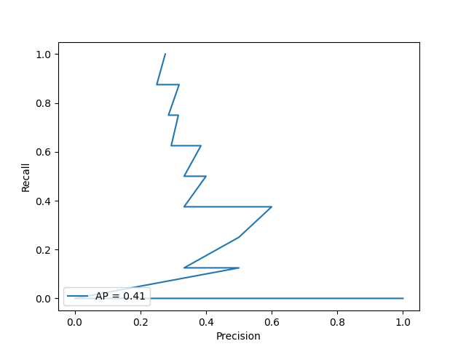

#### Precision-recall curve plot of fold 4

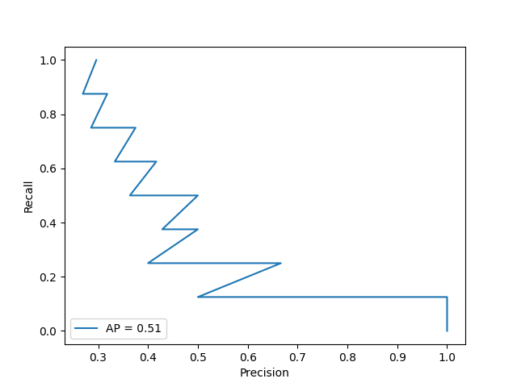

#### Precision-recall curve plot of fold 5

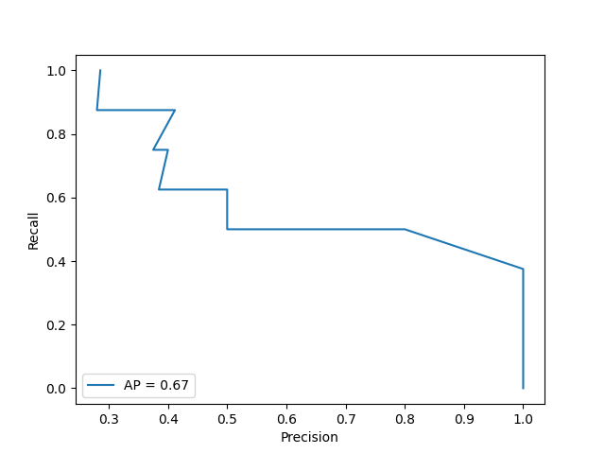

#### Precision-recall curve plot of fold 6

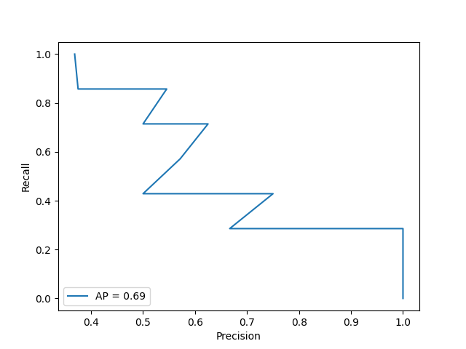

#### Precision-recall curve plot of fold 7

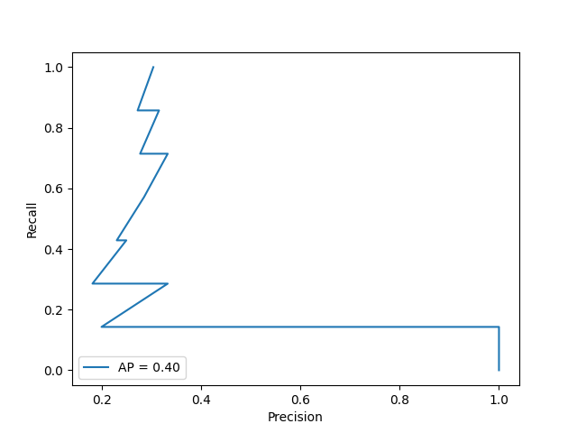

#### Precision-recall curve plot of fold 8

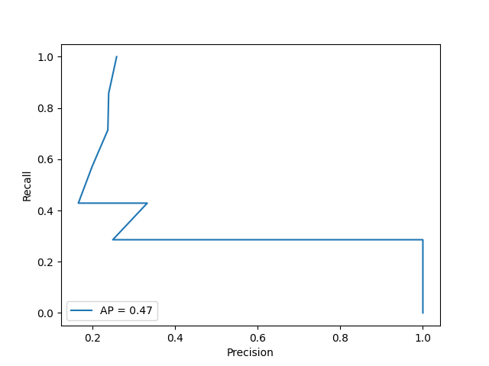

#### Precision-recall curve plot of fold 9

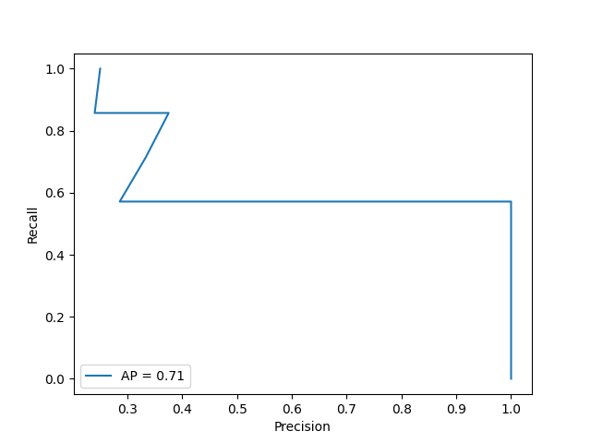

### ROC curve plots

#### ROC curve plot of fold 0

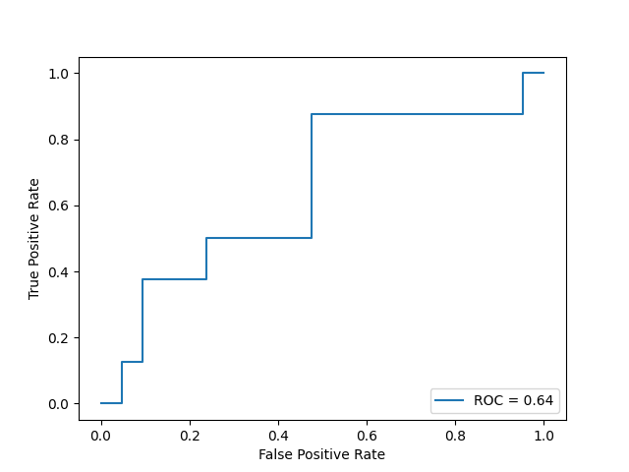

#### ROC curve plot of fold 1

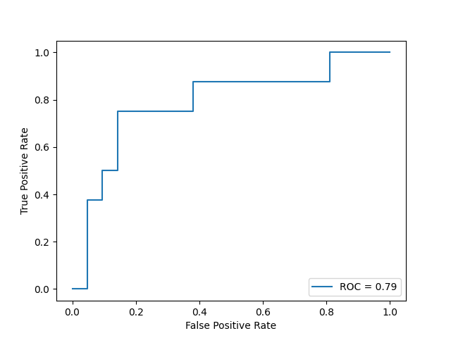

#### ROC curve plot of fold 2

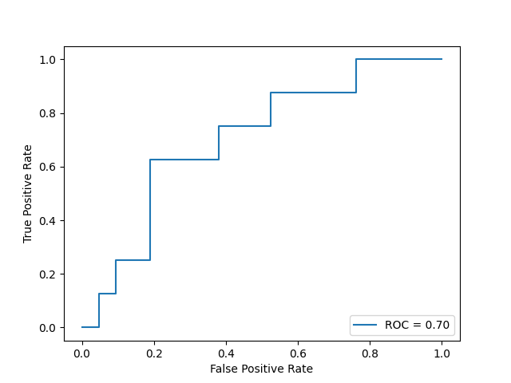

#### ROC curve plot of fold 3

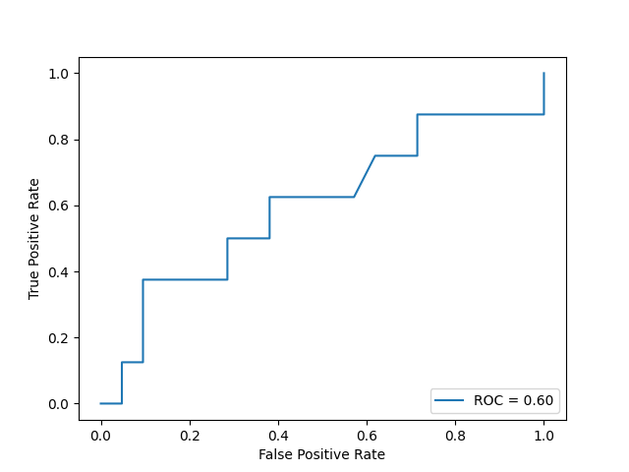

#### ROC curve plot of fold 4

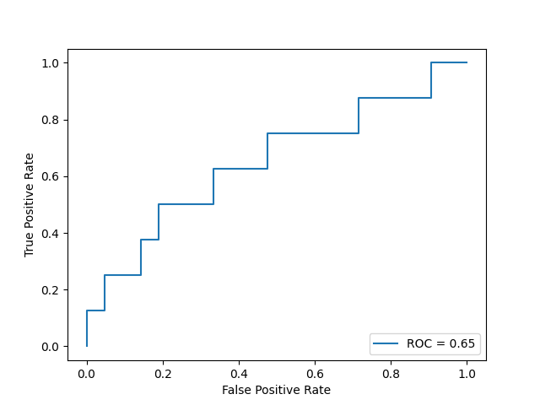

#### ROC curve plot of fold 5

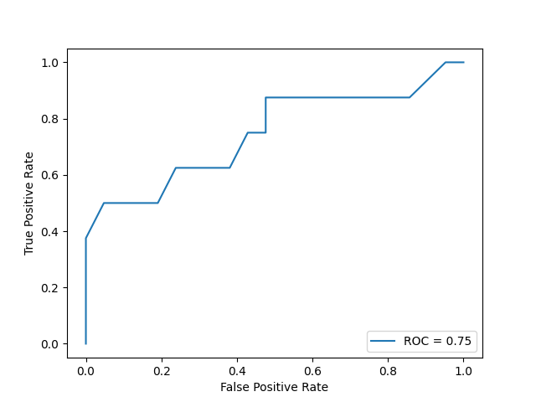

#### ROC curve plot of fold 6

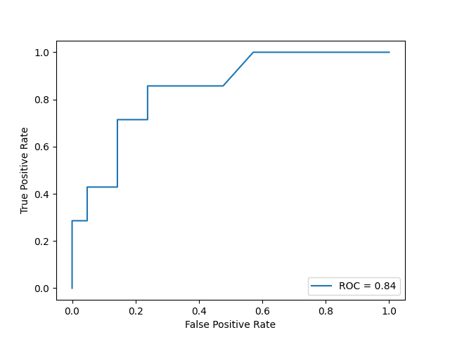

#### ROC curve plot of fold 7

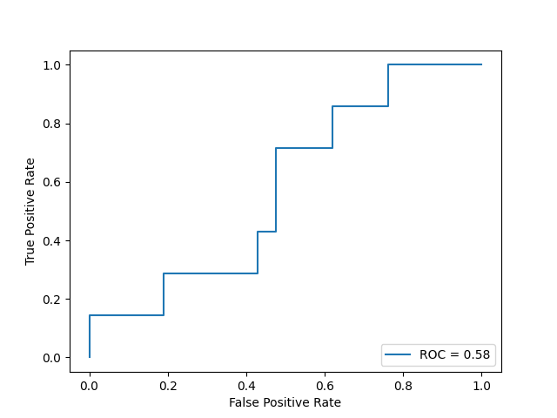

#### ROC curve plot of fold 8

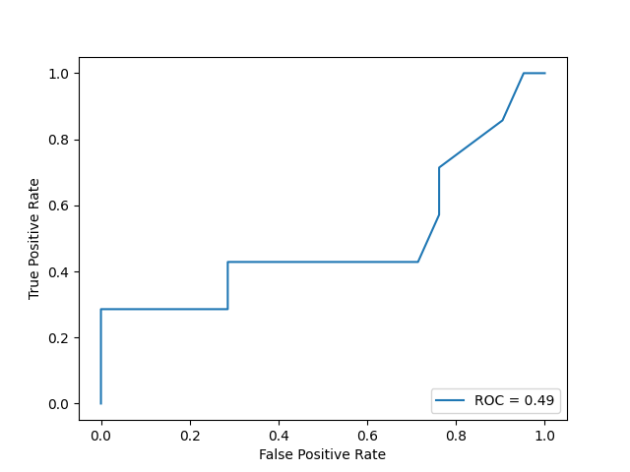

#### ROC curve plot of fold 9

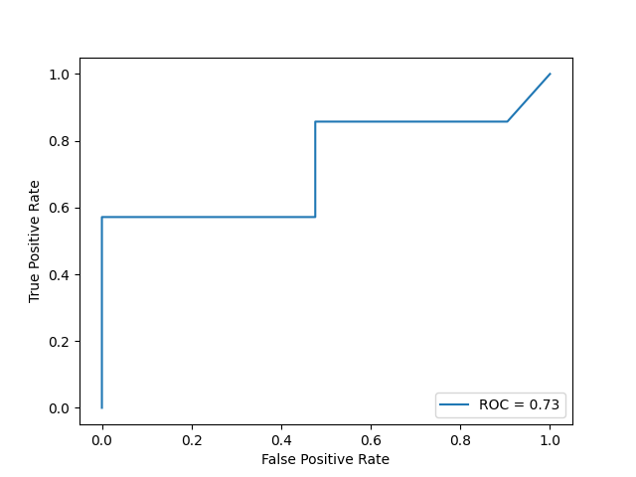

### Confusion matrix

#### Confusion matrix of fold 0

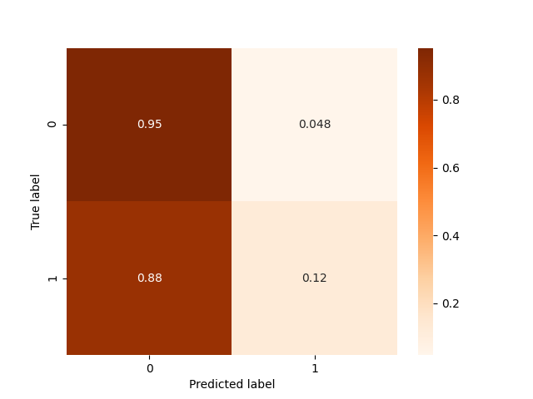

#### Confusion matrix of fold 1

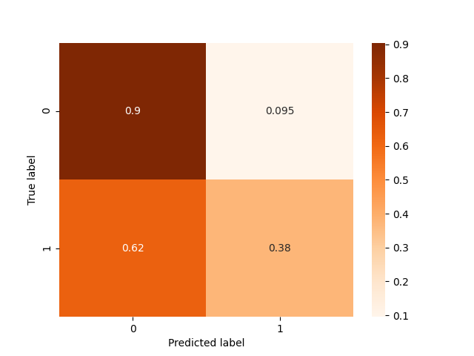

#### Confusion matrix of fold 2

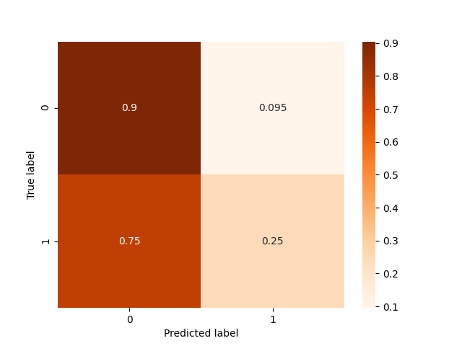

#### Confusion matrix of fold 3



#### Confusion matrix of fold 4

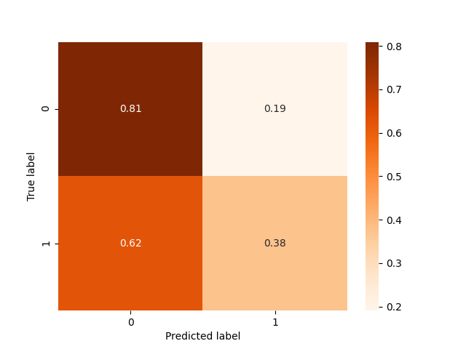

#### Confusion matrix of fold 5

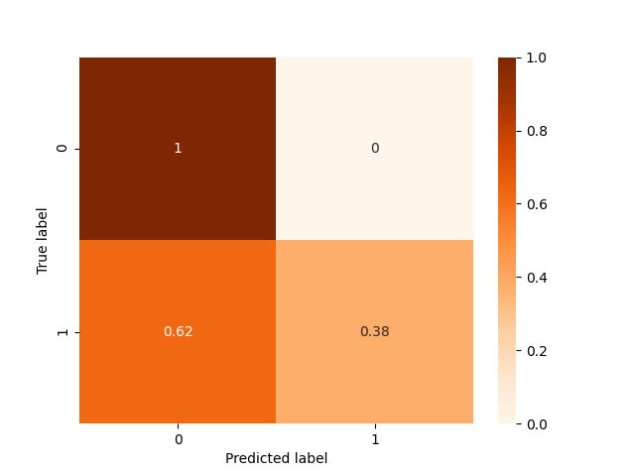

#### Confusion matrix of fold 6

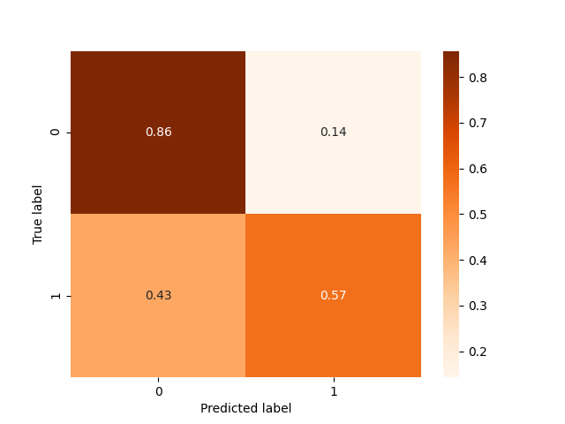

#### Confusion matrix of fold 7

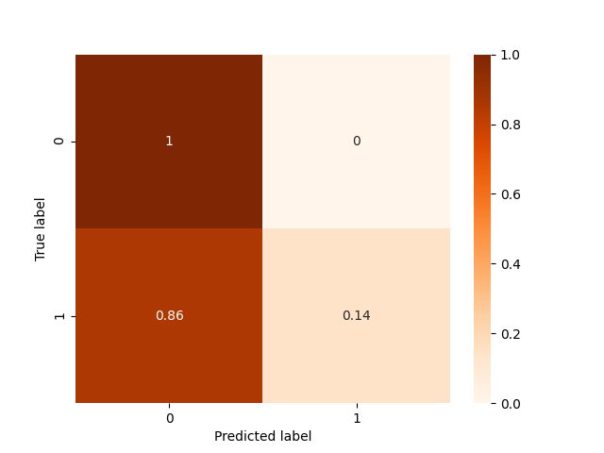

#### Confusion matrix of fold 8

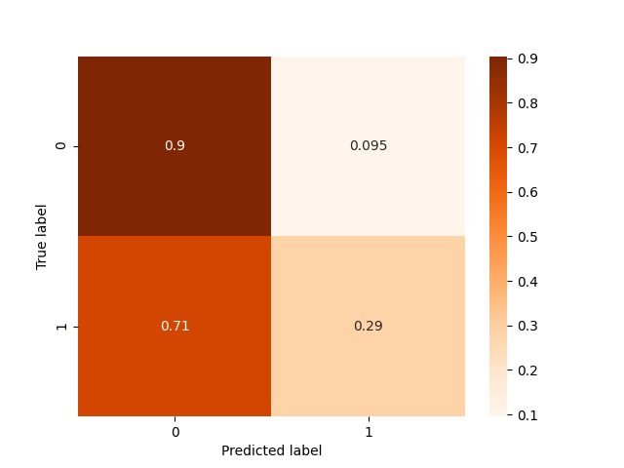

#### Confusion matrix of fold 9

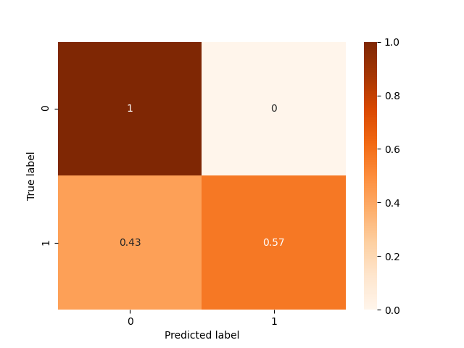

### Histograms

#### Histogram of fold 0

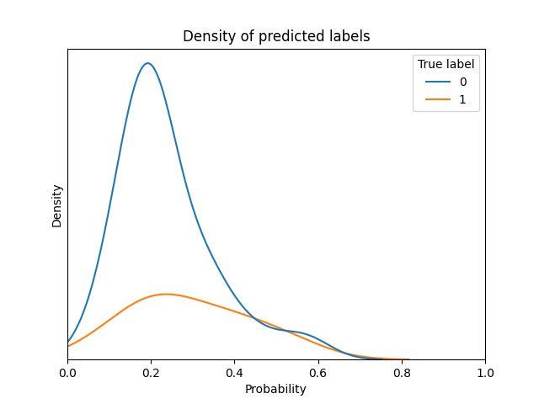

#### Histogram of fold 1

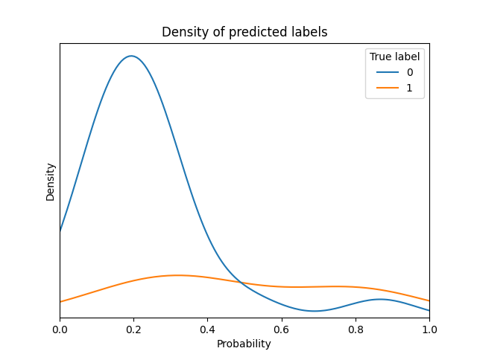

#### Histogram of fold 2

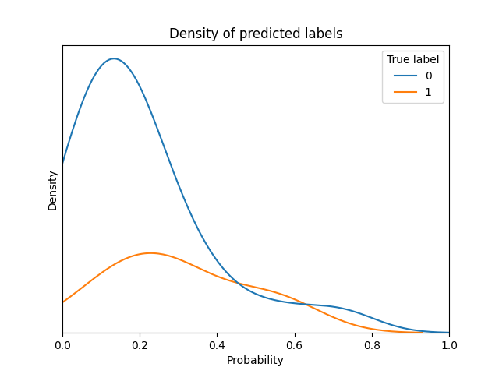

#### Histogram of fold 3

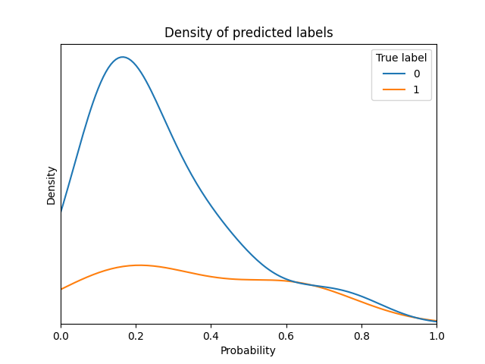

#### Histogram of fold 4

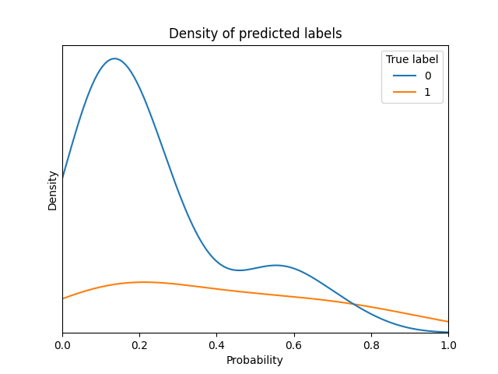

#### Histogram of fold 5

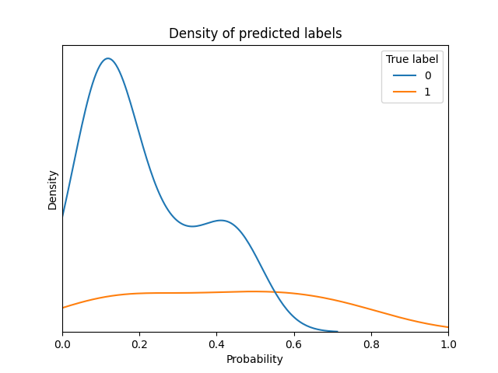

#### Histogram of fold 6

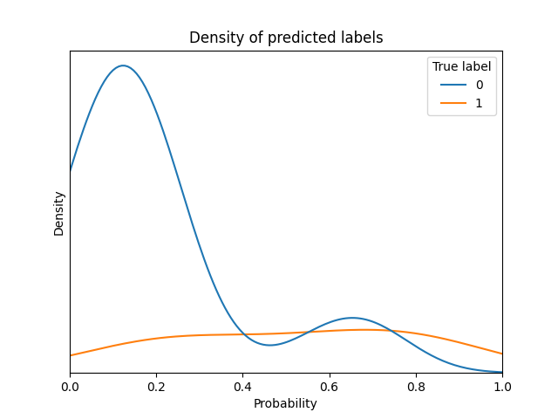

#### Histogram of fold 7

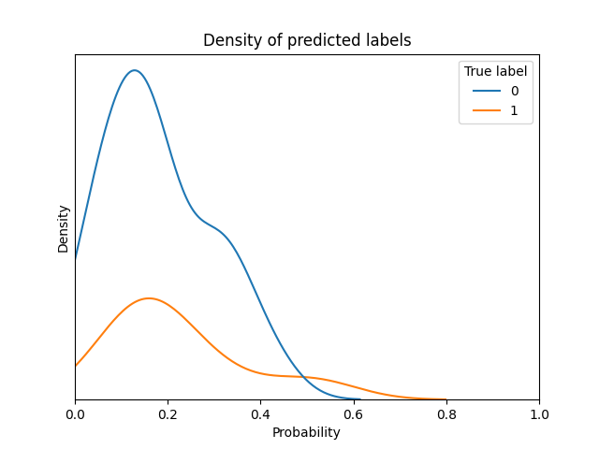

#### Histogram of fold 8

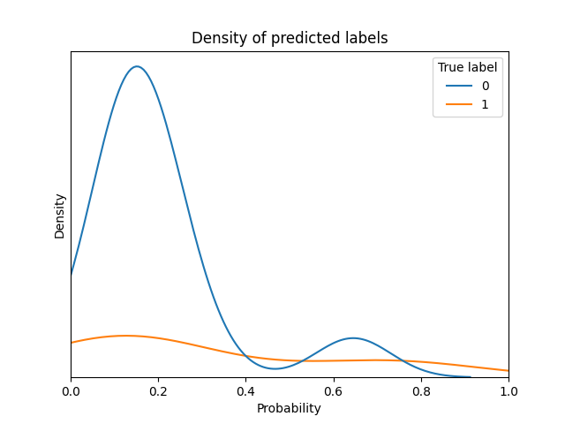

#### Histogram of fold 9

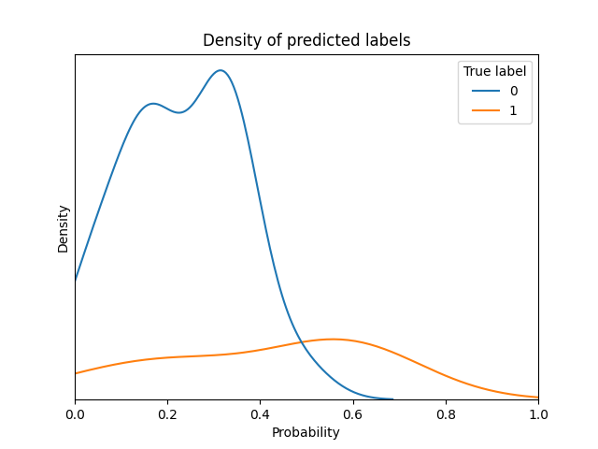

## Comparison of several predictions to assess variance

|  |  |  |  |  |  |  |  |  |  |  |  |  |
| --- | --- | --- | --- | --- | --- | --- | --- | --- | --- | --- | --- | --- |
| **Instance** | **Real label** | **Prediction by model of fold 0** | **Prediction by model of fold 1** | **Prediction by model of fold 2** | **Prediction by model of fold 3** | **Prediction by model of fold 4** | **Prediction by model of fold 5** | **Prediction by model of fold 6** | **Prediction by model of fold 7** | **Prediction by model of fold 8** | **Prediction by model of fold 9** | **Standard deviation in predictions of this instance** |
| 1 | 1 | 0.126 | 0.333 | 0.363 | 0.195 | 0.393 | 0.253 | 0.336 | 0.308 | 0.283 | 0.392 | 0.082 |
| 2 | 0 | 0.257 | 0.245 | 0.451 | 0.401 | 0.447 | 0.477 | 0.212 | 0.487 | 0.317 | 0.129 | 0.121 |
| 3 | 0 | 0.32 | 0.064 | 0.067 | 0.131 | 0.084 | 0.127 | 0.081 | 0.145 | 0.07 | 0.095 | 0.073 |
| 4 | 0 | 0.568 | 0.219 | 0.11 | 0.156 | 0.126 | 0.133 | 0.161 | 0.149 | 0.107 | 0.305 | 0.134 |
| 5 | 0 | 0.482 | 0.134 | 0.087 | 0.137 | 0.092 | 0.121 | 0.171 | 0.153 | 0.085 | 0.266 | 0.115 |
| 6 | 0 | 0.506 | 0.883 | 0.854 | 0.698 | 0.843 | 0.787 | 0.771 | 0.848 | 0.954 | 0.764 | 0.117 |
| 7 | 0 | 0.118 | 0.041 | 0.107 | 0.159 | 0.104 | 0.113 | 0.0 | 0.077 | 0.057 | 0.027 | 0.046 |
| 8 | 0 | 0.684 | 0.198 | 0.191 | 0.234 | 0.223 | 0.168 | 0.195 | 0.189 | 0.09 | 0.328 | 0.155 |
| 9 | 1 | 0.422 | 0.237 | 0.232 | 0.127 | 0.113 | 0.159 | 0.131 | 0.176 | 0.101 | 0.217 | 0.09 |
| 10 | 0 | 0.083 | 0.109 | 0.09 | 0.124 | 0.107 | 0.121 | 0.125 | 0.168 | 0.085 | 0.34 | 0.072 |
| 11 | 1 | 0.363 | 0.204 | 0.496 | 0.326 | 0.472 | 0.624 | 0.268 | 0.553 | 0.255 | 0.093 | 0.159 |
| 12 | 0 | 0.318 | 0.295 | 0.159 | 0.137 | 0.183 | 0.112 | 0.237 | 0.238 | 0.236 | 0.226 | 0.063 |
| 13 | 1 | 0.184 | 0.425 | 0.285 | 0.293 | 0.338 | 0.279 | 0.225 | 0.4 | 0.455 | 0.492 | 0.097 |
| 14 | 0 | 0.436 | 0.184 | 0.189 | 0.234 | 0.183 | 0.167 | 0.178 | 0.169 | 0.085 | 0.313 | 0.092 |
| 15 | 0 | 0.169 | 0.602 | 0.363 | 0.48 | 0.528 | 0.372 | 0.419 | 0.553 | 0.502 | 0.551 | 0.121 |
| 16 | 0 | 0.387 | 0.598 | 0.591 | 0.579 | 0.715 | 0.754 | 0.698 | 0.683 | 0.675 | 0.742 | 0.104 |
| 17 | 0 | 0.438 | 0.089 | 0.181 | 0.237 | 0.183 | 0.167 | 0.193 | 0.136 | 0.107 | 0.079 | 0.098 |
| 18 | 0 | 0.121 | 0.421 | 0.459 | 0.284 | 0.564 | 0.447 | 0.56 | 0.48 | 0.537 | 0.715 | 0.155 |
| 19 | 1 | 0.288 | 0.19 | 0.302 | 0.292 | 0.28 | 0.389 | 0.416 | 0.409 | 0.14 | 0.29 | 0.085 |
| 20 | 0 | 0.216 | 0.454 | 0.363 | 0.742 | 0.552 | 0.621 | 0.604 | 0.337 | 0.86 | 0.512 | 0.184 |

The average standard deviation is 0.108

# Report of inner trainings

## Report of inner training in fold 0 of outer Cross Validation

## Report of training in this outer fold

Best model with respect to selected metric is XGBClassifier with the following params:

* undersampling_majority_class: False
* max_k_undersampling: 3
* resample__sampling_strategy: all
* post_process__option: option_1
* model__max_depth: 4
* model__learning_rate: 0.065
* model__min_child_weight: 5
* model__subsample: 0.962
* model__colsample_bytree: 0.518
* model__scale_pos_weight: 1.935
* model__objective: binary:logistic

### Comparison of all models trained in this outer fold

|  |  |  |  |  |  |  |  |  |  |  |
| --- | --- | --- | --- | --- | --- | --- | --- | --- | --- | --- |
| **Model** | **Params** | **Comments** | **roc_auc on inner fold** | **neg_log_loss on inner fold** | **average_precision on inner fold** | **neg_brier_score on inner fold** | **roc_auc on outer fold** | **neg_log_loss on outer fold** | **average_precision on outer fold** | **neg_brier_score on outer fold** |
| XGBClassifier | * undersampling_majority_class: True * max_k_undersampling: 2 * resample__sampling_strategy: all * post_process__option: option_1 * model__max_depth: 5 * model__learning_rate: 0.129 * model__min_child_weight: 8 * model__subsample: 0.919 * model__colsample_bytree: 0.533 * model__scale_pos_weight: 5.55 * model__objective: binary:logistic | * option: build model with resampling * number of folds: 10 * average size of training set before resampling: 146.25 * average prop of minority class before resampling: 0.418 * average size of training set after resampling: 170.1 * average prop of minority class after resampling: 0.5 | 0.714 | 0.468 | 0.454 | 0.158 | 0.726 | 0.543 | 0.47 | 0.184 |
| XGBClassifier | * undersampling_majority_class: False * max_k_undersampling: 2 * resample__sampling_strategy: minority * post_process__option: option_1 * model__max_depth: 8 * model__learning_rate: 0.253 * model__min_child_weight: 7 * model__subsample: 0.827 * model__colsample_bytree: 0.723 * model__scale_pos_weight: 0.756 * model__objective: binary:logistic | * option: build model with resampling * number of folds: 10 * average size of training set before resampling: 231.3 * average prop of minority class before resampling: 0.265 * average size of training set after resampling: 340.2 * average prop of minority class after resampling: 0.5 | 0.739 | 0.448 | 0.495 | 0.15 | 0.613 | 0.566 | 0.427 | 0.191 |
| XGBClassifier | * undersampling_majority_class: False * max_k_undersampling: 2 * resample__sampling_strategy: all * post_process__option: option_2 * model__max_depth: 4 * model__learning_rate: 0.279 * model__min_child_weight: 7 * model__subsample: 0.82 * model__colsample_bytree: 0.183 * model__scale_pos_weight: 0.143 * model__objective: binary:logistic | * option: build model with resampling * number of folds: 10 * average size of training set before resampling: 231.3 * average prop of minority class before resampling: 0.265 * average size of training set after resampling: 340.2 * average prop of minority class after resampling: 0.5 | 0.735 | 0.446 | 0.487 | 0.149 | 0.729 | 0.51 | 0.473 | 0.169 |
| XGBClassifier | * undersampling_majority_class: True * max_k_undersampling: 3 * resample__sampling_strategy: all * post_process__option: option_2 * model__max_depth: 7 * model__learning_rate: 0.1 * model__min_child_weight: 6 * model__subsample: 0.992 * model__colsample_bytree: 0.48 * model__scale_pos_weight: 0.856 * model__objective: binary:logistic | * option: build model with resampling * number of folds: 10 * average size of training set before resampling: 117.9 * average prop of minority class before resampling: 0.481 * average size of training set after resampling: 122.4 * average prop of minority class after resampling: 0.5 | 0.763 | 0.415 | 0.54 | 0.138 | 0.735 | 0.534 | 0.492 | 0.181 |
| XGBClassifier | * undersampling_majority_class: False * max_k_undersampling: 3 * resample__sampling_strategy: all * post_process__option: option_1 * model__max_depth: 3 * model__learning_rate: 0.109 * model__min_child_weight: 10 * model__subsample: 0.922 * model__colsample_bytree: 0.164 * model__scale_pos_weight: 0.405 * model__objective: binary:logistic | * option: build model with resampling * number of folds: 10 * average size of training set before resampling: 231.3 * average prop of minority class before resampling: 0.265 * average size of training set after resampling: 340.2 * average prop of minority class after resampling: 0.5 | 0.717 | 0.465 | 0.467 | 0.156 | 0.545 | 0.559 | 0.484 | 0.183 |
| XGBClassifier | * undersampling_majority_class: True * max_k_undersampling: 3 * resample__sampling_strategy: all * post_process__option: option_1 * model__max_depth: 3 * model__learning_rate: 0.077 * model__min_child_weight: 9 * model__subsample: 0.849 * model__colsample_bytree: 0.163 * model__scale_pos_weight: 3.397 * model__objective: binary:logistic | * option: build model with resampling * number of folds: 10 * average size of training set before resampling: 117.9 * average prop of minority class before resampling: 0.481 * average size of training set after resampling: 122.4 * average prop of minority class after resampling: 0.5 | 0.706 | 0.462 | 0.482 | 0.153 | 0.762 | 0.528 | 0.547 | 0.177 |
| XGBClassifier | * undersampling_majority_class: True * max_k_undersampling: 3 * resample__sampling_strategy: minority * post_process__option: option_3 * model__max_depth: 8 * model__learning_rate: 0.057 * model__min_child_weight: 9 * model__subsample: 0.996 * model__colsample_bytree: 0.341 * model__scale_pos_weight: 0.291 * model__objective: binary:logistic | * option: build model with resampling * number of folds: 10 * average size of training set before resampling: 117.9 * average prop of minority class before resampling: 0.481 * average size of training set after resampling: 122.4 * average prop of minority class after resampling: 0.5 | 0.647 | 0.509 | 0.364 | 0.174 | 0.682 | 0.524 | 0.414 | 0.174 |
| XGBClassifier | * undersampling_majority_class: True * max_k_undersampling: 2 * resample__sampling_strategy: minority * post_process__option: option_2 * model__max_depth: 5 * model__learning_rate: 0.111 * model__min_child_weight: 3 * model__subsample: 0.859 * model__colsample_bytree: 0.278 * model__scale_pos_weight: 0.225 * model__objective: binary:logistic | * option: build model with resampling * number of folds: 10 * average size of training set before resampling: 146.25 * average prop of minority class before resampling: 0.418 * average size of training set after resampling: 170.1 * average prop of minority class after resampling: 0.5 | 0.765 | 0.415 | 0.54 | 0.138 | 0.744 | 0.541 | 0.475 | 0.185 |
| XGBClassifier | * undersampling_majority_class: False * max_k_undersampling: 3 * resample__sampling_strategy: all * post_process__option: option_1 * model__max_depth: 4 * model__learning_rate: 0.065 * model__min_child_weight: 5 * model__subsample: 0.962 * model__colsample_bytree: 0.518 * model__scale_pos_weight: 1.935 * model__objective: binary:logistic | * option: build model with resampling * number of folds: 10 * average size of training set before resampling: 231.3 * average prop of minority class before resampling: 0.265 * average size of training set after resampling: 340.2 * average prop of minority class after resampling: 0.5 | 0.777 | 0.419 | 0.561 | 0.136 | 0.643 | 0.576 | 0.431 | 0.192 |
| XGBClassifier | * undersampling_majority_class: False * max_k_undersampling: 3 * resample__sampling_strategy: minority * post_process__option: option_1 * model__max_depth: 3 * model__learning_rate: 0.153 * model__min_child_weight: 2 * model__subsample: 0.86 * model__colsample_bytree: 0.576 * model__scale_pos_weight: 1.863 * model__objective: binary:logistic | * option: build model with resampling * number of folds: 10 * average size of training set before resampling: 231.3 * average prop of minority class before resampling: 0.265 * average size of training set after resampling: 340.2 * average prop of minority class after resampling: 0.5 | 0.724 | 0.438 | 0.523 | 0.144 | 0.548 | 0.595 | 0.405 | 0.201 |

## Report of inner training in fold 1 of outer Cross Validation

## Report of training in this outer fold

Best model with respect to selected metric is XGBClassifier with the following params:

* undersampling_majority_class: False
* max_k_undersampling: 2
* resample__sampling_strategy: minority
* post_process__option: option_3
* model__max_depth: 5
* model__learning_rate: 0.065
* model__min_child_weight: 3
* model__subsample: 0.864
* model__colsample_bytree: 0.189
* model__scale_pos_weight: 0.186
* model__objective: binary:logistic

### Comparison of all models trained in this outer fold

|  |  |  |  |  |  |  |  |  |  |  |
| --- | --- | --- | --- | --- | --- | --- | --- | --- | --- | --- |
| **Model** | **Params** | **Comments** | **roc_auc on inner fold** | **neg_log_loss on inner fold** | **average_precision on inner fold** | **neg_brier_score on inner fold** | **roc_auc on outer fold** | **neg_log_loss on outer fold** | **average_precision on outer fold** | **neg_brier_score on outer fold** |
| XGBClassifier | * undersampling_majority_class: False * max_k_undersampling: 2 * resample__sampling_strategy: all * post_process__option: option_3 * model__max_depth: 5 * model__learning_rate: 0.212 * model__min_child_weight: 6 * model__subsample: 0.831 * model__colsample_bytree: 0.249 * model__scale_pos_weight: 3.287 * model__objective: binary:logistic | * option: build model with resampling * number of folds: 10 * average size of training set before resampling: 231.3 * average prop of minority class before resampling: 0.265 * average size of training set after resampling: 340.2 * average prop of minority class after resampling: 0.5 | 0.734 | 0.455 | 0.489 | 0.152 | 0.619 | 0.575 | 0.464 | 0.19 |
| XGBClassifier | * undersampling_majority_class: False * max_k_undersampling: 2 * resample__sampling_strategy: minority * post_process__option: option_3 * model__max_depth: 5 * model__learning_rate: 0.065 * model__min_child_weight: 3 * model__subsample: 0.864 * model__colsample_bytree: 0.189 * model__scale_pos_weight: 0.186 * model__objective: binary:logistic | * option: build model with resampling * number of folds: 10 * average size of training set before resampling: 231.3 * average prop of minority class before resampling: 0.265 * average size of training set after resampling: 340.2 * average prop of minority class after resampling: 0.5 | 0.776 | 0.419 | 0.549 | 0.139 | 0.786 | 0.484 | 0.583 | 0.155 |
| XGBClassifier | * undersampling_majority_class: False * max_k_undersampling: 3 * resample__sampling_strategy: all * post_process__option: option_2 * model__max_depth: 6 * model__learning_rate: 0.117 * model__min_child_weight: 3 * model__subsample: 0.872 * model__colsample_bytree: 0.493 * model__scale_pos_weight: 3.29 * model__objective: binary:logistic | * option: build model with resampling * number of folds: 10 * average size of training set before resampling: 231.3 * average prop of minority class before resampling: 0.265 * average size of training set after resampling: 340.2 * average prop of minority class after resampling: 0.5 | 0.696 | 0.476 | 0.437 | 0.16 | 0.631 | 0.554 | 0.513 | 0.182 |
| XGBClassifier | * undersampling_majority_class: True * max_k_undersampling: 3 * resample__sampling_strategy: all * post_process__option: option_2 * model__max_depth: 5 * model__learning_rate: 0.106 * model__min_child_weight: 9 * model__subsample: 0.972 * model__colsample_bytree: 0.132 * model__scale_pos_weight: 9.085 * model__objective: binary:logistic | * option: build model with resampling * number of folds: 10 * average size of training set before resampling: 117.9 * average prop of minority class before resampling: 0.481 * average size of training set after resampling: 122.4 * average prop of minority class after resampling: 0.5 | 0.767 | 0.42 | 0.531 | 0.141 | 0.917 | 0.4 | 0.747 | 0.128 |
| XGBClassifier | * undersampling_majority_class: True * max_k_undersampling: 3 * resample__sampling_strategy: minority * post_process__option: option_2 * model__max_depth: 8 * model__learning_rate: 0.254 * model__min_child_weight: 7 * model__subsample: 0.864 * model__colsample_bytree: 0.688 * model__scale_pos_weight: 0.279 * model__objective: binary:logistic | * option: build model with resampling * number of folds: 10 * average size of training set before resampling: 117.9 * average prop of minority class before resampling: 0.481 * average size of training set after resampling: 122.4 * average prop of minority class after resampling: 0.5 | 0.66 | 0.513 | 0.375 | 0.172 | 0.923 | 0.425 | 0.773 | 0.136 |
| XGBClassifier | * undersampling_majority_class: True * max_k_undersampling: 2 * resample__sampling_strategy: minority * post_process__option: option_2 * model__max_depth: 3 * model__learning_rate: 0.081 * model__min_child_weight: 4 * model__subsample: 0.954 * model__colsample_bytree: 0.314 * model__scale_pos_weight: 0.161 * model__objective: binary:logistic | * option: build model with resampling * number of folds: 10 * average size of training set before resampling: 146.25 * average prop of minority class before resampling: 0.418 * average size of training set after resampling: 170.1 * average prop of minority class after resampling: 0.5 | 0.741 | 0.443 | 0.501 | 0.146 | 0.935 | 0.334 | 0.83 | 0.098 |
| XGBClassifier | * undersampling_majority_class: True * max_k_undersampling: 2 * resample__sampling_strategy: all * post_process__option: option_1 * model__max_depth: 6 * model__learning_rate: 0.178 * model__min_child_weight: 3 * model__subsample: 0.844 * model__colsample_bytree: 0.372 * model__scale_pos_weight: 1.856 * model__objective: binary:logistic | * option: build model with resampling * number of folds: 10 * average size of training set before resampling: 146.25 * average prop of minority class before resampling: 0.418 * average size of training set after resampling: 170.1 * average prop of minority class after resampling: 0.5 | 0.711 | 0.465 | 0.457 | 0.157 | 0.696 | 0.549 | 0.456 | 0.185 |
| XGBClassifier | * undersampling_majority_class: False * max_k_undersampling: 2 * resample__sampling_strategy: all * post_process__option: option_1 * model__max_depth: 4 * model__learning_rate: 0.108 * model__min_child_weight: 1 * model__subsample: 0.922 * model__colsample_bytree: 0.206 * model__scale_pos_weight: 0.484 * model__objective: binary:logistic | * option: build model with resampling * number of folds: 10 * average size of training set before resampling: 231.3 * average prop of minority class before resampling: 0.265 * average size of training set after resampling: 340.2 * average prop of minority class after resampling: 0.5 | 0.656 | 0.513 | 0.401 | 0.171 | 0.637 | 0.569 | 0.372 | 0.194 |
| XGBClassifier | * undersampling_majority_class: True * max_k_undersampling: 3 * resample__sampling_strategy: minority * post_process__option: option_2 * model__max_depth: 3 * model__learning_rate: 0.237 * model__min_child_weight: 6 * model__subsample: 0.856 * model__colsample_bytree: 0.304 * model__scale_pos_weight: 2.869 * model__objective: binary:logistic | * option: build model with resampling * number of folds: 10 * average size of training set before resampling: 117.9 * average prop of minority class before resampling: 0.481 * average size of training set after resampling: 122.4 * average prop of minority class after resampling: 0.5 | 0.745 | 0.434 | 0.502 | 0.145 | 0.893 | 0.426 | 0.718 | 0.136 |
| XGBClassifier | * undersampling_majority_class: True * max_k_undersampling: 3 * resample__sampling_strategy: minority * post_process__option: option_2 * model__max_depth: 5 * model__learning_rate: 0.071 * model__min_child_weight: 2 * model__subsample: 0.891 * model__colsample_bytree: 0.373 * model__scale_pos_weight: 0.903 * model__objective: binary:logistic | * option: build model with resampling * number of folds: 10 * average size of training set before resampling: 117.9 * average prop of minority class before resampling: 0.481 * average size of training set after resampling: 122.4 * average prop of minority class after resampling: 0.5 | 0.758 | 0.431 | 0.526 | 0.142 | 0.857 | 0.436 | 0.698 | 0.14 |

## Report of inner training in fold 2 of outer Cross Validation

## Report of training in this outer fold

Best model with respect to selected metric is XGBClassifier with the following params:

* undersampling_majority_class: True
* max_k_undersampling: 2
* resample__sampling_strategy: minority
* post_process__option: option_2
* model__max_depth: 3
* model__learning_rate: 0.17
* model__min_child_weight: 2
* model__subsample: 0.918
* model__colsample_bytree: 0.457
* model__scale_pos_weight: 0.135
* model__objective: binary:logistic

### Comparison of all models trained in this outer fold

|  |  |  |  |  |  |  |  |  |  |  |
| --- | --- | --- | --- | --- | --- | --- | --- | --- | --- | --- |
| **Model** | **Params** | **Comments** | **roc_auc on inner fold** | **neg_log_loss on inner fold** | **average_precision on inner fold** | **neg_brier_score on inner fold** | **roc_auc on outer fold** | **neg_log_loss on outer fold** | **average_precision on outer fold** | **neg_brier_score on outer fold** |
| XGBClassifier | * undersampling_majority_class: False * max_k_undersampling: 3 * resample__sampling_strategy: all * post_process__option: option_2 * model__max_depth: 6 * model__learning_rate: 0.055 * model__min_child_weight: 4 * model__subsample: 0.899 * model__colsample_bytree: 0.432 * model__scale_pos_weight: 1.354 * model__objective: binary:logistic | * option: build model with resampling * number of folds: 10 * average size of training set before resampling: 231.3 * average prop of minority class before resampling: 0.265 * average size of training set after resampling: 340.2 * average prop of minority class after resampling: 0.5 | 0.705 | 0.469 | 0.459 | 0.158 | 0.708 | 0.554 | 0.438 | 0.192 |
| XGBClassifier | * undersampling_majority_class: False * max_k_undersampling: 2 * resample__sampling_strategy: minority * post_process__option: option_2 * model__max_depth: 8 * model__learning_rate: 0.294 * model__min_child_weight: 6 * model__subsample: 0.88 * model__colsample_bytree: 0.426 * model__scale_pos_weight: 7.688 * model__objective: binary:logistic | * option: build model with resampling * number of folds: 10 * average size of training set before resampling: 231.3 * average prop of minority class before resampling: 0.265 * average size of training set after resampling: 340.2 * average prop of minority class after resampling: 0.5 | 0.706 | 0.476 | 0.448 | 0.16 | 0.622 | 0.592 | 0.38 | 0.201 |
| XGBClassifier | * undersampling_majority_class: True * max_k_undersampling: 2 * resample__sampling_strategy: minority * post_process__option: option_2 * model__max_depth: 3 * model__learning_rate: 0.17 * model__min_child_weight: 2 * model__subsample: 0.918 * model__colsample_bytree: 0.457 * model__scale_pos_weight: 0.135 * model__objective: binary:logistic | * option: build model with resampling * number of folds: 10 * average size of training set before resampling: 146.25 * average prop of minority class before resampling: 0.418 * average size of training set after resampling: 170.1 * average prop of minority class after resampling: 0.5 | 0.774 | 0.404 | 0.543 | 0.136 | 0.702 | 0.571 | 0.454 | 0.193 |
| XGBClassifier | * undersampling_majority_class: False * max_k_undersampling: 2 * resample__sampling_strategy: all * post_process__option: option_3 * model__max_depth: 8 * model__learning_rate: 0.307 * model__min_child_weight: 2 * model__subsample: 0.881 * model__colsample_bytree: 0.144 * model__scale_pos_weight: 2.569 * model__objective: binary:logistic | * option: build model with resampling * number of folds: 10 * average size of training set before resampling: 231.3 * average prop of minority class before resampling: 0.265 * average size of training set after resampling: 340.2 * average prop of minority class after resampling: 0.5 | 0.712 | 0.466 | 0.479 | 0.155 | 0.613 | 0.579 | 0.406 | 0.197 |
| XGBClassifier | * undersampling_majority_class: True * max_k_undersampling: 2 * resample__sampling_strategy: minority * post_process__option: option_1 * model__max_depth: 7 * model__learning_rate: 0.203 * model__min_child_weight: 4 * model__subsample: 0.848 * model__colsample_bytree: 0.443 * model__scale_pos_weight: 0.195 * model__objective: binary:logistic | * option: build model with resampling * number of folds: 10 * average size of training set before resampling: 146.25 * average prop of minority class before resampling: 0.418 * average size of training set after resampling: 170.1 * average prop of minority class after resampling: 0.5 | 0.729 | 0.459 | 0.488 | 0.153 | 0.512 | 0.654 | 0.336 | 0.221 |
| XGBClassifier | * undersampling_majority_class: False * max_k_undersampling: 2 * resample__sampling_strategy: minority * post_process__option: option_1 * model__max_depth: 2 * model__learning_rate: 0.272 * model__min_child_weight: 2 * model__subsample: 0.92 * model__colsample_bytree: 0.372 * model__scale_pos_weight: 0.104 * model__objective: binary:logistic | * option: build model with resampling * number of folds: 10 * average size of training set before resampling: 231.3 * average prop of minority class before resampling: 0.265 * average size of training set after resampling: 340.2 * average prop of minority class after resampling: 0.5 | 0.753 | 0.445 | 0.495 | 0.149 | 0.42 | 0.703 | 0.269 | 0.242 |
| XGBClassifier | * undersampling_majority_class: True * max_k_undersampling: 3 * resample__sampling_strategy: minority * post_process__option: option_2 * model__max_depth: 8 * model__learning_rate: 0.064 * model__min_child_weight: 4 * model__subsample: 0.934 * model__colsample_bytree: 0.78 * model__scale_pos_weight: 0.152 * model__objective: binary:logistic | * option: build model with resampling * number of folds: 10 * average size of training set before resampling: 117.9 * average prop of minority class before resampling: 0.481 * average size of training set after resampling: 122.4 * average prop of minority class after resampling: 0.5 | 0.751 | 0.44 | 0.488 | 0.148 | 0.616 | 0.609 | 0.37 | 0.207 |
| XGBClassifier | * undersampling_majority_class: True * max_k_undersampling: 3 * resample__sampling_strategy: all * post_process__option: option_1 * model__max_depth: 4 * model__learning_rate: 0.144 * model__min_child_weight: 8 * model__subsample: 0.935 * model__colsample_bytree: 0.31 * model__scale_pos_weight: 0.177 * model__objective: binary:logistic | * option: build model with resampling * number of folds: 10 * average size of training set before resampling: 117.9 * average prop of minority class before resampling: 0.481 * average size of training set after resampling: 122.4 * average prop of minority class after resampling: 0.5 | 0.5 | 0.577 | 0.264 | 0.194 | 0.5 | 0.589 | 0.276 | 0.2 |
| XGBClassifier | * undersampling_majority_class: False * max_k_undersampling: 3 * resample__sampling_strategy: minority * post_process__option: option_1 * model__max_depth: 7 * model__learning_rate: 0.124 * model__min_child_weight: 3 * model__subsample: 0.846 * model__colsample_bytree: 0.17 * model__scale_pos_weight: 7.033 * model__objective: binary:logistic | * option: build model with resampling * number of folds: 10 * average size of training set before resampling: 231.3 * average prop of minority class before resampling: 0.265 * average size of training set after resampling: 340.2 * average prop of minority class after resampling: 0.5 | 0.73 | 0.473 | 0.46 | 0.159 | 0.488 | 0.63 | 0.287 | 0.217 |
| XGBClassifier | * undersampling_majority_class: False * max_k_undersampling: 2 * resample__sampling_strategy: minority * post_process__option: option_2 * model__max_depth: 4 * model__learning_rate: 0.226 * model__min_child_weight: 1 * model__subsample: 0.865 * model__colsample_bytree: 0.364 * model__scale_pos_weight: 1.478 * model__objective: binary:logistic | * option: build model with resampling * number of folds: 10 * average size of training set before resampling: 231.3 * average prop of minority class before resampling: 0.265 * average size of training set after resampling: 340.2 * average prop of minority class after resampling: 0.5 | 0.714 | 0.463 | 0.46 | 0.155 | 0.667 | 0.592 | 0.405 | 0.206 |

## Report of inner training in fold 3 of outer Cross Validation

## Report of training in this outer fold

Best model with respect to selected metric is XGBClassifier with the following params:

* undersampling_majority_class: True
* max_k_undersampling: 2
* resample__sampling_strategy: all
* post_process__option: option_3
* model__max_depth: 4
* model__learning_rate: 0.102
* model__min_child_weight: 10
* model__subsample: 0.915
* model__colsample_bytree: 0.57
* model__scale_pos_weight: 1.334
* model__objective: binary:logistic

### Comparison of all models trained in this outer fold

|  |  |  |  |  |  |  |  |  |  |  |
| --- | --- | --- | --- | --- | --- | --- | --- | --- | --- | --- |
| **Model** | **Params** | **Comments** | **roc_auc on inner fold** | **neg_log_loss on inner fold** | **average_precision on inner fold** | **neg_brier_score on inner fold** | **roc_auc on outer fold** | **neg_log_loss on outer fold** | **average_precision on outer fold** | **neg_brier_score on outer fold** |
| XGBClassifier | * undersampling_majority_class: True * max_k_undersampling: 2 * resample__sampling_strategy: all * post_process__option: option_2 * model__max_depth: 4 * model__learning_rate: 0.071 * model__min_child_weight: 9 * model__subsample: 0.822 * model__colsample_bytree: 0.448 * model__scale_pos_weight: 0.713 * model__objective: binary:logistic | * option: build model with resampling * number of folds: 10 * average size of training set before resampling: 146.25 * average prop of minority class before resampling: 0.418 * average size of training set after resampling: 170.1 * average prop of minority class after resampling: 0.5 | 0.756 | 0.433 | 0.506 | 0.144 | 0.586 | 0.598 | 0.373 | 0.2 |
| XGBClassifier | * undersampling_majority_class: True * max_k_undersampling: 3 * resample__sampling_strategy: all * post_process__option: option_2 * model__max_depth: 6 * model__learning_rate: 0.188 * model__min_child_weight: 10 * model__subsample: 0.959 * model__colsample_bytree: 0.269 * model__scale_pos_weight: 0.48 * model__objective: binary:logistic | * option: build model with resampling * number of folds: 10 * average size of training set before resampling: 117.9 * average prop of minority class before resampling: 0.481 * average size of training set after resampling: 122.4 * average prop of minority class after resampling: 0.5 | 0.65 | 0.506 | 0.374 | 0.171 | 0.601 | 0.591 | 0.472 | 0.199 |
| XGBClassifier | * undersampling_majority_class: False * max_k_undersampling: 2 * resample__sampling_strategy: minority * post_process__option: option_2 * model__max_depth: 3 * model__learning_rate: 0.234 * model__min_child_weight: 9 * model__subsample: 0.921 * model__colsample_bytree: 0.171 * model__scale_pos_weight: 2.879 * model__objective: binary:logistic | * option: build model with resampling * number of folds: 10 * average size of training set before resampling: 231.3 * average prop of minority class before resampling: 0.265 * average size of training set after resampling: 340.2 * average prop of minority class after resampling: 0.5 | 0.746 | 0.431 | 0.498 | 0.146 | 0.574 | 0.628 | 0.492 | 0.217 |
| XGBClassifier | * undersampling_majority_class: True * max_k_undersampling: 2 * resample__sampling_strategy: minority * post_process__option: option_2 * model__max_depth: 7 * model__learning_rate: 0.274 * model__min_child_weight: 4 * model__subsample: 0.93 * model__colsample_bytree: 0.196 * model__scale_pos_weight: 0.471 * model__objective: binary:logistic | * option: build model with resampling * number of folds: 10 * average size of training set before resampling: 146.25 * average prop of minority class before resampling: 0.418 * average size of training set after resampling: 170.1 * average prop of minority class after resampling: 0.5 | 0.763 | 0.42 | 0.541 | 0.14 | 0.61 | 0.569 | 0.528 | 0.192 |
| XGBClassifier | * undersampling_majority_class: False * max_k_undersampling: 2 * resample__sampling_strategy: minority * post_process__option: option_1 * model__max_depth: 2 * model__learning_rate: 0.226 * model__min_child_weight: 2 * model__subsample: 0.832 * model__colsample_bytree: 0.169 * model__scale_pos_weight: 1.179 * model__objective: binary:logistic | * option: build model with resampling * number of folds: 10 * average size of training set before resampling: 231.3 * average prop of minority class before resampling: 0.265 * average size of training set after resampling: 340.2 * average prop of minority class after resampling: 0.5 | 0.687 | 0.487 | 0.403 | 0.166 | 0.714 | 0.534 | 0.459 | 0.18 |
| XGBClassifier | * undersampling_majority_class: True * max_k_undersampling: 2 * resample__sampling_strategy: minority * post_process__option: option_3 * model__max_depth: 6 * model__learning_rate: 0.218 * model__min_child_weight: 9 * model__subsample: 0.811 * model__colsample_bytree: 0.511 * model__scale_pos_weight: 0.783 * model__objective: binary:logistic | * option: build model with resampling * number of folds: 10 * average size of training set before resampling: 146.25 * average prop of minority class before resampling: 0.418 * average size of training set after resampling: 170.1 * average prop of minority class after resampling: 0.5 | 0.744 | 0.434 | 0.514 | 0.144 | 0.622 | 0.593 | 0.489 | 0.199 |
| XGBClassifier | * undersampling_majority_class: False * max_k_undersampling: 2 * resample__sampling_strategy: all * post_process__option: option_2 * model__max_depth: 8 * model__learning_rate: 0.187 * model__min_child_weight: 9 * model__subsample: 0.953 * model__colsample_bytree: 0.205 * model__scale_pos_weight: 6.093 * model__objective: binary:logistic | * option: build model with resampling * number of folds: 10 * average size of training set before resampling: 231.3 * average prop of minority class before resampling: 0.265 * average size of training set after resampling: 340.2 * average prop of minority class after resampling: 0.5 | 0.75 | 0.436 | 0.515 | 0.145 | 0.616 | 0.615 | 0.524 | 0.214 |
| XGBClassifier | * undersampling_majority_class: True * max_k_undersampling: 2 * resample__sampling_strategy: all * post_process__option: option_2 * model__max_depth: 5 * model__learning_rate: 0.176 * model__min_child_weight: 4 * model__subsample: 0.846 * model__colsample_bytree: 0.166 * model__scale_pos_weight: 0.277 * model__objective: binary:logistic | * option: build model with resampling * number of folds: 10 * average size of training set before resampling: 146.25 * average prop of minority class before resampling: 0.418 * average size of training set after resampling: 170.1 * average prop of minority class after resampling: 0.5 | 0.773 | 0.417 | 0.527 | 0.139 | 0.634 | 0.591 | 0.523 | 0.2 |
| XGBClassifier | * undersampling_majority_class: False * max_k_undersampling: 2 * resample__sampling_strategy: minority * post_process__option: option_3 * model__max_depth: 4 * model__learning_rate: 0.162 * model__min_child_weight: 3 * model__subsample: 0.848 * model__colsample_bytree: 0.477 * model__scale_pos_weight: 1.161 * model__objective: binary:logistic | * option: build model with resampling * number of folds: 10 * average size of training set before resampling: 231.3 * average prop of minority class before resampling: 0.265 * average size of training set after resampling: 340.2 * average prop of minority class after resampling: 0.5 | 0.761 | 0.434 | 0.521 | 0.144 | 0.652 | 0.618 | 0.445 | 0.196 |
| XGBClassifier | * undersampling_majority_class: True * max_k_undersampling: 2 * resample__sampling_strategy: all * post_process__option: option_3 * model__max_depth: 4 * model__learning_rate: 0.102 * model__min_child_weight: 10 * model__subsample: 0.915 * model__colsample_bytree: 0.57 * model__scale_pos_weight: 1.334 * model__objective: binary:logistic | * option: build model with resampling * number of folds: 10 * average size of training set before resampling: 146.25 * average prop of minority class before resampling: 0.418 * average size of training set after resampling: 170.1 * average prop of minority class after resampling: 0.5 | 0.775 | 0.404 | 0.571 | 0.132 | 0.598 | 0.625 | 0.412 | 0.206 |

## Report of inner training in fold 4 of outer Cross Validation

## Report of training in this outer fold

Best model with respect to selected metric is XGBClassifier with the following params:

* undersampling_majority_class: True
* max_k_undersampling: 3
* resample__sampling_strategy: all
* post_process__option: option_2
* model__max_depth: 4
* model__learning_rate: 0.158
* model__min_child_weight: 9
* model__subsample: 0.884
* model__colsample_bytree: 0.297
* model__scale_pos_weight: 5.675
* model__objective: binary:logistic

### Comparison of all models trained in this outer fold

|  |  |  |  |  |  |  |  |  |  |  |
| --- | --- | --- | --- | --- | --- | --- | --- | --- | --- | --- |
| **Model** | **Params** | **Comments** | **roc_auc on inner fold** | **neg_log_loss on inner fold** | **average_precision on inner fold** | **neg_brier_score on inner fold** | **roc_auc on outer fold** | **neg_log_loss on outer fold** | **average_precision on outer fold** | **neg_brier_score on outer fold** |
| XGBClassifier | * undersampling_majority_class: False * max_k_undersampling: 2 * resample__sampling_strategy: minority * post_process__option: option_3 * model__max_depth: 8 * model__learning_rate: 0.154 * model__min_child_weight: 8 * model__subsample: 0.817 * model__colsample_bytree: 0.428 * model__scale_pos_weight: 0.146 * model__objective: binary:logistic | * option: build model with resampling * number of folds: 10 * average size of training set before resampling: 231.3 * average prop of minority class before resampling: 0.265 * average size of training set after resampling: 340.2 * average prop of minority class after resampling: 0.5 | 0.748 | 0.428 | 0.52 | 0.143 | 0.64 | 0.572 | 0.495 | 0.188 |
| XGBClassifier | * undersampling_majority_class: False * max_k_undersampling: 3 * resample__sampling_strategy: all * post_process__option: option_1 * model__max_depth: 8 * model__learning_rate: 0.145 * model__min_child_weight: 9 * model__subsample: 0.893 * model__colsample_bytree: 0.229 * model__scale_pos_weight: 3.053 * model__objective: binary:logistic | * option: build model with resampling * number of folds: 10 * average size of training set before resampling: 231.3 * average prop of minority class before resampling: 0.265 * average size of training set after resampling: 340.2 * average prop of minority class after resampling: 0.5 | 0.723 | 0.467 | 0.472 | 0.156 | 0.72 | 0.527 | 0.494 | 0.169 |
| XGBClassifier | * undersampling_majority_class: False * max_k_undersampling: 2 * resample__sampling_strategy: minority * post_process__option: option_3 * model__max_depth: 2 * model__learning_rate: 0.054 * model__min_child_weight: 9 * model__subsample: 0.878 * model__colsample_bytree: 0.773 * model__scale_pos_weight: 2.931 * model__objective: binary:logistic | * option: build model with resampling * number of folds: 10 * average size of training set before resampling: 231.3 * average prop of minority class before resampling: 0.265 * average size of training set after resampling: 340.2 * average prop of minority class after resampling: 0.5 | 0.796 | 0.413 | 0.567 | 0.137 | 0.625 | 0.562 | 0.553 | 0.181 |
| XGBClassifier | * undersampling_majority_class: False * max_k_undersampling: 3 * resample__sampling_strategy: all * post_process__option: option_1 * model__max_depth: 6 * model__learning_rate: 0.175 * model__min_child_weight: 4 * model__subsample: 0.896 * model__colsample_bytree: 0.586 * model__scale_pos_weight: 0.315 * model__objective: binary:logistic | * option: build model with resampling * number of folds: 10 * average size of training set before resampling: 231.3 * average prop of minority class before resampling: 0.265 * average size of training set after resampling: 340.2 * average prop of minority class after resampling: 0.5 | 0.741 | 0.446 | 0.502 | 0.149 | 0.679 | 0.56 | 0.47 | 0.186 |
| XGBClassifier | * undersampling_majority_class: True * max_k_undersampling: 3 * resample__sampling_strategy: all * post_process__option: option_1 * model__max_depth: 7 * model__learning_rate: 0.056 * model__min_child_weight: 10 * model__subsample: 0.945 * model__colsample_bytree: 0.723 * model__scale_pos_weight: 1.2 * model__objective: binary:logistic | * option: build model with resampling * number of folds: 10 * average size of training set before resampling: 117.9 * average prop of minority class before resampling: 0.481 * average size of training set after resampling: 122.4 * average prop of minority class after resampling: 0.5 | 0.744 | 0.438 | 0.503 | 0.148 | 0.699 | 0.546 | 0.506 | 0.182 |
| XGBClassifier | * undersampling_majority_class: False * max_k_undersampling: 2 * resample__sampling_strategy: minority * post_process__option: option_2 * model__max_depth: 3 * model__learning_rate: 0.158 * model__min_child_weight: 8 * model__subsample: 0.955 * model__colsample_bytree: 0.214 * model__scale_pos_weight: 0.157 * model__objective: binary:logistic | * option: build model with resampling * number of folds: 10 * average size of training set before resampling: 231.3 * average prop of minority class before resampling: 0.265 * average size of training set after resampling: 340.2 * average prop of minority class after resampling: 0.5 | 0.752 | 0.434 | 0.507 | 0.145 | 0.688 | 0.547 | 0.5 | 0.181 |
| XGBClassifier | * undersampling_majority_class: True * max_k_undersampling: 2 * resample__sampling_strategy: all * post_process__option: option_2 * model__max_depth: 7 * model__learning_rate: 0.072 * model__min_child_weight: 2 * model__subsample: 0.861 * model__colsample_bytree: 0.177 * model__scale_pos_weight: 2.479 * model__objective: binary:logistic | * option: build model with resampling * number of folds: 10 * average size of training set before resampling: 146.25 * average prop of minority class before resampling: 0.418 * average size of training set after resampling: 170.1 * average prop of minority class after resampling: 0.5 | 0.751 | 0.445 | 0.517 | 0.148 | 0.619 | 0.587 | 0.528 | 0.191 |
| XGBClassifier | * undersampling_majority_class: True * max_k_undersampling: 3 * resample__sampling_strategy: all * post_process__option: option_2 * model__max_depth: 4 * model__learning_rate: 0.158 * model__min_child_weight: 9 * model__subsample: 0.884 * model__colsample_bytree: 0.297 * model__scale_pos_weight: 5.675 * model__objective: binary:logistic | * option: build model with resampling * number of folds: 10 * average size of training set before resampling: 117.9 * average prop of minority class before resampling: 0.481 * average size of training set after resampling: 122.4 * average prop of minority class after resampling: 0.5 | 0.785 | 0.394 | 0.573 | 0.131 | 0.649 | 0.573 | 0.509 | 0.19 |
| XGBClassifier | * undersampling_majority_class: False * max_k_undersampling: 3 * resample__sampling_strategy: minority * post_process__option: option_2 * model__max_depth: 2 * model__learning_rate: 0.123 * model__min_child_weight: 3 * model__subsample: 0.989 * model__colsample_bytree: 0.202 * model__scale_pos_weight: 3.013 * model__objective: binary:logistic | * option: build model with resampling * number of folds: 10 * average size of training set before resampling: 231.3 * average prop of minority class before resampling: 0.265 * average size of training set after resampling: 340.2 * average prop of minority class after resampling: 0.5 | 0.735 | 0.452 | 0.469 | 0.153 | 0.631 | 0.598 | 0.492 | 0.193 |
| XGBClassifier | * undersampling_majority_class: True * max_k_undersampling: 2 * resample__sampling_strategy: all * post_process__option: option_1 * model__max_depth: 6 * model__learning_rate: 0.07 * model__min_child_weight: 7 * model__subsample: 0.854 * model__colsample_bytree: 0.371 * model__scale_pos_weight: 7.017 * model__objective: binary:logistic | * option: build model with resampling * number of folds: 10 * average size of training set before resampling: 146.25 * average prop of minority class before resampling: 0.418 * average size of training set after resampling: 170.1 * average prop of minority class after resampling: 0.5 | 0.693 | 0.48 | 0.433 | 0.163 | 0.762 | 0.518 | 0.585 | 0.172 |

## Report of inner training in fold 5 of outer Cross Validation

## Report of training in this outer fold

Best model with respect to selected metric is XGBClassifier with the following params:

* undersampling_majority_class: True
* max_k_undersampling: 2
* resample__sampling_strategy: all
* post_process__option: option_2
* model__max_depth: 7
* model__learning_rate: 0.066
* model__min_child_weight: 8
* model__subsample: 0.865
* model__colsample_bytree: 0.75
* model__scale_pos_weight: 1.009
* model__objective: binary:logistic

### Comparison of all models trained in this outer fold

|  |  |  |  |  |  |  |  |  |  |  |
| --- | --- | --- | --- | --- | --- | --- | --- | --- | --- | --- |
| **Model** | **Params** | **Comments** | **roc_auc on inner fold** | **neg_log_loss on inner fold** | **average_precision on inner fold** | **neg_brier_score on inner fold** | **roc_auc on outer fold** | **neg_log_loss on outer fold** | **average_precision on outer fold** | **neg_brier_score on outer fold** |
| XGBClassifier | * undersampling_majority_class: True * max_k_undersampling: 2 * resample__sampling_strategy: all * post_process__option: option_2 * model__max_depth: 7 * model__learning_rate: 0.066 * model__min_child_weight: 8 * model__subsample: 0.865 * model__colsample_bytree: 0.75 * model__scale_pos_weight: 1.009 * model__objective: binary:logistic | * option: build model with resampling * number of folds: 10 * average size of training set before resampling: 146.25 * average prop of minority class before resampling: 0.418 * average size of training set after resampling: 170.1 * average prop of minority class after resampling: 0.5 | 0.784 | 0.407 | 0.55 | 0.135 | 0.747 | 0.505 | 0.675 | 0.162 |
| XGBClassifier | * undersampling_majority_class: True * max_k_undersampling: 2 * resample__sampling_strategy: all * post_process__option: option_1 * model__max_depth: 7 * model__learning_rate: 0.083 * model__min_child_weight: 3 * model__subsample: 0.924 * model__colsample_bytree: 0.622 * model__scale_pos_weight: 0.31 * model__objective: binary:logistic | * option: build model with resampling * number of folds: 10 * average size of training set before resampling: 146.25 * average prop of minority class before resampling: 0.418 * average size of training set after resampling: 170.1 * average prop of minority class after resampling: 0.5 | 0.72 | 0.464 | 0.469 | 0.156 | 0.583 | 0.595 | 0.483 | 0.197 |
| XGBClassifier | * undersampling_majority_class: False * max_k_undersampling: 3 * resample__sampling_strategy: all * post_process__option: option_2 * model__max_depth: 4 * model__learning_rate: 0.177 * model__min_child_weight: 9 * model__subsample: 0.894 * model__colsample_bytree: 0.146 * model__scale_pos_weight: 9.714 * model__objective: binary:logistic | * option: build model with resampling * number of folds: 10 * average size of training set before resampling: 231.3 * average prop of minority class before resampling: 0.265 * average size of training set after resampling: 340.2 * average prop of minority class after resampling: 0.5 | 0.715 | 0.469 | 0.452 | 0.158 | 0.5 | 0.585 | 0.539 | 0.177 |
| XGBClassifier | * undersampling_majority_class: True * max_k_undersampling: 2 * resample__sampling_strategy: all * post_process__option: option_3 * model__max_depth: 4 * model__learning_rate: 0.282 * model__min_child_weight: 2 * model__subsample: 0.877 * model__colsample_bytree: 0.445 * model__scale_pos_weight: 0.105 * model__objective: binary:logistic | * option: build model with resampling * number of folds: 10 * average size of training set before resampling: 146.25 * average prop of minority class before resampling: 0.418 * average size of training set after resampling: 170.1 * average prop of minority class after resampling: 0.5 | 0.772 | 0.417 | 0.538 | 0.138 | 0.688 | 0.571 | 0.578 | 0.183 |
| XGBClassifier | * undersampling_majority_class: False * max_k_undersampling: 2 * resample__sampling_strategy: all * post_process__option: option_2 * model__max_depth: 5 * model__learning_rate: 0.149 * model__min_child_weight: 5 * model__subsample: 0.815 * model__colsample_bytree: 0.167 * model__scale_pos_weight: 0.428 * model__objective: binary:logistic | * option: build model with resampling * number of folds: 10 * average size of training set before resampling: 231.3 * average prop of minority class before resampling: 0.265 * average size of training set after resampling: 340.2 * average prop of minority class after resampling: 0.5 | 0.752 | 0.436 | 0.506 | 0.147 | 0.72 | 0.508 | 0.708 | 0.154 |
| XGBClassifier | * undersampling_majority_class: True * max_k_undersampling: 2 * resample__sampling_strategy: all * post_process__option: option_2 * model__max_depth: 6 * model__learning_rate: 0.237 * model__min_child_weight: 9 * model__subsample: 0.812 * model__colsample_bytree: 0.599 * model__scale_pos_weight: 0.13 * model__objective: binary:logistic | * option: build model with resampling * number of folds: 10 * average size of training set before resampling: 146.25 * average prop of minority class before resampling: 0.418 * average size of training set after resampling: 170.1 * average prop of minority class after resampling: 0.5 | 0.5 | 0.577 | 0.264 | 0.194 | 0.5 | 0.589 | 0.276 | 0.2 |
| XGBClassifier | * undersampling_majority_class: False * max_k_undersampling: 3 * resample__sampling_strategy: minority * post_process__option: option_3 * model__max_depth: 3 * model__learning_rate: 0.207 * model__min_child_weight: 6 * model__subsample: 0.96 * model__colsample_bytree: 0.159 * model__scale_pos_weight: 4.379 * model__objective: binary:logistic | * option: build model with resampling * number of folds: 10 * average size of training set before resampling: 231.3 * average prop of minority class before resampling: 0.265 * average size of training set after resampling: 340.2 * average prop of minority class after resampling: 0.5 | 0.76 | 0.439 | 0.525 | 0.146 | 0.732 | 0.492 | 0.666 | 0.154 |
| XGBClassifier | * undersampling_majority_class: False * max_k_undersampling: 3 * resample__sampling_strategy: minority * post_process__option: option_1 * model__max_depth: 6 * model__learning_rate: 0.053 * model__min_child_weight: 4 * model__subsample: 0.824 * model__colsample_bytree: 0.346 * model__scale_pos_weight: 0.307 * model__objective: binary:logistic | * option: build model with resampling * number of folds: 10 * average size of training set before resampling: 231.3 * average prop of minority class before resampling: 0.265 * average size of training set after resampling: 340.2 * average prop of minority class after resampling: 0.5 | 0.697 | 0.498 | 0.424 | 0.166 | 0.399 | 0.665 | 0.258 | 0.226 |
| XGBClassifier | * undersampling_majority_class: False * max_k_undersampling: 2 * resample__sampling_strategy: all * post_process__option: option_2 * model__max_depth: 4 * model__learning_rate: 0.234 * model__min_child_weight: 10 * model__subsample: 0.817 * model__colsample_bytree: 0.693 * model__scale_pos_weight: 0.176 * model__objective: binary:logistic | * option: build model with resampling * number of folds: 10 * average size of training set before resampling: 231.3 * average prop of minority class before resampling: 0.265 * average size of training set after resampling: 340.2 * average prop of minority class after resampling: 0.5 | 0.752 | 0.442 | 0.472 | 0.15 | 0.634 | 0.6 | 0.418 | 0.192 |
| XGBClassifier | * undersampling_majority_class: False * max_k_undersampling: 2 * resample__sampling_strategy: minority * post_process__option: option_1 * model__max_depth: 4 * model__learning_rate: 0.103 * model__min_child_weight: 7 * model__subsample: 0.918 * model__colsample_bytree: 0.177 * model__scale_pos_weight: 2.487 * model__objective: binary:logistic | * option: build model with resampling * number of folds: 10 * average size of training set before resampling: 231.3 * average prop of minority class before resampling: 0.265 * average size of training set after resampling: 340.2 * average prop of minority class after resampling: 0.5 | 0.692 | 0.485 | 0.434 | 0.161 | 0.542 | 0.607 | 0.487 | 0.204 |

## Report of inner training in fold 6 of outer Cross Validation

## Report of training in this outer fold

Best model with respect to selected metric is XGBClassifier with the following params:

* undersampling_majority_class: True
* max_k_undersampling: 3
* resample__sampling_strategy: minority
* post_process__option: option_3
* model__max_depth: 4
* model__learning_rate: 0.129
* model__min_child_weight: 6
* model__subsample: 0.864
* model__colsample_bytree: 0.742
* model__scale_pos_weight: 2.937
* model__objective: binary:logistic

### Comparison of all models trained in this outer fold

|  |  |  |  |  |  |  |  |  |  |  |
| --- | --- | --- | --- | --- | --- | --- | --- | --- | --- | --- |
| **Model** | **Params** | **Comments** | **roc_auc on inner fold** | **neg_log_loss on inner fold** | **average_precision on inner fold** | **neg_brier_score on inner fold** | **roc_auc on outer fold** | **neg_log_loss on outer fold** | **average_precision on outer fold** | **neg_brier_score on outer fold** |
| XGBClassifier | * undersampling_majority_class: True * max_k_undersampling: 3 * resample__sampling_strategy: all * post_process__option: option_1 * model__max_depth: 8 * model__learning_rate: 0.051 * model__min_child_weight: 2 * model__subsample: 0.855 * model__colsample_bytree: 0.508 * model__scale_pos_weight: 0.146 * model__objective: binary:logistic | * option: build model with resampling * number of folds: 10 * average size of training set before resampling: 118.8 * average prop of minority class before resampling: 0.477 * average size of training set after resampling: 124.2 * average prop of minority class after resampling: 0.5 | 0.718 | 0.465 | 0.461 | 0.158 | 0.697 | 0.516 | 0.419 | 0.172 |
| XGBClassifier | * undersampling_majority_class: True * max_k_undersampling: 3 * resample__sampling_strategy: minority * post_process__option: option_2 * model__max_depth: 7 * model__learning_rate: 0.127 * model__min_child_weight: 10 * model__subsample: 0.815 * model__colsample_bytree: 0.556 * model__scale_pos_weight: 2.411 * model__objective: binary:logistic | * option: build model with resampling * number of folds: 10 * average size of training set before resampling: 118.8 * average prop of minority class before resampling: 0.477 * average size of training set after resampling: 124.2 * average prop of minority class after resampling: 0.5 | 0.742 | 0.435 | 0.518 | 0.145 | 0.81 | 0.494 | 0.598 | 0.162 |
| XGBClassifier | * undersampling_majority_class: True * max_k_undersampling: 3 * resample__sampling_strategy: minority * post_process__option: option_3 * model__max_depth: 4 * model__learning_rate: 0.129 * model__min_child_weight: 6 * model__subsample: 0.864 * model__colsample_bytree: 0.742 * model__scale_pos_weight: 2.937 * model__objective: binary:logistic | * option: build model with resampling * number of folds: 10 * average size of training set before resampling: 118.8 * average prop of minority class before resampling: 0.477 * average size of training set after resampling: 124.2 * average prop of minority class after resampling: 0.5 | 0.818 | 0.369 | 0.61 | 0.123 | 0.844 | 0.407 | 0.694 | 0.134 |
| XGBClassifier | * undersampling_majority_class: False * max_k_undersampling: 3 * resample__sampling_strategy: minority * post_process__option: option_3 * model__max_depth: 5 * model__learning_rate: 0.255 * model__min_child_weight: 9 * model__subsample: 0.921 * model__colsample_bytree: 0.637 * model__scale_pos_weight: 0.63 * model__objective: binary:logistic | * option: build model with resampling * number of folds: 10 * average size of training set before resampling: 232.2 * average prop of minority class before resampling: 0.267 * average size of training set after resampling: 340.2 * average prop of minority class after resampling: 0.5 | 0.792 | 0.396 | 0.588 | 0.131 | 0.714 | 0.518 | 0.543 | 0.15 |
| XGBClassifier | * undersampling_majority_class: True * max_k_undersampling: 2 * resample__sampling_strategy: all * post_process__option: option_3 * model__max_depth: 5 * model__learning_rate: 0.244 * model__min_child_weight: 9 * model__subsample: 0.982 * model__colsample_bytree: 0.146 * model__scale_pos_weight: 2.853 * model__objective: binary:logistic | * option: build model with resampling * number of folds: 10 * average size of training set before resampling: 147.15 * average prop of minority class before resampling: 0.422 * average size of training set after resampling: 170.1 * average prop of minority class after resampling: 0.5 | 0.77 | 0.411 | 0.561 | 0.137 | 0.796 | 0.459 | 0.595 | 0.143 |
| XGBClassifier | * undersampling_majority_class: False * max_k_undersampling: 2 * resample__sampling_strategy: all * post_process__option: option_1 * model__max_depth: 6 * model__learning_rate: 0.125 * model__min_child_weight: 10 * model__subsample: 0.957 * model__colsample_bytree: 0.232 * model__scale_pos_weight: 0.494 * model__objective: binary:logistic | * option: build model with resampling * number of folds: 10 * average size of training set before resampling: 232.2 * average prop of minority class before resampling: 0.267 * average size of training set after resampling: 340.2 * average prop of minority class after resampling: 0.5 | 0.729 | 0.452 | 0.487 | 0.151 | 0.721 | 0.523 | 0.453 | 0.175 |
| XGBClassifier | * undersampling_majority_class: True * max_k_undersampling: 2 * resample__sampling_strategy: all * post_process__option: option_2 * model__max_depth: 2 * model__learning_rate: 0.094 * model__min_child_weight: 8 * model__subsample: 0.84 * model__colsample_bytree: 0.219 * model__scale_pos_weight: 5.81 * model__objective: binary:logistic | * option: build model with resampling * number of folds: 10 * average size of training set before resampling: 147.15 * average prop of minority class before resampling: 0.422 * average size of training set after resampling: 170.1 * average prop of minority class after resampling: 0.5 | 0.751 | 0.43 | 0.524 | 0.144 | 0.724 | 0.501 | 0.545 | 0.165 |
| XGBClassifier | * undersampling_majority_class: False * max_k_undersampling: 2 * resample__sampling_strategy: all * post_process__option: option_1 * model__max_depth: 5 * model__learning_rate: 0.069 * model__min_child_weight: 9 * model__subsample: 0.959 * model__colsample_bytree: 0.596 * model__scale_pos_weight: 1.546 * model__objective: binary:logistic | * option: build model with resampling * number of folds: 10 * average size of training set before resampling: 232.2 * average prop of minority class before resampling: 0.267 * average size of training set after resampling: 340.2 * average prop of minority class after resampling: 0.5 | 0.687 | 0.498 | 0.409 | 0.169 | 0.81 | 0.497 | 0.48 | 0.163 |
| XGBClassifier | * undersampling_majority_class: True * max_k_undersampling: 2 * resample__sampling_strategy: all * post_process__option: option_2 * model__max_depth: 4 * model__learning_rate: 0.084 * model__min_child_weight: 9 * model__subsample: 0.981 * model__colsample_bytree: 0.746 * model__scale_pos_weight: 0.256 * model__objective: binary:logistic | * option: build model with resampling * number of folds: 10 * average size of training set before resampling: 147.15 * average prop of minority class before resampling: 0.422 * average size of training set after resampling: 170.1 * average prop of minority class after resampling: 0.5 | 0.739 | 0.459 | 0.475 | 0.153 | 0.813 | 0.462 | 0.532 | 0.151 |
| XGBClassifier | * undersampling_majority_class: False * max_k_undersampling: 2 * resample__sampling_strategy: all * post_process__option: option_2 * model__max_depth: 3 * model__learning_rate: 0.256 * model__min_child_weight: 4 * model__subsample: 0.873 * model__colsample_bytree: 0.616 * model__scale_pos_weight: 4.881 * model__objective: binary:logistic | * option: build model with resampling * number of folds: 10 * average size of training set before resampling: 232.2 * average prop of minority class before resampling: 0.267 * average size of training set after resampling: 340.2 * average prop of minority class after resampling: 0.5 | 0.715 | 0.46 | 0.477 | 0.153 | 0.67 | 0.515 | 0.441 | 0.169 |

## Report of inner training in fold 7 of outer Cross Validation

## Report of training in this outer fold

Best model with respect to selected metric is XGBClassifier with the following params:

* undersampling_majority_class: False
* max_k_undersampling: 2
* resample__sampling_strategy: minority
* post_process__option: option_2
* model__max_depth: 3
* model__learning_rate: 0.154
* model__min_child_weight: 9
* model__subsample: 0.934
* model__colsample_bytree: 0.229
* model__scale_pos_weight: 4.286
* model__objective: binary:logistic

### Comparison of all models trained in this outer fold

|  |  |  |  |  |  |  |  |  |  |  |
| --- | --- | --- | --- | --- | --- | --- | --- | --- | --- | --- |
| **Model** | **Params** | **Comments** | **roc_auc on inner fold** | **neg_log_loss on inner fold** | **average_precision on inner fold** | **neg_brier_score on inner fold** | **roc_auc on outer fold** | **neg_log_loss on outer fold** | **average_precision on outer fold** | **neg_brier_score on outer fold** |
| XGBClassifier | * undersampling_majority_class: False * max_k_undersampling: 3 * resample__sampling_strategy: all * post_process__option: option_1 * model__max_depth: 6 * model__learning_rate: 0.116 * model__min_child_weight: 7 * model__subsample: 0.817 * model__colsample_bytree: 0.152 * model__scale_pos_weight: 0.478 * model__objective: binary:logistic | * option: build model with resampling * number of folds: 10 * average size of training set before resampling: 232.2 * average prop of minority class before resampling: 0.267 * average size of training set after resampling: 340.2 * average prop of minority class after resampling: 0.5 | 0.723 | 0.474 | 0.454 | 0.16 | 0.476 | 0.601 | 0.392 | 0.196 |
| XGBClassifier | * undersampling_majority_class: False * max_k_undersampling: 2 * resample__sampling_strategy: minority * post_process__option: option_2 * model__max_depth: 3 * model__learning_rate: 0.154 * model__min_child_weight: 9 * model__subsample: 0.934 * model__colsample_bytree: 0.229 * model__scale_pos_weight: 4.286 * model__objective: binary:logistic | * option: build model with resampling * number of folds: 10 * average size of training set before resampling: 232.2 * average prop of minority class before resampling: 0.267 * average size of training set after resampling: 340.2 * average prop of minority class after resampling: 0.5 | 0.792 | 0.406 | 0.589 | 0.134 | 0.578 | 0.57 | 0.403 | 0.19 |
| XGBClassifier | * undersampling_majority_class: True * max_k_undersampling: 3 * resample__sampling_strategy: minority * post_process__option: option_2 * model__max_depth: 3 * model__learning_rate: 0.229 * model__min_child_weight: 8 * model__subsample: 0.846 * model__colsample_bytree: 0.255 * model__scale_pos_weight: 0.567 * model__objective: binary:logistic | * option: build model with resampling * number of folds: 10 * average size of training set before resampling: 118.8 * average prop of minority class before resampling: 0.477 * average size of training set after resampling: 124.2 * average prop of minority class after resampling: 0.5 | 0.75 | 0.45 | 0.499 | 0.149 | 0.663 | 0.606 | 0.348 | 0.21 |
| XGBClassifier | * undersampling_majority_class: True * max_k_undersampling: 3 * resample__sampling_strategy: all * post_process__option: option_1 * model__max_depth: 6 * model__learning_rate: 0.079 * model__min_child_weight: 9 * model__subsample: 0.969 * model__colsample_bytree: 0.606 * model__scale_pos_weight: 2.641 * model__objective: binary:logistic | * option: build model with resampling * number of folds: 10 * average size of training set before resampling: 118.8 * average prop of minority class before resampling: 0.477 * average size of training set after resampling: 124.2 * average prop of minority class after resampling: 0.5 | 0.748 | 0.432 | 0.514 | 0.145 | 0.626 | 0.538 | 0.435 | 0.18 |
| XGBClassifier | * undersampling_majority_class: False * max_k_undersampling: 2 * resample__sampling_strategy: minority * post_process__option: option_2 * model__max_depth: 7 * model__learning_rate: 0.232 * model__min_child_weight: 7 * model__subsample: 0.999 * model__colsample_bytree: 0.164 * model__scale_pos_weight: 0.274 * model__objective: binary:logistic | * option: build model with resampling * number of folds: 10 * average size of training set before resampling: 232.2 * average prop of minority class before resampling: 0.267 * average size of training set after resampling: 340.2 * average prop of minority class after resampling: 0.5 | 0.781 | 0.431 | 0.551 | 0.141 | 0.609 | 0.577 | 0.372 | 0.189 |
| XGBClassifier | * undersampling_majority_class: False * max_k_undersampling: 3 * resample__sampling_strategy: minority * post_process__option: option_2 * model__max_depth: 5 * model__learning_rate: 0.06 * model__min_child_weight: 3 * model__subsample: 0.849 * model__colsample_bytree: 0.589 * model__scale_pos_weight: 0.255 * model__objective: binary:logistic | * option: build model with resampling * number of folds: 10 * average size of training set before resampling: 232.2 * average prop of minority class before resampling: 0.267 * average size of training set after resampling: 340.2 * average prop of minority class after resampling: 0.5 | 0.785 | 0.417 | 0.557 | 0.139 | 0.646 | 0.545 | 0.436 | 0.183 |
| XGBClassifier | * undersampling_majority_class: False * max_k_undersampling: 3 * resample__sampling_strategy: all * post_process__option: option_1 * model__max_depth: 7 * model__learning_rate: 0.105 * model__min_child_weight: 2 * model__subsample: 0.976 * model__colsample_bytree: 0.352 * model__scale_pos_weight: 3.869 * model__objective: binary:logistic | * option: build model with resampling * number of folds: 10 * average size of training set before resampling: 232.2 * average prop of minority class before resampling: 0.267 * average size of training set after resampling: 340.2 * average prop of minority class after resampling: 0.5 | 0.74 | 0.458 | 0.472 | 0.155 | 0.531 | 0.567 | 0.291 | 0.191 |
| XGBClassifier | * undersampling_majority_class: False * max_k_undersampling: 3 * resample__sampling_strategy: all * post_process__option: option_2 * model__max_depth: 6 * model__learning_rate: 0.074 * model__min_child_weight: 6 * model__subsample: 0.977 * model__colsample_bytree: 0.567 * model__scale_pos_weight: 1.635 * model__objective: binary:logistic | * option: build model with resampling * number of folds: 10 * average size of training set before resampling: 232.2 * average prop of minority class before resampling: 0.267 * average size of training set after resampling: 340.2 * average prop of minority class after resampling: 0.5 | 0.766 | 0.426 | 0.535 | 0.143 | 0.619 | 0.545 | 0.418 | 0.184 |
| XGBClassifier | * undersampling_majority_class: False * max_k_undersampling: 2 * resample__sampling_strategy: minority * post_process__option: option_2 * model__max_depth: 6 * model__learning_rate: 0.06 * model__min_child_weight: 9 * model__subsample: 0.867 * model__colsample_bytree: 0.564 * model__scale_pos_weight: 0.91 * model__objective: binary:logistic | * option: build model with resampling * number of folds: 10 * average size of training set before resampling: 232.2 * average prop of minority class before resampling: 0.267 * average size of training set after resampling: 340.2 * average prop of minority class after resampling: 0.5 | 0.772 | 0.417 | 0.543 | 0.139 | 0.67 | 0.578 | 0.378 | 0.195 |
| XGBClassifier | * undersampling_majority_class: True * max_k_undersampling: 3 * resample__sampling_strategy: minority * post_process__option: option_2 * model__max_depth: 5 * model__learning_rate: 0.255 * model__min_child_weight: 4 * model__subsample: 0.949 * model__colsample_bytree: 0.221 * model__scale_pos_weight: 0.313 * model__objective: binary:logistic | * option: build model with resampling * number of folds: 10 * average size of training set before resampling: 118.8 * average prop of minority class before resampling: 0.477 * average size of training set after resampling: 124.2 * average prop of minority class after resampling: 0.5 | 0.772 | 0.412 | 0.555 | 0.135 | 0.5 | 0.625 | 0.297 | 0.207 |

## Report of inner training in fold 8 of outer Cross Validation

## Report of training in this outer fold

Best model with respect to selected metric is XGBClassifier with the following params:

* undersampling_majority_class: False
* max_k_undersampling: 3
* resample__sampling_strategy: all
* post_process__option: option_3
* model__max_depth: 2
* model__learning_rate: 0.073
* model__min_child_weight: 8
* model__subsample: 0.901
* model__colsample_bytree: 0.417
* model__scale_pos_weight: 0.573
* model__objective: binary:logistic

### Comparison of all models trained in this outer fold

|  |  |  |  |  |  |  |  |  |  |  |
| --- | --- | --- | --- | --- | --- | --- | --- | --- | --- | --- |
| **Model** | **Params** | **Comments** | **roc_auc on inner fold** | **neg_log_loss on inner fold** | **average_precision on inner fold** | **neg_brier_score on inner fold** | **roc_auc on outer fold** | **neg_log_loss on outer fold** | **average_precision on outer fold** | **neg_brier_score on outer fold** |
| XGBClassifier | * undersampling_majority_class: True * max_k_undersampling: 3 * resample__sampling_strategy: minority * post_process__option: option_1 * model__max_depth: 4 * model__learning_rate: 0.296 * model__min_child_weight: 5 * model__subsample: 0.989 * model__colsample_bytree: 0.277 * model__scale_pos_weight: 1.3 * model__objective: binary:logistic | * option: build model with resampling * number of folds: 10 * average size of training set before resampling: 118.8 * average prop of minority class before resampling: 0.477 * average size of training set after resampling: 124.2 * average prop of minority class after resampling: 0.5 | 0.7 | 0.474 | 0.443 | 0.161 | 0.599 | 0.557 | 0.421 | 0.185 |
| XGBClassifier | * undersampling_majority_class: False * max_k_undersampling: 2 * resample__sampling_strategy: minority * post_process__option: option_2 * model__max_depth: 6 * model__learning_rate: 0.252 * model__min_child_weight: 6 * model__subsample: 0.953 * model__colsample_bytree: 0.177 * model__scale_pos_weight: 2.866 * model__objective: binary:logistic | * option: build model with resampling * number of folds: 10 * average size of training set before resampling: 232.2 * average prop of minority class before resampling: 0.267 * average size of training set after resampling: 340.2 * average prop of minority class after resampling: 0.5 | 0.757 | 0.43 | 0.529 | 0.143 | 0.497 | 0.606 | 0.409 | 0.2 |
| XGBClassifier | * undersampling_majority_class: False * max_k_undersampling: 2 * resample__sampling_strategy: all * post_process__option: option_3 * model__max_depth: 7 * model__learning_rate: 0.062 * model__min_child_weight: 9 * model__subsample: 0.81 * model__colsample_bytree: 0.353 * model__scale_pos_weight: 0.16 * model__objective: binary:logistic | * option: build model with resampling * number of folds: 10 * average size of training set before resampling: 232.2 * average prop of minority class before resampling: 0.267 * average size of training set after resampling: 340.2 * average prop of minority class after resampling: 0.5 | 0.769 | 0.434 | 0.536 | 0.143 | 0.418 | 0.674 | 0.275 | 0.222 |
| XGBClassifier | * undersampling_majority_class: True * max_k_undersampling: 2 * resample__sampling_strategy: all * post_process__option: option_3 * model__max_depth: 8 * model__learning_rate: 0.087 * model__min_child_weight: 9 * model__subsample: 0.962 * model__colsample_bytree: 0.242 * model__scale_pos_weight: 4.136 * model__objective: binary:logistic | * option: build model with resampling * number of folds: 10 * average size of training set before resampling: 147.15 * average prop of minority class before resampling: 0.422 * average size of training set after resampling: 170.1 * average prop of minority class after resampling: 0.5 | 0.794 | 0.394 | 0.606 | 0.129 | 0.636 | 0.544 | 0.541 | 0.181 |
| XGBClassifier | * undersampling_majority_class: True * max_k_undersampling: 2 * resample__sampling_strategy: all * post_process__option: option_1 * model__max_depth: 3 * model__learning_rate: 0.189 * model__min_child_weight: 4 * model__subsample: 0.84 * model__colsample_bytree: 0.583 * model__scale_pos_weight: 0.232 * model__objective: binary:logistic | * option: build model with resampling * number of folds: 10 * average size of training set before resampling: 147.15 * average prop of minority class before resampling: 0.422 * average size of training set after resampling: 170.1 * average prop of minority class after resampling: 0.5 | 0.722 | 0.466 | 0.495 | 0.154 | 0.361 | 0.635 | 0.235 | 0.215 |
| XGBClassifier | * undersampling_majority_class: False * max_k_undersampling: 2 * resample__sampling_strategy: all * post_process__option: option_3 * model__max_depth: 5 * model__learning_rate: 0.07 * model__min_child_weight: 8 * model__subsample: 0.841 * model__colsample_bytree: 0.151 * model__scale_pos_weight: 3.473 * model__objective: binary:logistic | * option: build model with resampling * number of folds: 10 * average size of training set before resampling: 232.2 * average prop of minority class before resampling: 0.267 * average size of training set after resampling: 340.2 * average prop of minority class after resampling: 0.5 | 0.774 | 0.418 | 0.558 | 0.138 | 0.633 | 0.558 | 0.408 | 0.187 |
| XGBClassifier | * undersampling_majority_class: False * max_k_undersampling: 3 * resample__sampling_strategy: minority * post_process__option: option_2 * model__max_depth: 6 * model__learning_rate: 0.186 * model__min_child_weight: 7 * model__subsample: 0.995 * model__colsample_bytree: 0.243 * model__scale_pos_weight: 1.565 * model__objective: binary:logistic | * option: build model with resampling * number of folds: 10 * average size of training set before resampling: 232.2 * average prop of minority class before resampling: 0.267 * average size of training set after resampling: 340.2 * average prop of minority class after resampling: 0.5 | 0.763 | 0.435 | 0.532 | 0.146 | 0.493 | 0.62 | 0.396 | 0.204 |
| XGBClassifier | * undersampling_majority_class: False * max_k_undersampling: 3 * resample__sampling_strategy: all * post_process__option: option_3 * model__max_depth: 2 * model__learning_rate: 0.073 * model__min_child_weight: 8 * model__subsample: 0.901 * model__colsample_bytree: 0.417 * model__scale_pos_weight: 0.573 * model__objective: binary:logistic | * option: build model with resampling * number of folds: 10 * average size of training set before resampling: 232.2 * average prop of minority class before resampling: 0.267 * average size of training set after resampling: 340.2 * average prop of minority class after resampling: 0.5 | 0.816 | 0.389 | 0.618 | 0.127 | 0.493 | 0.594 | 0.467 | 0.191 |
| XGBClassifier | * undersampling_majority_class: True * max_k_undersampling: 2 * resample__sampling_strategy: all * post_process__option: option_2 * model__max_depth: 2 * model__learning_rate: 0.242 * model__min_child_weight: 4 * model__subsample: 0.827 * model__colsample_bytree: 0.795 * model__scale_pos_weight: 0.616 * model__objective: binary:logistic | * option: build model with resampling * number of folds: 10 * average size of training set before resampling: 147.15 * average prop of minority class before resampling: 0.422 * average size of training set after resampling: 170.1 * average prop of minority class after resampling: 0.5 | 0.776 | 0.408 | 0.565 | 0.134 | 0.544 | 0.583 | 0.452 | 0.187 |
| XGBClassifier | * undersampling_majority_class: False * max_k_undersampling: 3 * resample__sampling_strategy: all * post_process__option: option_2 * model__max_depth: 7 * model__learning_rate: 0.067 * model__min_child_weight: 7 * model__subsample: 0.806 * model__colsample_bytree: 0.157 * model__scale_pos_weight: 8.161 * model__objective: binary:logistic | * option: build model with resampling * number of folds: 10 * average size of training set before resampling: 232.2 * average prop of minority class before resampling: 0.267 * average size of training set after resampling: 340.2 * average prop of minority class after resampling: 0.5 | 0.733 | 0.443 | 0.517 | 0.147 | 0.456 | 0.61 | 0.397 | 0.198 |

## Report of inner training in fold 9 of outer Cross Validation

## Report of training in this outer fold

Best model with respect to selected metric is XGBClassifier with the following params:

* undersampling_majority_class: False
* max_k_undersampling: 2
* resample__sampling_strategy: minority
* post_process__option: option_3
* model__max_depth: 3
* model__learning_rate: 0.064
* model__min_child_weight: 8
* model__subsample: 0.868
* model__colsample_bytree: 0.279
* model__scale_pos_weight: 2.374
* model__objective: binary:logistic

### Comparison of all models trained in this outer fold

|  |  |  |  |  |  |  |  |  |  |  |
| --- | --- | --- | --- | --- | --- | --- | --- | --- | --- | --- |
| **Model** | **Params** | **Comments** | **roc_auc on inner fold** | **neg_log_loss on inner fold** | **average_precision on inner fold** | **neg_brier_score on inner fold** | **roc_auc on outer fold** | **neg_log_loss on outer fold** | **average_precision on outer fold** | **neg_brier_score on outer fold** |
| XGBClassifier | * undersampling_majority_class: False * max_k_undersampling: 3 * resample__sampling_strategy: minority * post_process__option: option_2 * model__max_depth: 8 * model__learning_rate: 0.08 * model__min_child_weight: 2 * model__subsample: 0.982 * model__colsample_bytree: 0.254 * model__scale_pos_weight: 0.135 * model__objective: binary:logistic | * option: build model with resampling * number of folds: 10 * average size of training set before resampling: 232.2 * average prop of minority class before resampling: 0.267 * average size of training set after resampling: 340.2 * average prop of minority class after resampling: 0.5 | 0.755 | 0.439 | 0.503 | 0.149 | 0.789 | 0.436 | 0.703 | 0.137 |
| XGBClassifier | * undersampling_majority_class: True * max_k_undersampling: 3 * resample__sampling_strategy: all * post_process__option: option_2 * model__max_depth: 4 * model__learning_rate: 0.134 * model__min_child_weight: 3 * model__subsample: 0.989 * model__colsample_bytree: 0.385 * model__scale_pos_weight: 1.704 * model__objective: binary:logistic | * option: build model with resampling * number of folds: 10 * average size of training set before resampling: 118.8 * average prop of minority class before resampling: 0.477 * average size of training set after resampling: 124.2 * average prop of minority class after resampling: 0.5 | 0.739 | 0.444 | 0.517 | 0.149 | 0.762 | 0.422 | 0.736 | 0.124 |
| XGBClassifier | * undersampling_majority_class: True * max_k_undersampling: 3 * resample__sampling_strategy: all * post_process__option: option_1 * model__max_depth: 3 * model__learning_rate: 0.112 * model__min_child_weight: 10 * model__subsample: 0.962 * model__colsample_bytree: 0.295 * model__scale_pos_weight: 0.673 * model__objective: binary:logistic | * option: build model with resampling * number of folds: 10 * average size of training set before resampling: 118.8 * average prop of minority class before resampling: 0.477 * average size of training set after resampling: 124.2 * average prop of minority class after resampling: 0.5 | 0.699 | 0.47 | 0.464 | 0.158 | 0.837 | 0.446 | 0.738 | 0.14 |
| XGBClassifier | * undersampling_majority_class: False * max_k_undersampling: 2 * resample__sampling_strategy: all * post_process__option: option_1 * model__max_depth: 7 * model__learning_rate: 0.096 * model__min_child_weight: 8 * model__subsample: 0.92 * model__colsample_bytree: 0.168 * model__scale_pos_weight: 0.956 * model__objective: binary:logistic | * option: build model with resampling * number of folds: 10 * average size of training set before resampling: 232.2 * average prop of minority class before resampling: 0.267 * average size of training set after resampling: 340.2 * average prop of minority class after resampling: 0.5 | 0.689 | 0.49 | 0.424 | 0.164 | 0.687 | 0.509 | 0.652 | 0.164 |
| XGBClassifier | * undersampling_majority_class: True * max_k_undersampling: 3 * resample__sampling_strategy: minority * post_process__option: option_2 * model__max_depth: 6 * model__learning_rate: 0.059 * model__min_child_weight: 2 * model__subsample: 0.974 * model__colsample_bytree: 0.342 * model__scale_pos_weight: 6.312 * model__objective: binary:logistic | * option: build model with resampling * number of folds: 10 * average size of training set before resampling: 118.8 * average prop of minority class before resampling: 0.477 * average size of training set after resampling: 124.2 * average prop of minority class after resampling: 0.5 | 0.726 | 0.462 | 0.493 | 0.155 | 0.735 | 0.426 | 0.707 | 0.127 |
| XGBClassifier | * undersampling_majority_class: False * max_k_undersampling: 2 * resample__sampling_strategy: all * post_process__option: option_2 * model__max_depth: 4 * model__learning_rate: 0.065 * model__min_child_weight: 8 * model__subsample: 0.805 * model__colsample_bytree: 0.39 * model__scale_pos_weight: 0.115 * model__objective: binary:logistic | * option: build model with resampling * number of folds: 10 * average size of training set before resampling: 232.2 * average prop of minority class before resampling: 0.267 * average size of training set after resampling: 340.2 * average prop of minority class after resampling: 0.5 | 0.742 | 0.44 | 0.495 | 0.148 | 0.714 | 0.454 | 0.657 | 0.139 |
| XGBClassifier | * undersampling_majority_class: False * max_k_undersampling: 2 * resample__sampling_strategy: minority * post_process__option: option_3 * model__max_depth: 5 * model__learning_rate: 0.062 * model__min_child_weight: 8 * model__subsample: 0.95 * model__colsample_bytree: 0.604 * model__scale_pos_weight: 2.022 * model__objective: binary:logistic | * option: build model with resampling * number of folds: 10 * average size of training set before resampling: 232.2 * average prop of minority class before resampling: 0.267 * average size of training set after resampling: 340.2 * average prop of minority class after resampling: 0.5 | 0.765 | 0.43 | 0.524 | 0.145 | 0.701 | 0.521 | 0.637 | 0.156 |
| XGBClassifier | * undersampling_majority_class: False * max_k_undersampling: 2 * resample__sampling_strategy: minority * post_process__option: option_3 * model__max_depth: 3 * model__learning_rate: 0.064 * model__min_child_weight: 8 * model__subsample: 0.868 * model__colsample_bytree: 0.279 * model__scale_pos_weight: 2.374 * model__objective: binary:logistic | * option: build model with resampling * number of folds: 10 * average size of training set before resampling: 232.2 * average prop of minority class before resampling: 0.267 * average size of training set after resampling: 340.2 * average prop of minority class after resampling: 0.5 | 0.76 | 0.429 | 0.538 | 0.142 | 0.728 | 0.519 | 0.708 | 0.153 |
| XGBClassifier | * undersampling_majority_class: False * max_k_undersampling: 2 * resample__sampling_strategy: all * post_process__option: option_3 * model__max_depth: 5 * model__learning_rate: 0.185 * model__min_child_weight: 6 * model__subsample: 0.83 * model__colsample_bytree: 0.455 * model__scale_pos_weight: 0.167 * model__objective: binary:logistic | * option: build model with resampling * number of folds: 10 * average size of training set before resampling: 232.2 * average prop of minority class before resampling: 0.267 * average size of training set after resampling: 340.2 * average prop of minority class after resampling: 0.5 | 0.759 | 0.435 | 0.537 | 0.143 | 0.752 | 0.433 | 0.719 | 0.127 |
| XGBClassifier | * undersampling_majority_class: True * max_k_undersampling: 2 * resample__sampling_strategy: minority * post_process__option: option_2 * model__max_depth: 6 * model__learning_rate: 0.105 * model__min_child_weight: 10 * model__subsample: 0.973 * model__colsample_bytree: 0.313 * model__scale_pos_weight: 0.948 * model__objective: binary:logistic | * option: build model with resampling * number of folds: 10 * average size of training set before resampling: 147.15 * average prop of minority class before resampling: 0.422 * average size of training set after resampling: 170.1 * average prop of minority class after resampling: 0.5 | 0.761 | 0.429 | 0.532 | 0.143 | 0.728 | 0.444 | 0.704 | 0.134 |