Team E.S.G

Assignment 2 – Side Scroller

Medieval Meltdown a Side Scrolling Game from Team E.S.G

Version #0.1

All work copyright © 2018 by team E.S.G.

All rights reserved

Dennis Nguyen 101068295

MacDonald Mauder 101060770

James Bews 101085383

Mar,24th 2018

**Table of Contents**

***Version History* PG. 3**

***Game Description* PG. 4**

***Game Play Mechanics* PG. 5**

***Interface Sketch* PG. 6**

***Screen Captures* PG. 7**

***Art/ Multimedia Index* PG. 8**

**PG. 2**

**Version History**

Ver. 1.0 – added player movement (left, right and jumping), added collision with obstacles and test maps.

Ver. 2.0 - added actual playable maps (2 levels), and sprites (tiles and enemy).

Ver. 3.0- added side scrolling aspect, main menu and character sprite.

**PG. 3**

**Detailed Game Description**

**Game Overview**

The goal/win condition of the game is to get to the end of two available levels without losing all of the players allotted life.

**Controls**

The game will use touch controls for everything, Moving left, Right, jumping and shooting.

**Scoring**

The players score will be based on the amount of levels they complete.

**Character**

The character the player will be controlling is Mortimor Denju Apharda the third (on his moms side), a wizard with a long nose wearing a blue cloak and pointed hat that has stars woven on them.

**Game World**

The game will take place in some ruins located in a plains area.

**Levels**

There will be two levels in the game level one will be easy and introduce concepts to players while the other will be a true test for the player.

**Enemies**

There will be one type of enemy an ancient mini golem that will patrol until it hits a wall than it will turn around and move the other way.

**Weapons**

The weapon that our character has is his magic, but sadly he can only use one spell which is a bolt of fire that will travel in a straight line.

**PG. 4**

**Game Play Mechanics**

How we Intend the game to play is fairly simple the player starts the application and is taken to the Main Menu there they can choose to start the game or quit the game.

If the player chooses to quit the game the application will turn off, if the player chooses to start the game they will be taken to the first level, where they will need to advance through a series of obstacles and enemies to reach the end and win the level.

**PG. 5**

**Interface Sketches**

**Start Screen Level 1**

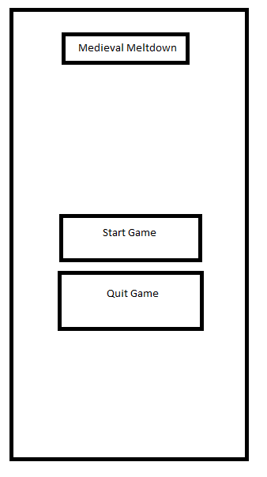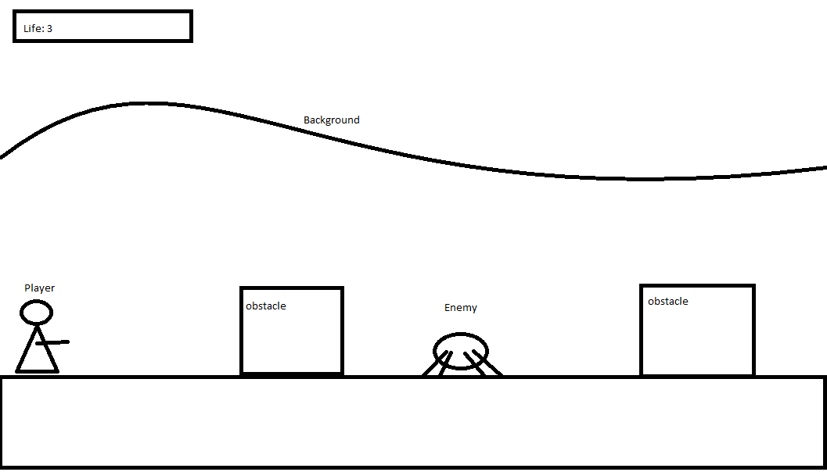

**Level 2**

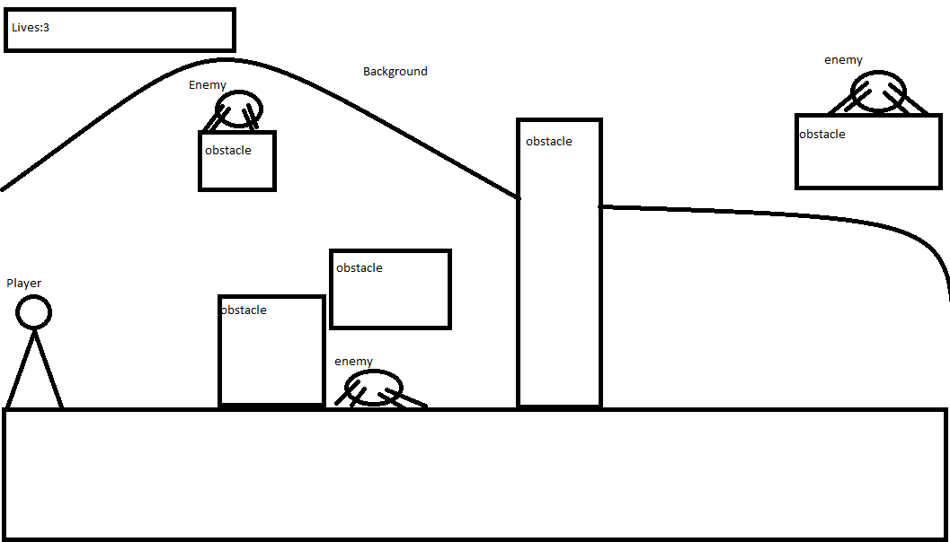

**PG.6**

**Menu and Screen Descriptions**

**PG. 7**

**Art/ Sound Index**

**Player sprite**



**Enemy sprite**

**C:\Users\Dennis\Desktop\sprites\golem.png**

**Brick Tile**



**Dirt blocks**

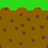 

**End Point**



**PG 8**