Exploiting a Natural Network Effect for Scalable, Fine-grained Clock Synchronization (nsdi18-geng)
Huygens is a software clock synchronization system that uses a synchronization network and leverages three key ideas. First, coded probes identify and reject impure probe data—data captured by probes which suffer queuing delays, random jitter, and NIC timestamp noise. Next, HUYGENS processes the purified data with Support Vector Machines, a widely-used and powerful classifier, to accurately estimate one-way propagation times and achieve clock synchronization to within 100 nanoseconds. Finally, HUYGENS exploits a natural network effect—the idea that a group of pair-wise synchronized clocks must be transitively synchronized— to detect and correct synchronization errors even further. HUYGENS is implemented in software running on standard hardware, it can be readily deployed in current data centers.

The Huygens algorithm synchronizes clocks in a network every 2 seconds in a “progressive-batch-delayed” fashion. Probe data gathered over the interval [0, 2) seconds will be processed during the interval [2, 4) seconds (hence batch and delayed). The algorithm completes the processing before 4 seconds and corrections can be applied to the timestamps at 1 sec, the midpoint of the interval [0, 2) seconds.
data pairs are the probes: each server probes(NICs) 10–20 others, regardless of the total number of servers in the network.
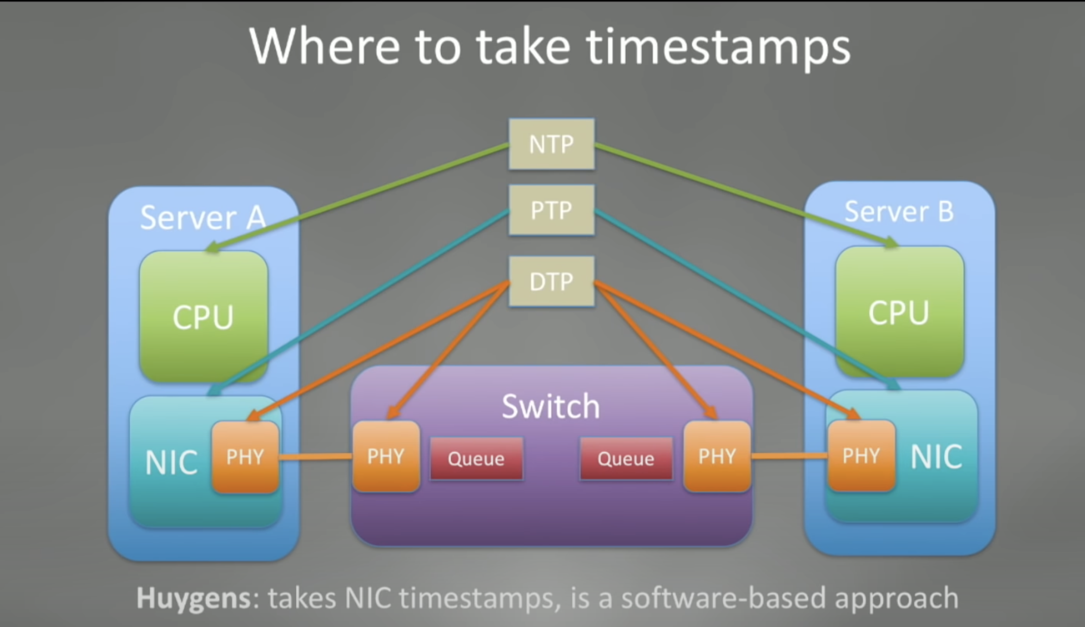
Cleaning: Coded probes filter out invalid probes.
Model: Run linear SVM with filtered probes to get the slope and intercept.
Test & performance: In a 40 Gbps data center testbed, HUYGENS only takes around 0.05% of the link bandwidth and less than 0.44% of a server’s CPU time.

Each Iteration:
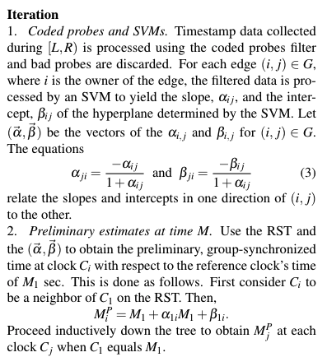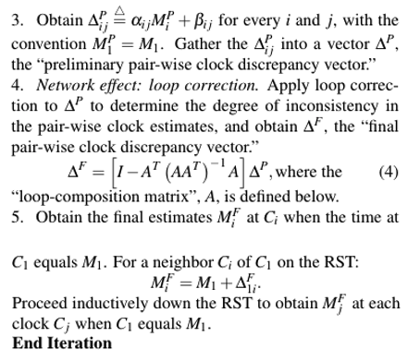

Why only NICs? SVMs provide much more accurate estimates of propagation times between a pair of NICs than possible by the simpler processing methods employed by NTP and PTP.
Why only SVM and why not regression? simple techniques such as estimating min-RTT or linear regression to process the probe data do not work. They can filter out large delays but cannot cope with small-magnitude path noise and are adversely affected by the negative-delay components which artifically shrink the OWD. The combination of coded probes and SVMs copes well with these problems.

