ChronoVisor in ChronoLog - master global clock
In this paper, we show how data consistency can be built around a system that uses physical time as a data identifier and handles the clock uncertainty and drift rate. A similar approach has been used by Spanner [65], Google’s globally-distributed database. Spanner uses physical time to globally distribute replicas of a database by modelling the clock uncertainty.
E. Ramifications of Physical Time: One key insight this paper offers is that using time as a method to distribute and order data is beneficial since it avoids expensive locking or synchronization mechanisms. However, this approach assumes that time is the same across all participants, something that is not true in most computing systems. Our thesis is that using physical time only makes sense in a log context, not in a general storage abstraction, since it is an append-only data structure that only moves forward, like a clock does. It is beneficial to deal with the ramifications of physical time to achieve higher performance and scalability.
The ChronoVisor handles client connections and chronicle metadata information. It also acts as the global clock enforcing time synchronization between all server nodes participating in a ChronoLog cluster. The ChronoVisor is deployed on its own server node (usually a head node).
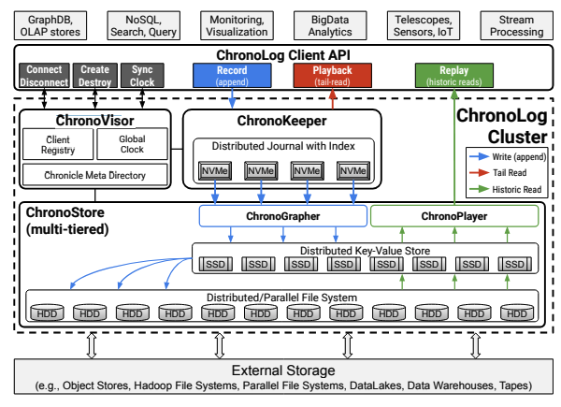
Clients have to first connect to a ChronoLog cluster by registering to the ChronoVisor. During connection, clients receive the ChronoVisor’s base clock value and its clock drift rate that are used to calculate the client’s time distance from the cluster. No client time synchronization is required (i.e., no need to change the client’s machine clock) since ChronoLog handles time relative to a global time reference, that of the ChronoVisor in a cluster.
