### Depicting U.S.-China Disputes on Tech Giants through Social Media: An Attempt of Computational Political Communication

*Author(s) Names(s): Anonymous ICME Submission*

#### Abstract

Computational political communication based on big data analytics of social media texts brings a prospecting framework to understand public's perception of and interaction with political issues globally. This study collects a large scale of user-generated data on Twitter for delineating online political communication dynamics upon U.S.-China disputes. Tech giants Huawei, Tencent and ByteDance are chosen as epitomes of U.S.-China power game to grasp more detailed opinions. Seven English-speaking countries: U.S., UK, Canada, Australia, New Zealand, India, and Pakistan, are selected as keywords for filtering among tweets collected from March September 2020 across the globe. An automated text-based sentiment analysis is conducted. This study shows that the popularity of discussions about certain country and company is not consistent, and might be event-induced. Also, discourse of all these companies are inter-related rather than separated. This research facilitates future study including fine-grained and categorized sentiment analysis and VICS to depict online public opinions.

**Index Terms—** Big data, Social media, Computational political communication, U.S.-China disputes, Tech giants, Twitter

**1. Introduction**

Big data analytics and social media are shedding new light on the interdisciplinary study of political communication. For the first time in history, researchers are faced with profuse political information and comments generated by ordinary citizens on social media, empowering them to explore the dynamics of public opinion on critical issues.

U.S.-China bilateral relation has become one of the most influential agenda in contemporary global politics. Over the past few years, started from increasing mutual tariffs, to the escalating conflicts embodied in almost every aspect of the two countries' interaction including international governance and national security, U.S.-China disputes have drastically altered the ecosystem for global trade, investment and supply chains. Most specifically, from the blacklisting of semi-conductor suppliers for Huawei, to the ban of TikTok alongside with WeChat, tech giants with a Chinese background are to a great extent posed as epitomes of the competitive power game scenario [1-2].

Despite its friendly and goodwill showbiz in the first two years, the Trump administration has then embedded a pivot of America's policy towards China. Published in December 2017, "National Security Strategy of the United States of America" initiates Washington's novel definition of China as a "competitor" "rival" "adversary" and "revisionist power", which served as curtain-raiser for the upheaval until this day [3]. With rising nationalism domestically and intensifying pressure externally, Chinese decision makers, on the other hand, have also been adopting a more "assertive" and "uncompromising" approach in both *Aussenpolitik* and *Innenpolitik* which inevitably accounts for de facto "lex talionis" deadlock [4].

The post-COVID-19 pandemic era has witnessed an exacerbated "decoupling" between the two major powers [5]. A vis-à-vis confrontation and retaliation has been projected to not only the sphere of trade but more structurally impacting the network of "global tech" constructed via cooperative efforts within last two decades. As a milestone of on-going industrial revolution, new phase of globalization and forefront of free trade, international tech giants have their roots in crossing-border information exchange, and simultaneously contribute to deepening the connection of "global village" [6-8].

Huawei, with its headquarter located in Shenzhen, is a representative telecommunication hardware manufacturer and flagship smart device company of China. In 2020, this 5G titan has ultimately met with the suppression from U.S. featuring the forced outage of its semi-conductor suppliers including TSMC, Samsung and SK Hynix [9]. China-based software companies have also been dramatically impacted in 2020 by the "Clean Network" action plan of U.S. government. TikTok, a social media app for short videos of ByteDance, and WeChat, another app for instant message, audio and video calls owned by Tencent, are recently included in the blacklist of Washington. Not until these latecomer high-tech innovators enjoyed their unprecedented international boom, they are confronted with the strike that may end their game in the U.S. or even all U.S. allies [10].

This study looks into Huawei, ByteDance and Tencent for their representativeness of hardware and software providers impacted by U.S.-China disputes, and for their huge user scale and global influence. Moreover, WeChat has its major income from Chinese Mainland while TikTok is an international market-oriented app. This can also serve as a comparison. Internet tech giants are considered to be the watershed of China's rise as a global competitor in technology, innovation and tertiary industry whereas at the same time an epicenter of China's "challenge" and "threat" to the U.S..

In this digital era, while state behaviors, state-company relations and geopolitical power plays can be more precisely and directly depicted from macroscopical policy-making level, the public's perception and interaction also constitute a fundamental sector to the decision-making process, possibly more profoundly than ever. Twitter, among all major global social media platforms, has its characteristics as an internationally connected, weak ties-based "public sphere", facilitates this study to depict a more comprehensive view of U.S.-China disputes [11-13]. Therefore, this study chooses Twitter data for delineating online political communication dynamics.

In this study, names of seven major English-speaking countries, namely, the United States, the United Kingdom, Canada, Australia, New Zealand, India, and Pakistan, are selected as keywords for filtering among all the Twitter data collected over six months across the globe. The U.S., UK, Canada, Australia and New Zealand are also known as "Five Eyes Alliance", which is an intelligence-based strategic ally group with its origin as "UKUSA" from the Second World War [14]. This study also notices the strong geopolitical proximity between India, Pakistan and China. These two South Asian countries, acknowledged as the biggest English-speaking countries adjacent to China and together populated over 1.5 billion, cast huge impact on China's overseas market and foreign strategies [15]. Names of the three Chinese tech giants, Huawei, Tencent, and ByteDance, are also used to target relevant tweets.

How does online public opinion perceive and respond to the disputes between America and China? What is the picture of social media discourse on specific tech giants? To our knowledge, this is the first study dedicated to answering these questions. In the second section, we will provide a concise review of the transition of political communication studies, and point out its promising future for both social and data scientists. Then, we go on to introduce preliminary findings of our Twitter data. Discussions and conclusions are offered at the end. This study hopes that publication of the dataset and its findings can inspire and facilitate more social science and data science scholars to participate in further research.

**2. EXISTING WORKS: ACHIEVEMENTS, DEFICIENCIES, AND EXPECTATIONS**

This section summarizes existing works in understanding the dynamics of public opinion, pointing out its shift from traditional media to social media and the impetus behind it. We show that large-scale social media data ensures a promising future for the interdisciplinary study of political communication as well as social simulating and modelling.

**2.1. Traditional media and surveys in the beginning: Efforts by social scientists**

Media framing of certain countries, issues or important figures have long been one of the most popular topics among political communication researchers. The manually-coded methods, e.g., text analysis, discourse analysis and content analysis, are widely adopted in the studies of images and agenda constructed by different media sources. While a majority of the researches by social scientists still focus on traditional media, namely newspapers, magazines, TVs, etc.

In recent years, China has won more and more attention to its international image presentation. Golan and Lukito's [16] describes the rise of China via looking into American Newspaper' "opinion articles" on China. Golan et al. reckons that opinion journalism, including "editorials" and "co-eds" of major newspapers, embodies the most clearly how a country's elites community is thinking about certain issues. This research mainly utilizes the inductive qualitative framework of analysis, looking into the Wall Street Journal (WSJ) editorials and the op-eds on China's rise. The text analysis focuses on key statements, positive or negative attitudes and use of quotes. It presents that "economic partnership", "internal dispute", "geopolitical threat" and "economic threat" are the main categories of WSJ's narrative framework. Golan et al. carried out the analysis based on a belief that the elites of society are responsible and influential to foreign policymaking. Similar frameworks are universally adapted in social scientist's research on media framing and international image-related topics.

While public opinion's response to certain countries and issues are becoming more well-attended in academia these days, classic methodology including surveys are applied in numerous social science researches. Yang [17] carried out the study on how China's image affect China's product selling in the United States. Focusing on public opinion as a key factor in this research, participants were recruited in a medium city of Ohio in both ways: printed and online questionnaires (On Facebook). However, this approach to depict public opinion about China's country-of-origin image still faces with questions that, is it comprehensive enough, and is it the most efficient way to do the research?

The Verb In Context System (VICS) is also an early attempt to understand the mentality of people, especially political leaders [18]. Based on the 1969 study of the "operational code" [19], the VICS analyzes people's political opinion and beliefs on power, predictability, role of chance, etc., through their use of verbs found in public accessible speeches and policy text. An exhaustive dictionary was established to provide reference to the orientation of each verb, e.g., friendly or hostile, optimistic or pessimistic. The VICS is widely used for study political figures [20-24], where methods including “Leadership Traits Analysis (LTA)” are adopted to depict the process of political decision making of leaders, especially when analyizing leaders’ personality’ influences during disputes and even armed conflicts [25], while its generalization to the public remains somehow stagnant, at least partly due to a lack of available texts written by ordinary citizens.

**2.2. The advent of social media: Promises for data scientists**

Entering the era of social media, the openness and user-generating nature of cyberspace empowers general public to express and construct online discourse. According to a Pew Research Center report, more than 40% of American adults accessed to information for the 2016 presidential election via social media, which provides a simple example for this ubiquitous phenomena nowadays. The rapid development of computer science enables data scientists to directly study the public's opinion for the first time. Opposite to traditional researchers' focus on limited information sources and target population, data scientists have been working to discover more latent and complex information from broader social media data.

Sentiment analysis is a frequently employed technique for study social media data in text modality. The basic goals of sentiment analysis are emotion recognition and polarity detection [26, 27]. Many researches used this method to explore country images, evaluate international relations, and predict electoral results. Xu et al. [28] and Chen et al. [29] are both event-based country image study with Twitter data, observing online public opinion during the 70th anniversary of the People's Republic of China and the COVID-19 pandemic, respectively. Their data was retrieved through Twitter Streaming API, and sentiments towards China (positive, negative, neutral) were analysed with machine learning algorithms trained on manually labelled data. Their features include: 1) Xu et al. collected and compared English and Chinese data, while Chen et al. focused on English discourse. It was found that a significant opposition existed between the online public opinions towards China of the two languages. 2) Chen et al. provided fine-grained sentiment analysis by dividing online public opinion towards China into seven categories: Politics, Economy, Foreign affairs, Culture, Epidemic situation, Anti-epidemic measures, and Racism. They revealed that the gradual increase in negative politics-, foreign affairs-, and racism-related tweets and the decrease in non-negative epidemic situation-, anti-epidemic measures-related tweets resulted in the overall sentiments' transition from non-negative to negative towards China. 3) Chen et al. displayed the different patterns in the attitudes of Congress members, media, and social bots, showing that social bots were more likely to spread negative sentiments towards China, while media were usually non-negative. For U.S. congress members, the Republicans were more negative than the Democrats. 4) Xu et al. explored how positive and negative tweets were distributed among different countries and found that states enjoying better diplomatic relations with China generally had a positive view towards China. 5) Xu el al. obtained word vectors for the top 100 frequently and uniquely used words for both English and Chinese, positive and negative tweets through word2vec. Preferred topics of distinct languages and sentiments were analysed, e.g., positive Chinese tweets mostly focused on celebration activities while negative Chinese tweets tended to talk about broader topics like Hong Kong.

Chambers et al. [30] modelled relations between nation states using sentiments revealed in Tweets with country names. Seventeen months of Twitter data was collected and aggregated sentiments for nation pairs were calculated with support vector machine. The results indicated an alignment between human polls and social media sentiments, verifying the validity of applying social media data to infer international relations.

Predicting election results with social media data is also a focus for researchers. Related works include [31-34]. Other papers addressing online public opinion towards political events include [35-37].

**2.3. The era of interdisciplinary collaboration: Computational political communication**

Despite the considerable endeavour and contributions the above-mentioned works made to the emerging field of computational political communication, the shortcomings of them are also prominent. Their implications to social challenges are vague. With their vision limited to describing general pictures, the advanced computational techniques are not fully utilized to answer more meaningful questions and bring about possible solutions. Meanwhile, a lack of real-time, or 'nowcast', analysis, which has the potential to detect major events at an early stage and provides governments and the society with necessary notifications, also stands out as a major deficiency for existing studies.

From the global communication perspective, it can be anticipated that a more comprehensive and real-time computational research on social media will become increasingly significant for academia and policy-makers. Computational political communication is undoubtedly a rising field for interdisciplinary collaboration, with social scientists' intrinsic dedication to find questions and create meanings and data scientists' capability to initiate more sophisticated quantitative researches. Data scientists should be encouraged to engage in more of these interdisciplinary research, honing and experimenting their methodologies and theories [38, 39].

**3. DATA COLLECTION AND ANALYSIS**

**3.1. Data Collection**

**Table 1.** Names and synonyms of countries and companies

| Type | Names and synonyms |
| --- | --- |
| Countries | 'the us', 'UnitedStates', 'United States', 'the states', 'America', ' uk ', 'UnitedKingdom', 'United Kingdom', 'Britain', 'Canada', 'Australia', 'aussie', 'NewZealand', 'New Zealand', 'India', 'Pakistan' |
| Companies | 'huawei', 'hua wei', 'bytedance', 'byte dance', 'zijietiaodong', 'zi jie tiao dong', 'tiktok', 'tik tok', 'douyin', 'dou yin', 'tencent', 'tengxun', 'teng xun', 'wechat', 'weixin', 'wei xin' |

The data analyzed in this study is collected through Twitter Streaming API, which allows users to retrieve tweets with designated hashtags. Since the dataset is expected to support research in a broader context and is not specific to this study, the hashtags for retrieving data are designed to include all major countries in the world (5 permanent members in the UN security council, G20 countries, OECD countries) and countries enjoying close contact with China (member states of Shanghai Cooperation Organization and the Association of Southeast Asian Nations, North Korea). The collection started from March 4, and will continue until next march. This study uses the data form March 4 to September 14, 2020.

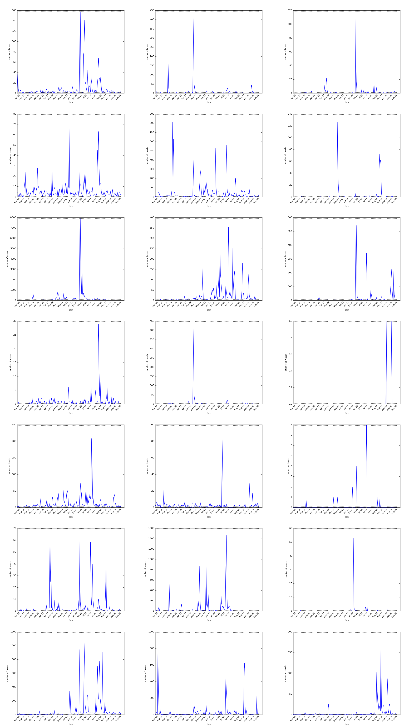

**Fig. 1.** Number of tweets discussing the seven countries and the three companies, from March 4 to September 14. (*from top to down: Australia, Canada, India, New Zealand, Pakistan, the United Kingdom, the United States; from left to right: ByteDance, Huawei, Tencent*)

Later, we filter the collected data with the following criteria: a tweet should simultaneously include names or synonyms of at least one of the seven English speaking countries and the names or synonyms of at least one of the three Chinese tech giants in order to be kept. The names and synonyms are shown in Table 1. Please note that the names and synonyms are case-insensitive, since all the tweets and names would be changed into lower case before filtering. At last, a total of 83,597 tweets were selected for this study.

**3.2. Data Analysis**

*3.2.1. Quantitative Characteristics and Linguistic Preferences*

This part reveals the quantitative characteristics and linguistic preferences of tweets linked to different countries and companies.

Fig. 1 displays the number of tweets talking about the seven chosen countries and the three selected companies during March 4 and September 14. It can be found that the ups and downs in popularity of country-company topics are significant: rarely mentioned in most days and intensively discussed in certain periods, possibly after an important event. Some events may induce massive discussions related to the same company in multiple countries, e.g., following India's ban on TikTok on 29 June, a peak of related tweets appear in Australia, India, U.K., and U.S. Also, public attention towards the three companies are uneven. Huawei receives the most mentions when people are simultaneously talking about Australia, Canada, New Zealand, and U.K., while ByteDance enjoys the popularity in India, Pakistan, and U.S.

Fig. 2 reveals the word vectors of frequently mentioned words (appeared more than 1,000 times in our collected corpus) by tweets related to different countries and companies. Limited by space, this paper only shows the word vectors of Australia, Pakistan, U.K., U.S.-related tweets. The word vectors were calculated through word2vec. It can be observed that, for any given country, words from tweets related to different companies generally form only one cluster, entangling with each other, rather than distributing separately. It indicates that discourse of all these companies are inter-related. The colors also provide an intuitive image of which company is more widely discussed, e.g., the prominent green in the U.K. picture tells that Huawei was more frequently talked about.

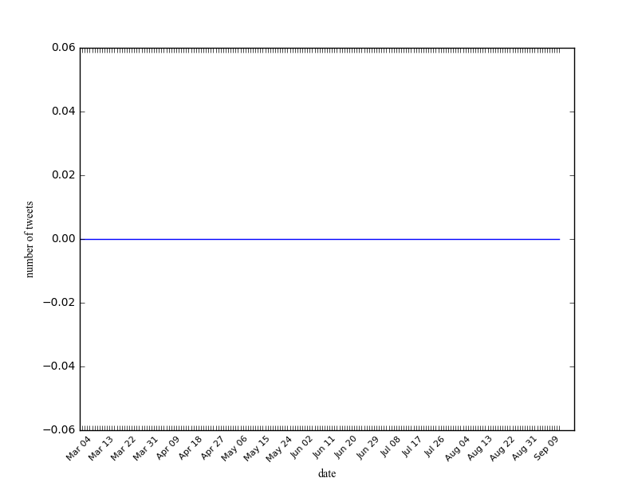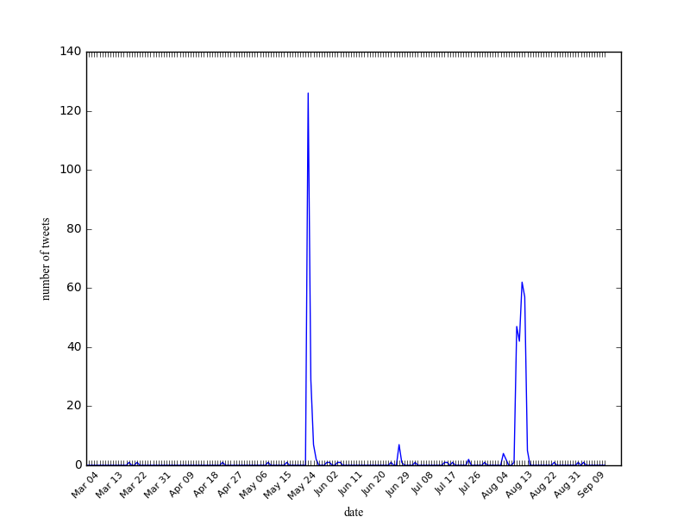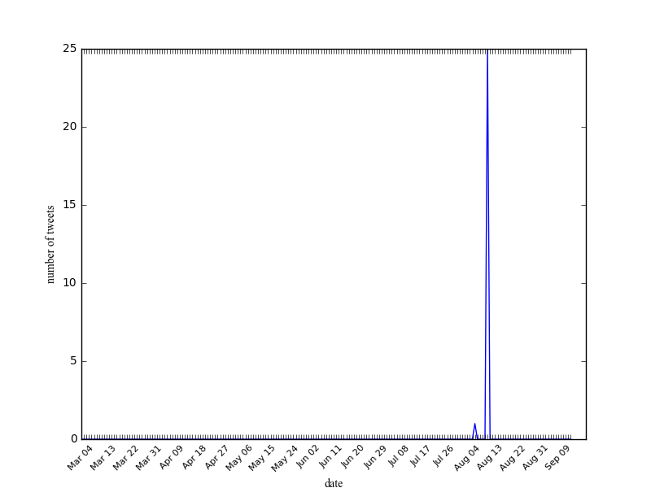

**Fig. 4.** Number of positive (left), neutral (middle) and negative (right) tweets mentioning Canada and Tencent.

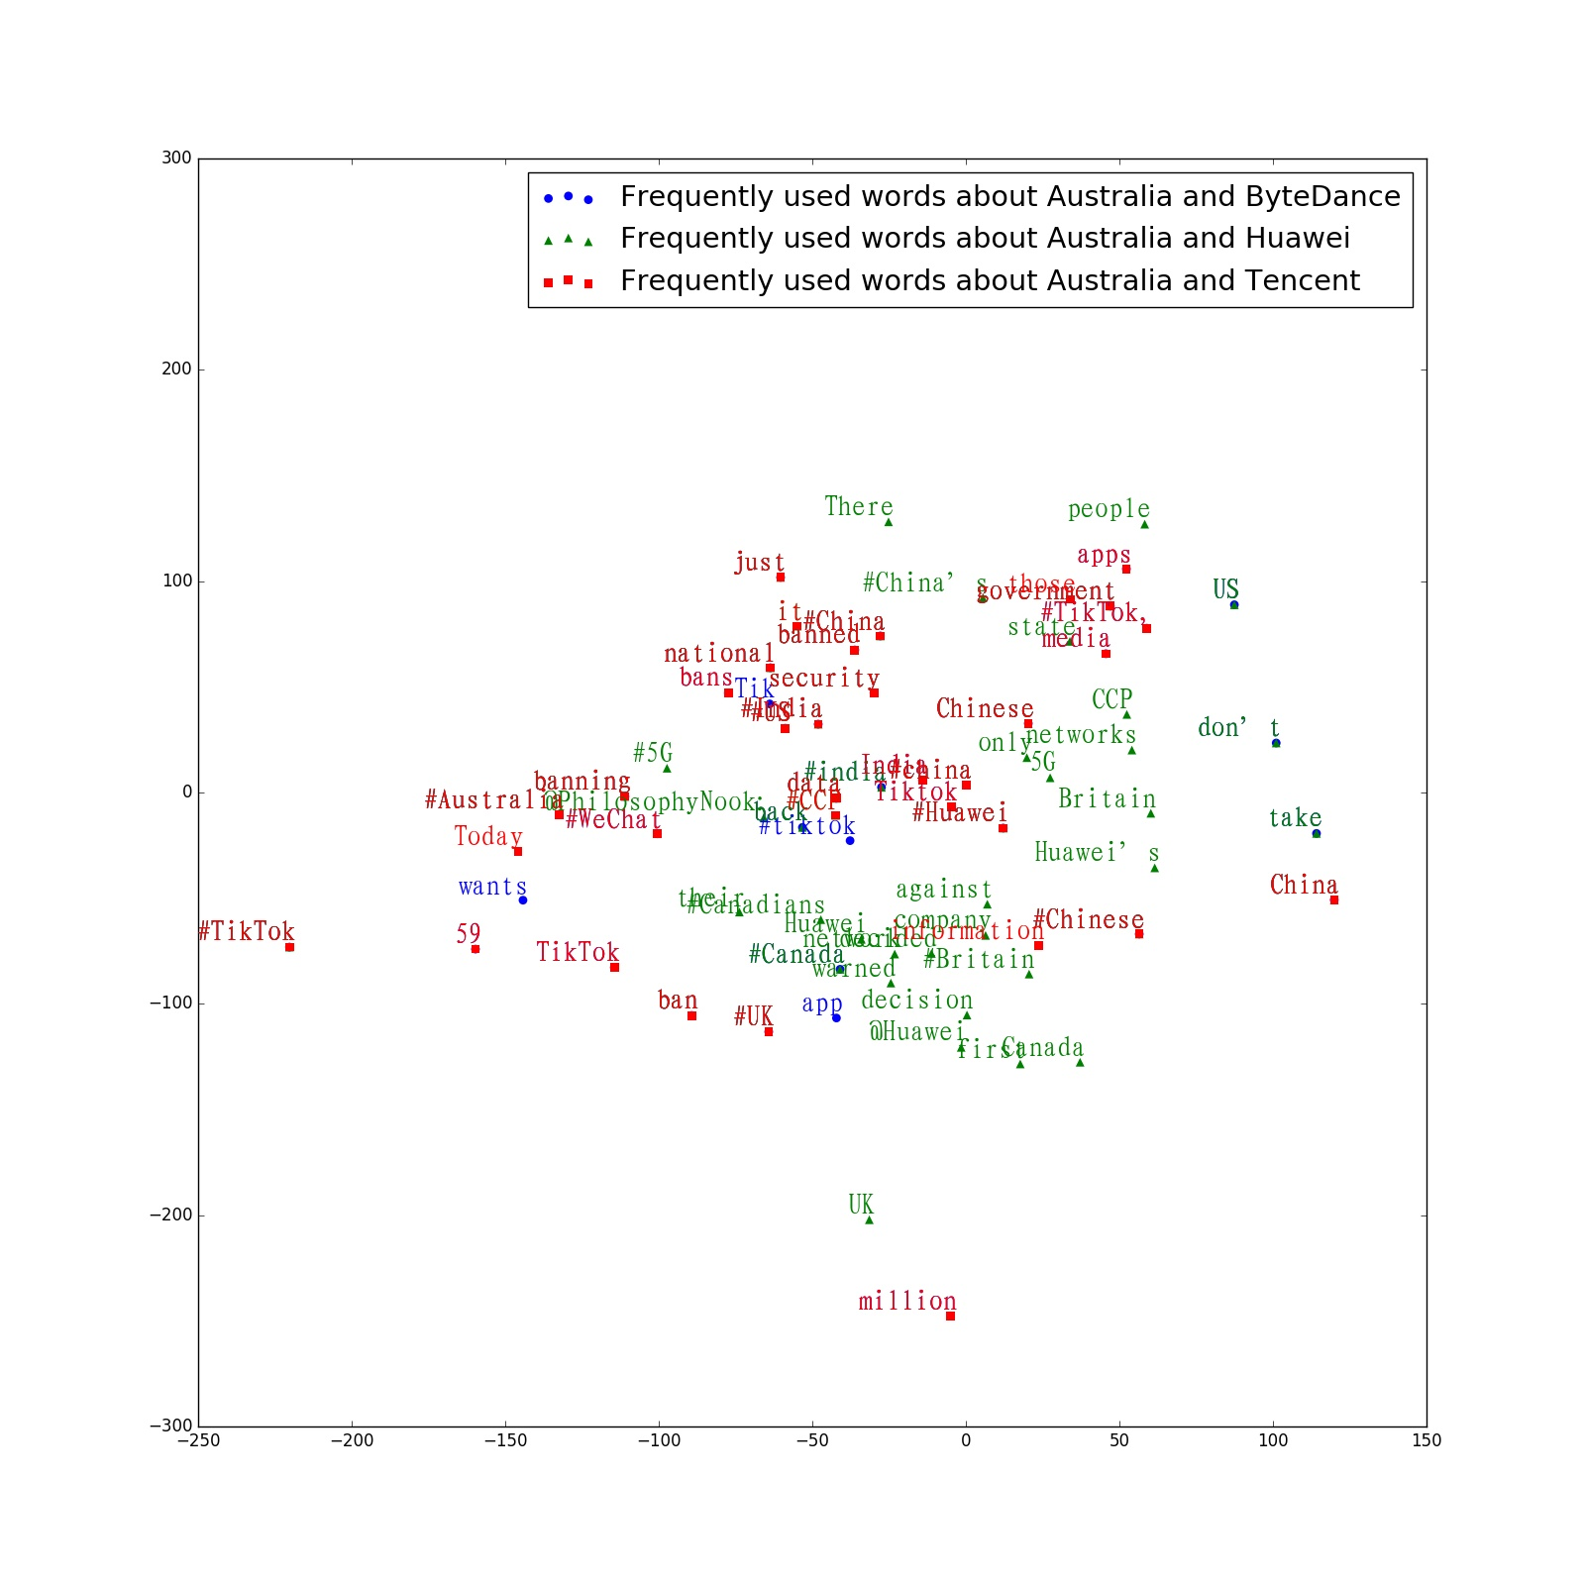 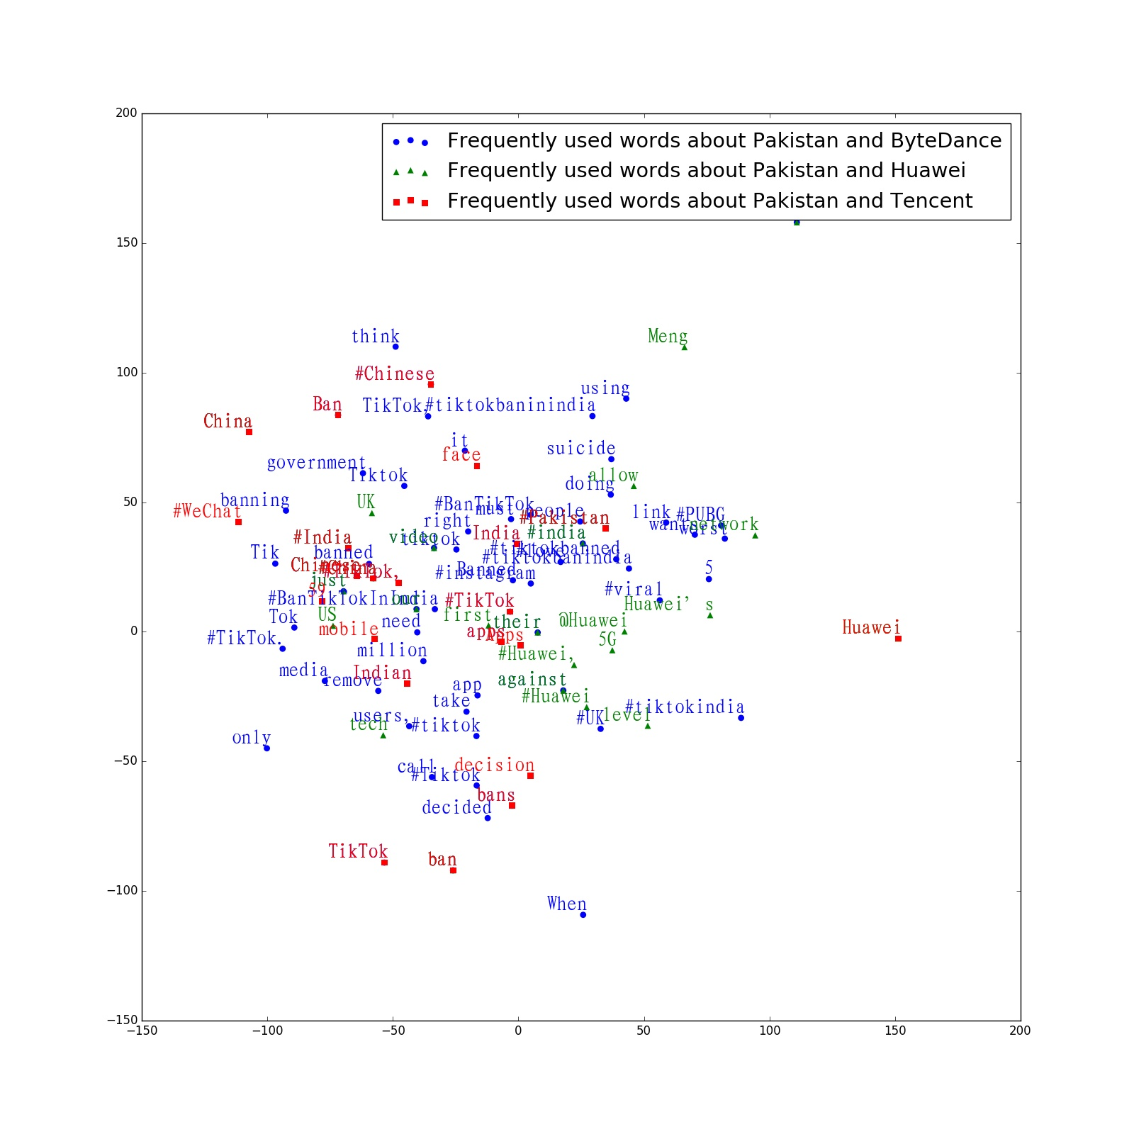

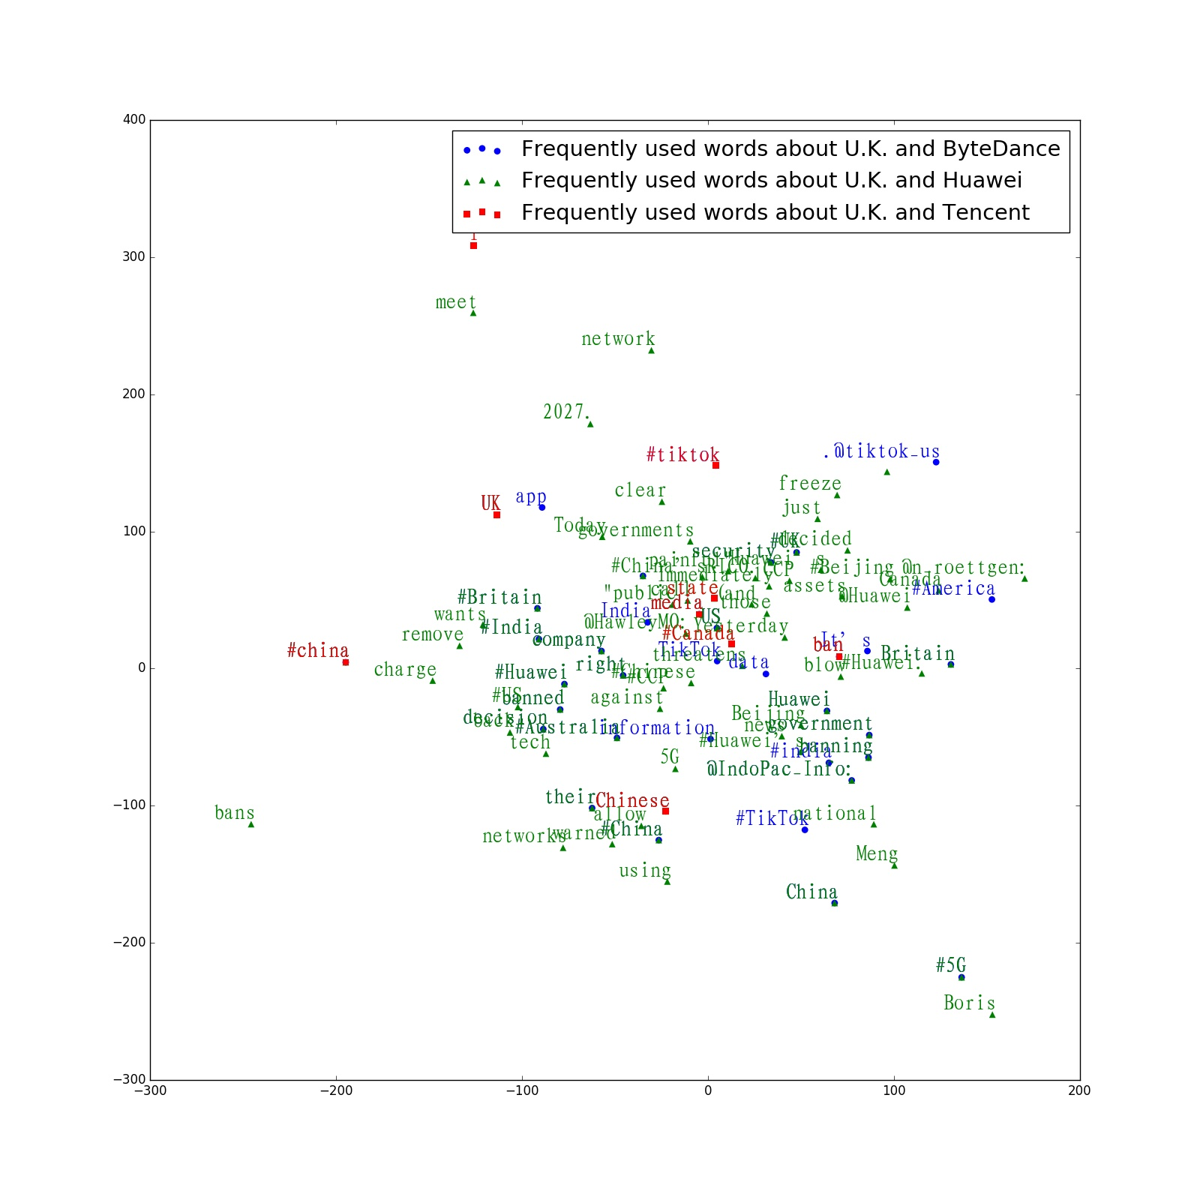 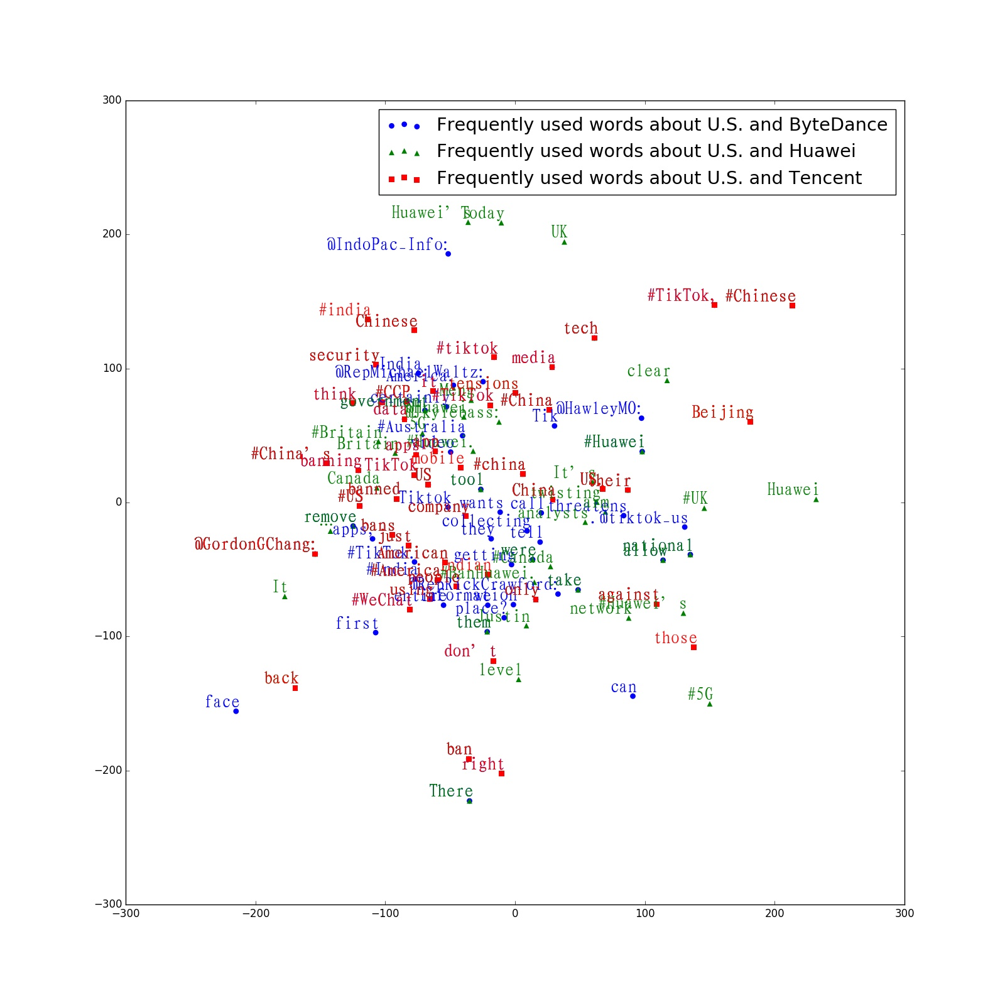

**Fig. 2.** Word vectors of frequently mentioned words. (from top to down and left to right: Australia, Pakistan, U.K., U.S.)

*3.2.2. Sentiments of the Tweets*

This section uses an unsupervised sentiment analysis method to show the attitudes of twitter users when they mention the countries and companies of interest.

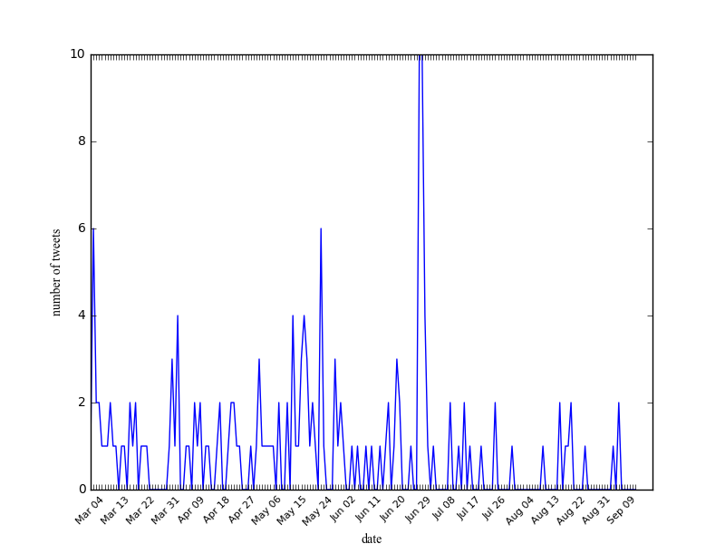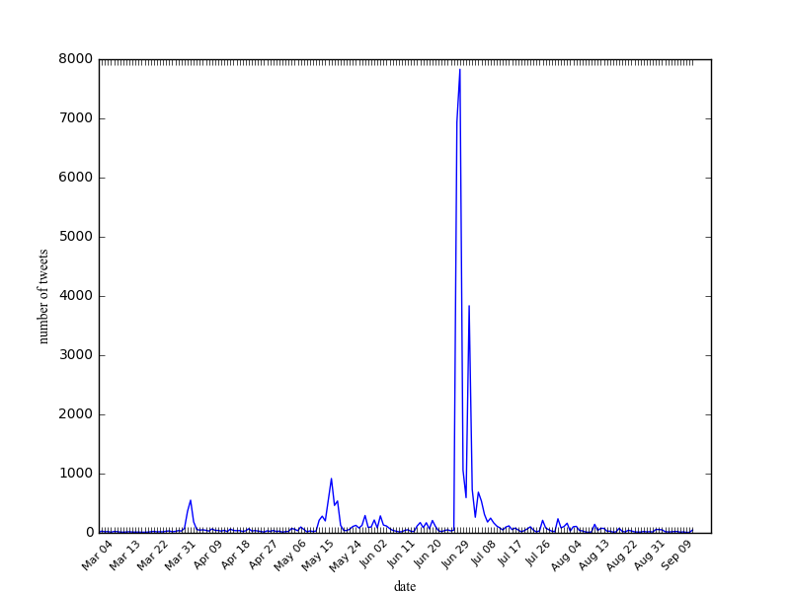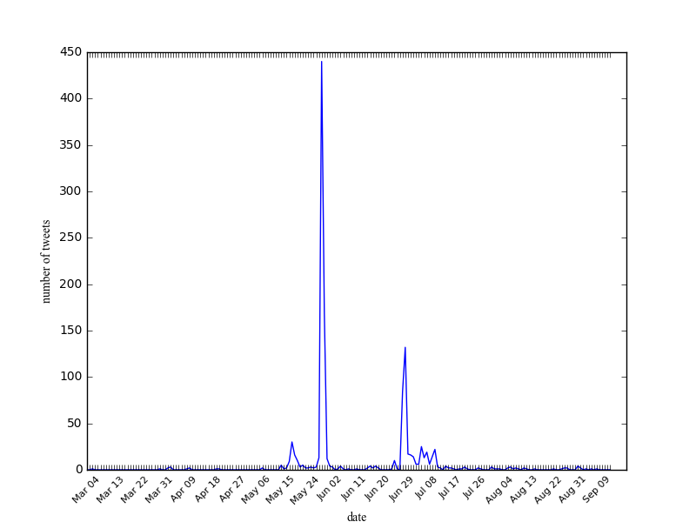

**Fig. 3.** Number of positive (left), neutral (middle) and negative (right) tweets mentioning India and Bytedance.

The algorithm in this study is an adapted version of the technique developed by Vashishtha and her colleague in 'Fuzzy Rule based Unsupervised Sentiment Analysis from Social Media Posts' [40]. With the Mamdani system and nine fuzzy rules, every tweet was classified as positive, negative, or neutral.

Fig. 3 to Fig. 4 are the fluctuation of the number of positive and negative tweets mentioning selected country-company pairs. It can be observed that most tweets are neutral, but negative tweets also significantly outnumber positive ones.

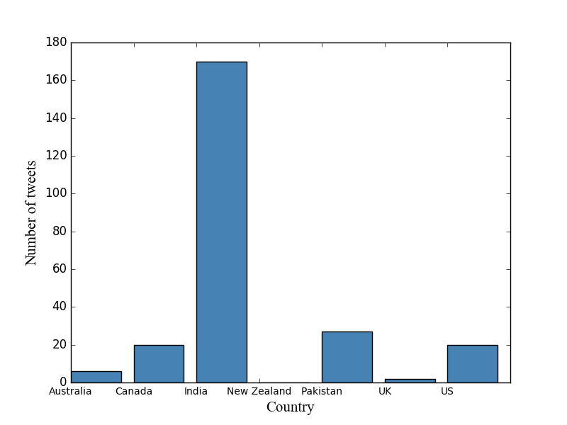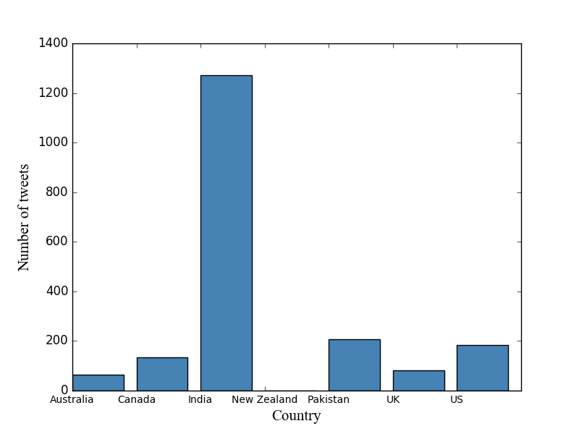

**Fig. 5.** Number of positive (left) and negative (right) tweets about Chinese tech giants when mentioning the seven English-speaking countries.

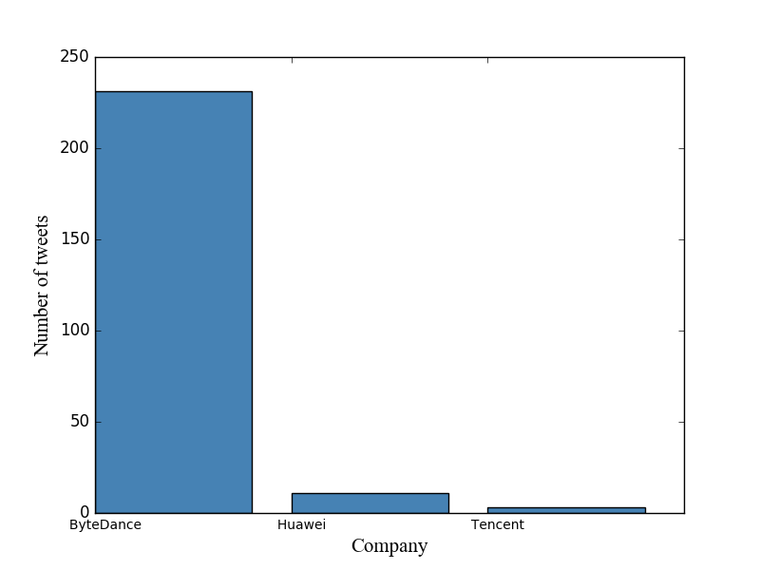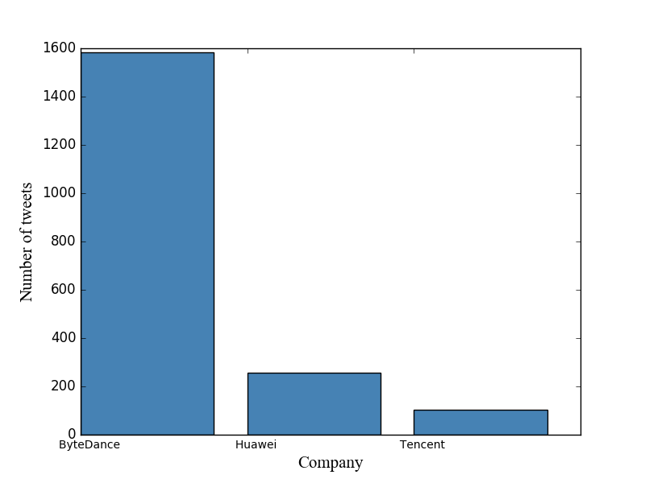

**Fig. 6.** Number of positive (left) and negative (right) tweets about the seven English-speaking countries when mentioning Chinese tech giants.

Fig. 5 and Fig. 6 show the number of positive and negative tweets in our data set about every country and company. India and ByteDance are the ones that attracts most attention on Twitter when discussing issues about countries and Chinese tech giants. And the rankings of the number of positive and negative tweets containing country names and company names are generally the same.

**4. CONCLUSIONS AND DISCUSSIONS**

The bilateral relation between U.S.-China in the past few years have been witnessing a "freefall", posing concern to global governance and international order. Social media, with its crossing-border and user-generated nature, provides a promising field for computational political communication research, which enables us to understand the mechanism of online public opinion's perception and interaction with global politics.

This study highlights the prospect computational political communication has for people's understanding of political events in the Internet era. After summarizing researchers' transition from traditional media and survey to large-scale social media data, we introduce a new Twitter dataset and provide an example for the use of such data by revealing its quantitative features and sentiment characteristics. Future research will include 1) From social scientists' perspective: generating more political communication questions that can be solved with large-scale social media data and computational methods and can facilitate high quality social governance & maximize the utility of all social participants; 2) From data scientists' perspective: developing more fine-grained sentiment analysis algorithms to discover latent information about the political leanings of Internet users, and realize real-time analysis.

**5. References**

1. M. Goodman et al., "Perspectives on the Global Economic Order in 2019: A U.S.-China Essay Collection," Center for Strategic and International Studies (CSIS), 2019.
2. C. Rosset, "Huawei Ban Means the End of Global Tech," *Foreign Policy*, vol. 17, 2019.
3. "National Security Strategy of the United States of America," The White House, Washington, 2017.
4. M. Clarke, "Beijing’s Pivot West: The Convergence of Innenpolitik and Aussenpolitik on China’s ‘Belt and Road’?," *Journal of Contemporary China*, vol. 29, no. 123, pp. 336-353, 2020.
5. T. Bernes et al., "Challenges of Global Governance Amid the COVID-19 Pandemic," Council on Foreign Relations, 2020.
6. A. Fatma and N. Bharti, "Perception vs. reality: understanding the US–China trade war," *Transnational Corporations Review*, vol. 11, no. 4, pp. 270-278, 2019.
7. A. Wyne, "How to Think about Potentially Decoupling from China," *The Washington Quarterly*, vol. 43, no. 1, pp. 41-64, 2020.
8. J. Barevičiūte, "The locality of the “global village” in the aspect of communication: Pro et contra m. McLuhan," *Limes: Cultural Regionalistics*, vol. 3, no. 2, pp. 184-194, 2010.
9. L. Guo, M. Y. Zhang, M. Dodgson, and D. Gann, "Huawei's catch-up in the global telecommunication industry: innovation capability and transition to leadership," *Technology Analysis & Strategic Management*, vol. 31, no. 12, pp. 1395-1411, 2019.
10. "The Clean Network." Secretary of State. https://www.state.gov/the-clean-network/ (accessed Sep 21, 2020).
11. M. Castells, "The New Public Sphere: Global Civil Society, Communication Networks, and Global Governance. " The ANNALS of the American Academy of Political and Social Science,vol. 616, no.1, pp. 78–93. 2008.
12. J. Habermas, S. Lennox, and F. Lennox. "The Public Sphere: An Encyclopedia Article (1964)." New German Critique, no. 3: pp. 49-55,1974.
13. C. B. Williams, "Introduction: Social media, political marketing and the 2016 US election," ed: Taylor & Francis, 2017.
14. S. Albers, F. Wohlgezogen, and E. J. Zajac, "Strategic alliance structures: An organization design perspective," *Journal of Management*, vol. 42, no. 3, pp. 582-614, 2016.
15. Y. Sun, "China and South Asia Crisis Management in the Era of Great Power Competition," Norwegian Institute for International Affairs (NUPI), 2020. Accessed: 21 Sep. 2020. [Online]. Available: www.jstor.org/stable/resrep25750
16. G. J. Golan and J. Lukito, "The rise of the dragon? Framing China’s global leadership in elite American newspapers," *International Communication Gazette*, vol. 77, no. 8, pp. 754-772, 2015.
17. C. Yang, "How China’s image affects Chinese products in a partisan-motivated US market," *Global Media and China*, p. 2059436420922702, 2020.
18. M. Schafer and S. G. Walker, "Operational code analysis at a distance: The verbs in context system of content analysis," in Beliefs and leadership in world politics: Springer, 2006, pp. 25-51.
19. A. L. George, "The 'operational code': A neglected approach to the study of political leaders and decision-making," *International studies quarterly*, vol. 13, no. 2, pp. 190-222, 1969.
20. S. G. Walker, "Anticipating attacks from the operational codes of terrorist groups," *Dynamics of Asymmetric Conflict*, vol. 4, no. 2, pp. 135-143, 2011.
21. J. Renshon, "When public statements reveal private beliefs: Assessing operational codes at a distance," *Political Psychology*, vol. 30, no. 4, pp. 649-661, 2009.
22. J. Renshon, "Stability and change in belief systems: The operational code of George W. Bush," *Journal of Conflict Resolution*, vol. 52, no. 6, pp. 820-849, 2008.
23. S. B. Dyson, "Alliances, domestic politics, and leader psychology: Why did Britain stay out of Vietnam and go into Iraq?," *Political Psychology*, vol. 28, no. 6, pp. 647-666, 2007.
24. E. Cuhadar, J. Kaarbo, B. Kesgin, and B. Ozkececi‐Taner, "Personality or role? Comparisons of Turkish leaders across different institutional positions," *Political Psychology*, vol. 38, no. 1, pp. 39-54, 2017.
25. S. Dyson. "Personality and foreign policy: Tony Blair's Iraq decisions." Foreign Policy Analysis, vol. 2, no.3, pp. 289-306, 2006.
26. E. Cambria, "Affective Computing and Sentiment Analysis," *Ieee Intelligent Systems*, vol. 31, no. 2, pp. 102-107, Mar-Apr 2016, doi: 10.1109/mis.2016.31.
27. S. Poria, E. Cambria, R. Bajpai, and A. Hussain, "A review of affective computing: From unimodal analysis to multimodal fusion," *Information Fusion*, vol. 37, pp. 98-125, 2017, doi: 10.1016/j.inffus.2017.02.003.
28. Y. Xu, Q. He, and S. Ni, "Understanding Online Public Sentiments: A Machine Learning-Based Analysis of English and Chinese Twitter Discourse during the 2019 Chinese National Day," Manuscript accpted by The 2nd International Multidisciplinary Information Technology and Engineering Conference (IMITEC 2020).
29. H. Chen et al., "Country Image in COVID-19 Pandemic: A Case Study of China," *IEEE Transactions on Big Data*, pp. 1-1, 2020, doi: 10.1109/TBDATA.2020.3023459.
30. N. Chambers et al., "Identifying political sentiment between nation states with social media," in *Proceedings of the 2015 Conference on Empirical Methods in Natural Language Processing*, 2015, pp. 65-75.
31. N. Tsirakis, V. Poulopoulos, P. Tsantilas, and I. Varlamis, "Large scale opinion mining for social, news and blog data," *Journal of Systems and Software*, vol. 127, pp. 237-248, 2017.
32. A. Jungherr, H. Schoen, O. Posegga, and P. Jürgens, "Digital trace data in the study of public opinion: An indicator of attention toward politics rather than political support," *Social Science Computer Review*, vol. 35, no. 3, pp. 336-356, 2017.
33. J. C. A. D. Lopez, S. Collignon-Delmar, K. Benoit, and A. Matsuo, "Predicting the brexit vote by tracking and classifying public opinion using twitter data," *Statistics, Politics and Policy*, vol. 8, no. 1, pp. 85-104, 2017.
34. E. D'Andrea, P. Ducange, A. Bechini, A. Renda, and F. Marcelloni, "Monitoring the public opinion about the vaccination topic from tweets analysis," *Expert Systems with Applications*, vol. 116, pp. 209-226, 2019.
35. S. C. McGregor, "Social media as public opinion: How journalists use social media to represent public opinion," *Journalism*, vol. 20, no. 8, pp. 1070-1086, 2019.
36. N. J. Adams-Cohen, "Policy Change and Public Opinion: Measuring Shifting Political Sentiment With Social Media Data," *American Politics Research*, vol. 48, no. 5, pp. 612-621, 2020.
37. A. D. Leong and S. S. Ho, "Perceiving online public opinion: The impact of Facebook opinion cues, opinion climate congruency, and source credibility on speaking out," *New Media & Society*, p. 1461444820931054, 2020.
38. D. B. Margolin, "Computational contributions: a symbiotic approach to integrating big, observational data studies into the communication field," *Communication Methods and Measures*, vol. 13, no. 4, pp. 229-247, 2019.
39. W. van Atteveldt and T.-Q. Peng, "When communication meets computation: Opportunities, challenges, and pitfalls in computational communication science," *Communication Methods and Measures*, vol. 12, no. 2-3, pp. 81-92, 2018.
40. S. Vashishtha and S. Susan, "Fuzzy Rule based Unsupervised Sentiment Analysis from Social Media Posts," *Expert Systems with Applications*, vol. 138, p. 112834, 2019.