**Lack of Care in Framing Political Terminology:**

**A Reflection on U.S.-China’s Thucydides Trap**

Mingqi Xie, Yekai Xu

**Abstract**

The popularization of “Thucydides Trap” is attributed by many to de facto big power competition, whereas the intrinsic linguistic feature and the framing process of which should not be neglected. At this moment when U.S.-China relations has reached the “freezing point” after Covid-19, this research provides a reflection on the general “emergence-proliferation-acceptance” process of this term for policy-makers, academia (Google Scholar, CNKI) and media (New York Times, Wall Street Journal; People’s Daily, Global Times) on both sides. This study argues that (a) “Thucydides Trap” was framed to gain strong political implications and high political context, that (b) analogy and metaphor techniques used in the framing process entitled the term with great language efficacy in both domestic and cross-cultural communication and (c) this framing and acceptance process constructs a narrative and atmosphere of inevitable armed-conflicts under realism paradigm, overlooking the fundamental care for peace of human society and life of individuals.

**Keywords**

U.S-China Relations; Thucydides Trap; Framing; Political Terminology; Metaphor and Analogy; Rhetoric; Narration; Language Efficacy; Strategic Communication

**Introduction**

Thucydides Trap, as a terminology possessing implications on U.S.-China relations, gained its name after a Financial Times article warning the U.S of falling into a “trap” aggregated upon the Pacific Ocean. During the subsequent debate conducted by researchers and practitioners from both sides, the relationship between U.S. and China was depicted to have an historical parallel in the conflict between Athens and Sparta. While this term originated from a short newspaper commentary, to an academic buzzword, end up mentioned publicly by the President of China, it has been empowered with increasing significance.

The outbreak of COVID-19 pandemic has been witnessing an exacerbated “freefall” of U.S.-China bilateral relations, where the anticipated cooperation-competition symbiosis has been eclipsed by vis-à-vis confrontation and tit-for-tat retaliation. The “decoupling” between these two major powers to this day has put the world in a tense and worrisome atmosphere pondering about the possibility of dispute escalation or even an ultimate war, which was to some extent foretold by a popular expression in the past few years, the “Thucydides Trap”. (Smith & Fallon 2020[1]; Hatuel-Radoshitzky et al. 2020[2]; Wyne 2020[3])

When Graham Allison first depicted the Pacific as an inevitable battlefield for U.S and China because of two variables “rise and fear”, in his *Financial Times* article “*Thucydides’s trap has been sprung in the Pacific*”[4], his bold naming and predicting stirred discussion. In opinion article and his subsequent book “*Destined for war: America, China and Thucydides’s Trap*”, Allison (2017) argued that the rise of China has put America into fear and pressure, which in turn serves as rationale and stimuli for the America’s strategic change and diversion, resembling a historical apparel between the superpower and rising power, Athens and Sparta, who end up in the Peloponnesian War (B.C. 431–404). [5]Allison (2018) adds supplementary remarks that in a Thucydides Trap, there is highly possible a war to be commenced between the “Rising Power” and “Established Power” whereas there also exits several exceptions in history. [6]

While before any Sino-America armed conflict commences, the theoretical assumption or prediction by “Thucydides Trap” cannot be empirically tested as it stands. Barring the endurance and reliability of the theory itself, questions should be raised upon the process how this terminology has been accepted by researchers, practitioners and the press, especially when it was transmitted from U.S. to China, where it became a prevailing issue heating up widespread discussion for both the elites and the public. And the fact that Chinese scholarship and media initially accepted this terminology with limited hesitation, criticism and qualification, generating plentiful interpretation circling which has therefore inevitably pictured a negative future of U.S.-China bilateral relations. (Chen, 2018[7]; Qian, 2018[8]; Ren, 2018[9]) The de facto rising nationalism in Chinese society alongside with a more uncompromising and assertive foreign policy by the Chinese government are simultaneously reflecting the social atmosphere of “self-defense” and “preparing for war”. (Bhattacharya, 2017[10]; Helle, 2017[11]; Xie, 2018[12]; Xu, Xie et al., 2020[13])

Despite the unprecedented influence it projected both intentionally and unintentionally on Chinese academia, politics and even the public, few exhaustive researches have been done to focus on the framing and diffusion process of “Thucydides Trap” as a political terminology.

Based on the data set overviewing related publications in English (Google Scholar) and Chinese (CNKI, Baidu Scholars) academia and articles on representative Chinese (People’s Daily, Global Times) and U.S. media (Wall Street Journal, New York Times), this article provides an empirical reflection on how this terminology was accepted, crossing-culturally communicated and elevated. To depict the rationale of *framing-acceptance-communication*, this article analyzes the intrinsic linguistic features (Metaphor and Analogy) lying in the term that facilitated its communication power. As conclusion, this research points out the lack of general humanitarian care in the making of a prevailing political terminology, implying and even provoking potential armed-conflicts whereas circumventing emphasizing the destructive nature of it.

**Theoretical Formation of Thucydides Trap**

Previous to the theoretical assumptions presented by Allison in 2012, the representativeness and symbolism of the Peloponnesian War has aroused attention of the academia for a relatively long period of time. The conflicts between ancient Athens and Sparta was categorized into a systematic contradiction. (Welch, 2003)[14] The theory of “hegemonic war” also emerged from Thucydides’ narration of the Peloponnesian War. Some international relations researchers put that Thucydides in fact implies a discernible and recurrent course of a hegemonic war. (Gilpin, 1988) [15]

Learning from Athens and Sparta, it is concluded that a hegemonic war, in which regional and global hegemonies may cause fundamental power transition, originating from an initial phase of a stable international system dominated by a hegemonic power; and when a subordinate “runner-up” power begins to rise, posing threat to the predominant hierarchical structure, conflicts will arise between the hegemony and the rising power. Gilpin (1988) also argues that a bipolarization system will be formed by both sides allying-up to face the option of a pre-emptive war. Thus, a zero-sum bipolarized system will be constructed, considered to be anarchical and unstable, where a tiny touch has the possibility to trigger a crisis and precipitate an ultimate war. The resolution of the war will determine a new hegemony and the world will enter a new stage of hierarchical ecosystem.[16]

Before the end of the Cold War and the rise of China in the 21st century, the theory of “hegemonic war” was mainly utilized to regularize the empirical puzzles of Europe after the crushing defeat of Spanish “Invincible Armanda”, from when no land-maritime rising power successfully replaced the predominating hegemon, most of which failed and lost the disproportionate development potential it had witnessed before the conflict. (Kristof, 1993)[17] For example, the First World War, where Third Reich end up with “Treaty of Versailles” and piles of scrap iron which used to be the Imperial Navy’s submarine U-boats manufactured and deployed to compete with the hegemonic British Empire at first place.

After the disintegration of the Soviet Union, China is regarded as the only country possessing attribute of a systemic rising power. (Yan, 1995)[18]As a researcher- practitioner, Shirk (2008) was the first to put Thucydides’ historical narrative in correlation to the de facto China-U.S. relations.

*“In the continuity of the Thucydides thesis, that history has produced evidence in support of the tendency for rising powers to cause war.” (Susan L. Shirk, “China: The fragile superpower”)[19]*

From 2011, the subtle connection between status quo on the Pacific and the antiquity war took place on the Aegean started to arouse attention. At the beginning of 2011, when global economy index showed that China’s annual GDP has overpassed Japan in 2010, making China the No.2 largest economy of the world, second only to America. A systematical rise became undeniable and inevitable as expounded articles and comments filled with concerns. China and America, became the modern duplicated version of Athens and Sparta.[20]

In May 2012, General Martin Dempsey, then chairman of the U.S. Joint Chiefs of Staff, mentioned Thucydides in a speech, in which he is optimistic about avoiding the “Trap”.[21][22] From when Chinese mainstream media started to mention and discuss about this term in reports and stories concerning China-America relations. They easily adopted and adapted this word into their narratives, as if it had been an existing scene on the Pacific. “How to avoid Thucydides Trap?” became the topic discussed by scholars and media commentators. [23]

When Chinese President Xi Jinping officially visited the U.S. in 2015, barely 4 years after “Thucydides Trap” was created, he mentioned this term in one speech delivered at Washington State:

*"There is no such thing as a 'Thucydides’s trap' in the world, but with repeated strategic miscalculations between the major powers, it is possible that they will create a 'Thucydides’s trap' for themselves.” (President Xi, visiting U.S.A, September 2015)*

“Thucydides Trap” reached the level of international discussion, from theory to practice, from academia to politics, gaining high political context as emphasized by the authority and decision-making level officers of both nations.

**Publications and Media Articles about Thucydides Trap**

Throughout the past decade, Thucydides Trap was adopted by academia and the press from both sides, the U.S. and China. A general analysis of related academic publications retrieved from Web of Science and Baidu Scholar shows that scholars across the world possess fervent attention on this topic, especially in recent years.

Figure 1 shows the number of academic publications about the ‘Thucydides Trap’ written in Chinese and English. The search results of Baidu Scholar, a widely used academic tool in China’, provides the data shown in the left, while Web of Science offers the data for the right. Both results are obtained by searching ‘Thucydides Trap’. Due to differences in search mechanisms, the numbers in the two graphs are not comparable, but the tendencies are the same: studies about the ‘Thucydides Trap’ have been rising since 2012, and may have reached their peak in around 2019.

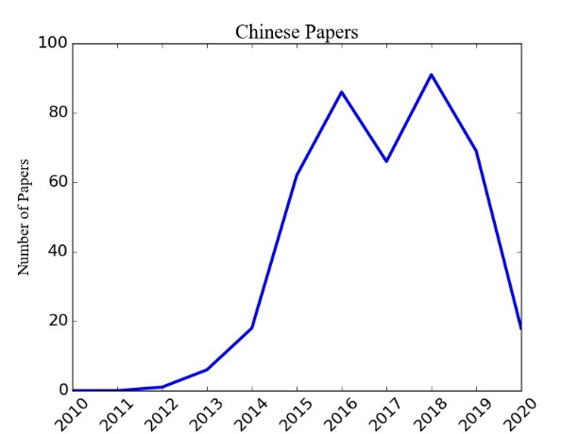 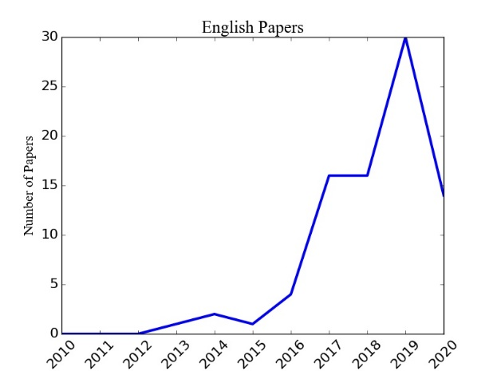

Figure 1. Number of academic publications about the ‘Thucydides Trap’

To provide an intuitive perception of these papers, we search ‘Thucydides Trap’ on Google Scholar and select the top 50 papers shown. We calculate the frequencies of words for their abstracts. After removing stop words, the frequencies are shown in Table. 1. Words like ‘war’ and ‘power’ occupy primary positions. Also, word vectors for frequently used words are obtained through the word2vec algorithm. Their dimensions are originally 200, and are reduced to 2 with t-SNE algorithm. The word vectors are provided in Figure 2. The closer the words, the more usually they are used in the same context. Thus, word vectors can help understand topics in the discourse. For example, it can be found at the bottom-left part of the figure that some abstracts tend to talk about trade and economics, while some focus more on history (at the center of the figure).

Table 1. Frequently used words in abstracts (used more than 20 times in the 50 papers’ abstracts)

|  |  |
| --- | --- |
| Words | Frequencies |
| 'war' | 103 |
| 'China' | 102 |
| 'Thucydides' | 101 |
| 'power' | 82 |
| 'Trap' | 47 |
| 'rising' | 37 |
| 'US' | 34 |
| 'relation' | 32 |
| 'United' | 31 |
| 'States' | 29 |
| 'two' | 29 |
| 'Chinese' | 25 |
| 'both' | 21 |
| 'economic' | 21 |
| 'Athens' | 21 |
| 'Allison' | 21 |
| 'country' | 20 |

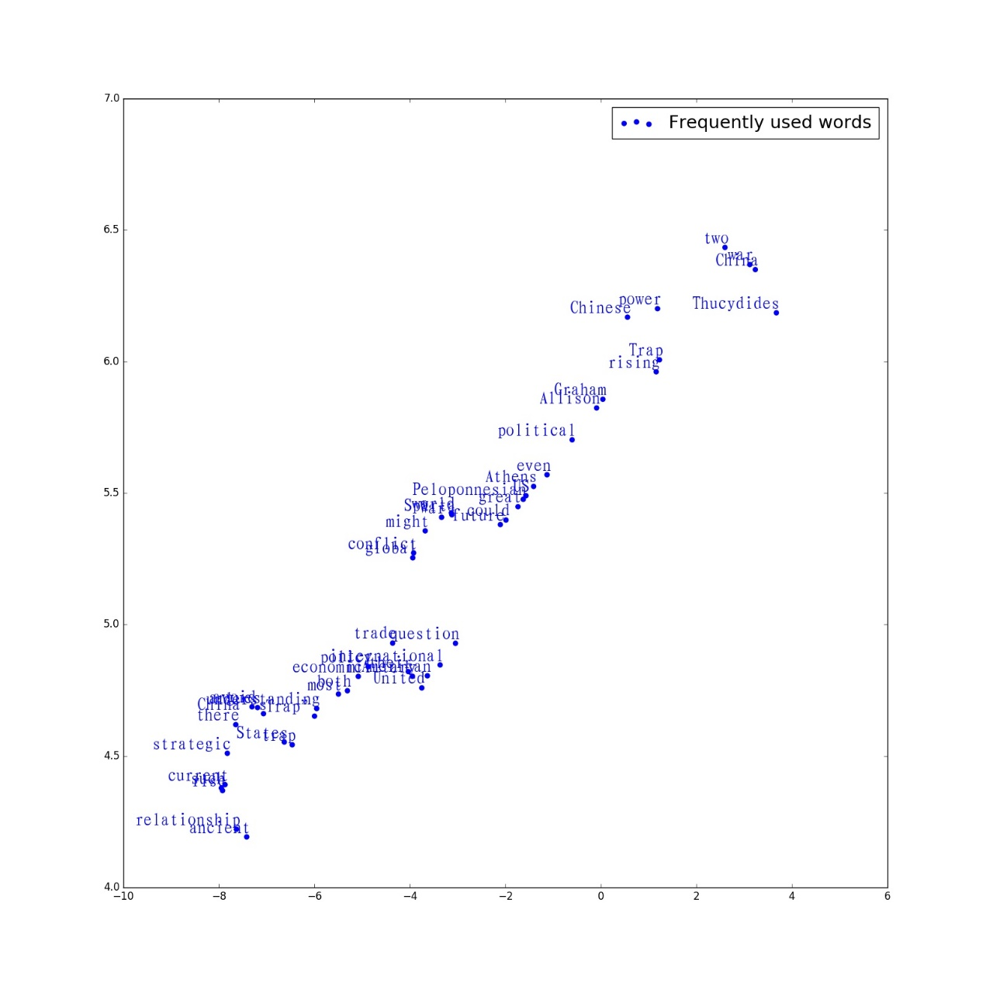

Figure 2. word vectors for frequently used words

Table 2 shows the countries of the authors’ institution. It can be found that scholars in China and the US are highly concerned about the topic, and researchers in Asia-Pacific countries, e.g., Japan, Republic of Korea, Australia, also contribute a lot.

Table 2. Institutes of which country wrote the most papers about the ‘Thucydides Trap’?

|  |  |
| --- | --- |
| Country of the author’s institution | Number of publications from the country |
| China | 15 |
| The United States | 15 |
| Japan | 5 |
| The United Kingdom | 4 |
| Australia | 2 |
| Republic of Korea | 2 |
| Singapore | 2 |
| Brazil | 1 |
| Canada | 1 |
| Greece | 1 |
| Italy | 1 |
| Russia | 1 |

How media report the ‘Thucydides Trap’ is also essential for understanding the word’s influence. We collected all the coverages about ‘Thucydides Trap’ by two major Chinese newspapers, People’s Daily and Global Times, and two major US newspapers, New York Times and Wall Street Journal, between 2010 and 2020. Figure 3 shows the number of relevant articles on these media. For Chinese media, the word ‘Thucydides Trap’ was frequently mentioned from 2014 to 2019, while for American media, the coverages were much less, and most reports were published in 2017.

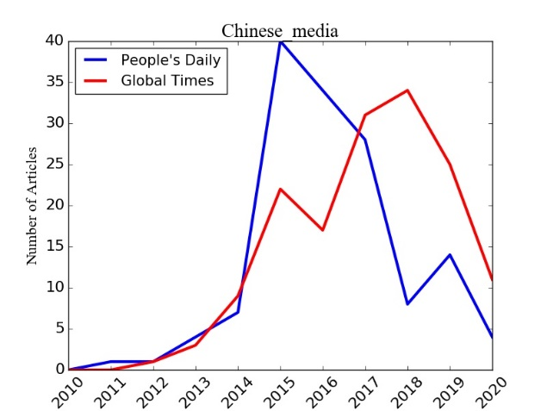 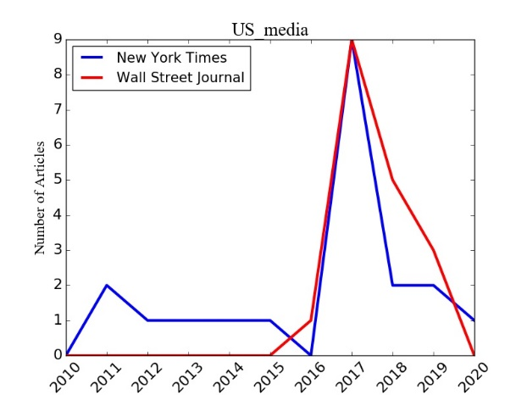

Figure 3. Number of media coverages about the ‘Thucydides Trap’

Different media tend to use different words when mentioning ‘Thucydides Trap’. Table 3 shows the frequently used words in the four newspaper’s titles when reporting the ‘Thucydides Trap’. People’s Daily used a lot of ‘cooperation’ and ‘new’ while New York Times and the Wall Street Journal cared more about Xi Jinping, the Chinese president.

Table 3. Frequently used words in the title of reports on ‘Thucydides Trap’

|  |  |  |  |  |  |  |  |
| --- | --- | --- | --- | --- | --- | --- | --- |
| People’s Daily | | Global Times | | New York Times | | Wall Street Journal | |
| Words | Times | Words | Times | Words | Times | Words | Times |
| 新 (new) | 39 | 美 (U.S,) | 61 | Book | 4 | China | 10 |
| 中国 (China) | 31 | 中China) | 54 | Xi | 2 | News | 2 |
| 中 (China) | 30 | 中国 (China) | 40 | Obama | 2 | Collision | 2 |
| 美 (U,S.) | 26 | 美国 (U.S.) | 23 | Dambisa | 2 | Xi | 2 |
| 关系 (relation) | 24 | 关系(relation) | 22 | Letters | 2 | Jinping | 2 |
| 合作 (cooperation) | 19 | 陷阱 (trap) | 21 | China | 2 | Emperor | 2 |
| 大国 (great power) | 18 | 不 (not) | 18 | Superpower | 1 | review | 2 |
| 钟声 (name of an author) | 16 | 新 (new) | 12 | Chinese | 1 | U.S.-China | 2 |
| 陷阱 (trap) | 15 | 接收 (accept) | 11 | U.S.-China | 1 | Behold | 2 |
| 世界 (world) | 15 | 战略 (strategy) | 11 | Threatening | 1 | World | 2 |

**Framing Process**

Having inspired generations of scholars’ insights toward a formation mechanism of the systematical warfare, Greek historian and military general Thucydides, the author of *The History of the Peloponnesian War*, is proved to have left no exact description of a “Thucydides’s Trap” in his book. While the scenario of a regional conflict happened more than 2,400 years ago between Athens and Sparta has been constructed to be an ancient warning and *horrible dictum* in the 2010s, the endeavors of the academia and media theorizing and framing it is to be attributed to.

Framing theory, before gaining its multi-disciplinary orientations, originally introduced by Bateson in 1955, and characterized by his 1972 work as “*the physical analogy of the picture frame and the more abstract…analogy of the mathematical set*”.[24] Framing is a way of persuasion, in Bateson’s view, based on culture and nature cognition. When a statement or opinion is posed, the content attached before or after the argument can be seen as a manifest message. Therefore, what information to be covered in the message, what structure and order the information is organized and how to tell the story, are all called “framing”. [25] In this perspective, framing is bridging the opinion and language of the speaker with the culture and cognition of the audience.

In communication field, framing theory is also described as “a way to describe the power of a communicating text” (Entman, 1993)[26] To frame is to describe the reality for the audience to perceive. The aspects of the reality are selected, and the words are carefully edited en route for a specific purpose of communicators. Framing, thus contains different *definition of the problems, interpretation of the causality, evaluation of morality and recommendation of treatment*. (Matthes, 2012)[27]

Framing theory are widely applied to media studies. The framing is regarded as a part of journalists and editors’ daily work, where journalists adapt frames from the others and at the same time create their own frames. The manifest in news content can be journalistic frames and the media outlets as a whole frame political issues, influencing public opinions which in the end having impact on policy-making process. (Matthes & Kohring, 2008)[28]

For an overall analysis of the terminology “Thucydides’s Trap”, to look into the framing procedures of it is crucial and fundamental. Both culture cognition paradigm and communication paradigm are adopted in this study, since the term itself originated from a revision to ancient history, possessing implications on bilateral relations, geopolitical issues, power transition and global system, and at the same time gaining power through three processes of cross-cultural communication. (See Figure 1)

The first process of cross-cultural communication (See Figure 1, Process 1), was from the ancient Greek narration to modern American international relations field. To understand the situation depicted by Thucydides and adapt it into a modern narrative requires framing. The second process, as mentioned above, was from America to China.

When “Thucydides’s Trap” starts from the debate among American researchers and practitioners, setting the agenda for Chinese media and academia, and ends up mentioned in a negative phrase by the Chinese President, it has no doubt aroused attention in both cultures, in which process, framing also took effect.

One more process that is easily ignored by the western observers lies in the cross-cultural communication from Greek historiography to contemporary China’s context. The way Chinese society looks into ancient Aegean culture should be considered as a factor that influences the framing process as a whole. Farther away from the western culture circle shared by America and many European countries, rooted in the ancient civilization of Greece and Rome.

Figure 1. Historical, political and cross-cultural features of Thucydides’s Trap

Thucydides’s Trap

History: Athens and Sparta

Politics: China and America

Process 1

Process 2

Process 3

The analysis structure built for this study is composed of three levels: 1) the ancient war; 2) the theory system; 3) the China-U.S. relations.

In each level, the framing contains three factors: a) the selected information; b) the intentionally omitted information; c) the supplementary manifest information.

First taking Allison’s article “Thucydides’s trap has been sprung in the Pacific”[29] which marked the debate around this concept as a case, this structure is to demonstrate how “Thucydides’s Trap” was originally framed.

|  |  |  |  |  |
| --- | --- | --- | --- | --- |
| Messages  Levels | Information Selected | Information Omitted | Manifest Information | Framed Features |
| Level 1:  the war | **Athens:** dramatic rise; centre of civilization.  **Sparta**: shocked; fear.  **War:** Sparta’s respond compelled by fear. | **Athens:** Democracy; Loose city states; Care more about business than force.  **Sparta:** Authoritarian; Concentrated Power; Care more about force than business.  **War:** between maritime power and land power; neighboring countries( very close). | *Thucydides said……“It was the rise of Athens and the fear that this inspired in Sparta that made war inevitable.”* | Caused by rise and Fear;  Inevitable. |
| Level 2:  the theory | **Rising power** disturb the established power system, causing fear of **the hegemon**, end in war. | **The attributes and wills** of the rising power and established power.  **The side** that started the war, could also be the rising power. | *Think about Germany …… In 1914 and in 1939, its aggression and the UK’s response produced world wars.* | Rising power: threat and challenge.  Established power: starts a war. |
| Level 3:  the relation | **China:** NO.2 in GDP; increasingly aggressive posture towards sea territory issues.  **U.S.:** Hegemony from 1890; Uncomfortable. | **The gap** between two countries in comprehensive national strength;  **The cost** and willingness for each side to start a war.  **The geopolitical distance** and attributes of two nations.  **The overall world system** and collective security restriction. | *The rapid emergence of any new power disturbs the status quo. In the 21st century……“a diva of such proportions cannot enter the stage without effect”.* | The Thucydides’s trap is happening between China and America.  A war between them is possible and predictable, and undoubtedly, disastrous. |

Table 1. The framing structure of “Thucydides’s Trap”.

As indicated in the framing structure shown in Table 1, three features were emphasized out of other actors:

* **Similarity**: how the China-U.S. relation nowadays apparel to the ancient Athens-Sparta.
* **Danger & Risk:** how the rise of China will change the overall world system and how dangerous it is for U.S. to be in this trap.
* **Credibility & Predictability:** how the other countries in 1500 years’ history proved this trap, how believable this trap is.

Empirical tests need to be done to prove that whether these three factors enhance people’s rational and emotional recognition of the concept. While according to news theory, when a story is easy to understand, close to people’s life, trustable, it gains more attention. In addition, in realism theory, the basic interest of a nation, is security interest, that is to survive. An ultimate hegemony war, just like what is told in Greek history, proved to be true for 15 centuries, which will destroy more than half of the earth, undoubtedly, is a remarkable “story”.

While in the framing process, it is the use of rhetoric skills that make the item popular and intimidating. The concept “Thucydides’s Trap” itself is constructed by a narrative of metaphors and analogies, essentially equipped with strong language efficacy.

**Analogy & Metaphor**

In both formal and informal communication, metaphor and analogy are commonly used as a rhetoric tool to assist the understanding and perceiving of some specific ideas or facts, facilitating communication and comprehension.[30]

Metaphor is a rhetoric method making comparison between unrelated concepts, which may share less attributive similarity but with some common characteristics. The comparative narration always take place in solid physical reality, based on unspecific and abstract concepts. Metaphors in language instruct the listeners’ understanding of the information from the speaker, and at the same time reflect and imply the recognition and way of perceiving information of the speaker.[31]

Metaphor has its vitality and vigor in different languages. In Chinese history there was a poetess living in the Eastern Jing Dynasty, who was daughter of the grand councilor, wife to the general. A widely known tale of this lady is a “metaphor competition” with her brother. In a snowy day, her brother romantically and boldly made his poet that “the snow is just like sprinkling salt into our sky”. While she disagreed, chanting that “the snow is more like willows’ flowers blown up by wind”. Snow as the same physical reality, as called *Noumenon,* was matched with different comparison concepts, *Metaphor*, in the two poets’ separate description and narration.

What can be inferred from the “metaphor competition” is that, the siblings had discrete recognition of the reality. The man saw the snow more glittering and translucent in granular structure, while the lady perceived it softer, lighter in an irregular shape and motion, signifying a coming spring full of hope.

In English, “Raining cats and dogs” was an example of common metaphors. In Korean, “Filling potatoes in stomach” means having something to say but cannot find a proper time. From these simple examples, it can be found that different languages may have cross-cultural hinders when using metaphors.

Analogy, is another common rhetoric tactic. Similar to metaphors, analogies draw comparisons between two objects, while analogy things with similar features of two domains.[32]

Metaphor has its *Noumenon(N)* and *Metaphor(M)*, as discussed above, N is the physical reality and M is some concept used to compare and depict.

Analogy has their Analog Concept(A) and Target Concept(T). A is used to describe and assist the understanding of some features about T. A and T can both be people, plants or nations, the objects of analogy is not limited. However, when a nation is described as a flower, then it is a metaphor; when it is acting like a country in history, then it should be considered as analogy.

For the term “Thucydides’s Trap”, both metaphor and analogy are applied in the framing and narration. (See Figure 2.)

Figure 2. Metaphor and Analogy in “Thucydides’s Trap”

**Topic:** The China-U.S. relation today.

**Metaphor**

**Analogy**

***Noumenon:***

The status quo and bilateral relation of two countries.

***Metaphor:***

A trap.

***Target Concept:***

China and America.

***Analog***

***Concept:***

Athens-Sparta;

Germany-Britain.

***Metaphor Features:***

Dangerous;

Risky;

Invisible.

***Analogy***

***Features:***

Rising power and dominating power;

Ending in war.

Information provided by metaphor and analogy alone are not sufficient nor complete. In the framing process, metaphor and analogy may highlight some of the features while ignore some others. A metaphor or analogy tends to neglect some dissimilar factors to make the statement more persuasive. [33]

The metaphor and analogy in the terminology and narration of “Thucydides’s Trap” (See Figure 2.) sheds different lights on the efficacy of language.

Metaphor in this context frames the relations between two countries to be dangerous and risky, while the danger and risk can be invisible, forming a warning to the listener. Analogy, however, takes other countries in history as analogs, strengthening the credibility of this concept.

**Framing a Strategy Environment**

Metaphor and analogy as communication skills, have been widely adapted into policy education (Osenga, 2013), environmental communication (Armstrong, 2018), organizational strategic communication (Cornelissen, Holt & Zundel, 2011) and many other studies. Researchers with multidisciplinary backgrounds were aware of the significant connection between framing and rhetoric skills.

In 2011 strategic communication study work by Cornelissen, Holt & Zundel, put that the extent to which analogy and metaphor in framing works depends two factors: the cultural familiarity to listeners; the connectiveness with the original motivations of the listeners.[34]

Adapting the cultural motivational factors, connecting with the prior findings, hypothesis can be made that through the framing of “Thucydides’s Trap”, the culture familiarity and motivation differs in two countries may also be counted as a reason why this concept stirred heated discussion in the States domestically and communicated to the globe crossing three processes (See Figure 1.), crossing-culturally.

The recognition to the immediate and potential environment is based on culture values and motivations towards future. In international relations studies, when making estimation of the environment one sovereignty is confronted with, three main factors were taken into consideration, which is called a “Strategy Environment Theory”：

* NATURE OF CONFLICT：Inevitable or Abnormal phenomenon?
* NATURE OF ENEMY：Zero-Sum or Not Zero-Sum?
* EFFECT OF FORCE：Strong or Weak?

Via the use of analogy and metaphor in framing the “Thucydides’s War”, it can be concluded that the features “selected” on three levels of the frames, and the features emphasized by analogy and metaphor tells the audience that: The Thucydides’s Trap is possessing an inevitable, zero-sum, strong enemy in the strategy environment.

While the motivation of both sides to keep security and development, the rhetoric is great likely to work with high efficacy. For cultural background of two countries, when Greek history has closer connection with American contemporary society, and China has less cultural familiarity, it is still remain to be study that whether the mysterious or other features in the framing process of Chinese to Ancient Greece affect the understanding and perceiving of the concept.

**Conclusion**

Thucydides’s Trap is a concept rooted in history, but narratively framed by modern scholars. Through a long period of time when researchers look into the formation procedures of major wars, hegemony war, land-sea war and countless theorization endeavors were made. While it is in recent years, that the “Thucydides’s Trap” became a dark horse and arouse attention in both countries, put to a high political context. Through this study, three main findings may be qualified to explain part of the reasons.

Thucydides’s Trap

Historiographical Narrative

Contemporary Adaptation

Metaphor

Analogy

Framing the Strategy Environment

Figure 3. The overall framing process.

First, the term itself, in a linguistic perspective, is formed with analogy and metaphor. The metaphor of a “trap” is literally presented, while the analogy of “the Peloponnesian War” lies in the narration on a slightly deep layer to which explanation is needed.

Second, the framing by Allison and other scholars, also by the media who took the term as granted, ignoring the potential negative effects it may arouse, from three levels, constructed a predictable, inevitable and ultimate war.

Last, the strategy environment is framed by brick and brick of these terms implying political issues. The original motivation for both sides to avoid a catastrophic war, maintain security and pace of development, in turn enhances the ability and willingness to accept the rhetoric narrative and be framed.

This study is a bold trial to bridge communication studies, linguistic and rhetoric studies with international relations field. More empirical researches need to be done to support the basic hypothesis of this essay, when the findings now are limited but filled with potentials and inspiration.

**References**

Allison, G (2012), “Thucydides’s trap has been sprung in the Pacific”, Financial Times, August 28, 2012. http://www.ftchinese.com/story/001046228/ce?archive, last visited on December 20, 2018.

Allison, G (2017), “Destined for War: Can America and China Escape Thucydides’s Trap?”, Houghton Mifflin Harcourt.

Allison, G (2018). "The Thucydides trap: when one great power threatens to displace another, war is almost always the result--but it doesn't have to be." Foreign Policy May-June 2017: 80+. Business Insights: Global. Web. 20 Dec. 2018.

Armstrong, A., Krasny, M., & Schuldt, J. (2018). USING METAPHOR AND ANALOGY IN CLIMATE CHANGE COMMUNICATION. In Communicating Climate Change: A Guide for Educators (pp. 70-74). ITHACA; LONDON: Cornell University Press.

Bourgeois, L. (1980). Strategy and Environment: A Conceptual Integration. The Academy of Management Review, 5(1), 25-39. Retrieved from <http://www.jstor.org/stable/257802>

Bateson G (1955/1972) Steps to an ecology of mind. New York: Ballantine

Cornelissen, J. P., Holt, R., & Zundel, M. (2011). The Role of Analogy and Metaphor in the Framing and Legitimization of Strategic Change. *Organization Studies*, 32(12), 1701–1716.

Entman, R. M. (1993). Framing: Toward clarification of a fractured paradigm. *Journal of Communication*, 43(4), 51-58.

Gilpin, R. (1988). The Theory of Hegemonic War. *The Journal of Interdisciplinary History*, 18(4), 591-613. doi:10.2307/204816

*Global Times*. Missile hype to fuel tensions – U.S. have ulterior motives in reporting S. China Sea defense. Feb. 18, 2016, pp. 1–2

Helle, H. (2017). China and the us: A Balance of Power? In China: Promise or Threat? : A Comparison of Cultures (pp. 24-39). LEIDEN; BOSTON: Brill.

Hutchings, D. (1998). Communicating with metaphor: A dance with many veils. *American Journal of Hospice and Palliative Medicine*®, 15(5), 282–284. https://doi.org/10.1177/104990919801500510

Kristof, N. (1993). The Rise of China. Foreign Affairs, 72(5), 59-74. doi:10.2307/20045814

Kristen Osenga. (2013). The Internet is Not a Super Highway: Using Metaphors to Communicate Information and Communications Policy. *Journal of Information Policy*, 3, 30-54. doi:10.5325/jinfopoli.3.2013.0030

Masson, R. (2001). Analogy and Metaphoric Process. *Theological Studies,* 62(3), 571–596. <https://doi.org/10.1177/004056390106200306>

Matthes, J. (2012). Framing Politics: An Integrative Approach. *American Behavioral Scientist*, 56(3), 247–259. https://doi.org/10.1177/0002764211426324

Matthes, J. (2008). Media frames and public opinion: Exploring the boundaries of framing effects in a two-wave panel study. *Studies in Communication Sciences*, 8(2), 101-128.

Osenga, K. (2013). The Internet is Not a Super Highway: Using Metaphors to Communicate Information and Communications Policy. *Journal of Information Policy*, 3, 30-54. doi:10.5325/jinfopoli.3.2013.0030

Schott, B. The Thucydides Trap. *The New York Times* of January 31, 2011.

Shirk, S, L. (2008). “China: The fragile superpower”, Oxford University Press, U.S.A. , p220.

Welch, D. (2003). Why International Relations Theorists Should Stop Reading Thucydides. Review of International Studies, 29(3), 301-319. Retrieved from <http://www.jstor.org/stable/20097856>

Wolf, J., & Egelhoff, W. (2002). A Reexamination and Extension of International Strategy-Structure Theory. Strategic Management Journal, 23(2), 181-189. Retrieved from http://www.jstor.org/stable/3094441

Yan, X. (1995). The possible options of China’ Rise. Strategy and Management, 1995(06):11-14.

1. Smith, N. R., & Fallon, T. (2020). An Epochal Moment? The COVID-19 Pandemic and China’s International Order Building. World Affairs, 183(3), 235–255. https://doi.org/10.1177/0043820020945395
2. Hatuel-Radoshitzky, M., Heistein, A., Bernes, T., Brozus, L., Greco, E., Sasnal, P., . . . Caballero-Anthony, M. (2020). Challenges of Global Governance Amid the COVID-19 Pandemic (pp. 10-12, Rep.). Council on Foreign Relations. doi:10.2307/resrep24934.5
3. Ali Wyne (2020) How to Think about Potentially Decoupling from China, The Washington Quarterly, 43:1, 41-64, DOI: 10.1080/0163660X.2020.1735854
4. Allison, G (2012), “Thucydides’s trap has been sprung in the Pacific”, *Financial Times*, August 28, 2012. <http://www.ftchinese.com/story/001046228/ce?archive>, last visited on December 20, 2018.
5. Allison, G (2017), “*Destined for War: Can America and China Escape Thucydides’s Trap?*”, Houghton Mifflin Harcourt.
6. Allison, G (2018). "The Thucydides trap: when one great power threatens to displace another, war is almost always the result--but it doesn't have to be." *Foreign Policy* May-June 2017: 80+. Business Insights: Global. Web. 20 Dec. 2018.
7. 陈康令.“修昔底德陷阱”是一个话语陷阱[J].红旗文摘.2018-11-12.
8. 钱乘旦. 拨开“修昔底德陷阱”迷雾[N]. 新华日报,2018-07-24(014).
9. 任晓.国际关系学的“去历史化”和“再历史化”——兼疑“修昔底德陷阱”[J].世界经济与政治,2018(07):142-154.
10. Bhattacharya, A. (2007). CHINESE NATIONALISM AND CHINA'S ASSERTIVE FOREIGN POLICY. The Journal of East Asian Affairs, 21(1), 235-262. Retrieved November 6, 2020, from http://www.jstor.org/stable/23258004
11. Helle, H. (2017). China and the us: A Balance of Power? In China: Promise or Threat? : A Comparison of Cultures (pp. 24-39). LEIDEN; BOSTON: Brill.
12. Working Paper
13. IEEE under review
14. Welch, D. (2003). Why International Relations Theorists Should Stop Reading Thucydides. *Review of International Studies*, 29(3), 301-319. Retrieved from http://www.jstor.org/stable/20097856
15. Gilpin, R. (1988). The Theory of Hegemonic War. *The Journal of Interdisciplinary History*, 18(4), 591-613. doi:10.2307/204816
16. Gilpin, R. (1988). The Theory of Hegemonic War. *The Journal of Interdisciplinary History*, 18(4), 591-613. doi:10.2307/204816
17. Kristof, N. (1993). The Rise of China. *Foreign Affairs*, 72(5), 59-74. doi:10.2307/20045814
18. Yan, Xuetong (1995). The possible options of China’ Rise. *Strategy and Management*, 1995(06):11-14.
19. Susan L. Shirk, “*China: The fragile superpower*”, Oxford University Press, U.S.A. 15 Aug. 2008, p220.
20. Ben Schott, “*The Thucydides Trap*”, The New York Times of January 31, 2011.
21. Helle, H. (2017). *China and the us: A Balance of Power? In China: Promise or Threat? : A Comparison of Cultures* (pp. 24-39). LEIDEN; BOSTON: Brill.
22.
23. *Global Times.* Missile hype to fuel tensions – U.S. have ulterior motives in reporting S. China Sea defense. Feb. 18, 2016, pp. 1–2
24. Bateson G (1955/1972) *Steps to an ecology of mind*. New York: Ballantine
25. Cornelissen, J. P., Holt, R., & Zundel, M. (2011).The Role of Analogy and Metaphor in the Framing and Legitimization of Strategic Change. *Organization Studies*, 32(12), 1701–1716. https://doi.org/10.1177/0170840611425729
26. Entman, R. M. (1993). Framing: Toward clarification of a fractured paradigm. *Journal of Communication*, 43(4), 51-58.
27. Matthes, J. (2012). Framing Politics: An Integrative Approach*.* *American Behavioral Scientist*, 56(3), 247–259. https://doi.org/10.1177/0002764211426324
28. Matthes, J. (2008). Media frames and public opinion: Exploring the boundaries of framing

    effects in a two-wave panel study. *Studies in Communication Sciences,* 8(2), 101-128.
29. Allison, G (2012), “Thucydides’s trap has been sprung in the Pacific”, *Financial Times*, August 28, 2012. http://www.ftchinese.com/story/001046228/ce?archive, last visited on December 20, 2018.
30. Armstrong, A., Krasny, M., & Schuldt, J. (2018). *USING METAPHOR AND ANALOGY IN CLIMATE CHANGE COMMUNICATION. In Communicating Climate Change: A Guide for Educators* (pp. 70-74). ITHACA; LONDON: Cornell University Press. Retrieved from http://www.jstor.org/stable/10.7591/j.ctv941wjn.15
31. Masson, R. (2001). Analogy and Metaphoric Process. *Theological Studies*, 62(3), 571–596. https://doi.org/10.1177/004056390106200306
32. Armstrong, A., Krasny, M., & Schuldt, J. (2018). *USING METAPHOR AND ANALOGY IN CLIMATE CHANGE COMMUNICATION. In Communicating Climate Change: A Guide for Educators* (pp. 70-74). ITHACA; LONDON: Cornell University Press. Retrieved from http://www.jstor.org/stable/10.7591/j.ctv941wjn.15
33. Kristen Osenga. (2013). The Internet is Not a Super Highway: Using Metaphors to Communicate Information and Communications Policy. *Journal of Information Policy*, 3, 30-54. doi:10.5325/jinfopoli.3.2013.0030
34. Cornelissen, J. P., Holt, R., & Zundel, M. (2011). The Role of Analogy and Metaphor in the Framing and Legitimization of Strategic Change. *Organization Studies*, 32(12), 1701–1716.