Open CMO, log in as michaelgetty.test@cropins.net

Nav to Anson Family Farms

View 2016 Policy, 1018247

Download Corn Policy (includes YE Option)

Open in SalesTools

Nav to APH break out from scenario,

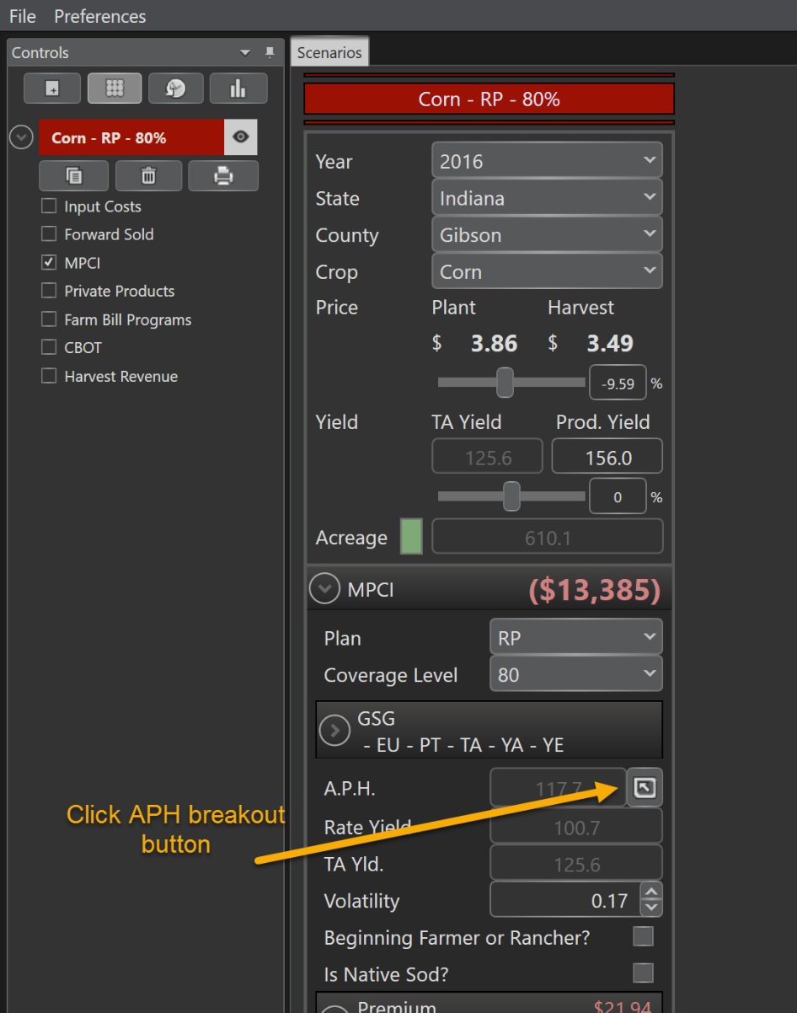

then again to view Unit Details

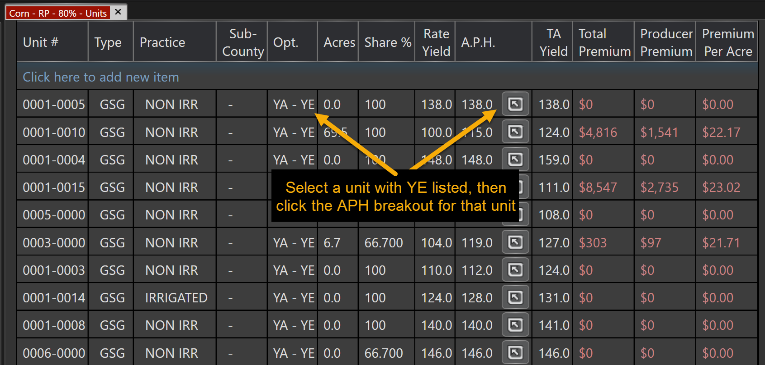

Make note of current selections. (screenshot?)

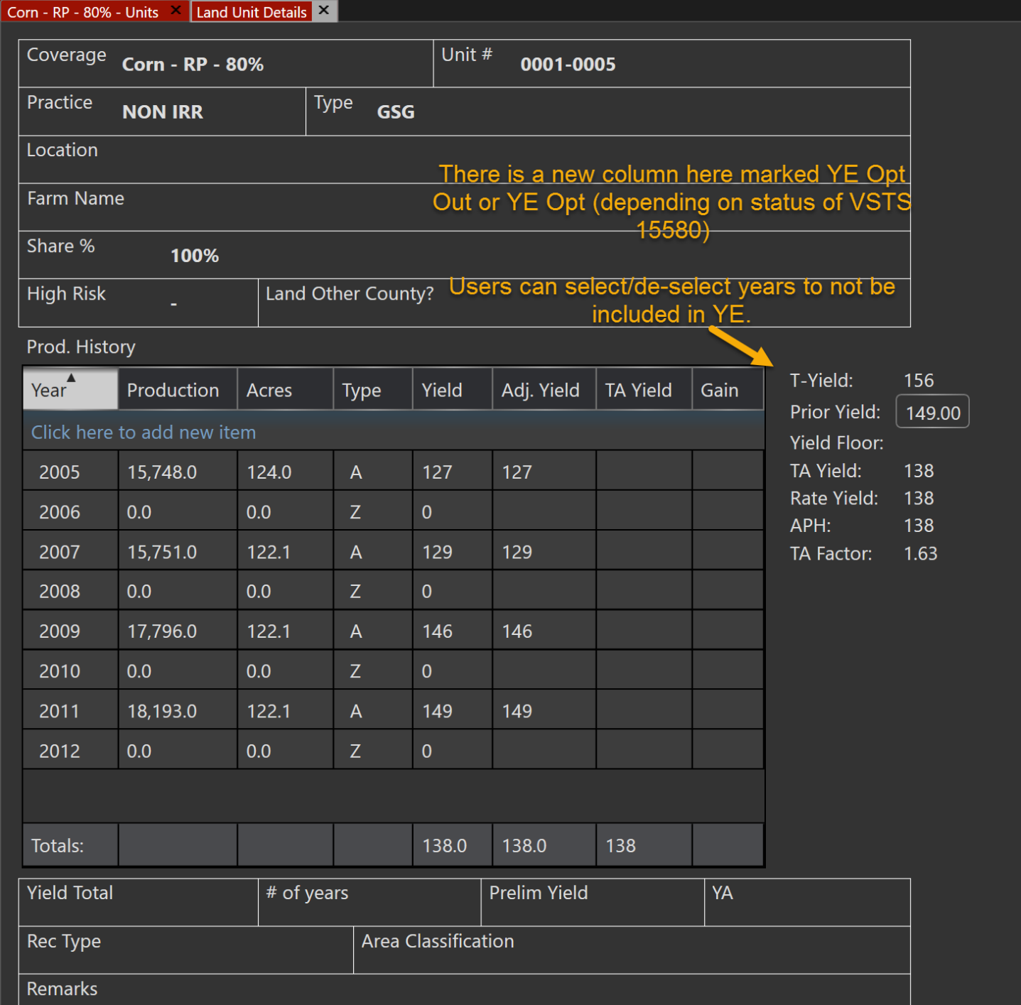

Change year to 2017

Open APH breakouts again and

change some of the YE selections in the Unit Details screen.

Export changed quote to Client Database, then compare in EPIC using steps in PBI description (this level of detail not viewable in CMO) to ensure changes were included in export.