On host-parasite interaction: …

Nanda Vo, 504607

WWU – IEB Münster

Primary Supervisor: Prof. Dr. Joachim Kurtz

Secondary Supervisor: Dr. Jaime Mauricio Anaya-Rojas

Date:

**Table of contents:**

1. **Abstract**
2. **Introduction**
3. **Material and methods**
4. **Results**
   1. **Batch 1**
   2. **Batch 2**
   3. **Batch 3**
   4. **Batch 4**
5. **Discussion**
   1. **Conclusions**
   2. **Batch 1**
   3. **Batch 2**
   4. **Batch 3**
   5. **Batch 4**
   6. **Outlook**

**1. Abstract:**

Among every food web, trophic chains belong to the most important aspects of population and community dynamics. However, species interactions such as parasitism are often neglected in them, even though it’s a very common strategy in nature. It is well known that many parasites are able to change their host’s phenotype (e.g., in it’s metabolic rate) either chemically or physically to their very own advantage. Parasites have their own metabolism, they need nutrients meaning a nutrient loss (or malnutrition) for their hosts since many parasites gather their needed resources from their hosts. Phenotypic changes caused by a parasite may alter the behavior of its host as well, which can also have an impact on the common habitat. In this theses, I study how infections by the trophical transmited parasite *Schistocephalus solidus* ater the feeding behavior of their first host, the copepod *Macrocyclops albidus.* Specifically, we investigate whether the functional response curves of *M. albidus* are alter by *S. solidus*  Add here the main results, and what it means.

**2. Introduction**

Among every living organism, trophic chains belong to the most important aspects of population dynamics. Parasitism and parasitic influence are often neglected in them, even though it’s a very common strategy in nature. Studies of the effects of host-parasite interactions may contribute to a better understanding of population dynamics and evolutionary ecology. In many cases, trophic chains only display the interaction between the different trophic levels in regard of the population dynamic, although, parasites may have an important role for those interactions as well [1]. For instance, it’s well known that some parasite species are able to change their host’s behavior to their very own advantage. Furthermore, in this case, *S. solidus* is known to be able to change the behavior of its first intermediate host *M. albidus*. For this specific interaction, *S. solidus* is known to lower the activity rate of *M. albidus* after successful infections in order to reduce the predation risk [2], [3]. *S. solidus* is an obligate endoparasite with a complex lifecycle which means that it infects multiple hosts of different species throughout its life. Inside the body cavity of its first intermediate host *M.albidus,* *S. solidus* grows from its coracidia stage into the procercoid stage. The growth into the procercoid stage provides the transmissibility to the second intermediate host *G. aculeatus*. During early post-infection periods, it’s crucial that the copepod host survives just long enough for *S. solidus* to complete its growth into the procercoid stage which takes approximately two weeks [4], [5]. After the transmission to the second intermediate host, *S. solidus* grows into its final stage, the plerocercoid stage. The final host of *S. solidus* are fish-predatory birds that feast on *G. aculeatus*. Sexual reproduction then takes place in the guts of the definitive host and its eggs get excreted with the definitive host’s faeces.

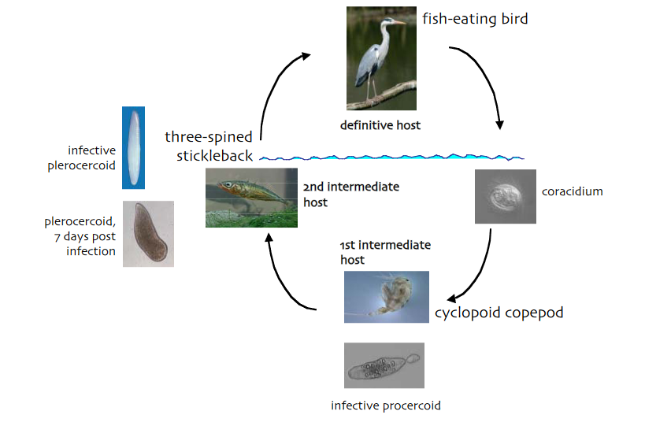

Figure 1: Lifecycle of S. solidus including its hosts. From K. Hammerschmidt 2006

Being infected with a parasite often means a nutrient loss for the host due to the parasite’s metabolism. A malnutrition caused by a parasite may result in an increased hunger and therefore increased foraging. At this point, *S. solidus* may has to deal with the tradeoff between nutritional needs from its host and the avoidance of its host’s predation just until reaching the next transmittable stage to its next host [6].

*M. albidus* is a limnic omnivorous cyclopoid copepod species. It’s the natural prey of limnetic three-spined sticklebacks (*Gasterousteus. aculeatus*) which is a crucial part of the life history of *S. solidus* regarding its transmission [7]. The diet of *M. albidus inter alia* consists of crustacean nauplii, crustaceans smaller than themselves and mosquito larvae [8]. Due to the predation on mosquito larvae, *M. albidus* is considered to be a biological pest control agent, furthermore, it's able to reduce mosquito stocks very efficiently [9]. In analogy to the meaning of trophic chains for population dynamics, *S. solidus* may be an important factor for the capability of *M. albidus* as pest control agent against mosquitos. *S. solidus* decreases its copepod host’s activity ratio during its growth from the coracidia stage into its procercoid stage [2], [3], but it’s unknown, how this affects the foraging and feeding rate of *M. albidus*.

For instance, it’s unknown as well, how the feeding behavior of *M. albidus* changes during the infection with *S. solidus* due to the tradeoff between the nutritional needs of *S. solidus*  from its host and the avoidance of its host’s predation. Since this may be important information for the understanding of *M. albidus*’ capability as biological pest control agent against mosquitos, this paper aims to fill this knowledge gap by investigating the functional response of *M. albidus* in dependency of *S. solidus*. For this matter, copepods will be isolated in 24 well plates and measured for functional response in dependency of *S. solidus*. It’s unknown whether the actual feeding behavior and functional changes in dependency of *S. solidus*, but if *S. solidus* is able to alter its host’s feeding behavior, changes in the foraging rate, hunger and feeding activity should be notable. At this point, a positive or negative change in comparison to an unexposed and uninfected control group of copepods should be notable in dependency of the relevance the avoidance of predation and nutritional needs for *S. solidus*. Decreased foraging and feeding activity may imply for a higher relevance for *S. solidus* to try to keep its host alive while *vice versa*, increased foraging and feeding activity could imply for a higher relevance of nutritional supplies for *S. solidus* in order to grow into its next stage inside the first intermediate host. Either way, the if *S. solidus* is capable of changing the feeding behavior of its host by any matter, the handling time and/or attack rate of the functional response [10] of its host should either increase or decrease depending on the priorities of *S. solidus*.

However, the study of the functional response of *M. albidus*, generally and in dependency of *S. solidus*, will only provide data of the predatory behavior of *M. albidus* for the applied methods/parameters (e.g. medium size, population density), since the actual functional response and (predatory) feeding behavior of *M. albidus* consists of many factors. In fact, any predator-prey interaction consists of many complex components which themselves are connected to each other and/or other factors [11]. Therefore, in order to understand ecological relationships between and within species, the whole complex system of population and ecological dynamics has to be broken down into smaller pieces fitting for experimental analyses. For this experiment, a young nauplius larval stages of *Artemia* spec. will be used as prey. As already mentioned, the measurements of the predatory feeding behavior of *M. albidus* is only related to the used prey species meaning that the functional response of *M. albidus* measured in this case is only the relative feeding behavior and functional response of *M. albidus* if it’s feeding on nauplii of *Artemia* spec. since other prey may provide altered feeding behavior and functional responses.

*has* has The results of my previous experiment [12] from the *Projektmodul* showed a high mortality which’s cause was assumed to be the growth of fungi and bacteria inside the wells containing the copepods. Some copepods were woven in fungal hyphae (Figure 2) and in the end, the used copepods were most likely more delicate to pathogens because they’ve been in their early copepodid stages. There are no reports of this issue for adult copepods but in order to avoid another high mortality rate caused by fungi, methylene blue will be used in this experiment in order to prevent fungal growth [13].

Ein Bild, das Meeresgrund enthält.

Figure 2: Example of a dead copepod, woven in fungal hyphae. © N. Vo 2022

**3. Material and methods:**

Multiple families of *S. solidus* were bred in an artificial bird gut and incubated by 20 °C afterwards for two weeks in the dark. For each batch (Figure 3), 45 copepods were isolated into three 24-well plates filled up with approximately 2 mL stale tab water (Figure 4, supplementary tables 1-3), for instance, three plates were used and each contained 15 copepods. The infection plan can be found in the supplementary tables 1-3.

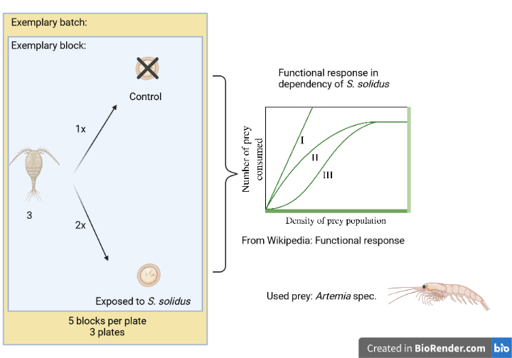

Figure 3: Visualization of the design of an exemplary batch of this experiment.

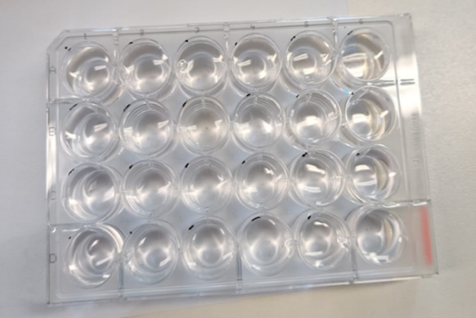

Figure 4: Example of used well plates. The wells inside the red mark represent the used wells for each plate. © N. Vo 2022

The copepods were sorted in five blocks per plate, each containing three individuals (Supplementary tables 1-3). Within those blocks, the copepods were organized into two treatments:

* Control, no exposure to *S. solidus* (n = 1)
* Exposed, exposure to *S. solidus* (n = 2)

Four batches (Figure 4) were created for the experiment. Every batch was kept under constant conditions, for instance, they were kept at approximately 18°C and constant lighting with no sunlight throughout the day. The treatments (Figure 3) also remained the same for every batch, only the measurement (method) partially differs between some batches. Regarding the organization of the treatments between the batches, every batch received the same infection plan (supplementary tables 1-3). For the analyses, the lids of each plate within a batch were switched by another student in order to blind me during the measurements.

After the well plates with the isolated copepods were prepared, the incubated eggs of *S. solidus* were prepared to hatch by exposing them to light for four hours at night (18:00) and approx. three hours at noon (12:00) since light induces the hatching for the eggs [2]. The copepods were left to starve for one day before infection in order to increase the chances for them to consume the coracidia. Afterwards, each copepod was either exposed to one coracidia or not exposed. After the exposure, copepods were fed with 10 µL of a hay water solution containing paramecium every Monday, Wednesday and Friday around 4 p.m. until the measurements began. The measurements for each batch began five days after the exposure of the copepods to the coracidia of *S. solidus*. The period of five days were was supposed to give the copepods, that were exposed to *S. solidus* (uninfected and infected), time for immune responses while the coracidia were able to grow inside their hosts after successful infections during that time.

Originally, it was planed to infect all the batches with the same family in order to avoid greater variation in the host manipulation caused by phenotypical differences between the families. However, this was not possible because the batches of eggs that were prepared for the experiment were completely used up after exposing the copepod batches to the coracidia. At first, it was only planned to do one batch but since multiple problems occurred throughout the experiment (which will be mentioned later), multiple measurement batches of copepods had to be created, meaning that I didn’t expect to need more eggs of the family used for each corresponding batch. The used families of *S. solidus* for each batch are shown in table 1.

Table 1: Used families of S. solidus for each batch. The families IBB originate from Ibbenbüren whereas the family LK originates from Lake Konstanz.All of those families were collected in the year 2021 which is represented by the “21” at the end of their names. The single digits stands for the family number among the other families of S. solidus stored in the IEB Münster.

|  |  |  |  |  |
| --- | --- | --- | --- | --- |
| Copepod batch | Batch 1 | Batch 2 | Batch 3 | Batch 4 |
| Used family | IBB 2 21 | LK 2 21 | IBB 2 21 | IBB 4 21 |

Batch 1 only containing adult male copepods also received 10 µL of 0,001% methylene blue solution in order to prevent the growth of fungi [13]. Male copepods were used since they are prone to be easier infectable due to the tradeoff between immune functions and testosterone [4], [14] and furthermore, female copepods may unnotably develop egg sacs after the isolation, even though, none were visible during the isolation. Bearing egg sacs adds another variable to the experiment which should be avoided in order to standardize as much as possible except the infection status. Adult male copepods can be easily differentiated from females by their spermatophores (Figure 5).

Ein Bild, das Gliederfüßer, Wirbellose, Kiemenfußkrebse, Ruderfußkrebs enthält.

Figure 5: Example of a male adult copepod. The red marked area shows its spermatophores.

© N. Vo 2022

After one week, the first batch was discarded due to a high mortality among the copepods. Around 60% of the copepods were found dead while their bodies were intact which indicates that methylene blue may be deadly toxic for the copepods, even in low concentrations. The second and third batch only contained male copepods as well.

Just like the first batch, that was discarded, each copepod individual in the second batch received six different densities of prey. The prey that was used were *Artemia* spec. nauplius larvae of the same stage (Figure 6). This stage was not determined but the only relevant factor was to only use the same larval stages as standardized prey.

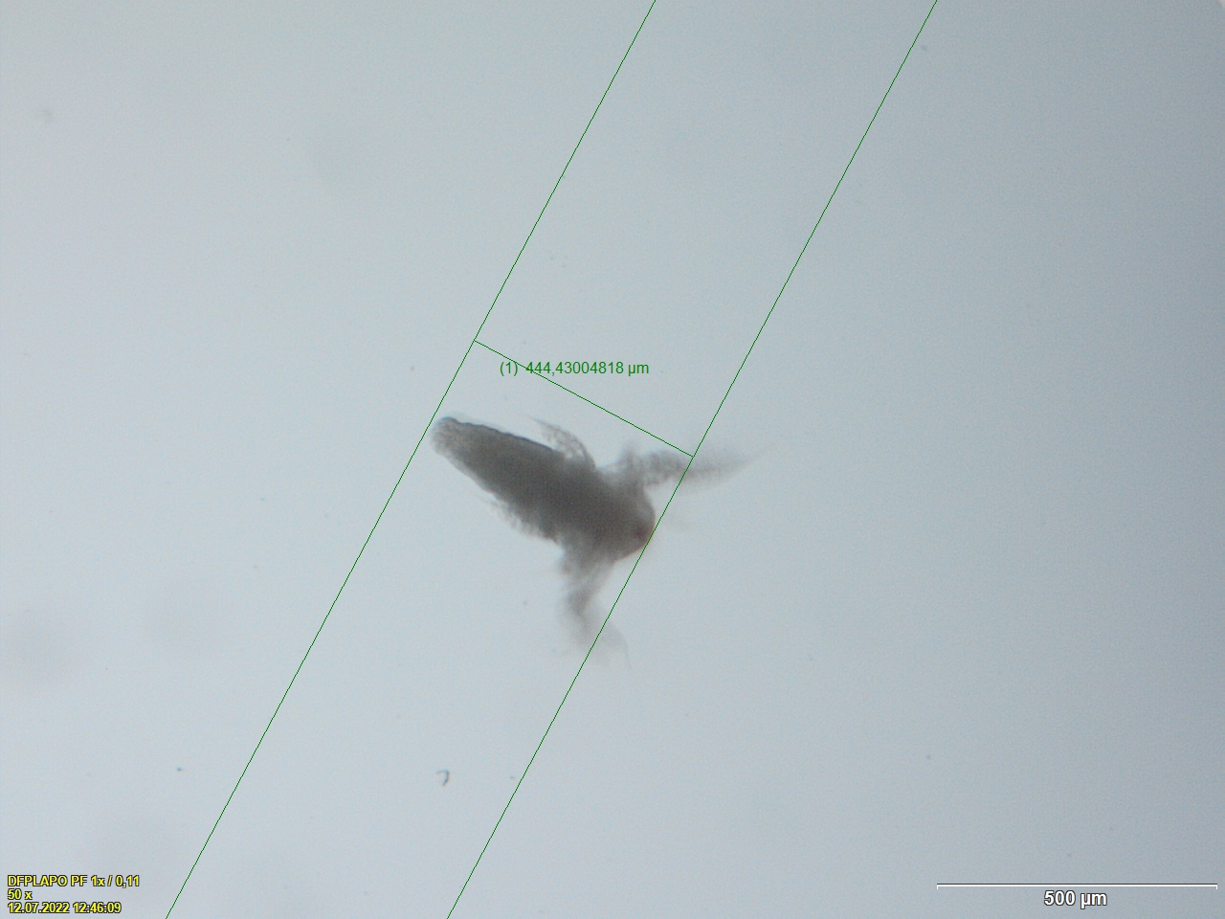

Figure 6: Example of Artemia larval stage used with body length. This exemplary had a body length of 444.43 µm.

© N. Vo 2022

In order to prepare the prey, the *Artemia* spec. larvae were bred in 3% salt water under constant oxygen influx approximately 36 hours before feeding them to the copepods. Afterwards, the eggs were flushed from the tanks and the larvae washed with tab water to reduce the salinity before isolating them under a binocular microscope into the specific densities for each copepod for the assigned day. After the isolation of the different densities for each copepod, the larvae were pipetted into the wells containing the copepods. Generally, it’s important to include several lower densities in order to distinguish between a type ll and type lll functional response (hereafter FR), because the clearance rate of a type lll FR increases with the prey density [10]. Therefore, the different prey densities for the copepods are: 2, 3, 5, 10, 15 and 25 first stage nauplii of *Artemia* spec. In total, each individual received the six different prey densities distributed on six different days. Five days after the exposure of the copepods to the coracidia, measurements were made every Monday, Wednesday and Friday around 4 p.m. and the supplementary table 4 shows the feeding plan for every batch. After the copepods received their specific prey (density) for the measurement day, they were left to consume the prey for two hours. After those two hours, the remaining *Artemia* spec. larvae were removed from the wells containing the copepods by pipetting them out together with a small proportion of the water. Water exchanges were done by that every time the copepods received their prey as well. Since the usage of methylene blue seems to be no option due to the mortality of the copepods, the water exchange was supposed to remove a proportion of the bacteria and fungi growing inside the wells. Furthermore, most of the time, three quarters of the water inside the wells was exchanged every time the measurement for each individual copepod was made.

The results of the first measurement implied that the male adult copepods don’t consume more than 2 – 3 larvae so the parameters for batch 3 and 4 were changed in order to receive better results to create FR curves. Batch 3 already contained male copepods so this batch was exposed to coracidia of *S. solidus* after the first three measurements of batch 2. This batch was measured in the foraging activity of *M. albidus* in dependency of *S. solidus*. For instance, each copepod only received one larva. Every individual was measured in its consumption time of a single larva of *Artemia* spec and received six measurements five days after the exposure of the corresponding copepod treatment (Figure 3, supplementary tables 1-3). For the measurements, the time was started after administering a larva into the copepod-containing well and stopped after the copepod caught its prey (Figure 7).

BILD COPEPOD FRISST ARTEMIE FIG 7

In order to test the FR properly, female copepods were isolated for the fourth batch in hope that they consume much more than 2-3 larvae like the male adult copepods. For *M. albidus*, female individuals grow larger than male individuals. In fact, adult male copepods are approximately 0,8 mm long while female individuals grow up to approximately 1,2 mm [15]. The larger body size of (adult) female individuals was used to filter them from smaller copepod individuals. Afterwards female individuals without egg sac (Figure 8) were isolated into 24 well plates and exposed with the same treatments to *S. solidus* as the other three batches were (supplementary tables 1-3). Five days after the exposure of the corresponding group to the coracidia of *S. solidus*, the three plates received their measurements regarding FR with the same methods that were applied to batch 2 with the only exception of feeding the copepods every Tuesday, Thursday and Sunday instead of Monday, Wednesday and Friday. Many of the female individuals developed egg sacs up to three weeks after the isolation which unintentionally adds variables to the data. For that matter, the hatched nauplii were extracted with the regular water exchanges with the aim to remove potential food for the adult female copepods since they may eat their own nauplii [16].

Ein Bild, das Text, Wirbellose, Gliederfüßer enthält.

Figure 8: Example of female copepod with egg sacs. From L. Sivars Becker 2004

For every batch, the copepods were checked for procercoids 14 days after the exposure of their corresponding individuals to the exposed treatment (supplementary tables 1-3). For male copepods, procercoids of *S. solidus* can be seen under a microscope inside their body cavity (Figure 9).

Ein Bild, das Wirbellose, Gliederfüßer, Kiemenfußkrebse, Ruderfußkrebs enthält.

Figure 9: Example of a procercoid inside the body cavity of its male copepod host. The blue marked area shows the procercoid. Modified from J. Kurtz 2006.

Female copepods need to be dissected in order to have a proper look on the presence of procercoids, because looking at them through microscope doesn’t provide a proper insight to their body cavity (Figure 8). The female individuals were dissected by grabbing them by their head and tail with narrow dissection tweezers and pulling them apart. By doing so, the individuals die and the movement of they themselves and their organs stop while the procercoids of *S. solidus* remain alive and eventually move outside the fresh corpse of their host. Furthermore, a few drops fresh water taken from tanks containing *G. aculeatus*, the second intermediate host of *S. solidus*, were administered to the dissected copepods in hope that *S. solidus* may be attracted to the odor of it’s next obligate host.

After receiving the data from the infection status of the copepods, the results of the FR measurements were statistically analyzed. Since the first batch was discarded, it wasn’t analyzed since most data points (copepods) died. The remaining three batches were all analyzed with fitting statistical methods and models.

**4. Results:**

**4.1. Batch 1:**

Since this batch was discarded, it couldn’t be used for further analyses.

**4.2. Batch 2:**

Throughout the experiment, 5/45 of the individuals have died of unknown reasons. Among the dead copepods, four of them belonged to the exposed group. The remaining dead copepod belonged to the control group.

Two weeks after the infection, the copepods were checked for procercoids under a microscope. Eight successful infections could be seen. The male copepods showed a rapid saturation independently of the density of the administered nauplii of *Artemia*spec. The majority the three groups were saturated after two nauplii which is being represented by a type ll FR. Every group shows very similar type ll curves for the mean FR of this batch (Figure 10). Successfully infected individuals show a slight tendency for a lower handling time represented as the red curve having a slightly higher saturation point (Figure 10) meaning that their capability to consume higher amounts of prey was slightly higher. Exposed, but uninfected individuals show a identical saturation curve in comparison to the control group (Figure 10).

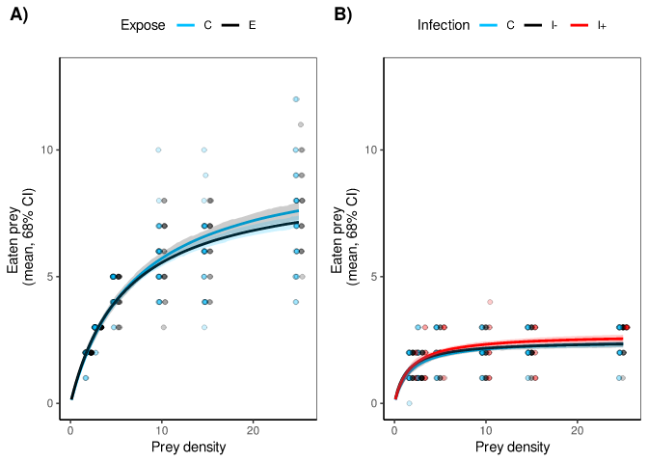

Figure 10: Number of prey (Artemia. spec nauplii) eaten by each copepod of batch 2 in dependency of administered prey density. The control group (C) wasn’t exposed to S. solidus whereas each exposed individual had been exposed (I- = no infection, I+ = successfully infected) to one coracidia five days before the first measurement. Confidence interval = 68%

The Bayesian interference method was chosen to calculate probabilities of effects caused by the infection statuses [17] [18]. Following values were provided by running a model based on the Holling formula (Supplements) that was created for this project (Supplementary link 1):

* Attack rate: 52.8 % of the infected individuals had a higher attack rate in comparison to the control group, therefore there’re no major differences.
* Handling time: 20.95% of the infected individuals had a higher handling time in comparison to the control group, whereas the remaining infected individuals showed a slightly lower handling time than the control group.
* Among the infected copepods, 83% of the individuals showed a slightly higher FR than the control group. In comparison to the other exposed copepods that weren’t exposed, 79% of the actually infected individuals showed a higher FR as well.

**4.3. Batch 3:**

Throughout the experiment, 11/45 of the individuals died of unknown reasons. Among the dead copepods, eight of them belonged to the exposed group, whereas the remaining three individuals belonged to the control group. Two weeks after the infection, the copepods were checked for procercoids under a microscope. No successful infections were observable.

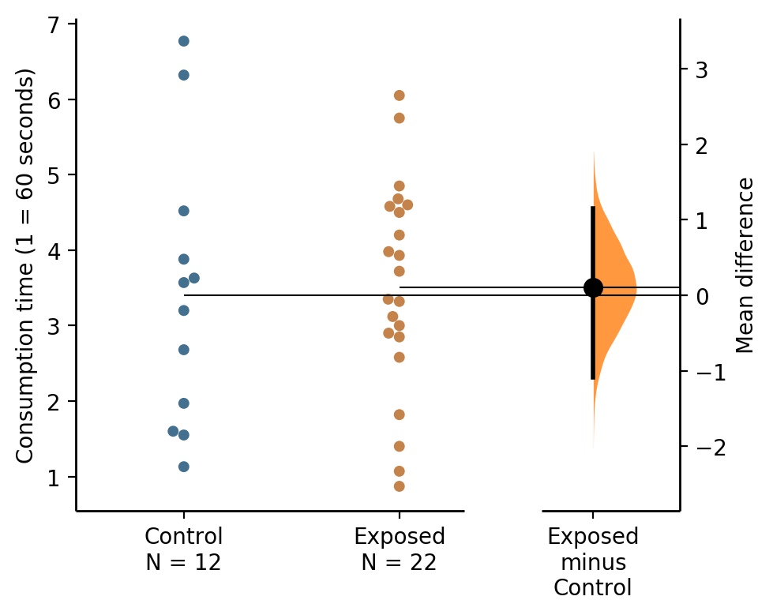

Figure 11: Mean difference between the prey consumption time of copepods not exposed to S. solidus (Control) and copepods that have been exposed to one coracidia (Exposed) five days before the measurements shown in a Gardner-Altman estimation plot. The mean difference is plotted on a floating axis on the right as a bootstrap sampling distribution. The mean difference is depicted as a dot; the 95% confidence interval is indicated by the ends of the vertical error bar. Created by estimationstats.com [19]

Both, the control and exposed group, were compared in the difference between their mean consumption time of one *Artemia* spec. larva. The bootstrap method was used in combination with a two-sided permutation t-test to determine the effect size with a null hypothesis assuming that the exposed group has the same mean prey consumption time as the control group.

5000 bootstrap samples were taken and the analysis provided following statistical values:

* P-value = 0.855
* [95.0% Confidence: -1.09, 1.15]

The P- value was calculated under the assumption of the null hypothesis, stating that there are differences between the control and exposed group.

Remotely, the t-test was separately performed for both groups with the aim to check for the major differences in their mean. Following values were provided by doing so:

* Mean (Exposed) = 3.51; Mean (Control) = 3.40
* P- value = 0.43
* t-value = 0.186525523; critical t-value = 1.69
* Variance = 2.41
* df = 32

NORMALVERTEILUGN ZUR VISUALISIERUNG

**4.4. Batch 4:**

Throughout the experiment, 2/45 of the individuals of died of unknown reasons. Both of those individuals belonged to the exposed group. Two weeks after the infection, the copepods were dissected and checked for procercoids under a microscope. Only one successful infection was seen. Comparing the remaining 42 copepods to one infected copepod wouldn’t make sense, so this copepod was grouped together with the remaining 29 exposed copepods. The cause of the poor infectivity is unknown.

During the six different measurements, I saw that up to 20 individuals developed egg sacs throughout the experiment, meaning that those individuals were fertilized during the isolation, even though, no egg sacs were visible at this time. This unintentionally adds a variable (= presence of egg sacs) to the data which biases the reliability of the data.

For the analysis, the model used for this batch is almost similar to the model for batch 3 with the exception of having no infection group (Supplementary link 2).

The female copepods showed a steadily growing saturation curve depending on the density of prey administered. The majority (mean) of both groups were saturated after seven *Artemia* spec. nauplii, which is being represented by a type ll FR. Every group shows a nearly identical type ll curve for the mean FR of this batch (Figure 12).

* Attack rate: 69.95% of the exposed had a higher attack rate in comparison to the control group, therefore there’re no major differences.
* Handling time: 56.5% of the exposed had a higher attack rate in comparison to the control group, therefore there’re no major differences.

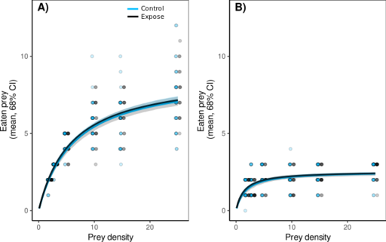

Figure 12: Number of prey (Artemia. spec nauplii) eaten by each copepod of batch 4 in dependency of administered prey density. The control group wasn’t exposed to S. solidus whereas each exposed individual had been exposed to one coracidia five days before the first measurement.

**5. Discussion:**

**5.1. Conclusions:**

The aim of this study was to test if *S. solidus* is able to change its first intermediate host’s, *M. albidus’*, feeding behavior which was tested by measuring *ir effects on functional response curves*. Many problems occurred throughout the experiment and therefore the results can’t be used to support the initial hypothesis. Initially, I hypothesized that infected copepods (eventually also exposed but uninfected copepods) may either show a positive or negative change in the feeding behavior caused by *S. solidus*. The major problem that occurred throughout every batch was the poor infectivity of the coracidia. A technician noticed that the temperature control of incubator fridge for *S. solidus* often appears to be accidentally turned off meaning that the eggs of *S. solidus* may have been stored in wrong temperatures throughout the preparation. Incubating and storing them in temperatures warmer than 20°C may be the reason for the poor infectivity, but it’s unknown if this was actually the case. Else, the actual reason for the poor activity of the coracidia remains unknown.

Nonetheless, the experiment provides a good basis on investigating the feeding behavior of *M. albidus* further in dependency of *S. solidus* and independent of *S. solidus.* *M. albidus* is an important biological pest control agent and further knowledge about its feeding behavior provides helpful data for ecological and population dynamics. The results of this experiment couldn’t provide reliable data for the influence of *S. solidus* to the feeding behavior of *M. albidus* but I was able to create consistent and reliable FR curves (Figure 12) for female copepods (respectively, FR curves for the usage of *Artemia* spec. as prey). Many female copepods developed egg sacs throughout the experiment so that the variable added by the egg sacs was partially consistent for those individuals. Still, future experiments using female adult copepods may require an isolation of the individuals up to three/four weeks before the actual preparation (e.g. parasite exposure) or measurements in order to replace individuals that developed egg sacs throughout that period of time. For male copepods, the data provides the knowledge that male individuals averagely consume two *Artemia* spec. larvae (Figure 10) which is 71.43% less than the females averagely consumed before saturation (Figure 12).

Either way, both sexes showed a type ll FR (Figures 10, 12) for the applied parameters meaning that the copepods didn’t rely on any increase in their foraging activity or attack rate on prey. The intake rate of the copepods is limited by the size and therefore capacity of their guts for food. At this point, it makes sense that the female copepods consume notably more than male copepods since female individuals grow larger than male copepods, in fact, female individuals grow up to 50% larger [15]. As mentioned, the data for the FR of the copepods are only applicable for the used parameters since the actual FR of *M. albidus* in the wild and their actual ecosystems consist of many additional components. For instance, intra- and interspecific competition [21] wasn’t taken into account in my experiment, therefore increased densities of *M. albidus* causing competitional stress may also increase the foraging and attack rate of the copepods. Another important factor of any predator-prey relationship is the predator-prey population dynamics [20]. My experiment only administered a fixed number of prey for the isolated copepods (supplementary table), which doesn’t recreate the ecosystem dynamics of the *M. albidus* as predator in its natural habitats by any means. To do so, it would require to recreate an entire natural habitat of *M. albidus* with the usage of natural inhabitants of this habitat as prey for further FR measurements. This is barely possible, not to mention observable and measurable. The closest way to achieve that would be the creation of mesocosms, but for small predator and prey species like *M. albidus* and *Artemia* spec., it remains difficult to track each individual of both parties, predators and prey. In conclusion, computing proper models and measuring the FR of predator-prey systems is a difficult task, working on a very complex system consisting of many linked components.

Studies like mine provide knowledge fragments for the understanding of entire ecosystems in their entirety. Only by studying the many different components, ecosystems may be approached and understood in their entirety by linking different studies of those so-called components.

**5.2. Batch 1:**

This batch was the only one that showed a very noticeable mortality for the copepods. Within the initial two weeks, more copepods of this batch died than in any other batch throughout the entire experiment. Methylene blue may has a significant effect to the mortality of the copepods. Other studies verify the toxicity of methylene blue to cells at higher concentrations [22], [23] and since *M. albidus* only weights between approx. 5 µg (male dry weight) and 20 µg(female dry weight) [24], 10 µgof a 0,001% methylene blue added to the copepod medium of 2 mL tab water may already be a lethal dose.

In total, the remaining batches didn’t show any noticeable problems with growth of fungi due to regular water exchanges, but in the final weeks of the measurements of those batches, fungal growth was still noticeable even though it wasn’t as severe as in my study of the *Projektmodul*  [12]. I think that the husbandry of the copepods as it was practiced has its limits at approx. six weeks until reaching critical growth of fungi which may become a problem to the health of the copepods. At this point, future experiments may deal with the question whether the copepods are capable of dealing with lower doses of methylene blue. I think that a simple experimental design of comparing a control group (no methylene blue) to groups that get exposed to methylene blue in different concentrations may already be sufficient to learn, if there is a way to use methylene blue against fungal growth for experimental copepod husbandry.

**5.3. Batch 2:**

This batch couldn’t show any major differences between the exposed, infected and control groups, since the male copepods showed a rapid saturation of the individuals (Figure 10) after consuming two/three prey individuals of *Artemia* spec.

The applied parameters for the measurements provide a rapidly saturated type ll curve (Figure 10), therefore the copepods of the three different groups (control, exposed, infected) can’t be compared by their differences in the consumed prey in dependency of the prey density administered. Considering the strong consistency of the majority of this batch being saturated after two prey individuals (Figure 10), the gut size of male copepods most likely limits their interest in prey/food to approx. two *Artemia* spec. nauplii before saturation independently of the copepods being exposed, infected or not.

In order to create better FR curves with more variations between and among the groups, smaller prey (e.g. *Paramecium* spec.) is required, but with decreasing size of the prey, the difficulty to count the prey increases.

**5.4. Batch 3:**

Batch 3 and 4 were heavily affected by the poor infectivity of the used coracidia, only one individual (of batch 4) was infected from 60 individuals in total from both batches together. Therefore, differences between the control and exposed groups are speculative assumptions since those differences may only be related to phenotypical variations of the copepods themselves regarding the metabolism. Further conclusions can’t be drawn by the data since the incapability of the used coracidia to successfully infect their host leaves the uncertainty of actual alterations of the copepod behavior caused by *S. solidus*.

**5.5. Batch 4:**

This batch couldn’t show any major differences between the exposed and control groups. Having only one successful infection doesn’t provide reliable and sufficient data in order to make statements about probable effects based on this single successful infection. Similar to batch 3, having no infections for the 29 copepods that were exposed for this batch leaves the uncertainty of any influence of *S. solidus,* because of the uncertainty of any successful entrance of the coracidias into their host’s bodies in order to infest and change their host’s behavior to their own advantage for growth into the procercoid stage.

The applied parameters for the measurements provide a steadily saturated type ll curve (Figure 12), but the copepods of the control and exposed group didn’t show any major differences in the consumed prey in dependency of the prey density administered.

Conclusions

**5.6. Outlook:**

Future studies of the FR of male copepods require smaller prey in order to receive variating clearance rates dependent of the prey density administered. For *Artemia* spec. it won’t be possible to create proper FR curves since male individuals of *M. albidus* only consume up to two or three *Artemia* spec. larvae independently of the prey density. I think that the applied parameters provided a good insight to the ingestion rate, such as it is being part of the handling time, of the (female) copepods, but no proper indications for the attack rate, which is also an important factor of the handling time, since the attack rate didn’t show any major differences between the exposed and control group. The well plates used for this experiment have a diameter of 1,8 cm. Being held in a small medium removes the reliance on higher attack rates and foraging activities due to the higher chance provided by a smaller medium to encounter prey randomly (e.g. by wandering or while being idle), therefore the handling time is altered due to the shifted importance of its components (e.g. attack rate, ingestion time). It’s difficult to distinguish between a type ll and type lll FR this way since the attack rate won’t be the driving force of the copepods’ successful predation in a small medium so therefore, future experiments may require larger well plates or other mediums in order to measure the attack rate of the copepods properly. However, consecutive studies to this experiment aiming for a broader understanding of the FR of *M. albidus*, generally and in dependency of *S. solidus*, may require different repeats with several different parameter combinations regarding medium size, prey density, feeding duration, etc. By repeating the same experiment with different parameters, the relevance of the different parameters (e.g. medium size) may be calculated. This way, many data points may be created that could be used to further approach the actual FR of *M. albidus* in its genuine natural habitats.

Originally, it was planned to measure the individual FR of each copepod with the aim to notice probable changes caused by *S. solidus* infections. For that matter, I wanted to measure the FR over two cycles starting: two days after the infection; 14 days after the infections. By doing so, it would have been possible to check for individual changes in the FR which would avoid probable differences caused by individual variating metabolic rates of the copepods themselves instead of the influence of *S. solidus*. The experiment required a lot of restructuring so there wasn’t enough time anymore to do two measurement cycles for the female copepods. Future studies based on the knowledge gained from my experiment may carry on at this point by repeating the experiment with two measurements cycle as already mentioned.

**Supplements:**

*Supplementary table 1: Distribution of the copepods within the 24 well plates (Figure 4). Each different color represents a block within the plate. This exposure plan was used for every plate 1 of every batch.*

*Legend: E = Exposed to coracidia C = Control group, no exposure / = no copepods*

|  |  |  |  |  |  |  |
| --- | --- | --- | --- | --- | --- | --- |
| Plate 1 | 1 | 2 | 3 | 4 | 5 | 6 |
| A | E | C | E | C | E | E |
| B | E | E | C | E | C | E |
| C | C | E | E | / | / | / |
| D | / | / | / | / | / | / |

*Supplementary table 2: Distribution of the copepods within the 24 well plates (Figure 4). Each different color represents a block within the plate. This exposure plan was used for every plate 2 of every batch.*

*Legend: E = Exposed to coracidia C = Control group, no exposure / = no copepods*

|  |  |  |  |  |  |  |
| --- | --- | --- | --- | --- | --- | --- |
| Plate 2 | 1 | 2 | 3 | 4 | 5 | 6 |
| A | C | E | E | E | E | C |
| B | E | C | E | E | C |  |
| C | E | E | C | / | / | / |
| D | / | / | / | / | / | / |

*Supplementary table 3: Distribution of the copepods within the 24 well plates (Figure 4). Each different color represents a block within the plate. This exposure plan was used for every plate 3 of every batch.*

*Legend: E = Exposed to coracidia C = Control group, no exposure / = no copepods*

|  |  |  |  |  |  |  |
| --- | --- | --- | --- | --- | --- | --- |
| Plate 3 | 1 | 2 | 3 | 4 | 5 | 6 |
| A | E | E | C | E | C | E |
| B | E | C | E | C | E | E |
| C | C | E | E | / | / | / |
| D | / | / | / | / | / | / |

*Supplementary table 4: Feeding schedule for the copepods. Every plate used this plan to standardize the schedule of every plate. This tables shows the different prey densities (=number of prey individuals) administered to the corresponding copepods for each day of measurement.*

|  |  |  |  |  |  |  |
| --- | --- | --- | --- | --- | --- | --- |
| Well | Density on  24.07.2022 | Density on  26.07.2022 | Density on  28.07.2022 | Density on  31.07.2022 | Density on  02.08.2022 | Density on  04.08.2022 |
| 1 | 25 | 3 | 10 | 5 | 2 | 15 |
| 2 | 10 | 5 | 25 | 3 | 15 | 2 |
| 3 | 3 | 15 | 5 | 2 | 25 | 10 |
| 4 | 15 | 25 | 5 | 10 | 3 | 2 |
| 5 | 3 | 15 | 25 | 5 | 2 | 10 |
| 6 | 2 | 5 | 10 | 15 | 3 | 25 |
| 7 | 2 | 25 | 15 | 5 | 10 | 3 |
| 8 | 25 | 10 | 3 | 5 | 2 | 15 |
| 9 | 10 | 2 | 5 | 3 | 25 | 15 |
| 10 | 5 | 10 | 25 | 15 | 3 | 2 |
| 11 | 5 | 3 | 15 | 2 | 25 | 10 |
| 12 | 10 | 5 | 3 | 25 | 15 | 2 |
| 13 | 15 | 5 | 2 | 10 | 25 | 3 |
| 14 | 3 | 2 | 25 | 10 | 15 | 5 |
| 15 | 10 | 15 | 3 | 5 | 2 | 25 |

**Holling formular:**

* = function of resource density
* a = predator’s attack coefficient
* h = handling time (for this paper = maximum ingestion rate)
* b = “Hill exponent”

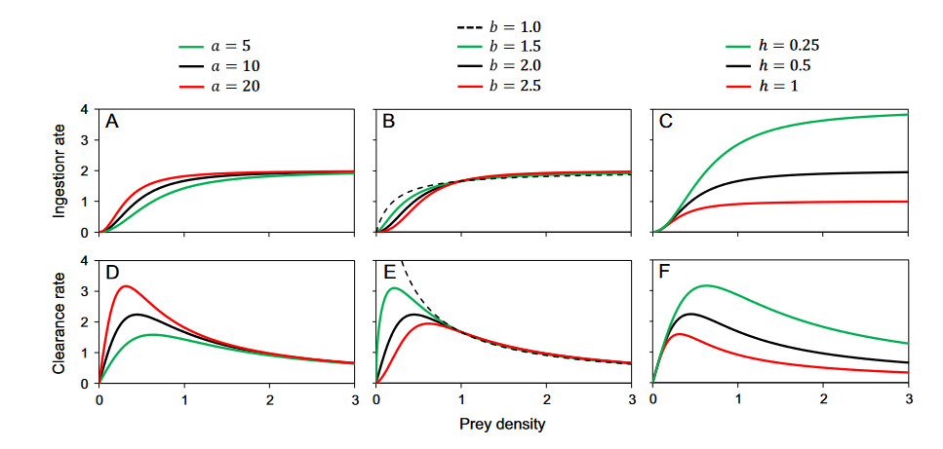

Supplementary Figure 1: Influence of the parameters on shape of the functional response curve. From Uszko et. al. 2020.

**Links:**

* Bayesian interference males (links to be added)
* Bayesian interference females

**Literature:**

[1] C. L. Wood and P. T. Johnson, “A world without parasites: exploring the hidden ecology of infection,” *Front. Ecol. Environ.*, vol. 13, no. 8, pp. 425–434, 2015, doi: 10.1890/140368.

[2] D. P. Benesh, “Tapeworm manipulation of copepod behaviour: parasite genotype has a larger effect than host genotype,” *Biol. Lett.*, vol. 15, no. 9, p. 20190495, Sep. 2019, doi: 10.1098/rsbl.2019.0495.

[3] N. Vo, V. Eichhorn, and D. J. M. Anaya-Rojas, “Host-parasite interaction: The behavioral effects of Schistocephalus solidus on copepods; Final report of the Vertiefungsmodul ‘Animal Evolutionary Ecology,’” Dec. 2021.

[4] C. Wedekind, “The infectivity, growth, and virulence of the cestode *Schistocephalus solidus* in its first intermediate host, the copepod *Macrocyclops albidus*,” *Parasitology*, vol. 115, no. 3, pp. 317–324, Sep. 1997, doi: 10.1017/S0031182097001406.

[5] P. J. Jakobsen, J. P. Scharsack, K. Hammerschmidt, P. Deines, M. Kalbe, and M. Milinski, “In vitro transition of Schistocephalus solidus (Cestoda) from coracidium to procercoid and from procercoid to plerocercoid,” *Exp. Parasitol.*, vol. 130, no. 3, pp. 267–273, Mar. 2012, doi: 10.1016/j.exppara.2011.09.009.

[6] N. Hafer and M. Milinski, “An experimental conflict of interest between parasites reveals the mechanism of host manipulation,” *Behav. Ecol.*, vol. 27, no. 2, pp. 617–627, Jan. 2016, doi: 10.1093/beheco/arv200.

[7] J. Kurtz, “Evolutionary ecology of immune defence in copepods,” *J. Plankton Res.*, vol. 29, no. suppl_1, pp. i27–i38, Jan. 2007, doi: 10.1093/plankt/fbl063.

[8] G. Fryer, “The Food of Some Freshwater Cyclopoid Copepods and its Ecological Significance,” *J. Anim. Ecol.*, vol. 26, no. 2, pp. 263–286, 1957, doi: 10.2307/1747.

[9] G. G. Marten, “ELIMINATION OF AEDES ALBOPICTUS FROM TIRE PILES BY INTRODUCING MACROCYCLOPS ALBIDUS (COPEPODA, CYCLOPIDAE),” *J. Am. Mosq. CONTROL Assoc.*, vol. 6, p. 5, 1990.

[10] W. Uszko, S. Diehl, and J. Wickman, “Fitting functional response surfaces to data: a best practice guide,” *Ecosphere*, vol. 11, no. 4, Apr. 2020, doi: 10.1002/ecs2.3051.

[11] C. S. Holling, “The Functional Response of Predators to Prey Density and its Role in Mimicry and Population Regulation,” *Mem. Entomol. Soc. Can.*, vol. 97, no. S45, pp. 5–60, ed 1965, doi: 10.4039/entm9745fv.

[12] N. Vo and D. J. M. Anaya-Rojas, “On host-parasite interactions: The effects of Schistocephalus solidus on the growth of Macrocyclops albidus; Final report of the Studienarbeit of the Projektmodul,” Jun. 2022.

[13] M. A. Ansari, Z. Fatima, and S. Hameed, “Antifungal Action of Methylene Blue Involves Mitochondrial Dysfunction and Disruption of Redox and Membrane Homeostasis in C. albicans,” *Open Microbiol. J.*, vol. 10, pp. 12–22, Feb. 2016, doi: 10.2174/1874285801610010012.

[14] A. Peters, “Testosterone and carotenoids: an integrated view of trade-offs between immunity and sexual signalling,” *BioEssays*, vol. 29, no. 5, pp. 427–430, 2007, doi: 10.1002/bies.20563.

[15] L. Sivars Becker, “Food and parasites - life-history decisions in copepods,” Uppsala University Uppsala, 2004. Accessed: Apr. 04, 2022. [Online]. Available: https://pure.mpg.de/pubman/faces/ViewItemOverviewPage.jsp?itemId=item_1507224

[16] Z. Brandl and C. H. Fernando, “The impact of predation by cyclopoid copepods on zooplankton,” *SIL Proc. 1922-2010*, vol. 21, no. 3, pp. 1573–1577, Dec. 1981, doi: 10.1080/03680770.1980.11897236.

[17] G. Gilioli, S. Pasquali, and F. Ruggeri, “Bayesian Inference for Functional Response in a Stochastic Predator–Prey System,” *Bull. Math. Biol.*, vol. 70, no. 2, pp. 358–381, Feb. 2008, doi: 10.1007/s11538-007-9256-3.

[18] A. M. Ellison, “Bayesian inference in ecology,” *Ecol. Lett.*, vol. 7, no. 6, pp. 509–520, 2004, doi: 10.1111/j.1461-0248.2004.00603.x.

[19] J. Ho, T. Tumkaya, S. Aryal, H. Choi, and A. Claridge-Chang, “Moving beyond P values: data analysis with estimation graphics,” *Nat. Methods*, vol. 16, no. 7, Art. no. 7, Jul. 2019, doi: 10.1038/s41592-019-0470-3.

[20] E. van Leeuwen, Å. Brännström, V. A. A. Jansen, U. Dieckmann, and A. G. Rossberg, “A generalized functional response for predators that switch between multiple prey species,” *J. Theor. Biol.*, vol. 328, pp. 89–98, Jul. 2013, doi: 10.1016/j.jtbi.2013.02.003.

[21] P. A. Abrams, “Consumer functional response and competition in consumer-resource systems,” *Theor. Popul. Biol.*, vol. 17, no. 1, pp. 80–102, Feb. 1980, doi: 10.1016/0040-5809(80)90016-7.

[22] J. I. Clifton and J. B. Leikin, “Methylene Blue,” *Am. J. Ther.*, vol. 10, no. 4, pp. 289–291, Aug. 2003.

[23] L. S. Peloi, R. R. S. Soares, C. E. G. Biondo, V. R. Souza, N. Hioka, and E. Kimura, “Photodynamic effect of light-emitting diode light on cell growth inhibition induced by methylene blue,” *J. Biosci.*, vol. 33, no. 2, pp. 231–237, Jun. 2008, doi: 10.1007/s12038-008-0040-9.

[24] E. Michaloudi, “Dry Weights of the Zooplankton of Lake Mikri Prespa (Macedonia, Greece),” p. 5.