# “光环”泡沫无人机总体气动动力数据

# 1 总体数据

质量3Kg

展长1.6m

弦长 0.2075m

机翼面积0.332m2

惯量Ibxx= 0.11931 kg.m2

Ibyy= 0.31096 kg.m2

Ibzz= 0.42318 kg.m2

Ibxz= -0.01537 kg.m2

# 2 气动数据

## 2.1 纵向气动特性

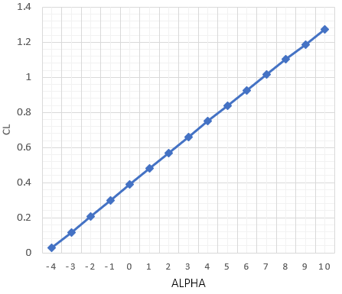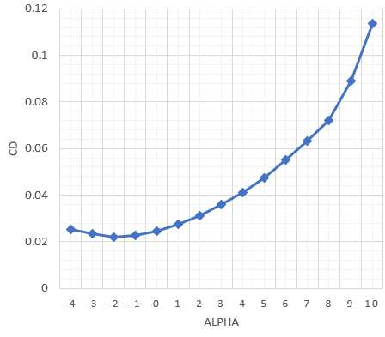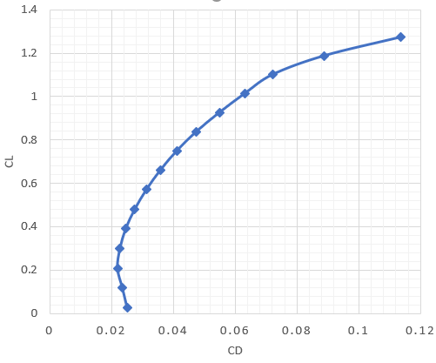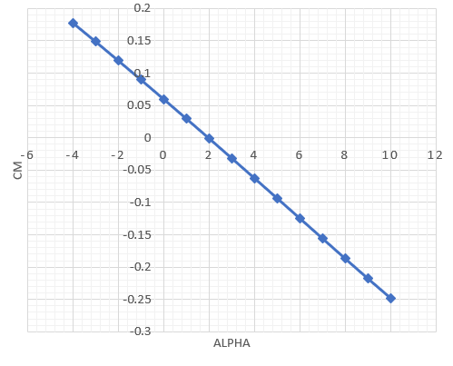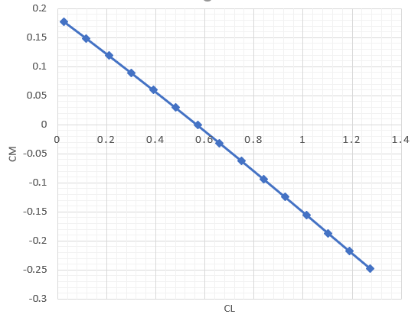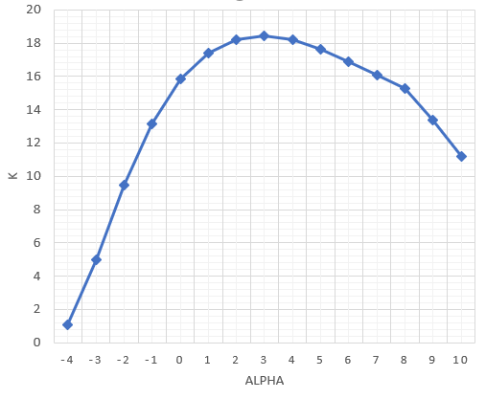

图 1 无人机纵向气动特性曲线

表1 V=15m/s教学无人机纵向气动数据

|  |  |  |  |  |  |
| --- | --- | --- | --- | --- | --- |
| Alpha/(̊) | CL | CD | Cm | K | ΔCm/ΔCL |
| -4 | 0.026789 | 0.025102 | 0.177658 | 1.067206 |  |
| -3 | 0.117645 | 0.023564 | 0.148782 | 4.992573 | -0.31782 |
| -2 | 0.208478 | 0.021974 | 0.119392 | 9.487485 | -0.32356 |
| -1 | 0.299224 | 0.022784 | 0.089776 | 13.13308 | -0.32636 |
| 0 | 0.389818 | 0.024616 | 0.059845 | 15.83596 | -0.33039 |
| 1 | 0.480196 | 0.02757 | 0.029645 | 17.41734 | -0.33415 |
| 2 | 0.570294 | 0.031307 | -0.00081 | 18.21618 | -0.33807 |
| 3 | 0.660047 | 0.035806 | -0.0315 | 18.43398 | -0.34184 |
| 4 | 0.749392 | 0.041138 | -0.06236 | 18.21654 | -0.34544 |
| 5 | 0.838268 | 0.047478 | -0.09336 | 17.65592 | -0.34882 |
| 6 | 0.926611 | 0.05497 | -0.12443 | 16.85667 | -0.35172 |
| 7 | 1.014362 | 0.06319 | -0.15556 | 16.05257 | -0.35472 |
| 8 | 1.10146 | 0.072211 | -0.18671 | 15.25335 | -0.35769 |
| 9 | 1.187848 | 0.088883 | -0.21755 | 13.36418 | -0.35694 |
| 10 | 1.273466 | 0.113566 | -0.24777 | 11.21344 | -0.35294 |

表 2无人机纵向气动特征数据

|  |  |  |  |
| --- | --- | --- | --- |
| αCLmax | 10˚ | CLmax | 1.4293 |
| Kmax | 18.4 | aKmax | 3˚ |
| ΔCm/ΔCLKmax | 34% | CLKmax | 0.660047 |
| CmKmax | -0.0315 | αCm=0 | 2˚ |
| CLCm=0 | 0.57 | KCm=0 | 15.8 |

## 2.2 横航向气动特性

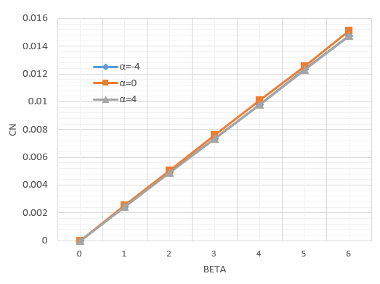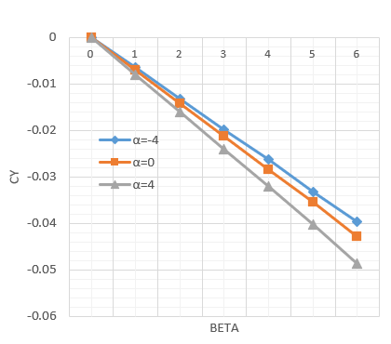

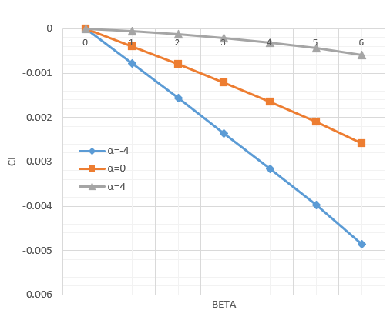

图 2 无人机横航向气动特性曲线

表 3构型09-3无人机横航向气动特性

|  |  |  |  |  |  |  |  |
| --- | --- | --- | --- | --- | --- | --- | --- |
| Alpha/(̊) | Beta/(̊) | CY | Cl | Cn | CYβ | Clβ | Cnβ |
| -4 | 0 | 0 | 0 | 0 |  |  |  |
| 1 | -0.00646 | -0.00078 | 0.002411 | -0.00646 | -0.00078 | 0.002411 |
| 2 | -0.01314 | -0.00157 | 0.004926 | -0.00668 | -0.00079 | 0.002515 |
| 3 | -0.01984 | -0.00236 | 0.007347 | -0.0067 | -0.00079 | 0.002421 |
| 4 | -0.02631 | -0.00316 | 0.009784 | -0.00647 | -0.0008 | 0.002437 |
| 5 | -0.03322 | -0.00398 | 0.012359 | -0.00692 | -0.00082 | 0.002575 |
| 6 | -0.03966 | -0.00485 | 0.014739 | -0.00644 | -0.00087 | 0.00238 |
| 0 | 0 | 0 | 0 | 0 |  |  |  |
| 1 | -0.00708 | -0.0004 | 0.002527 | -0.00708 | -0.0004 | 0.002527 |
| 2 | -0.01419 | -0.0008 | 0.005053 | -0.00711 | -0.0004 | 0.002526 |
| 3 | -0.0212 | -0.00121 | 0.007576 | -0.00701 | -0.00041 | 0.002523 |
| 4 | -0.02835 | -0.00165 | 0.010101 | -0.00715 | -0.00043 | 0.002525 |
| 5 | -0.03544 | -0.0021 | 0.012575 | -0.00709 | -0.00046 | 0.002474 |
| 6 | -0.04277 | -0.00258 | 0.015122 | -0.00733 | -0.00048 | 0.002547 |
| 4 | 0 | 0 | 0 | 0 |  |  |  |
| 1 | -0.00802 | -5.6E-05 | 0.002457 | -0.00802 | -0.000056 | 0.002457 |
| 2 | -0.01603 | -0.00012 | 0.004901 | -0.00801 | -0.000067 | 0.002444 |
| 3 | -0.02399 | -0.0002 | 0.00735 | -0.00795 | -0.000081 | 0.002449 |
| 4 | -0.0321 | -0.00031 | 0.009807 | -0.00811 | -0.000101 | 0.002457 |
| 5 | -0.04029 | -0.00043 | 0.012275 | -0.00819 | -0.000128 | 0.002468 |
| 6 | -0.04857 | -0.0006 | 0.014747 | -0.00829 | -0.000162 | 0.002472 |

## 2.3 构型09-3舵面气动特性

### 2.3.1 方向舵气动效能

计算时取迎角-4、0、4，侧滑角为0，方向舵偏转角度：0、5、10、15、20。其中方向舵定义为右偏为正，左偏为负。

表 4 方向舵气动特性

|  |  |  |  |  |  |  |  |
| --- | --- | --- | --- | --- | --- | --- | --- |
| Alpha/(̊) | δe/(̊) | CY | Cl | Cn | ΔCY/Δδe | ΔCl/Δδe | ΔCn/Δδe |
| -4 | 0 | 0 | 0 | 0 |  |  |  |
| 5 | 0.007598 | 0.000264 | -0.00312 | 0.0015196 | 0.0000528 | -0.0006248 |
| 10 | 0.013652 | 0.00049 | -0.00561 | 0.0012108 | 0.0000452 | -0.0004976 |
| 15 | 0.019069 | 0.000701 | -0.00784 | 0.0010834 | 0.0000422 | -0.0004452 |
| 20 | 0.024065 | 0.000903 | -0.00989 | 0.0009992 | 0.0000404 | -0.0004104 |
| 0 | 0 | 0 | 0 | 0 |  |  |  |
| 5 | 0.007685 | 0.000039 | -0.00314 | 0.001537 | 0.0000078 | -0.0006282 |
| 10 | 0.013806 | 0.000085 | -0.00564 | 0.0012242 | 0.0000092 | -0.0005 |
| 15 | 0.019283 | 0.000135 | -0.00788 | 0.0010954 | 0.00001 | -0.0004472 |
| 20 | 0.02433 | 0.00019 | -0.00994 | 0.0010094 | 0.000011 | -0.0004122 |
| 4 | 0 | 0 | 0 | 0 |  |  |  |
| 5 | 0.007696 | -0.00019 | -0.00311 | 0.0016652 | 0.0004448 | -0.0007082 |
| 10 | 0.013826 | -0.00032 | -0.00559 | 0.001226 | -0.0000266 | -0.000495 |
| 15 | 0.019308 | -0.00043 | -0.0078 | 0.0010964 | -0.000022 | -0.0004426 |
| 20 | 0.024358 | -0.00052 | -0.00984 | 0.00101 | -0.0000186 | -0.000408 |
| 8 | 0 | 0 | 0 | 0 |  |  |  |
| 5 | 0.007632 | -0.0004 | -0.00304 | 0.0015264 | -0.0000806 | -0.000607 |
| 10 | 0.01371 | -0.00071 | -0.00545 | 0.0012156 | -0.000061 | -0.0004828 |
| 15 | 0.019144 | -0.00097 | -0.00761 | 0.0010868 | -0.0000528 | -0.0004316 |
| 20 | 0.024148 | -0.00121 | -0.0096 | 0.0010008 | -0.000047 | -0.0003976 |

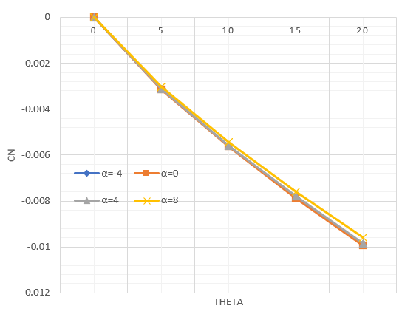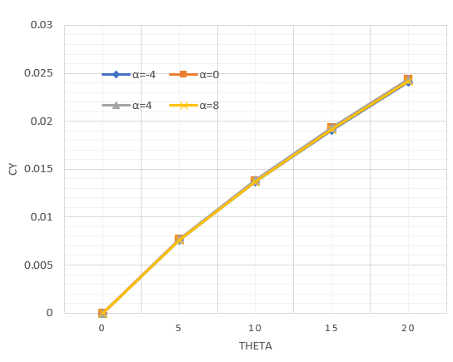

图 3 方向舵操纵效能曲线

### 2.3.2 升降舵气动效能

采用全动式升降舵布置，计算时取迎角-4、0、4、8，侧滑角为0，方向舵偏转角度：-20、-15、-10、-5、0、5、10、15、20。其中升降舵定义为下偏为正，上偏为负。

表 5 升降舵气动效能数据

|  |  |  |  |  |  |  |  |
| --- | --- | --- | --- | --- | --- | --- | --- |
| Alpha/(̊) | δe/(̊) | CL | CD | Cm | ΔCL/Δδe | ΔCD/Δδe | ΔCm/Δδe |
| -4 | -20 | -0.04187 | 0.040193 | 0.388959 |  |  |  |
| -15 | -0.02574 | 0.03438 | 0.338713 | 0.0032256 | -0.0011626 | -0.0100492 |
| -10 | -0.01042 | 0.029012 | 0.291103 | 0.0030658 | -0.0010736 | -0.009522 |
| -5 | 0.004519 | 0.024688 | 0.244862 | 0.0029868 | -0.0008648 | -0.0092482 |
| 0 | 0.026968 | 0.021879 | 0.175708 | 0.0044898 | -0.0005618 | -0.0138308 |
| 5 | 0.062257 | 0.021163 | 0.067569 | 0.0070578 | -0.0001432 | -0.0216278 |
| 10 | 0.094756 | 0.021152 | -0.03185 | 0.0064998 | -2.2E-06 | -0.0198842 |
| 15 | 0.122045 | 0.022215 | -0.11511 | 0.0054578 | 0.0002126 | -0.016652 |
| 20 | 0.146479 | 0.024468 | -0.18944 | 0.0048868 | 0.0004506 | -0.0148658 |
| 0 | -20 | 0.307087 | 0.035117 | 0.304661 |  |  |  |
| -15 | 0.325332 | 0.030237 | 0.249328 | 0.003649 | -0.000976 | -0.0110666 |
| -10 | 0.343533 | 0.026051 | 0.194178 | 0.0036402 | -0.0008372 | -0.01103 |
| -5 | 0.362523 | 0.022915 | 0.13658 | 0.003798 | -0.0006272 | -0.0115196 |
| 0 | 0.387943 | 0.021731 | 0.059055 | 0.005084 | -0.0002368 | -0.015505 |
| 5 | 0.420621 | 0.022481 | -0.04085 | 0.0065356 | 0.00015 | -0.0199818 |
| 10 | 0.4495 | 0.02415 | -0.12915 | 0.0057758 | 0.0003338 | -0.0176594 |
| 15 | 0.474307 | 0.026832 | -0.20501 | 0.0049614 | 0.0005364 | -0.0151718 |
| 20 | 0.496977 | 0.030612 | -0.27441 | 0.004534 | 0.000756 | -0.0138794 |
| 4 | -20 | 0.653866 | 0.045948 | 0.213251 |  |  |  |
| -15 | 0.673961 | 0.042335 | 0.153438 | 0.004019 | -0.0007226 | -0.0119626 |
| -10 | 0.694748 | 0.039666 | 0.09132 | 0.0041574 | -0.0005338 | -0.0124236 |
| -5 | 0.717461 | 0.038108 | 0.023071 | 0.0045426 | -0.0003116 | -0.0136498 |
| 0 | 0.745468 | 0.038486 | -0.06192 | 0.0056014 | 7.56E-05 | -0.0169984 |
| 5 | 0.775192 | 0.04056 | -0.15269 | 0.0059448 | 0.0004148 | -0.0181528 |
| 10 | 0.800122 | 0.043804 | -0.22917 | 0.004986 | 0.0006488 | -0.0152972 |
| 15 | 0.822135 | 0.047969 | -0.29702 | 0.0044026 | 0.000833 | -0.013569 |
| 20 | 0.842749 | 0.053091 | -0.36089 | 0.0041228 | 0.0010244 | -0.0127744 |
| 8 | -20 | 0.994547 | 0.070587 | 0.116555 |  |  |  |
| -15 | 1.016188 | 0.068482 | 0.052906 | 0.0043282 | -0.000421 | -0.0127298 |
| -10 | 1.039231 | 0.067551 | -0.0155 | 0.0046086 | -0.0001862 | -0.013682 |
| -5 | 1.065295 | 0.067965 | -0.09363 | 0.0052128 | 8.28E-05 | -0.0156252 |
| 0 | 1.0955 | 0.069906 | -0.18506 | 0.006041 | 0.0003882 | -0.018286 |
| 5 | 1.121941 | 0.073214 | -0.26586 | 0.0052882 | 0.0006616 | -0.0161604 |
| 10 | 1.14264 | 0.078225 | -0.33003 | 0.0041398 | 0.0010022 | -0.0128332 |
| 15 | 1.161599 | 0.083863 | -0.38937 | 0.0037918 | 0.0011276 | -0.0118692 |
| 20 | 1.179912 | 0.090213 | -0.4472 | 0.0036626 | 0.00127 | -0.0115646 |

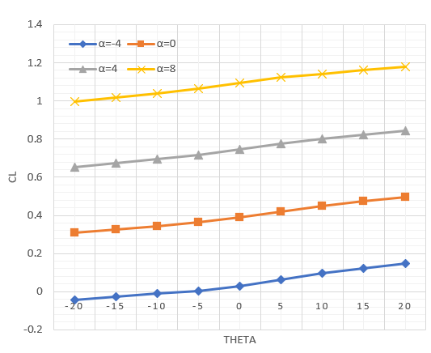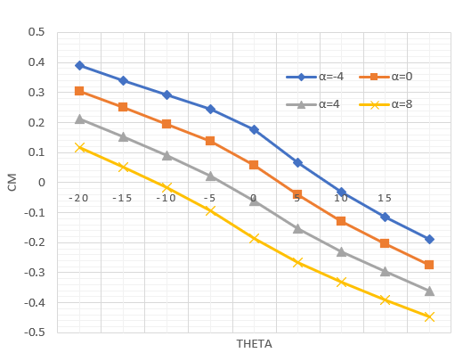

图 4 升降舵气动效能曲线

### 2.3.3 副翼气动效能

|  |  |  |  |  |  |  |  |
| --- | --- | --- | --- | --- | --- | --- | --- |
| Alpha/(̊) | δe/(̊) | CY | Cl | Cn | ΔCY/Δδe | ΔCl/Δδe | ΔCn/Δδe |
| -4 | 0 | 0 | 0 | 0 |  |  |  |
| 5 | -0.00349 | -0.02349 | -0.00019 | -0.000697 | -0.0046972 | -0.0000384 |
| 10 | -0.00647 | -0.04335 | -0.00025 | -0.000596 | -0.003972 | -0.0000124 |
| 15 | -0.0093 | -0.06207 | -6.1E-05 | -0.0005672 | -0.0037442 | 0.0000386 |
| 20 | -0.01207 | -0.08016 | 0.000065 | -0.0005528 | -0.0036176 | 0.0000252 |
| 0 | 0 | 0 | 0 | 0 |  |  |  |
| 5 | -0.00357 | -0.02355 | -0.00034 | -0.0007134 | -0.004709 | -0.0000686 |
| 10 | -0.00656 | -0.04333 | -0.00027 | -0.0005986 | -0.003957 | 0.0000146 |
| 15 | -0.00942 | -0.06201 | -4.2E-05 | -0.0005714 | -0.0037362 | 0.0000456 |
| 20 | -0.01221 | -0.08007 | 0.000008 | -0.000558 | -0.003612 | 0.00001 |
| 4 | 0 | 0 | 0 | 0 |  |  |  |
| 5 | -0.00362 | -0.02349 | -0.00041 | -0.0007244 | -0.004698 | -0.0000814 |
| 10 | -0.0066 | -0.04311 | -0.00045 | -0.0005948 | -0.0039234 | -0.0000088 |
| 15 | -0.00945 | -0.06166 | -0.0004 | -0.0005698 | -0.0037098 | 0.0000104 |
| 20 | -0.01223 | -0.0796 | -0.00039 | -0.0005576 | -0.0035892 | 0.0000026 |
| 8 | 0 | 0 | 0 | 0 |  |  |  |
| 5 | -0.00365 | -0.02332 | -0.00021 | -0.0007298 | -0.0046644 | -0.0000414 |
| 10 | -0.00657 | -0.04267 | -0.00034 | -0.000585 | -0.0038704 | -0.0000264 |
| 15 | -0.00938 | -0.061 | -0.00029 | -0.000562 | -0.0036656 | 0.0000106 |
| 20 | -0.01214 | -0.07875 | -7.6E-05 | -0.0005518 | -0.0035488 | 0.000042 |

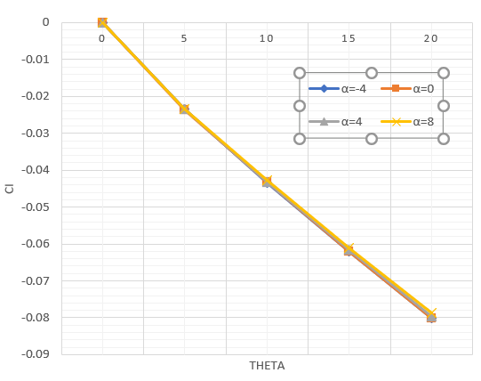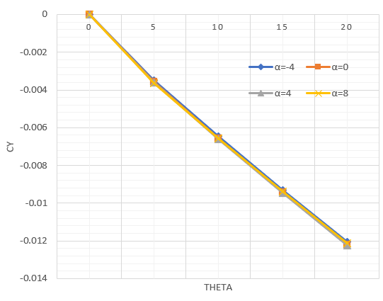

图 5 副翼气动效能曲线

## 2.4 教学无人机动导数特性

表6 H=500m、V=15/s无人机动导数特性

|  |  |  |  |  |  |  |  |  |
| --- | --- | --- | --- | --- | --- | --- | --- | --- |
| Alpha | CYp | Clp | Cnp | CLq | Cmq | CYr | Clr | Cnr |
| 2° | -0.07474 | -0.51302 | -0.09846 | 10.06864 | -16.76863 | 0.38431 | 0.14807 | -0.12997 |

数据修正建议：

 ；

Clr减到上表的0.5倍；

Cnr增大到上表的1.5倍。

# 3 动力能源数据

## 3.1 动力数据

电机型号：4410

螺旋桨型号：11*7‘’

表7 H=5000m、V=10/s无人机动导数特性

|  |  |
| --- | --- |
| 油门 | 推力（N） |
| 0 | 0 |
| 0.1 | 0.33 |
| 0.2 | 1.17 |
| 0.3 | 2.41 |
| 0.4 | 4.11 |
| 0.5 | 5.99 |
| 0.6 | 8.58 |
| 0.7 | 10.75 |
| 0.8 | 12.89 |
| 0.9 | 14.67 |
| 0.97 | 16 |



## 3.2 能源数据

电池标称电压：22.2V （6S）

电池标称容量：50Ah