Computational Discovery of Cold Adapted UvsX Recombinases
Jaime Duarte-Niemen
Table of Contents

Introduction

The need for portable DNA diagnostics
Rapid nucleic acid detection is essential for clinical diagnostics, disease surveillance, and environmental monitoring. However, conventional molecular diagnostic workflows often require centralised laboratory infrastructure, specialised equipment, and trained personnel, limiting their deployment in field-based and resource-limited settings.
The development of portable diagnostic platforms aims to overcome these limitations by enabling rapid molecular testing directly at the point of need. Such technologies have the potential to improve outbreak response, support environmental monitoring, and expand access to molecular diagnostics beyond traditional laboratory environments. Achieving this requires amplification methods that maintain high sensitivity while operating with minimal equipment.

What is Recombinase Polymerase Amplification (RPA)
Before the development of nucleic acid amplification technologies, infectious disease diagnosis primarily relied on clinical symptoms, microscopy, immunological assays, and microbial culture-based methods. However, these approaches often lacked accuracy, sensitivity, required time-consuming workflows, or depended on the ability to successfully culture the target organism. The development of polymerase chain reaction (PCR) represented a major advancement in molecular diagnostics by enabling the rapid and highly sensitive amplification of specific DNA sequences from minimal starting material. PCR remains the gold standard nucleic acid amplification method due to its high analytical sensitivity, specificity, and robustness across a wide range of diagnostic applications.
Despite its widespread adoption, PCR requires repeated thermal cycling between different temperatures for DNA denaturation, primer annealing, and extension. This dependence on specialised thermocycling equipment increases assay complexity, limits portability, and can restrict deployment in resource-limited or point-of-care settings. These limitations have driven the development of alternative amplification technologies that retain the sensitivity of PCR while reducing equipment requirements.
Recombinase polymerase amplification (RPA) is a rapid, highly sensitive isothermal DNA amplification method that enables nucleic acid detection without the need for thermal cycling or complex laboratory equipment (Piepenburg, 2006). By combining recombinase-mediated primer targeting with strand-displacing DNA polymerase activity, RPA achieves exponential amplification at low, constant temperatures and can detect very low concentrations of target DNA. These characteristics make RPA well suited for portable diagnostics and point-of-care applications, with the potential to overcome key limitations associated with conventional PCR-based testing.
Despite these advantages, current RPA systems still require controlled incubation temperatures, typically between 37–42°C, meaning that external heating remains necessary. This requirement represents a remaining barrier to truly equipment-free molecular diagnostics. Since amplification efficiency depends on the temperature-dependent activity of the RPA enzymes.

How RPA works
Recombinase polymerase amplification (RPA) is an isothermal DNA amplification technique that combines recombinase-mediated primer targeting with strand-displacing DNA synthesis. A typical RPA reaction contains the recombinase UvsX, its loading factor UvsY, the single-stranded DNA-binding protein gp32, and a strand-displacing DNA polymerase (Piepenburg, 2006).
Single-stranded DNA primers are designed to flank the target region and anneal to opposite strands of the template DNA, with their 3’ ends oriented toward the region to be amplified. In solution, gp32 binds strongly to single-stranded DNA, including primers, preventing premature secondary structure formation and nonspecific interactions. UvsY promotes the assembly of UvsX onto the primers by facilitating displacement of gp32 and stabilising the formation of ATP-bound UvsX–DNA nucleoprotein filaments as seen in figure 1.
These nucleoprotein filaments actively scan double-stranded DNA for homologous sequences through transient, ATP-dependent interrogation of short base segments. Upon identification of sufficient sequence complementarity, the filament promotes strand invasion, displacing the complementary strand and forming a displacement loop (D-loop). gp32 binds the displaced single strand, stabilising the intermediate and preventing branch migration-mediated dissociation.
ATP hydrolysis regulates UvsX filament dynamics, promoting disassembly after successful strand invasion and thereby exposing the primer 3’ end. This allows a strand-displacing DNA polymerase (commonly the large fragment of Bacillus subtilis DNA polymerase I) to extend the primer. Repeated cycles of filament formation, strand invasion, and primer extension lead to exponential amplification of the target sequence under isothermal conditions (Lobato, 2018).
Because successful amplification depends on dynamic processes including UvsX filament assembly, DNA homology searching and strand invasion, changes in protein flexibility and conformational dynamics may influence the temperature range over which RPA remains efficient.
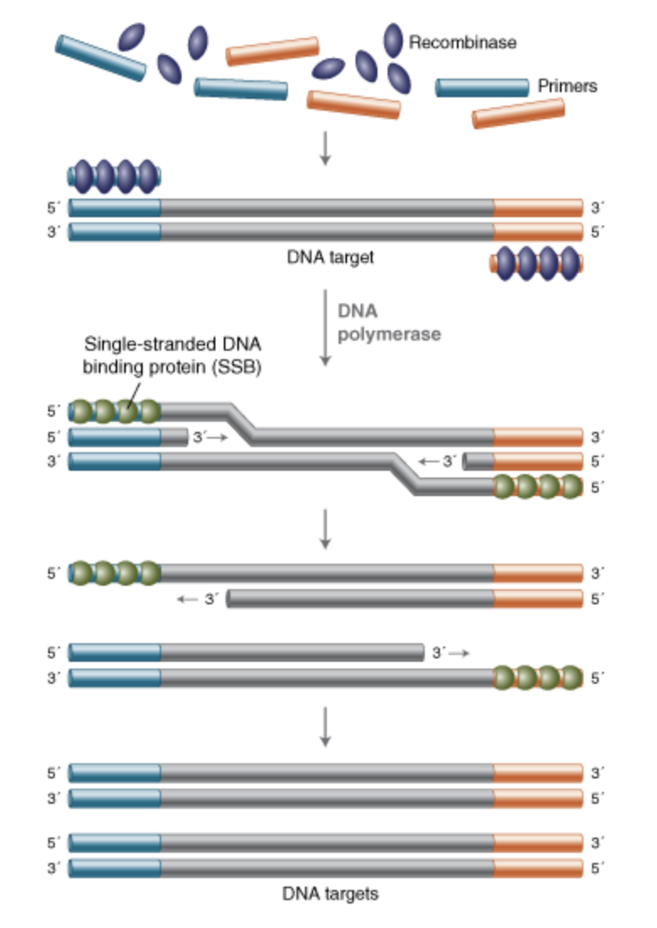 Figure 1. Overview of recombinase polymerase amplification (RPA).
Schematic representation of the RPA mechanism. UvsX recombinase binds single-stranded primers and facilitates their invasion into homologous double-stranded DNA regions. Following primer binding, strand displacement synthesis by polymerase enables rapid DNA amplification under isothermal conditions without the need for thermal cycling.

RPA vs PCR comparison
Feature | Recombinase Polymerase Amplification (RPA) | Polymerase Chain Reaction (PCR)
Temperature requirement | Isothermal amplification performed at a constant low temperature (~37-42°C) | Requires repeated thermal cycling between denaturation, annealing, and extension temperatures
Equipment requirements | Minimal equipment; can be performed using simple heating devices, enabling portable and point-of-care applications | Requires a specialised thermocycler, limiting portability
Amplification speed | Rapid amplification, typically producing detectable products within ~20-40 minutes | Generally slower due to multiple thermal cycling steps
Sensitivity | Highly sensitive and capable of detecting low concentrations of target nucleic acids | Highly sensitive, particularly when combined with quantitative PCR (qPCR)
Specificity | Can tolerate some primer-template mismatches, which may increase the risk of non-specific amplification | Generally higher specificity due to strict primer annealing requirements and controlled thermal cycling
Quantification capability | Primarily qualitative or semi-quantitative due to rapid amplification kinetics | Excellent quantitative capability when using qPCR approaches
Primer design | Relatively simple but still requires optimisation to minimise non-specific amplification | Well-established primer design principles and extensive optimisation tools available
Applications | Point-of-care diagnostics, field pathogen detection, environmental monitoring, and resource-limited settings | Clinical diagnostics, research applications, pathogen detection, and molecular biology workflows
Table 1. Summary of the comparative advantages and limitations of recombinase polymerase amplification (RPA) and polymerase chain reaction (PCR).

Why Cold adapted orthologs would revolutionize DNA diagnostics.
Although RPA eliminates the need for thermal cycling, current reactions are typically performed at 37–42 °C to ensure optimal activity of the recombinase and polymerase enzymes. While this temperature is considerably lower than that required for PCR, it still necessitates an external heat source, limiting the deployment of RPA in truly equipment-free settings. Developing an RPA system capable of operating efficiently at ambient temperatures (approximately 20–25 °C) would therefore represent a significant advancement for point-of-care molecular diagnostics.
One potential strategy is the identification of cold-adapted UvsX orthologues from psychrophilic organisms. Psychrophilic proteins often exhibit adaptations that maintain catalytic activity at low temperatures, including increased structural flexibility, which can compensate for the reduced molecular motion associated with cold environments. If similar adaptations are conserved in recombinase orthologues, they may enable efficient homology searching, strand invasion and primer targeting at room temperature without compromising amplification efficiency. This makes naturally occurring cold-adapted orthologues a promising source of recombinases with altered biochemical properties that may extend the operational temperature range of RPA.
An ambient-temperature RPA system would further reduce the equipment requirements of nucleic acid amplification by removing the need for incubators or portable heating devices. This would simplify testing in resource-limited settings, facilitate field-based pathogen surveillance, improve environmental DNA (eDNA) monitoring, and enable rapid diagnostics during disease outbreaks where laboratory infrastructure is unavailable. Lower operating temperatures may also reduce power consumption, increase assay portability and simplify integration into disposable diagnostic devices.
This project therefore investigates naturally occurring cold-adapted UvsX orthologues as a means of extending the operational temperature range of RPA. By identifying recombinases that retain ATP-dependent DNA strand exchange activity at ambient temperatures, this work aims to contribute towards the development of a truly portable DNA amplification platform capable of delivering rapid and sensitive molecular diagnostics outside of conventional laboratory environments.

UvsX
UvsX is a recombinase protein encoded by bacteriophage T4 that plays a central role in homologous recombination. The protein is 391 amino acids in length and belongs to the RecA-like family of ATP-dependent recombinases. UvsX is evolutionarily related to the bacterial recombinase RecA, sharing a common RecA-like structural fold and conserved functional regions involved in homologous recombination. Similar to RecA, UvsX forms ATP-dependent nucleoprotein filaments on single-stranded DNA (ssDNA), which mediate the search for homologous sequences within double-stranded DNA (dsDNA) and facilitate strand exchange.
Among the components of the RPA reaction, UvsX represents a particularly attractive target for optimisation because recombinase-mediated filament formation and strand invasion constitute the first rate-limiting steps of amplification. Improving UvsX activity under reduced thermal conditions could therefore increase the operational range of the entire reaction.

ATP binding domains
ATP hydrolysis controls the dynamic assembly and disassembly of UvsX-DNA filaments, mutations affecting ATP-binding regions could alter recombinase activity and therefore influence amplification efficiency.

Walker A motif
The Walker A motif, also known as the P-loop, is a conserved phosphate-binding region responsible for ATP binding. In UvsX, the Walker A motif is located at residues 59–67. Structural comparison between UvsX and RecA demonstrates conservation of this motif in both position and residue composition, indicating preservation of the ATP-binding architecture. The Walker A motif interacts with the phosphate groups of ATP and provides the primary nucleotide-binding site within the ATPase domain (Gajewski, 2011).

Walker B motif
The Walker B motif of UvsX is located at residues 138–143. This motif contains a conserved aspartic acid residue (Asp143), which coordinates the Mg$​^{2+}$ ion required for ATP hydrolysis. Additionally, the catalytic glutamic acid residue (Glu92) is conserved and contributes to ATP hydrolysis. Conservation of these catalytic residues indicates that UvsX retains the characteristic ATP-dependent mechanism of RecA-like ATPases (Gajewski, 2011).

DNA binding loops
DNA binding requires conformational rearrangement of flexible loop regions, these regions may represent potential contributors to temperature-dependent changes in recombinase activity.
UvsX interacts with both ssDNA and dsDNA through conserved DNA-binding loops located within the core RecA-like domain. Despite relatively low sequence conservation between UvsX and RecA, the overall folding of the core domain is highly conserved, including the presence of two DNA-binding loops, L1 and L2. These flexible loops mediate interactions with DNA and are positioned to stabilise nucleic acid binding within the UvsX nucleoprotein filament. Structural studies of RecA-like recombinases suggest that these loops undergo conformational flexibility to accommodate DNA, with each UvsX monomer interacting with approximately three nucleotide or DNA base pairs (Pan, 2023).
The N-terminal and C-terminal regions of UvsX primarily contribute to oligomerisation and filament formation rather than directly contacting DNA. These domains interact with the core domain to stabilise the recombinase filament, creating the appropriate architecture for DNA binding and homologous pairing. Through coordinated action of the core DNA-binding loops and filament-forming regions, UvsX is able to bind ssDNA and facilitate homology searching against dsDNA during strand exchange (Ando, 1998).
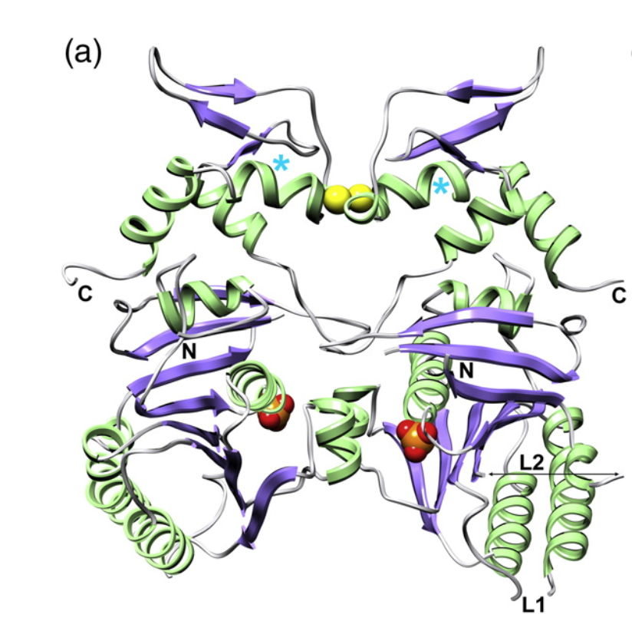 Figure 2. Crystal structure of the UvsX dimer highlighting the RecA-like ATPase domain and DNA binding Loops.
The dimeric arrangement of UvsX showing the conserved RecA-like core domain and the location of the ATP-binding sites at the dimer interface. The positions of the N- and C-terminal regions and the DNA-binding loops L1 and L2 are indicated, highlighting the structural organisation of the domains involved in ATP-dependent recombination and DNA binding.

Thermal adaption
Temperature is a fundamental determinant of protein function, influencing both the rate of biochemical reactions and the structural dynamics required for catalysis. As temperature decreases, molecular motion is reduced, resulting in fewer productive collisions between enzymes and their substrates and an increase in the energetic barriers associated with conformational change. Enzyme catalysis depends on the ability of proteins to undergo precise structural rearrangements that position catalytic residues, orient substrates correctly, and stabilise the high-energy transition state intermediate formed during a chemical reaction. By reducing the activation energy required to reach this transition state, enzymes accelerate reaction rates; therefore, reduced conformational flexibility at low temperatures can limit catalytic efficiency. Organisms inhabiting permanently cold environments have consequently evolved proteins that maintain sufficient flexibility and catalytic activity despite reduced thermal energy.
Protein thermal adaptation is governed by a fundamental trade-off between catalytic activity and structural stability. Thermophilic proteins maximise stability through extensive intramolecular interactions, including increased hydrophobic packing, hydrogen bonding, and salt bridge formation, enabling them to resist thermal unfolding at elevated temperatures. Maintaining a stable folded structure is essential because protein function depends on the precise three-dimensional arrangement of amino acid residues that form active sites and interaction surfaces. Thermal unfolding disrupts these structural features, resulting in loss of enzymatic activity and potentially irreversible aggregation. In contrast, psychrophilic proteins have evolved to favour catalytic efficiency over stability, allowing them to remain highly active at low temperatures through increased structural flexibility while becoming more susceptible to thermal denaturation. This activity–stability trade-off is considered a defining characteristic of enzyme thermal adaptation.
Early models proposed that psychrophilic enzymes achieved this increased activity through enhanced flexibility of the active site, allowing catalytic residues to undergo the conformational changes required for catalysis despite reduced thermal energy. However, advances in molecular dynamics simulations and computational enzymology have challenged this hypothesis. Comparative studies of psychrophilic, mesophilic and thermophilic citrate synthases demonstrated the expected differences in activation thermodynamics but found little evidence that active-site residues themselves exhibited greater atomic fluctuations. Instead, the reduction in activation enthalpy ($ΔH^{‡}$) originated predominantly from regions outside the active site, suggesting that cold adaptation is driven by changes in the global dynamics of the protein rather than local increases in catalytic-site flexibility (Åqvist, 2017).
Current evidence therefore supports the view that psychrophilic enzymes possess altered conformational energy landscapes rather than simply more flexible active sites. Structural adaptations, including reduced hydrophobic packing, fewer stabilising electrostatic interactions and subtle amino acid substitutions, increase the mobility of loops, domain interfaces and other regions distant from the catalytic centre. These long-range dynamic changes lower the energetic cost of the conformational rearrangements required during catalysis while preserving the precise geometry of the catalytic residues. Consequently, the active site remains highly conserved and structurally competent, whereas the surrounding protein scaffold provides the flexibility necessary to maintain efficient catalysis at low temperatures.
These principles are particularly relevant to recombinase proteins such as UvsX. Unlike many metabolic enzymes, UvsX functions through a series of ATP-dependent conformational transitions that drive nucleoprotein filament assembly, homologous DNA searching, strand invasion, ATP hydrolysis and filament disassembly. The efficiency of these processes depends not only on the integrity of the ATP- and DNA-binding sites but also on coordinated structural dynamics throughout the protein. It is therefore plausible that cold-adapted UvsX orthologues have evolved modifications to their global conformational dynamics that permit efficient recombinase activity at lower temperatures without substantially altering the conserved functional regions responsible for ATP binding or DNA recognition.
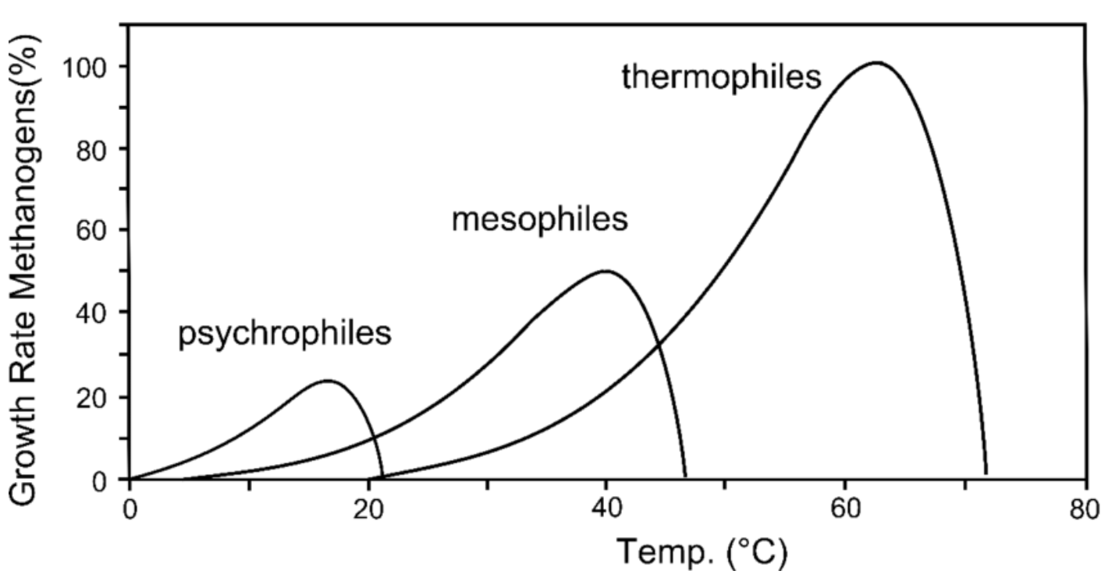 Figure 3. Thermal ranges of organisms and associated protein adaptations.
Comparison of the environmental temperature ranges occupied by psychrophilic, mesophilic, and thermophilic organisms. Cold-adapted proteins from psychrophilic organisms exhibit structural adaptations that maintain catalytic activity and flexibility at reduced temperatures, providing a potential source of enzymes for low-temperature biotechnological applications.

Computational bioprospecting of UvsX orthologues
The rapid expansion of genomic and metagenomic datasets has enabled computational bioprospecting, where bioinformatic approaches are used to explore biological diversity and identify proteins with potentially valuable functional properties. By screening previously unexplored genetic resources, including extremophilic microbial communities, computational approaches provide a route to discovering novel biomolecules beyond experimentally characterised systems.
For the discovery of temperature-adapted UvsX recombinases, experimentally validated proteins provide essential references for identifying sequence and structural features associated with functional activity. The bacteriophage T4 UvsX recombinase represents the canonical member of this family due to its established role in homologous recombination and extensive biochemical characterisation. Additionally, the recently characterised UvsX$​_{t}$ (7Z3M) and UvsX$​_{p}$ (9GBG) orthologues, identified from extremophilic phages through the Virus-X project, demonstrate functional diversity across phage lineages while retaining conserved RecA-like ATPase and DNA-binding features (Tarrant, 2026).
Together, these characterised UvsX proteins provide reference points for computational pipelines designed to identify novel recombinases with potentially altered temperature adaptations. Comparing candidate sequences against experimentally validated examples enables the prioritisation of proteins with characteristics consistent with functional UvsX activity.

Current limitations of RPA
Although recombinase polymerase amplification (RPA) offers rapid amplification, high analytical sensitivity and minimal equipment requirements, several limitations currently restrict its widespread adoption. RPA tolerates primer-template mismatches, this increased mismatch tolerance reduces assay specificity. Consequently, background DNA present in complex biological samples may undergo unintended amplification, increasing the likelihood of false-positive results in diagnostic applications (Rohrman, 2015).
While RPA is generally more resistant to common PCR inhibitors and can therefore be applied to less purified samples, its performance is highly dependent on careful optimisation of reaction conditions. The amplification process relies on a coordinated interaction between the recombinase UvsX, the loading factor UvsY, gp32 single-stranded DNA-binding protein and a strand-displacing DNA polymerase. Small changes in enzyme concentration, primer design or reaction chemistry can significantly affect amplification efficiency and increase the risk of non-specific products (Oliveira, 2021).
Although primer design is simpler than in other isothermal amplification techniques such as loop-mediated isothermal amplification (LAMP), dedicated primer design software remains limited and assay optimisation is often empirical, however there have been recent progress made at the Emergent Bioinformatics Lab who have released PrimedRPA to address this issue (Rabiu, 2026; Higgins, 2017). Furthermore, unlike quantitative PCR (qPCR), RPA provides relatively poor quantitative discrimination because amplification begins almost immediately after the reaction is initiated, making precise quantification challenging. As a result, RPA is predominantly used as a qualitative or semi-quantitative diagnostic technique (Tan, 2022).
Practical considerations also limit wider implementation. Commercial RPA reagents remain relatively expensive owing to proprietary enzyme formulations, and fewer commercial kits are available compared with the extensive range of PCR assays. Consequently, despite its advantages of rapid amplification (typically within 20–40 minutes), low operating temperature (37–42 °C) and minimal equipment requirements, RPA has yet to achieve the widespread adoption of PCR in routine diagnostic laboratories.

Aims & Objectives
The development of ambient-temperature RPA requires the identification of recombinase enzymes capable of maintaining efficient DNA strand exchange under reduced thermal conditions. This project aims to identify and characterise cold-adapted UvsX orthologues with the potential to extend the operational temperature range of RPA-based DNA amplification.
To achieve this aim, the following objectives will be addressed:
- Identify candidate cold-adapted UvsX orthologues from publicly available sequence databases. Experimentally validated UvsX sequences will be used as reference standards to discover putative orthologues across diverse phage and microbial lineages.
- Develop an in silico screening pipeline to prioritise candidate UvsX proteins. Candidate sequences will be evaluated using profile-based and sequence-based approaches, including hidden Markov models (HMMs), alongside computational predictors of protein adaptation and thermal preference.
- Evaluate the structural dynamics of candidate UvsX orthologues. Molecular dynamics simulations will be used to investigate protein flexibility, stability, and conformational behaviour, identifying structural characteristics associated with cold adaptation.
Together, these approaches aim to establish a computational framework for discovering cold-adapted UvsX enzymes and identifying promising candidates for future experimental validation in ambient temperature RPA systems.

Methods

Selection of gold standard proteins
Experimentally characterised UvsX proteins were first identified to establish reference sequences for candidate discovery and downstream validation. These proteins provided experimentally supported examples of UvsX proteins with known functionality, thermal characteristics and available structural information.
The primary reference sequence was bacteriophage T4 UvsX, the recombinase utilised in conventional recombinase polymerase amplification (RPA). Additional validated UvsX orthologues were selected based on their experimentally characterised thermal adaptation properties. These included the thermophilic orthologue 7Z3M and the psychrophilic orthologue 9GBG (Tarrant, 2026).
Both orthologues were identified through metagenomic analysis as part of the Virus-X project, which aimed to characterise proteins recovered from extremophile environments. The thermophilic orthologue 7Z3M was isolated from a hot spring, whereas the psychrophilic orthologue 9GBG was recovered from marine sediments approximately 1,000 m below sea level, where the ambient temperature was approximately 0.5 °C.
The engineered K35G/E198R UvsX variant was also included as a representative directed-evolution-derived protein exhibiting enhanced catalytic activity. Other engineered variants from the same study were excluded to avoid overrepresentation of highly similar sequences differing only by individual amino acid substitutions.
The resulting set of four gold standard proteins was used to guide downstream sequence-based screening, including HMM construction, conserved motif identification and structural comparison.

Construction of a curated UvsX sequence database
A comprehensive database of candidate UvsX-like proteins was constructed using three publicly available protein resources: UniProt, NCBI, and InterPro. Candidate sequences were retrieved using database-specific search strategies designed to identify putative UvsX recombinase homologs. For UniProt and NCBI, keyword-based searches were performed using terms associated with UvsX and phage recombinase proteins. To complement these searches, the two InterPro entries (“IPR049428”, “IPR049047”) associated with UvsX were queried through the InterPro API to retrieve all proteins annotated with the corresponding domains. All databases were queried in April 2026
For every retrieved sequence, the associated protein sequence and available metadata, including accession identifiers, organism information and taxonomic identifiers, were collected. Sequences obtained from each source were combined into a single candidate database before undergoing a series of curation and filtering steps to identify high-confidence UvsX orthologues.

Sequence database curation and redundancy removal
The combined database was first curated to remove redundant entries while preserving biologically meaningful diversity. Duplicate accession identifiers were removed to ensure that each database record was represented only once.
To further reduce redundancy, protein sequences were grouped according to amino acid identity. Within each group, taxonomic identifiers were used to distinguish proteins originating from the same species from those originating from different species. Where identical sequences originated from the same species, only a single representative sequence was retained. Identical sequences originating from different species were preserved to maintain taxonomic and evolutionary diversity for downstream analyses.
The resulting non-redundant sequence set was subsequently subjected to sequence quality filtering.

Sequence length filtering
Following redundancy removal, candidate proteins were filtered based on sequence length to remove likely annotation artefacts and incomplete protein models. The filtering thresholds were selected relative to the experimentally characterised T4 UvsX recombinase, which consists of 391 amino acids.
Proteins shorter than 326 amino acids or longer than 426 amino acids were excluded from further analysis. This range was selected to retain proteins comparable in size to characterised UvsX recombinases while reducing the inclusion of incomplete or incorrectly annotated sequences.

Identification of candidate UvsX orthologues using profile- and motif-based screening
A multi-stage screening framework was developed to identify high-confidence UvsX orthologues from the curated sequence database. Candidate proteins were evaluated using a combination of Hidden Markov Models (HMMs) and conserved ATP-binding motif identification.

Hidden Markov model construction
Three Hidden Markov Models (HMMs) were constructed using HMMER3 (HMMER 3.4) (Eddy, 2009).
The first HMM was generated from the curated Pfam (Sonnhammer, 1998; Mistry, 2021) seed alignment corresponding to the conserved UvsX ATPase domain (PF00154) using the hmmbuild function.
Two custom HMMs were generated using experimentally characterised UvsX proteins. The first was constructed from a multiple sequence alignment of the four gold standard proteins. The second was generated by identifying the conserved Pfam domain regions within the gold standard proteins, extracting these regions, aligning them, and constructing a profile HMM from the resulting alignment.
Each HMM was used to search the filtered sequence database using hmmsearch, and significant matches were retained for downstream candidate evaluation.

Conserved ATP-binding motif identification
In addition to profile-based screening, candidate proteins were assessed for the presence of conserved ATP-binding motifs characteristic of RecA-family recombinases.
The Walker A motif was identified using a regular expression representing the conserved P-loop nucleotide-binding motif. To accommodate sequence variation within UvsX proteins, the search pattern was adapted to account for the phenylalanine residue present within the T4 UvsX motif:
Gxxxx[G/F]K[T/S]
The Walker B motif was identified using the conserved hydrophobic residue pattern:
hhhh[D/E]
where h represents any hydrophobic amino acid.
DNA-binding regions were not included within the screening framework due to the absence of a conserved sequence motif and their predominantly structural mode of conservation. Instead, conserved ATP-binding motifs were used as functional sequence markers to increase confidence that identified candidates possessed the molecular features required for UvsX recombinase activity.

Prediction of protein thermal optima
Predicted optimal temperatures (Topt) were generated using Seq2Topt (v1.0.0), an ab initio machine learning model that predicts enzyme thermal optima directly from amino acid sequence information (Qiu, 2025). Predictions were generated for high-confidence candidate sequences identified through the scoring framework. These predictions were subsequently used alongside literature-derived thermal classifications to investigate relationships between sequence-derived thermal predictions and experimentally reported thermal adaptations.

Phylogenetic analysis
Phylogenetic analysis was performed to investigate evolutionary relationships between candidate sequences and experimentally characterised UvsX proteins. Selected candidate sequences were aligned using multiple sequence alignment. MAFFT was initially evaluated for sequence alignment; however, due to computational limitations associated with the dataset size, FAMSA was used for large-scale alignment generation. Resulting alignments were filtered using trimAl to remove low-confidence alignment regions prior to downstream phylogenetic analysis.
Although the resulting phylogeny provided an overview of sequence relationships, it did not yield sufficient biological insight to inform candidate prioritisation beyond the sequence-based screening framework. Consequently, downstream analyses focused on the high-confidence candidates identified through the combined HMM and conserved motif screening approach.

Agentic literature retrieval and thermal classification pipeline
While Seq2Topt provides ab-initio thermal predictions, experimentally validated evidence describing protein thermal adaptation remains scattered throughout the scientific literature. To integrate this evidence into the discovery pipeline, the Thermophile–Mesophile–Psychrophile (TMP) classification pipeline was developed to identify experimentally reported evidence describing the thermal adaptation of candidate proteins and their associated host organisms. The software, built in Python using LangGraph and Ollama, derives its name from the three thermal adaptation classes it predicts: thermophile, mesophile and psychrophile.
The workflow accepts NCBI protein accession identifiers as input and automatically retrieves associated metadata from NCBI resources. Metadata extracted includes protein annotations, organism information, taxonomic identifiers and linked scientific publications. Where available, publications directly associated with the queried protein accession are retrieved from PubMed and PubMed Central for analysis. If insufficient literature is associated with the accession, an additional literature search is automatically performed using a search query generated from the available protein and organism metadata to identify further relevant publications. In parallel, the pipeline performs organism-level analysis by identifying the source organism of each protein and retrieving publications associated with the host organism to provide additional evidence for thermal classification.
Retrieved literature is processed using large language models to identify experimentally reported growth temperatures, environmental conditions and other evidence indicative of thermal adaptation. Depending on the pipeline implementation, this evidence is analysed either directly from individual publications or after an intermediate evidence synthesis stage. The extracted information is subsequently used to assign each protein to one of three thermal adaptation classes: psychrophilic, mesophilic or thermophilic.
To evaluate the effectiveness of different agentic reasoning strategies, a benchmark dataset was constructed comprising protein accession identifiers from bacteriophages with experimentally established thermal adaptations. Organisms were selected through manual literature curation to represent psychrophilic, mesophilic and thermophilic phages, and representative protein accession identifiers from these organisms were compiled into a labelled validation dataset. This benchmark enabled quantitative comparison of multiple pipeline architectures against known thermal classifications.
Three iterative versions of TMP were developed and evaluated during software development.
All software development, testing and benchmarking were performed on an Apple MacBook Pro equipped with an Apple M4 Pro processor and 48 GB of unified memory.

Fast implementation
The Fast implementation prioritised computational efficiency by terminating literature analysis once the first sufficiently convincing piece of evidence supporting a thermal classification was identified. To maximise the likelihood of analysing informative publications first, retrieved papers were ranked using a regular expression-based scoring system that counted the occurrence of predefined thermal adaptation keywords (e.g. psychrophilic, thermophilic, growth temperature, optimal temperature). Publications containing a greater number of matching terms were prioritised for analysis by the language model. While this substantially reduced inference time and computational cost, classifications remained dependent on a single publication and were therefore more susceptible to misleading, incomplete or contradictory evidence.
Figure 5. Workflow of the Fast implementation. ClassifyThermalMetadata attempts a classification based on NCBI metadata associated with the accession. CreateAccessionLibrary pulls and stores the literature associated with the accession. ClassifyThermalLiterature ranks papers using a regex of keywords and iterates over each paper attempting a classification of thermal adaptation. ClassifyHostMetadata attempts a classification of the host bacteria from the metadata associated with the accession. ClassifyHostLiterature ranks papers using a regex of keywords and iterates over each paper attempting a classification of the host bacteria. CreateHostLibrary pulls and stores the literature associated with the host bacteria. ClassifyThermalRangeHostLiterature ranks the papers using a regex of keywords and iterates over each paper in the host library attempting a classification of the thermal adaption of the host bacteria. ClassifyThermalForced is a fall back forced classification using the metadata if no other classification was found.

Democratic implementation
The Democratic implementation sought to improve robustness by independently analysing each retrieved publication associated with a protein or host organism. As with the Fast implementation, publications were first ranked using the regular expression-based keyword scoring system to prioritise the most informative literature. Each publication generated an independent thermal classification, with every paper contributing one vote towards the final prediction. The overall thermal classification was then determined using majority voting across all analysed publications. This approach reduced the influence of individual erroneous classifications while allowing conflicting evidence within the literature to be represented during decision making.
Figure 6. Workflow of the Democratic implementation. CreateAccessionLibrary Pulls and stores the literature associated with the accession. ClassifyHostMetadata attempts a classification of the host bacteria from the metadata. ClassifyHostLiterature iterates over the literature associated with the accession and attempts a classification of the host bacteria if not made from the metadata. CreateHostLibrary pulls the literature associated with the host and stores it. ClassifyHostMetadata makes a classification of thermal range from the metadata and stores it as a vote towards one of Thermophile, Mesophile, Psychrophile or none. ClassifyThermalLiterature iterates over each paper and attempts a classification of thermal range, storing each result from a paper as a vote towards the final classification. ClassifyThermalRangeHostLiterature iterates literature from host and attempts a classification of thermal range, storing each result from a paper as a vote towards the final classification. ClassifyThermalForced is a final forced classification from the metadata, ensuring there is at least one vote for a thermal range. The classification with the highest number of votes is returned as the classification.

Summary implementation
The final Summary implementation adopted a hierarchical reasoning strategy. Unlike the previous implementations, retrieved publications first underwent an automated relevance assessment to remove articles that contained little or no information relating to thermal adaptation. Relevant publications were then synthesised into a structured evidence summary describing the collective thermal characteristics reported across the literature. A final thermal classification was subsequently generated from this consolidated summary rather than from individual publications. By reasoning over an integrated body of evidence instead of isolated studies, this approach aimed to reduce inconsistencies arising from individual papers while enabling the language model to consider the complete evidence base before assigning a classification.
Figure 7. Workflow of the Summary implementation. CreateAccessionLibrary Pulls and stores the literature associated with the accession. ClassifyHostMetadata attempts a classification of the host bacteria on the metadata. ClassifyHostLiterature iterates over the literature associated with the accession and attempts a classification of the host bacteria if not made from the metadata. CreateHostLibrary pulls the literature associated with the host and stores it. FilterRelevantLiterature and FilterRelevantHostLiterature checks each paper and stores the ones that have information useful for a thermal adaptation classification. SummariseLiterature iterates over each relevant paper and summarises the information, writing them all to the same txt file. ClassifySummary attempts a classification of thermal adaptation based on the summarised information. ClassifyThermalForced is a forced classification of the metadata if one is not possible from literature or has not yet been made.
The performance of each pipeline architecture was evaluated using the curated benchmark dataset, allowing the effect of different agentic reasoning strategies on thermal classification accuracy to be assessed. Literature-derived classifications were subsequently compared with sequence-based thermal predictions generated by the machine learning pipeline to determine the degree of agreement between evidence-based and sequence-based approaches. Together, these complementary analyses provided increased confidence in candidate selection by integrating experimental evidence from the scientific literature with computational predictions derived from protein sequence.

Protein structure prediction and structural comparison
Structural models were generated for selected UvsX proteins using Boltz (v2.2.1) (Passaro, 2025). Structural prediction was performed using amino acid sequences as input, with additional multiple sequence alignments supplied where appropriate.
Experimentally determined crystal structures of the gold standard proteins were used as structural references. Prior to structural comparison and molecular dynamics simulations, crystal structures were processed using PDBFixer (v1.12) to repair incomplete structural information, including missing residues and atoms, and to generate complete models suitable for downstream analyses.
To investigate strategies for improving Boltz structural predictions, several sequence preparation approaches were evaluated. These included predictions generated from full-length protein sequences and trimmed sequences corresponding to experimentally resolved structural regions. Multiple sequence alignments generated from UniRef100 using ColabFold (v1.6.2, as well as custom alignments generated from high-confidence UvsX orthologues identified during the in silico screening workflow, were supplied as additional inputs to Boltz where appropriate (Mirdita, 2022).
Predicted structures were compared with experimentally determined crystal structures using US-align (Version 20241108) to assess structural similarity (Zhang, 2022). AlphaFold-predicted structures were generated for the same proteins and evaluated using the same structural comparison workflow to benchmark prediction accuracy and identify the most suitable structural models for downstream molecular dynamics simulations (Abramson, 2024).

Molecular dynamics simulations
Molecular dynamics (MD) simulations were performed using GROMACS to investigate the structural stability and conformational dynamics of representative UvsX proteins (Van Der Spoel, 2005)§.
Experimentally determined crystal structures of the gold standard proteins were simulated to provide reference trajectories for comparison. In addition, representative psychrophilic, mesophilic, and thermophilic UvsX orthologues identified through the Thermal Metadata Pipeline (TMP) were selected for simulation. Structural models for these orthologues were obtained from AlphaFold and prepared for molecular dynamics simulations. The K35G/E198R was not simulated due to high similarity to UvsX.
This research utilised Queen Mary’s Apocrita HPC facility, supported by QMUL Research-IT. (T. King, 2016)

System preparation
Protein topologies were generated using the CHARMM27 force field with the TIP3P water model. Each protein was placed within a dodecahedral simulation box with a minimum distance of 1.0 nm between the protein and the box boundary. Systems were solvated, neutralised using potassium and chloride ions, and adjusted to a final ionic concentration of 0.10 M, to mimic RPA reaction conditions.

Energy minimisation
Energy minimisation was performed using the steepest descent algorithm with a convergence criterion of 1000 kJ mol$​^{−1}$ nm$​^{−1}$ and a maximum of 500 minimisation steps before equilibration.

Equilibration
Following minimisation, each system underwent sequential NVT and NPT equilibration.
Simulations were performed under three temperature conditions representing different thermal adaptation environments:
- Psychrophilic: 288K / 14.85$​^{o}$c
- Mesophilic: 310K / 36.85$​^{o}$c
- Thermophilic: 338K / 64.85$​^{o}$c
Temperature, pressure and system density were monitored throughout equilibration to confirm system stability before production simulations.

Production molecular dynamics simulations
Production molecular dynamics simulations were performed using the equilibrated structures under the corresponding temperature conditions.

Trajectory analysis
Simulation trajectories were processed to remove periodic boundary artefacts before analysis. Structural stability and protein dynamics were characterised using:
- Root mean square deviation (RMSD)
- Root mean square fluctuation (RMSF)
- Radius of gyration (Rg)
- Minimum intramolecular distance
These analyses were used to compare the structural stability and dynamic behaviour of the reference proteins and candidate UvsX orthologues under different thermal conditions.

Results

1. Identification of UvsX orthologues from sequence databases

1.1 Construction of the curated UvsX sequence dataset
Initial database searches across UniProt, NCBI and InterPro retrieved a total of 26,486 candidate protein sequences. Removal of duplicate accessions and redundant protein sequences reduced the dataset to 20,548 unique sequences.
Examination of the sequence length distribution revealed substantial variation in protein length, with numerous sequences considerably shorter or longer than experimentally characterised UvsX recombinases (Figure 8). These proteins were likely to represent incomplete protein models, annotation artefacts or non-UvsX homologs and were therefore excluded from further analysis using the predefined length filter of 326–426 amino acids.
Application of the sequence length filter reduced the dataset to 5,161 candidate proteins suitable for downstream screening.
The taxonomic composition of the dataset before and after sequence length filtering is shown in Figures 9 and 10. Although the total number of sequences was substantially reduced, the filtered dataset retained broad taxonomic diversity across bacteriophage families, including Straboviridae, the family containing the experimentally characterised T4 UvsX protein. This indicates that the filtering strategy removed likely artefactual sequences while preserving biologically relevant diversity of UvsX homologues.
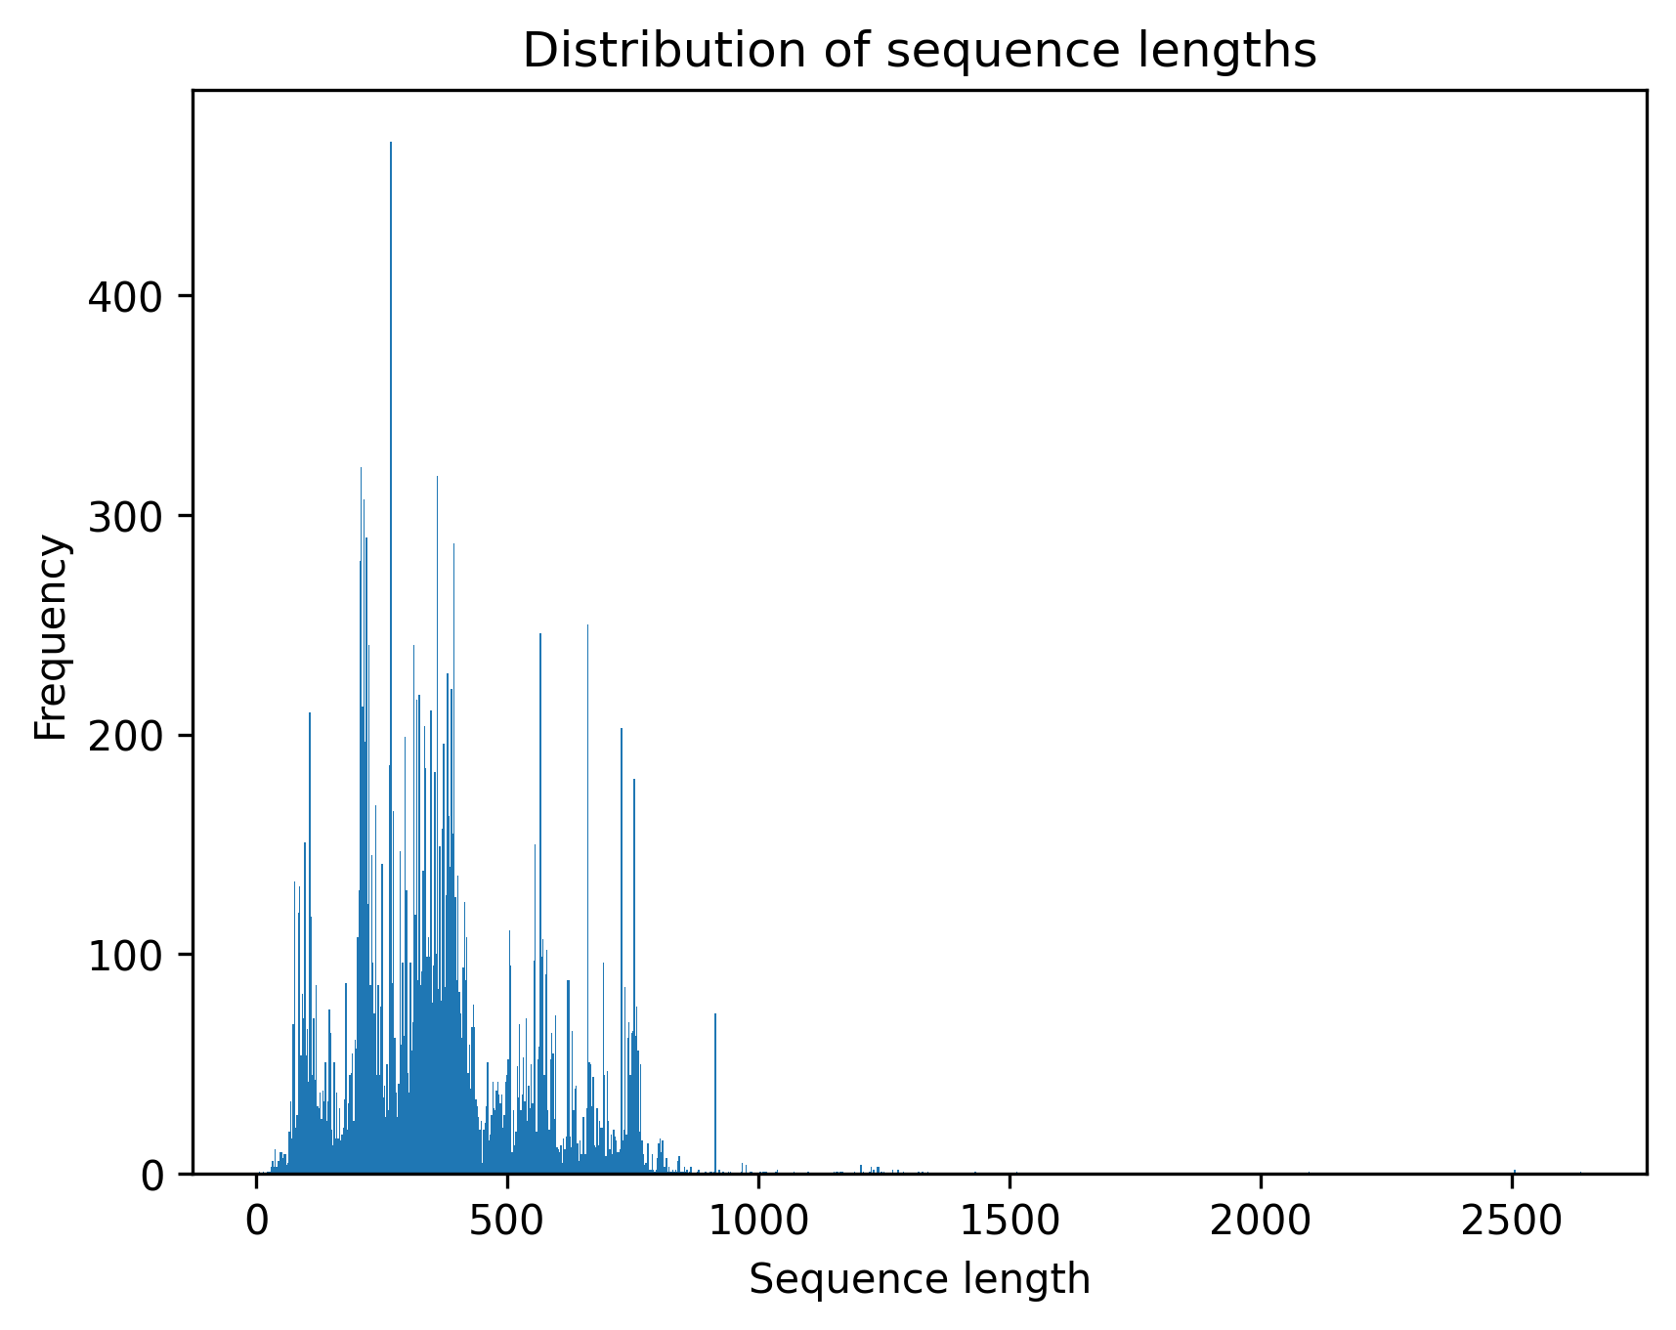
Figure 8. Distribution of protein sequence lengths following redundancy removal. The sequence length distribution was used to identify proteins comparable in size to experimentally characterised UvsX recombinases, with sequences outside the 326–426 amino acid range excluded during downstream filtering.
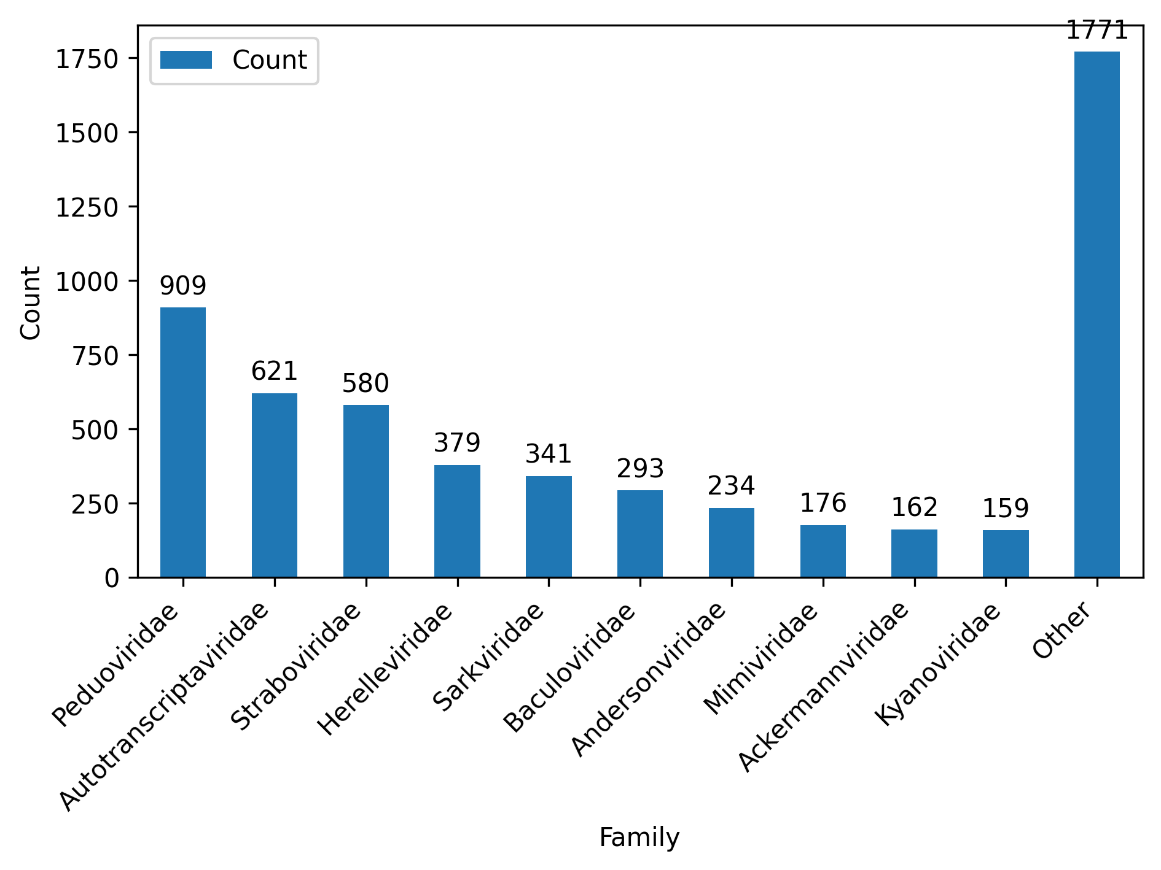
Figure 9. Taxonomic family distribution of the curated sequence database prior to sequence length filtering.
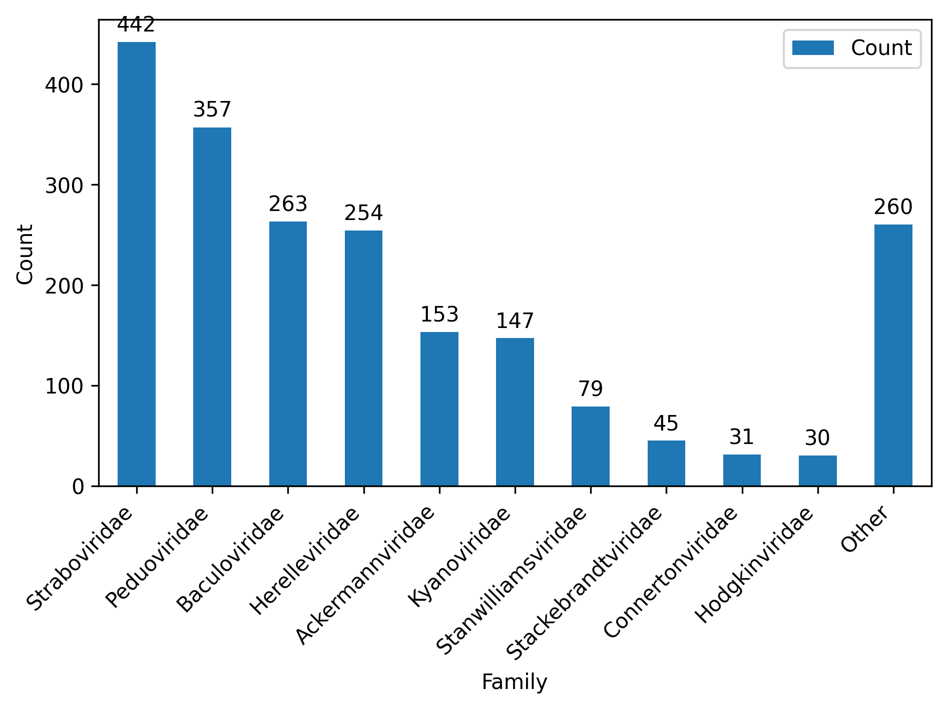
Figure 10. Taxonomic family distribution following sequence length filtering.

1.2 HMM-based identification of UvsX candidates
The filtered sequence dataset was screened using the three Hidden Markov Models constructed from experimentally characterised UvsX proteins and the conserved Pfam ATPase domain.
A total of 2,501 proteins matched all three Hidden Markov Models and were retained for subsequent motif-based screening. The overlap between the three HMMs is shown in Figure 11. The large intersection between all three models demonstrates substantial agreement between independently generated HMM profiles and supports their effectiveness for identifying conserved UvsX homologues.
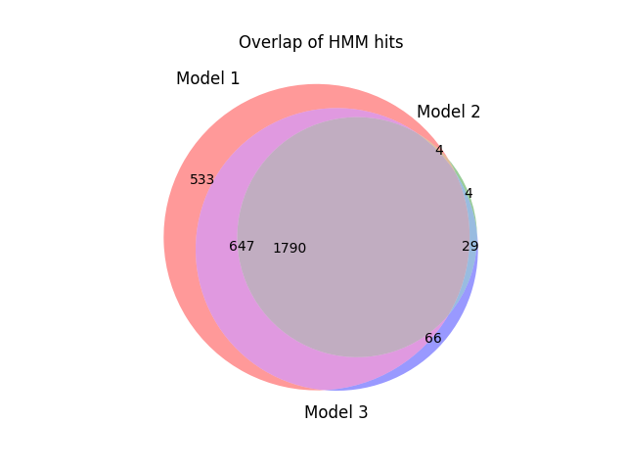
Figure 11. Venn diagram of proteins identified by the three Hidden Markov Models. Proteins retained for downstream analysis were required to match all three HMM profiles.

1.3 Motif-based validation of candidate UvsX proteins
The 2,501 proteins identified through HMM screening were subsequently assessed for the presence of the conserved Walker A and Walker B ATP-binding motifs.
Application of the motif-based screening criteria reduced the candidate dataset to 1,498 proteins. These proteins satisfied every stage of the screening framework, including sequence length filtering, all three Hidden Markov Models and both conserved ATP-binding motif requirements.
The resulting dataset represents a high-confidence collection of putative UvsX orthologues that was used for all downstream thermal prediction, literature analysis, structural modelling and molecular dynamics simulations.

1.4 Characteristics of the final high-confidence UvsX dataset
The final high-confidence dataset comprised 1,498 candidate UvsX proteins spanning a broad range of bacteriophage families (Figure 12). Despite the stringent filtering strategy, substantial taxonomic diversity was retained, demonstrating that the screening framework was capable of identifying UvsX homologues across diverse evolutionary lineages.
The sequence length distribution of the final candidates was consistent with experimentally characterised UvsX proteins, with the majority of proteins falling within the expected size range (Figure 13). This confirms that the combined filtering strategy successfully enriched for proteins possessing the characteristic sequence features of UvsX recombinases while removing likely annotation artefacts and unrelated ATPase proteins.
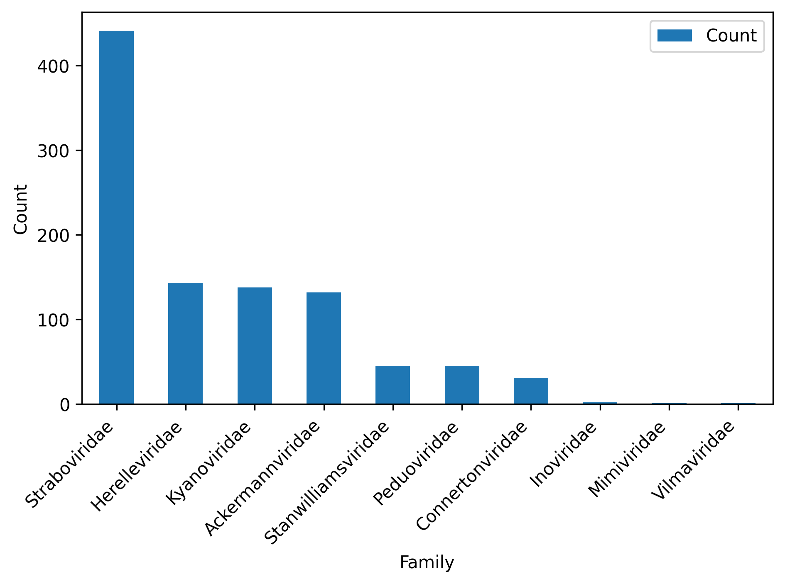
Figure 12. Taxonomic family distribution of the 1,498 high-confidence UvsX candidate proteins.
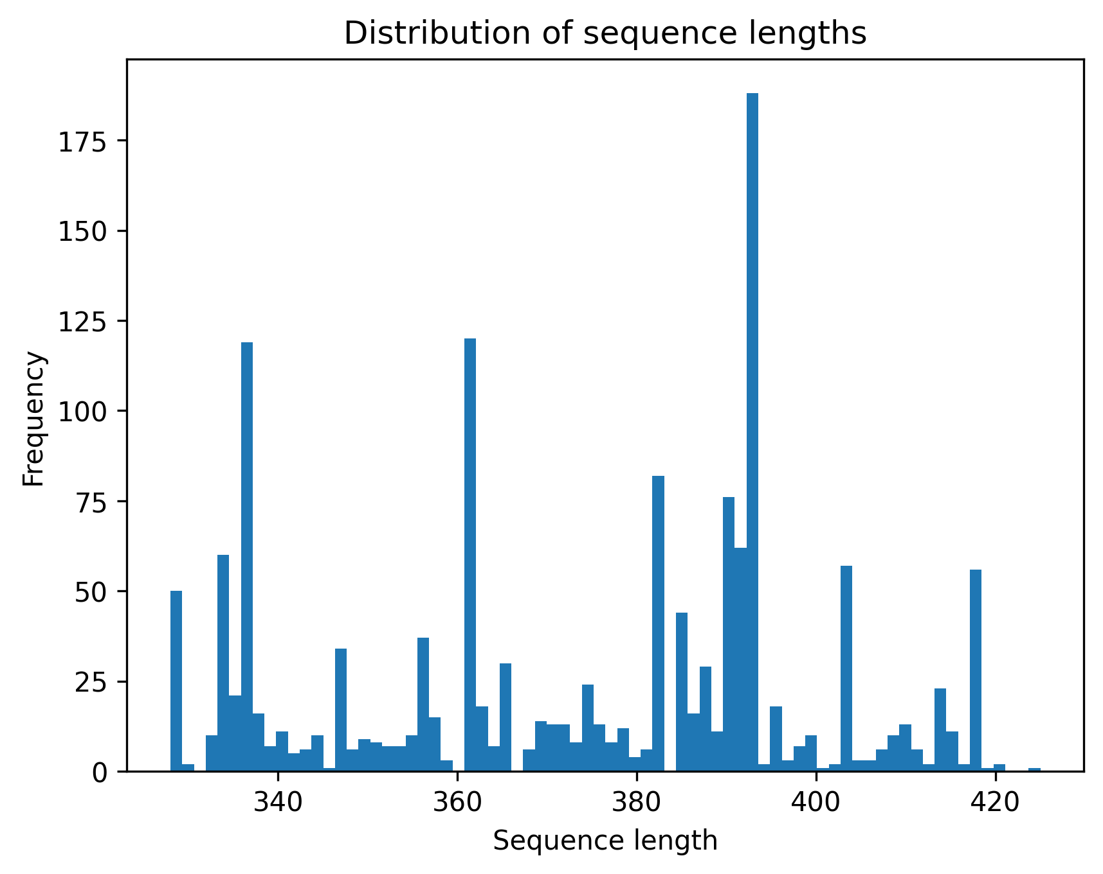
Figure 13. Sequence length distribution of the final high-confidence UvsX candidate dataset.

1.5 Candidate selection
The complete database construction and candidate selection pipeline is summarised in Figure 14, illustrating the progressive reduction from over 26,000 initially retrieved protein sequences to the final high-confidence dataset used for thermal prediction, literature-based thermal classification, structural modelling and molecular dynamics simulations.
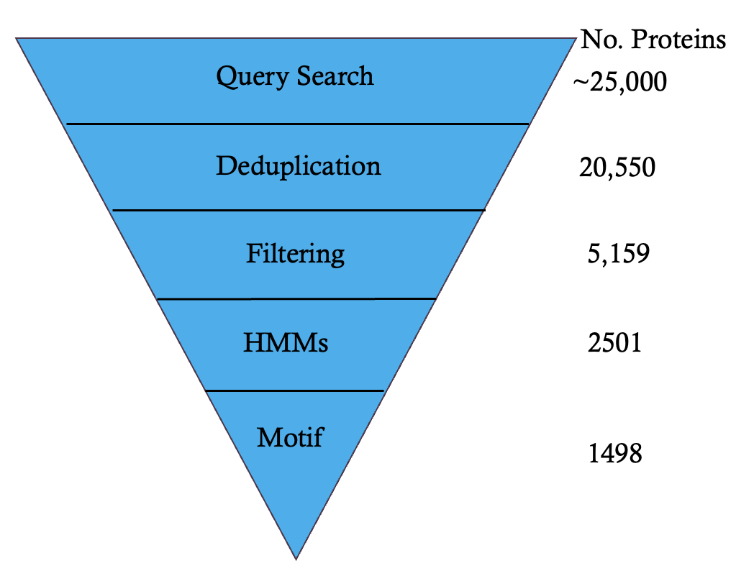
Figure 14. Computational workflow used to construct the curated UvsX database and identify high-confidence candidate orthologues. Candidate proteins were retrieved from UniProt, NCBI and InterPro before undergoing redundancy removal, sequence length filtering, Hidden Markov Model screening and conserved motif identification. Proteins satisfying all screening criteria were retained for downstream analyses.

2. Thermal prediction and classification of candidate UvsX proteins

2.1 Seq2Topt predicted thermal optima
Predicted optimal temperatures (Topt) were generated for all 1,498 high-confidence UvsX candidates using Seq2Topt. Predicted temperatures ranged from 30°C to 80°C, with a mean predicted optimal temperature of 43.1°C (Figure 15).
The distribution of predicted temperatures was centred around mesophilic conditions, with comparatively fewer candidates predicted to exhibit extreme psychrophilic or thermophilic thermal optima. This suggests that the majority of identified UvsX proteins are predicted to function within moderate temperature environments.
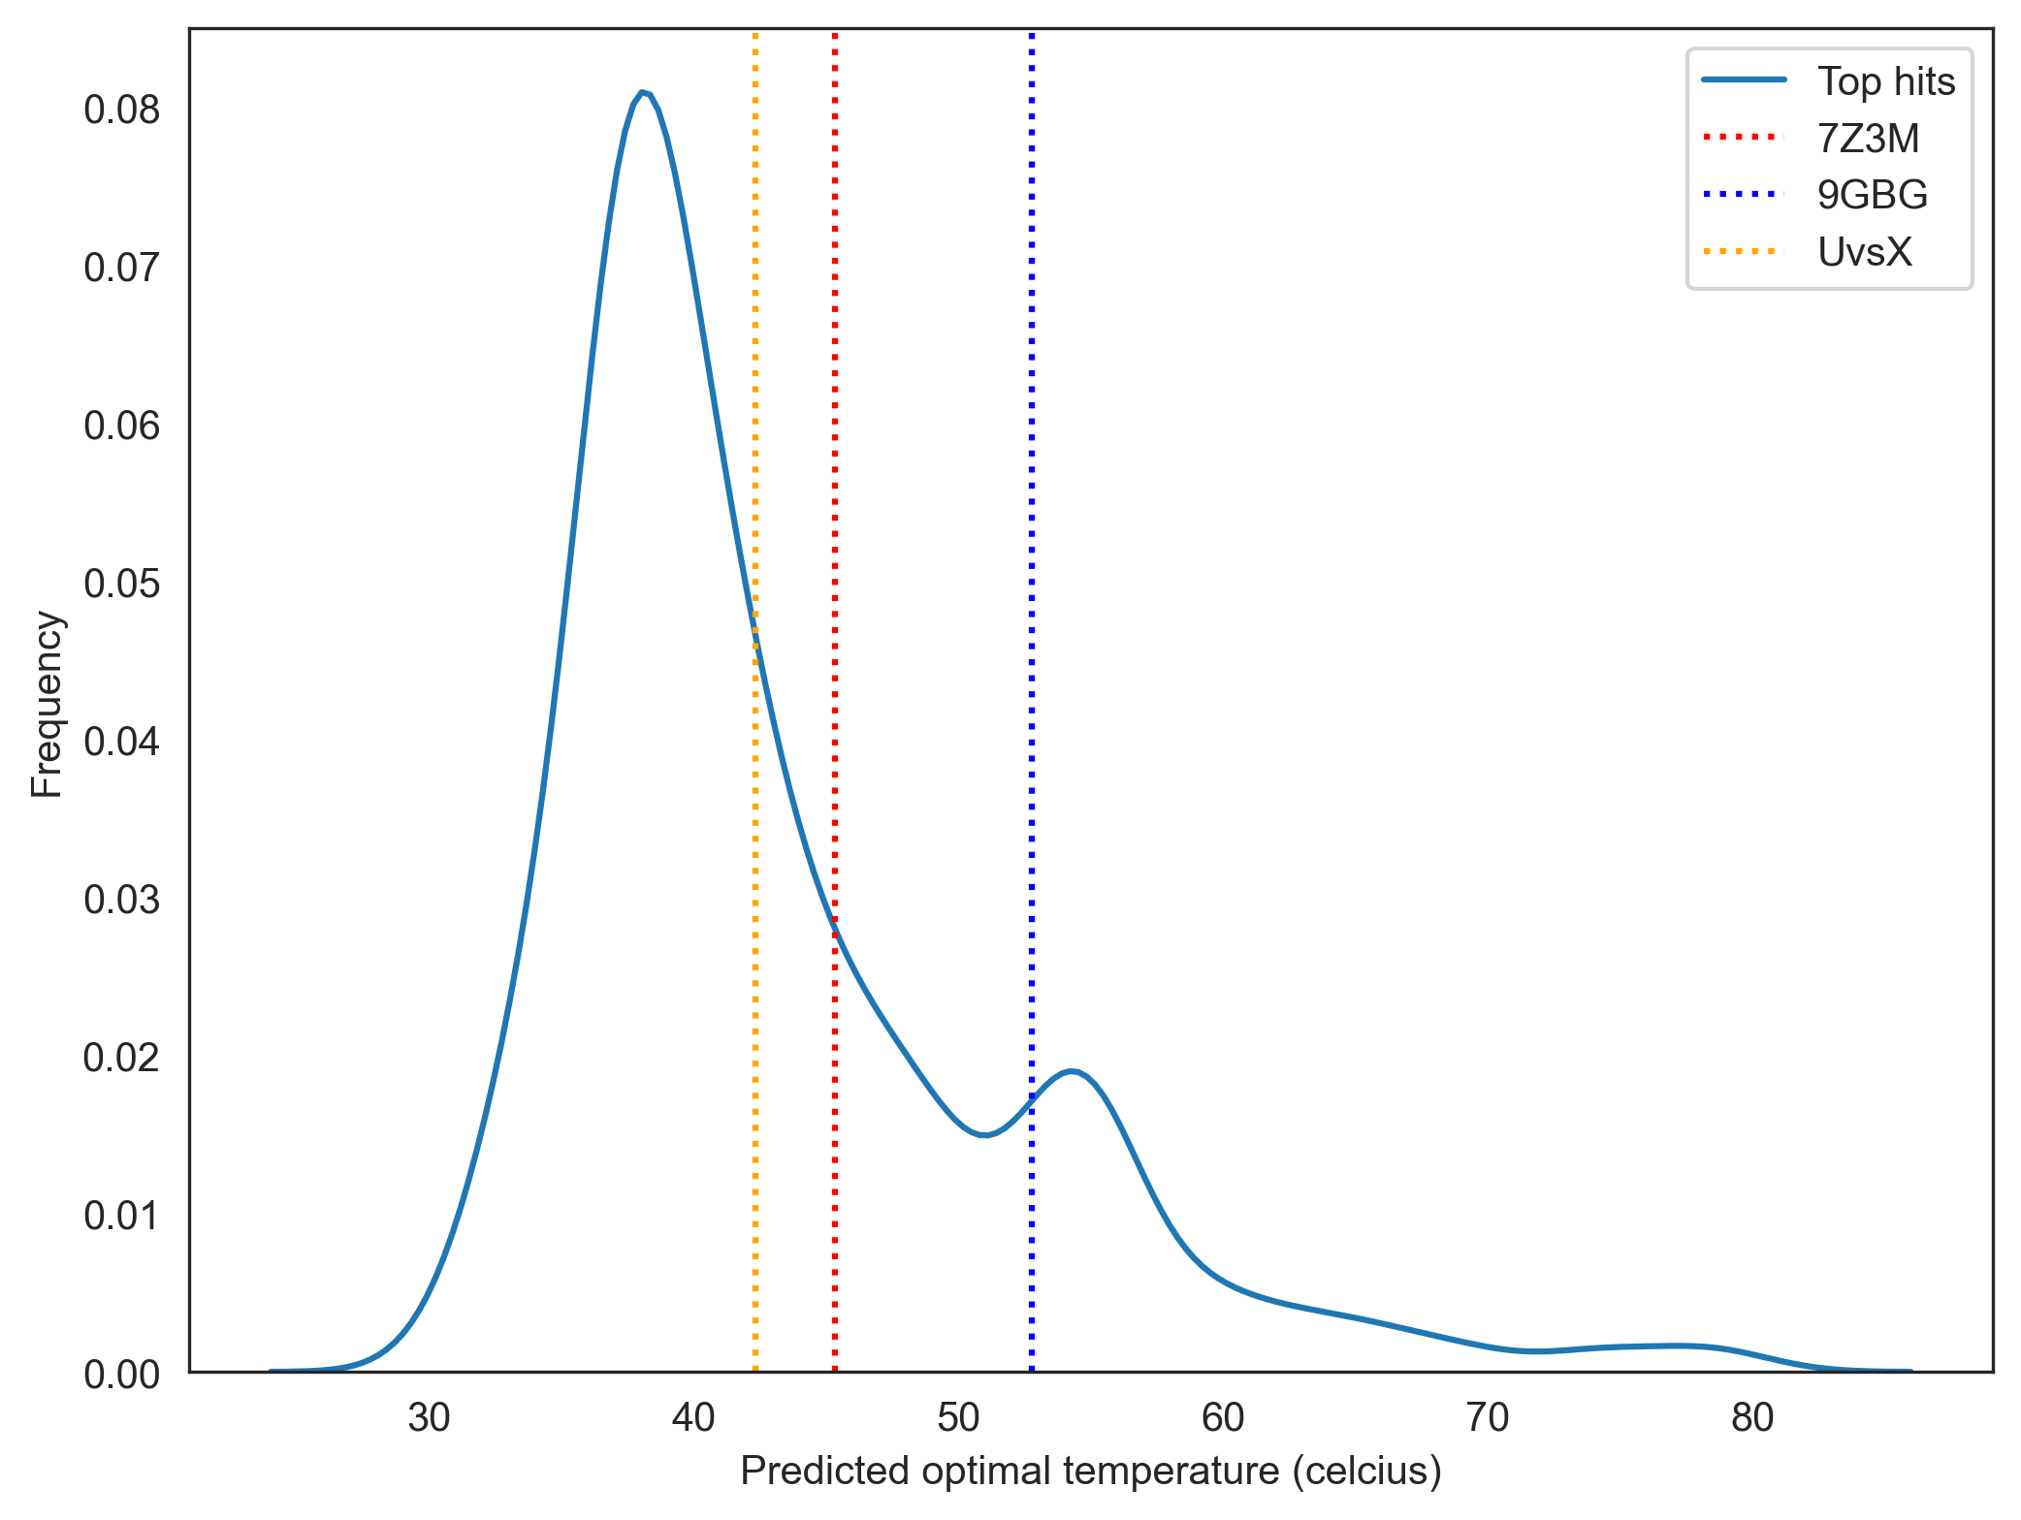
Figure 15. Distribution of Seq2Topt-predicted optimal temperatures for the 1,498 high-confidence UvsX candidate proteins. Experimentally characterised reference UvsX proteins are indicated for comparison, including the psychrophilic UvsX protein 9GBG, the thermophilic UvsX protein 7Z3M, and the mesophilic T4 UvsX protein.
To assess the suitability of Seq2Topt for predicting UvsX thermal adaptation, predictions for experimentally characterised reference proteins were compared with their known thermal characteristics. The thermophilic and psychrophilic reference proteins were predicted to have optimal temperatures of 46°C and 52°C, respectively, despite representing opposite extremes of thermal adaptation.
These observations are consistent with the reported performance of Seq2Topt, which has a published root mean square error (RMSE) of approximately 12°C. The limited separation between experimentally characterised psychrophilic and thermophilic UvsX proteins indicated that sequence-based prediction alone was insufficient for reliable thermal classification. Consequently, the Thermophile–Mesophile–Psychrophile (TMP) pipeline was developed to investigate whether integrating experimentally reported evidence from the scientific literature could improve classification of protein thermal adaptation.

2.2 Thermal classification using TMP
To evaluate the performance of the Thermophile–Mesophile–Psychrophile (TMP) pipeline, a benchmark dataset comprising 60 proteins with experimentally established thermal adaptations was assembled.
The benchmark dataset consisted of 20 psychrophilic, 20 mesophilic, and 20 thermophilic proteins, providing a balanced dataset for evaluating classification performance across the three thermal adaptation classes.
The curated benchmark dataset was subsequently used to compare the performance of the Fast, Democratic and Summary implementations of TMP.
Thermal classification | Number of proteins
Psychrophilic | 20
Mesophilic | 20
Thermophilic | 20
Total | 60
Table 2. Composition of the benchmark dataset used to evaluate the performance of the TMP thermal classification pipeline.

2.3 Comparison of TMP implementations
Three versions of the Thermophile–Mesophile–Psychrophile (TMP) pipeline were evaluated using the 60-protein benchmark dataset: Fast, Democratic and Summary.
The three implementations differed primarily in the amount of literature evidence incorporated before generating a final thermal classification. The Fast implementation prioritised computational efficiency by terminating analysis once sufficient evidence was identified. The Democratic implementation incorporated classifications from multiple publications using majority voting. The Summary implementation performed an intermediate evidence synthesis step before generating the final classification.
The computational time required to classify all 60 benchmark proteins differed substantially between the three approaches (Figure 16). The Fast implementation required the shortest runtime, while the Summary implementation required the greatest computational time due to the additional literature processing and evidence synthesis steps.
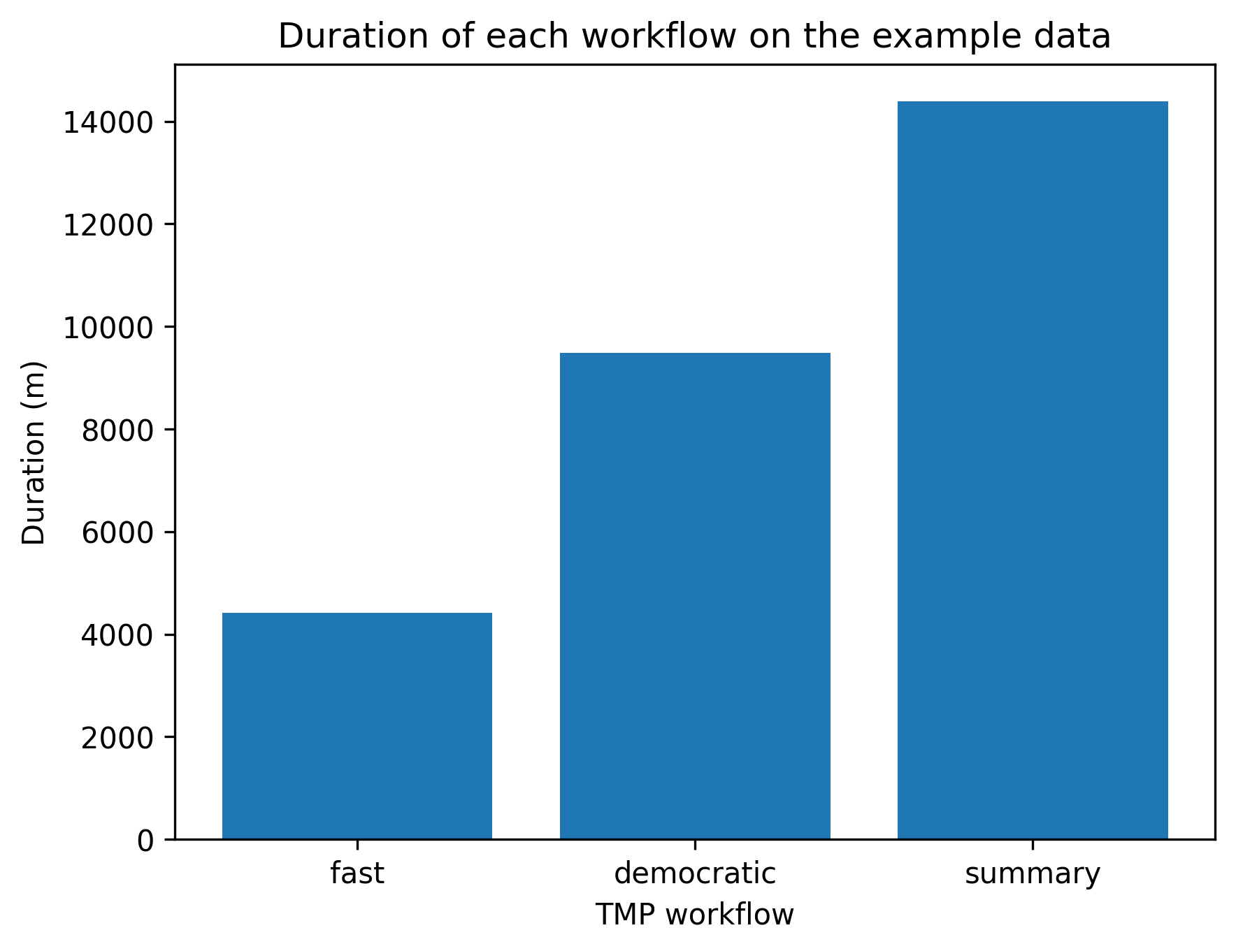
Figure 16. Total runtime required for each TMP implementation to classify the 60 benchmark proteins.
Classification performance was assessed using accuracy, precision, recall and F1-score. Across all three approaches, thermophilic proteins were classified with high confidence, whereas greater variation was observed between mesophilic and psychrophilic classifications.

Fast TMP
The Fast implementation achieved an overall classification accuracy of 78% across the benchmark dataset (Figure 17). Thermophilic proteins were classified correctly in all cases (recall = 1.00), while psychrophilic proteins showed reduced recall (0.40), with several proteins incorrectly classified as mesophilic.
Although structured output constraints were implemented to restrict model responses to the predefined thermal classification categories, occasional invalid classifications were still generated during inference. These outputs required post-processing before evaluation, demonstrating the importance of additional validation steps when applying automated literature-based classification workflows.
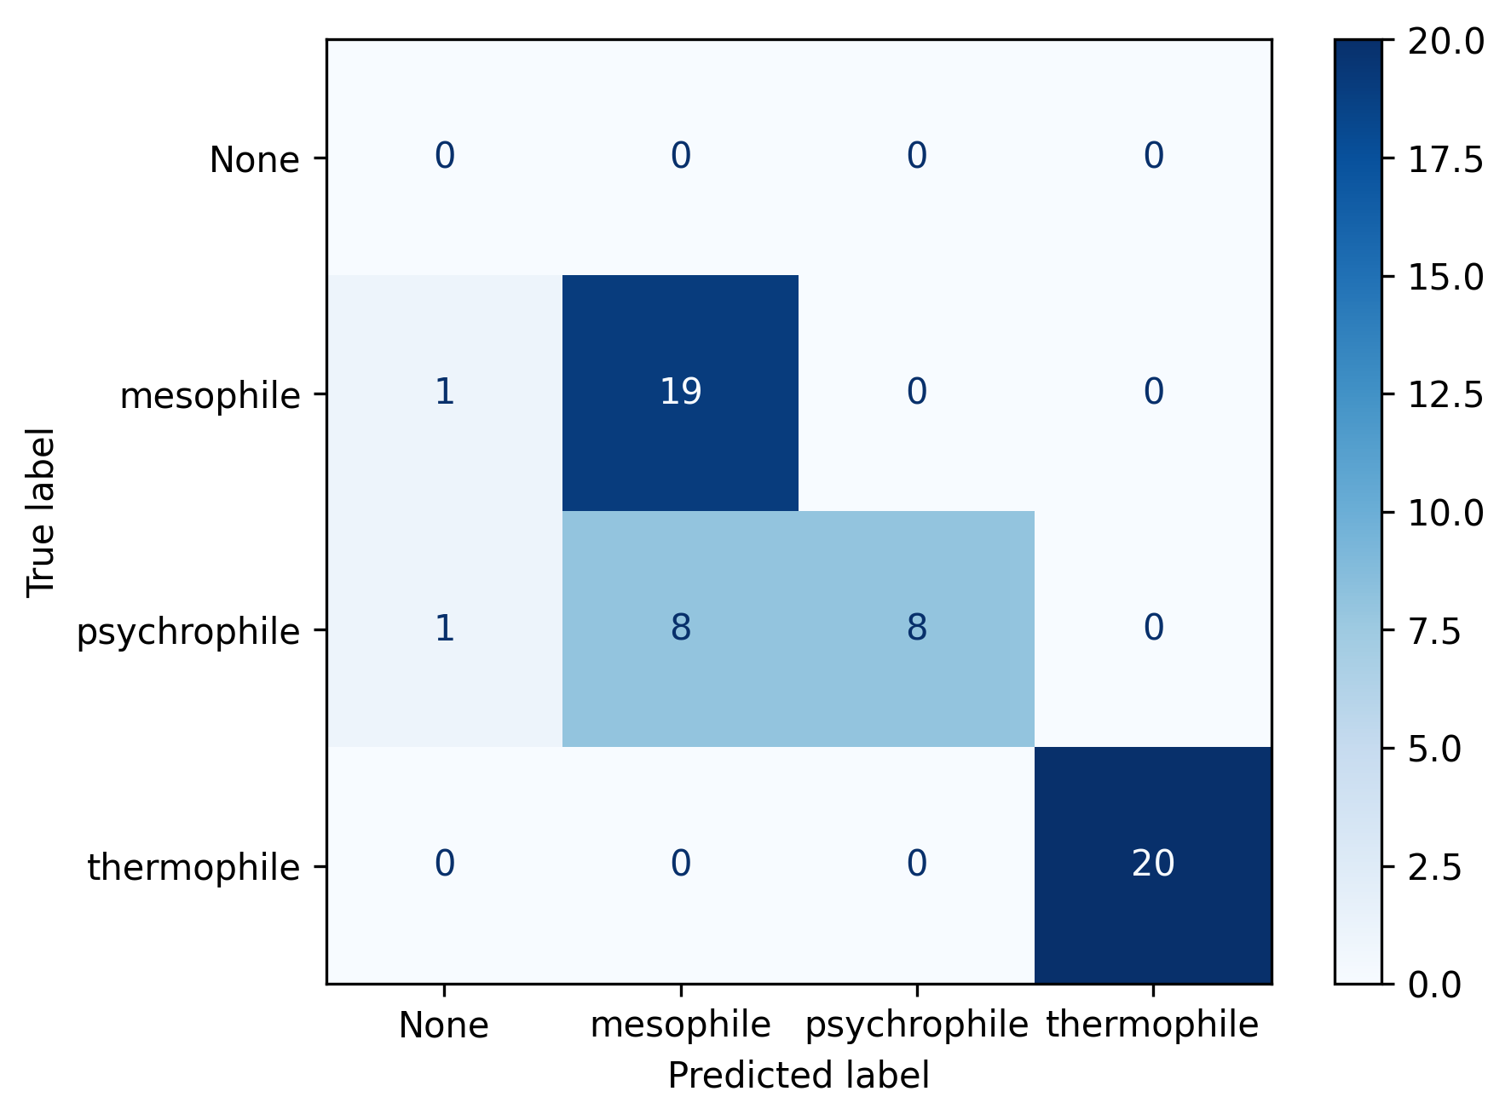 Figure 17. Confusion matrix showing classification performance of the Fast TMP implementation on the benchmark dataset.

Democratic TMP
The Democratic implementation improved overall classification accuracy to 80% (Figure 18). Similar to the Fast implementation, all thermophilic proteins were correctly identified, while psychrophilic proteins remained the most challenging class, with a recall of 0.40.
The increase in accuracy compared with the Fast implementation suggests that incorporating evidence from multiple publications reduced some classification errors. However, the persistence of misclassification between psychrophilic and mesophilic proteins indicated that majority voting alone was insufficient to fully resolve conflicting literature evidence.
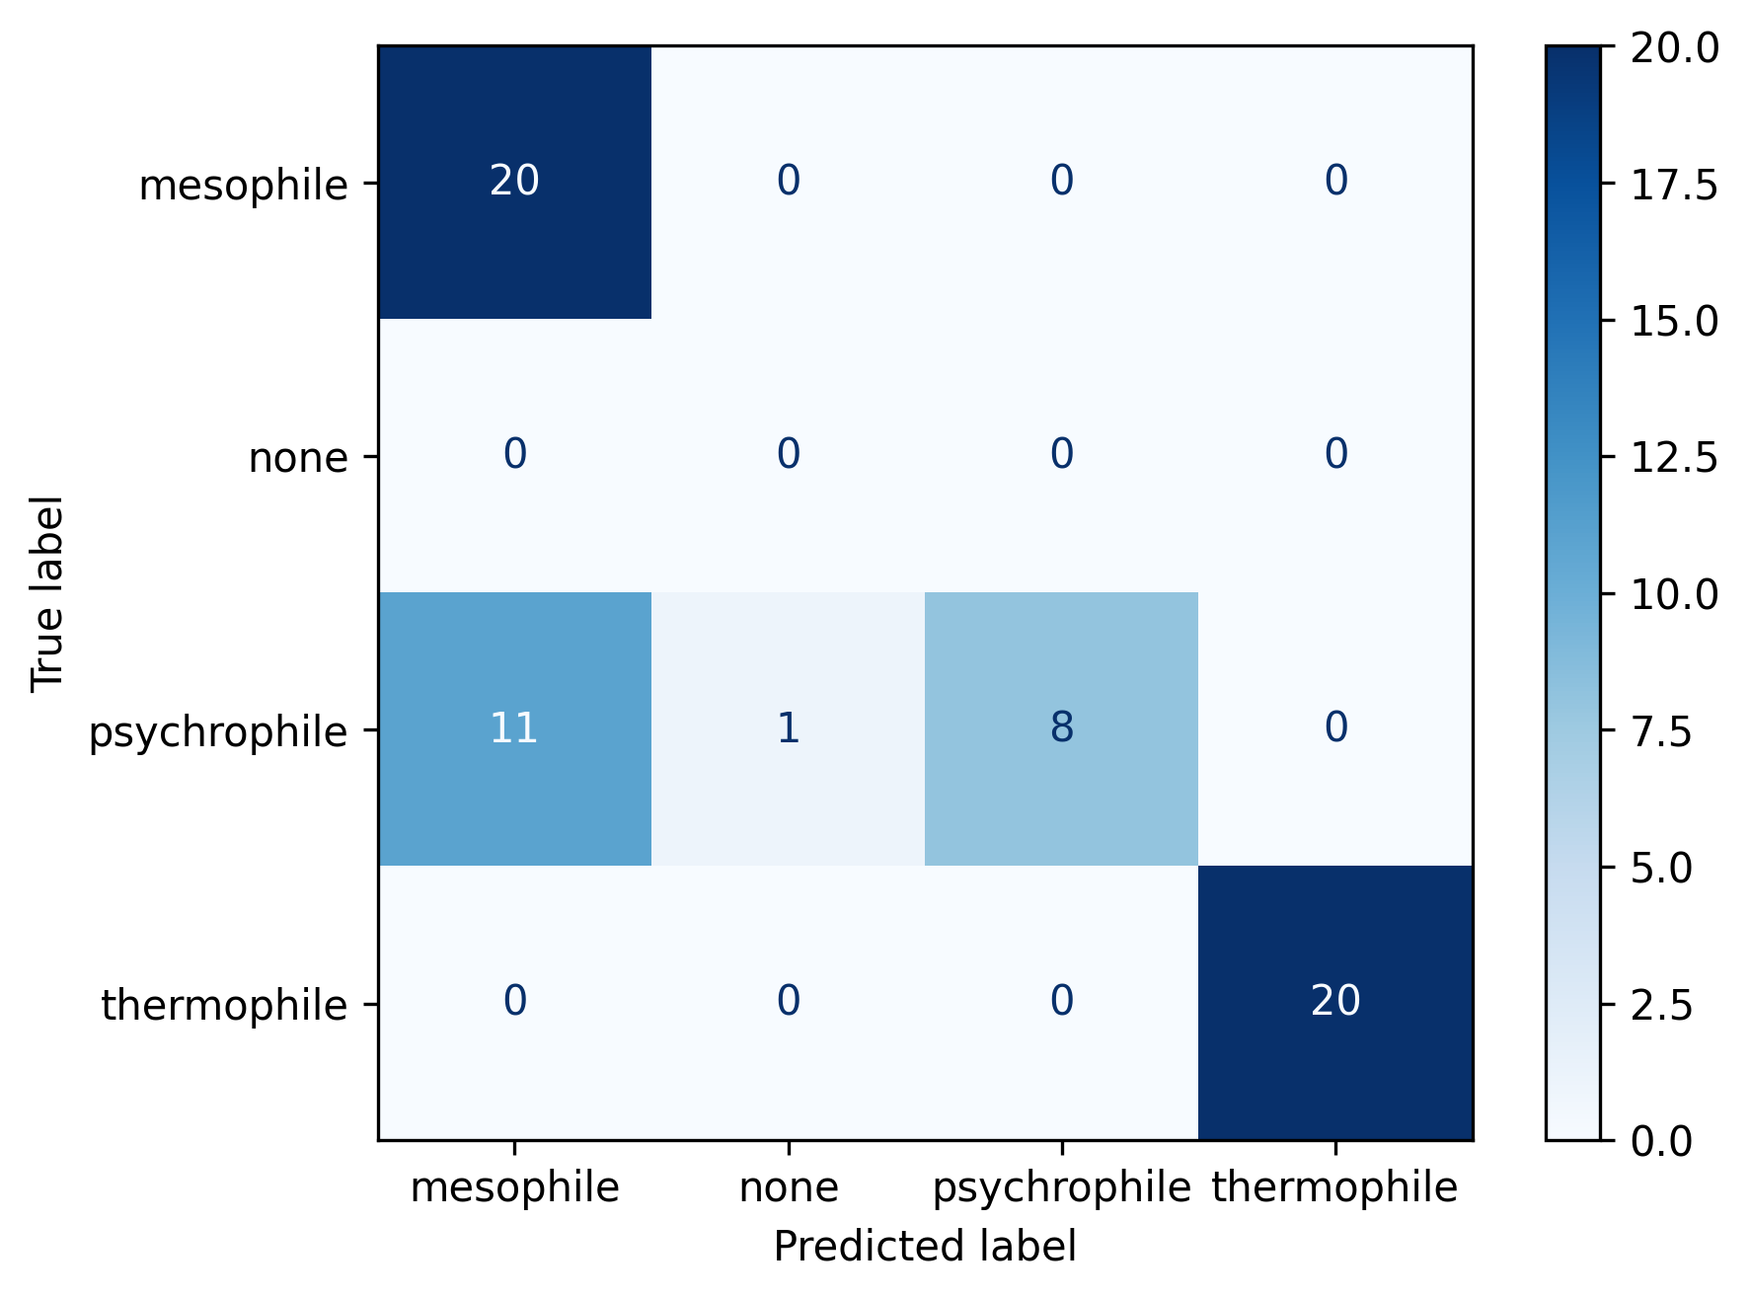 Figure 18. Confusion matrix showing classification performance of the Democratic TMP implementation on the benchmark dataset.

Summary TMP
The Summary implementation achieved the highest classification performance, with an overall accuracy of 90% (Figure 19). Thermophilic proteins were classified correctly in all cases (recall = 1.00), while psychrophilic and mesophilic classifications also improved compared with the previous approaches.
The largest improvement was observed for psychrophilic proteins, where recall increased from 0.40 in both the Fast and Democratic implementations to 0.70 in the Summary implementation. This suggests that summarising evidence across multiple publications before classification reduced errors arising from individual conflicting studies. Additionally, the invalid classification outputs observed during the Fast and Democratic implementations were no longer observed in the Summary approach, indicating improved compliance with the predefined classification categories following evidence synthesis.
Despite requiring the longest runtime, the Summary implementation provided the most accurate and consistent classification performance and was therefore selected as the final TMP workflow for downstream analysis of candidate UvsX proteins.
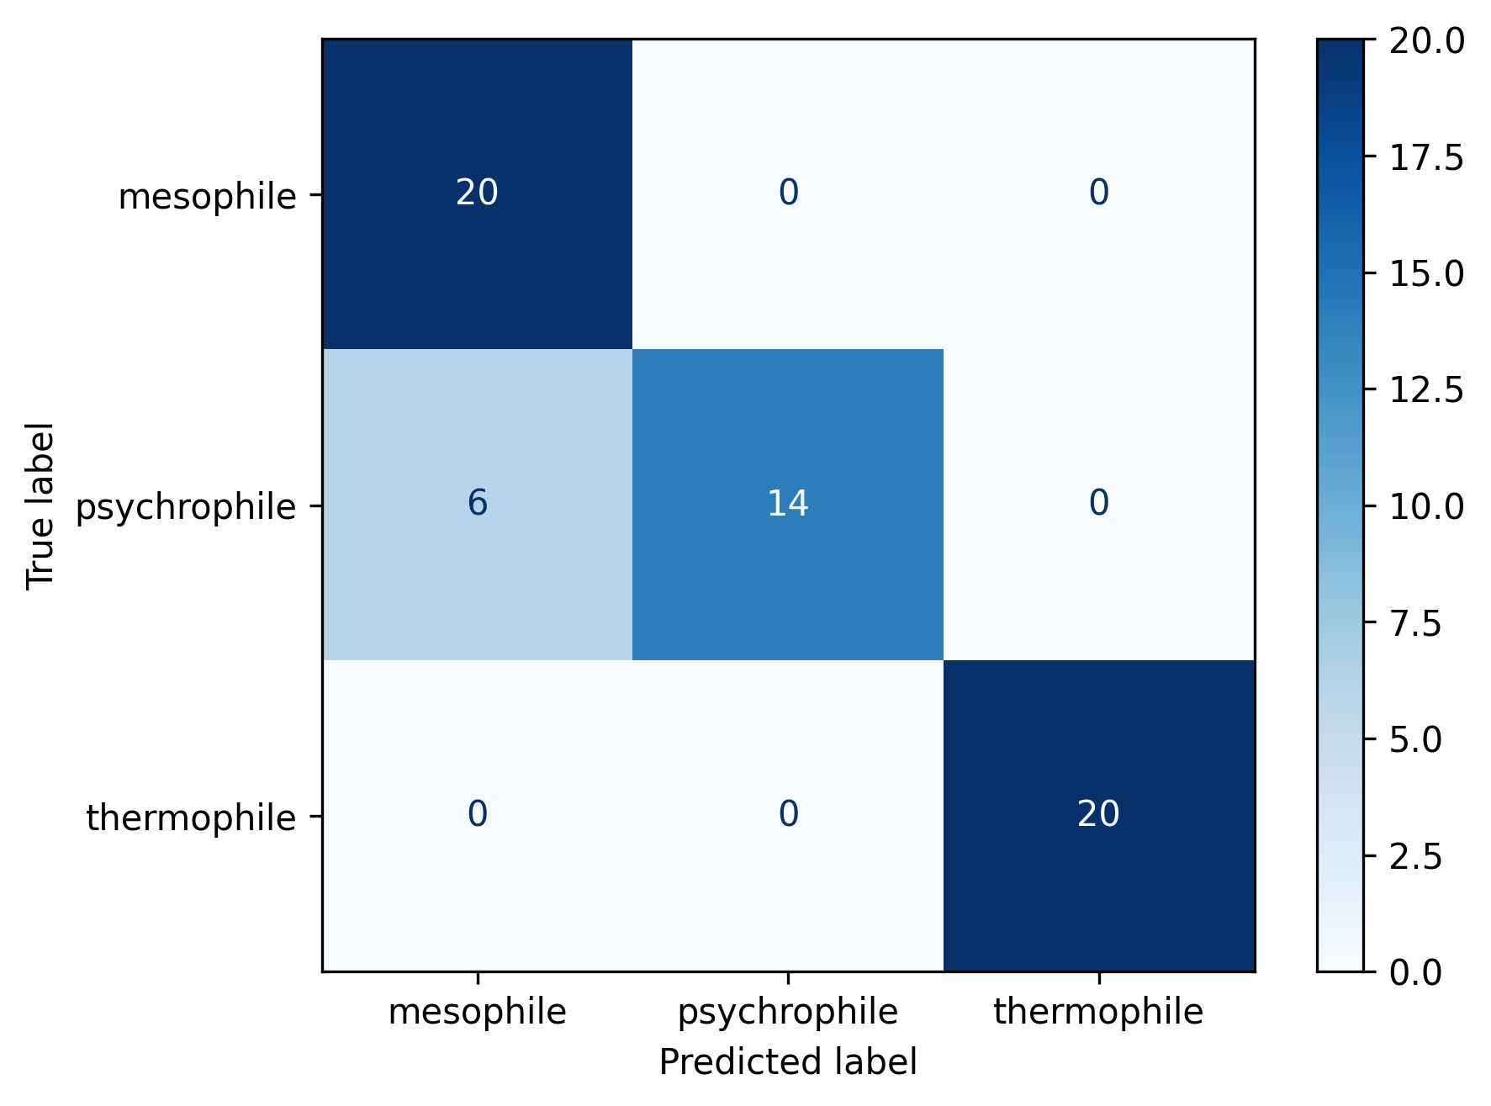 Figure 19. Confusion matrix showing classification performance of the Summary TMP implementation on the benchmark dataset.
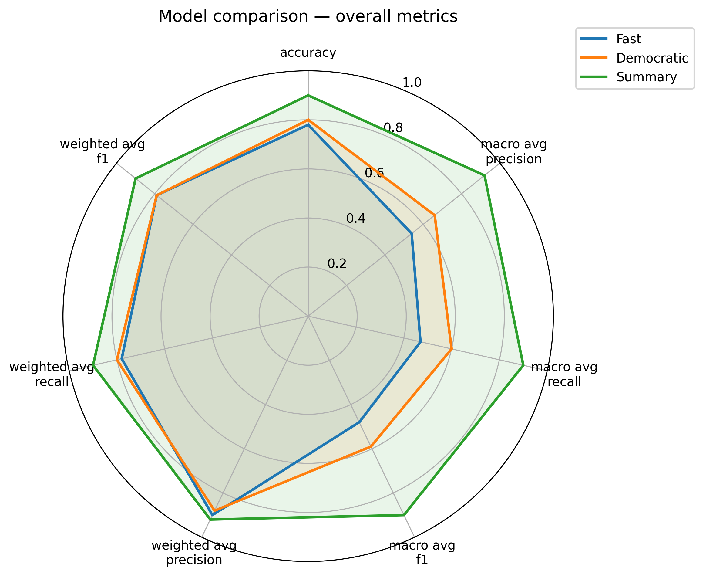 Figure 20. Comparison of TMP workflow performance using classification metrics. Radar plot showing accuracy, macro-averaged precision, recall and F1-score for the Fast, Democratic and Summary implementations evaluated on the 60-protein benchmark dataset. Each axis represents a classification metric, with values normalised between 0 and 1. Higher values indicate improved performance across the benchmark dataset.
TMP Implementation | Accuracy | Macro Precision | Macro Recall | Macro F1-score | Runtime (min)
Fast | 0.78 | 0.54 | 0.47 | 0.48 | 73.59
Democratic | 0.80 | 0.66 | 0.60 | 0.59 | 158.11
Summary | 0.90 | 0.92 | 0.90 | 0.90 | 210.05
Table 3. Comparison of TMP implementation performance on the 60-protein benchmark dataset. Classification metrics represent overall model performance across psychrophilic, mesophilic and thermophilic classes, while runtime indicates the computational time required to complete all classifications.

2.4 Agreement between TMP and Seq2Topt
To investigate the relationship between sequence-based thermal predictions and literature-derived thermal classifications, Seq2Topt-predicted optimal temperatures were compared with TMP classifications for the high-confidence UvsX candidate dataset.
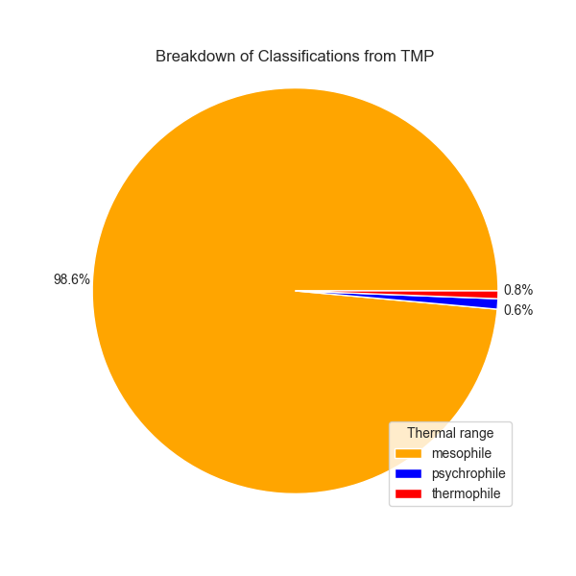 Figure 21. Distribution of TMP-derived thermal classifications across the 1,498 high-confidence UvsX candidate proteins.
TMP classified the majority of candidate proteins as mesophilic, accounting for 98.6% of all predictions. Thermophilic and psychrophilic classifications represented a small proportion of the dataset, accounting for 0.8% and 0.6% of candidates, respectively.
To compare TMP classifications with sequence-based thermal predictions, Seq2Topt-predicted optimal temperatures were plotted according to TMP thermal categories (Figure 22). Candidates classified as psychrophilic by TMP exhibited lower predicted optimal temperatures compared with candidates classified as thermophilic, indicating that the two approaches identified consistent trends in thermal adaptation.
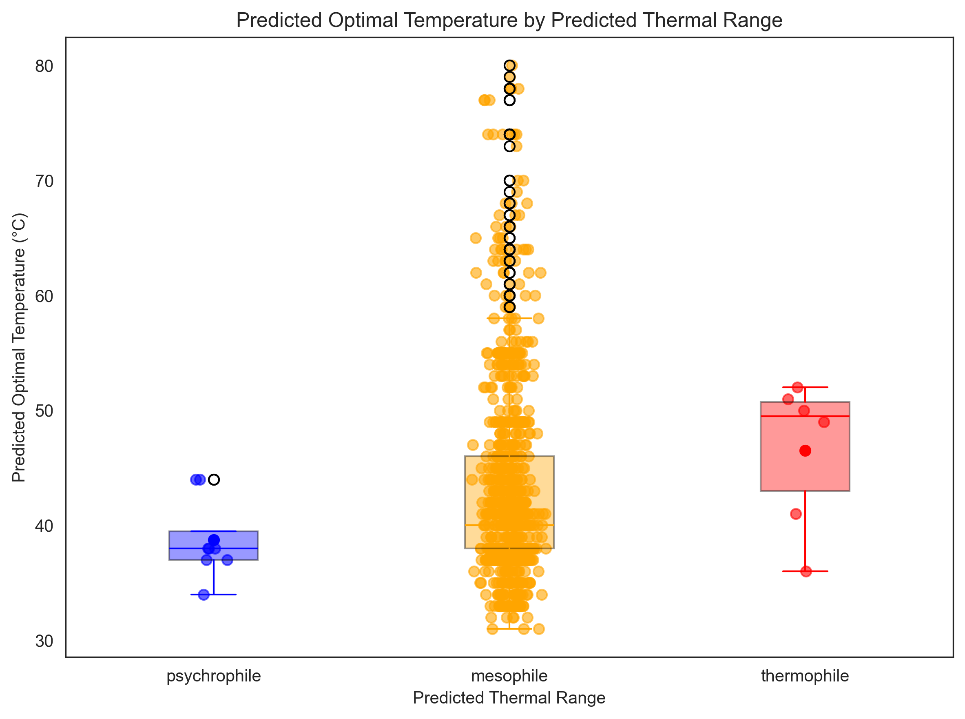 Figure 22. Distribution of Seq2Topt-predicted optimal temperatures grouped by TMP thermal classification.
Despite the strong enrichment of candidates within the mesophilic category, the distribution of Seq2Topt predictions showed overlap between thermal classes. This indicates that while TMP classifications and sequence-based predictions captured broad differences in thermal adaptation, predicted optimal temperatures alone were insufficient to clearly separate all thermal groups.

3. Structural prediction and validation of UvsX proteins

3.1 Comparison of structure prediction methods
Structural models generated using AlphaFold and Boltz were compared against experimentally determined crystal structures of the gold standard UvsX proteins using US-align. Structural similarity was assessed using TM-score normalised by the reference crystal structure together with root mean square deviation (RMSD).
Protein | Prediction method | TM-score | RMSD (Å)
T4 UvsX | AlphaFold | 0.682 | 1.03
T4 UvsX (PDB trimmed) | AlphaFold | 0.809 | 1.02
T4 UvsX (SWISS trimmed) | AlphaFold | 0.849 | 1.09
7Z3M | AlphaFold | 0.770 | 1.89
9GBG | AlphaFold | 0.821 | 1.51
T4 UvsX | Boltz | 0.251 | 6.63
T4 UvsX (PDB trimmed) | Boltz | 0.255 | 5.94
T4 UvsX (SWISS trimmed) | Boltz | 0.279 | 6.68
7Z3M | Boltz | 0.268 | 6.50
9GBG | Boltz | 0.262 | 5.86
Table 4. Structural similarity between predicted models and experimentally determined crystal structures measured using US-align. TM-scores are normalised by the length of the reference crystal structure.
AlphaFold consistently generated structural models with high similarity to the experimentally determined crystal structures. TM-scores ranged from 0.682 to 0.849, while RMSD values ranged from 1.02 Å to 1.89 Å, indicating close agreement between predicted and experimental structures.
For T4 UvsX, prediction accuracy improved when the AlphaFold model was generated using a sequence corresponding to the experimentally resolved region of the protein. The PDB structure contains residues 30–358, while the SWISS-MODEL trimmed sequence covered residues 31–342, reducing the influence of unresolved terminal regions. This approach produced the highest structural agreement, achieving a TM-score of 0.849 and an RMSD of 1.09 Å. Similar agreement was observed for the thermophilic (7Z3M) and psychrophilic (9GBG) reference proteins, which achieved TM-scores of 0.770 and 0.821, respectively.
In contrast, Boltz predictions exhibited substantially lower agreement with the crystal structures. TM-scores ranged from 0.251 to 0.279, with RMSD values between 5.86 Å and 6.68 Å, indicating considerably poorer structural accuracy across all reference proteins.
These results demonstrate that AlphaFold consistently produced more accurate structural models of UvsX proteins than Boltz and was therefore selected as the primary structure prediction method for downstream analyses.
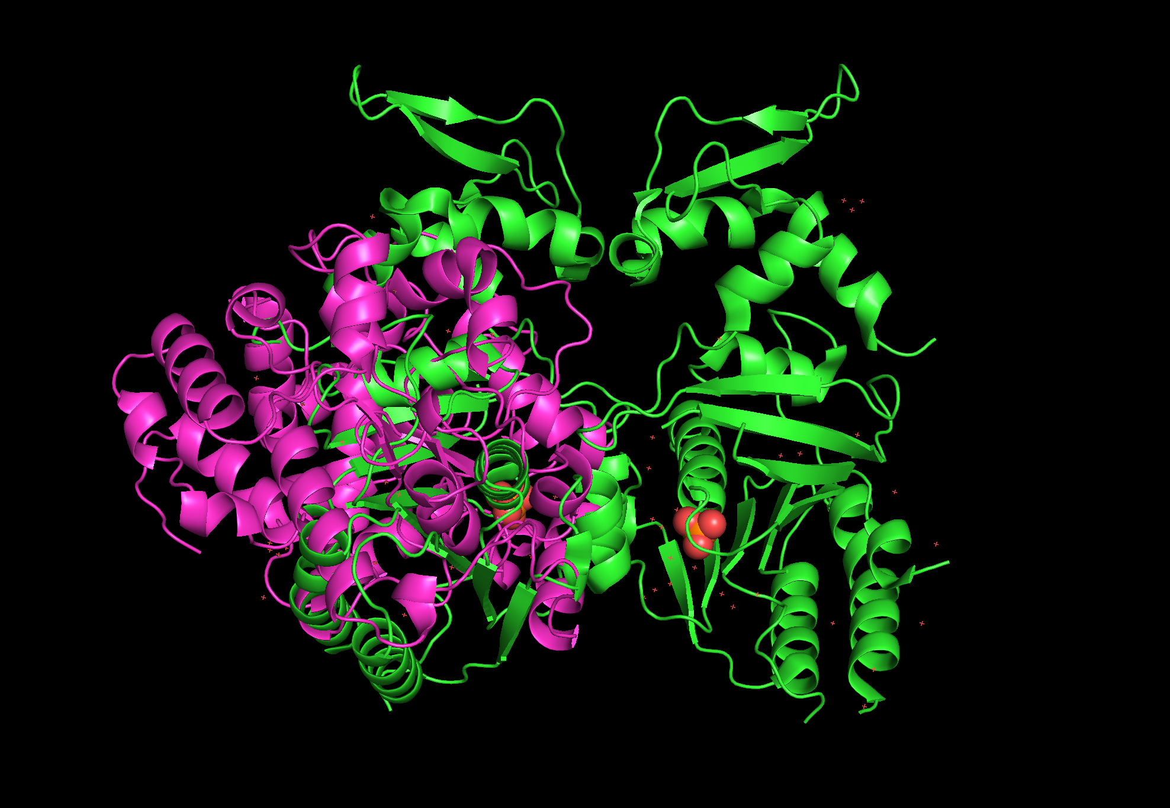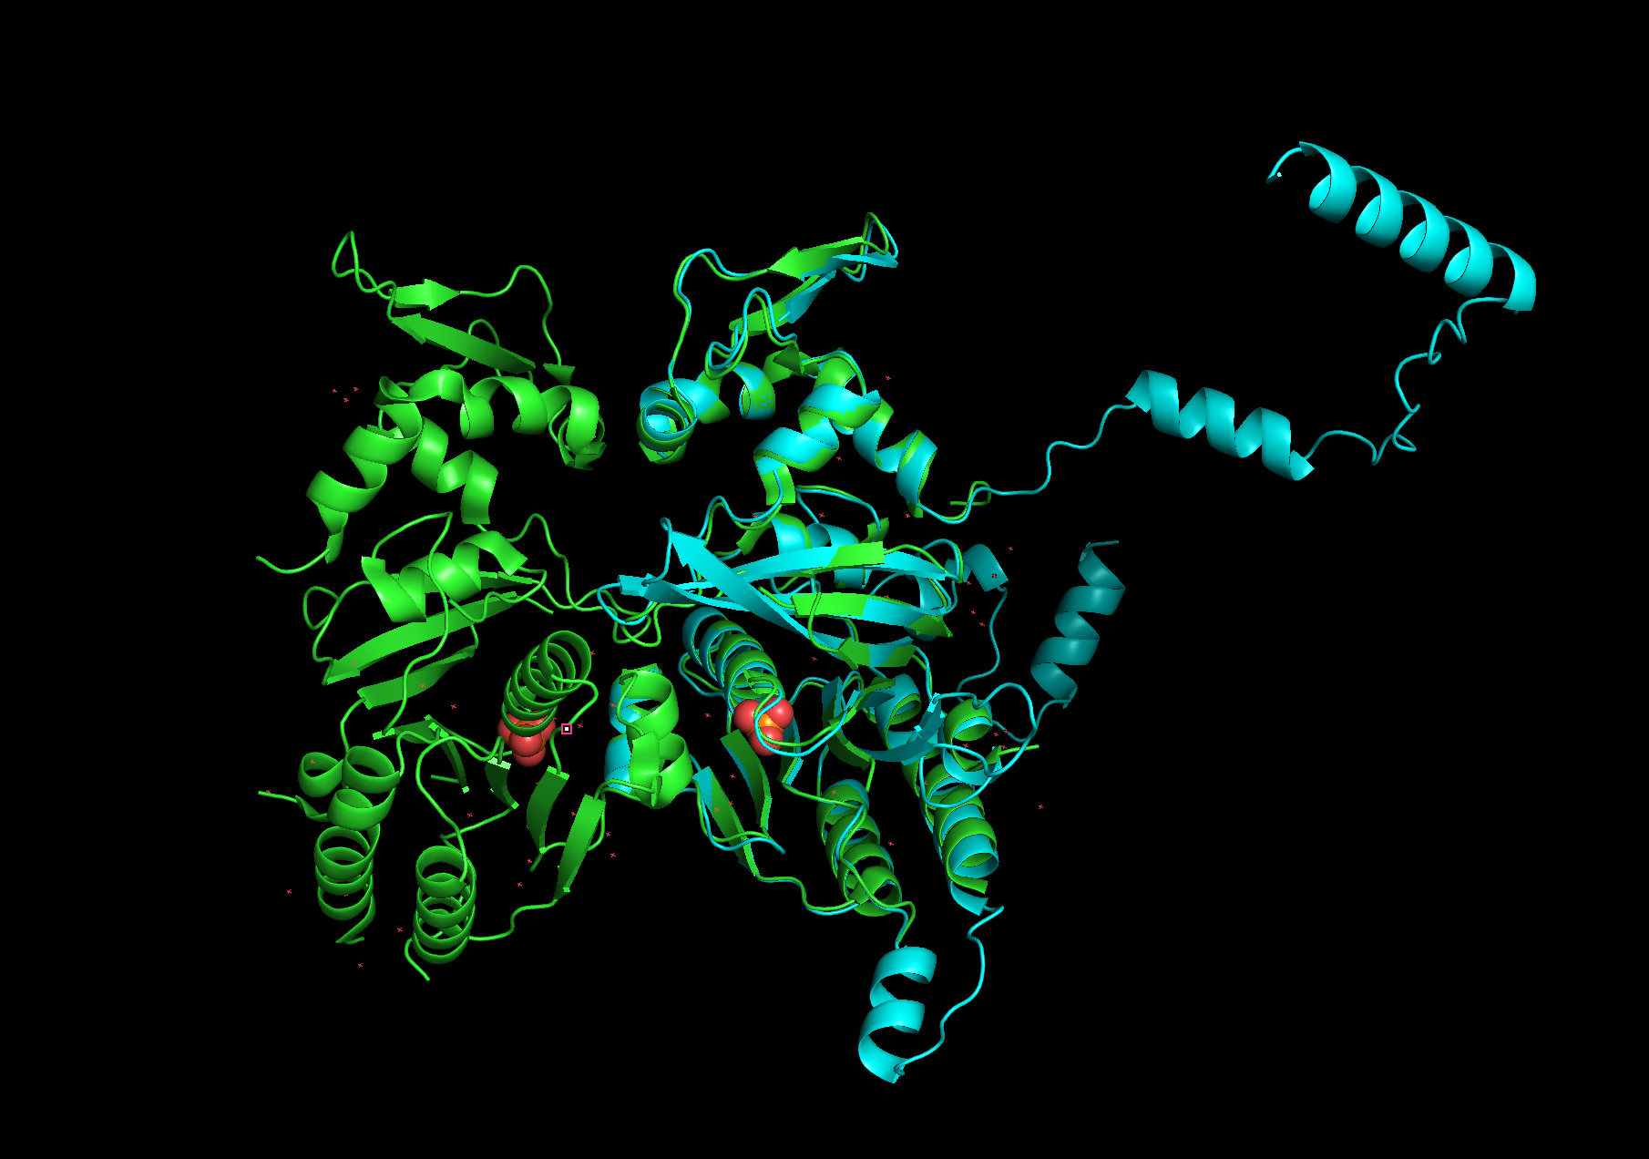
Figure 23. Comparison of predicted T4 UvsX structures with the experimentally determined crystal structure. The Boltz (top) and AlphaFold (bottom) predicted models were aligned against the reference crystal structure using US-align. Structural agreement was assessed using TM-score and RMSD values.

3.2 Effect of sequence input strategy on Boltz prediction
Several alternative sequence preparation strategies were evaluated to determine whether Boltz prediction accuracy could be improved. These included prediction from full-length protein sequences, trimmed sequences corresponding to experimentally resolved structural regions, UniRef100 multiple sequence alignments generated using ColabFold, and custom multiple sequence alignments generated from the curated UvsX candidate database.
Input strategy | T4 UvsX | 7Z3M | 9GBG
Full-length sequence | 0.251 | 0.268 | 0.262
Trimmed sequence | 0.279 | — | —
UniRef100 MSA | 0.293 | 0.269 | 0.266
Custom UvsX MSA | 0.243 | 0.229 | 0.259
Table 5. Comparison of Boltz prediction strategies using TM-scores normalised by the reference crystal structure.
For T4 UvsX, both sequence trimming and incorporation of a UniRef100 multiple sequence alignment produced modest improvements in structural similarity compared with prediction from the full-length sequence. The highest TM-score obtained using Boltz was 0.293 when a UniRef100 multiple sequence alignment generated using ColabFold was supplied.
Supplying a custom multiple sequence alignment generated from the curated UvsX candidate database did not improve prediction accuracy and generally produced lower TM-scores than the UniRef100 alignment.
For the thermophilic (7Z3M) and psychrophilic (9GBG) reference proteins, only minimal differences were observed between the alternative prediction strategies, with all TM-scores remaining below 0.30. Overall, modifications to sequence preparation and multiple sequence alignment inputs were insufficient to substantially improve Boltz prediction accuracy for UvsX proteins.

4. Molecular dynamics analysis of UvsX thermal adaptation
Molecular dynamics simulations were performed to investigate whether AlphaFold-generated models captured comparable patterns of structural stability, flexibility and global conformational behaviour to experimentally characterised proteins. Following this assessment, AlphaFold structures were used for molecular dynamics simulations of representative UvsX orthologues identified through the TMP classification pipeline.

4.1 Validation of AlphaFold structures using experimentally characterised UvsX proteins
To evaluate whether AlphaFold-generated structures were suitable for molecular dynamics analysis, experimentally characterised UvsX proteins were used as validation cases. Molecular dynamics simulations were performed using both experimentally determined crystal structures and corresponding AlphaFold predictions for three reference proteins representing different thermal adaptations: psychrophilic 9GBG, mesophilic T4 UvsX and thermophilic 7Z3M.
Structural behaviour was assessed using RMSD, RMSF and radius of gyration (Rg) analyses to compare the stability, residue-level flexibility and global compactness of predicted and experimentally determined structures.

4.1.1 Structural stability comparison using RMSD
Root mean square deviation (RMSD) was calculated to compare structural deviation between AlphaFold-predicted and experimentally determined UvsX structures during molecular dynamics simulations.
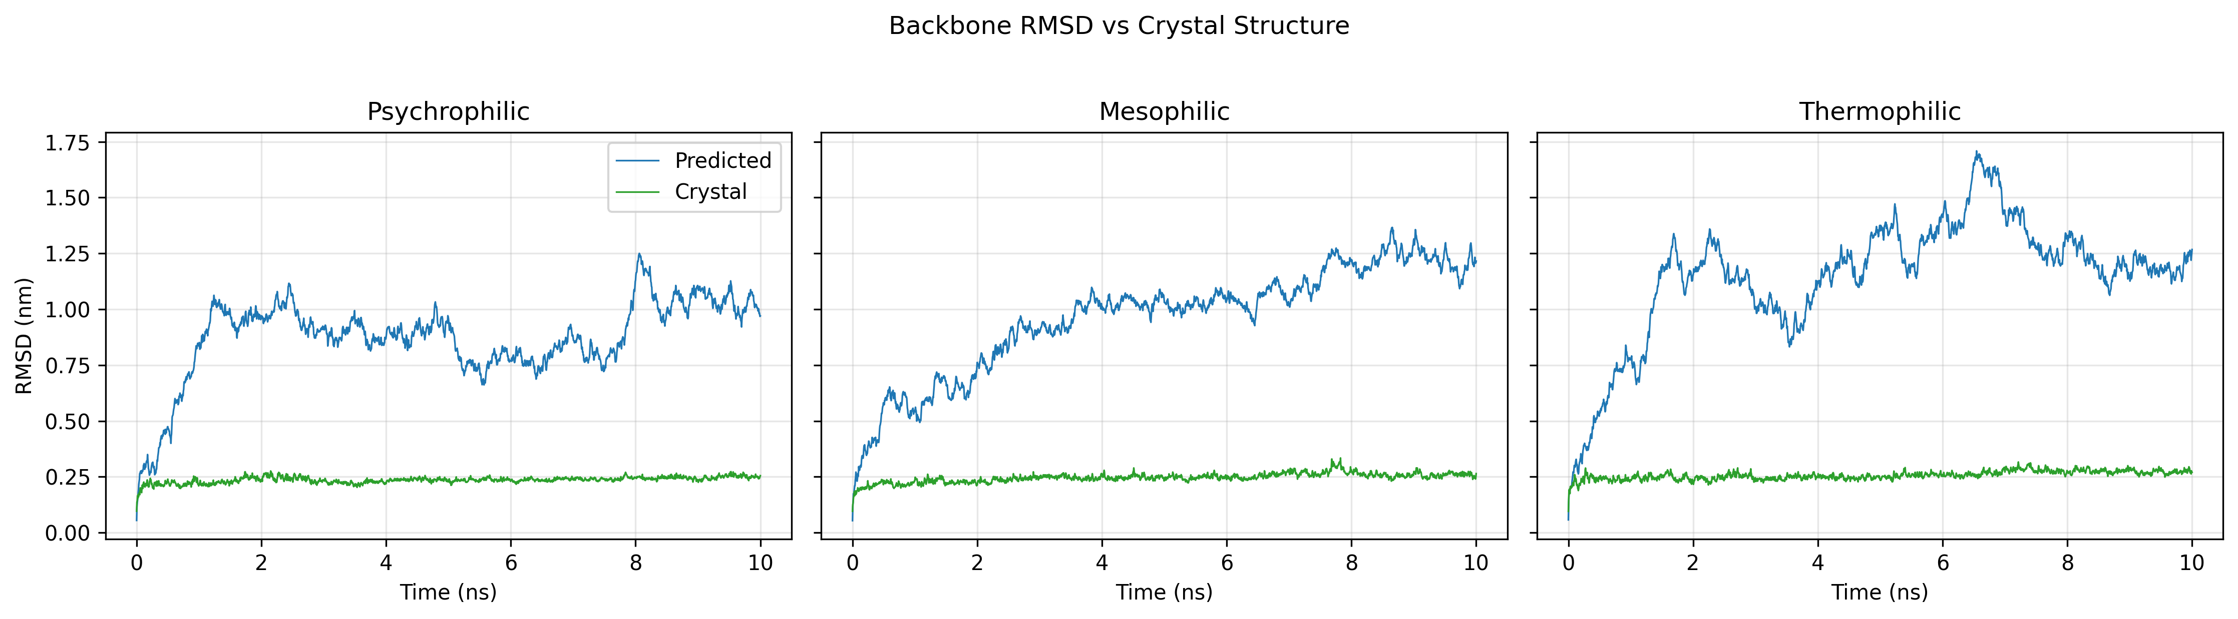 Figure 25. RMSD profiles comparing experimentally determined and AlphaFold-predicted T4 UvsX structures during molecular dynamics simulations.
The experimentally determined T4 UvsX structure displayed low RMSD values across all simulated temperature conditions. Mean RMSD values ranged from 0.236–0.257 nm, with similar values observed under psychrophilic, mesophilic and thermophilic conditions.
The corresponding AlphaFold-predicted structure showed increased structural deviation compared with the experimental structure. Mean RMSD values ranged from 0.872–1.147 nm with the highest deviation observed under thermophilic conditions.
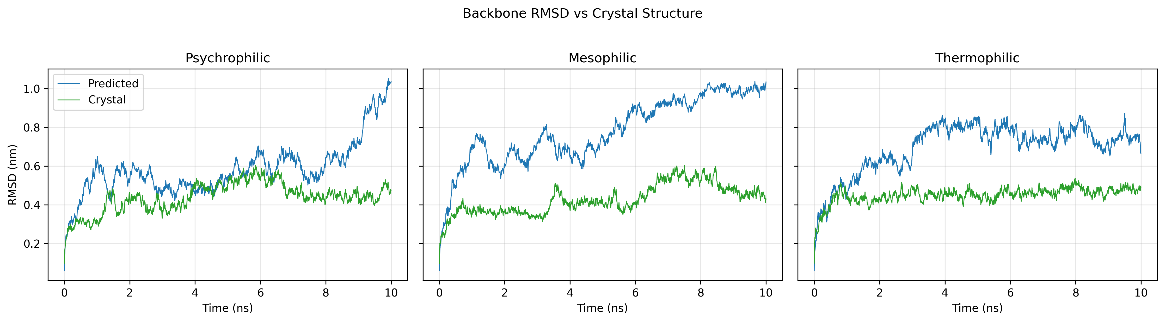 Figure 26. RMSD profiles comparing experimentally determined and AlphaFold-predicted 7Z3M UvsX structures during molecular dynamics simulations.
The 7Z3M thermophilic UvsX protein showed closer agreement between predicted and experimental simulations compared with T4 UvsX. The crystal structure displayed mean RMSD values between 0.427–0.450 nm, while the AlphaFold model showed mean RMSD values ranging from 0.583–0.779 nm.
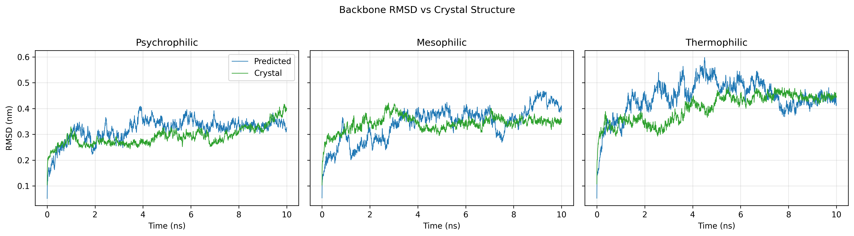 Figure 27. RMSD profiles comparing experimentally determined and AlphaFold-predicted 9GBG UvsX structures during molecular dynamics simulations.
The psychrophilic 9GBG protein displayed the lowest difference between predicted and experimental RMSD profiles. The crystal structure showed mean RMSD values between 0.236–0.264 nm, while the AlphaFold model exhibited mean RMSD values ranging from 0.872–0.970 nm.

4.1.2 Comparison of residue flexibility between predicted and experimental structures
Residue-level flexibility was assessed using root mean square fluctuation (RMSF) analysis to compare local mobility patterns between AlphaFold-generated and experimentally determined structures.
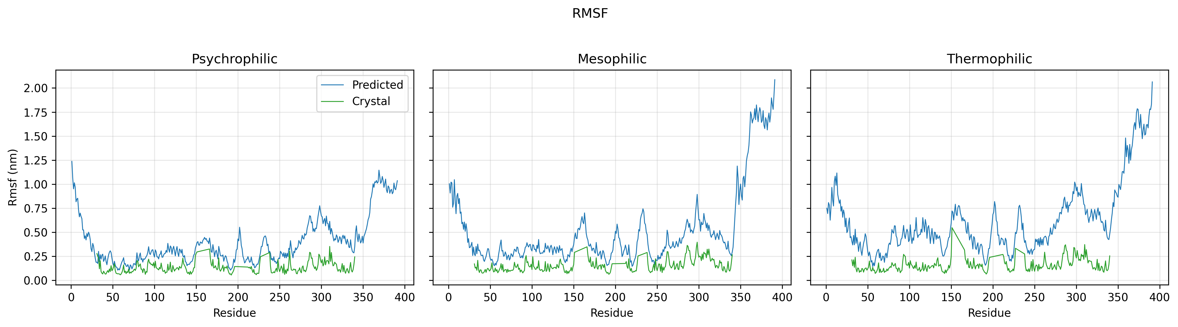
Figure 28. RMSF profiles comparing experimentally determined and AlphaFold-predicted T4 UvsX structures during molecular dynamics simulations.
The experimentally determined T4 UvsX structure showed low residue fluctuations across all conditions, with mean RMSF values ranging from 0.133–0.158 nm.
The AlphaFold-predicted structure exhibited increased residue mobility, with mean RMSF values ranging from 0.401–0.624 nm.
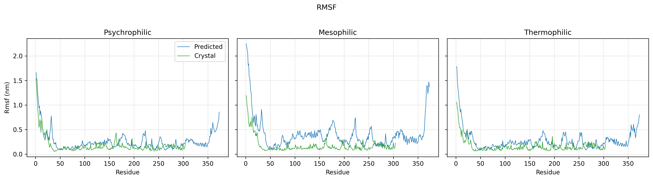 Figure 29. RMSF profiles comparing experimentally determined and AlphaFold-predicted 7Z3M UvsX structures during molecular dynamics simulations.
The 7Z3M crystal structure displayed mean RMSF values between 0.162–0.175 nm, while the AlphaFold model showed increased values ranging from 0.263–0.410 nm.
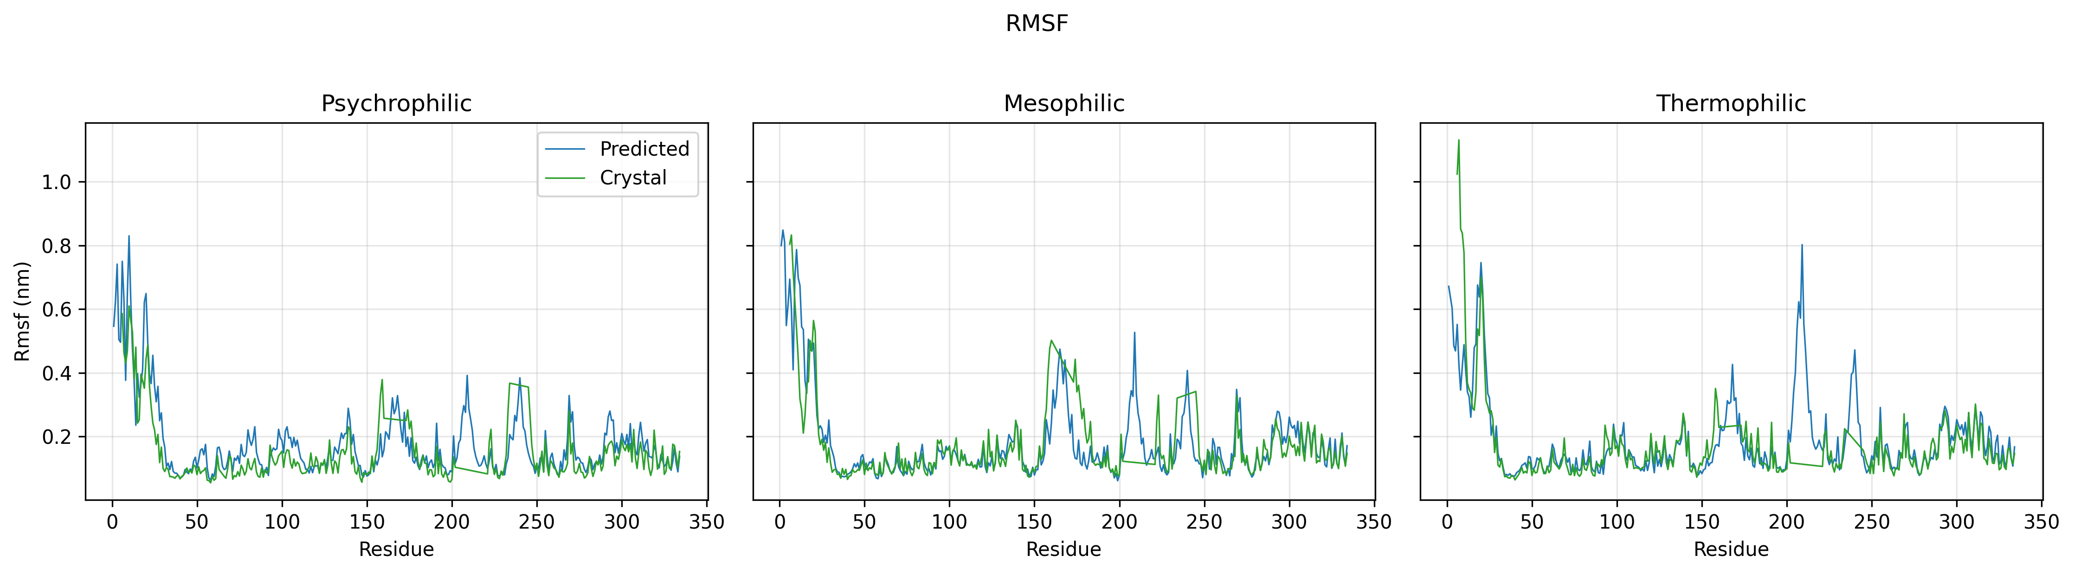 Figure 30. RMSF profiles comparing experimentally determined and AlphaFold-predicted 9GBG UvsX structures during molecular dynamics simulations.
The psychrophilic 9GBG protein displayed the closest agreement in residue flexibility between predicted and experimental structures. The crystal structure exhibited mean RMSF values between 0.133–0.154 nm, while the AlphaFold model showed values ranging from 0.263–0.526 nm.
Across all three reference proteins, AlphaFold predictions showed increased RMSF values compared with experimental structures, while maintaining similar overall flexibility profiles.

4.1.3 Comparison of global structural compactness
Radius of gyration (Rg) was analysed to compare global structural compactness between AlphaFold-generated and experimentally determined UvsX structures.
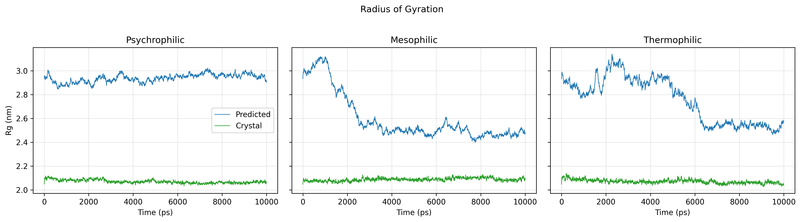 Figure 31. Radius of gyration profiles comparing experimentally determined and AlphaFold-predicted T4 UvsX structures during molecular dynamics simulations.
The T4 UvsX crystal structure maintained stable compactness throughout the simulations, with mean Rg values ranging from 2.070–2.087 nm and low variation between trajectories.
The AlphaFold-predicted T4 UvsX structure displayed increased Rg values, ranging from 2.599–2.939 nm, with greater variation observed under mesophilic (310k) and thermophilic conditions (338k).
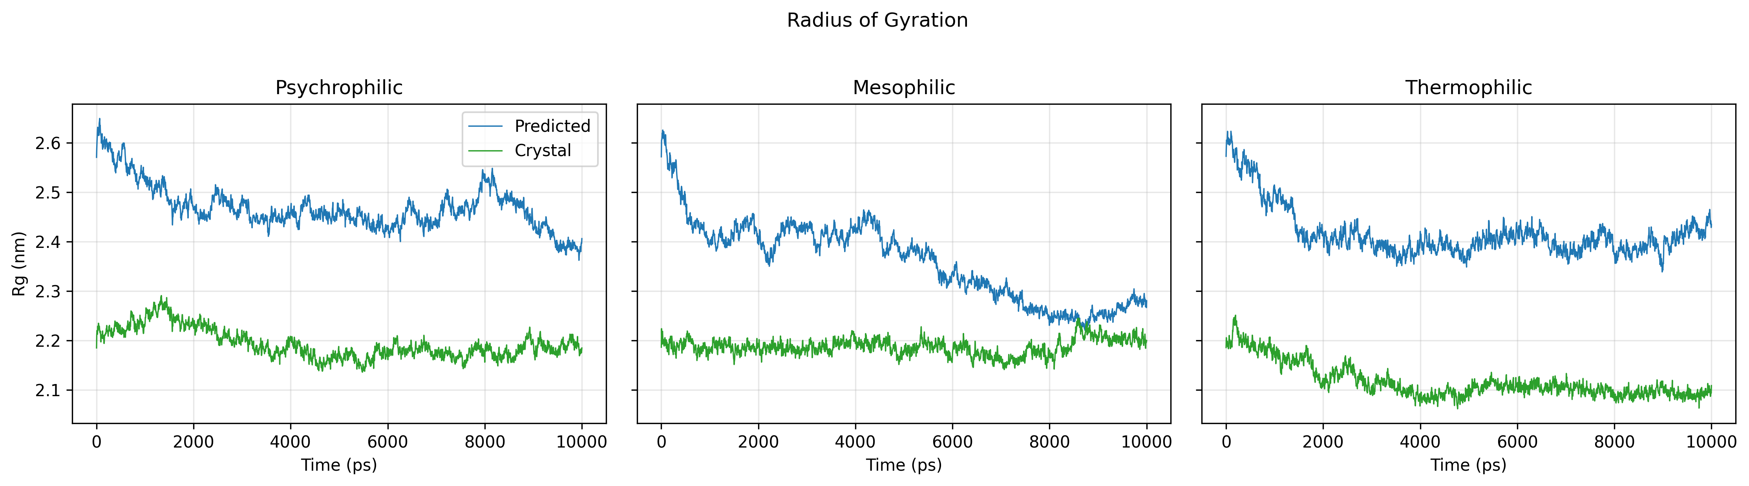 Figure 32. Radius of gyration profiles comparing experimentally determined and AlphaFold-predicted 7Z3M UvsX structures during molecular dynamics simulations.
The 7Z3M crystal structure displayed mean Rg values between 2.117–2.193 nm, while the AlphaFold model showed slightly higher values ranging from 2.360–2.469 nm.
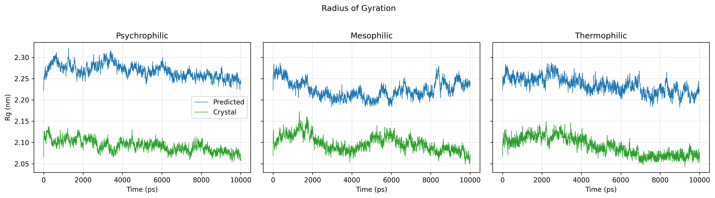 Figure 33. Radius of gyration profiles comparing experimentally determined and AlphaFold-predicted 9GBG UvsX structures during molecular dynamics simulations.
The 9GBG AlphaFold model maintained a similar overall Rg profile to the experimentally determined structure, although the predicted model consistently displayed higher absolute Rg values. (Figure 33)

Summary of AlphaFold validation
Across RMSD, RMSF and radius of gyration analyses, AlphaFold-generated UvsX structures displayed similar overall dynamic trends to experimentally determined structures while showing increased structural variability.
The psychrophilic 9GBG and thermophilic 7Z3M structures showed the closest agreement between predicted and experimental simulations across all three analyses. The T4 UvsX AlphaFold model displayed the largest differences, with increased RMSD, RMSF and radius of gyration values compared with the experimentally determined structure.

4.2 Molecular dynamics behaviour of thermally adapted UvsX orthologues
Following validation of AlphaFold predictions against experimentally determined structures, representative UvsX orthologues from different thermal environments were simulated using predicted structures.

4.2.1 Structural stability differs between thermal groups
To investigate whether UvsX proteins assigned to different thermal adaptation groups displayed distinct structural stability profiles, RMSD analysis was performed on representative psychrophilic, mesophilic and thermophilic candidates identified through the TMP pipeline. Three proteins from each thermal group were selected and simulated under three temperature conditions representing psychrophilic (288 K), mesophilic (310 K) and thermophilic (338 K) environments.
Root mean square deviation (RMSD) was used to assess structural deviation from the initial protein conformation throughout the simulations, with lower RMSD values indicating greater structural stability.
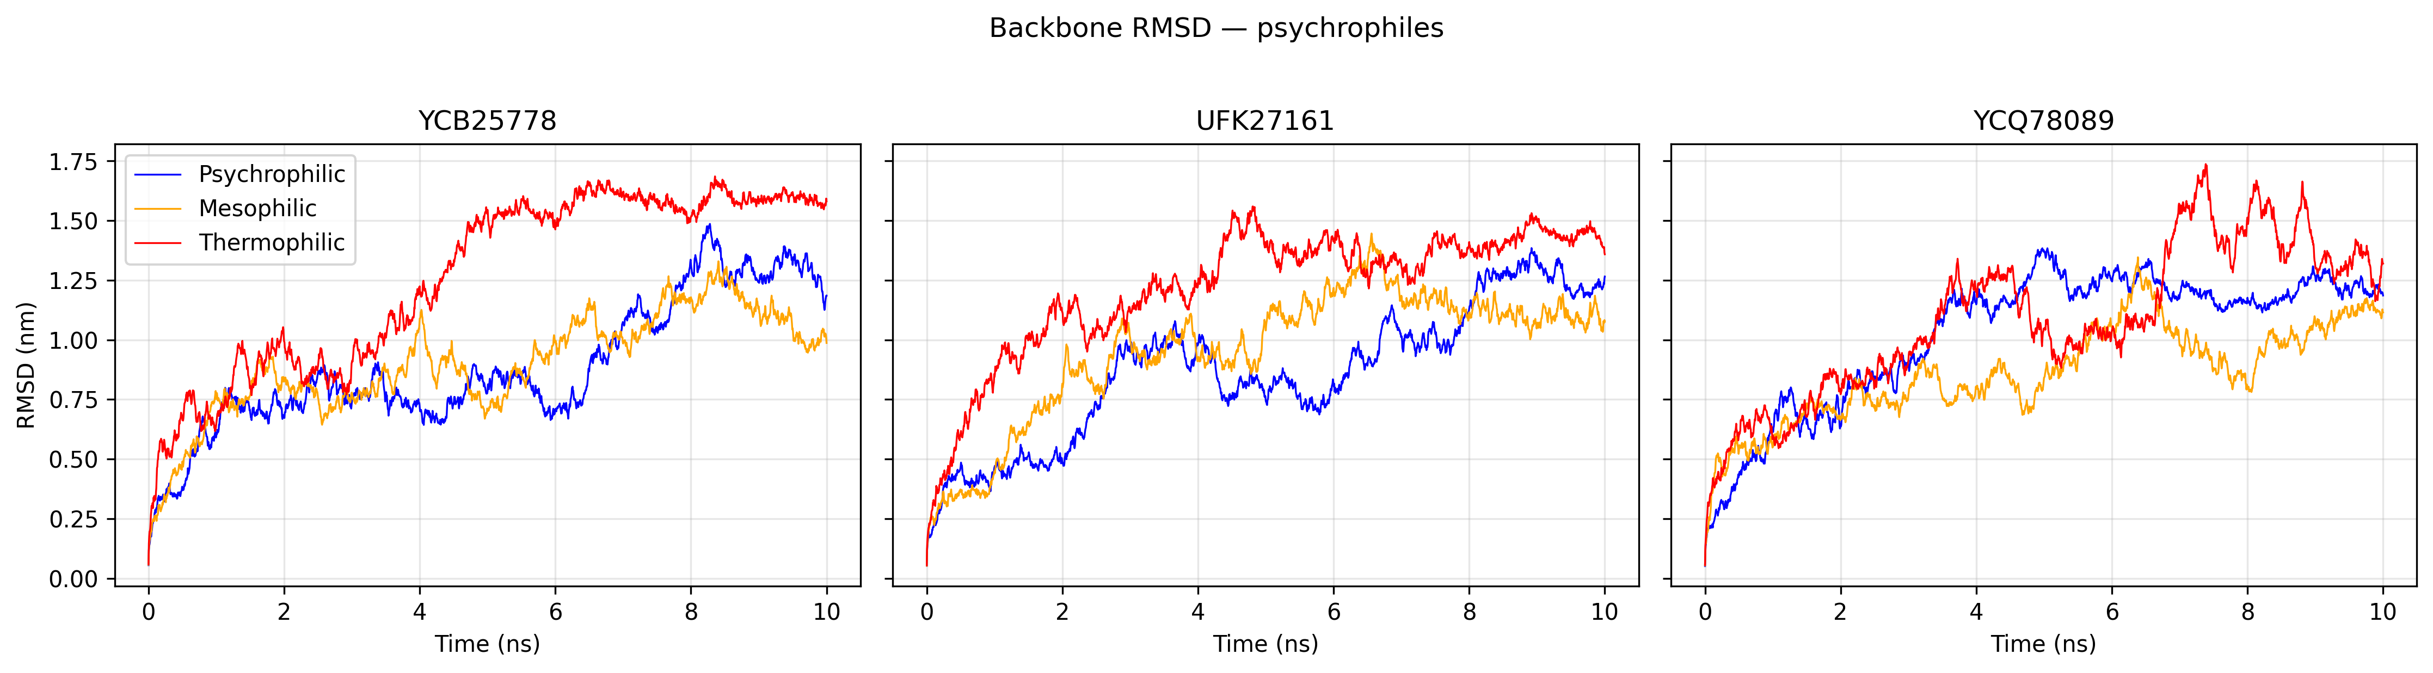 Figure 32. RMSD profiles of three TMP-classified psychrophilic UvsX orthologues simulated under psychrophilic (288 K), mesophilic (310 K) and thermophilic (338 K) conditions.
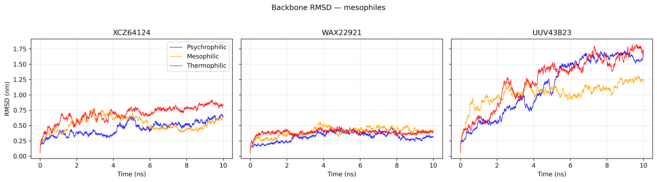 Figure 33. RMSD profiles of three TMP-classified mesophilic UvsX orthologues simulated under psychrophilic (288 K), mesophilic (310 K) and thermophilic (338 K) conditions.
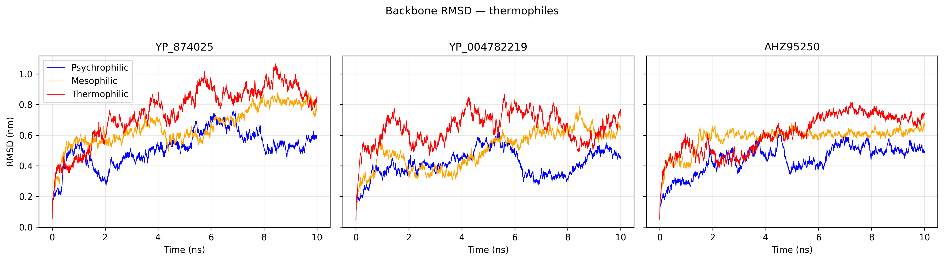 Figure 34. RMSD profiles of three TMP-classified thermophilic UvsX orthologues simulated under psychrophilic (288 K), mesophilic (310 K) and thermophilic (338 K) conditions.
RMSD analysis revealed clear differences in structural stability between the three TMP-classified thermal groups. Thermophilic orthologues generally exhibited the lowest structural deviation, psychrophilic orthologues displayed the greatest conformational flexibility, and mesophilic proteins showed intermediate behaviour. However, these differences were maintained across simulation temperatures, suggesting that thermal classification was associated with inherent structural characteristics rather than a simple optimisation of stability at a single temperature.
Psychrophilic candidates exhibited the highest RMSD values across all simulation conditions, with mean values ranging from approximately 0.86–1.03 nm. For example, YCB25778 increased from 0.89 nm at 288 K to 1.26 nm at 338 K, while UFK27161 similarly showed increased structural deviation under elevated temperature, reaching a mean RMSD of 1.22 nm at 338 K. These observations indicate that psychrophilic orthologues generally underwent larger conformational rearrangements during simulation, particularly at higher temperatures.
In contrast, thermophilic candidates consistently maintained lower RMSD values, ranging from 0.41–0.76 nm across all conditions. YP_004782219 displayed the greatest overall stability, with mean RMSD values of 0.41 nm, 0.50 nm and 0.65 nm at 288 K, 310 K and 338 K, respectively. Although several thermophilic proteins showed increasing RMSD with temperature—for example, YP_874025 increased from 0.52 nm to 0.76 nm between 288 K and 338 K—they nevertheless remained more structurally stable than the psychrophilic candidates.
Mesophilic orthologues displayed intermediate behaviour, with RMSD values generally falling between those of the psychrophilic and thermophilic groups. Temperature-dependent increases in structural deviation were also observed within this group, although the magnitude of these changes varied between individual proteins.
Collectively, RMSD analysis showed that thermophilic orthologues generally exhibited lower structural deviation than psychrophilic candidates, while mesophilic proteins displayed intermediate behaviour. These differences were observed across all simulation temperatures, although RMSD generally increased with increasing temperature.

4.2.2 Residue flexibility differs between thermal groups
To investigate whether thermal adaptation was associated with differences in local protein flexibility, residue-level fluctuations were analysed using root mean square fluctuation (RMSF). RMSF values represent the average displacement of individual residues throughout the simulation and provide insight into regions of increased flexibility within each UvsX orthologue.
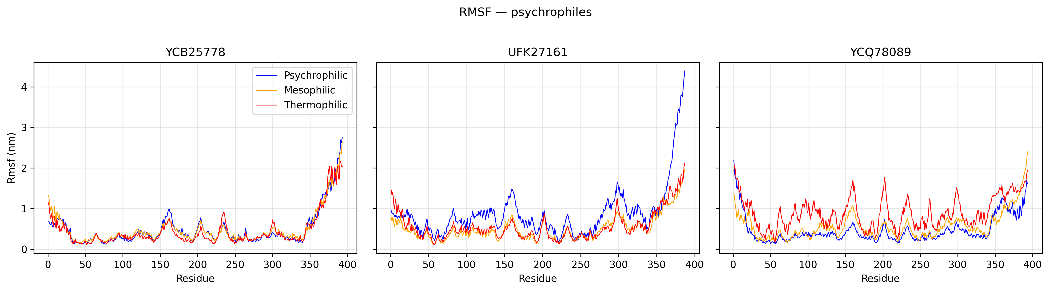 Figure 35. RMSF profiles of three TMP-classified psychrophilic UvsX orthologues simulated under psychrophilic (288 K), mesophilic (310 K), and thermophilic (338 K) conditions.
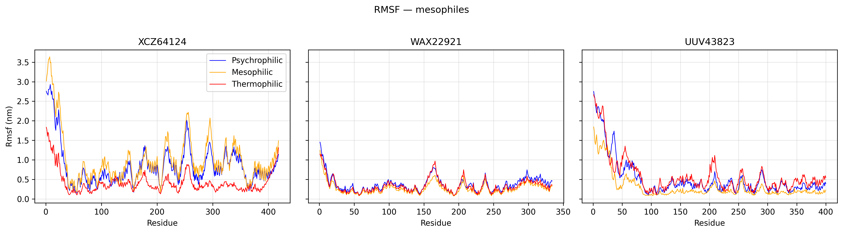 Figure 36. RMSF profiles of three TMP-classified mesophilic UvsX orthologues simulated under psychrophilic (288 K), mesophilic (310 K), and thermophilic (338 K) conditions.
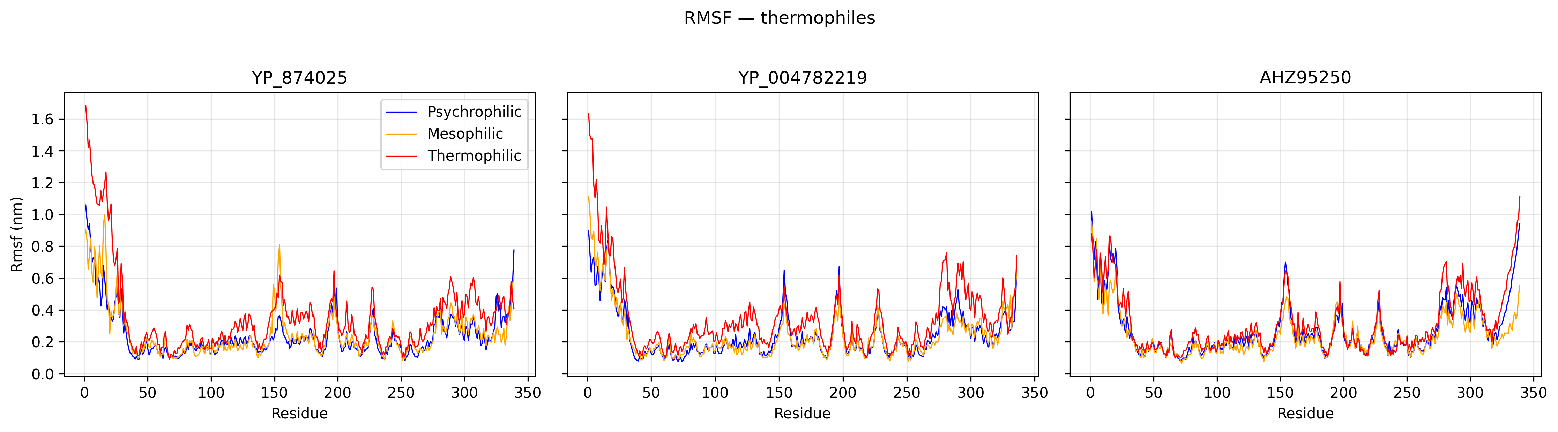 Figure 37. RMSF profiles of three TMP-classified thermophilic UvsX orthologues simulated under psychrophilic (288 K), mesophilic (310 K), and thermophilic (338 K) conditions.
RMSF analysis revealed distinct patterns of residue-level flexibility between the three TMP-classified thermal groups. Thermophilic orthologues generally displayed reduced residue fluctuations, consistent with increased structural rigidity, whereas psychrophilic candidates exhibited greater flexibility. Mesophilic proteins showed intermediate behaviour but displayed substantial variation between individual sequences.
Psychrophilic candidates showed the greatest overall residue mobility, with mean RMSF values ranging from 0.447–0.879 nm across the simulated conditions. UFK27161 exhibited the highest flexibility among the analysed proteins, with a mean RMSF of 0.879 nm under psychrophilic (288k) conditions. In contrast, YCB25778 displayed a more moderate flexibility profile, with mean RMSF values ranging from 0.447–0.493 nm across all temperatures, demonstrating that psychrophilic proteins do not share a uniform dynamic behaviour.
Thermophilic orthologues displayed the lowest and most consistent RMSF values across the dataset, with mean fluctuations ranging from 0.240–0.362 nm. YP_004782219 showed particularly limited residue mobility, with mean RMSF values of 0.243 nm, 0.240 nm and 0.352 nm under psychrophilic, mesophilic (310k) and thermophilic (338k) simulation conditions, respectively. Although residue flexibility increased slightly at elevated temperature, the magnitude of this change remained substantially lower than observed for several psychrophilic and mesophilic candidates, indicating that thermophilic proteins maintained a more constrained dynamic state.
Mesophilic proteins exhibited intermediate flexibility but showed the greatest variation between individual orthologues. WAX22921 maintained relatively low RMSF values across all conditions (0.270–0.368 nm), whereas XCZ64124 displayed substantially increased flexibility, particularly under mesophilic conditions (310k) where mean RMSF reached 1.003 nm. This variability suggests that mesophilic proteins represent a broader dynamic category rather than a single conserved flexibility profile.
Overall, RMSF analysis supports the presence of distinct dynamic characteristics associated with thermal adaptation. Thermophilic UvsX proteins generally maintained reduced residue mobility, whereas psychrophilic candidates displayed increased flexibility consistent with enhanced conformational sampling. However, the variability observed within each thermal group indicates that flexibility is influenced by protein-specific sequence and structural features rather than temperature alone.

4.2.3 Changes in global structural compactness between thermal groups
Radius of gyration (Rg) was analysed to investigate differences in global protein compactness between TMP-classified UvsX orthologues. Rg provides a measure of the overall dimensions of a protein structure, with lower values indicating a more compact conformation.
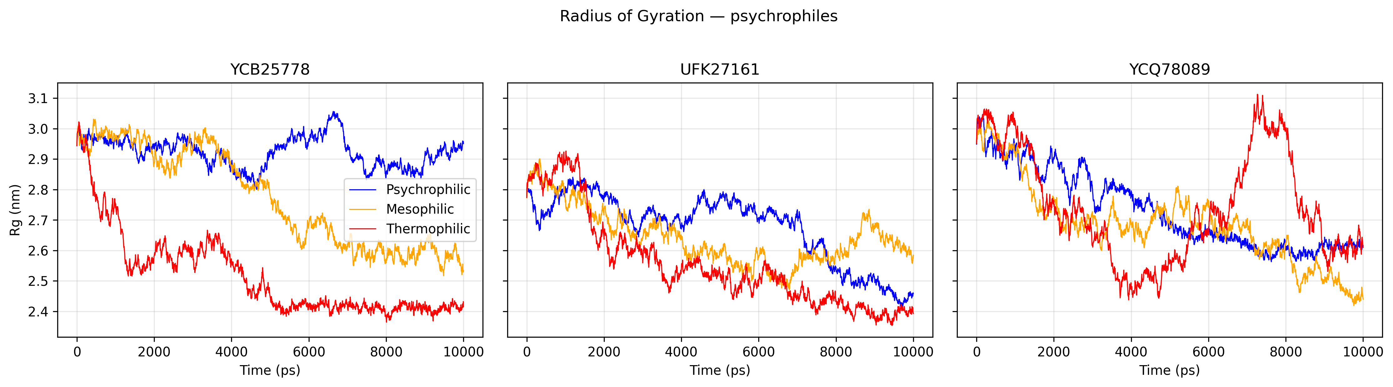 Figure 38. Radius of gyration profiles of three TMP-classified psychrophilic UvsX orthologues simulated under psychrophilic (288 K), mesophilic (310 K), and thermophilic (338 K) conditions.
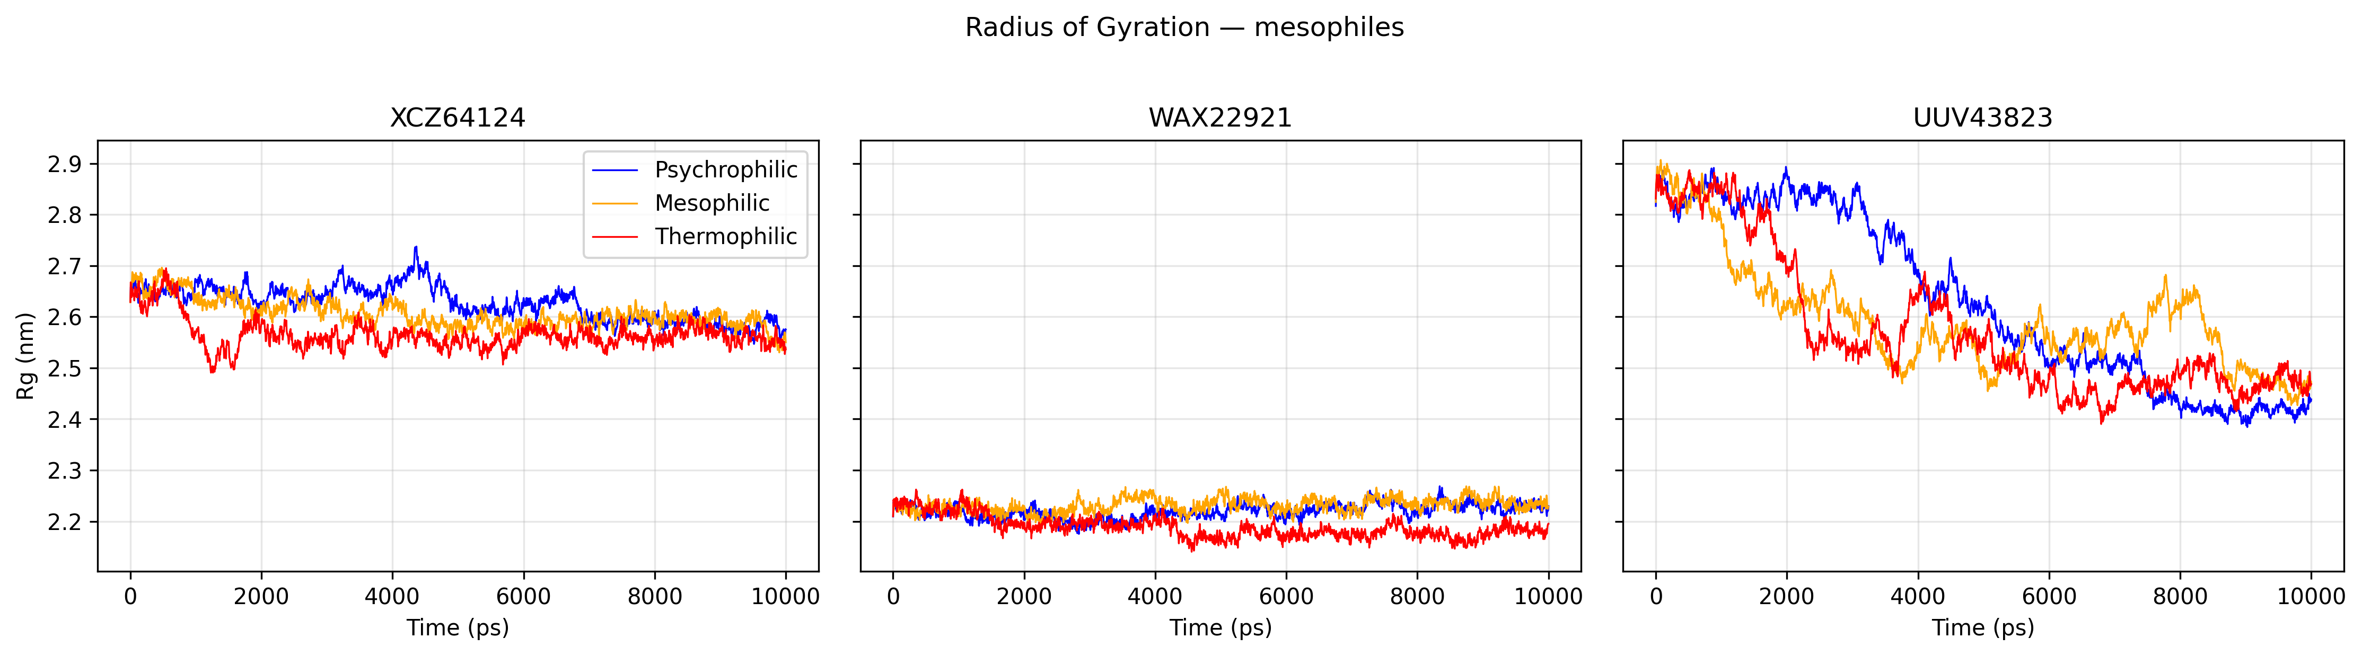 Figure 39. Radius of gyration profiles of three TMP-classified mesophilic UvsX orthologues simulated under different temperature conditions.
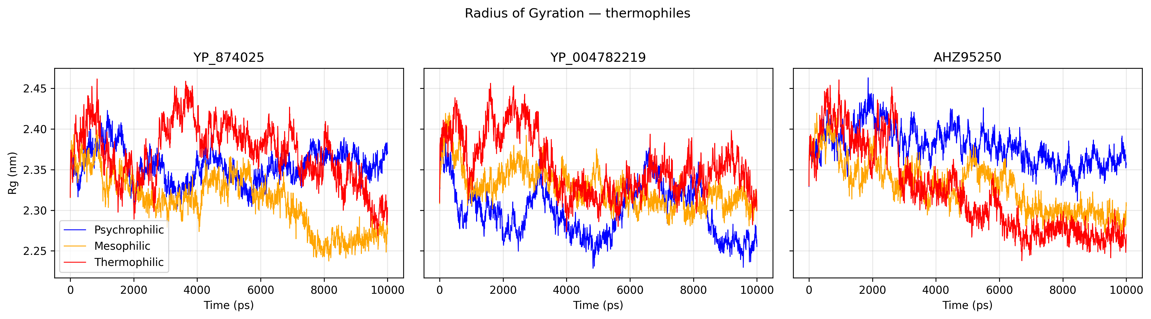 Figure 40. Radius of gyration profiles of three TMP-classified thermophilic UvsX orthologues simulated under different temperature conditions.
Rg analysis revealed differences in global structural organisation between thermal groups, with thermophilic UvsX orthologues maintaining the most consistent compactness across simulation conditions. In contrast, psychrophilic candidates displayed greater variation in global dimensions, indicating increased structural rearrangement during temperature changes. Mesophilic proteins showed intermediate behaviour, with substantial variability between individual orthologues.
Thermophilic candidates maintained the most stable global architecture, with mean Rg values remaining within a narrow range of approximately 2.30–2.38 nm across all three proteins and simulation conditions. This limited variation indicates that thermophilic UvsX proteins preserved their overall structural organisation despite changes in temperature. Although small increases in Rg were observed at elevated temperatures, these changes were comparatively minor, consistent with the reduced conformational flexibility observed in RMSD and RMSF analyses.
Psychrophilic candidates exhibited greater variation in global compactness, with mean Rg values ranging from 2.52–2.93 nm. YCB25778 displayed the largest temperature-dependent change, decreasing from a mean Rg of 2.925 nm under psychrophilic (288k) conditions to 2.516 nm under thermophilic conditions (338k). Similar, although less pronounced, changes were observed for UFK27161 and YCQ78089. These results indicate that psychrophilic proteins underwent greater changes in global structural organisation in response to temperature variation.
Mesophilic orthologues displayed intermediate behaviour but showed considerable variability between individual proteins. WAX22921 maintained relatively compact structures across all conditions, with Rg values of approximately 2.2 nm, whereas UUV43823 exhibited greater temperature-dependent changes in global compactness. This suggests that mesophilic proteins represent a diverse group with variable structural responses despite similar predicted thermal classifications.

5. Integrated identification of promising psychrophilic UvsX candidates
Following sequence-based identification and molecular dynamics analysis, candidates were prioritised by integrating TMP thermal classification with their simulated structural dynamics. Selection focused on increased conformational flexibility while maintaining overall structural organisation.
Candidate | Key MD evidence
UFK27161 | Highest residue-level flexibility, with RMSF reaching 1.51 nm, alongside moderate structural compactness.
YCB25778 | Increased flexibility and temperature-dependent structural variation with a relatively stable RMSF profile.
YCQ78089 | Moderate-to-high flexibility while maintaining relatively stable global compactness.
Table 7. Summary of key molecular dynamics characteristics of selected psychrophilic UvsX candidates identified through TMP classification. Candidates are compared based on residue-level flexibility and global structural compactness.
These candidates represent the most promising targets for future experimental characterisation. UFK27161 due to its pronounced flexibility, while YCB25778 and YCQ78089 displayed more moderate dynamic profiles. Experimental testing will be required to determine whether these structural characteristics translate into enhanced recombinase activity at low temperatures.

Discussion

Evaluation of the computational discovery pipeline for identifying cold-adapted UvsX orthologues
The central aim of this project was to develop a computational pipeline capable of identifying potential cold-adapted UvsX orthologues from public databases. The pipeline reduced over 26,000 initial protein sequences to three priority psychrophilic candidates, demonstrating its ability to narrow a large candidate pool to a small number of proteins with the strongest evidence for potential cold adaptation, suitable for future experimental validation. This highlights the value of the developed pipeline as a tool for directing experimental efforts towards the most promising UvsX orthologues.
The combination of sequence curation, HMM-based identification, conserved motif screening, thermal classification and molecular dynamics analysis enabled candidates to be prioritised using multiple independent features rather than sequence similarity alone. This increased confidence that the selected proteins represented genuine UvsX orthologues with characteristics consistent with cold adaptation.
Although computational analysis cannot confirm improved RPA activity at ambient temperatures, the identification of three promising candidates provides focused targets for experimental validation. Following recombinant expression and purification, ATPase activity, ssDNA binding, presynaptic filament formation and DNA strand exchange assays performed across a range of temperatures could determine whether these candidates retain recombinase activity and exhibit characteristics consistent with psychrophilic adaptation.

Balancing sensitivity and specificity in UvsX candidate screening
The in-silico screening strategy required balancing sensitivity and specificity when identifying candidate UvsX orthologues. The use of multiple HMM profiles provided a stringent method for identifying proteins with similarity to characterised UvsX sequences. However, the overlap between HMM searches demonstrated that some models were more inclusive than others, with one HMM identifying a subset of candidates fully contained within the broader hits from the remaining models. This HMM therefore did not increase the number of candidates identified and may have provided limited additional value for expanding the search space. However, as the aim of this pipeline was to prioritise high-confidence UvsX orthologues rather than maximise candidate recovery, maintaining stringent criteria was considered appropriate.
Similarly, the use of conserved ATP-binding motifs provided increased confidence that retained candidates possessed features required for UvsX recombinase activity, but may have excluded some functional proteins. For example, the experimentally validated psychrophilic UvsX orthologue 9GBG does not contain a canonical Walker B motif despite demonstrating recombinase activity. This indicates that strict motif-based filtering has the potential to remove biologically relevant candidates with sequence divergence within conserved regions.
In this study, stringent filtering criteria were deliberately applied to prioritise candidates with high confidence for functional UvsX activity, favouring specificity over sensitivity. This approach reduced the likelihood of progressing false-positive candidates into downstream thermal prediction and structural analyses but may also have excluded more divergent UvsX homologues that retain recombinase activity despite lacking canonical sequence characteristics. Future iterations of the pipeline could therefore explore less restrictive filtering strategies, such as allowing greater variation within ATP-binding motifs, incorporating adaptive motif thresholds, or including candidates identified by fewer HMM criteria. Such approaches may increase the discovery of divergent cold-adapted recombinases while maintaining confidence through subsequent structural and functional analyses.

Limitations of ab-initio thermal prediction
Seq2Topt provided a useful estimate of optimal growth temperature, but its performance was limited for the cold-adapted candidates identified in this study (RMSE = 12.26°C, R² = 0.57). This limitation likely reflects the composition of the training dataset, which contained only 461 psychrophilic proteins out of 2917 total samples. Therefore, the model had comparatively limited representation of proteins adapted to low temperatures, potentially reducing its ability to accurately predict candidates within this range. Additionally, thermal adaptation may be encoded through subtle sequence changes associated with flexibility and stability rather than broad amino acid composition patterns, which may not be fully captured by the features used by Seq2Topt.
This limitation was demonstrated by the misclassification of 9GBG, a psychrophilic candidate, which was predicted to have a higher optimal temperature than 7Z3M, a known thermophilic protein. Seq2Topt uses protein language model embeddings generated from the amino acid sequence, allowing it to capture complex sequence patterns beyond simple amino acid composition. However, predictions remain dependent on the extent to which sequence-derived features reflect thermal adaptation.
Psychrophilic adaptation is often associated with subtle structural and biophysical changes that promote increased flexibility and activity at low temperatures. These adaptations may arise from specific residue substitutions, altered local interactions, or changes in protein stability rather than strong global sequence patterns. Consequently, sequence embeddings may not always capture the features that distinguish cold-adapted proteins from proteins adapted to higher temperatures, particularly when these differences are subtle or context-dependent.
This may explain why 9GBG was predicted to have a higher optimal temperature than 7Z3M despite being experimentally associated with psychrophilic adaptation. The result highlights a limitation of relying solely on sequence-based prediction, where biologically meaningful thermal adaptations may not always translate into clear sequence-level signals. This limitation motivated the development of TMP, which incorporates literature-derived evidence as an additional source of information for classifying candidate cold-adapted recombinases within this study.

Performance and limitations of agentic literature-based thermal classification
TMP classified thermophilic proteins with high confidence, whereas greater variation was observed between mesophilic and psychrophilic classifications. This difference likely reflects the unequal availability and depth of information describing proteins from different thermal environments. Thermophilic organisms and proteins have been extensively studied, with many well-characterised examples and clearer descriptions of the molecular features associated with thermal adaptation. This provides a stronger knowledge base for identifying thermophilic characteristics through literature-derived evidence.
In contrast, mesophilic proteins represent the most commonly studied group and are often used as the default comparison when describing protein function and environmental adaptation. As a result, distinguishing between mesophilic and psychrophilic proteins can be more challenging, particularly when specific cold-adaptation features are not explicitly reported. Psychrophilic proteins were comparatively underrepresented in the public data. When using the search terms “mesophile”, “thermophile” and “psychrophile” in NCBI, only 12.9% of the total papers returned were associated with the psychrophile search. Consequently, the majority of psychrophilic examples originated from a small number of species, limiting the diversity of the training dataset.
The summary version of TMP was selected as the most appropriate approach within this study, as it provided a balance between the speed of the fast implementation and the broader evidence consideration of the democratic approach. By incorporating a relevance check and summarising information across multiple literature sources, TMP reduced the likelihood of erroneous classifications caused by relying on a single retrieved example, as observed in the fast version. This allowed classifications to be based on a broader representation of the available evidence rather than the first relevant result identified.
Additionally, the summary approach helped address potential biases introduced by the democratic version, where classifications could be disproportionately influenced by the weighting or selection of individual literature examples. By integrating evidence across sources, the summary approach provided a more consistent interpretation of thermal adaptation characteristics and improved confidence in the resulting classifications.
The classification of psychrophilic UvsX candidates was constrained by the limited availability of published literature describing cold-adapted bacteriophages and their proteins. Unlike thermophilic systems, which are comparatively well characterised, psychrophilic phages have received less experimental attention, resulting in fewer studies available for literature-based interpretation. As TMP classifies proteins by retrieving and summarising relevant publications associated with each accession, a smaller body of available evidence can reduce confidence in classification and make it more challenging to distinguish genuine psychrophilic adaptations from broader descriptions of protein function or environmental context. Consequently, TMP classifications should be interpreted within the context of the currently available literature, and their reliability is expected to improve as additional psychrophilic phages and their proteins are experimentally characterised and described.
Future improvements could include expanding TMP beyond its current implementation by incorporating automated access to larger language models through application programming interfaces (APIs), allowing more efficient retrieval and interpretation of relevant literature. Additionally, development of a graphical user interface or web-based application would improve accessibility and enable broader application of TMP for screening candidate proteins.

Complementary evidence from Seq2Topt and TMP for UvsX thermal classification
When Seq2Topt predictions were compared across TMP classifications, a divergence was observed between the predicted optimal temperatures of proteins classified as psychrophilic and thermophilic (Figure 22). The separation between these groups suggests that, despite the limitations of sequence-based prediction, Seq2Topt was able to capture sequence-level signals associated with thermal adaptation that were broadly consistent with TMP classifications.
This agreement between independent approaches provides additional confidence in the candidate classifications, as the two methods rely on different sources of information. The observed divergence therefore supports the value of combining both approaches, where agreement between sequence-based prediction and literature-based classification strengthens confidence in identifying potential cold-adapted recombinases.

Evaluation of Boltz and AlphaFold for UvsX structural prediction
AlphaFold consistently generated highly accurate structural models of UvsX proteins, achieving strong agreement with experimentally determined crystal structures across all tested proteins. In contrast, Boltz predictions showed substantially lower structural similarity, with TM-scores remaining below 0.30 regardless of the sequence preparation strategy or multiple sequence alignment input. This suggests that the reduced performance was not due to the inherent difficulty of modelling UvsX proteins, but rather reflects differences in prediction performance between the two methods.
Several approaches were explored to improve Boltz performance, including removal of unresolved terminal regions and incorporation of alternative multiple sequence alignments. For the T4 UvsX reference protein, sequence trimming and the use of UniRef100-based alignments produced small improvements, suggesting that input quality influenced predictions to some extent. However, these improvements were insufficient to approach the accuracy achieved by AlphaFold. Similarly, custom UvsX-specific multiple sequence alignments did not improve predictions, indicating that increasing the number of closely related candidate sequences alone was not sufficient to enhance structural accuracy.
The difference between AlphaFold and Boltz performance may therefore reflect differences in how each model processes sequence and evolutionary information. AlphaFold has been extensively benchmarked and benefits from large-scale training on experimentally determined structures and optimised prediction pipelines. In contrast, Boltz may require further optimisation of input preparation, model parameters, or inference settings for accurate prediction of divergent protein families such as UvsX. Additional approaches, such as testing alternative MSA generation methods, increasing prediction sampling, or optimising model-specific parameters, may improve future Boltz performance.
Despite the reduced accuracy of Boltz predictions in this study, the evaluation demonstrates the importance of validating structural prediction methods against experimentally determined references before applying them to novel candidates. Based on the strong agreement between AlphaFold predictions and available crystal structures, AlphaFold was selected as the preferred method for downstream structural analysis of candidate UvsX proteins.

Validation of AlphaFold-generated UvsX structures for molecular dynamics analysis
Across RMSD, RMSF and radius of gyration analyses, AlphaFold models reproduced the major dynamic characteristics observed for experimentally determined UvsX structures. However, predicted structures generally displayed greater conformational variation than their corresponding crystal structures, including increased structural deviation, residue-level flexibility and changes in global compactness. This suggests that AlphaFold models successfully capture the overall structural architecture of UvsX proteins while sampling a broader range of conformational states during molecular dynamics simulations.
The strongest agreement between predicted and experimental structures was observed for the psychrophilic 9GBG and thermophilic 7Z3M proteins. Both models exhibited similar patterns of structural stability, flexibility and compactness across simulation conditions, despite differences in the magnitude of fluctuations. These results indicate that AlphaFold-generated structures can reproduce the major dynamic characteristics of experimentally characterised UvsX proteins and are suitable for comparative analyses of thermal adaptation.
The largest differences between predicted and experimental simulations were observed for T4 UvsX. Although the AlphaFold model showed high structural similarity to the experimentally resolved structure, it displayed increased RMSD, RMSF and radius of gyration values during molecular dynamics simulations. Since both structures represented the monomeric form of T4 UvsX, these differences are unlikely to result from differences in oligomeric state. Instead, they likely reflect differences between a crystallographically stabilised structure and a predicted model capable of exploring a broader conformational landscape. Crystal structures represent a single experimentally resolved state that may be influenced by crystal packing interactions and experimental conditions, whereas AlphaFold models may contain regions of increased conformational freedom that become apparent during simulation.
Increasing temperature generally increased conformational flexibility in AlphaFold-predicted UvsX structures, particularly for T4 UvsX, where higher simulation temperatures resulted in increased RMSD and RMSF values. However, this relationship was not consistent across all proteins, with 7Z3M displaying the greatest flexibility under mesophilic rather than thermophilic conditions. This suggests that thermal adaptation is not determined solely by a universal increase in rigidity at elevated temperatures, but instead reflects protein-specific structural features that influence conformational stability and temperature-dependent behaviour. The greater stability observed in experimentally determined structures across conditions further supports the interpretation that AlphaFold models sample a wider conformational landscape during molecular dynamics simulations.
The increased flexibility observed in AlphaFold models compared with crystal structures does not necessarily indicate reduced prediction accuracy. Instead, it may reflect the ability of molecular dynamics simulations to explore conformational states that are not represented within static experimental structures. Therefore, the purpose of AlphaFold validation in this study was not to reproduce experimental trajectories exactly, but to establish whether predicted structures retained sufficient accuracy for comparative analysis of UvsX dynamics. The preservation of overall trends between predicted and experimental models demonstrates that AlphaFold structures provide reliable starting points for investigating sequence-dependent differences in stability, flexibility and compactness among candidate orthologues.
Together, these findings support the use of AlphaFold-generated structures for downstream molecular dynamics analysis of UvsX proteins. Although predicted structures may exhibit greater conformational mobility than experimentally determined models, they provide suitable representations for assessing structural characteristics associated with thermal adaptation.

Molecular dynamics reveals differences in thermal adaptation among UvsX orthologues
Molecular dynamics simulations provided an additional layer of structural evidence for the TMP classifications by assessing whether predicted thermal groups exhibited distinct conformational behaviours. Within this study, the expectation was that thermophilic and psychrophilic UvsX orthologues would display contrasting dynamic properties, reflecting previously described differences in protein adaptation to temperature. Thermophilic proteins are generally expected to favour increased rigidity and structural compactness to maintain stability at elevated temperatures, whereas psychrophilic proteins are often characterised by increased flexibility (Åqvist, 2017). This enhanced flexibility is proposed to compensate for reduced molecular motion at low temperatures, allowing cold-adapted enzymes to maintain sufficient conformational sampling and catalytic activity despite slower reaction kinetics.
Consistent with these expectations, thermophilic orthologues and 7Z3M, the thermophilic gold-standard protein, displayed the most stable dynamic profiles across simulation conditions. These proteins generally maintained lower RMSD values, reduced residue-level fluctuations and limited changes in radius of gyration, indicating preservation of their overall structural organisation. This increased rigidity is consistent with known mechanisms of thermostability, where reduced conformational flexibility and tighter structural packing contribute towards maintaining protein integrity under thermal stress.
In contrast, several TMP-classified psychrophilic candidates displayed increased conformational flexibility compared with thermophilic proteins. However, comparison with the experimentally characterised psychrophilic reference protein 9GBG demonstrated that increased global flexibility is not a universal requirement for cold adaptation. Despite its psychrophilic classification, 9GBG maintained a relatively stable dynamic profile across simulation temperatures, suggesting that cold adaptation may also arise through more localised structural modifications that are not captured by global metrics such as RMSD or RMSF.
This observation is consistent with previous studies showing that no single structural feature is universally associated with psychrophilic adaptation. Although increased flexibility, particularly within functional regions such as enzyme active sites, is frequently proposed to enhance catalytic efficiency at low temperatures, comparative structural analyses have demonstrated that cold-adapted proteins can differ through multiple sequence and structural characteristics rather than a single conserved mechanism. Features such as altered hydrophobic interactions, surface properties, residue composition and local structural changes may contribute towards cold adaptation without necessarily producing increased global flexibility.
Therefore, while molecular dynamics supported the presence of distinct structural behaviours among TMP-classified thermal groups, the behaviour of 9GBG demonstrates that thermal adaptation cannot be defined solely by global measures of protein flexibility. These findings suggest that TMP classifications identify proteins with structural characteristics associated with thermal adaptation, but that cold adaptation likely reflects a combination of sequence, structural and dynamic features rather than a single universal mechanism.
It should also be recognised that each protein was represented by a single molecular dynamics trajectory. Because protein dynamics are inherently stochastic, multiple independent simulations would provide greater confidence that the observed differences are reproducible rather than trajectory-specific. Furthermore, molecular dynamics evaluates structural behaviour rather than directly measuring recombinase activity or thermal adaptation. Consequently, differences in flexibility, stability and compactness should be interpreted as supporting evidence that complements sequence and literature-based analyses rather than definitive confirmation of psychrophilic function.
Future simulations could extend this work by modelling ATP-bound and ssDNA-bound UvsX complexes. Because recombinase function depends upon ATP-driven conformational changes and filament formation on DNA, simulations of these biologically relevant states may provide additional insight into the structural mechanisms underlying thermal adaptation (Gajewski, 2011).

Broader significance
Overall, this study establishes a computational framework for identifying candidate cold-adapted UvsX recombinases from large sequence datasets and provides three high-confidence proteins for future biochemical characterisation. More broadly, the workflow demonstrates how integrating sequence analysis, literature-derived evidence, structural prediction and molecular dynamics can improve prioritisation of candidate proteins while reducing experimental screening effort.

References
Abramson, J., Adler, J., Dunger, J., Evans, R., Green, T., Pritzel, A., Ronneberger, O., Willmore, L., Ballard, A.J., Bambrick, J. and Bodenstein, S.W., 2024. Accurate structure prediction of biomolecular interactions with AlphaFold 3. Nature, 630(8016), pp.493-500.
Åqvist, J., Isaksen, G.V. and Brandsdal, B.O., 2017. Computation of enzyme cold adaptation. Nature Reviews Chemistry, 1(7), p.0051.
Ando, R.A. and Morrical, S.W., 1998. Single-stranded DNA binding properties of the UvsX recombinase of bacteriophage T4: binding
Eddy, S.R., 2009. A new generation of homology search tools based on probabilistic inference. In Genome Informatics 2009: Genome Informatics Series Vol. 23 (pp. 205-211).
Gajewski, S., Webb, M.R., Galkin, V., Egelman, E.H., Kreuzer, K.N. and White, S.W., 2011. Crystal structure of the phage T4 recombinase UvsX and its functional interaction with the T4 SF2 helicase UvsW. Journal of molecular biology, 405(1), pp.65-76.
Lobato, I.M. and O’Sullivan, C.K., 2018. Recombinase polymerase amplification: Basics, applications and recent advances. Trac Trends in analytical chemistry, 98, pp.19-35.
Mirdita, M., Schütze, K., Moriwaki, Y., Heo, L., Ovchinnikov, S. and Steinegger, M., 2022. ColabFold: making protein folding accessible to all. Nature methods, 19(6), pp.679-682.
Mistry, J., Chuguransky, S., Williams, L., Qureshi, M., Salazar, G.A., Sonnhammer, E.L., Tosatto, S.C., Paladin, L., Raj, S., Richardson, L.J. and Finn, R.D., 2021. Pfam: The protein families database in 2021. Nucleic acids research, 49(D1), pp.D412-D419.
Oliveira, B.B., Veigas, B. and Baptista, P.V., 2021. Isothermal amplification of nucleic acids: The race for the next “gold standard”. Frontiers in Sensors, 2, p.752600.
Pan, Y., Xie, N., Zhang, X., Yang, S. and Lv, S., 2023. Computational insights into the dynamic structural features and binding characteristics of recombinase UvsX compared with RecA. Molecules, 28(8), p.3363.
Passaro, S., Corso, G., Wohlwend, J., Reveiz, M., Thaler, S., Somnath, V.R., Getz, N., Portnoi, T., Roy, J., Stark, H. and Kwabi-Addo, D., 2025. Boltz-2: Towards accurate and efficient binding affinity prediction. BioRxiv.
Piepenburg, O., Williams, C.H., Stemple, D.L. and Armes, N.A., 2006. DNA detection using recombination proteins. PLoS biology, 4(7), p.e204.
Qiu, S., Hu, B., Zhao, J., Xu, W. and Yang, A., 2025. Seq2Topt: a sequence-based deep learning predictor of enzyme optimal temperature. Briefings in Bioinformatics, 26(2), p.bbaf114.
Rohrman, B. and Richards-Kortum, R., 2015. Inhibition of recombinase polymerase amplification by background DNA: a lateral flow-based method for enriching target DNA. Analytical chemistry, 87(3), pp.1963-1967.
Sonnhammer, E.L., Eddy, S.R., Birney, E., Bateman, A. and Durbin, R., 1998. Pfam: multiple sequence alignments and HMM-profiles of protein domains. Nucleic acids research, 26(1), pp.320-322.
Tan, M., Liao, C., Liang, L., Yi, X., Zhou, Z. and Wei, G., 2022. Recent advances in recombinase polymerase amplification: Principle, advantages, disadvantages and applications. Frontiers in Cellular and Infection Microbiology, 12, p.1019071.
Tarrant, E., Cormack, I.G., Hunter, C.E., Werbowy, O., Dorawa, S., Wang, L., Steen, I.H., Sandaa, R.A., Guðmundsdóttir, E.E., Ketelsen-Striberny, B. and Kaczorowska, A.K., 2026. Structure, function, and applications of two novel phage recombinases from extreme environments. Nucleic acids research, 54(4), p.gkag069.
T. King, S. Butcher, and L. Zalewski, Apocrita—High performance computing cluster for Queen Mary University of London, J. High Energy Phys. 11 (2016) 091.
Van Der Spoel, D., Lindahl, E., Hess, B., Groenhof, G., Mark, A.E. and Berendsen, H.J., 2005. GROMACS: fast, flexible, and free. Journal of computational chemistry, 26(16), pp.1701-1718.
Zhang, C., Shine, M., Pyle, A.M. and Zhang, Y., 2022. US-align: universal structure alignments of proteins, nucleic acids, and macromolecular complexes. Nature methods, 19(9), pp.1109-1115.

