No bound constraint

Number of constrains: 12177 rows, 12248 columns

Obj: 3.329903706e-02

At t = 0.1:

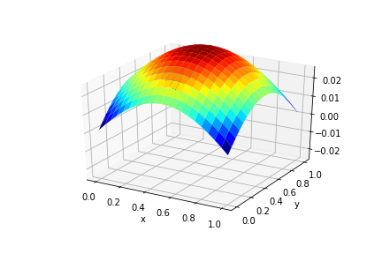

Upper bound = 0.5, lower bound = -0.5

Number of constraints: 25895 rows, 12248 columns

Obj: 3.329903706e-02

At t = 0.1:



Upper bound = 0.015, no lower bound

Number of constraints: 19036 rows, 12248 columns

Obj: 6.153324287e-02

At t = 0.1:

