 | CHAROTAR UNIVERSITY OF SCIENCE & TECHNOLOGY  DEVANG PATEL INSTITUTE OF ADVANCE TECHNOLOGY AND RESEARCH | 

WEEKLY REPORT

Project ID: | Student ID: D25DCE175 , D25DCE170, D25DCE164
From Date: 20-07-2026 | To Date: 26-07-2026
Semester: 5 | Internship ID:

Work done from Date: 20-07-2026 to 26-07-2026

Module | Key Requirements
A – Architecture Advisor | Accept GitHub URL / text input · Parse manifests (package.json, requirements.txt, Dockerfile, *.tf) · Bedrock stack inference (JSON) · Rules-engine service mapping · SVG diagram generation · Per-service cost estimate via Pricing API · Email delivery via SES · Graceful fallback for empty/private repos
B – Cost Monitoring | Daily Cost Explorer ingestion · 7-day rolling average per service · Spike flag when spend > avg × threshold (default 2.0×) · Rank spikes by $ impact · Email alerts · 30-day trend chart

- Prepared the detailed Software Requirements Specification (SRS) covering functional and non-functional requirements for all four modules: AI Architecture Advisor, Cost Monitoring .

- Conducted a feasibility study across three dimensions technical (Node.js + React + AWS SDK v3 stack validated), operational (university lab environment and AWS free-tier confirmed sufficient), and economic (zero-cost deployment using AWS free-tier and open-source tools).

- Drafted Use Case Diagrams for all four modules, identifying primary actors (Student/Booth Visitor, Small Team Founder) and their interactions with each system component.

- Drafted Level-0 and Level-1 Data Flow Diagrams (DFDs) for the AI Architecture Advisor and Cost Monitoring modules, illustrating data inputs, processing logic, and output flows.

- Outlined the initial three-tier system architecture: React frontend, Node.js/Express backend, data, and Amazon Bedrock for LLM inference; produced a high-level component diagram.

- Defined the draw.io XML output contract and confirmed the closed-pattern template approach (5–8 architecture patterns) for deterministic, reproducible diagram generation.

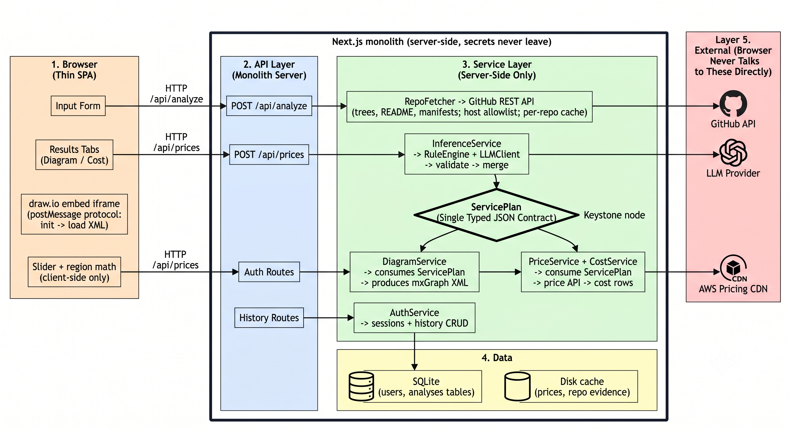

Plans for next week: Date: 28-07-2026 to 03-08-2026

References:

- IEEE Std 830-1998 — IEEE Recommended Practice for Software Requirements Specifications, IEEE Standards Association.
- Yourdon, E. & DeMarco, T. — Structured Design: Fundamentals of a Discipline of Computer Program and Systems Design, Pearson (1979). [DFD methodology reference]

Signature of Student Signature of Mentor

