TOPSTECHNOLOGIES **Software testing assignment**

**Module–1(fundamental)**

1 What is SDLC ?

= SDLC is a structure imposed on the development of a software product that defines the process for planning, implementation, testing, documentation, deployment, and ongoing maintenance .

2 What is agile methodology ?

= Agile SDLC model is a combination of iterative and incremental process models with focus on process adaptability and customer satisfaction by rapid delivery of working software product .

3 What is SRS ?

= A software requirements specification SRS is a complete description of the behaviour of the system to be developed .

4 What is OOPS ?

= Object-Oriented programming is a programming language model organized around objects rather than actions and data rather than logic.

5 What Basic concepts of oops ?

= Class

Encapsulation

Abstraction

Polymorphism: 1 Compile time polymorphism (Overloading)

2 Runtime polymorphism (overriding)

Inheritance

6 What is object ?

= An object holds both variables and methods one object mind represent you a second objects might represent me.

7 What is class ?

= When defining a class we creating a new abstract data a type that can be treated like any other built in data type.

8 What is encapsulation ?

= Encapsulation is the practice of including in an object everything it needs hidden from other objects .

9 What is inheritance ?

= Inheritance means that class inherits the characteristics of another class . This is also called is a relationship .

10 What is polymorphism ?

= Polymorphism means it allows different to respond to the same message in different ways, the response specific to the type of the object.

11 What is RDBMS ?

= Relational Database Management System .

12 What is SQL ?

= SQL is Structured Query Language, which is a computer language for storing, manipulating and retrieving data stored in relational database.

13 What SQL commands

= DDL-Data definition language

DML-Data manipulation language

DCL-Data control language

DQL-Data query language

14 Write SDLC phases with basic introduction ?

= Requirements collection / gathering – Establish customer needs

Analysis – Model and specify the requirement - what

Design – Model and specify a solution – why

Implementation – construct a solution in software

Testing – validate the solution against the requirements

Maintenance – repair defects and adapt the solution to the new requirement

15 Explain phases of the waterfall model ?

= 1 Requirements collection

2 Second analysis

3 Design

4 Implementation

5 Testing

6 Maintenance

16 write phases of spiral modal ?

= Planning

Risk analysis

Engineering

Customer evaluation

17 write agile manifesto principles

= Individuals and interactions

Working software

Customer collaboration

Responding to change

18 What is join ?

19 Explain working methodology of agile model and also write pros and cons.

= Agile SDLC model a combination of iterative and incremental process models with focus on process adaptability and customer satisfaction by rapid delivery of working software product .

(Advantages)

Is a very realistic approach to software development .

Resource requirement are minimum .

Suitable for fixed or changing requirement.

Delivers early pratial working solutions .

Easy to manage .

Little or no planning required .

Gives flexibility to developers .

(Disadvantages)

Not suitable for handing complex dependencies .

There is very high individual dependency , since there is minimum documentation generated .

Transfer of technology to new team members may be quite challenging due to lack of.

More risk of sustainability , maintainability and extensibility.

20 Draw Usecase on online book shopping ?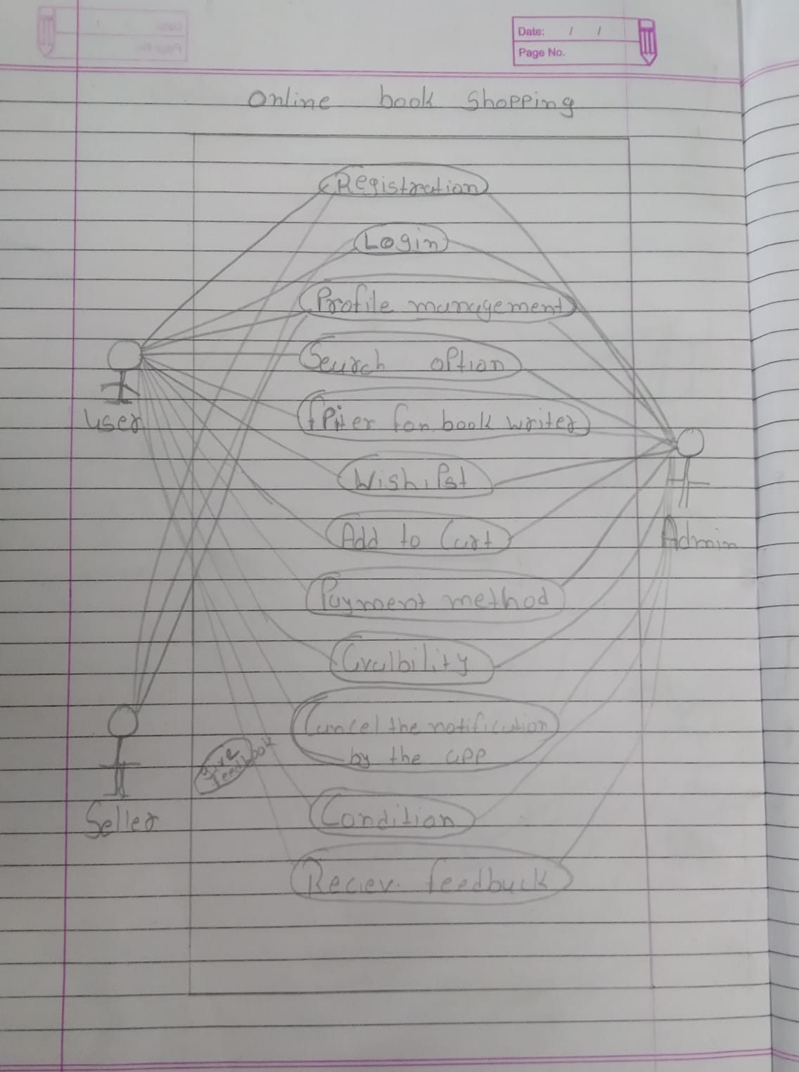

21 Draw Usecase on online bill payment system (paytm)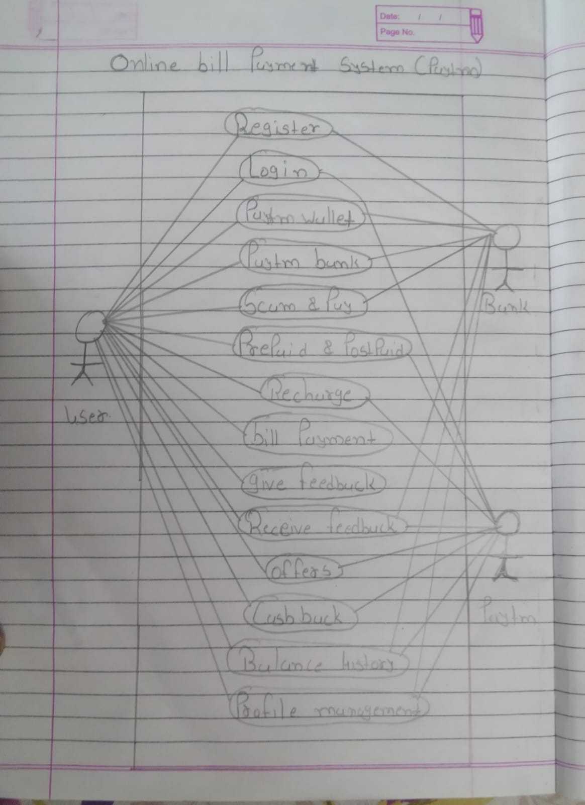

22 Draw usecase on online shopping product using COD

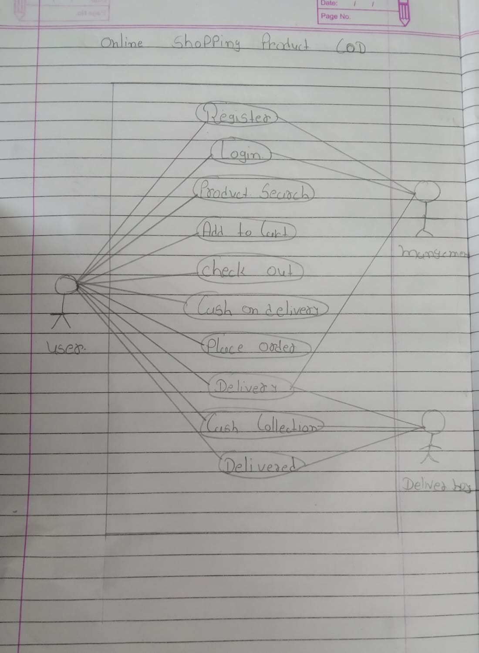

23 Draw usecase on online shopping product using payment gateway 