**Module-4**

**1.What are the main factors that can affect PPC**

**bidding?**

PPC (Pay-Per-Click) bidding is the process of setting and adjusting

the maximum amount you're willing to pay for each click on your

online advertisements. Several factors can affect PPC bidding,

including:

**1. Keyword Relevance:** The relevance of your keywords to your ad

campaign is crucial. Bidding on highly relevant keywords helps

improve your ad's Quality Score, which can lead to lower costs

and better ad placements.

**2. Competition:** The level of competition for specific keywords in

your industry impacts bidding. Popular keywords with high

demand may have more advertisers competing for them, driving

up the cost per click (CPC).

**3. Ad Rank:** Ad Rank is determined by factors like your bid

amount, ad quality, expected click-through rate (CTR), ad

relevance, and landing page experience. Higher ad ranks can lead

to better ad placements, and improving any of these factors can

positively impact your bidding.

**4. Quality Score:** Quality Score is a metric used by search engines

to assess the relevance and quality of your keywords, ads, and

landing pages. A higher Quality Score can lead to lower CPCs and

better ad positions.

**5. Budget:** Your daily or monthly budget for PPC advertising

affects bidding. If you have a limited budget, you may need to

adjust your bidding strategy to ensure your budget is utilized

effectively.

**6. Ad Scheduling:** The time of day and days of the week when

your ads are displayed can impact bidding. If certain times or days

are more valuable for your business, you may choose to adjust

your bids accordingly.

**7. Geographic Targeting:** Targeting specific locations can affect

bidding. The competition and demand for keywords can vary

across different regions, impacting the cost and effectiveness of

your bids.

**8. Ad Performance:** The historical performance of your ads, such

as click-through rates, conversion rates, and engagement metrics,

can influence bidding. High-performing ads may lead to lower

costs and better ad placements.

**9. Device Targeting:** Bidding can be adjusted based on the type of

device (desktop, mobile, tablet) on which your ads are displayed.

Performance and user behavior can vary across devices, which

may influence bidding decisions.

**10. Ad Extensions:** Including ad extensions, such as site links, call

extensions, or review extensions, can improve the visibility and

performance of your ads. Enhanced ad formats may impact

bidding strategies.

It's important to regularly monitor and optimize your PPC

campaigns based on these factors to maximize your advertising

budget and achieve your campaign goals.

**2.How does a search engine calculate actual CPC?**

A search engine calculates the actual cost per click (CPC) through a

bidding system and an auction process. The following steps outline

how a search engine determines the actual CPC:

**1. Advertiser Bids:** Advertisers who want their ads to appear in

search engine results enter into an auction by bidding on specific

keywords or search terms. They specify the maximum amount they

are willing to pay for a click on their ad, which is called the maximum

bid.

**2. Quality Score:** In addition to the bid, search engines also consider

the quality of the ad and its relevance to the search query. The

search engine assigns a Quality Score to each ad, based on factors

such as the ad's click-through rate (CTR), the relevance of the ad to

the search query, and the quality of the landing page.

**3. Ad Rank Calculation:** The search engine calculates an ad rank for

each advertiser by multiplying the maximum bid with the Quality

Score. The ad with the highest ad rank gets the top position in the

search results.

**4. Actual CPC Calculation:** The actual CPC is determined by the

following formula:

Actual CPC = (Ad Rank of the Advertiser below / Quality Score of

the Advertiser) + $0.01

In other words, the actual CPC is equal to the ad rank of the

advertiser below divided by the Quality Score of the current

advertiser, plus a small increment of $0.01.

**5. Position Determination:** The search engine determines the

position of the ad based on the ad rank. The higher the ad rank, the

more likely the ad will appear in a prominent position on the search

results page.

**6. Ad Placement:** When a user performs a search, the search engine

runs the auction process to determine which ads to display and in

what order. The search engine considers both the actual CPC and the

ad rank to determine the final ad placement.

**7. Cost Incurred:** The advertiser is charged the actual CPC when a

user clicks on their ad. The actual CPC may vary depending on the ad

rank and the bids of other advertisers competing for the same

keyword.

It's important to note that the process described above is a simplified

overview, and search engine algorithms may take into account

additional factors to determine the actual CPC. These factors can

vary across different search engines and advertising platforms

**3.What is a quality score and why it is important for Ads?**

The Quality Score is Google's rating of the overall user experience that your ads and landing pages provide when users search for your keyword(s). This is represented on a scale of 1-10, with 1 being the lowest and 10 being the highest.

**4.** **Create an ad for your website/ blog in Google Ads that display on the display network with the properly targeted audience.**

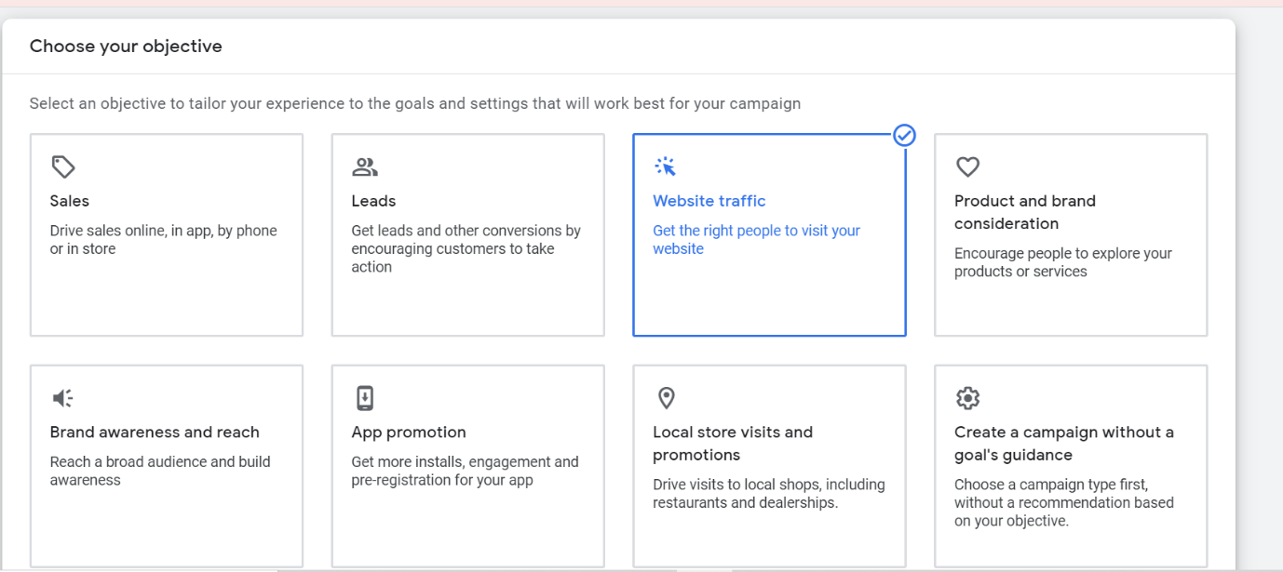



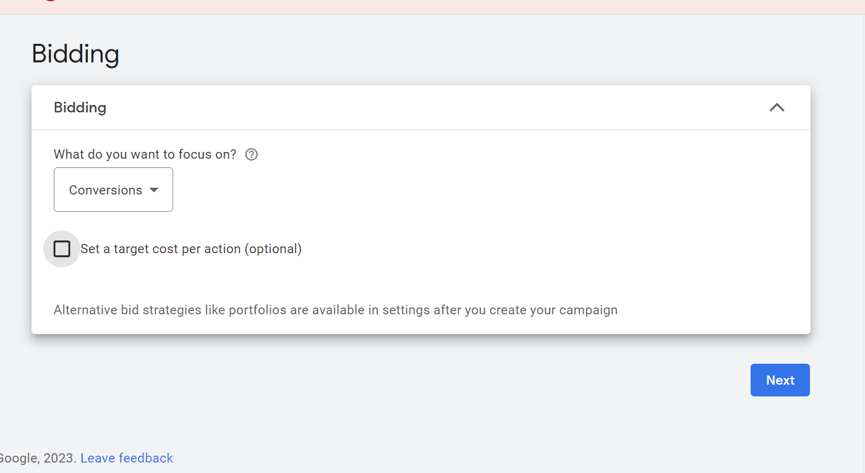

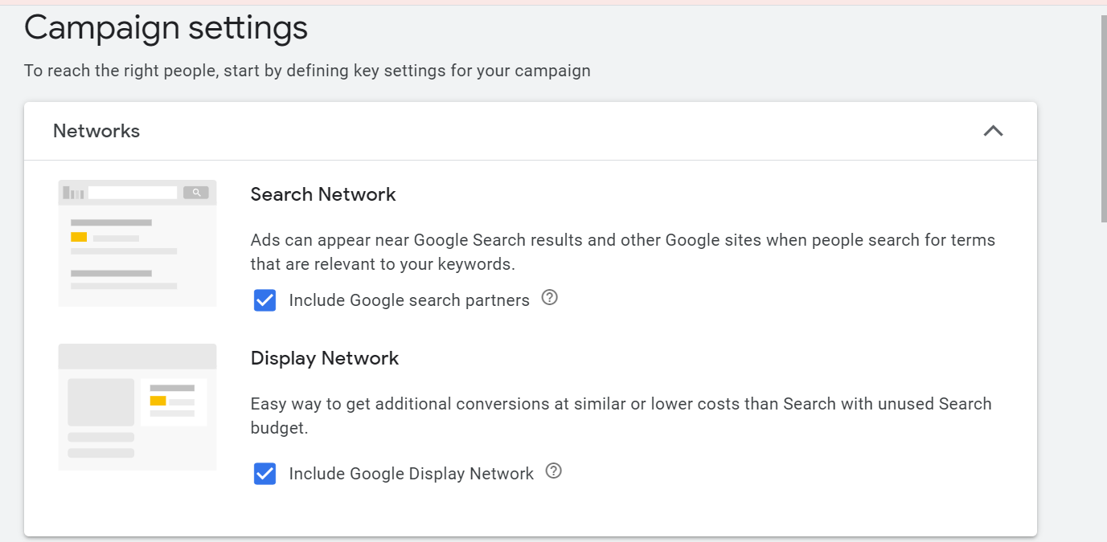

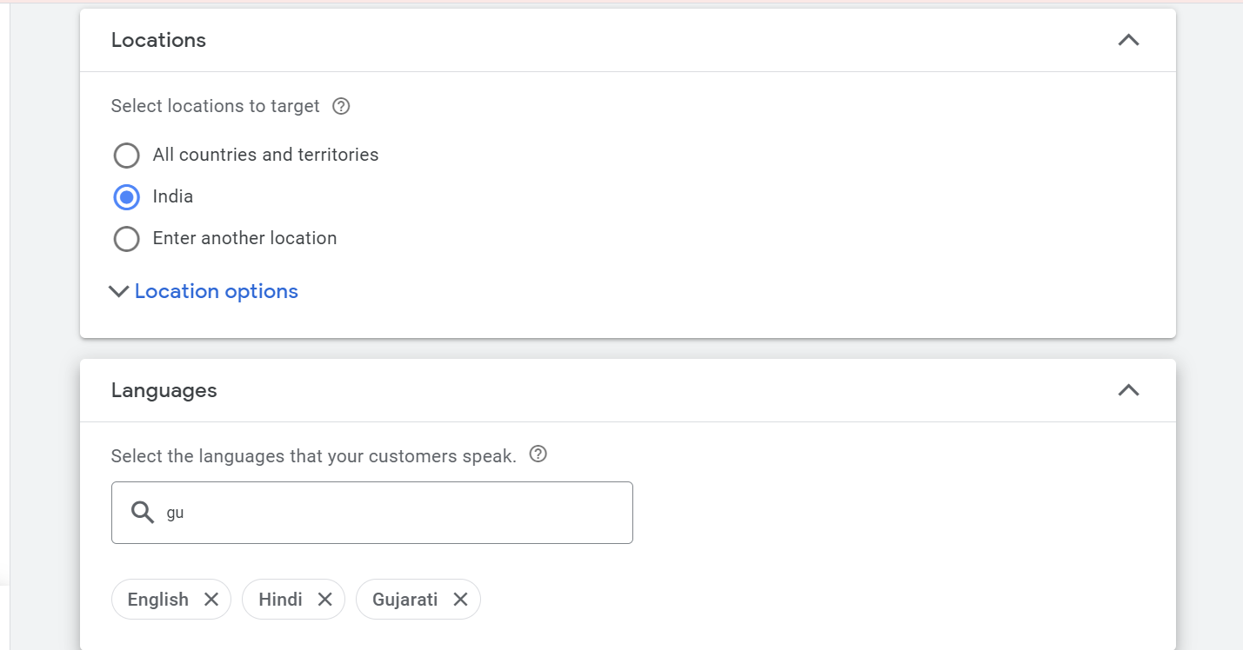

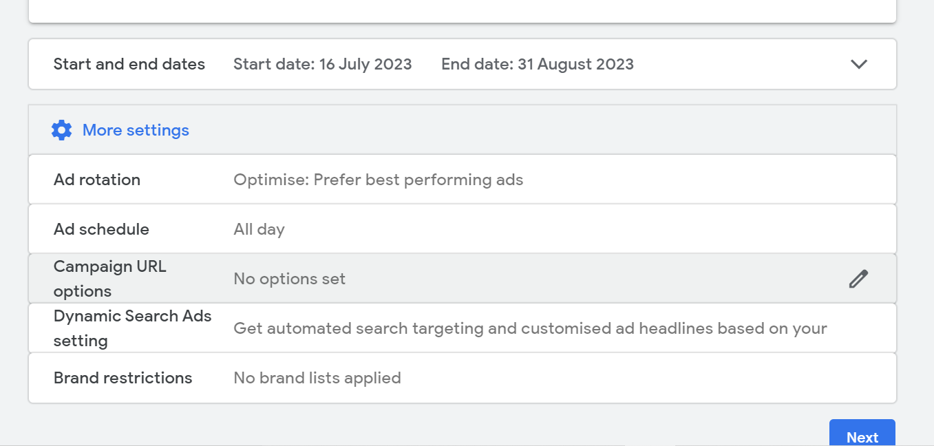

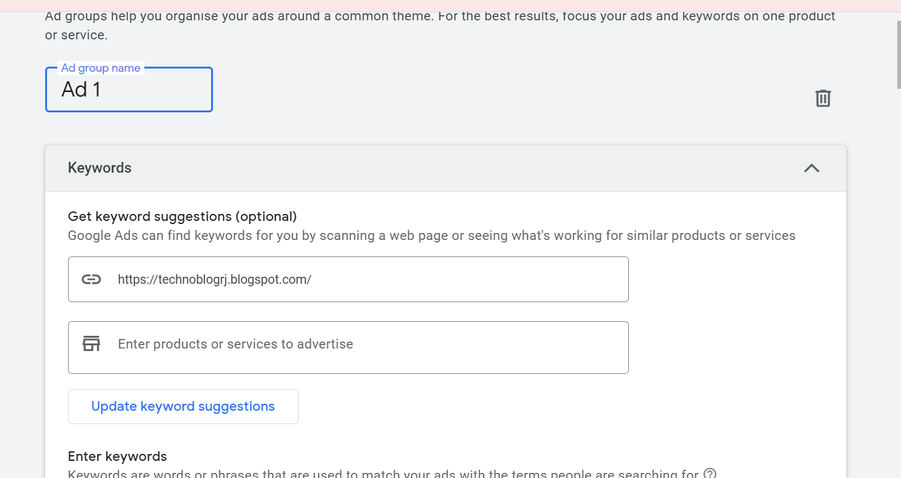

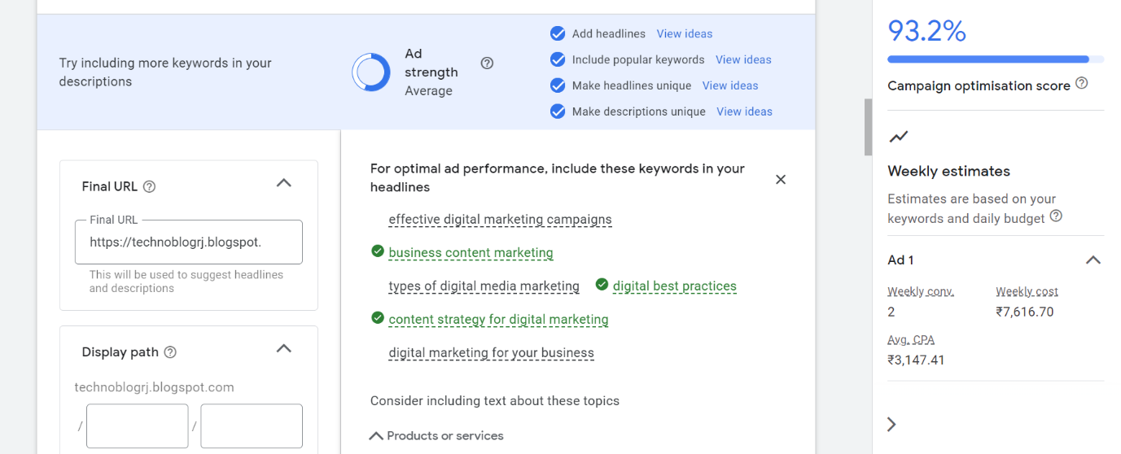

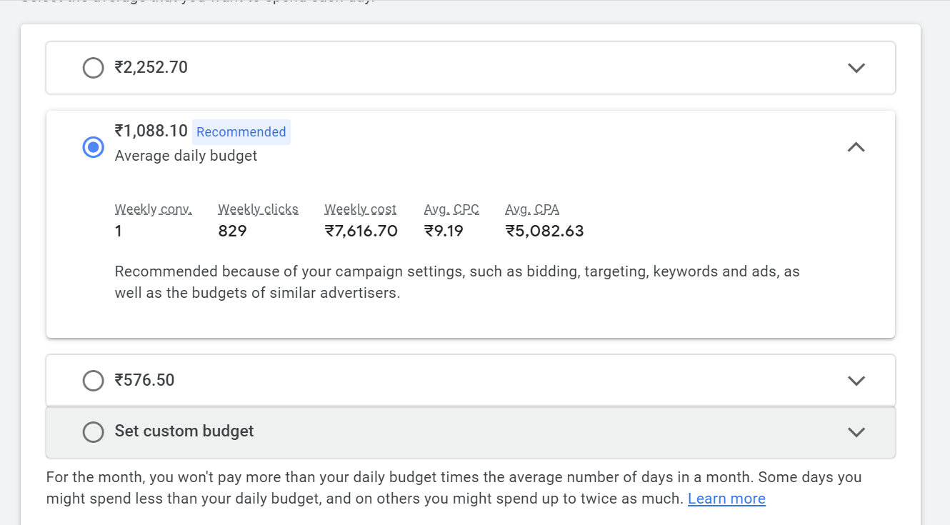

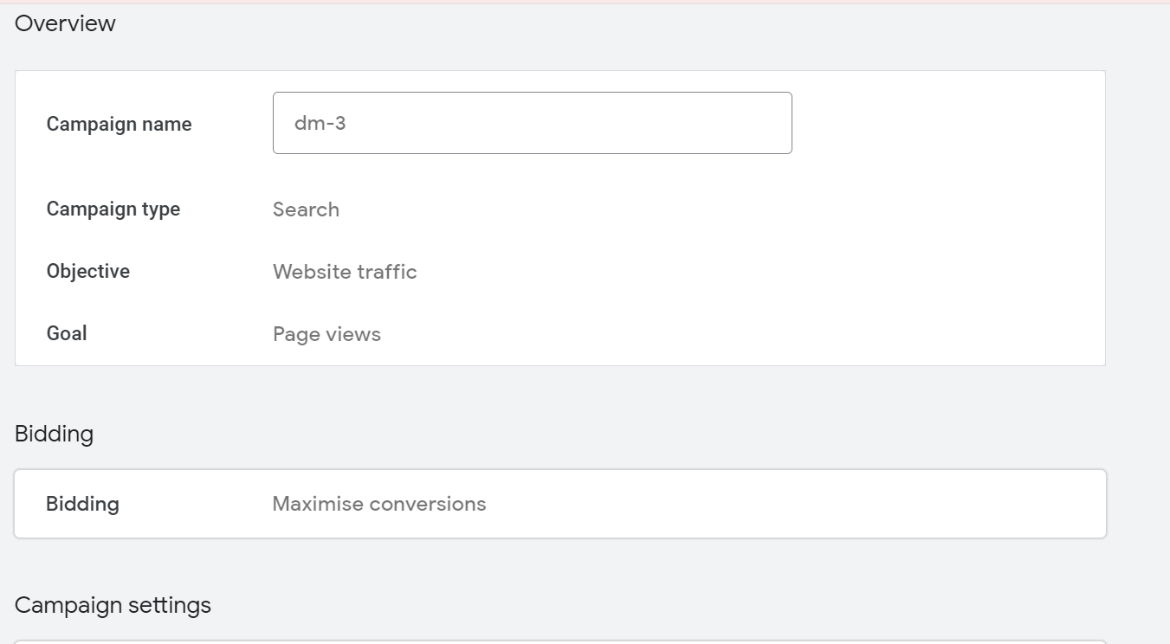

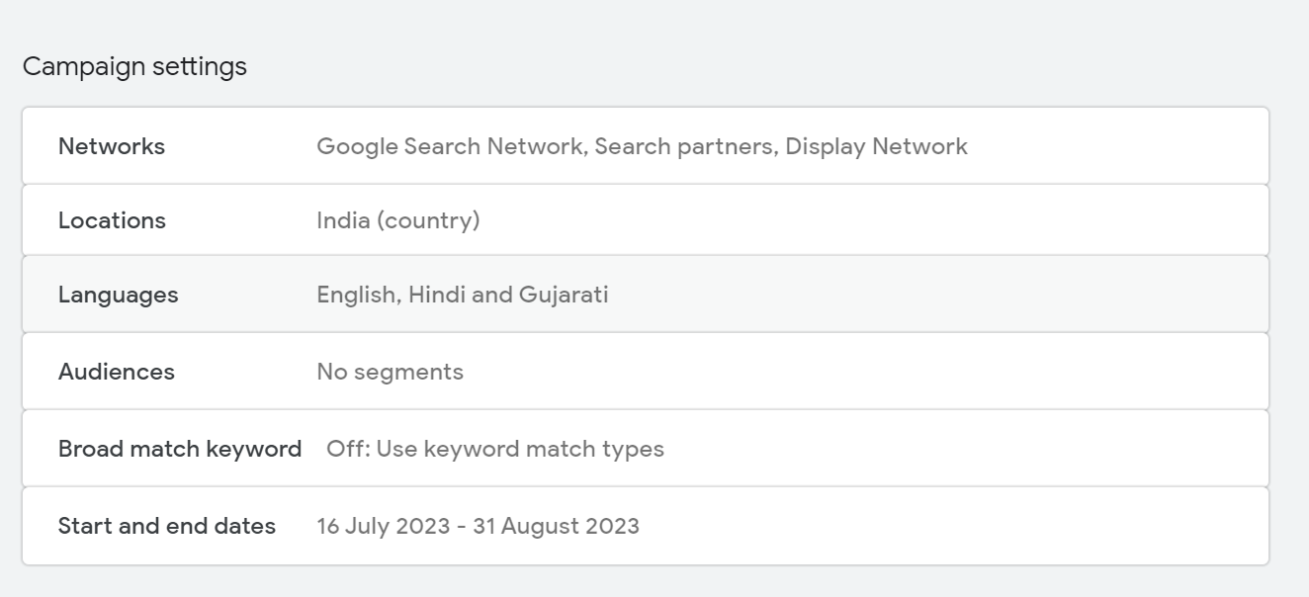

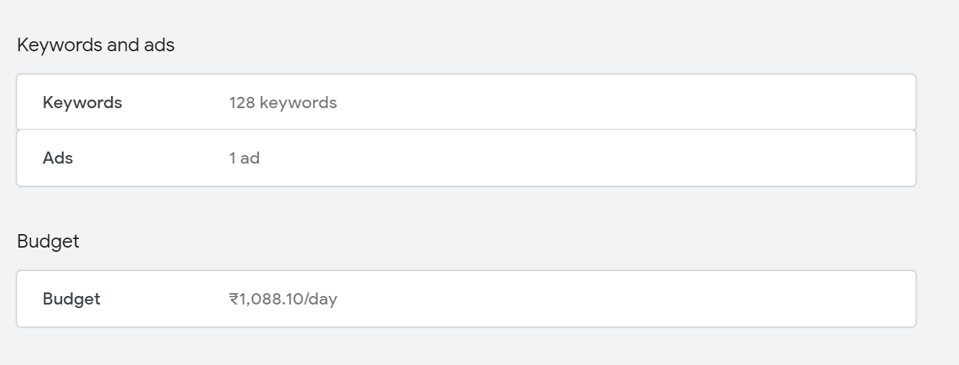

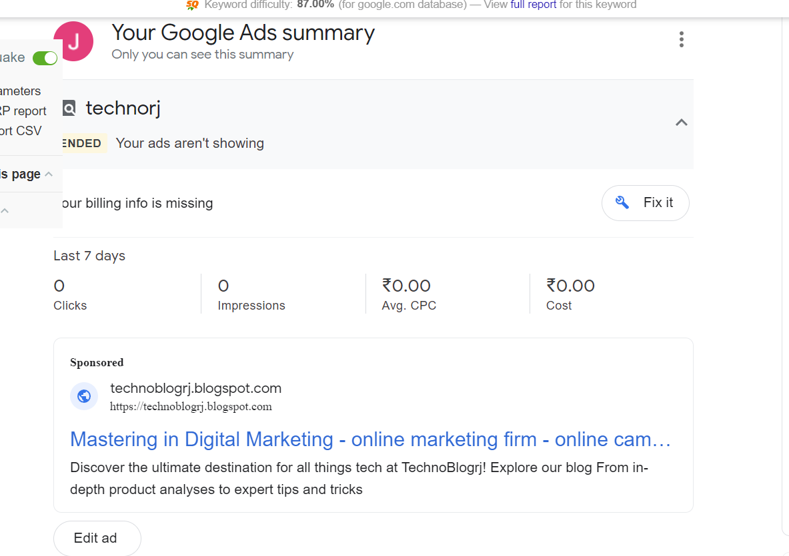

**5. Create an ad for http://esellerhub.com/ to get the maximum Clicks.**









