**Module-6**

**1.What are events in Google analytics?**

An event allows you to measure a specific interaction or occurrence on your website or app. For example, you can use an event to measure when someone loads a page, clicks a link, or completes a purchase, or to measure system behavior, such as when an app crashes or an impression is served.

**2. Connect your blog to Google Analytics and study the different types of traffic on your site.**

To connect your blog to Google Analytics and study the different types of traffic on your site, follow these steps:

Step 1: Set up a Google Analytics Account

If you don't already have one, create a Google Analytics account by visiting the Google Analytics website (https://analytics.google.com) and signing in with your Google account.

Step 2: Create a Property in Google Analytics

Once logged in, click on the "Admin" tab at the bottom left corner of the screen. In the "Account" column, click on the drop-down menu and select "Create Account." Follow the prompts to set up a new property for your blog.

Step 3: Add the Tracking Code to Your Blog

After creating the property, you'll be provided with a tracking code. Copy the tracking code provided by Google Analytics. In most blogging platforms, you can paste the code into the "Header" or "Footer" section of your blog's settings. This allows Google Analytics to collect data from your blog.

Step 4: Verify Tracking Setup

Once you've added the tracking code, return to your Google Analytics account and click on the "Admin" tab. Under the "Property" column, select "Tracking Info" and then "Tracking Code." Here, you can verify if the tracking code is active and collecting data by checking for the status "Receiving Data."

Step 5: Analyze Traffic in Google Analytics

Now that your blog is connected to Google Analytics, you can study the different types of traffic on your site. Here are a few key metrics and reports to explore:

- Overview: The "Overview" report provides an overview of your blog's performance, including metrics like sessions, users, bounce rate, and average session duration.

- Traffic Sources: Navigate to "Acquisition" > "All Traffic" > "Source/Medium" to see the sources driving traffic to your blog. This report shows you which platforms, search engines, social media sites, or other websites are referring visitors to your blog.

- Channels: In the "Channels" report (under "Acquisition"), you can see the traffic breakdown by channel, such as organic search, direct, referral, social, and more. This report helps you understand how visitors are finding your blog.

- Referrals: Under "Acquisition," select "All Traffic" > "Referrals" to see which specific websites are referring traffic to your blog. This report is useful for identifying potential partnerships or websites that are sharing your content.

- Organic Search: To analyze organic search traffic, go to "Acquisition" > "All Traffic" > "Channels" > "Organic Search." Here, you can see the keywords visitors are using to find your blog through search engines.

- Social Media: To understand the impact of social media, visit "Acquisition" > "Social" > "Overview." This report displays the social networks driving traffic to your blog and the performance of individual social media platforms.

- Behavior Flow: The "Behavior Flow" report (under "Behavior") provides a visual representation of how visitors navigate through your blog, showing the most common paths and drop-off points.

These are just a few examples of the reports available in Google Analytics. Spend time exploring the various sections and reports to gain insights into your blog's performance, visitor behavior, and different types of traffic.

**3. Create a goal for your business and study reports whether it has been completed or not.**

Goal: Increase Blog Subscriptions by 20% in the Next Quarter

To study reports and determine whether the goal of increasing blog subscriptions by 20% has been completed or not, follow these steps:

Step 1: Define the Goal in Google Analytics

1. Log in to your Google Analytics account.

2. Navigate to the Admin section.

3. Under the "View" column, click on "Goals" and then the "+ New Goal" button.

4. Select a goal template or choose "Custom" if none of the templates fit your goal.

5. Set up the goal details, such as the goal name (e.g., "Blog Subscriptions"), type (e.g., "Destination"), and the specific parameters (e.g., a URL or event that indicates a successful subscription).

6. Save the goal.

Step 2: Monitor Goal Completion

1. After setting up the goal, return to the Google Analytics homepage.

2. Navigate to the "Reporting" section.

3. In the left-hand sidebar, click on "Conversions" > "Goals" > "Overview."

4. The overview report will show you the overall goal conversion rate, which indicates the percentage of visitors who completed the goal (in this case, subscribed to the blog).

Step 3: Analyze Goal Reports

1. Explore the various reports under the "Conversions" and "Goals" sections to gain deeper insights into goal completion.

- Goal URLs: This report shows the specific URLs that triggered goal completions. It helps identify the most effective pages or conversion points on your blog.

- Funnel Visualization: If you set up a funnel for your goal, this report provides a visual representation of the user journey leading to goal completion. It helps identify potential drop-off points in the conversion process.

- Reverse Goal Path: This report shows the path users took before completing the goal, helping you understand the different routes visitors took on their way to subscribing to your blog.

2. Analyze goal completion data over time to see if you have achieved the target of a 20% increase in blog subscriptions. Compare the current conversion rate with the previous period to assess progress.

3. Additionally, segment the data to gain insights into different user groups or traffic sources that contribute to goal completion. For example, you can analyze goal completion by channel (organic search, social media, referral) or by user demographics.

4. Utilize custom reports and data visualization tools in Google Analytics to create customized views and visualizations of goal completion metrics.

Step 4: Take Action and Optimize

1. If the goal has been completed or is on track to be completed, celebrate the achievement and identify the strategies and tactics that contributed to the increase in blog subscriptions. Consider replicating and refining those approaches in future campaigns.

2. If the goal has not been completed, analyze the reports to identify areas for improvement. Look for patterns, potential obstacles, or underperforming channels or pages. Adjust your strategies, such as optimizing landing pages, enhancing content, or refining your marketing efforts, to increase the chances of achieving the goal in the future.

3. Continuously monitor the goal completion reports and make data-driven decisions to optimize your efforts, refine your marketing strategies, and improve the conversion rate.

Remember, goals should be reviewed regularly and adjusted based on business objectives, market conditions, and other relevant factors to ensure they align with your business growth plans.

**4. Track the following interactions in Google tag manager for www.esellerhub.com**

• Link clicks :- 5

• Page load :- 13.8s

• Time (How long a visitor stayed on a particular page ) :-7.3s

• Button click :- 0

**5.Connect your created website and blog to search console, analytics, and google tag manager and add your faculty as user with required permission in it.**

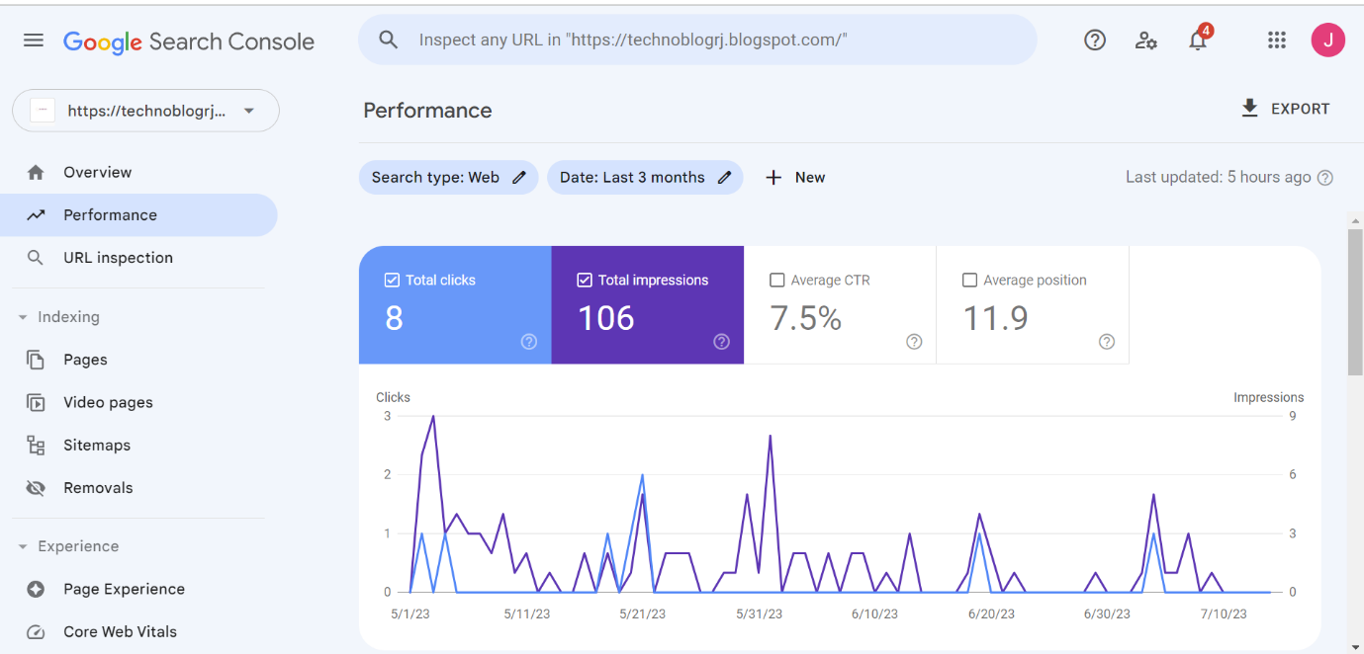

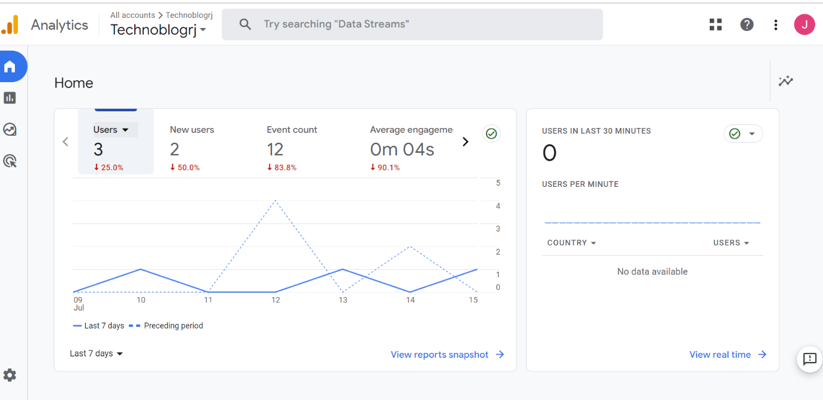

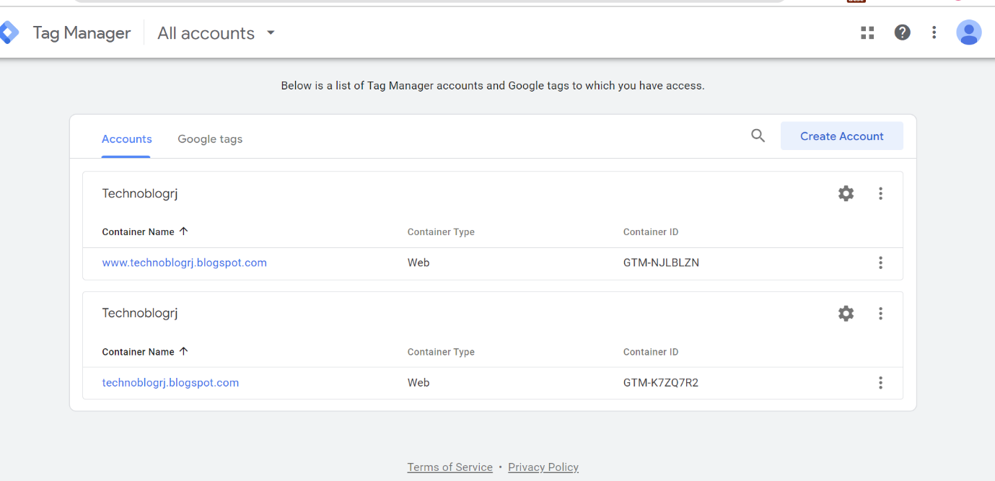

**6.** **Submit the sitemap and robot.txt file in the search console for your website.**

**robot.txt file :-**

# Blogger Sitemap created on Sat, 10 Jun 2023 03:41:22 GMT

# Sitemap built with https://www.labnol.org/blogger/sitemap

User-agent: *

Disallow: /search

Allow: /

Sitemap: https://technoblogrj.blogspot.com/atom.xml?redirect=false&start-index=1&max-results=500

