Name: Laha Ale

laha_mpi.h file implementation of Scatter, Gather, and All_gather functions.

The rest of the files call the function. Line charts and jumshots are provided.

Scatter implementation: root rank send data to all ranks with order by using a for loop and MPI_send function. And all of ranks receive the corresponded data.

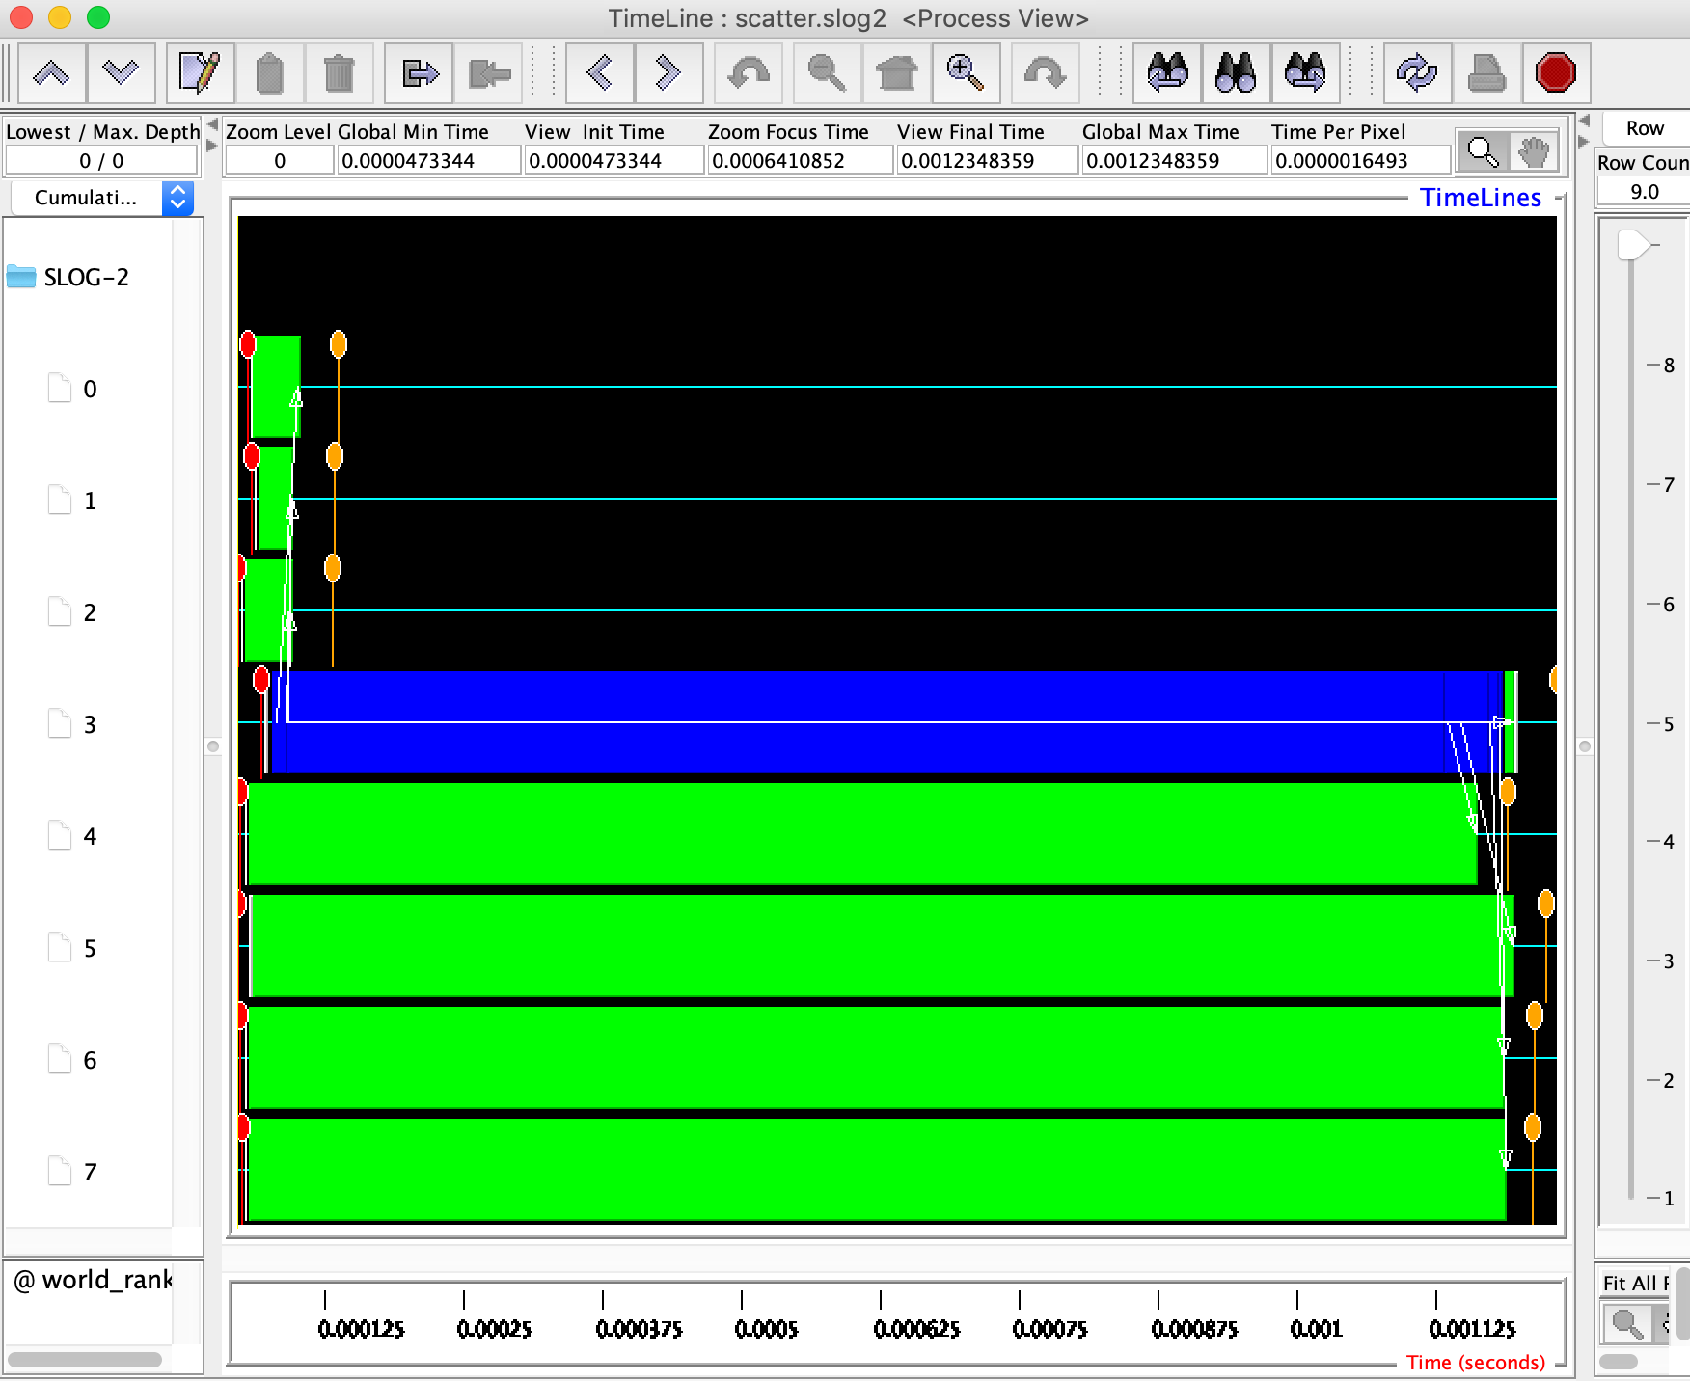

Gather Implementation: All of ranks send data to root. Used a for loop to iterated all the ranks and send data to the root. And root receive the corresponded data.

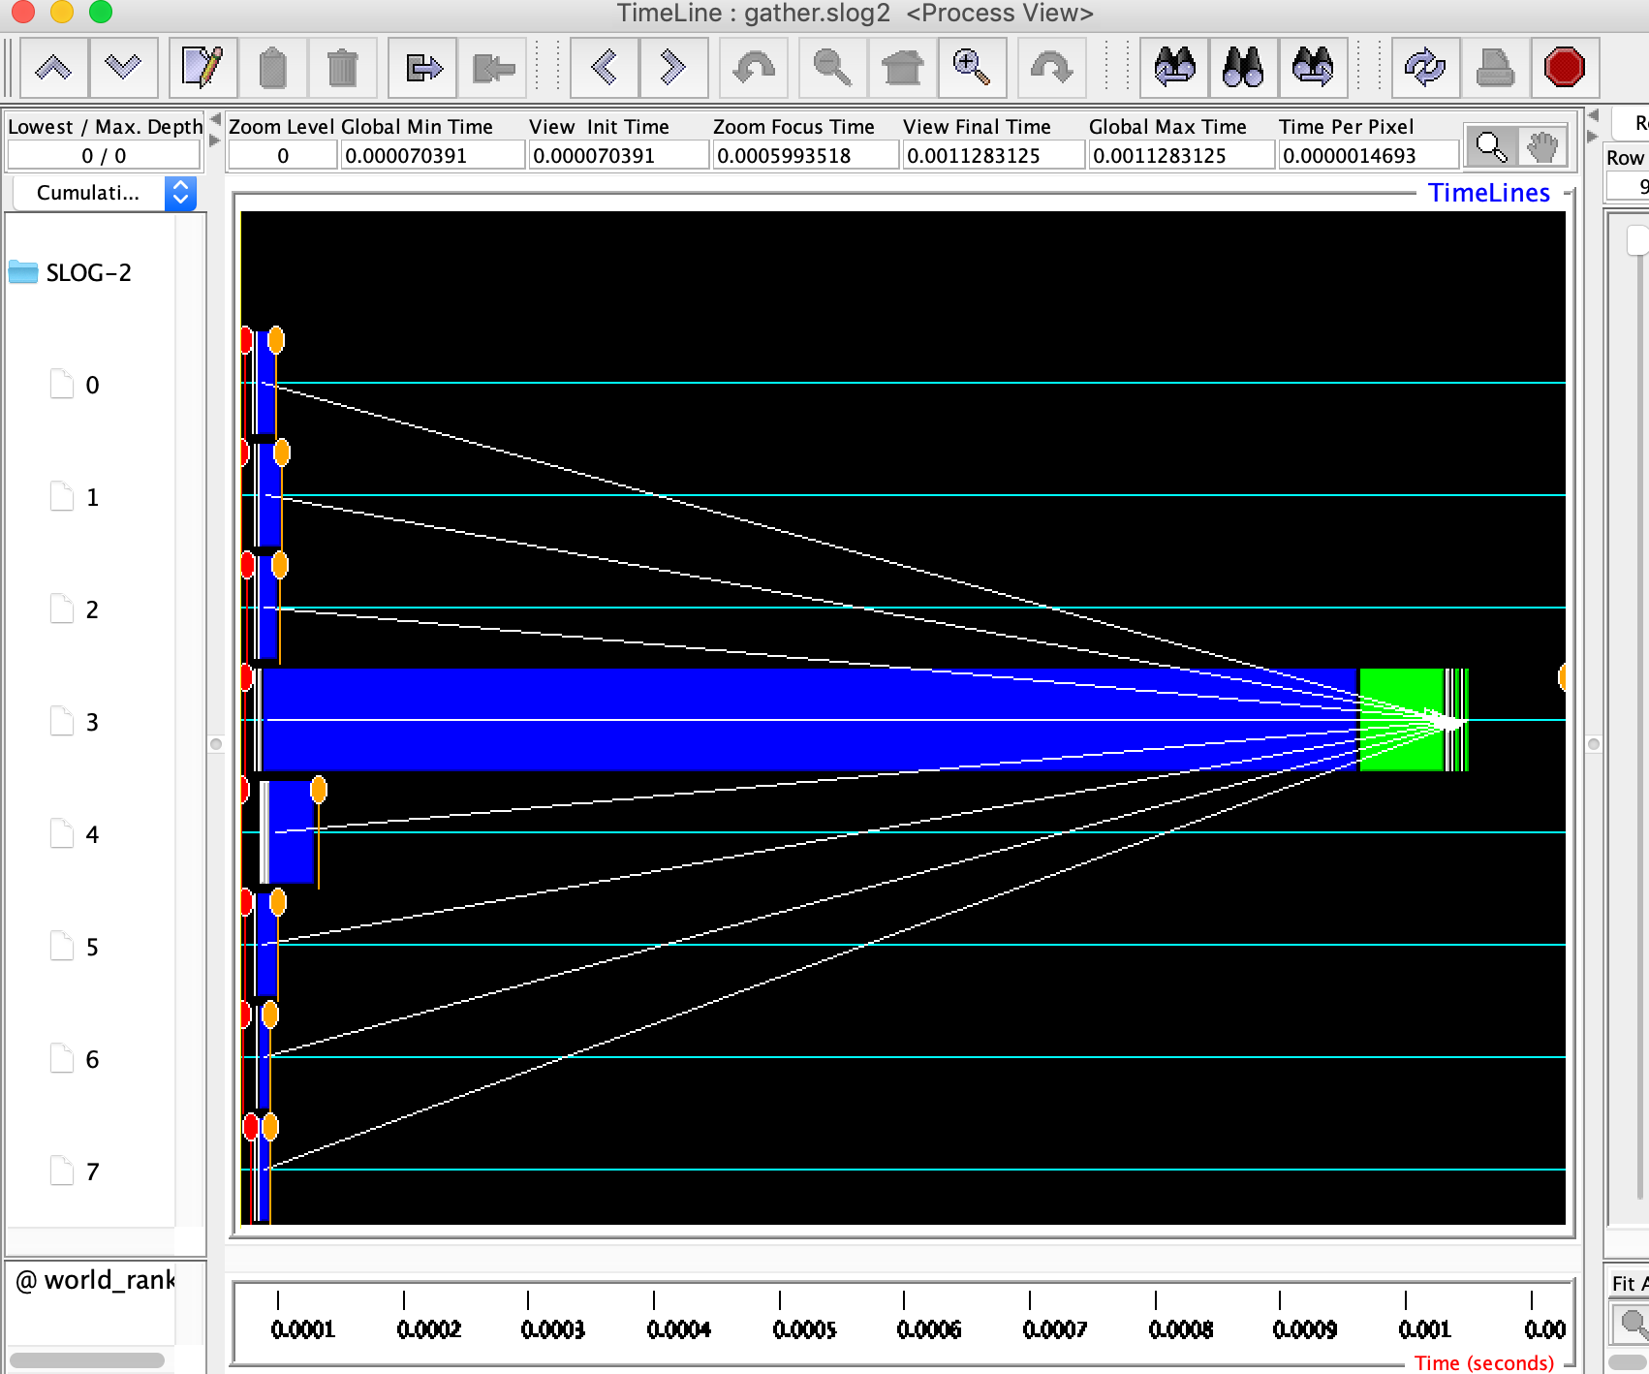

All_gather implementation: called above gather function in all ranks, which means all data will send to all the ranks and all the ranks are receive all the corresponded data. It probably not efficient solution but I leave to here for now.

