Baseline11 Auto Correlation Tester Guide
From Postman collection execution to a validated JMeter 5.6.3 test plan
Purpose. This guide explains how a tester uses Baseline11 Auto Correlate to run a working Postman collection twice, confirm dynamic producer and consumer relationships, generate a correlated JMX, and validate it with Apache JMeter. Baseline11 can run the collection itself in isolated Newman containers (recommended), or accept two Newman JSON reports the tester already captured (advanced).
Expected outcome. The tester receives a structurally valid JMX in which dynamic response values are extracted and reused automatically, while credentials remain external JMeter properties unless the tester explicitly chooses to embed them.
Document | Audience | Version | Date
Operating guide | API, QA and performance testers | 2.0 | 25 September 2026

What the tester needs
- A Postman collection that already executes successfully against public HTTPS endpoints.
- A Postman environment or another safe source for host and credential values.
- Access to the Baseline11 Auto Correlate web application and Apache JMeter 5.6.3.
- Advanced mode only: Newman and two successful Newman JSON reports from the same collection and request order.

Quick Start
Use this page when the collection, environment and credentials are already prepared. The detailed procedure begins on the next page.

Recommended: let Baseline11 run the collection
Step | Action | Expected result
1 | Choose mode | Select Run a Postman collection.
2 | Upload files | Add the collection and, optionally, its environment, then click Inspect collection. Nothing is sent to any API yet.
3 | Supply variables | Enter any values the collection needs that are not in the environment. Secrets stay hidden.
4 | Review scope | Pick the whole collection or one folder, check the target domains, then click Run collection twice.
5 | Wait | Baseline11 runs the collection twice in isolated Newman containers and opens the analysis.
6 | Correlate | Check Run Health, then click Auto correlate all reused values once.
7 | Generate | Preview, generate and download the JMX and manifest.
8 | Validate | Supply runtime secrets and execute the plan with JMeter 5.6.3.

Advanced: upload two Newman reports
Use this mode when the collection must run from a network Baseline11 cannot reach, such as a private test environment. Run Newman twice yourself (section 3), choose Upload existing Newman reports, upload baseline.json first and comparison.json second, then continue from step 6 above.

The Core Concept
Newman does not convert a Postman collection into JSON. Newman executes the collection and records the resolved requests, responses, status codes, assertions and timings in a JSON report. Baseline11 compares two reports to prove which response values are dynamic and where later requests reuse them.
Postman collection + environment
|
+--> Newman baseline run --> baseline.json
+--> Newman comparison run --> comparison.json
|
+--> Baseline11 --> correlated JMX --> JMeter

Why Two Runs
A single run can show that a value is reused, but it cannot reliably distinguish a dynamic identifier from static configuration. Two successful runs show that the value changes while the producer response path and consumer request locations remain stable.

1 Run a Postman Collection in Baseline11 (Recommended)
Baseline11 can execute the collection for you. It inspects the collection first, asks for any missing values, then runs it twice with Newman 6.2.2 in fresh isolated containers from identical starting values. Both reports go through exactly the same analysis as uploaded reports.
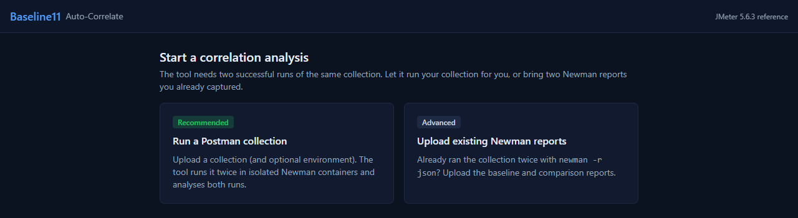
Figure 1 Choose Run a Postman collection

Step 1 Files
Add the exported collection (.postman_collection.json) and, if the collection uses one, the environment (.postman_environment.json). Click Inspect collection. Inspection reads the files only; no request is sent to any API.

Step 2 Variables
Baseline11 lists every variable the collection uses and where each one comes from: the environment file, a Postman built-in such as $guid, or a script in the collection that sets it at runtime. Variables with no source must be supplied before the run can start; values are never silently replaced with empty strings. Secret-looking variables are masked and are never written to logs, job status, errors or the generated JMX.
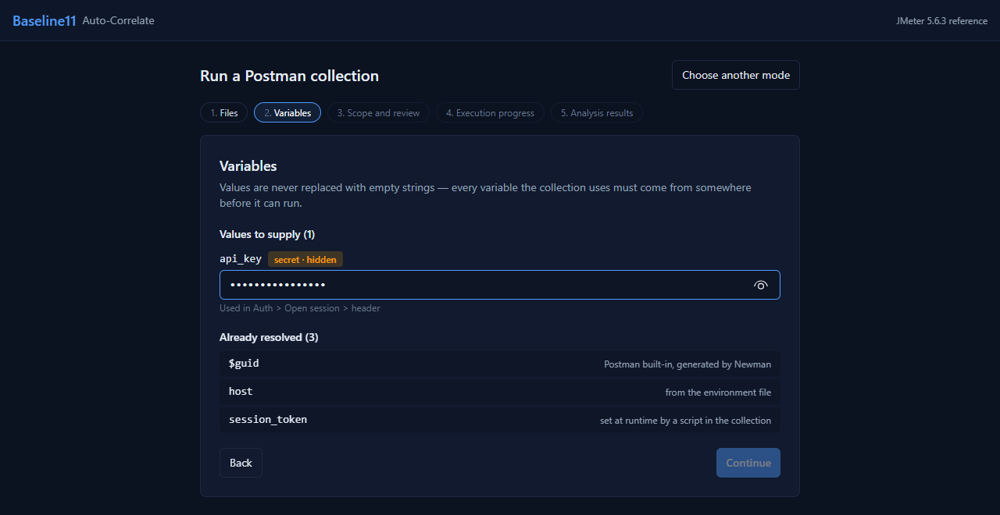
Figure 2 Supply missing values; resolved variables show their source

Step 3 Scope and review
Pick the whole collection or a single folder, then check the summary: request count, target domains, the values you supplied and the execution limits. Click Run collection twice. Repeated clicks do not start duplicate jobs.
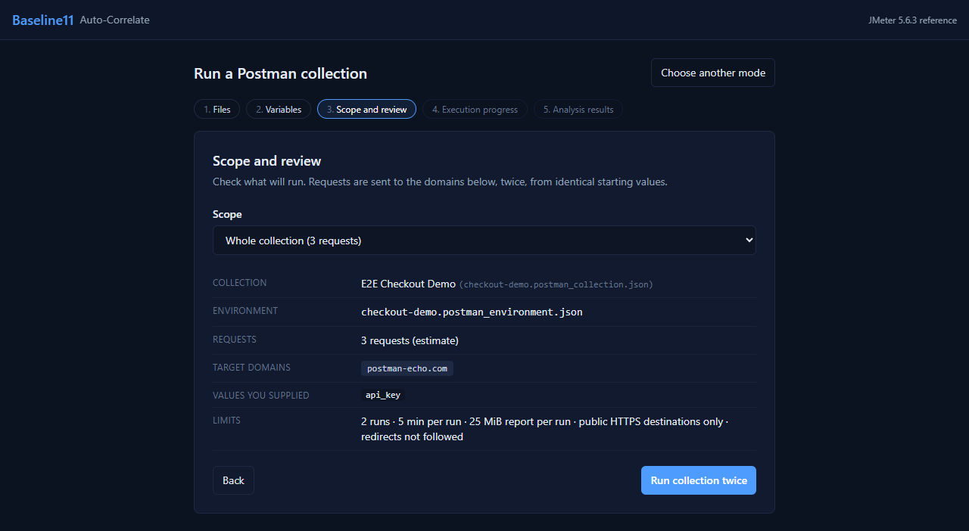
Figure 3 Confirm what will run before anything is sent
Limit | Value | Why
Runs | 2 (baseline and comparison) | Two runs prove which values are dynamic.
Time | 5 minutes per run | Stops hanging endpoints and runaway scripts.
Report size | 25 MiB per run | Keeps analysis responsive; choose a folder for large collections.
Destinations | Public HTTPS only; redirects not followed | Blocks localhost, private networks and cloud metadata addresses.
Isolation | Fresh container per run, no host files or credentials | Collection scripts are untrusted code.

Step 4 Execution progress
The progress view shows each stage: waiting for a runner, checking destinations, Run A, Run B, and analysis. A run can be cancelled at any time.
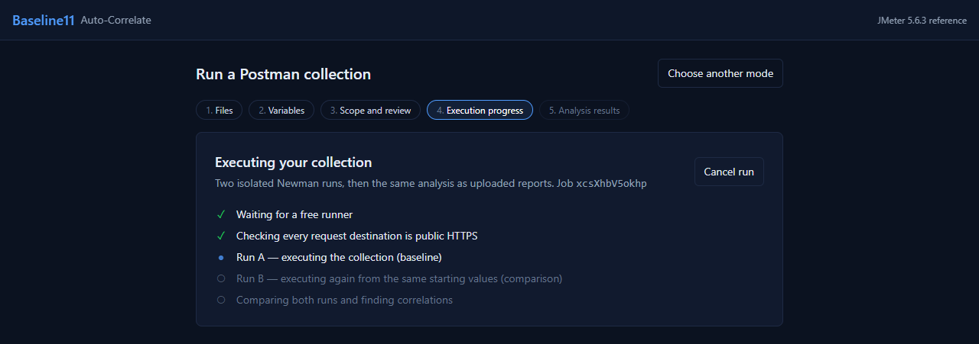
Figure 4 Two isolated Newman runs, then the standard analysis

Step 5 Analysis results
When both runs finish, Baseline11 opens the same analysis screens used for uploaded reports, starting with Run Health. Continue with section 5 to review and accept correlations.
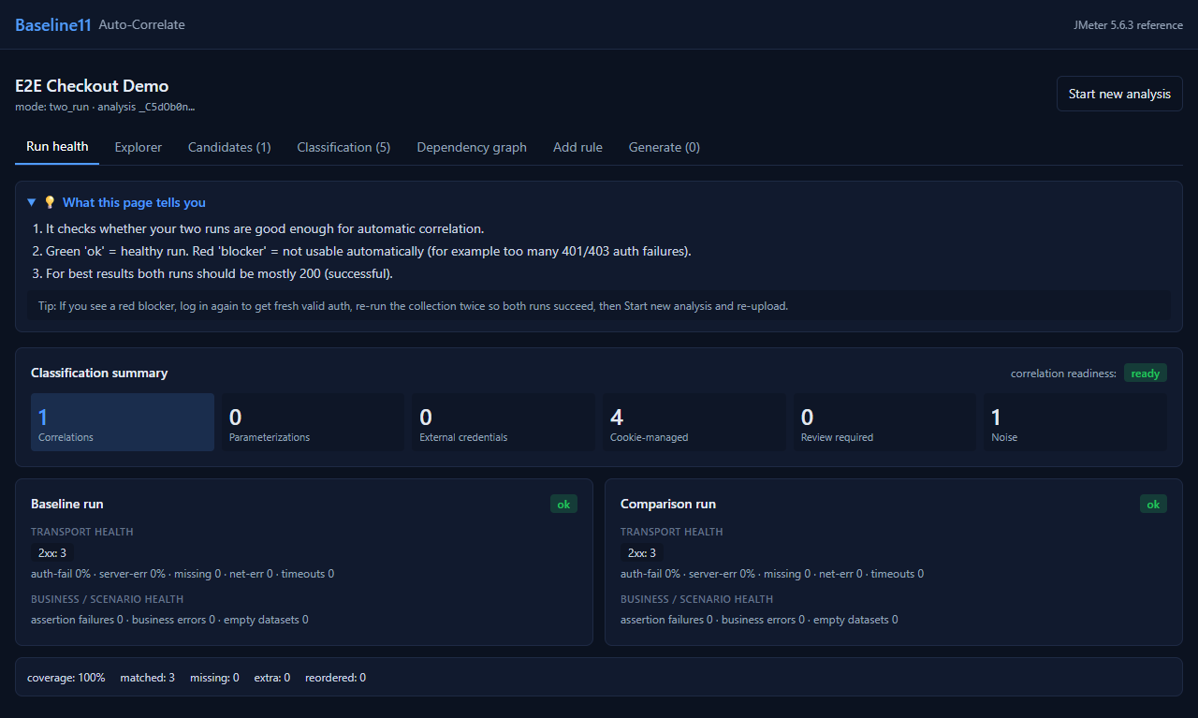
Figure 5 The executed collection opens directly in Run Health

When a run does not complete
Failures are shown in the progress view with the reason, the affected request and what to do next. Retry reuses the same inputs; Start over returns to the files step.
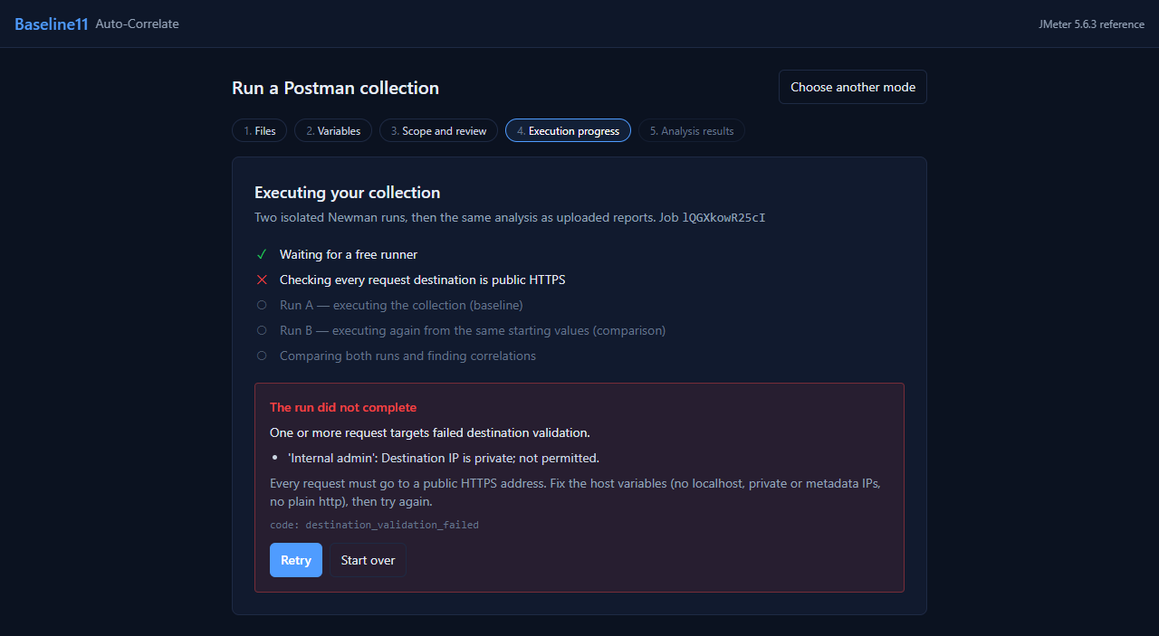
Figure 6 A blocked private destination, with guidance
Code | Meaning | Tester action
destination_validation_failed | A request targets localhost, a private or metadata IP, or plain HTTP. | Point host variables at a public HTTPS address, or use advanced mode from inside the network.
timeout | A run exceeded 5 minutes. | Choose a smaller folder or check for a hanging endpoint.
report_too_large | A run produced a report over 25 MiB. | Choose a smaller folder.
resource_limit | A run used too much memory or too many processes. | Try a smaller folder or simplify heavy scripts.
runner_unavailable | The Newman runner is not available. | Ask the administrator to check the runner service, then retry.
analysis_error | Both runs finished but could not be analysed. | Check that both runs succeed (mostly 2xx) and retry.

2 Prepare the Postman Collection
The collection must complete the intended API journey before it is uploaded indirectly through Newman reports. Baseline11 translates an observed working flow into JMeter; it does not repair authentication failures or unresolved Postman placeholders.

Collection readiness checklist
- Requests are ordered in the same sequence the business flow requires.
- Authentication resolves from the selected environment.
- Producer requests return successful status codes and usable response bodies.
- Postman scripts capture values required for the collection itself to continue.
- Later requests use Postman variables such as {{order_id}} instead of literal {order_id} text.
- Assertions fail when a required producer response or identifier is missing.

Example dynamic flow
Create Order returns:
{
"id": "order_ABC123",
"amount": 10000,
"status": "created"
}
A Postman post-response script keeps the collection executable:
const response = pm.response.json();
pm.test("Order ID was returned", function () {
pm.expect(response.id).to.be.a("string").and.not.empty;
});
pm.collectionVariables.set("order_id", response.id);
A downstream Postman request uses:
GET https://api.example.com/v1/orders/{{order_id}}

Environment guidance
Keep real keys and secrets in a local environment file. Share only a template with empty values. Confirm that exported environment values are populated before running Newman; some Postman workflows export variable definitions without the local values.

3 Generate Newman Reports (Advanced Mode)

Install the command line tools
npm install -g newman newman-reporter-htmlextra
newman --version

Generic baseline command
newman run "C:\QA\collection.postman_collection.json" ^
-e "C:\QA\test.postman_environment.json" ^
--folder "Business Flow" ^
-r cli,json,htmlextra ^
--reporter-json-export "C:\QA\reports\baseline.json" ^
--reporter-htmlextra-export "C:\QA\reports\baseline.html"
Run the same command again with comparison output names:
newman run "C:\QA\collection.postman_collection.json" ^
-e "C:\QA\test.postman_environment.json" ^
--folder "Business Flow" ^
-r cli,json,htmlextra ^
--reporter-json-export "C:\QA\reports\comparison.json" ^
--reporter-htmlextra-export "C:\QA\reports\comparison.html"

Command reference
Argument | Purpose
newman run | Executes a Postman collection.
-e | Loads a Postman environment.
--folder | Limits execution to one folder or scenario.
-r cli,json,htmlextra | Prints terminal output and creates JSON and HTML reports.
--reporter-json-export | Writes the machine-readable report consumed by Baseline11.
--reporter-htmlextra-export | Writes a human-readable execution report for review.

Report acceptance criteria
- Both runs use the same collection, folder and request order.
- The producer and intended consumers return successful responses.
- There are no authentication, network or missing-response failures.
- Required assertions pass.
- Dynamic values differ between the two runs.

4 Upload and Review the Analysis
In the recommended mode Baseline11 opens this analysis automatically when both runs finish. In advanced mode, choose Upload existing Newman reports and upload baseline.json first and comparison.json second. Do not upload the Postman collection, environment, HTML report or a JMX into the report uploader.

Run Health
Run Health verifies transport success, assertion results, business response heuristics and sequence alignment. A warning is reviewable; a blocker means the reports are not safe for automatic correlation.
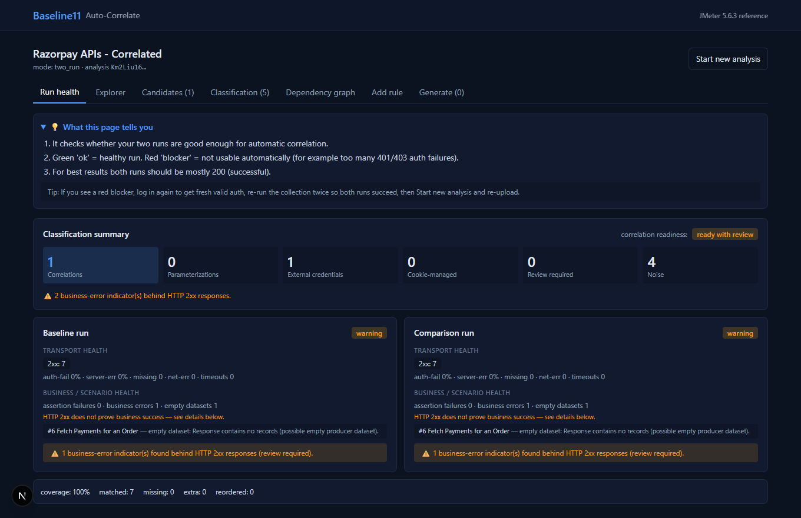
Figure 7 Example Run Health with seven aligned HTTP 200 requests

How to interpret common health results
Result | Meaning | Tester action
Ready | Both reports are suitable for analysis. | Continue to Candidates.
Ready with review | Transport is usable but a business heuristic needs review. | Read the warning and continue only when the response is valid for the scenario.
Blocker | Authentication, response availability or alignment is too poor. | Fix the collection or credentials and create two new reports.
Empty dataset | A successful response returned no records. | Confirm whether an empty result is expected, such as payments for a new unpaid order.

5 Review and Accept Correlation
Candidates are response values that changed between runs and were reused by later requests in both runs. Inspect the producer path, consumer count, confidence and evidence before acceptance.
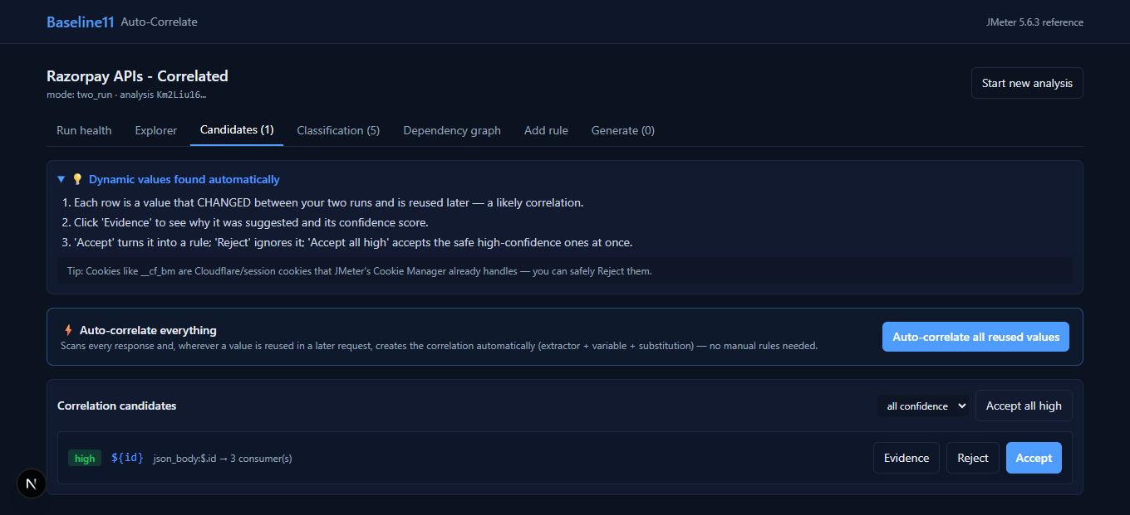
Figure 8 One high-confidence ID candidate produced at JSONPath $.id and reused by three requests

Decision rules
Observation | Decision
Earlier response produces the value and later requests reuse it | Accept or use automatic correlation.
Value changes but no earlier response produces it | Treat it as input parameterization or runtime configuration.
Authorization, API key or secret | Keep it as an external JMeter property.
Cookie maintained by session behavior | Use JMeter HTTP Cookie Manager.
Host, Content-Length, Postman-Token or Accept-Encoding | Treat as transport noise and let JMeter compute it.

Automatic option
- Click Auto correlate all reused values once.
- Confirm the button changes to Correlation completed and becomes disabled.
- Open Dependency graph and verify the producer points to the expected consumers.
- Confirm Generate displays the accepted rule count.
Variable names may be edited for clarity. For example, a response field named id can be renamed from ${id} to ${order_id} when the business meaning is an order identifier.

6 Generate the JMeter Plan
Open Generate after accepting the correlation. Use Preview Draft to inspect the planned producer, extractor, variable and consumers before creating the JMX.

Recommended generation settings
Setting | Recommended value | Reason
Threads | 1 for functional validation | Reduces diagnostic noise before load sizing.
Loops | 1 for functional validation | Confirms one complete business journey.
Parameterize host | Enabled | Keeps the target environment configurable.
Cache Manager | Enabled when browser-like caching is desired | Replays common HTTP caching behavior.
Keep User-Agent | Disabled unless required | Lets JMeter manage transport headers.
Embed static secrets | Disabled | Prevents credentials from being stored in the JMX.

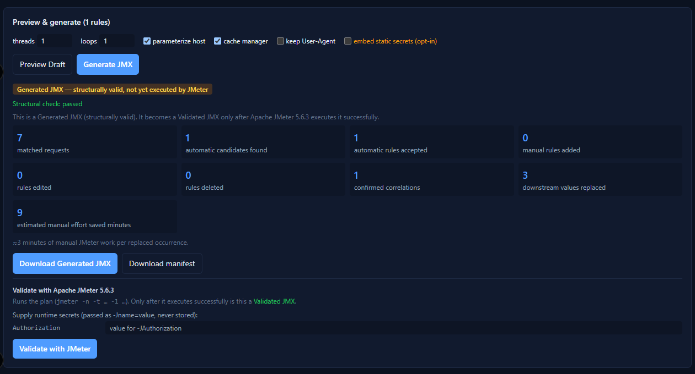
Figure 9 Generated JMX summary and runtime Authorization property required for validation

What the JMX should contain
- One HTTP sampler per aligned Newman execution.
- A JSON Extractor attached to the producer request, for example $.id.
- JMeter variable references such as ${id} or ${order_id} in downstream requests.
- Cookie and cache managers where selected.
- External property expressions such as ${__P(Authorization,)} for credentials.

7 Validate with Apache JMeter 5.6.3
Generated means the XML structure is valid. Validated means Apache JMeter executed the plan successfully with the required runtime properties. The web validation form passes secrets only to that execution and does not store them in the JMX.

Authorization value for Basic authentication
Supply the complete Basic Authorization header value, not only the key or secret. It has this form:
Basic <Base64(api_key:api_secret)>
Create the value locally without printing the secret:
$e = Get-Content -Raw -LiteralPath 'C:\QA\test.postman_environment.json' | ConvertFrom-Json
$key = ($e.values | Where-Object key -eq 'api_key').value
$secret = ($e.values | Where-Object key -eq 'api_secret').value
$auth = 'Basic ' + [Convert]::ToBase64String([Text.Encoding]::ASCII.GetBytes($key + ':' + $secret))

Open the JMX in the JMeter GUI with runtime credentials
& 'C:\Tools\apache-jmeter-5.6.3\bin\jmeter.bat' `
"-JAuthorization=$auth" `
-t 'C:\QA\output\correlated.jmx'
For a non-GUI validation run:
& 'C:\Tools\apache-jmeter-5.6.3\bin\jmeter.bat' `
-n -t 'C:\QA\output\correlated.jmx' `
"-JAuthorization=$auth" `
-l 'C:\QA\output\results.jtl'

Validation acceptance criteria
- All required samplers execute.
- Authentication succeeds and there are no HTTP 401 or 403 responses.
- The producer response is successful.
- The extractor captures a value instead of __NOT_FOUND__.
- Downstream requests contain the extracted runtime value.
- The sampler error ratio meets the project threshold.

8 Package the Deliverables
Give testers the files needed to reproduce the workflow while separating reusable assets from secrets.
File | Share | Purpose
collection.postman_collection.json | Yes | Defines the API workflow.
environment.template.json | Yes | Documents required variables with empty values.
environment.json with real credentials | No | Contains secrets.
baseline.json and comparison.json | Restricted | Contain executed requests, responses and possibly credentials or personal data.
correlated.jmx | Yes when secrets are external | Runs the correlated JMeter workflow.
manifest.json | Yes | Explains variables, extractors, consumers and required properties.
run-jmeter.ps1 template | Yes | Provides a repeatable runtime command without embedded secret values.

Suggested tester package
tester-package/
collection.postman_collection.json
environment.template.json
correlated.jmx
manifest.json
run-jmeter.ps1
Baseline11_Auto_Correlation_Tester_Guide.docx

Security rules
- Never commit filled environment files, Authorization values or API secrets to source control.
- Treat Newman reports as sensitive until request headers and bodies have been reviewed.
- Keep Embed static secrets disabled for shared or production test plans.
- Use test-mode credentials for demonstrations.
- Rotate a key if it has been exposed in a screenshot, report, ticket or repository.

9 Troubleshooting
Symptom | Likely cause | Corrective action
401 Unauthorized in Newman | Environment values are empty, incorrect, or overridden by request-level auth. | Verify exact variable names and request-level Basic Auth settings, then export the environment again.
URL contains null | The producer failed or its Postman script did not set the variable. | Fix the producer response and assertion before creating reports.
Literal {order_id} remains | The collection uses API-documentation braces instead of Postman syntax. | Use {{order_id}} in the Postman collection.
No candidates | Values did not change, were not reused, or runs are misaligned. | Use two fresh successful runs and verify the downstream request contains the produced value.
Duplicate ID candidates | A later response echoes a value already produced earlier. | Use a current Baseline11 build; the earliest original producer should be retained.
Ready with review | A business heuristic detected an empty or error-like payload behind HTTP 2xx. | Review the response. Continue when the empty result is valid for the scenario.
401 in downloaded JMX | The external Authorization JMeter property was not supplied. | Launch JMeter with -JAuthorization or provide the value in the validation form.
Extractor returns __NOT_FOUND__ | The response path or response content differs at runtime. | Inspect the producer response and verify the extractor expression and match number.
Generate shows 0 | No candidate has been accepted. | Run automatic correlation or accept the reviewed candidate.

For failures of the collection run itself, see the code table in section 1.

Tester completion checklist
- [ ] Collection completes successfully (run in Baseline11, or twice in Newman for advanced mode).
- [ ] Both runs came from the same collection, folder and starting values.
- [ ] Run Health has no blocker.
- [ ] Candidate producer and consumers match the intended business flow.
- [ ] Automatic correlation completed once.
- [ ] Dependency graph shows the expected edges.
- [ ] Generated JMX passes structural validation.
- [ ] JMeter execution succeeds with runtime properties.
- [ ] Extracted variables have real values and are not __NOT_FOUND__.
- [ ] No real credentials are included in the shared package.

Glossary
Term | Meaning
Producer | An earlier response that returns a dynamic value.
Consumer | A later request that reuses the produced value.
Correlation | Capturing a dynamic response value and substituting it into later requests.
Extractor | A JMeter post-processor that reads a value from a response.
Parameterization | Supplying user or environment input that has no response producer.
JMeter property | A runtime value accessed with ${__P(name,)} and normally passed with -Jname=value.
Generated JMX | A structurally valid plan that has not necessarily executed successfully.
Validated JMX | A generated plan that Apache JMeter executed within the configured success threshold.

End of tester guide

