Module -1: Understanding of Hardware and Its Components

Section 1: Multiple Choice

1. Which of the following is NOT a component of the CPU?
1. ALU
2. RAM
3. CU
4. 1 and 3 both
A=(RAM)
2. What is the function of RAM in a computer?
RAM (Random Access Memory) temporarily stores data and instructions needed by the CPU for quick access. It helps in fast processing and smooth multitasking but loses all data when the power is turned off.
3. Which of the following is a primary storage device?
1. HDD
2. SSD
3. SD card
4. 1 and 2 both
A=(1 and 2 both)
4. What is the purpose of a GPU?
A GPU (Graphics Processing Unit) purpose is to make pictures, videos, and games look smooth and fast on a computer. It also helps in doing many tasks at the same time, making work quicker.

Section 2: True or False
5. The motherboard is the main circuit board of a computer where other components are attached
True
6. A UPS (Uninterruptible Power Supply) is a hardware device that provides emergency power to a load when the input power source fails
True
7. An expansion card is a circuit board that enhances the functionality of a component.
True

Section 3: Short Answer
8. Explain the difference between HDD and SSD.
HDD (Hard Disk Drive) | SSD (Solid State Drive)
Uses spinning magnetic disks to store data. | Uses flash memory (no moving parts) to store data.
Slower read/write speed compared to SSD. | Much faster read/write speed than HDD, leading to quicker boot times and file access.
More prone to physical damage due to moving parts. | More durable and energy-efficient.
Usually cheaper and available in larger storage capacities. | Generally more expensive per GB than HDD.

9. Describe the function of BIOS in a computer system.
The BIOS (Basic Input/Output System) is a program built into a computer’s motherboard. When the computer is turned on, it checks and initializes the hardware like the CPU, RAM, and storage. After that, it finds and loads the operating system into the memory. BIOS also helps the system and software communicate with the hardware properly. It is essential for the computer to start and run correctly.
10. List and briefly explain three input devices commonly used with computers.
1. Keyboard – Allows users to enter text, numbers, and commands into the computer by pressing keys.
2.Mouse – A pointing device used to move the cursor, select items, and interact with graphical elements on the screen.
3.Scanner – Converts physical documents or images into digital form so the computer can process, store, or edit them
Section 4: Practical Application

Section 4: Practical Application

11. Identify and label the following components on a diagram of a motherboard: ● CPU ● RAM slots ● SATA connectors● PCI-E slot
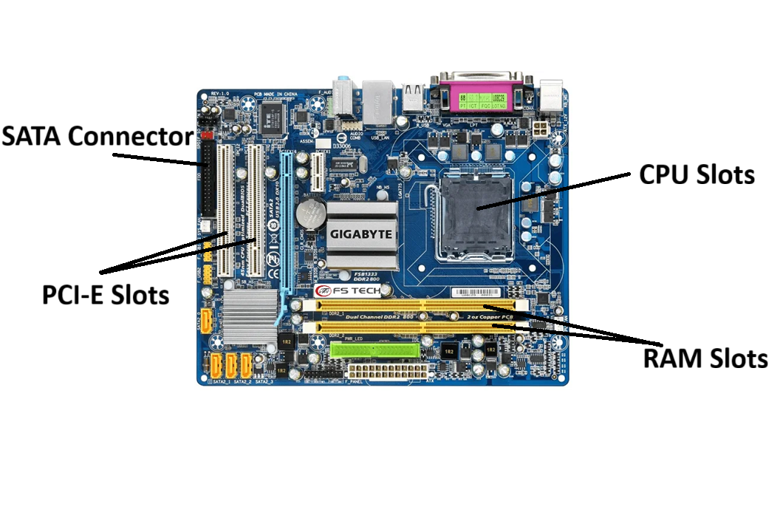

12. Demonstrate how to install a RAM module into a computer
Steps:
- Power Down and Unplug
  - Turn off your computer completely.
  - Unplug it from the power source.
- Open the Case
  - Remove the screws or latches on the side panel of the case.
  - Slide off or lift the panel to access the motherboard.
- Ground Yourself
  - Wear an anti-static wrist strap or touch a metal part of the case to avoid static damage.
- Locate the RAM Slots
  - Find the long slots near the CPU (usually next to the CPU socket).
  - These are typically labeled “DIMM” or “DDR4/DDR5 slots.”
- Prepare the RAM Module
  - Identify the notch on the RAM stick.
  - Align the notch with the slot key on the motherboard—RAM only fits one way.
- Insert the RAM
  - Open the clips at both ends of the RAM slot.
  - Place the RAM into the slot, aligning the notch correctly.
  - Press down firmly until the clips snap into place.
- Verify Installation
  - Make sure the RAM is seated evenly and the clips are fully engaged.

- Close the Case
  - Replace the side panel and secure it with screws or latches.
- Power On
  - Plug in the computer and turn it on.
  - Enter BIOS (usually by pressing DEL or F2 during boot) to verify the RAM is recognized.

Section 5: Essay

13. Discuss the importance of proper cooling mechanisms in a computer system. Include examples of cooling methods and their effectiveness.
Proper cooling is very important for a computer to work efficiently and last longer. When a computer runs, its components like the CPU, GPU, and power supply generate heat. If this heat is not removed, it can make the computer slow, crash, or even damage the hardware.
There are different cooling methods used in computers. Air cooling is the most common method. It uses fans to blow cool air over the hot components, keeping them at safe temperatures. Liquid cooling is another method where a liquid, usually water with special chemicals, absorbs heat and carries it away from the components. This is more effective for high-performance computers. Heat sinks are also used. They are metal pieces attached to chips to help transfer heat away.
Proper cooling ensures the computer runs smoothly, increases the life of components, and prevents unexpected shutdowns. For example, gaming computers often use both air and liquid cooling because they produce more heat.
In short, without proper cooling, a computer cannot perform well or last long. Using the right cooling method keeps the system safe and efficient.

14. Explain the concept of bus width and its significance in computer architecture.
In a computer, a bus is like a highway that carries data between the CPU, memory, and other components. The bus width tells us how many bits of data can travel on this highway at the same time. For example, a 32-bit bus can transfer 32 bits at once, while a 64-bit bus can transfer 64 bits at once.
The bus width is very important because it affects the speed and performance of the computer. A wider bus can move more data at the same time, which makes the computer faster. This is especially helpful for tasks that need a lot of data, like gaming, video editing, or running large programs.
A wider bus also makes communication between the CPU and memory more efficient. It reduces the number of trips data has to make, which saves time and improves overall system performance.
In short, bus width determines how much data a computer can handle at once, and increasing it can make the computer faster and more efficient.

