DNS (Domain Name System) Server
Tasks
1.Install BIND9 DNS server on your Linux machine and verify the installation by checking the version with the named -v command.

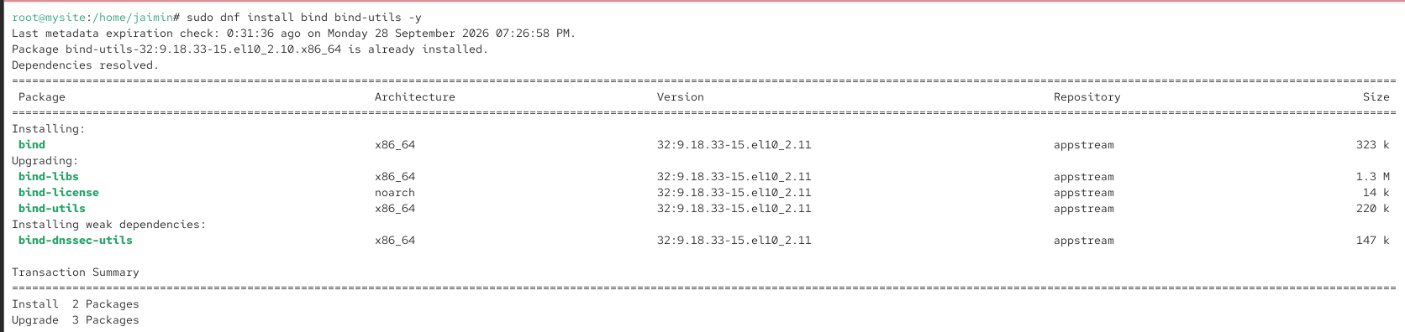
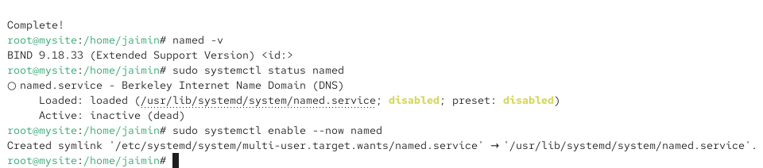
2.Configure a basic DNS zone file in /etc/bind/ for a custom domain like myzomatoclone.local, mapping it to 127.0.0.1, and restart the DNS service to apply changes.Hint: Edit named.conf.local and create a new zone file using db.local as a template.

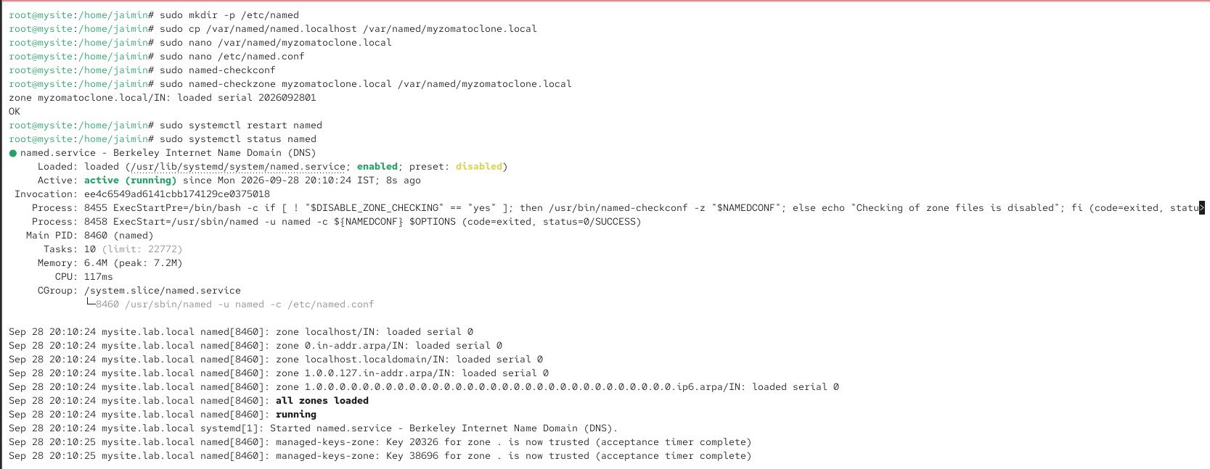
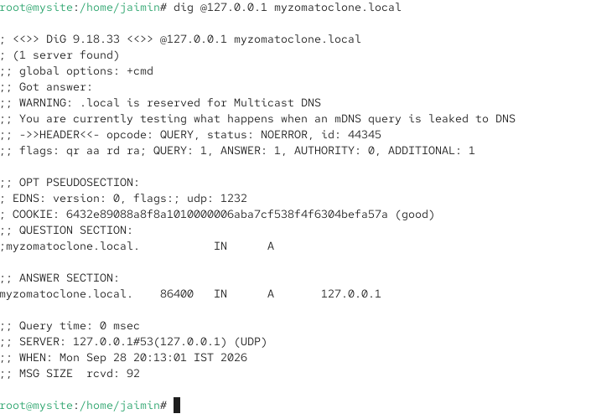
3.Set your system's DNS resolver to use your local BIND9 server and test domain resolution for myzomatoclone.local using the dig or nslookup command.

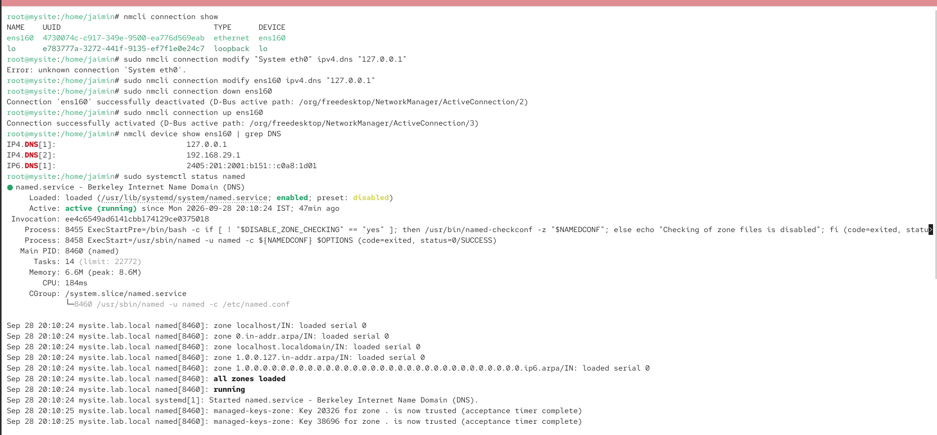
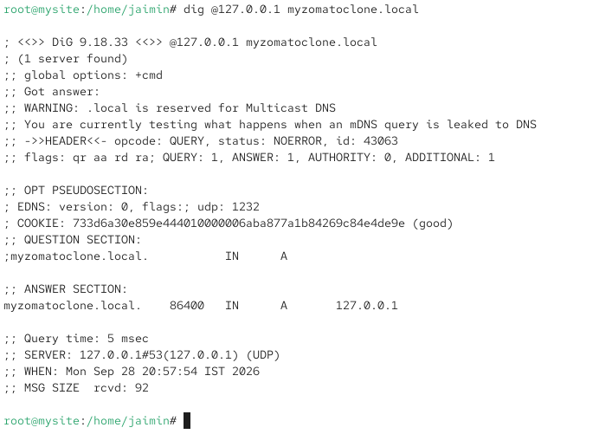

4.Add a CNAME record in your zone file to create an alias foodsearch.myzomatoclone.local that points to myzomatoclone.local, then verify the alias works with dig.

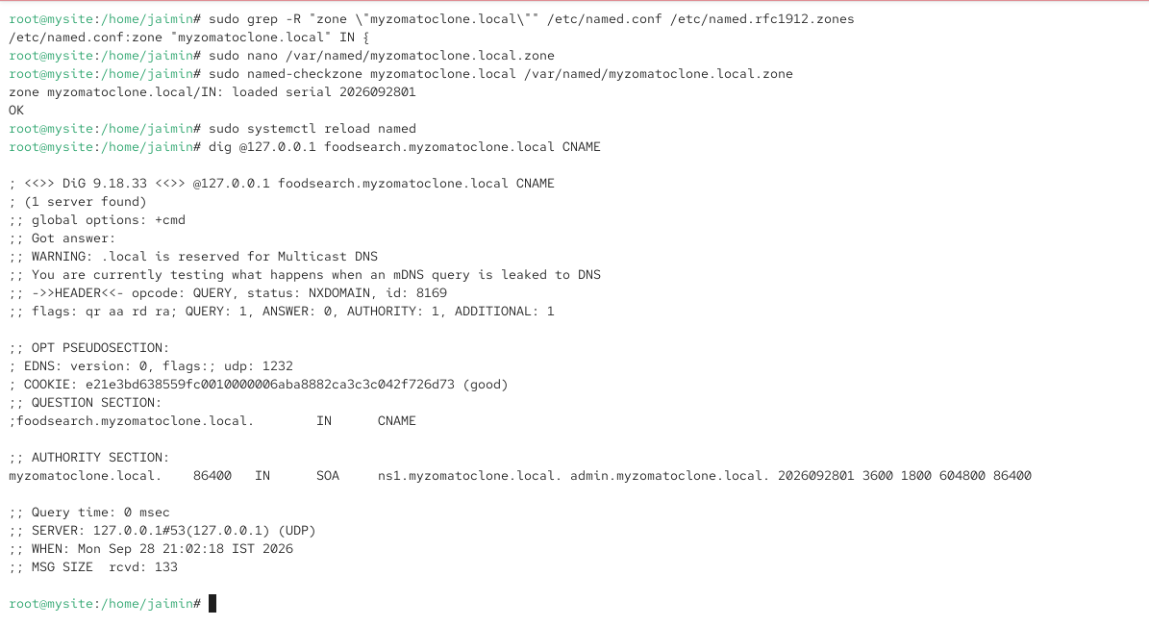
5.Find and fix the error in this zone file snippet: 'myzomatoclone.local. IN A 127.0.0.1 foodsearch IN CNAME myzomatoclone.local.' — the CNAME is not resolving as expected.Hint: Check the syntax and placement of the CNAME record.

