Assignment :- 1

**Done by :- jaimin.n.trivedi**

1. What is software? What is software engineering?

SOFTWARE :-

🡪Software refers to a group of packages, records, and commands that allow a pc machine to carry out precise obligations or capabilities

🡪 It encompasses everything from operating systems and applications to scripts and libraries that allow numerous functionalities on computers, smartphones, and other virtual devices. Software may be categorized into gadget software program (e.G., running systems, device drivers) and application software (e.G., word processors, internet browsers)

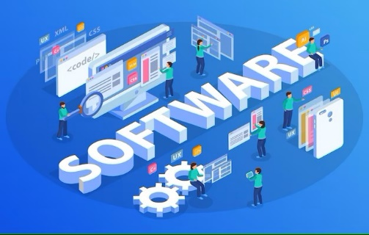

SOFTWARE ENGINEERING :-

🡪Software engineering, then again, is the systematic approach to the design, development, trying out, and maintenance of software program

🡪It includes applying engineering ideas and methodologies to create super, dependable, and scalable software systems. Software engineering encompasses diverse activities, such as necessities analysis, software design, coding, checking out, debugging, and maintenance.

🡪Software engineers use various gear, techniques, and excellent practices to manipulate the complexity of software program development and make sure that the final product.

meets the preferred specs and quality requirements

**2. Explain types of software**

--> Software is a set of instructions and data that tell a computer how to perform specific tasks or functions.

--> there are 5 type of software

1. Application software :-

Application software is a type of software designed to perform specific tasks or functions for end-users, such as word processing, gaming, or email.

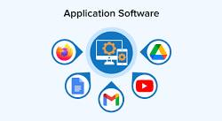

2. system software :-

System software is a type of software designed to provide a platform for running application software and managing computer hardware resources.

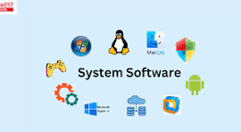

3. driver software :-

A driver is software that enables communication between a computer's operating system and specific hardware devices attached to it.

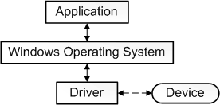

4. middleware :-

Middleware is software that acts as a bridge between different applications, allowing them to communicate and interact with each other.

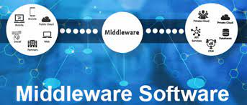

5. programming software :-

Programming software is a tool used by developers to write, test, and debug code for creating computer programs and applications.

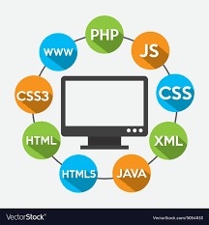

3. What is SDLC? Explain each phase of SDLC

**.** SDLC is know as software development life cycle

**.** SDLC help to creating high-quality software is quick and easy way

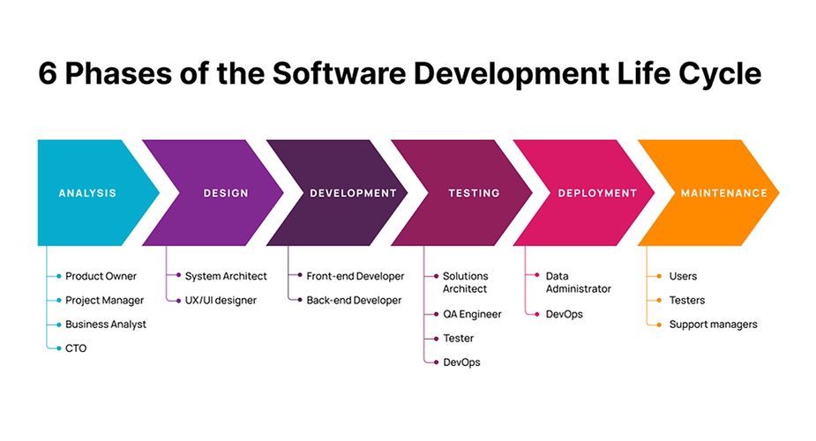

ANALSIS :- to analysis the product and make or refer a project management team the system architecture

Is also defined and includes dev design oft the hardware ,software ,and requirement

DESING :- to work on system architect and ux /ui designer

DEVELOPMENT :- to develop the front- end and back-end coding we can develop code in IDE the IDE provide a platform where tools and development processes are coordinated in order to provide a convenient way of accessing the resources require during the development

TESTING:- to test the web app that dev develop and give query .program this also allows computer programmers to find out and solve any defects that may interface with the application

DEPLOYMENT:-to work on given instructions given by testing team and work on the programs is operating on a production server . it’s been created in the production environment

MAINTENACE:- to maintenance the web app accounting to user and tester and modify and maintain the web app or server and update to improve the experience of webapp

These levels are regularly iterative, meaning that remarks from one section can have an effect on activities in another section. Additionally, various SDLC fashions, including Waterfall, Agile, and DevOps, provide one-of-a-kind processes to organizing and executing these stages primarily based on task necessities and priorities

3.What is DFD? Create a DFD diagram on Flipkart

🡪DFD stands for Data Flow Diagram. Here are four key points about DFD

* + - 1. Visual Representation:- DFD is a graphical representation of the flow of data within a system. It illustrates how data moves through various processes, stores, and external entities
      2. Components: DFDs consist of four main components:

🡪Processes: Represent functions or activities that transform data.

🡪Data Stores: Depict where data is held within the system.

🡪Data Flows: Show the movement of data between processes, stores, and external entities.

External Entities: Represent sources or destinations of data outside the system.

**“DFD DIAGRAM OF FILPCART “**

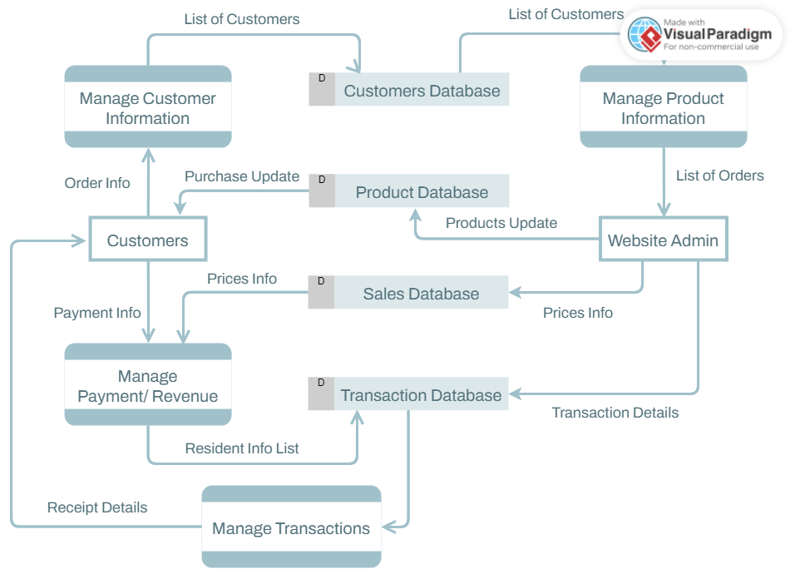

5. What is Flow chart? Create a flowchart to make addition of two numbers ?

🡪 A flowchart is a visual representation of a process or algorithm, using standardized symbols to depict the sequence of steps or actions.

“THE FLOWCHART TO MAKE ADDITION OF TWO NUMBERS”

READ A

READ B

CAL SUM A+B

PRINT SUM

6.What is Use case Diagram? Create a use-case on bill payment on paytm?

🡪 A use case diagram is a visual representation of the interactions between actors (users) and a system, depicting various scenarios or actions the system performs to achieve specific goals.

“a bill payment on paytm”



visitor

admin

Registered

Service provider

User