Week 4: Comprehensive Data Science Report and Insights Presentation Plan
Hypothetical Customer Churn Prediction & Retention Intelligence Project
Final integration report • Executive communication • Mock analytical evidence

1. Executive Summary
This final report presents a comprehensive strategy for converting a hypothetical customer churn prediction project into a polished, executive-ready data science communication package. The purpose is to demonstrate not only analytical thinking, but also the ability to translate technical work into clear business evidence, actionable insights, and practical recommendations.
The hypothetical analysis examines customer characteristics, service usage, contract behavior, support experience, tenure, and other relevant signals to identify customers who may be at higher risk of leaving. The project combines structured data preparation, exploratory analysis, predictive modeling, model evaluation, and business interpretation. The findings in this document are explicitly mock-up illustrations rather than results from a real dataset; they show how findings would be presented once validated against actual project data.
The proposed executive narrative focuses on three questions: where churn risk is concentrated, which factors are associated with elevated risk, and what actions could be tested to improve retention. The report therefore emphasizes evidence hierarchy, visual clarity, uncertainty, and business impact rather than technical complexity alone.

2. Week 4 Learning Outcomes
- Consolidate the full data science lifecycle into one coherent, professional reporting structure.
- Translate analytical outputs into concise business insights and actionable recommendations.
- Design charts, tables, and visual narratives that support—not distract from—the main conclusions.
- Explain technical methodology, model performance, assumptions, and limitations to non-technical stakeholders.
- Distinguish validated findings from illustrative/mock findings and communicate uncertainty responsibly.
- Develop an executive storytelling approach that connects business question → evidence → insight → action.
- Prepare a presentation structure suitable for management or executive-level review.
- Develop recommendations that are measurable, testable, and connected to operational decisions.

3. Methodology Overview
The hypothetical project follows an end-to-end analytical workflow. The methodology is designed to be reproducible and business-oriented, beginning with the prediction objective and ending with monitored business action.
- Business framing: define churn, prediction horizon, stakeholders, decision points, and success criteria.
- Data preparation: inspect data types, duplicates, missing values, inconsistent categories, and unusual records.
- Exploratory analysis: examine distributions, segment differences, trends, relationships, and potential anomalies.
- Feature engineering: create meaningful variables such as tenure bands, usage intensity, support frequency, and contract indicators.
- Model development: compare a simple baseline with Logistic Regression, Decision Tree, Random Forest, and Gradient Boosting/XGBoost candidates.
- Validation: use appropriate train/validation/test design, cross-validation, and time-aware validation where the business process requires it.
- Evaluation: review Precision, Recall, F1-score, ROC-AUC, PR-AUC, calibration, confusion matrix, and segment-level behavior.
- Interpretation: convert model and EDA outputs into understandable drivers, risk groups, and potential interventions.
- Communication: present evidence through a concise executive narrative with supporting charts and transparent limitations.

4. Illustrative Findings and Analysis
The following findings are mock-ups created to demonstrate the intended reporting style. They are not claims about an actual customer population and would be replaced by validated statistics after real data analysis.

Finding 1 — Contract structure may be a major risk signal
The illustrative model narrative assumes that customers with flexible or month-to-month contracts show higher observed risk than customers with longer commitments. The business implication is that retention efforts may need to begin before renewal or cancellation points.

Finding 2 — Service engagement can indicate changing risk
A hypothetical decline in usage or engagement may provide an early-warning signal. A trend chart can help stakeholders distinguish isolated changes from sustained deterioration.

Finding 3 — Support experience may provide actionable context
Repeated support interactions or unresolved service issues could be examined alongside churn outcomes. This is useful because the associated intervention may be operational—such as proactive support—rather than purely promotional.

Finding 4 — Risk is likely to be heterogeneous
A single overall churn rate can hide meaningful differences across contract type, tenure, customer segment, or product usage. Segment-level reporting is therefore essential before selecting interventions.
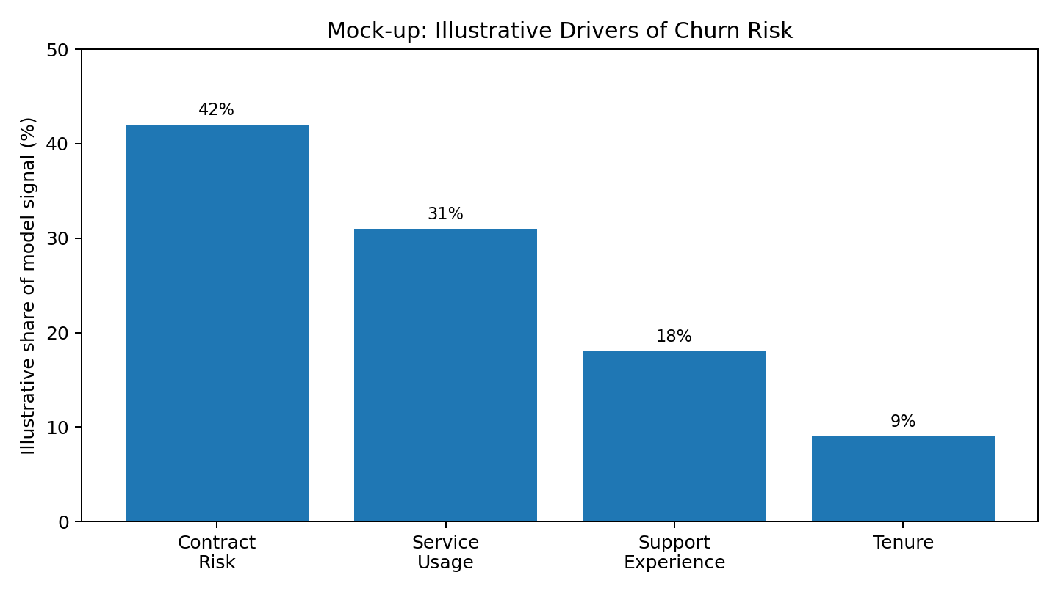
Figure 1. Mock-up only: illustrative model-signal communication. Percentages are hypothetical.
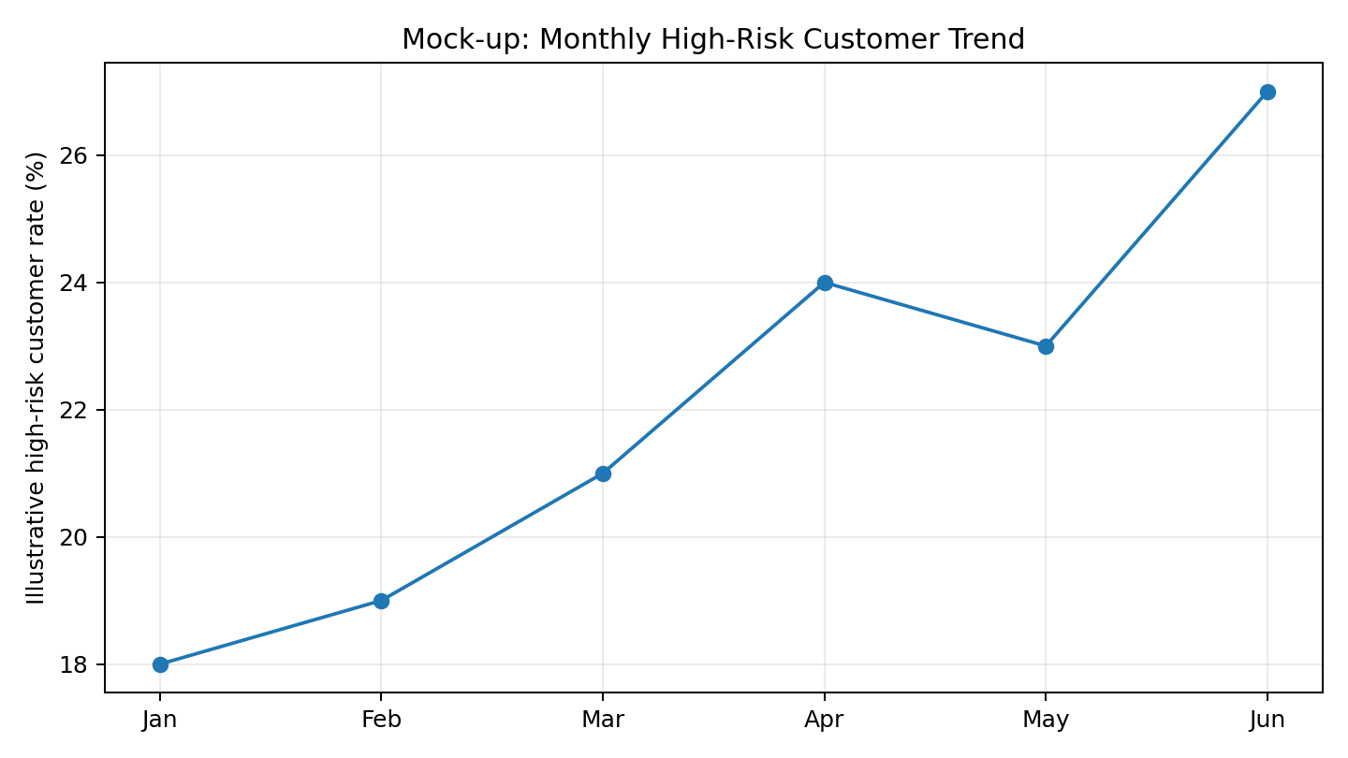
Figure 2. Mock-up only: illustrative monthly risk trend. Actual values would be calculated from validated data.
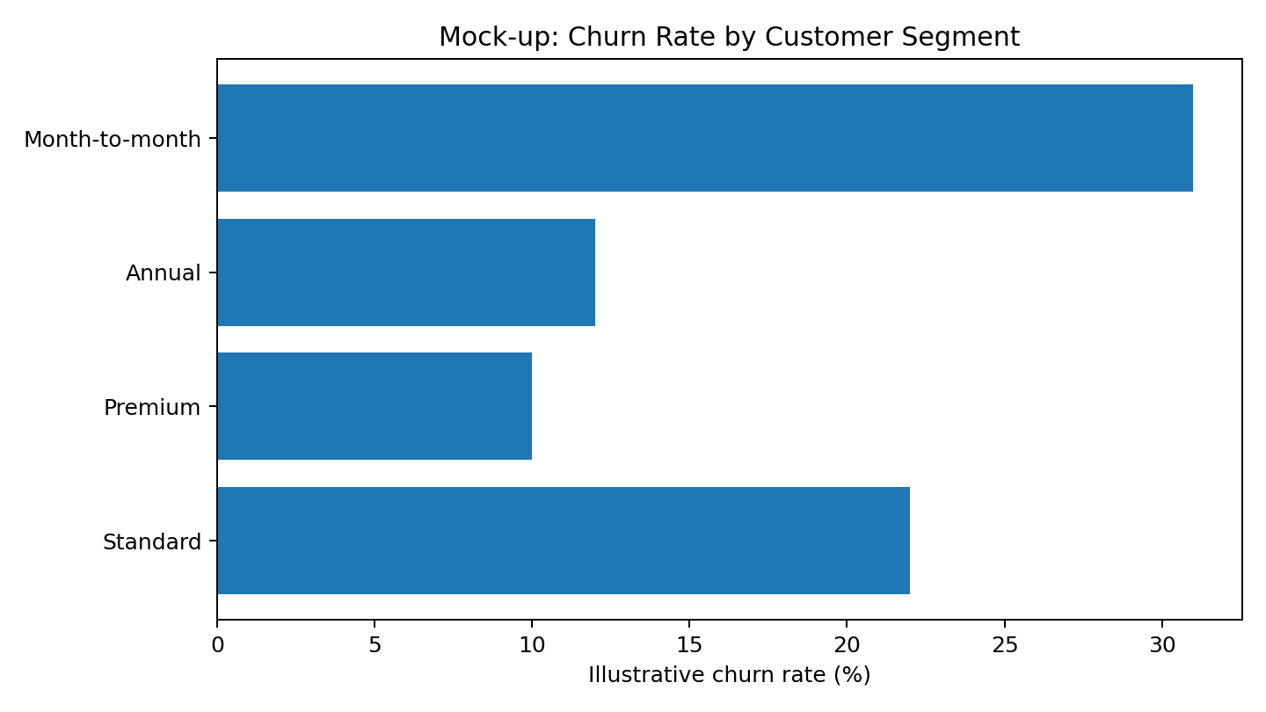
Figure 3. Mock-up only: illustrative segment comparison. Segment definitions and rates would be validated.

5. Visualization and Evidence Plan
Visual | Purpose | What it communicates | Design rationale
KPI cards | Executive scan | Churn rate, high-risk share, model recall, retention opportunity | Fast comprehension; limited to decision-critical metrics.
Line chart | Trend analysis | Change in risk/churn over time | Makes direction, seasonality, and anomalies visible.
Bar chart | Segment comparison | Differences across contracts, products, or customer groups | Easy ranking without implying causation.
Confusion matrix | Model quality | Correct/incorrect classifications by class | Connects model performance to operational consequences.
Feature importance / explanation plot | Model interpretation | Variables associated with predictions | Supports discussion of drivers while noting association is not causation.
Action table | Decision support | Risk signal → recommended intervention → owner → KPI | Directly links analysis to execution.

6. Communication Strategy for a Non-Technical Audience
The presentation should avoid beginning with algorithms, code, or statistical terminology. Instead, it should begin with the business question and the decision the audience needs to make. Technical detail should remain available in an appendix or methodology section for reviewers who need it.
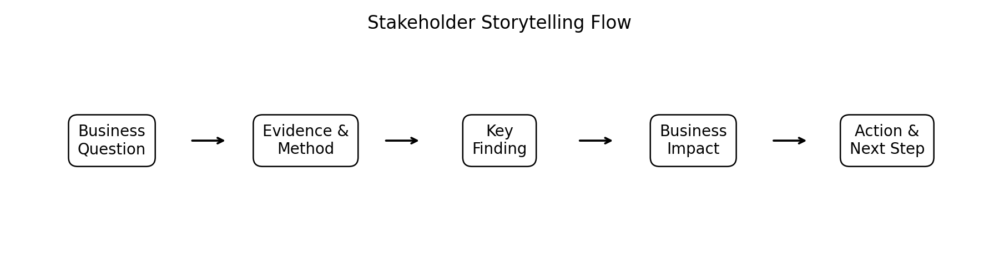
Figure 4. Recommended stakeholder storytelling sequence.

Recommended presentation storyline
- Start with the business problem: explain why customer retention matters and what decision the analysis supports.
- State the headline insight: use one sentence and one visual to establish the main message.
- Show the evidence: present only the charts needed to support the claim.
- Explain business impact: connect the finding to revenue, customer experience, operational workload, or risk.
- Present the action: explain what should be tested, who should own it, and what metric will determine success.
- Close with limitations and next steps: clearly distinguish evidence from assumptions and identify what should be validated.

Language translation examples
Technical wording | Stakeholder-friendly wording
The model achieved 0.78 recall. | The model identifies about 78% of the customers who actually churned, under the illustrative evaluation setup.
Feature importance is high for contract type. | Contract type is strongly associated with the model's risk estimates; this suggests where retention analysis should focus.
PR-AUC is more informative under class imbalance. | Because churners may be a minority, we need a metric that reflects how well we identify the customers who actually need attention.
Prediction probability is calibrated. | The model's risk percentages can be interpreted more consistently as estimated likelihoods, subject to validation.

7. Actionable Recommendations
Recommendation | Proposed action | Success measure
Create a prioritized retention queue | Use validated risk estimates to group customers into practical action bands rather than treating every customer identically. | Measure retention rate, intervention uptake, and false-positive workload.
Test proactive support interventions | For customers showing declining engagement or repeated service issues, test targeted support before cancellation. | Measure resolution rate, subsequent usage, and churn among contacted vs. eligible control groups.
Review contract-risk patterns | Investigate whether contract flexibility is associated with churn and whether renewal communications can be improved. | Track renewal conversion, cancellation timing, and customer experience.
Build an executive monitoring dashboard | Combine churn KPIs, segment trends, model performance, and intervention outcomes in one recurring view. | Monitor business KPIs and model-health indicators monthly.
Run controlled experiments | Do not assume that a predictive signal is a causal driver. Test interventions experimentally where feasible. | Use incremental retention or revenue as the primary decision metric.
Establish model governance | Document data sources, model versions, thresholds, limitations, monitoring rules, and retraining criteria. | Track drift, calibration, performance, and documented approval history.

8. Future Work and Further Research
- Validate all mock findings using the actual project dataset and a clearly documented observation period.
- Investigate causal drivers separately from predictive associations using experiments or quasi-experimental methods where appropriate.
- Evaluate model performance across important customer segments and monitor potential disparities or unintended effects.
- Compare threshold strategies based on the operational cost of missed churners versus unnecessary interventions.
- Test uplift or treatment-effect approaches if the objective evolves from predicting churn to identifying who is most likely to respond to an intervention.
- Automate data-quality checks, model monitoring, and recurring executive reporting.
- Conduct periodic model refreshes when customer behavior, products, pricing, or business processes change.

9. Limitations and Responsible Interpretation
- All numerical findings and charts in this document are illustrative mock-ups; they must not be presented as actual business results.
- Predictive association does not establish causation. A variable that helps prediction is not automatically the correct intervention target.
- Model performance depends on data quality, sampling, label definition, prediction horizon, and validation design.
- Executive summaries should preserve uncertainty and avoid overstating precision.
- Any deployment should include appropriate privacy, access control, documentation, monitoring, and human oversight.

10. Final Presentation Structure
Slide/Section | Core message | Primary visual
1. Executive summary | What problem was addressed and what should decision-makers remember? | 3 KPI cards + headline
2. Business context | Why churn matters and what decision is being supported. | Problem statement graphic
3. Methodology | How the evidence was produced and validated. | End-to-end workflow
4. Key finding #1 | Where risk is concentrated. | Segment bar chart
5. Key finding #2 | How risk changes over time. | Trend chart
6. Key finding #3 | Which signals require investigation. | Driver chart / explanation plot
7. Model evaluation | How reliable the predictive solution is. | Confusion matrix + metrics
8. Recommended actions | What should happen next. | Action matrix
9. Measurement plan | How success will be tracked. | KPI framework
10. Limitations & next steps | What remains uncertain and what to validate. | Next-step roadmap

11. 32-Hour Work Plan
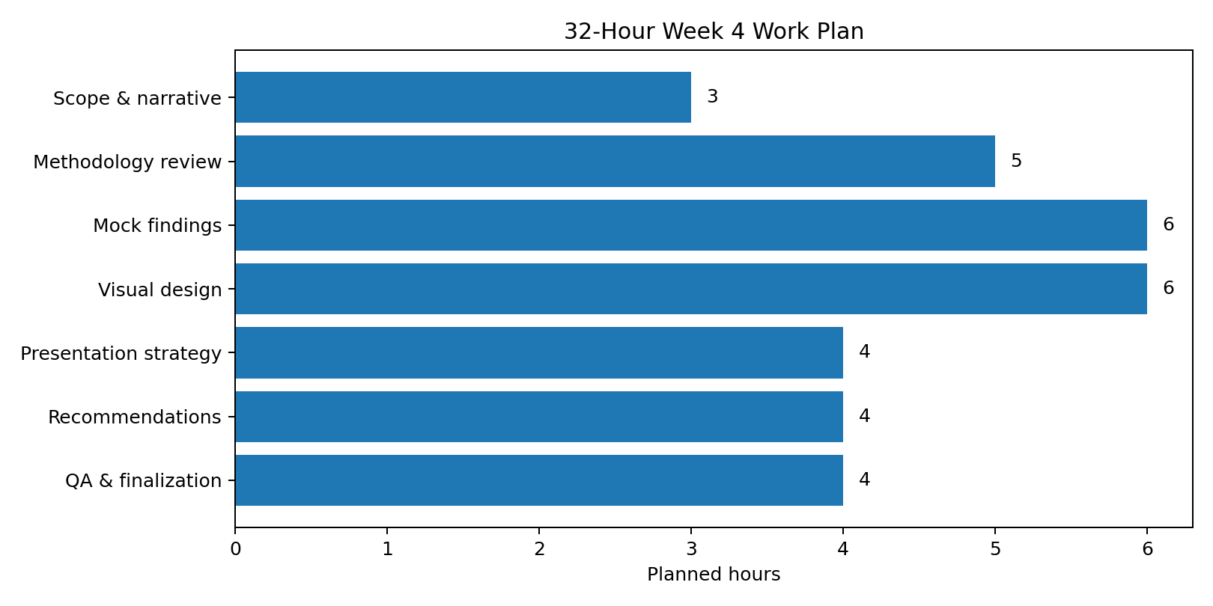
Figure 5. Planned 32-hour effort across report, visual, narrative, and quality-review activities.
Activity | Hours
Scope and executive narrative | 3
Methodology review and evidence framework | 5
Illustrative findings and analysis design | 6
Mock-up charts, tables, and visual QA | 6
Non-technical presentation strategy | 4
Recommendations and future-work plan | 4
Final review, formatting, consistency, and submission | 4
Total | 32

12. Evaluation Criteria and Submission Readiness
- Clarity and comprehensiveness: the report provides a coherent narrative from business problem to evidence and action.
- Analytical translation: technical outputs are converted into understandable conclusions without removing important limitations.
- Visual quality: every chart or table has a defined purpose and supports the surrounding message.
- Communication strategy: the presentation is structured around stakeholder decisions rather than algorithmic detail.
- Actionability: recommendations identify practical next steps and measurable outcomes.
- Professionalism: terminology, formatting, mock-data labeling, assumptions, and limitations are documented consistently.

13. Conclusion
Week 4 completes the data science workflow by connecting analytical strategy with professional communication. A strong data science project does not end when a model produces predictions; it ends when decision-makers can understand the evidence, assess its limitations, and determine what action should be tested next. This report therefore combines methodology review, illustrative findings, visualization planning, stakeholder storytelling, recommendations, future research, and a structured 32-hour production plan. The resulting framework is designed to serve as a professional portfolio artifact and as a blueprint for converting a validated analytical project into an executive-level report and presentation.

End of Week 4 Report

