WEEK 1 PROJECT PLAN
Data Science Project Planning & Strategy Design
Hypothetical Project: Customer Churn Prediction & Retention Intelligence
Document Information | Details
Project type | Hypothetical Python-based Data Science Project
Planning horizon | Week 1 — Strategy & Conceptualization
Planned effort | 32 hours
Business goal | Identify customers at risk of churn and support proactive retention decisions
Core stack | Python, Pandas, NumPy, Scikit-learn, Matplotlib/Seaborn, SQL, Jupyter, Streamlit
Primary deliverable | Comprehensive DOCX project plan with methodology, diagrams, timeline, tools, risks and evaluation

Prepared as a Week 1 Data Science Strategy Submission

1. Executive Summary
This project proposes a complete data science workflow for predicting customer churn in a subscription-based business. The hypothetical company has customer profiles, subscriptions, transactions, product usage, support interactions and feedback. The business needs an evidence-based method to identify customers who may leave so that limited retention resources can be prioritized.
Week 1 focuses on conceptualization and planning rather than dataset implementation. The plan defines the problem, scope, data requirements, methodology, model candidates, validation approach, technical stack, timeline, risks and expected outcomes.

Strategic principles
- Start with a measurable business decision rather than an algorithm.
- Treat target definition, data quality and leakage prevention as core requirements.
- Establish a simple baseline before complex models.
- Use chronological validation for a forward-looking prediction problem.
- Balance predictive performance, interpretability and operational usefulness.
- Design the solution for monitoring and future retraining.

Definition of success
The project is successful when it produces a reproducible churn-risk workflow, a validated model or model shortlist, understandable churn drivers, an actionable risk-segmentation approach, and a monitoring plan suitable for later implementation.

2. Project Background & Business Problem

2.1 Hypothetical context
Assume a subscription company serving about 100,000 customers. Customers use digital products, make recurring payments, contact support and receive periodic offers. A portion of customers cancel or fail to renew each month. Current retention activity is largely reactive, occurring after strong warning signs or cancellation.

2.2 Problem statement
Develop a binary classification system that estimates whether an active customer is likely to churn during a defined future window, such as the next 30 days, using only information available before the prediction date.

2.3 Motivation
- Retention capacity is limited, so teams need a consistent prioritization method.
- Early signals may exist in declining usage, payment friction, support issues or engagement changes.
- A model can combine many weak signals instead of relying on one rule.
- Explainable outputs can help teams understand why a customer is considered higher risk.
- A measurable prediction process creates a foundation for later testing of retention interventions.

2.4 Key business questions
- Which customers are most likely to churn within the prediction window?
- Which behavioral, transactional and service signals are associated with churn?
- How much improvement can ML provide over a simple baseline?
- How many customers should be prioritized at different intervention thresholds?
- How should model performance and data quality be monitored after deployment?

3. Project Objectives & Scope

3.1 Objectives
ID | Objective | Completion evidence
O1 | Define churn precisely | Approved target, observation window, prediction horizon and exclusions
O2 | Design a reliable analytical dataset | Source inventory, schema, joins and validation rules
O3 | Establish a baseline | Simple reference model/rule documented
O4 | Develop candidate models | Logistic regression and tree-based candidates evaluated
O5 | Explain drivers | Feature importance and customer-level explanation approach
O6 | Make predictions actionable | Risk segments linked to retention capacity
O7 | Plan monitoring | Performance, drift and data-quality monitoring specification

3.2 In scope
- Churn definition and prediction design.
- Data source and schema planning.
- Cleaning, missing-value treatment and duplicate handling.
- EDA and feature engineering.
- Baseline and supervised classification.
- Time-aware validation and threshold analysis.
- Interpretability and stakeholder reporting.
- Conceptual deployment and monitoring architecture.

3.3 Out of scope
- Production deployment during Week 1.
- Automated customer outreach.
- Collecting unnecessary sensitive information.
- Causal claims that a variable causes churn.
- A/B testing of interventions.
- Real-time streaming implementation.
- Final cloud infrastructure and production cost optimization.

4. Methodology & Strategy
The workflow is inspired by CRISP-DM and adapted for a modern Python analytics project. Each stage has an explicit output and quality gate, while findings can feed back into feature design and model refinement.
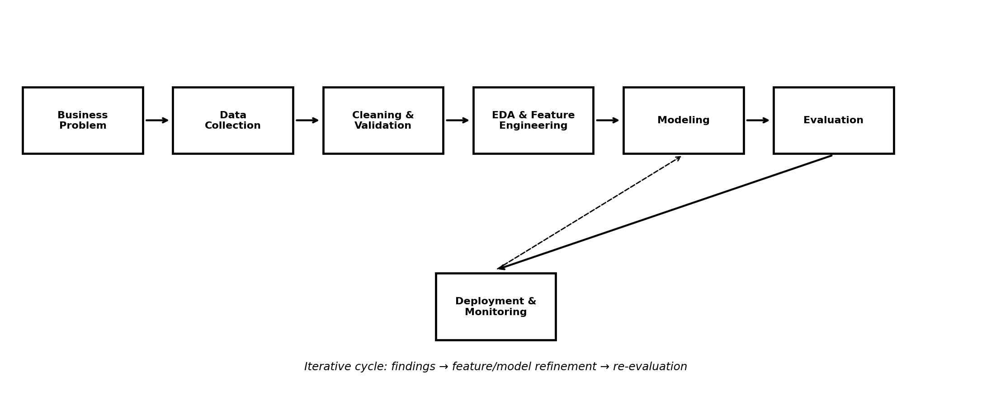
Figure 1. End-to-end data science planning workflow.

4.1 Business understanding
- Confirm the business definition of churn.
- Define the prediction decision and intended user.
- Agree model and business success metrics.
- Document assumptions, constraints and stakeholders.

4.2 Data collection and integration
- Inventory customer, subscription, billing, usage, support and feedback sources.
- Define a common customer identifier and join logic.
- Record source owner, grain, refresh frequency and historical coverage.
- Build point-in-time snapshots so future information cannot enter historical training records.

4.3 Cleaning and validation
- Check row counts, uniqueness, key integrity and duplicates.
- Profile missingness by variable and segment.
- Standardize dates, categories, units and types.
- Investigate outliers before deciding whether to cap or remove them.
- Validate impossible values and inconsistent dates.
- Record transformations for reproducibility.

4.4 Exploratory analysis
- Measure churn overall and by meaningful segments.
- Compare usage, tenure, support and payment behavior.
- Inspect distributions, outliers and candidate relationships.
- Check class imbalance and temporal patterns.
- Treat correlation as association, not proof of causation.

5. Feature Engineering & Modeling Strategy

5.1 Candidate feature groups
Group | Examples | Design rule
Customer profile | Tenure, segment, plan type | Use snapshot available before prediction
Engagement | Login frequency, active days, sessions | Rolling 7/30/90-day windows
Usage | Feature usage, inactivity, trend | Recency and trend features
Billing | Payment failures, invoice amount, discounts | Historical values only
Support | Ticket count, unresolved tickets, resolution time | Pre-cutoff history
Feedback | CSAT/NPS, survey response, complaints | Latest available pre-cutoff value

5.2 Target design
Proposed target: churn_within_30_days = 1 if an active customer cancels or fails to renew within the following 30 days after the observation date; otherwise 0. The exact definition must be confirmed before training.

5.3 Leakage prevention
- Exclude fields created after cancellation or renewal.
- Use point-in-time snapshots.
- Exclude post-churn support tickets or cancellation-reason fields from predictors.
- Run a dedicated leakage review before final evaluation.

5.4 Candidate models
Model | Role | Strength
Majority/simple rule | Baseline | Defines minimum reference performance
Logistic Regression | Interpretable baseline | Fast, transparent coefficients
Decision Tree | Non-linear candidate | Easy to communicate
Random Forest | Ensemble candidate | Robust non-linear relationships
Gradient Boosting / XGBoost-style | Advanced tabular candidate | Often strong on structured data

5.5 Training strategy
- Use chronological train/validation/test periods.
- Fit preprocessing only on training data using pipelines.
- Use class weights or threshold tuning when imbalance is material.
- Tune models after establishing a baseline.
- Lock the final test period until model selection is complete.

6. Technical Architecture & Python Tooling
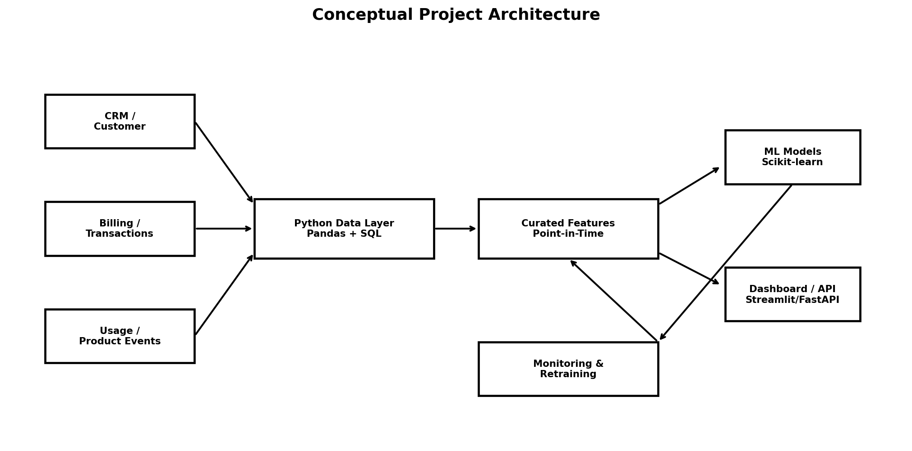
Figure 2. Conceptual architecture for the proposed solution.

6.1 Planned libraries and tools
Tool | Planned use
Python | Primary programming language
Pandas | Data loading, cleaning, transformation and aggregation
NumPy | Numerical operations
Matplotlib / Seaborn | Exploratory and reporting visuals
Scikit-learn | Preprocessing, pipelines, models, metrics and validation
XGBoost (optional) | Gradient-boosted tree candidate
SHAP (optional) | Model and feature explanations
SQL | Source extraction and relational aggregation
Jupyter Notebook | Exploration and reproducible experiments
Streamlit / FastAPI | Later-stage dashboard or prediction API
Git / GitHub | Version control and collaboration

6.2 Proposed project structure
customer-churn-project/
├── data/raw/ # source data
├── data/processed/ # curated datasets
├── notebooks/ # EDA and experiments
├── src/ # reusable Python modules
├── models/ # serialized model artifacts
├── reports/ # figures and documentation
├── app/ # later dashboard/API
├── tests/ # validation tests
└── README.md

7. Data Strategy, Quality & Governance

7.1 Source plan
Source | Example fields | Likely grain | Purpose
Customer master | ID, segment, region, signup date | Customer | Reference attributes
Subscription | Plan, renewal date, contract type | Customer/contract | Target context
Transactions | Invoices, payments, refunds | Transaction | Financial behavior
Product usage | Sessions, active days, feature use | Event/customer-day | Engagement
Support | Tickets, category, resolution time | Ticket | Service experience
Feedback | CSAT/NPS, survey response | Response | Customer sentiment

7.2 Data-quality checklist
- Completeness: quantify missing values and systematic missingness.
- Uniqueness: verify identifiers where uniqueness is expected.
- Consistency: align categories, time zones, dates and units.
- Validity: detect impossible or contradictory values.
- Timeliness: confirm refresh dates and historical coverage.
- Integrity: test join coverage and key relationships.
- Bias: examine whether customer groups are underrepresented.
- Lineage: record source, transformation and version.

7.3 Privacy and governance
- Use the minimum information required for the objective.
- Avoid direct identifiers in modeling tables when unnecessary.
- Restrict raw customer-level access according to policy.
- Document data ownership and retention expectations.
- Keep model outputs auditable and reproducible.

8. Evaluation Framework

8.1 Technical metrics
Metric | Question answered | Why it matters
Precision | Of flagged customers, how many churn? | Useful when outreach capacity is limited
Recall | Of churners, how many are identified? | Measures missed-risk exposure
F1-score | How well are precision and recall balanced? | Useful for imbalanced classification
ROC-AUC | How well does the model rank cases? | Broad model comparison
PR-AUC | How well does it perform on the positive class? | Useful with class imbalance
Calibration | Do probabilities reflect observed rates? | Important for risk prioritization

8.2 Business evaluation
- Estimate how many customers can be contacted within retention capacity.
- Compare intervention cost with expected retention value.
- Compare observed churn across risk segments.
- Measure downstream retention after controlled interventions in a later phase.
- Track false-positive burden to avoid unnecessary outreach.

8.3 Threshold strategy
Thresholds should reflect intervention capacity, customer value, contact cost and the cost of missed churn. Accuracy alone should not determine the operating threshold.

8.4 Validation gates
- Data-quality checks pass with exceptions documented.
- Target definition is approved and leakage review passes.
- Baseline is established.
- Candidate models are compared on predefined validation metrics.
- Final model is tested once on a locked future period.
- Business stakeholders review explanations and operational feasibility.

9. 32-Hour Project Timeline
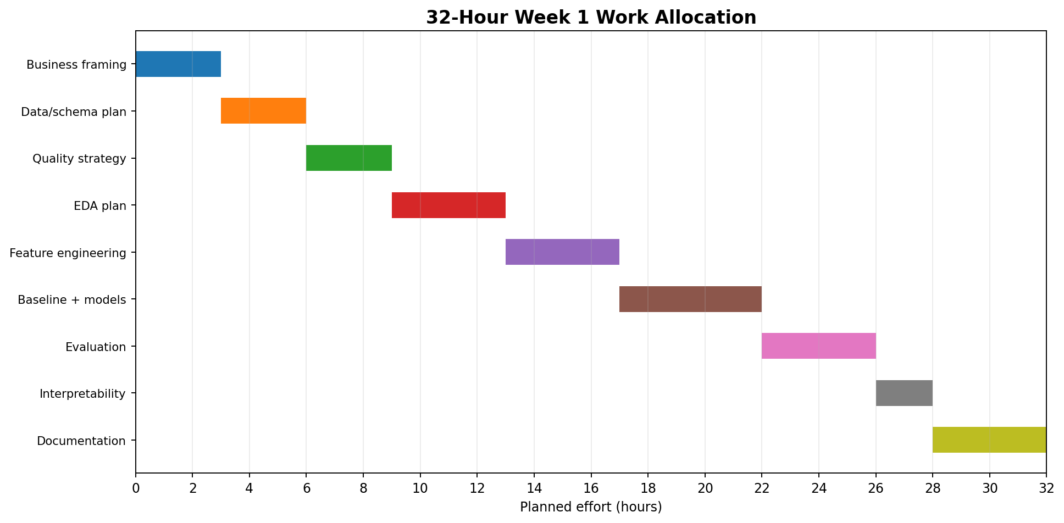
Figure 3. Planned 32-hour allocation.
Phase | Work package | Hours | Main output
1 | Project framing & KPIs | 3 | Problem, target, stakeholders and success criteria
2 | Data source & schema plan | 3 | Source inventory, grain, joins and data dictionary
3 | Data quality strategy | 3 | Quality rules, missingness and leakage controls
4 | EDA plan | 4 | Questions, segments and visual analysis plan
5 | Feature engineering | 4 | Feature groups, windows and transformations
6 | Baseline + ML models | 5 | Candidate model strategy and validation
7 | Evaluation | 4 | Metrics, thresholding and test design
8 | Interpretability | 2 | Explanations and business review
9 | Documentation | 4 | Final report, diagrams and review

Total planned effort: 32 hours.

Execution principles
- Resolve target definition and data availability early.
- Reserve explicit time for data quality and leakage checks.
- Do not spend the entire schedule tuning models.
- Protect the final test set and documentation time.
- Use review checkpoints to revise assumptions when evidence changes.

10. Expected Outcomes, Challenges & Mitigation

10.1 Expected outcomes
- Documented churn definition and prediction framework.
- Reproducible data-preparation design.
- Baseline and candidate classification models.
- Temporal validation strategy.
- Feature importance and explanation framework.
- Risk segmentation concept for retention teams.
- Deployment and monitoring blueprint.

10.2 Challenges and mitigation
Challenge | Impact | Mitigation
Class imbalance | Minority churn class may be missed | Use PR-AUC, recall, class weighting and threshold analysis
Data leakage | Inflated validation performance | Point-in-time snapshots and formal leakage review
Missing data | Biased or unstable features | Profile missingness and distinguish unknown from no event
Concept drift | Performance may degrade | Monitor drift and validate on recent periods
Interpretability | Lower stakeholder trust | Compare interpretable models and provide explanations
Actionability | Predictions may not create value | Link scores to capacity, cost and measurable outcomes
Selection bias | Historical actions may affect labels | Document intervention history; test interventions later

10.3 Contingency plan
- If key data are unavailable, use a reduced feature set and document the limitation.
- If the churn label is unreliable, resolve the business definition before modeling.
- If advanced models add little value, consider the simpler model when it is easier to maintain and explain.
- If data volume is insufficient, focus on descriptive analysis and a stronger data-acquisition plan.

11. Deliverables & Evaluation Criteria
ID | Deliverable | Acceptance evidence
D1 | Project charter | Problem, motivation, stakeholders, objectives and assumptions
D2 | Data strategy | Sources, schema, quality, privacy and governance
D3 | Methodology | EDA, feature engineering, modeling and validation plan
D4 | Technical architecture | Python workflow and system design
D5 | Timeline | 32-hour allocation and milestones
D6 | Risk register | Challenges, impact and mitigation
D7 | Evaluation framework | Technical and business metrics
D8 | Final DOCX | Integrated professional submission

Rubric alignment
Criterion | Evidence in this plan
Completeness | All requested sections are included with explicit outputs and assumptions.
Process understanding | The workflow covers business understanding through monitoring and iteration.
Logical organization | The plan progresses from problem → scope → data → methodology → evaluation → execution.
Strategic justification | Model choices and validation are tied to the business decision.
Visual clarity | Flowchart, architecture and timeline are embedded as images.
Professional readiness | The document provides a blueprint for later implementation.

12. Conclusion & Next-Week Readiness
The proposed customer churn project provides a realistic framework for applying Python-based data science to a business problem without requiring a dataset during Week 1. The strategy emphasizes clear target definition, data quality, leakage prevention, reproducible preprocessing, appropriate validation, interpretability and business impact.
The next implementation phase can begin with a representative dataset, a data dictionary, validation tests, exploratory analysis, point-in-time feature engineering and a baseline model. The Week 1 plan provides guardrails so that technical work remains aligned with the original business question.

Immediate next steps
- Confirm the churn definition and prediction horizon.
- Acquire or generate representative data.
- Create the data dictionary and point-in-time table specification.
- Implement data-quality and leakage tests.
- Build the baseline and first candidate models.
- Review results against technical and business criteria.
- Prepare a reproducible notebook and stakeholder-facing dashboard.

Final strategic statement
The model is not the product. The product is a trustworthy decision-support process that turns reliable data into actionable insight, can be evaluated honestly, and can be maintained as the business changes.

