WEEK 2 PROJECT PLAN
Exploratory Data Analysis (EDA) & Visualization Framework
A Dataset-Agnostic Python Strategy for Structured Data Exploration
Document Information | Details
Project phase | Week 2 — Exploratory Analysis & Visualization Planning
Planned effort | 32 hours
Dataset requirement | No dataset required for the planning deliverable
Primary objective | Define a repeatable EDA and visualization process adaptable to many datasets
Core tools | Python, Pandas, NumPy, Matplotlib, Seaborn, Plotly, Jupyter
Final deliverable | Detailed DOCX framework with techniques, chart strategies, reporting plan and visual guides

Prepared as a Data Science Week 2 Strategy Submission

1. Introduction to Exploratory Data Analysis
Exploratory Data Analysis (EDA) is the systematic process of inspecting, summarizing, visualizing and questioning a dataset before formal statistical modeling or machine-learning development. EDA helps a data scientist understand what the data contains, whether it is reliable, how variables behave, where unusual observations exist, and which relationships deserve deeper investigation.
Because the Week 2 task does not provide a dataset, this document defines a reusable framework rather than reporting dataset-specific findings. The same framework can be adapted to customer, financial, healthcare, marketing, operations, sensor, transactional or other structured datasets.

Why EDA matters
- Reveals data-quality problems before they contaminate downstream analysis.
- Shows distributions, ranges, skewness and unusual observations.
- Helps identify meaningful relationships and potential predictors.
- Supports informed feature engineering and transformation decisions.
- Provides evidence for choosing suitable statistical and machine-learning methods.
- Creates a shared visual language for communicating findings to technical and non-technical stakeholders.

EDA principle
EDA should be iterative rather than a one-time checklist. An unexpected pattern should generate a question; the question should lead to a focused analysis; and the result should either strengthen, revise or reject the initial interpretation.

2. EDA Workflow Framework
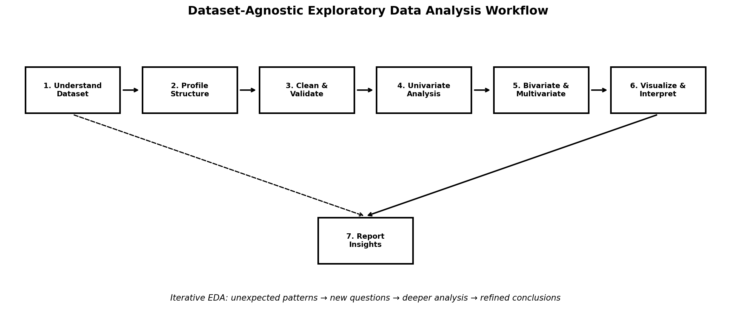
Figure 1. General-purpose EDA workflow from dataset understanding to documented insight.

Stage 1 — Understand the analytical context
- Clarify the business or research question.
- Identify the unit of observation, such as customer, transaction, product, day or event.
- Understand how each variable was generated and what decisions it may support.
- Identify target variables, key dimensions and known constraints.

Stage 2 — Profile the dataset
- Inspect number of rows and columns.
- Review column names, data types and memory usage.
- Check unique counts and representative values.
- Summarize numeric and categorical variables.
- Inspect date ranges and time granularity where applicable.

Stage 3 — Validate data quality
- Check missing values and missingness patterns.
- Detect duplicate records.
- Check invalid categories and inconsistent labels.
- Identify impossible numerical values and invalid dates.
- Check key uniqueness and join integrity.
- Document assumptions and unresolved quality issues.

Stage 4 — Explore and visualize
Move from simple to complex analysis: univariate → bivariate → multivariate. Use visualizations to confirm patterns rather than creating charts merely for decoration.

Stage 5 — Synthesize and report
- Translate charts into concise findings.
- Separate observations from assumptions and causal claims.
- Record limitations and unanswered questions.
- Recommend next analytical or modeling steps.

3. Data Types & Exploration Techniques
Data type | Examples | Primary EDA techniques
Numerical — continuous | Revenue, height, temperature | Summary statistics, histogram, KDE, box/violin, scatter
Numerical — discrete | Count, quantity, number of tickets | Frequency, bar chart, histogram, grouped summaries
Categorical — nominal | Region, product category, channel | Frequency tables, count plots, grouped bars
Categorical — ordinal | Low/Medium/High, satisfaction level | Ordered bars, cumulative views, group comparisons
Datetime | Order date, signup date, timestamp | Trend lines, seasonality, rolling statistics
Boolean | Active/inactive, yes/no | Counts, proportions, grouped comparisons
Text | Reviews, comments, descriptions | Length, frequency, token patterns; NLP later if required
Identifier | Customer ID, transaction ID | Uniqueness, duplicate and referential-integrity checks

3.1 Basic profiling
- Shape: rows × columns.
- Data types: numeric, categorical, datetime, boolean, text and identifiers.
- Cardinality: unique values per feature.
- Summary statistics: count, mean, median, standard deviation, quartiles, minimum and maximum.
- Frequency summaries for categorical variables.
- Date coverage and event frequency for temporal data.

3.2 Recommended Pandas profiling actions
df.shape
df.head()
df.info()
df.describe(include="all")
df.isna().sum()
df.nunique()
df.duplicated().sum()
df.select_dtypes(include="number").corr()

4. Univariate Analysis
Univariate analysis studies one variable at a time. Its purpose is to understand the variable's distribution, frequency, scale, variability and potential data-quality issues.

4.1 Numerical variables
- Calculate mean, median, standard deviation, range and quartiles.
- Inspect skewness and heavy tails.
- Use histograms to understand distribution shape.
- Use box plots to identify potential outliers.
- Use KDE plots when a smooth distribution view is useful.
- Compare mean and median to identify possible skew.

4.2 Categorical variables
- Calculate value counts and percentages.
- Inspect rare categories and unexpected labels.
- Use count plots or horizontal bar charts.
- Consider grouping very rare categories only when analytically justified.

4.3 Time variables
- Identify earliest and latest dates.
- Check frequency by day, week, month or quarter.
- Look for gaps in expected observations.
- Inspect trend and seasonality before aggregation.

Questions to answer
- What does a typical observation look like?
- Which variables have extreme variability or skew?
- Which categories dominate the dataset?
- Are there suspicious values or unexpected categories?
- Are there gaps or irregularities in time?

5. Bivariate Analysis
Bivariate analysis examines relationships between two variables. The appropriate technique depends on the variable types.
Variable pair | Recommended techniques | Example question
Numeric + Numeric | Scatter plot, correlation, regression line | Does usage increase with revenue?
Numeric + Categorical | Box/violin/strip plot, grouped summary | Does revenue differ by region?
Categorical + Categorical | Cross-tabulation, grouped/stacked bars, heatmap | Is product category associated with channel?
Datetime + Numeric | Line chart, rolling mean | How does sales change over time?
Datetime + Categorical | Multi-line/grouped trends | How do categories evolve over time?

Correlation strategy
- Use Pearson correlation for approximately linear numeric relationships.
- Consider Spearman correlation when ranks or monotonic relationships are more appropriate.
- Treat correlation as a measure of association, not causation.
- Inspect scatter plots because a single coefficient can hide nonlinear or subgroup patterns.
- Investigate highly correlated predictors for potential redundancy in later modeling.

Recommended questions
- Which variables move together?
- Are relationships linear, nonlinear or segmented?
- Do groups have noticeably different distributions?
- Are apparent relationships driven by outliers?
- Does the relationship remain consistent across time or segments?

6. Multivariate Analysis
Multivariate EDA examines several variables simultaneously. It is useful for detecting interactions, clusters, confounding patterns and segment-specific behavior that may not appear in two-variable analysis.

6.1 Techniques
- Correlation heatmaps for groups of numerical variables.
- Pair plots for a focused subset of numeric variables.
- Faceted charts to compare relationships across categories.
- Pivot tables and grouped aggregations.
- Segmented time-series analysis.
- Dimensionality-reduction visuals such as PCA when the feature space is large and visualization is useful.
- Cluster exploration when segmentation is a legitimate analytical objective.

6.2 Multivariate questions
- Does a relationship between two variables change across customer or product segments?
- Which variables appear redundant or highly correlated?
- Do different groups form distinct behavioral patterns?
- Are unusual observations isolated to one segment?
- Do multiple variables jointly explain an observed trend?

Avoiding over-interpretation
Multivariate patterns can look persuasive while being driven by confounding variables, selection effects or aggregation choices. Findings should therefore be checked across relevant subgroups and, where appropriate, tested using statistical or modeling methods in later stages.

7. Missing Data & Outlier Strategy

7.1 Missing data workflow
- Measure missingness by column and, where useful, by segment or time.
- Determine whether missingness represents an absent event, an unknown value or a data-collection problem.
- Inspect whether missingness is concentrated in particular groups.
- Select treatment based on variable meaning rather than applying one universal rule.
- Record the treatment and its justification.
Situation | Potential approach | Caution
Small random missingness | Median/mode imputation or row exclusion | Check that exclusion does not bias results
Numeric with strong skew | Median or robust imputation | Mean may be distorted by extreme values
Categorical missingness | Explicit 'Unknown' category | Do not assume missing = a meaningful category without evidence
Time-series gaps | Forward/backward fill or interpolation where justified | Never fill blindly across long gaps
Systematic missingness | Investigate source/process | Imputation may hide a data-quality problem

7.2 Outlier workflow
- Detect using IQR, z-scores, robust statistics or domain limits.
- Visualize outliers before deciding what to do.
- Check whether the value is a valid extreme observation or an error.
- Correct obvious data-entry errors when the source evidence supports correction.
- Consider transformation, winsorization, robust methods or exclusion only with justification.
- Record all decisions so the analysis remains reproducible.

8. Visualization Strategy
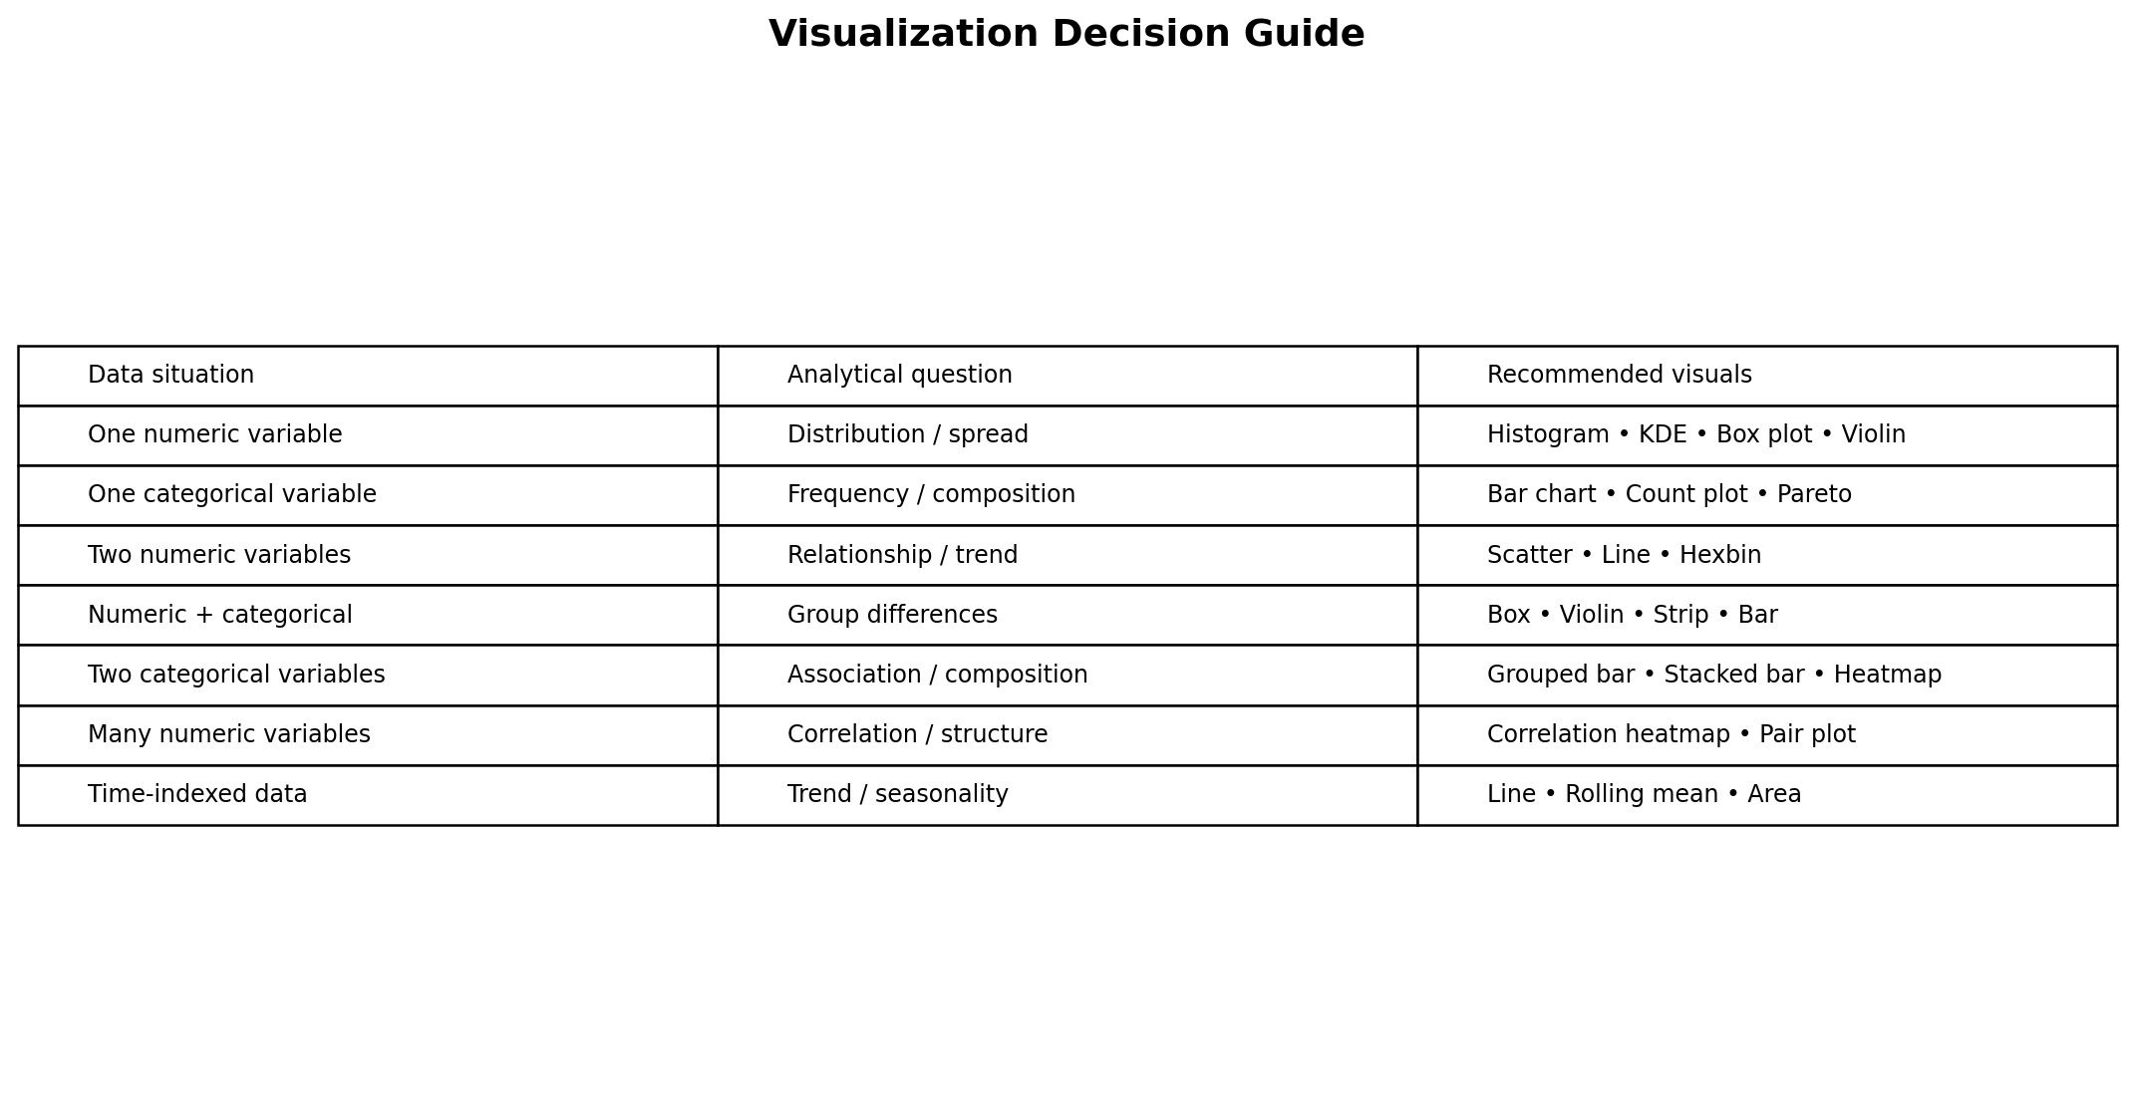
Figure 2. Chart-selection guide based on variable types and analytical questions.

8.1 Distribution visuals
Chart | Best use | Key interpretation
Histogram | Numeric distribution | Shape, skew, spread and unusual regions
KDE plot | Smooth distribution comparison | Approximate density and group differences
Box plot | Compare distributions across groups | Median, quartiles and potential outliers
Violin plot | Distribution + group comparison | Density shape across categories
Count plot | Categorical frequency | Category dominance and imbalance

8.2 Relationship visuals
Chart | Best use | Key interpretation
Scatter plot | Numeric vs numeric | Direction, strength, clusters and outliers
Line chart | Time series | Trend, seasonality and change points
Heatmap | Correlation or matrix relationships | Strength/patterns across many variables
Grouped bar | Category comparisons | Differences across groups
Stacked bar | Composition | Part-to-whole patterns across groups
Pair plot | Small multivariate numeric set | Pairwise relationships and clusters

9. Visualization Design Standards
A technically correct chart can still communicate poorly. The framework therefore includes presentation standards for every visualization.
- Every chart should answer a defined analytical question.
- Use descriptive titles that communicate the finding or purpose.
- Label axes clearly and include units where applicable.
- Use consistent category names and ordering.
- Avoid unnecessary 3D effects and decorative elements.
- Keep scales honest; do not truncate axes when doing so could mislead interpretation.
- Use annotations when they clarify important events, thresholds or anomalies.
- Prefer small multiples/facets over overcrowded multi-series charts.
- Use accessible contrast and readable font sizes.
- Include source/time period notes when the chart may be viewed independently.

Plot selection examples
Question | Suggested chart | Reason
What is the distribution of sales? | Histogram + box plot | Shows shape and potential extremes
Which category has the most observations? | Sorted horizontal bar | Easy category comparison
How does revenue change over time? | Line chart | Preserves temporal order
Do two numerical variables relate? | Scatter plot | Shows direction and nonlinear patterns
How do groups differ? | Box/violin plot | Shows distribution rather than only averages
Which numeric variables are correlated? | Heatmap | Compact overview of many pairwise associations

10. Python Libraries & Tools
Library / Tool | Role in EDA | Typical use
Pandas | Core data manipulation | Load, clean, filter, group, pivot and summarize
NumPy | Numerical foundation | Arrays, mathematical operations and efficient calculations
Matplotlib | Low-level visualization | Custom, publication-style static charts
Seaborn | Statistical visualization | Distribution, categorical and relationship plots
Plotly | Interactive visualization | Hoverable charts, dashboards and exploration
Jupyter Notebook | Interactive analysis | Narrative EDA with code, outputs and commentary
SciPy | Statistical utilities | Distributions, tests and supporting calculations
Scikit-learn | Later analytical support | Preprocessing, feature analysis and baseline models
OpenPyXL | Excel interoperability | Inspect or export spreadsheet-based datasets when needed
Git / GitHub | Version control | Track notebooks, scripts and documentation changes

Recommended environment
- Python 3.x virtual environment.
- JupyterLab or VS Code for analysis.
- requirements.txt or pyproject.toml for dependency reproducibility.
- Git repository with separate folders for data, notebooks, source code, figures and reports.

11. EDA Quality-Control Checklist
- Dataset shape and schema have been inspected.
- Data types have been validated and converted where necessary.
- Duplicate records have been measured and investigated.
- Missingness has been quantified and explained.
- Unique categories and invalid labels have been checked.
- Numerical ranges and impossible values have been tested.
- Date ranges, gaps and time granularity have been reviewed.
- Univariate distributions have been examined.
- Important bivariate relationships have been investigated.
- Relevant multivariate patterns have been explored.
- Outliers have been investigated rather than automatically deleted.
- Charts have clear titles, labels, units and appropriate scales.
- Insights are separated from assumptions and causal claims.
- All transformations and analytical decisions are documented.
- Key limitations and unanswered questions are explicitly recorded.

EDA stopping rule
EDA should be considered sufficiently mature when the analyst can explain the dataset's structure and quality, identify the most important patterns and anomalies, justify major transformations, state the principal limitations, and propose evidence-based next steps. More charts are not automatically better EDA.

12. Reporting & Documentation Framework

12.1 Proposed final report structure
Section | Content
1. Executive Summary | Top findings, implications and recommended next steps.
2. Objective & Context | Question, audience, scope and assumptions.
3. Dataset Overview | Source, dimensions, data dictionary and time coverage.
4. Data Quality | Missingness, duplicates, validity issues and treatments.
5. Univariate Findings | Key distributions and category patterns.
6. Bivariate Findings | Important relationships and group differences.
7. Multivariate Findings | Interactions, segments and broader patterns.
8. Visualization Highlights | Most decision-relevant charts with concise interpretation.
9. Limitations | Data gaps, bias risks, assumptions and uncertainty.
10. Recommendations | Next analytical steps, feature ideas or business actions.
11. Appendix | Additional charts, code references and technical notes.

12.2 Insight-writing template
Observation → Evidence → Interpretation → Implication → Limitation
Example: “Monthly revenue increased during Q3 (Observation), with the largest increase occurring in the enterprise segment (Evidence). This pattern suggests segment mix contributed to the overall rise (Interpretation). Future analysis should examine whether the increase is sustained (Implication). The current analysis is descriptive and does not establish causality (Limitation).”

12.3 Reproducibility requirements
- Keep raw data separate from transformed data.
- Store analysis code with version control.
- Use deterministic random seeds when sampling or modeling requires randomness.
- Record library versions for important analyses.
- Save final charts from reproducible code rather than manual editing.
- Maintain a clear notebook or script sequence from data load to final insight.

13. 32-Hour Week 2 Work Plan
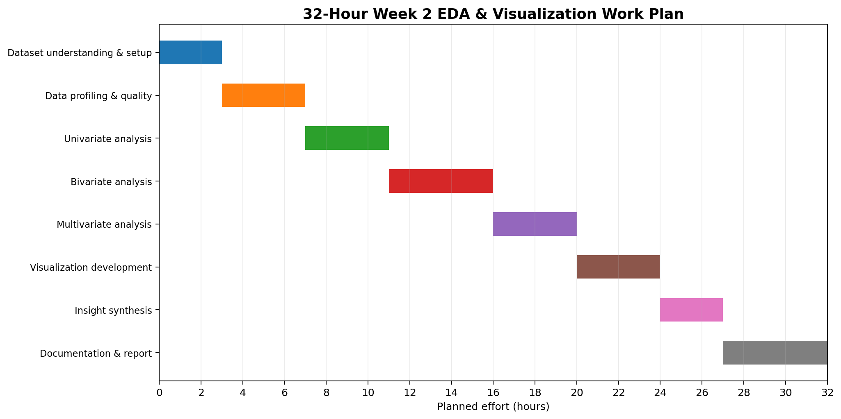
Figure 3. Planned 32-hour allocation for EDA and visualization framework development.
Phase | Activity | Hours | Output
1 | Dataset understanding & setup | 3 | Context, schema and analytical questions
2 | Data profiling & quality | 4 | Data-quality profile and issue register
3 | Univariate analysis | 4 | Distribution and frequency findings
4 | Bivariate analysis | 5 | Relationship and group-comparison findings
5 | Multivariate analysis | 4 | Correlation, segmentation and interaction findings
6 | Visualization development | 4 | Decision-relevant chart set
7 | Insight synthesis | 3 | Key findings, implications and limitations
8 | Documentation & report | 5 | Final EDA report/framework

Total planned effort: 32 hours.

Suggested milestones
- Hour 3: context and data structure understood.
- Hour 7: data-quality risks documented.
- Hour 11: univariate patterns documented.
- Hour 16: bivariate relationships reviewed.
- Hour 20: multivariate exploration completed.
- Hour 24: visualization set refined.
- Hour 27: major insights and limitations drafted.
- Hour 32: report finalized and quality-checked.

14. Expected Outcomes & Common Challenges

Expected outcomes
- A clear understanding of dataset structure and quality.
- A documented set of important distributions and relationships.
- A reusable visualization library of decision-relevant charts.
- A list of potential feature-engineering opportunities.
- Identification of anomalies, data gaps and potential biases.
- A concise set of evidence-backed insights for stakeholders.
- A reproducible EDA notebook/report ready for the modeling phase.

Challenges and mitigation
Challenge | Risk | Mitigation
Too many variables | Analysis becomes unfocused | Prioritize by business question and analytical relevance
Too many charts | Stakeholders miss the important findings | Use a chart-selection guide and insight hierarchy
Missing data | Biased summaries | Analyze missingness patterns before treatment
Outliers | Distorted statistics | Validate extreme values against domain context
Correlation misuse | False causal interpretation | Use neutral association language and further testing
Data leakage | Invalid downstream models | Exclude post-outcome information during EDA planning
Overplotting | Patterns become unreadable | Use aggregation, sampling, transparency or faceting
Inconsistent categories | Incorrect group comparisons | Standardize labels and validate mappings
Time aggregation | Important variation disappears | Inspect multiple time granularities before choosing one

15. Evaluation Criteria & Submission Readiness
Evaluation criterion | How this framework addresses it
Depth and clarity of EDA process | Covers profiling, quality, univariate, bivariate, multivariate, missing data, outliers and interpretation.
Visualization methodology | Maps variable types and analytical questions to suitable chart families.
Tool understanding | Explains practical roles of Pandas, NumPy, Matplotlib, Seaborn, Plotly and supporting tools.
Logical adaptability | Framework is dataset-agnostic and begins with context and data type identification.
Documentation quality | Provides a final-report structure, reproducibility requirements and insight-writing template.
Visual communication | Includes workflow, chart-selection and timeline diagrams.
Time planning | Allocates 32 hours across the complete Week 2 task.

Final quality gate
- All required task sections are present.
- The EDA workflow is understandable to a reviewer who does not have a dataset.
- Visualization choices are justified by variable type and analytical question.
- Missing-value and outlier strategies are conditional rather than one-size-fits-all.
- The report distinguishes descriptive findings from causal claims.
- The 32-hour plan is realistic and covers both analysis and documentation.
- The final DOCX has consistent headings, tables, diagrams and readable formatting.

16. Conclusion
This Week 2 framework establishes a structured, repeatable approach to Exploratory Data Analysis and visualization using Python. It begins with analytical context and dataset profiling, progresses through data-quality validation and increasingly detailed exploration, and ends with evidence-backed insights and professional documentation.
The central principle is that visualization should serve a question. Histograms, box plots, scatter plots, heatmaps, line charts and other visuals are selected according to the variable types and the decision the analysis needs to support. Missing values, outliers, correlations and unusual patterns are treated as investigation opportunities rather than automatic errors.
By following this framework, the next stage of a data science project can begin from a stronger foundation: the analyst understands the data's structure, knows which variables require attention, has identified important patterns and limitations, and can make more informed decisions about feature engineering, statistical analysis and machine learning.

Next-step readiness
- Move from the generic framework to a real dataset.
- Create the first profiling notebook.
- Implement data-quality checks.
- Build the prioritized visualization set.
- Document insights and limitations.
- Use EDA findings to guide Week 3 feature engineering and modeling.

