WEEK 3 PROJECT PLAN
Python-Based Machine Learning Model Development & Evaluation Plan
Customer Churn Prediction — From Data Preparation to Deployment
Document Information | Details
Project phase | Week 3 — Machine Learning Development & Evaluation Planning
Planned effort | 32 hours
Problem type | Binary classification — customer churn prediction
Primary goal | Design a reliable, validated Python ML pipeline for churn-risk prediction
Core stack | Python, Pandas, NumPy, Scikit-learn, Matplotlib/Seaborn, optional XGBoost/SHAP
Deliverable | Detailed DOCX plan covering preprocessing, model selection, training, validation, evaluation and deployment

Prepared as a Week 3 Data Science Strategy Submission

1. Project Overview & Problem Definition

1.1 Hypothetical problem
The project will develop a machine learning system that predicts whether an active subscription customer is likely to churn within the next 30 days. The hypothetical organization has customer profile information, subscription records, product-usage activity, transaction history, support interactions and customer feedback.

1.2 Why machine learning?
Churn is influenced by multiple signals that may interact in nonlinear ways. A machine-learning approach can combine behavioral, transactional and service features to produce a probability or risk score for each customer. This score can support prioritization by a retention team. The model is intended as decision support rather than an automatic decision-maker.

1.3 Target definition
Proposed target: churn_within_30_days = 1 when a customer cancels or fails to renew during the 30-day period following the observation date, and 0 otherwise. The target definition, observation window and exclusion rules must be approved before model development.

1.4 Success criteria
- A reproducible preprocessing and modeling pipeline.
- No target leakage between training features and the future outcome.
- Performance that materially improves upon a simple baseline on a future test period.
- Useful precision/recall trade-offs at operational thresholds.
- Well-calibrated probabilities where risk scores are used for prioritization.
- Documented model limitations and a monitoring strategy.

2. End-to-End Machine Learning Workflow
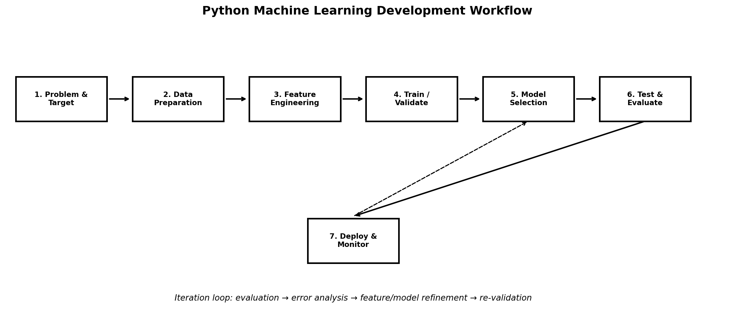
Figure 1. Planned Python machine-learning workflow.
The workflow is intentionally iterative. Evaluation results can reveal feature problems, subgroup weaknesses or calibration issues that require changes to preprocessing or model design before the final model is selected.

Workflow stages
- Define the business problem, prediction target, observation window and success criteria.
- Acquire and validate the analytical dataset.
- Split data using a strategy that matches how predictions will be made in production.
- Build preprocessing and feature-engineering pipelines.
- Establish a simple baseline.
- Train candidate models.
- Tune hyperparameters using validation data only.
- Evaluate the selected model on a locked test period.
- Perform error analysis, subgroup checks and interpretability review.
- Package the pipeline for deployment and define monitoring/retraining rules.

3. Data Preprocessing Strategy

3.1 Data cleaning
- Remove or resolve duplicate records when duplication is not meaningful.
- Standardize data types, dates, units and category labels.
- Validate customer identifiers and joins across source systems.
- Check impossible values and investigate source errors.
- Document every transformation.

3.2 Missing-value treatment
Data situation | Potential strategy | Control
Numeric, limited missingness | Median or model-based imputation | Fit imputer only on training data
Categorical missingness | Explicit Unknown category or most-frequent value | Check whether missingness is informative
No event recorded | Represent as zero only if business meaning is confirmed | Avoid confusing missing with zero
Systematic missingness | Investigate source/process first | Do not hide data-quality failures

3.3 Encoding and scaling
- One-hot encode nominal categories when suitable.
- Use ordinal encoding only when category order is meaningful.
- Scale numerical variables for models sensitive to feature magnitude, such as logistic regression.
- Tree-based models generally do not require feature scaling.
- Keep transformations inside a Scikit-learn Pipeline or ColumnTransformer to prevent train/test contamination.

3.4 Train/validation/test split
Because churn prediction is forward-looking, the preferred design is a chronological split. Older observations are used for training, a later period for validation/tuning, and the newest period is held out as a final test set.

4. Feature Engineering & Selection
Feature family | Examples | Reason
Tenure | Days/months since signup | Customer lifecycle context
Engagement | Active days, sessions, login frequency | Detect engagement changes
Usage trend | 30-day vs previous 30-day usage | Capture deterioration or growth
Recency | Days since last activity | Capture inactivity
Billing | Payment failures, invoice amount, discount usage | Identify payment friction
Support | Tickets, unresolved issues, response time | Capture service experience
Feedback | CSAT/NPS or survey signals | Customer sentiment
Contract | Plan type, renewal timing, contract length | Commercial context

Feature engineering principles
- Use only information available before the prediction timestamp.
- Prefer features with a clear business interpretation.
- Create rolling-window statistics such as 7-, 30- and 90-day activity where appropriate.
- Capture both level and trend when behavior changes are meaningful.
- Avoid excessive feature generation that increases noise and maintenance burden.

Feature selection
- Remove direct identifiers that have no predictive meaning.
- Remove constant or near-constant variables when appropriate.
- Inspect highly correlated variables for redundancy.
- Use domain knowledge to remove variables that create leakage or are operationally unavailable.
- Use model-based importance or regularization as supporting evidence rather than blindly selecting by a single score.

5. Model Selection & Training Strategy
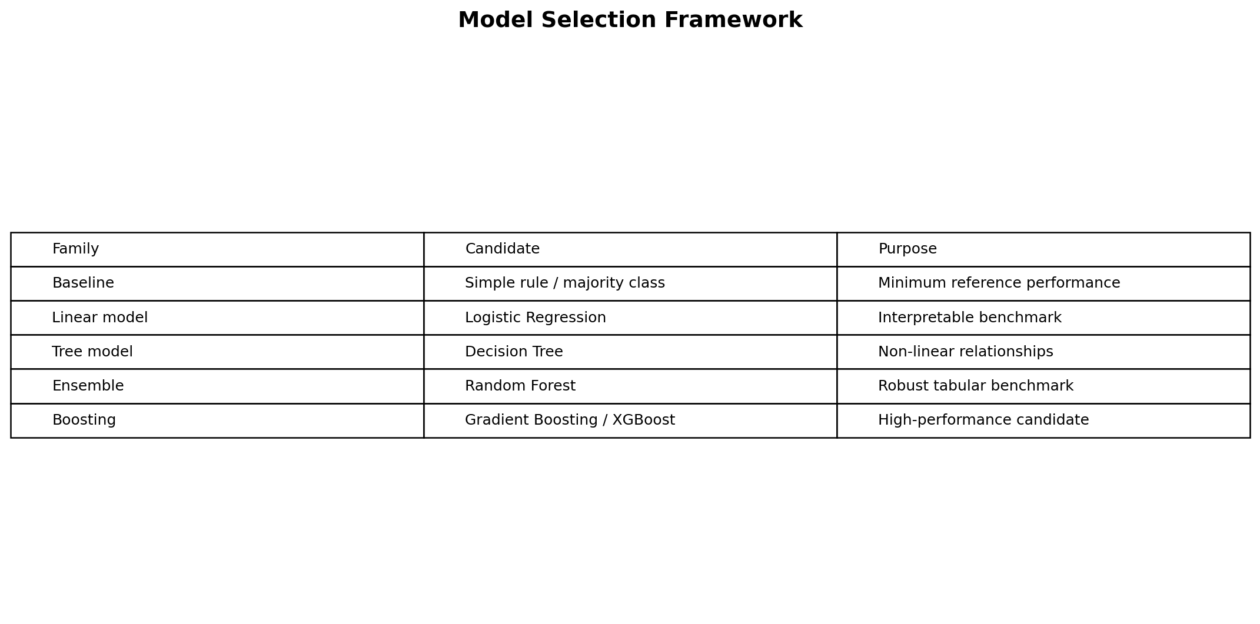
Figure 2. Candidate model framework and role of each model family.

5.1 Candidate models
Model | Purpose | Strengths | Risks
Majority/simple rule | Baseline | Easy to understand | Often weak on minority class
Logistic Regression | Interpretable benchmark | Fast, transparent, probability output | Limited nonlinear interactions
Decision Tree | Nonlinear benchmark | Easy to visualize | Can overfit
Random Forest | Robust ensemble | Handles nonlinearities and interactions | Less transparent than linear model
Gradient Boosting / XGBoost | Advanced candidate | Strong performance on tabular data | More tuning and interpretability work

5.2 Selection principle
Model selection should consider validation performance, calibration, interpretability, inference cost, maintenance complexity and operational requirements. The strongest model by one metric is not automatically the most suitable production model.

5.3 Training sequence
- Create a baseline using the training period.
- Train logistic regression as an interpretable benchmark.
- Train tree-based models using the same evaluation protocol.
- Compare models using predefined metrics.
- Tune only the strongest candidates.
- Lock the selected configuration before evaluating the final test period.

6. Hyperparameter Tuning & Cross-Validation

6.1 Hyperparameter examples
Model | Parameters to consider
Logistic Regression | Regularization strength C, penalty, class_weight
Decision Tree | max_depth, min_samples_split, min_samples_leaf
Random Forest | n_estimators, max_depth, max_features, min_samples_leaf
Gradient Boosting | learning_rate, n_estimators, max_depth, subsampling

6.2 Tuning strategies
- Grid search: systematic evaluation of a defined parameter grid.
- Randomized search: efficient exploration when many parameters exist.
- Bayesian/advanced optimization: optional for larger search spaces.
- Use a reproducible random seed where stochastic search is used.
- Keep the final test set completely isolated from tuning.

6.3 Cross-validation
For independent and identically distributed data, stratified k-fold cross-validation can preserve class proportions across folds. For time-dependent churn data, ordinary random k-fold can leak future information. A time-aware validation approach such as rolling or expanding windows should be preferred.

Validation example
- Training window: historical months 1–9.
- Validation window: month 10.
- Repeat by expanding the training window and moving the validation period forward.
- Reserve the latest month or future period as the final untouched test set.

7. Performance Evaluation Metrics

7.1 Classification metrics
Metric | Definition / question | Use in churn project
Accuracy | Overall proportion correctly classified | Secondary metric when classes are imbalanced
Precision | Of predicted churners, how many actually churn? | Important when outreach capacity is limited
Recall | Of actual churners, how many are identified? | Important when missed churn is costly
F1-score | Harmonic balance of precision and recall | Useful summary under class imbalance
ROC-AUC | Ranking performance across classification thresholds | Useful general comparison
PR-AUC | Precision-recall performance across thresholds | Especially informative for rare churn
Log loss | Quality of predicted probabilities | Useful when probability quality matters
Brier score | Squared probability error | Supports calibration assessment

7.2 Confusion matrix
The confusion matrix should be reviewed at operational thresholds to understand true positives, false positives, true negatives and false negatives. For a retention use case, the business should explicitly discuss the relative cost of missed churn versus unnecessary outreach.

7.3 Calibration
- Compare predicted probabilities with observed churn rates.
- Use calibration curves and appropriate calibration methods if needed.
- Avoid treating a probability such as 0.80 as meaningful unless it is reasonably calibrated.

8. Error Analysis, Robustness & Responsible Evaluation

8.1 Error analysis
- Inspect representative false positives and false negatives.
- Identify feature patterns associated with errors.
- Compare errors across important customer segments.
- Investigate whether errors arise from data-quality problems or model limitations.
- Use findings to improve features or model design rather than tuning solely for aggregate performance.

8.2 Segment-level checks
Performance should be examined across relevant segments such as customer plan, tenure group, geography or acquisition channel when those segments are legitimate and sufficiently populated. Large performance differences may indicate data coverage problems, different behavioral patterns or a need for segment-specific analysis.

8.3 Responsible use
- Do not use protected or highly sensitive attributes unless there is a clear, lawful and documented purpose.
- Treat model output as a prioritization signal, not a definitive statement about an individual.
- Maintain an audit trail for training data, features, model version and evaluation results.
- Document known limitations and situations where predictions should not be used.

9. Conceptual Model Deployment & Maintenance
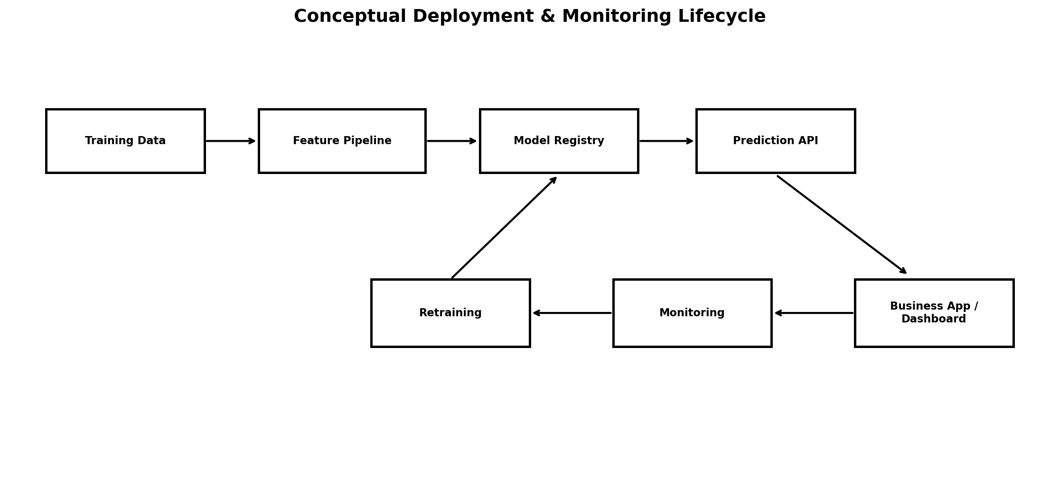
Figure 3. Conceptual deployment, monitoring and retraining lifecycle.

9.1 Deployment options
- Batch scoring: generate daily or weekly churn-risk scores and store them for business use.
- API scoring: expose the preprocessing + model pipeline through FastAPI for on-demand predictions.
- Dashboard: use Streamlit or a BI layer to display risk segments, model explanations and monitoring metrics.

9.2 Model packaging
- Serialize the complete preprocessing + model pipeline.
- Version the model artifact and training dataset specification.
- Store model metadata such as training period, feature list, metrics and threshold.
- Expose a stable prediction interface.
- Test the pipeline using representative input records before release.

9.3 Monitoring
Monitoring area | Example signal | Response
Data quality | Missingness, invalid values, schema changes | Investigate pipeline/source
Data drift | Feature distribution shifts | Review model validity
Prediction drift | Risk-score distribution changes | Investigate behavior/data changes
Performance | Precision, recall, PR-AUC when labels arrive | Retrain/review if threshold breached
Calibration | Predicted vs observed risk | Recalibrate if needed
Business impact | Retention rate, outreach conversion | Review intervention strategy

9.4 Retraining strategy
Retraining should be triggered by a defined schedule or by evidence such as sustained performance degradation, meaningful drift or a major product/business change. Every retrained model should pass the same validation and approval gates before replacement.

10. Suggested Python Implementation Blueprint
from sklearn.compose import ColumnTransformer
from sklearn.pipeline import Pipeline
from sklearn.impute import SimpleImputer
from sklearn.preprocessing import OneHotEncoder, StandardScaler
from sklearn.linear_model import LogisticRegression
from sklearn.model_selection import TimeSeriesSplit, RandomizedSearchCV
# 1. Define numeric and categorical feature lists
# 2. Build preprocessing transformers
# 3. Combine preprocessing + estimator in a Pipeline
# 4. Fit only on training data
# 5. Tune using time-aware validation
# 6. Evaluate once on the locked test period
# 7. Save the complete pipeline for deployment

Implementation rules
- Never fit an imputer, scaler or encoder on the test set.
- Keep preprocessing and model steps in one pipeline where practical.
- Log model versions, parameters, training dates and evaluation results.
- Use configuration files rather than hard-coding environment-specific settings.
- Write tests for feature transformations and prediction input validation.

11. Challenges & Mitigation Strategies
Challenge | Potential effect | Mitigation
Class imbalance | Low recall or misleading accuracy | Use PR-AUC, class weights, threshold tuning and stratified/time-aware evaluation
Target leakage | Artificially high validation performance | Point-in-time features and leakage review
Overfitting | Poor future performance | Cross-validation, regularization, simpler models and locked test
Data drift | Performance degrades after deployment | Monitor feature distributions and retrain when justified
Feature drift | Features become unavailable or change meaning | Data contracts and schema monitoring
Small sample size | Unstable estimates | Simpler models, resampling where appropriate and uncertainty reporting
High-dimensional data | Noise and computational cost | Feature selection, regularization or dimensionality reduction
Poor calibration | Risk scores are misleading | Calibration curves and post-hoc calibration
Operational mismatch | Model cannot be acted upon | Align threshold with capacity and intervention workflow

Risk prioritization
- Highest-priority controls are target definition, leakage prevention and temporal validation.
- Next priority is reliable preprocessing and data-quality monitoring.
- Model complexity should be increased only when evidence shows it adds useful performance.

12. 32-Hour Week 3 Timeline
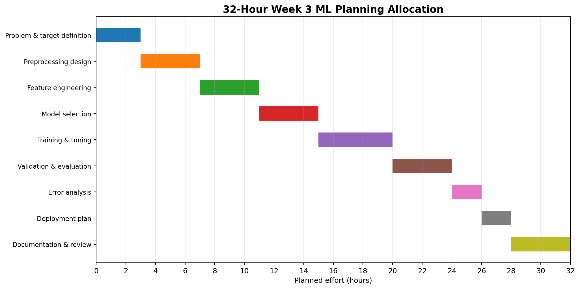
Figure 4. Planned 32-hour allocation across ML development and evaluation planning.
Phase | Work package | Hours | Output
1 | Problem & target definition | 3 | Target, business objective and success criteria
2 | Preprocessing design | 4 | Cleaning, encoding, scaling and split strategy
3 | Feature engineering | 4 | Point-in-time feature specification
4 | Model selection | 4 | Baseline and candidate model shortlist
5 | Training & tuning | 5 | Hyperparameter and CV strategy
6 | Validation & evaluation | 4 | Metrics, test strategy and calibration
7 | Error analysis | 2 | Failure modes and segment checks
8 | Deployment plan | 2 | Packaging, monitoring and retraining design
9 | Documentation & review | 4 | Final DOCX and quality check

Total planned effort: 32 hours.

Milestones
- Hour 3: problem, target and evaluation objectives finalized.
- Hour 7: preprocessing and split strategy documented.
- Hour 11: feature design completed.
- Hour 15: candidate models selected.
- Hour 20: training and tuning strategy finalized.
- Hour 24: evaluation framework finalized.
- Hour 26: error-analysis plan completed.
- Hour 28: deployment and monitoring plan completed.
- Hour 32: final documentation reviewed.

13. Evaluation Criteria & Submission Readiness
Criterion | How this plan addresses it
Thoroughness | Covers problem definition, preprocessing, feature engineering, selection, training, tuning, validation, evaluation, error analysis and deployment.
Clarity | Uses a step-by-step workflow with explicit inputs, outputs and quality gates.
Diagrams | Includes ML workflow, model-selection framework, deployment lifecycle and timeline visuals.
Evaluation understanding | Explains precision, recall, F1, ROC-AUC, PR-AUC, log loss, calibration and time-aware validation.
Real-world relevance | Addresses leakage, imbalance, drift, monitoring, thresholding and operational constraints.
Python readiness | Provides a practical Scikit-learn pipeline blueprint and tooling plan.
Time planning | Allocates 32 hours across all required Week 3 activities.

Final quality gate
- Target definition is unambiguous.
- Train/validation/test design matches the prediction setting.
- Preprocessing cannot leak test information.
- A baseline exists before complex models are compared.
- Metrics reflect class imbalance and business costs.
- The final test set remains untouched during tuning.
- Error analysis and calibration are included.
- Deployment includes monitoring and retraining conditions.
- Documentation is reproducible and version-aware.

14. Conclusion & Next-Phase Readiness
This Week 3 plan defines a structured approach for developing and evaluating a Python-based machine-learning model for customer churn prediction. The strategy moves from a precisely defined business problem through preprocessing, point-in-time feature engineering, model selection, training, hyperparameter tuning, validation, final testing, error analysis and conceptual deployment.
A key principle is that model development should optimize for trustworthy future performance rather than impressive training results. Chronological validation, leakage prevention, appropriate classification metrics, calibration and segment-level error analysis are therefore treated as core requirements.
The framework is designed to be implemented in later weeks using Pandas and Scikit-learn, with optional XGBoost, SHAP, FastAPI and Streamlit components. The final system can eventually support batch or API-based scoring, monitoring, model versioning and evidence-based retraining.

Next implementation steps
- Acquire and validate the real or representative dataset.
- Implement the data-quality and point-in-time feature pipeline.
- Create chronological train/validation/test splits.
- Build the baseline and logistic-regression benchmark.
- Train and compare tree-based models.
- Tune shortlisted models using appropriate cross-validation.
- Evaluate the final model on the locked test period.
- Perform error analysis and calibration review.
- Package the selected pipeline and define deployment monitoring.

