AI Practical : Factorial and Fibonacci

KHUSHI JAIN 204024

Factorial:

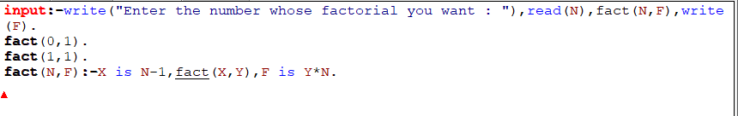

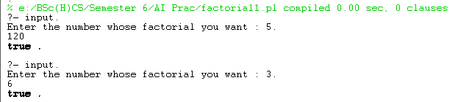

Fibonacci:

