AI PRACTICAL

**Ques : Write a Prolog program to implement power (Num,Pow, Ans) : where Num is raised to the power Pow to get Ans.**

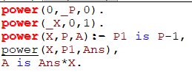



**Ques : Prolog program to implement multi (N1, N2, R) : where N1 and N2 denotes the numbers to be multiplied and R represents the result.**



