**AI PRACTICAL**

**Guildlines Ques 16. Write a prolog program to implement insert_nth (I, N, L, R) that inserts an item I into Nth position of list L to generate a list R.**

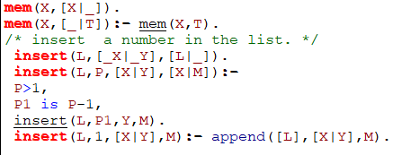



**Ques 17. Write a Prolog program to implement delete_nth (N, L, R) that removes the element on Nth position from a list L to generate a list R**.

