**AI PRACTICAL**

Guildlines Ques 8) Write a Prolog program to implement memb(X, L): to check whether X is a member of L or not.

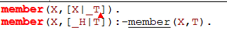

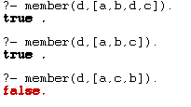

Ques 14. Write a Prolog program to implement nth_element (N, L, X) where N is the desired position, L is a list and X represents the Nth element of L.



