LAB 2
TASK 1
Line Plot
- Plot the rent (“Rent” column) against the size (“Size” column).
- Use different line styles (solid, dashed, dotted) for better visualization.
- Add gridlines to the plot.
- Title: "Rent vs. Size"
- Label the x-axis as "Size (sq ft)" and the y-axis as "Rent (INR)".
- Set the legend position to the top-right corner
INPUT
avg = data.groupby('Furnishing Status')['Rent'].mean()
fig, ax = plt.subplots(figsize = (12, 10))
avg.plot(kind = 'bar', color = ['red', 'blue', 'green'], title="Average Rent by Furnishing Status" )
ax.set(xlabel='Furnishing Status', ylabel='Average Rent (INR)')
fig.savefig("Tasks2.png")
plt.show()
OUTPUT
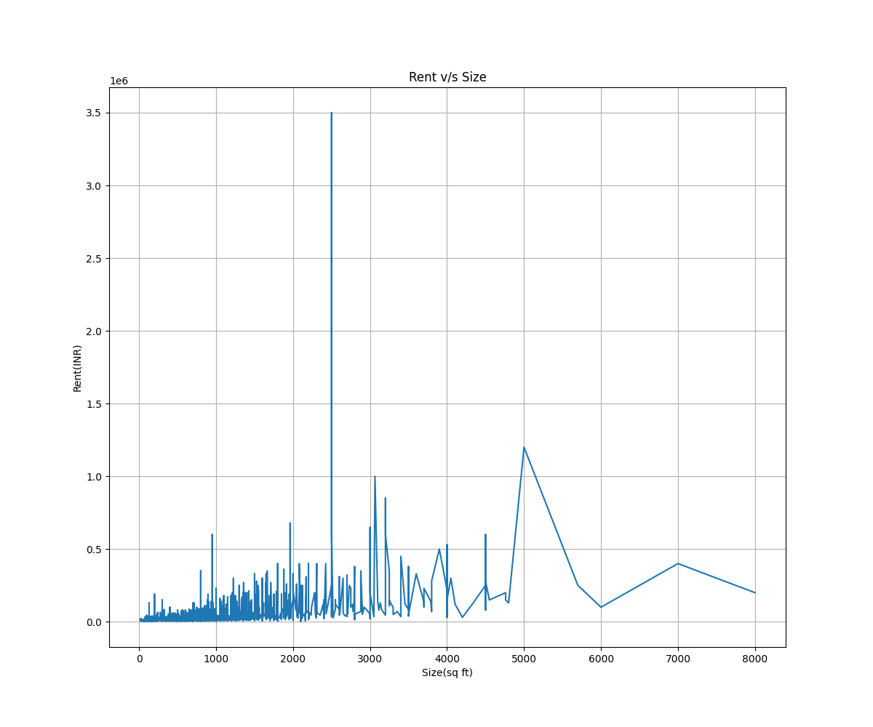
TASK 2
BarChart
- Createabar chart to display the average rent for each furnishing status
- Use different colors for each bar.
- Title: "Average Rent by Furnishing Status"
- Label the x-axis as "Furnishing Status" and the y-axis as "Average Rent (INR)"
INPUT
avg = data.groupby('Furnishing Status')['Rent'].mean()
fig, ax = plt.subplots(figsize = (12, 10))
avg.plot(kind = 'bar', color = ['red', 'blue', 'green'], title="Average Rent by Furnishing Status" )
ax.set(xlabel='Furnishing Status', ylabel='Average Rent (INR)')
fig.savefig("Tasks2.png")
plt.show()
OUTPUT
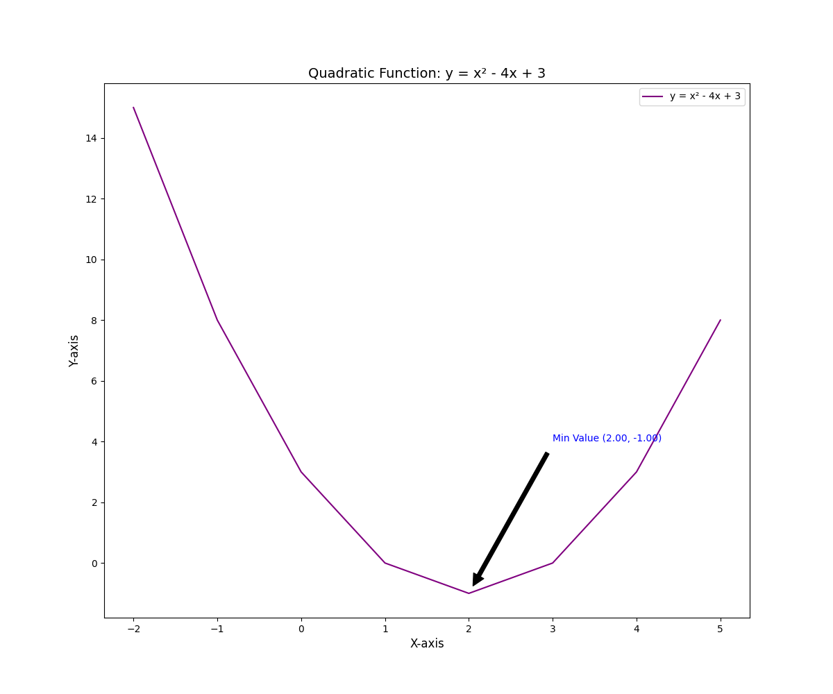
TASK 3
Scatter Plot
- Plot the number of bathrooms (“Bathroom” column) against the rent (“Rent”
column).
- Use different marker styles for points representing flats in different cities (“City”
column).
- Title: "Bathrooms vs. Rent"
- Label the x-axis as "Number of Bathrooms" and the y-axis as "Rent (INR)".
- Use a legend to indicate cities and place it below the plot.
INPUT
# Plot the number of bathrooms (“Bathroom” column) against the rent (“Rent”column)
fig, axes = plt.subplots(figsize=(12, 10))
for city in data['City'].unique():
new_data = data[data['City'] == city]
axes.scatter(x = new_data['Bathroom'], y = new_data['Rent'],marker = 'H', label=city,s=12, alpha = 0.3)

axes.set(xlabel='Numebr of Bathrooms', ylabel='Rent(INR)', title='Bathroom v/s Rent')
ax.legend()
ax.grid(True)
fig.savefig("Task3.png")
plt.show()
OUTPUT
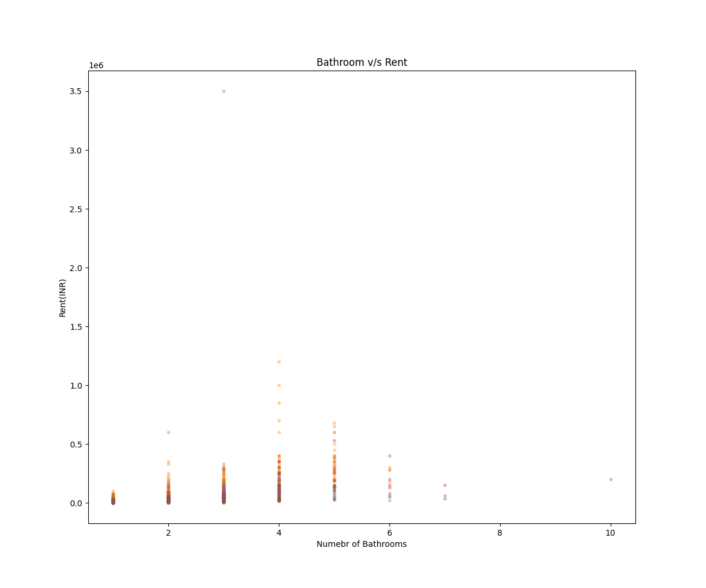
TASK 4
Consider monthly temperature data for the year 2023 and plot it using a time-series line graph.
months = ['Jan', 'Feb', 'Mar', 'Apr', 'May', 'Jun', 'Jul', 'Aug', 'Sep', 'Oct', 'Nov', 'Dec']
temperature = [12, 14, 18, 24, 30, 34, 32, 31, 28, 22, 16, 13]
Label the x-axis as Months
INPUT
months = ['Jan', 'Feb', 'Mar', 'Apr', 'May', 'Jun', 'Jul', 'Aug', 'Sep', 'Oct', 'Nov', 'Dec']
temperatures = [12, 14, 18, 24, 30, 34, 32, 31, 28, 22, 16, 13]

x= months
y = temperatures

plt.plot(x, y)
plt.title("Temperature(°C) variation with the months")
plt.xlabel("Months")
plt.ylabel("Temperature(°C)")
plt.savefig("Task4.png")
plt.show()
OUTPUT
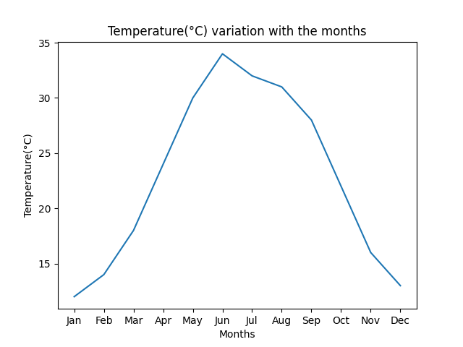
TASK 5
Plot three mathematical functions on the same graph:
- y=x²(Red,DashedLine)
- y=2x+1(Blue,Solid Line)
- y=sqrt(x) (Green, Dotted Line)
Add a legend, labels, and title.
INPUT
# Define the value of x with equal spaces
import numpy as np
x = np.arange(0, 10, 1)

# Compute the functions
Y1 = x**2
Y2 = 2*x + 1
Y3 = np.sqrt(x)

plt.plot(x, Y1, label='x²', color='red', linestyle = 'dashed', linewidth=2)
plt.plot(x, Y2, label='2x+1', color='blue', linestyle = 'solid', linewidth=2)
plt.plot(x, Y3, label='sqrt(x)', color='green', linestyle= 'dotted', linewidth=2)
plt.title("Mathematical functions")
plt.legend()
plt.xlabel("X-aixs")
plt.xlabel("Y-aixs")
plt.savefig("Task51.png")
plt.show()
OUTPUT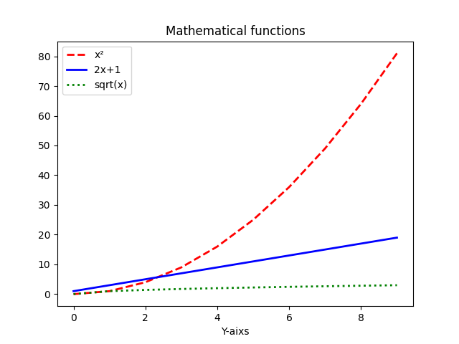
TASK 6
Create a dual-axis plot where:
- Theprimaryy-axis represents the monthly rainfall (in mm) in 2023 as a bar chart.
- Thesecondary y-axis represents the average temperature (in °C) as a line graph on the same plot.
months = ['Jan', 'Feb', 'Mar', 'Apr', 'May', 'Jun', 'Jul', 'Aug', 'Sep', 'Oct', 'Nov', 'Dec']
rainfall = [78, 62, 55, 41, 32, 140, 300, 280, 150, 90, 85, 80]
temperature = [12, 14, 18, 24, 30, 34, 32, 31, 28, 22, 16, 13]
Label both y-axes and use different colors for bars and the line
INPUT
import matplotlib.pyplot as plt
import numpy as np

# Define the data
months = ['Jan', 'Feb', 'Mar', 'Apr', 'May', 'Jun', 'Jul', 'Aug', 'Sep', 'Oct', 'Nov', 'Dec']
rainfall = [78, 62, 55, 41, 32, 140, 300, 280, 150, 90, 85, 80]
temperature = [12, 14, 18, 24, 30, 34, 32, 31, 28, 22, 16, 13]

x = months
Y1 = rainfall
Y2 = temperature

fig, ax1 = plt.subplots()
# Left Y-axis plot
color = 'tab:red'
ax1.set_xlabel('Months')
ax1.set_ylabel('Rainfall (mm)', color=color)
line1, = ax1.plot(x, Y1, color=color, label="Rainfall (mm)") # unpack with comma
ax1.tick_params(axis='y', labelcolor=color)

# Right Y-axis plot
ax2 = ax1.twinx() # Shares the same x-axis
color = 'tab:blue'
ax2.set_ylabel('Temperature (°C)', color=color)
line2, = ax2.plot(x, Y2, color=color, label="Temperature (°C)") # unpack with comma
ax2.tick_params(axis='y', labelcolor=color)

# Combine legends from both axes
lines = [line1, line2]
labels = [l.get_label() for l in lines]
ax1.legend(lines, labels, loc="upper left")
fig.tight_layout()
plt.savefig("Task6.png")
plt.show()
OUTPUT
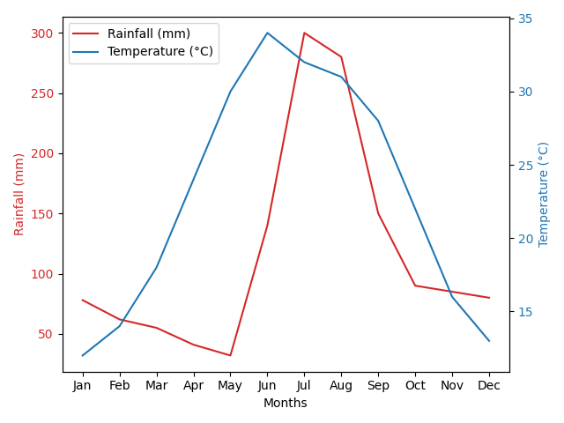
TAK 7
Draw a house using matplotlib line charts
INPUT
# Walls
x_walls = [1, 1, 5, 5, 1]
y_walls = [1, 5, 5, 1, 1]
plt.plot(x_walls, y_walls, color='saddlebrown', label='Walls')

# Roof
x_roof = [1, 3, 5]
y_roof = [5, 7, 5]
plt.plot(x_roof, y_roof, color='saddlebrown', label='Roof')

# Door
x_door = [1.5, 1.5, 2.5, 2.5, 1.5]
y_door = [1, 3, 3, 1, 1]
plt.plot(x_door, y_door, color='blue', label='Door')

# Window1
x_win1 = [4, 4, 4.5, 4.5, 4]
y_win1 = [1.5, 2, 2, 1.5, 1.5]
plt.plot(x_win1, y_win1, color='teal', label='Window 1')

# Window2
x_win2 = [4, 4, 4.5, 4.5, 4]
y_win2 = [3, 3.5, 3.5, 3, 3]
plt.plot(x_win2, y_win2, color='teal', label='Window 2')

plt.title("House Using Line Plots with Multiple Colors")
plt.xlabel("X-axis")
plt.ylabel("Y-axis")
plt.legend(loc='upper right')
plt.grid(True)
plt.axis('equal') # Keep aspect ratio square
plt.savefig("Task7.png")
plt.show()
OUTPUT
